Buildroot image with Qt5 . OPEGN GLS 2.0 , mesa VC4 driver in 32 bit

starting from the raspberry pi configuration for 32 bit:

make raspberrypi3_defconfig

nothing to be change in Target architecture
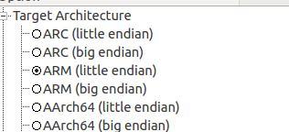

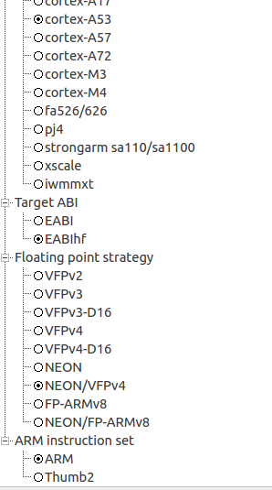

Change as usual the savedefconfig and download location

to the same place where all the builds you do. It could save time if downloaded package already there.

Before I will go over the QT5 VC4 settings, I will start with the compiler.
While adding QT5 in 32 bit I am getting compiler error when using external download compiler and external pre built

I tried to compile several times with external toolchain

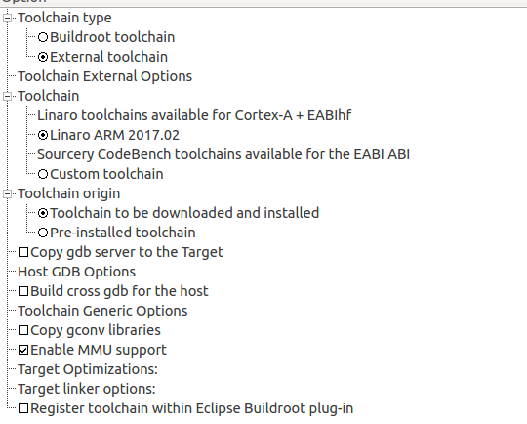

But I got the following error when compiling with QT5 in the 32bit.
This is a problem of the compiler.
When I am using buildroot internal toolchin I dont get this error

D_FILE_OFFSET_BITS=64 -Os --sysroot=/home/first/buildroot/blrpi3_32/buildroot-2017.05/output/host/usr/arm-buildroot-linux-gnueabihf/sysroot -O3 -O3 -std=c++1z -fvisibility=hidden -fvisibility-inlines-hidden -Wall -W -Wvla -Wdate-time -Wshift-overflow=2 -Wduplicated-cond -D_REENTRANT -fPIC -DQT_NO_USING_NAMESPACE -DQT_NO_FOREACH -DQT_USE_ICU -DQT_HAVE_POLL -DQT_HAVE_PPOLL -DQT_BUILD_CORE_LIB -DQT_BUILDING_QT -DQT_NO_CAST_TO_ASCII -DQT_ASCII_CAST_WARNINGS -DQT_MOC_COMPAT -DQT_USE_QSTRINGBUILDER -DQT_DEPRECATED_WARNINGS -DQT_DISABLE_DEPRECATED_BEFORE=0x050000 -D_LARGEFILE64_SOURCE -D_LARGEFILE_SOURCE -DQT_NO_DEBUG -I. -Iglobal -I../3rdparty/harfbuzz/src -I../3rdparty/md5 -I../3rdparty/md4 -I../3rdparty/sha3 -I../3rdparty/double-conversion/include -I../3rdparty/double-conversion/include/double-conversion -I../3rdparty/forkfd -I../../include -I../../include/QtCore -I../../include/QtCore/5.8.0 -I../../include/QtCore/5.8.0/QtCore -I.moc -I../../mkspecs/devices/linux-buildroot-g++ -o .obj/qhash.o tools/qhash.cpp
tools/qhash.cpp:148:54: error: attribute(target("+crc")) is unknown
static uint crc32(const Char *ptr, size_t len, uint h)

to solve this I edit the qhash.cpp and add at the top
#undef __ARM_FEATURE_CRC32

The internal build root compiler , complains about other error that I don't konw why.
Never mind , I don't want the internal toolchain any case.

One thing left to check is external pre build compiler from cross tol ng for 32 bit
The armv8-rpi3-linux-gnueabihf

so I run cr-ng armv8-rpi3-linux-gnueabihf
and ct-ng build
to bulid that compiler.
Once does I will write about the success or not when compiling build root 32 bit + Qt5
with that compiler

Qt settings

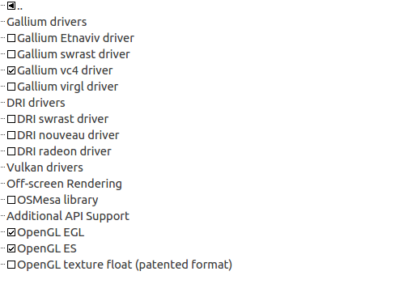

Enable the masa drivers
and the VC4 open gl driver by Broadcom.

