Buildroot – build image with wifi
24.06.2017

Start with buildroot 2017 05 , raspberry pi 3 32 bit defconfig:

make raspberrypi3_defconfig

#
# configuration written to /mnt/sd/buildroot/wifii/buildroot-2017.05/.config
#

run:
make xconfig

Change tool chain to external Linaro

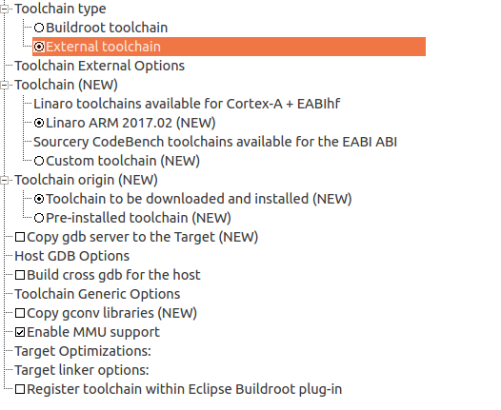

Change build options

change the save config to a name you want to save
the download dir to a common place for all your buildroot
and compiler cache.

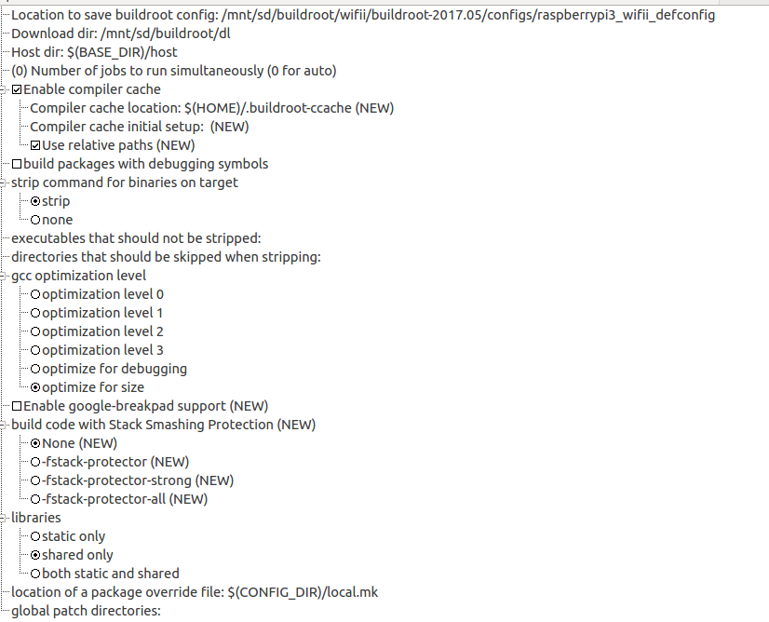

System configuration
Set eudev device manager , change the password , dont leave blank ( bad for dropbear)

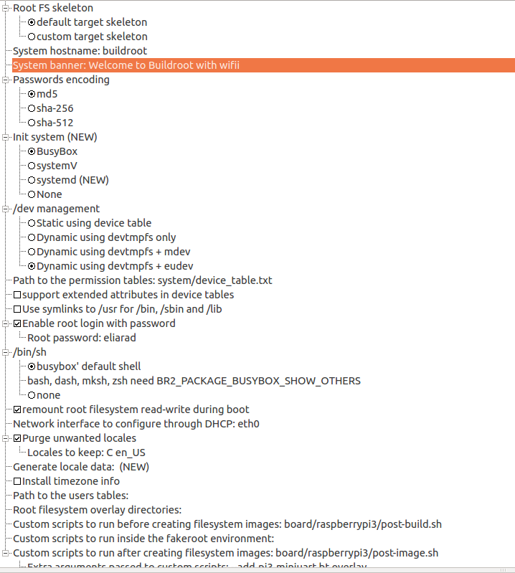
Add time zone info

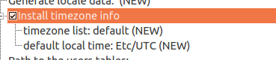

search for dropbear using Ctrl+F
SSH server

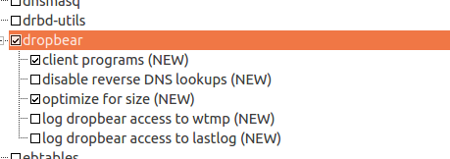

in Firmware add the raspberry pi 3 wifi firmware

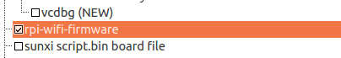

wpa supplicant:
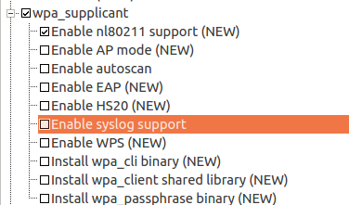

AP mode: - access point mode:
http://blog.hoxnox.com/gentoo/wifi-hotspot.html

WPS:
http://web.mit.edu/freebsd/head/contrib/wpa/wpa_supplicant/README-WPS



https://wiki.archlinux.org/index.php/WPA_supplicant

Connecting with wpa_cli
This connection method allows scanning for the available networks, making use of wpa_cli, a command line tool which can be used to interactively configure wpa_supplicant at runtime. See wpa_cli(8) for details.
In order to use wpa_cli, a control interface must be specified for wpa_supplicant, and it must be given the rights to update the configuration. Do this by creating a minimal configuration file:
/etc/wpa_supplicant/example.conf
ctrl_interface=/run/wpa_supplicant
update_config=1

Now start wpa_supplicant with:
# wpa_supplicant -B -i interface -c /etc/wpa_supplicant/example.conf
Tip: To discover your wireless network interface name, issue the ip link command.
At this point run:
# wpa_cli
For now , I dont want auto scan or access point:
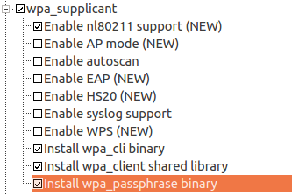

Node js
I will want to run a simple server with angular and node js:
https://github.com/EliArad/quicksite

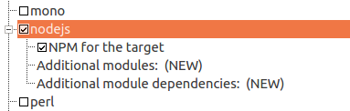

The node js version is:
NODEJS_VERSION = 7.10.0
see packages\nodejs\nodejs.mk
which is fine for us.

In javascript:
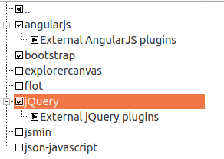

Lets change the angular version to 1.5
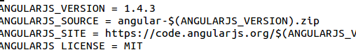

to:
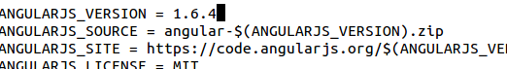

all the angular versions are here:
https://code.angularjs.org/
1.6.4 is the latest version for today 24.6.2017
and delete the hash file:
rm package/angularjs/angularjs.hash

The bootstrap is 3.3.1 which is fine.

Lets also install git:


and libcurl and curl binary as well.

as to now , I dont know if we need to increase the file system default size of: 61440 blocks
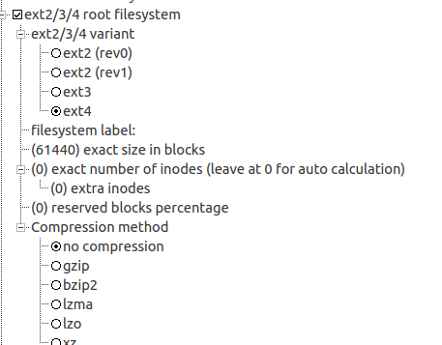

Build-root will tells us right before it finished the build if the size is not enough.
When it happened, we can just increase it more and run make, it will continue from that point.

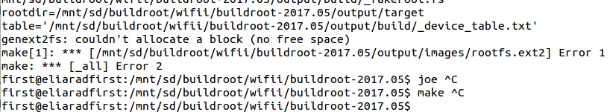
We need more space:
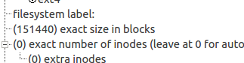

Increase to 151440

Buildroot also add the nginx reverse proxy server:
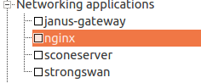

but it is not for now.
That's it . Lets compile
make ( and wait for 2 hours at least)......................
The image is ready.

lsmod shows that the wifi driver brcmfmac is loaded:
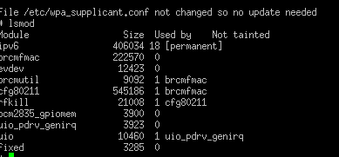

First , lets setup the wifii in Raspbian jessie

There are two options in raspbian.
1. to install wpa_gui and using the gui create network parameters in wpa_supplicant.conf
2. To edit wpa_supplicant.conf manually.

First we need to edit /etc/network/interface

allow-hotplug wlan0
iface wlan0 inet dhcp
wpa-conf /etc/wpa_supplicant/wpa_supplicant.conf

The above points to wpa_supplicant.conf

ctrl_interface=DIR=/var/run/wpa_supplicant GROUP=pi
The group is very important!!
you can type
groups and user name to get all the groups that your user belongs to:
pi : pi adm dialout cdrom sudo audio video plugdev games users input netdev spi i2c gpio

This is the entire wpa_supplicant file in my Raspbian:

ctrl_interface=DIR=/var/run/wpa_supplicant GROUP=pi
ctrl_interface_group=0
update_config=1

network={
ssid="Tenda_16A828"
psk="12345678"
proto=WPA
key_mgmt=WPA-PSK
pairwise=CCMP
auth_alg=OPEN
}

if everything is ok , than wpa_supplicant will start, if not you can run it manually and it will tell you if you have errors.

sudo wpa_supplicant -i wlan0 -c /etc/wpa_supplicant/wpa_supplicant.conf -Dwext

if you see errors , fixed them and then it will start because it is already in network/interfaces.
You can also install wpa gui in Raspbian:
sudo apt-get install wpagui
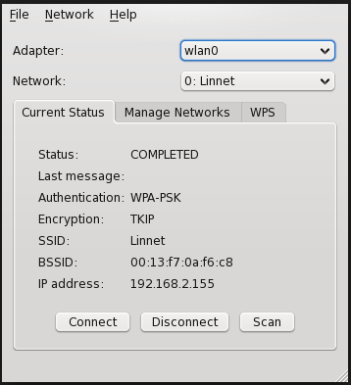

wpa_passphrase with your wifi ssid
wpa_passphrase is already installed by buildroot

for examples
wpa_passphrase Tenda_16A828

it will ask you for the password of the wifi:

and will create a psk for you:

# reading passphrase from stdin
12345678
network={
ssid="Tenda_16A828"
#psk="12345678"
psk=c26574103af8f7dcdf00a452e6eea20ba660e842aa41d6d3b02139c05c8e0bff
}

ifconfig:

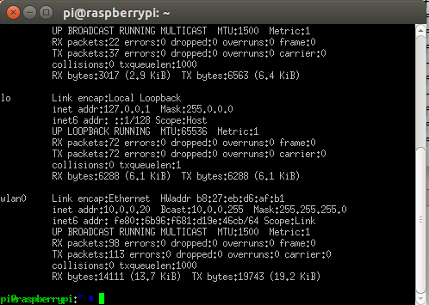

we can see that we have ip addedd in wlan0 after reboot

using putty we can connect to the wifi address:
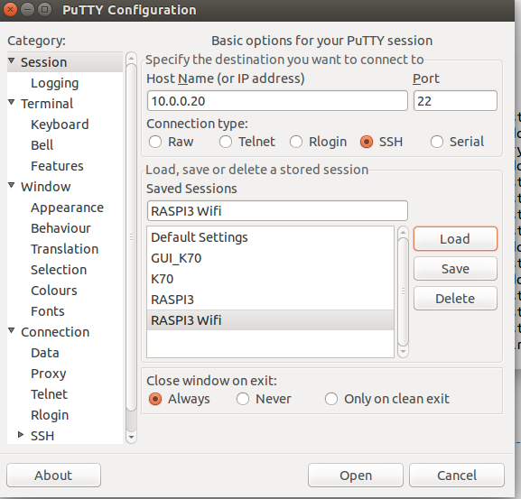

user: pi
password: raspberry

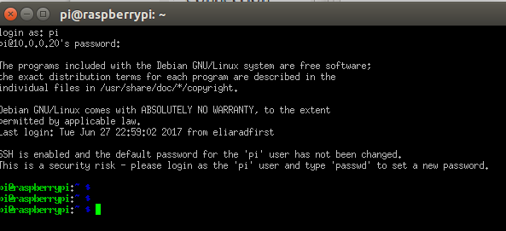
and we are in:

Now lets do it Buildroot

after login to the image we created.

we can type:

id

uid=0(root) gid=0(root) groups=0(root),10(wheel)

we can also install groups using busybox ( which is not installed in default)

make busybox-menuconfig

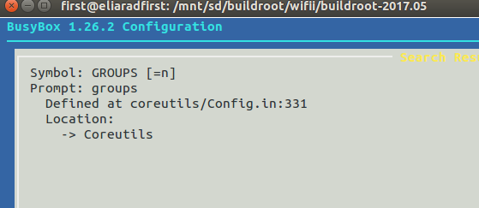

we then , can exist the menuconfig and type make to build again.
This should takes 30 seconds no more.

We can find the groups utility in
output/target/usr/bin/groups

We can copy the utility into our target pi without the need of burning just now the image ( which will take longer to do)

sudo scp usr/bin/groups root@10.0.0.2:/usr/bin/

we can type now groups and get
root wheel

in buildroot the group is root.
Lets add to /etc/network/interfaces

The below network/interfaces was taken from here:
https://github.com/danielnilsson9/buildroot-rpi3

auto wlan0
iface wlan0 inet dhcp
wireless-essid "Tenda_16A828"
wireless-key "12345678"
pre-up wpa_supplicant -i wlan0 -c /etc/wpa_supplicant.conf -B
post-down killall -q wpa_supplicant

The change here is that the wpa-conf
is located at /etc and not at /etc/wpa_supplicant

Lets change the wpa_supplicant.conf the all we know already:

ctrl_interface=DIR=/var/run/wpa_supplicant GROUP=root
ctrl_interface_group=0
update_config=1

network={
ssid="Tenda_16A828"
psk="12345678"
proto=WPA
key_mgmt=WPA-PSK
pairwise=CCMP
auth_alg=OPEN
}
ssid is the router , access point ssid
psk can be in not encrypt or encrypt form.

http://www.cs.upc.edu/lclsi/Manuales/wireless/files/wpa_supplicant.conf

# pairwise: list of accepted pairwise (unicast) ciphers for WPA
# CCMP = AES in Counter mode with CBC-MAC [RFC 3610, IEEE 802.11i/D7.0]
# TKIP = Temporal Key Integrity Protocol [IEEE 802.11i/D7.0]
# NONE = Use only Group Keys (deprecated, should not be included if APs support
# pairwise keys)
# If not set, this defaults to: CCMP TKIP
# auth_alg: list of allowed IEEE 802.11 authentication algorithms
# OPEN = Open System authentication (required for WPA/WPA2)
# SHARED = Shared Key authentication (requires static WEP keys)
# LEAP = LEAP/Network EAP (only used with LEAP)
# If not set, automatic selection is used (Open System with LEAP enabled if
# LEAP is allowed as one of the EAP methods).

# key_mgmt: list of accepted authenticated key management protocols
# WPA-PSK = WPA pre-shared key (this requires 'psk' field)
# WPA-EAP = WPA using EAP authentication (this can use an external
# program, e.g., Xsupplicant, for IEEE 802.1X EAP Authentication
# IEEE8021X = IEEE 802.1X using EAP authentication and (optionally) dynamically
# generated WEP keys

the best is to reboot now.

Another link:
http://weworkweplay.com/play/automatically-connect-a-raspberry-pi-to-a-wifi-network/

running a quick site node js + angular from github

git clone https://github.com/EliArad/quicksite

