Building initramfs

http://nairobi-embedded.org/initramfs_tutorial.html

Initramfs images are compressed (typically, gzip) cpio archive files.

The initramfs image is embed in the kernel
the kernel expand and extract the compressed CPIO archive

There is an option to External initramfs
An external initramfs is a separate compressed cpio archive that is not linked into the kernel image

to embed an initramfs in the kernel , we need a kernel.
As usual we will select the raspberry pi 3 kernel.
The rasp pi 3 defconfig is already exists in the latest kernel 4.11.3
we learned how to build a kernel, for example for raspberry pi 3:
cp arch/arm/configs/bcm2835_defconfig .config

( everything need a cross comiler , so before you start make sure you read the crossng tool prepare cross compile)

The kernel has options for the source of the initramfs
searching for initramfs in the menuconfig:

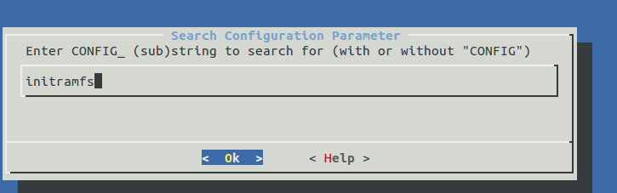
will give us all the compression options and the source:

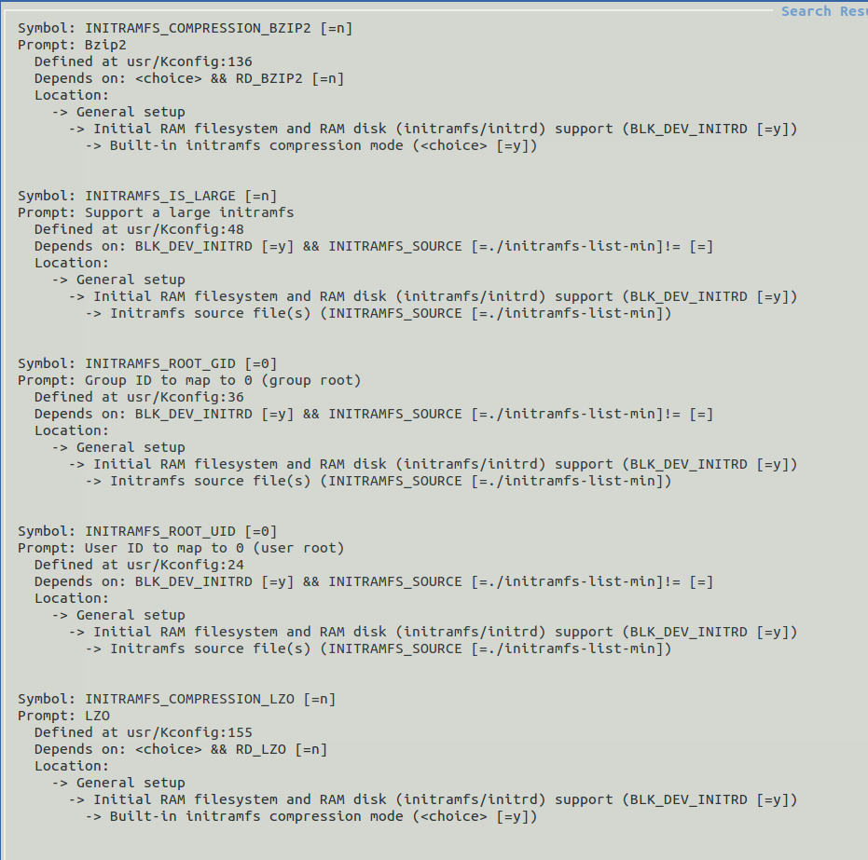
And the source of the init ram fs file

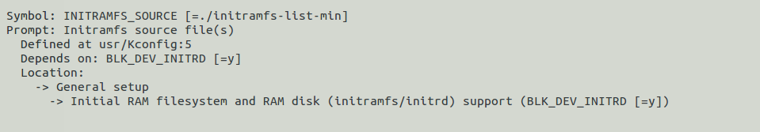

The initramfs is a text file , defining the directories , nodes , files to copy
and the links ( form busy box usually)

dir /dev 0755 0 0
dir /dev/pts 0755 0 0
dir /dev/input 0755 0 0
dir /root 0700 0 0
dir /proc 0755 0 0
dir /sys 0755 0 0
dir /etc 0755 0 0
dir /var 0755 0 0
dir /var/config 0755 0 0
dir /var/tmp 0755 0 0
dir /var/log 0755 0 0
dir /var/run 0755 0 0
dir /var/lock 0755 0 0
dir /bin 755 0 0
dir /tmp 755 0 0
dir /mnt 755 0 0
dir /mnt/appfs 755 0 0
dir /mnt/appfs/Fonts 755 0 0
dir /mnt/appfs/Images 755 0 0
dir /mnt/appfs/animations 755 0 0
dir /mnt/appfs/Scripts 755 0 0
dir /mnt/appfs/Screen 755 0 0

nod /dev/tty 0666 0 0 c 5 0
nod /dev/console 0600 0 0 c 5 1
nod /dev/ptmx 0666 0 0 c 5 2
nod /dev/ttyS0 0666 0 0 c 4 64
nod /dev/ttyS1 0666 0 0 c 4 65
nod /dev/ttyS2 0666 0 0 c 4 66
nod /dev/ttyS3 0666 0 0 c 4 67
nod /dev/ttyS4 0666 0 0 c 4 68
nod /dev/ttyS5 0666 0 0 c 4 69
nod /dev/null 0600 0 0 c 1 3
nod /dev/mem 0600 0 0 c 1 1
nod /dev/kmem 0600 0 0 c 1 2
nod /dev/zero 0600 0 0 c 1 5
nod /dev/random 0600 0 0 c 1 8
nod /dev/urandom 0600 0 0 c 1 9
nod /dev/rtc0 0600 0 0 c 254 0

nod /dev/mtd0 0600 0 0 c 90 0
nod /dev/mtd0ro 0600 0 0 c 90 1
nod /dev/mtd1 0600 0 0 c 90 2
nod /dev/mtd1ro 0600 0 0 c 90 3
nod /dev/mtd2 0600 0 0 c 90 4
nod /dev/mtd2ro 0600 0 0 c 90 5
nod /dev/mtd3 0600 0 0 c 90 6
nod /dev/mtd3ro 0600 0 0 c 90 7

nod /dev/mtdblock0 0600 0 0 b 31 0
nod /dev/mtdblock1 0600 0 0 b 31 1
nod /dev/mtdblock2 0600 0 0 b 31 2
nod /dev/mtdblock3 0600 0 0 b 31 2

nod /dev/fb0 0600 0 0 c 29 0
nod /dev/input/mouse0 0600 0 0 c 13 32
nod /dev/input/event0 0600 0 0 c 13 64
nod /dev/input/mice 0600 0 0 c 13 63
nod /dev/psaux 0600 0 0 c 10 1
nod /dev/sda 0600 0 0 b 8 0
nod /dev/sda1 0600 0 0 b 8 1

nod /dev/mmcblk0 0600 0 0 b 179 0
nod /dev/mmcblk0p1 0666 0 0 b 179 1
nod /dev/mmcblk0p2 0666 0 0 b 179 2
nod /dev/mmcblk0p3 0666 0 0 b 179 3
nod /dev/mmcblk0p4 0666 0 0 b 179 4

ifarch A2F file /etc/inittab ${INSTALL_ROOT}/projects/${SAMPLE}/local/inittab.ALL 755 0 0
ifarch LPC file /etc/inittab ${INSTALL_ROOT}/projects/${SAMPLE}/local/inittab.ALL 755 0 0
ifarch K70 file /etc/inittab ${INSTALL_ROOT}/projects/${SAMPLE}/local/inittab.K70 755 0 0

file /etc/rc ${INSTALL_ROOT}/projects/${SAMPLE}/local/rc 755 0 0
file /etc/powerdown ${INSTALL_ROOT}/projects/${SAMPLE}/local/powerdown 755 0 0
file /etc/hosts ${INSTALL_ROOT}/projects/${SAMPLE}/local/hosts 644 0 0
file /etc/services ${INSTALL_ROOT}/projects/${SAMPLE}/local/services 644 0 0
file /etc/passwd ${INSTALL_ROOT}/projects/${SAMPLE}/local/passwd 644 0 0
file /etc/group ${INSTALL_ROOT}/projects/${SAMPLE}/local/group 644 0 0
file /etc/shadow ${INSTALL_ROOT}/projects/${SAMPLE}/local/shadow 644 0 0
file /etc/securetty ${INSTALL_ROOT}/projects/${SAMPLE}/local/securetty 644 0 0
file /etc/inetd.conf ${INSTALL_ROOT}/projects/${SAMPLE}/local/inetd.conf 644 0 0

file /bin/busybox ${INSTALL_ROOT}/A2F/busybox/busybox 755 0 0
#slink /bin/passwd busybox 777 0 0
slink /bin/init busybox 777 0 0
slink /init /bin/init 777 0 0
slink /bin/insmod busybox 777 0 0
slink /bin/rmmod busybox 777 0 0
slink /bin/lsmod busybox 777 0 0
slink /bin/hostname busybox 777 0 0
slink /bin/cat busybox 777 0 0
slink /bin/grep busybox 777 0 0
slink /bin/find busybox 777 0 0
slink /bin/flash_eraseall busybox 777 0 0
slink /bin/flashcp busybox 777 0 0
slink /bin/cp busybox 777 0 0
slink /bin/chmod busybox 777 0 0
slink /bin/chown busybox 777 0 0
slink /bin/date busybox 777 0 0
slink /bin/dd busybox 777 0 0
slink /bin/echo busybox 777 0 0
slink /bin/head busybox 777 0 0
slink /bin/hush busybox 777 0 0
slink /bin/kill busybox 777 0 0
slink /bin/killall busybox 777 0 0
slink /bin/ln busybox 777 0 0
slink /bin/login /bin/busybox 777 0 0
slink /bin/ls busybox 777 0 0
slink /bin/mkdir busybox 777 0 0
slink /bin/mknod busybox 777 0 0
slink /bin/mv busybox 777 0 0
slink /bin/ps busybox 777 0 0
slink /bin/pwd busybox 777 0 0
slink /bin/reboot busybox 777 0 0
slink /bin/rm busybox 777 0 0
slink /bin/sh busybox 777 0 0
slink /bin/sleep busybox 777 0 0
slink /bin/mount busybox 777 0 0
slink /bin/umount busybox 777 0 0
slink /bin/ping busybox 777 0 0
slink /bin/ifconfig busybox 777 0 0
slink /bin/telnetd busybox 777 0 0
slink /bin/wc busybox 777 0 0
slink /bin/netstat busybox 777 0 0
slink /bin/nslookup busybox 777 0 0
slink /bin/ntpd busybox 777 0 0
slink /bin/route busybox 777 0 0
slink /bin/telnet busybox 777 0 0
slink /bin/traceroute busybox 777 0 0
slink /bin/wget busybox 777 0 0
slink /bin/vi busybox 777 0 0
slink /bin/udhcpc busybox 777 0 0
slink /bin/hexdump busybox 777 0 0
slink /bin/hd busybox 777 0 0
slink /bin/ftpd busybox 777 0 0
slink /bin/mkdosfs busybox 777 0 0
slink /bin/df busybox 777 0 0
slink /bin/inetd busybox 777 0 0
slink /bin/hwclock busybox 777 0 0
slink /bin/syslogd busybox 777 0 0
slink /bin/less busybox 777 0 0
slink /bin/fdisk busybox 777 0 0
slink /bin/free busybox 777 0 0
slink /bin/top busybox 777 0 0
slink /bin/locale busybox 777 0 0

slink /bin/ubiattach busybox 777 0 0
slink /bin/ubidetach busybox 777 0 0

slink /bin/tftp busybox 777 0 0
slink /bin/tftpd busybox 777 0 0

ifarch A2F file /bin/iap_tool ${INSTALL_ROOT}/A2F/root/usr/bin/iap_tool 755 0 0

dir /usr 755 0 0
dir /usr/bin 755 0 0
dir /usr/share 755 0 0
dir /usr/share/udhcpc 755 0 0
file /usr/share/udhcpc/default.script ${INSTALL_ROOT}/projects/${SAMPLE}/local/default.script 755 0 0

slink /usr/bin/[ ../../bin/busybox 777 0 0
slink /usr/bin/[[ ../../bin/busybox 777 0 0

file /usr/bin/fw-update ${INSTALL_ROOT}/projects/${SAMPLE}/local/fw-update 755 0 0

file /mntsd/ar ${INSTALL_ROOT}/projects/${SAMPLE}/local/ar 755 0 0
file /mntsd/as ${INSTALL_ROOT}/projects/${SAMPLE}/local/as 755 0 0

file /usr/bin/dbclient ${INSTALL_ROOT}/A2F/root/usr/bin/dbclient 755 0 0
file /usr/bin/scp ${INSTALL_ROOT}/A2F/root/usr/bin/scp 755 0 0
slink /usr/bin/ssh dbclient 777 0 0

# Dropbear ssh server
dir /etc/dropbear 0755 0 0
#file /etc/dropbear/dropbear_dss_host_key ${INSTALL_ROOT}/projects/${SAMPLE}/local/ssh_host_dss_key 644 0 0
file /etc/dropbear/dropbear_rsa_host_key ${INSTALL_ROOT}/projects/${SAMPLE}/local/ssh_host_rsa_key 644 0 0
file /usr/bin/dropbear ${INSTALL_ROOT}/A2F/root/usr/sbin/dropbear 755 0 0
slink /bin/mdev busybox 777 0 0
slink /bin/dmesg busybox 777 0 0
slink /bin/mode busybox 777 0 0
dir /home 755 0 0

We have several commands:

dir
slink
file
ifarch
node

dir - will create a directory on the target
slink – create a symbolic link
slink /bin/less busybox 777 0 0

file – copy a file first argument is the destianation , secons is the source from your host linux pc
file /mntsd/ar ${INSTALL_ROOT}/projects/${SAMPLE}/local/ar 755 0 0

nod:
create device node for the device driver
nod /dev/ttyS3 0666 0 0 c 4 67

The slink for busybox can be replaced with one command to add all busybox utilities
busybox --install -s
Or choose each one of the busybox utilities by your self using slink command.

Another post
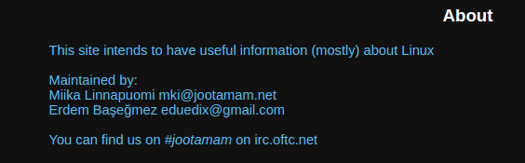
http://jootamam.net/howto-initramfs-image.htm

Create initramfs using the existing buildroot.

We used buildroot to generate kernel and rootfs for the raspberry pi 3.
Lets use some of buildroot outputs to generate a initramfs.

In the output directory , create a directory initramfs

mkdir initramfs

And inside initramfs director create those directories:

mkdir bin etc proc sbin sys usr var

Like In the post above , but with a slight change.
I want to keep only the ram fs and not to switch to the actual file system
for now:

So the switch_root section in the init script will not be there:

#Mount the root device
mount "${root}" /newroot

#Check if $init exists and is executable
if [[ -x "/newroot/${init}" ]] ; then
#Unmount all other mounts so that the ram used by
#the initramfs can be cleared after switch_root
umount /sys /proc

#Switch to the new root and execute init
exec switch_root /newroot "${init}"
fi

I copy the mdev ( it is a light udev in busybox)

I changed the root to the same from parameters from buildroot cmdline.txt
those are argument for the kernel
root=/dev/mmcblk0p2 rootwait console=tty1 console=ttyS0,115200

This article explain perfectly what are the partitions naming in raspberry pi
https://github.com/raspberrypi/noobs/wiki/Standalone-partitioning-explained

in short

mmcblk0p2
is the second partition of the sd card that raspberry name it.

And also this paragraph is very important
Because the partition table (and raw partitions) are copied directly from the .img file to the SD card, the root partition will be the exact size that the .img specifies. Therefore if your SD card is much larger than the .img file, you'll have a lot of unused space after the end of the root partition. To make use of this unused space you can use a tool like raspi-config to automatically resize the root partition as large as possible.

It means that we will use the gparted utility to:
1. delete the partitions
2. create empty new ext4 partitions and format it
3. leave it empty – we will not switch to real file system in this examples

