Using raspberry pi 3 GPIO's

To the wifi image , I want to add GPIO support to togle some leds.

First , the pinout :

http://www.hobbytronics.co.uk/raspberry-pi-gpio-pinout

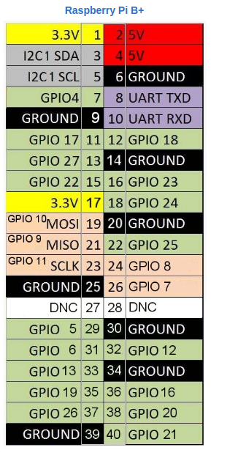

Wiring PI
http://wiringpi.com/

Great explanation here:

https://pinout.xyz/pinout/wiringpi

The wiring pi uses different pin numbering as describe in the link and can be use with python also
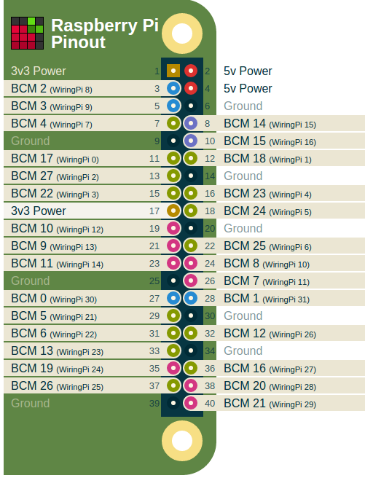

Enable wiring pi in buildroot


The GPIO utility
https://projects.drogon.net/raspberry-pi/wiringpi/the-gpio-utility/

maybe it is refereed to the one here in buildroot:

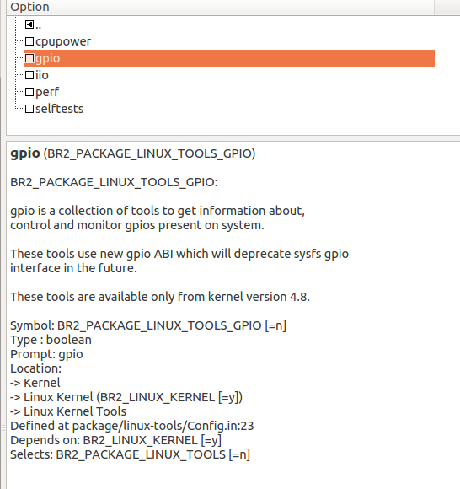

example code using several interfaces
http://elinux.org/RPi_GPIO_Code_Samples

Sysfs:

in make linux-menuconfig we can see that sysfs interface is already checked in

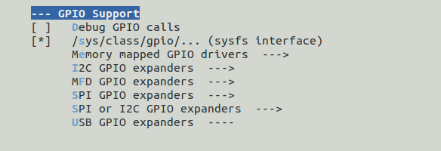
device drivers->gpio

The sysfs inteface shuold use the BCM numbering ( to check it)

using node js:

https://www.sitepoint.com/getting-started-with-the-raspberry-pi-gpio-pins-in-node-js/

Connecting Led

https://thepihut.com/blogs/raspberry-pi-tutorials/27968772-turning-on-an-led-with-your-raspberry-pis-gpio-pins

Must connect 330 Ohm to limit the current the the Led wants.

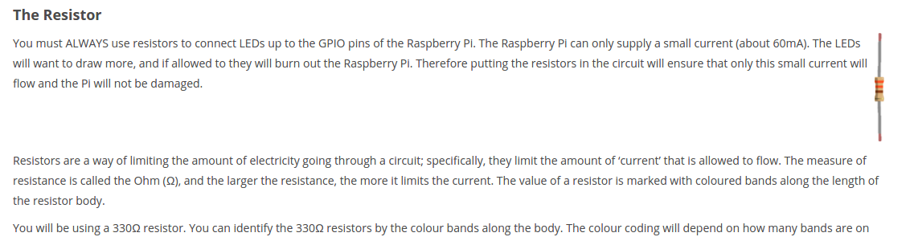

Raspberry pi 3 GPIO with Python.
http://makezine.com/projects/tutorial-raspberry-pi-gpio-pins-and-python/

