Raspberry pi 3 I2C1

This tutorial is devided into three parts.
1. Setup I2C-1 in raspberry pi 3
2. Setup slave and writing the example in kw40z
3. Setup I2C-2 in beaglebone and communicating also with kw40z.

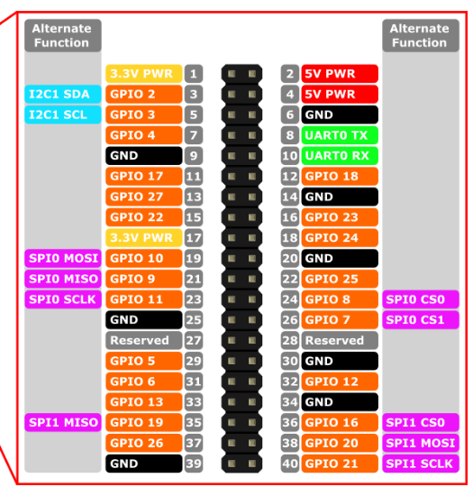

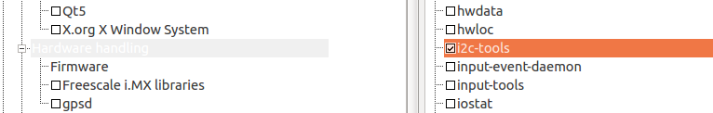
Add I2c-tools in buildroot

The I2C1 can be found at the external header PIN 3 and PIN 5.
It is alternate functions , that's mean that it should be pin mux.
In raspberry pi , pin mux is done using device tree.

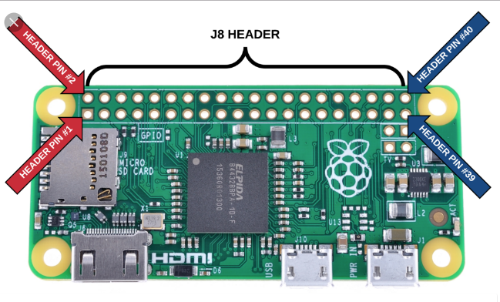
https://unix.stackexchange.com/questions/185044/buildroot-missing-i2c-kernel-modules

in buildroot type make linux-menuconfig

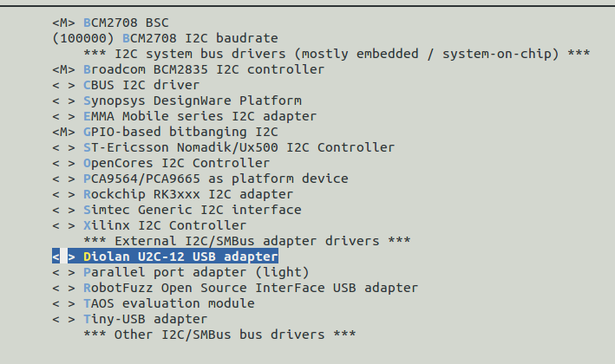

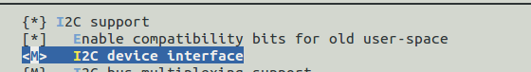
Go to Device Drivers menu and check the I2C support pressing ‘Y’.
- Enter the I2C menu, go to I2C device interface and Press ‘M’ for module support.
- Enter the I2C Hardware Bus support menu and press ‘M’ BCM2708 BSC

after the image is read we need to:

modprobe i2c-dev
modprobe i2c-bcm2835

not i2c-bcm2708 - which is the raspberry pi 2 probably

lsmod shows?

I2c-dev
i2c-bcm2835

https://www.digitalpeer.com/blog/raspberry-pi-i2c-256k-eeprom-tutorial

Pins 3 and 5 on the Raspberry Pi GPIO header are the SDA and SCL pins for I2C respectively (I2C is a 2 wire bus). Those get wired directly to the same pins on the chip. It turns out, these two pins have internal pull-ups on the Raspberry Pi. So, when they are configured for I2C, and you're not communicating, you'll see these pins high.

config.txt:

output/config/rpi-firmware/config.txt

see:
https://www.raspberrypi.org/documentation/configuration/device-tree.md

add:
dtparam=i2c_arm=on

https://raspberrypi.stackexchange.com/questions/68293/populate-dev-in-buildroot/68300

OK. I can confirm that:
- using the Buildroot System Configuration | /dev management | Dynamic using devtmpfs + mdev
- together with having dtparam=i2c_arm=on in output/images-rpi-firmware/config.txt
does the trick. After loading i2c_dev module the /dev/i2c-1is created.
modprobe i2c-dev
modprobe i2c-bcm2835

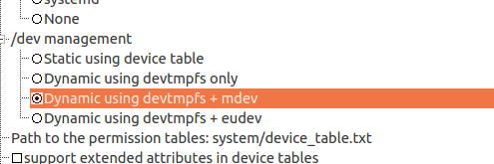

Dont forget to add dropbear utility in buildroot config for SSH.

Several notes:
1. Even if the hardware is setup correct and the wires are connected correct between master and slave BUT the slave ID is incorrect , we wil get Input/Output error

2. We can use i2c-detect -r 1
Where 1 is the interface number /dev/i2c-1 to see the slave id.
It will scan all the slave id.

The i2c detect -r 1 shows incorrect slave id:

# i2cdetect -r 1
WARNING! This program can confuse your I2C bus, cause data loss and worse!
I will probe file /dev/i2c-1 using read byte commands.
I will probe address range 0x03-0x77.
Continue? [Y/n] y
0 1 2 3 4 5 6 7 8 9 a b c d e f
00: -- -- -- -- -- -- -- -- -- -- -- -- --
10: -- -- -- -- -- -- -- -- -- -- -- -- -- -- -- 1f
20: -- -- -- -- -- -- -- -- -- -- -- -- -- -- -- --
30: -- -- -- -- -- -- -- -- -- -- -- -- -- -- -- --
40: -- -- -- -- -- -- -- -- -- -- -- -- -- -- -- --
50: -- -- -- -- -- -- -- -- -- -- -- -- -- -- -- --
60: -- -- -- -- -- -- -- -- -- -- -- -- -- -- -- --
70: -- -- -- -- -- -- -- --

the slave id is 0x7F , but still it says that we have connection and we can start write the code.

