Build raspberry pi 3 with external pre-built tool chain

In order to save time , lets build a cross compiler for ARM 32 bit with floating point hardware

To prepare an external cross compiler, go to
http://crosstool-ng.github.io/
http://crosstool-ng.github.io/docs/

or read my summery doc and video tutorial.

Once we have the cross compiler in place, download build root, extract it
https://buildroot.uclibc.org/download.html

buildroot-2017.05.tar.gz
tar xvzf buildroot-2017-0.5.tar.gz

make raspberrypi_defconfig

it will copy the configs/raspberrypi_defconfig to .config

you should be running this from the top level directory:

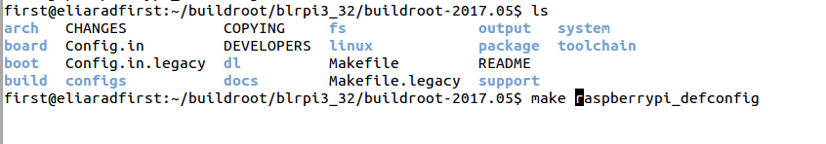
run
make xconfig

and modify the toolchain as follow:

Notes:
1. select external toolchain->custom toolchain->pre installed toolchain
2. specify the toolchain path with out the bin directory
3. set the toolchain prefix with out the -g++ , just the name

4. specify of the toolchain was using uclibc or glibc
The kernel headers that was used to compile the toolchain and the gcc version

you should know all of this information from the time you compiled and select the toolchain parameters with the menu config.

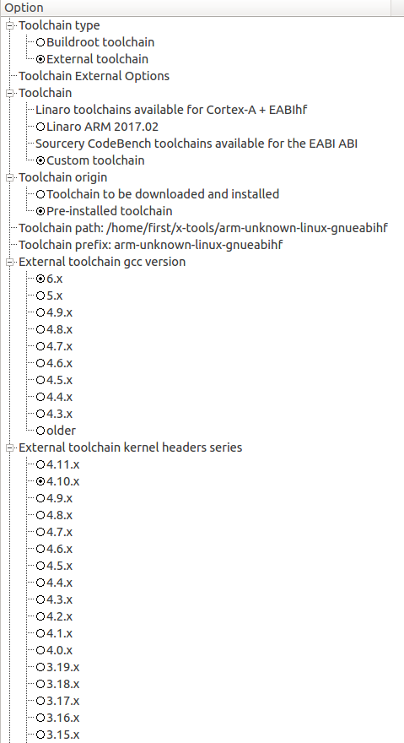

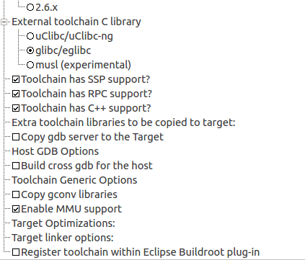

We also need to set if the tool chain as the following support , SSP , RCP, C++

save and exit xconfig
and run
make

it will take time, but less than using internal toolchain or external with download and installed
because we already handed a toolchain to buildroot.

Once does , we have in output/image all the files, buildroot create an img for us with all the partitions and copy the files to the image.
Sdcard.img

this file can be burn using Etcher
https://etcher.io/

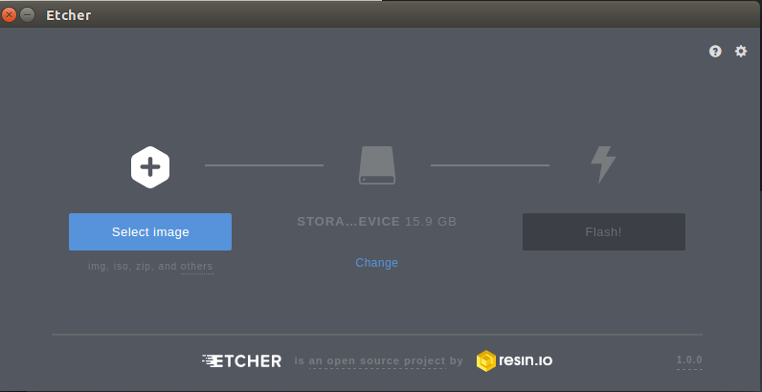

Etcher will not let you format the main drive /dev/sda unless you are not in safe mode.
It will format the disk before writing.

ls -l output/images/
total 162996
-rw-r--r-- 1 first first 17564 Jun 2 07:39 bcm2710-rpi-3-b.dtb
-rw-r--r-- 1 first first 16320 Jun 2 07:39 bcm2710-rpi-cm3.dtb
-rw-r--r-- 1 first first 33554432 Jun 2 07:40 boot.vfat
-rw-r--r-- 1 first first 62914560 Jun 2 07:40 rootfs.ext2
lrwxrwxrwx 1 first first 11 Jun 2 07:40 rootfs.ext4 -> rootfs.ext2
drwxr-xr-x 3 first first 4096 Jun 2 06:34 rpi-firmware
-rw-r--r-- 1 first first 96469504 Jun 2 07:40 sdcard.img
-rw-r--r-- 1 first first 4564112 Jun 2 07:39 zImage
Once done , place the sdcard in raspberry pi 3 and hopefully the boot will go smooth.

