Crosstool-ng addition to doc:

the faster way is just do
./configure

without any –prefix

make && make install

it will install it to :
/usr/local/bin/ct-ng

it will be immidiate in the path so we can use it.

Cross tool ng select the c library:

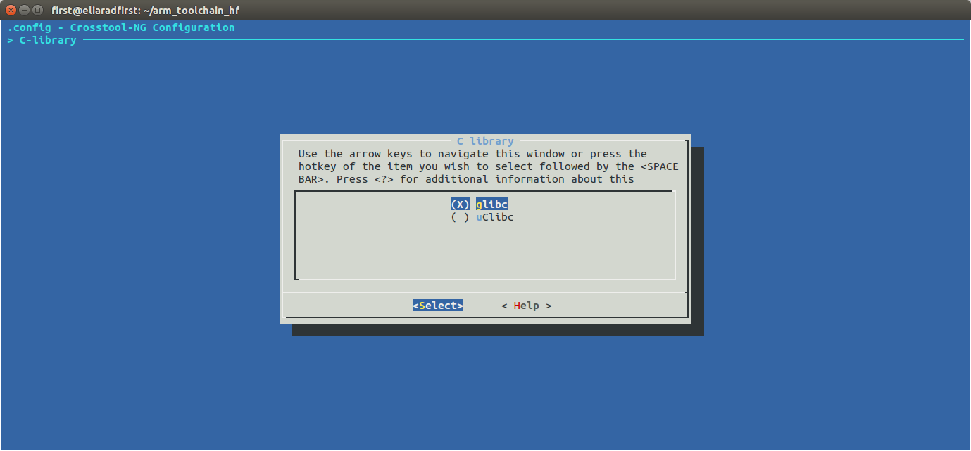
we can select the gcc version:

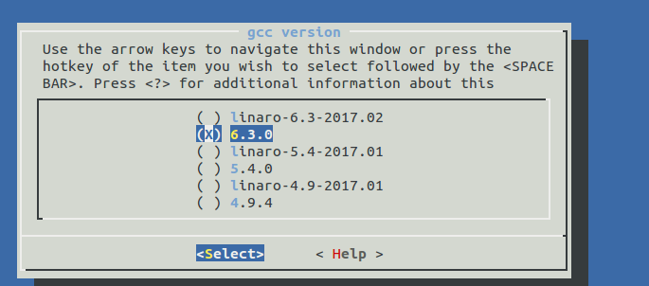
not too much options

target architecture:

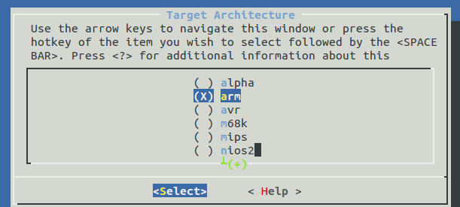
endiannes:


bitness , 32 or 64 ?

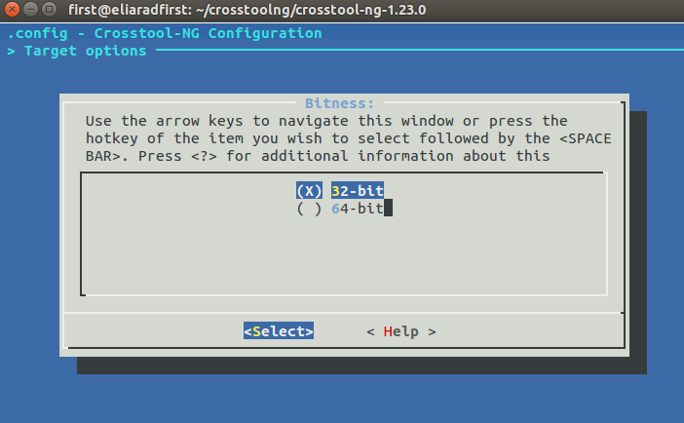

floating point , or not?

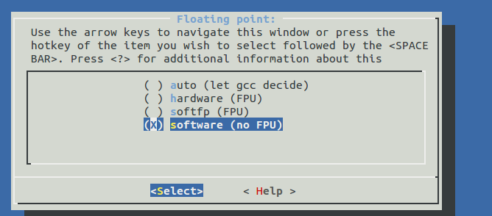

Linux kernel version:
for kernel headers

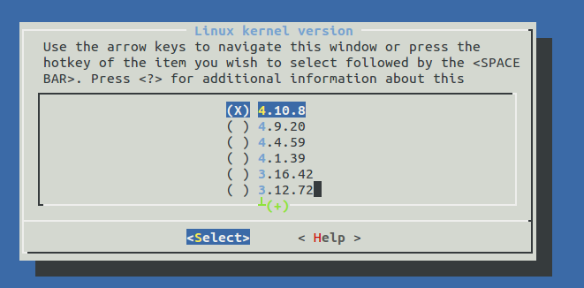

and build shared libraries yes or no.

The select C++ and Java:

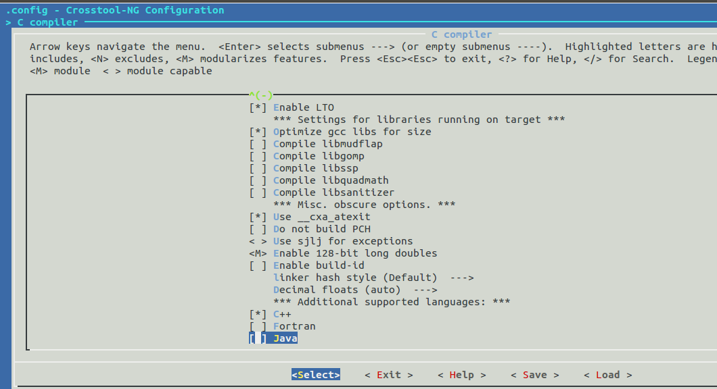

more libraries like GMP, MPFR ..

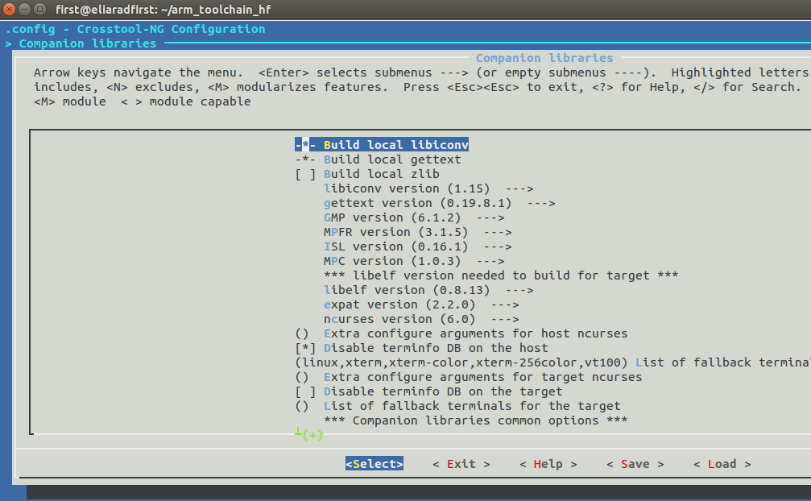

There is a sample configuration for the raspberry pi 3 64 bit compiler:

ct-ng aarch64-rpi3-linux-gnueabi

note that the place we specify the cortex M is in emit assembly for CPU

we know that the raspberry pi 3 is a corext-A53

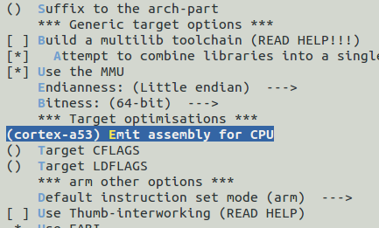

the result compiler will be located at:
/home/first/x-tools/aarch64-rpi3-linux-gnueabi

building the raspberry cross compiler takes more then 95 minutes
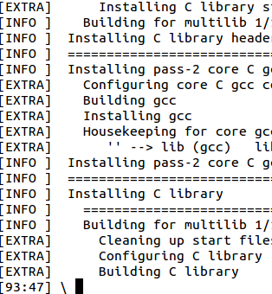

that's mean the use internal tool chain from build root is crazy option

