Beaglebone device tree changes instead of overlays.
Enable SPI devices
Enable I2 devices

Two main device tree files for the beagle boneblack:

output/build/linux-adde2ca9f86797071f6e7b2b9e779fa5e4a8f3cd/arch/arm/boot/dts/am335x-bone-common.dtsi

output/build/linux-adde2ca9f86797071f6e7b2b9e779fa5e4a8f3cd/arch/arm/boot/dts/am335x-boneblack.dts
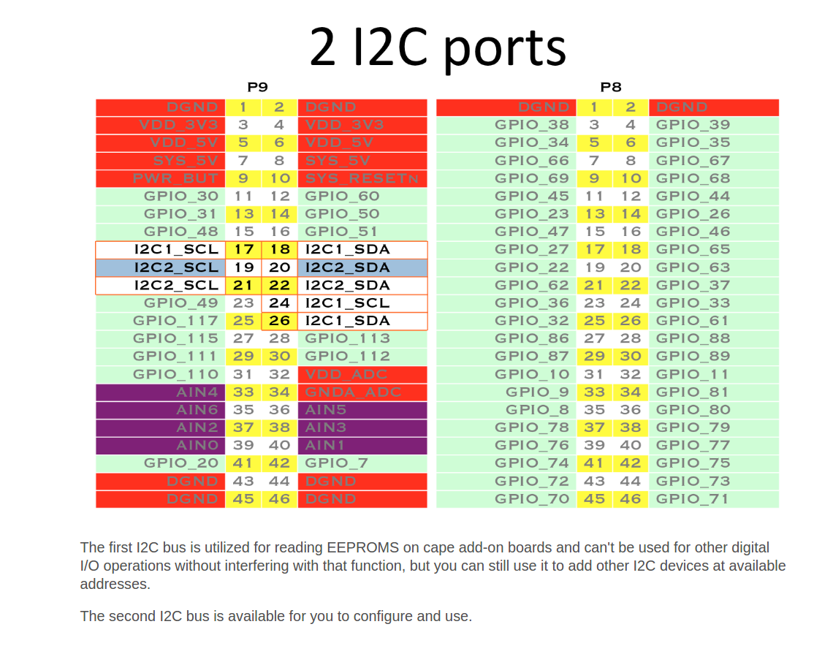
Every cape that utilizes pins on the expansion header is expected to notify software on the board by providing contents within EEPROM connected to I2C2 with an address from 0x54 to 0x5

If we want to use I2C2 for out own purpose , other then selecting a cape through EEPROM , we need to modify the device tree accordingly.

We can take the content of each overlay and inserted it carefully into the device tree.
https://github.com/jadonk/cape-firmware/tree/master/arch/arm/boot/dts
or different place around the net.

The pinmux is define as:

&am33xx_pinmux {

It has:
pinctrl-names = "default";

and pin muxing:

i2c0_pins: pinmux_i2c0_pins {
pinctrl-single,pins = <
0x188 (PIN_INPUT_PULLUP | MUX_MODE0) /* i2c0_sda.i2c0_sda */
0x18c (PIN_INPUT_PULLUP | MUX_MODE0) /* i2c0_scl.i2c0_scl */
>;
};

i2c2_pins: pinmux_i2c2_pins {
pinctrl-single,pins = <
0x178 (PIN_INPUT_PULLUP | MUX_MODE3) /* uart1_ctsn.i2c2_sda */
0x17c (PIN_INPUT_PULLUP | MUX_MODE3) /* uart1_rtsn.i2c2_scl */
>;
};

We can see that i2c0 in boneblack.dts is assign to hdmi:
pinctrl-0 = <&nxp_hdmi_bonelt_pins>;

Let also add I2C1
we can use the generator here:
http://www.kilobaser.com/blog/2014-07-28-beaglebone-black-devicetreeoverlay-generator

And this is the overlay for I2C1
https://github.com/beagleboard/devicetree-source/blob/master/arch/arm/boot/dts/BB-I2C1-00A0.dts

P9.18 is I2C1 SDA
P9.17 is I2C2 SCL

i2c1_pins: pinmux_i2c1_pins {
pinctrl-single,pins = <
0x158 (SLEWCTRL_SLOW | PIN_INPUT_PULLUP | MUX_MODE2) /* i2c1_sda */
0x15c (SLEWCTRL_SLOW | PIN_INPUT_PULLUP | MUX_MODE2) /* i2c1_scl */
>;
};

&i2c1 {
status = "okay";
pinctrl-names = "default";
pinctrl-0 = <&i2c1_pins>;
/* this is the configuration part */
clock-frequency = <100000>;
#address-cells = <1>;
#size-cells = <0>;
};
SPI0 and I2C1 using the same pin
We need to select one interface between them.
I am showing here how to add all pinmux any case.

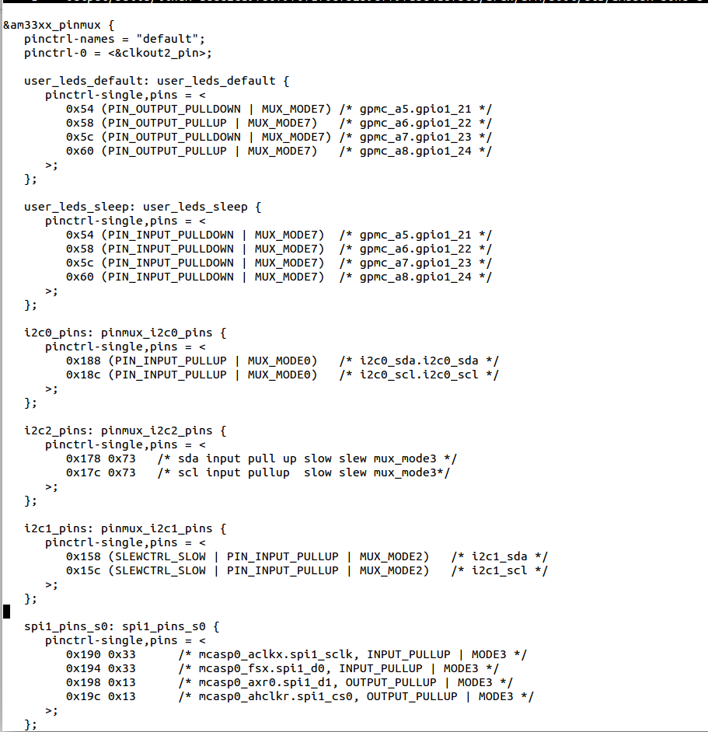

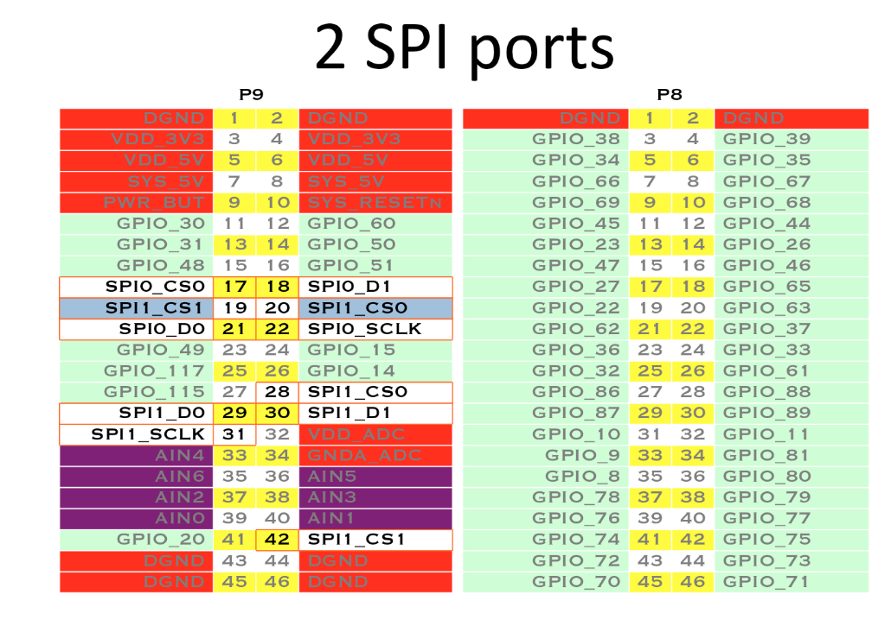
Now , lets add SPI pin mux.

In this page:
http://elinux.org/BeagleBone_Black_Enable_SPIDEV

We have overlay.

But in buildroot , we don't have cape manager to load the overlay.
So we need to edit the main device tree common and boneblack to add the overlay inside.

Lets take the overlay:

SPI1 D1 Output and D0 Input
We see that the target of the overlay is
target = <&am33xx_pinmux>;

spi1_pins_s0: spi1_pins_s0 {
pinctrl-single,pins = <
0x190 0x33 /* mcasp0_aclkx.spi1_sclk, INPUT_PULLUP | MODE3 */
0x194 0x33 /* mcasp0_fsx.spi1_d0, INPUT_PULLUP | MODE3 */
0x198 0x13 /* mcasp0_axr0.spi1_d1, OUTPUT_PULLUP | MODE3 */
0x19c 0x13 /* mcasp0_ahclkr.spi1_cs0, OUTPUT_PULLUP | MODE3 */
>;
};

So lets add into

am335x-bone-common.dtsi the above pin mux

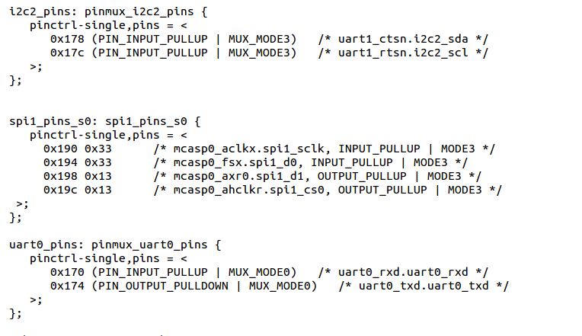
I have just added it after the i2c2_pins

The next fragment@0
fragment@1 {
target = <&spi1>;
Is target to be &spi1
So lets add in am335x-boneblack.dts this fragment.

Edit the file am335x-boneblack.dts and add

&spi1 {

#address-cells = <1>;
#size-cells = <0>;
status = "okay";
pinctrl-names = "default";
pinctrl-0 = <&spi1_pins_s0>;

spidev@1 {
spi-max-frequency = <24000000>;
reg = <0>;
compatible = "linux,spidev";
};
};
as a separate section.
Note that am335-boneblack.dts also contain more pin mux in addition to the common one,
The &spi1 should be place not in the pin mux , but as a separate node.

To recompile
delete the .stamp_built .stamp_configure in linux directory
delete the am335x-boneblack.dtb In boot/dts and in output/images

load spidev.ko module ( make sure the driver module is enabled in the kernel config)

By default the device driver in buildroot is not probe
we must do:
modprobe spidev.ko

once it is loaded:

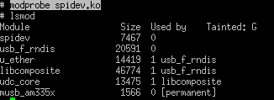

We will have in /dev/ and /dev/spidev*
User mode SPI driver support need to be enable:

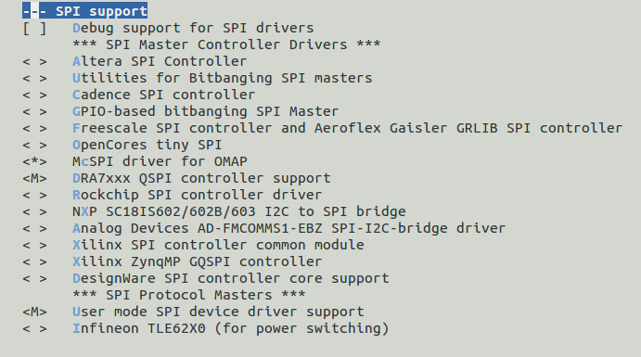

I added the spi0 also

spi0_pins_s0: spi0_pins_s0 {
pinctrl-single,pins = <
0x150 0x30 /* spi0_sclk, INPUT_PULLUP | MODE0 */
0x154 0x30 /* spi0_d0, INPUT_PULLUP | MODE0 */
0x158 0x10 /* spi0_d1, OUTPUT_PULLUP | MODE0 */
0x15c 0x10 /* spi0_cs0, OUTPUT_PULLUP | MODE0 */
>;
};

&spi0 {
#address-cells = <1>;
#size-cells = <0>;
status = "okay";
pinctrl-names = "default";
pinctrl-0 = <&spi0_pins_s0>;
spidev@0 {
spi-max-frequency = <24000000>;
reg = <0>;
compatible = "linux,spidev";
};
};

and now I have in /dev two spi devices:
spidev1.0 spidev2.0

https://mail.google.com/mail/u/0/#inbox/15dd296fbc72ecbf?projector=1

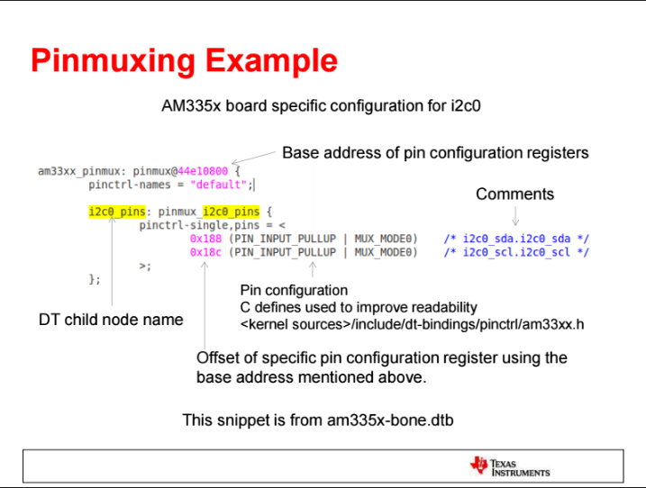

To tell in linux which device tree is loaded and used:

cat /proc/device-tree/model

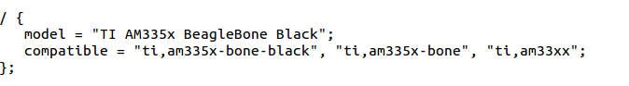
# cat /proc/device-tree/model
TI AM335x BeagleBone Black

I changed the model , compile again the dtb ( delete stamp and dtb)
to add my note to the model:
cat /proc/device-tree/model
TI AM335x BeagleBone Black buildroot
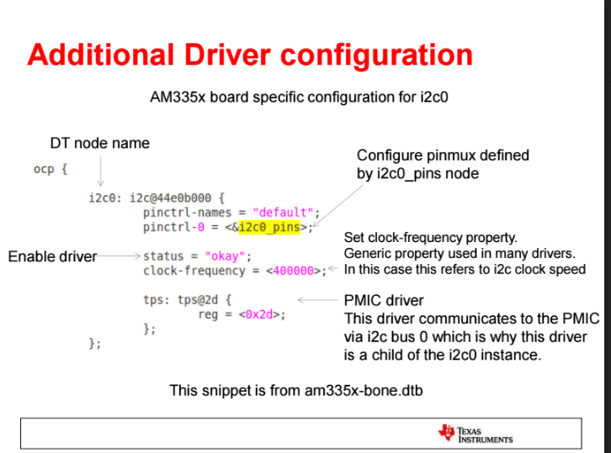

Note:

Currently I changed in beaglebone the uboot parameters manually using env set

bootpart=0:1
bootargs=console=ttyO0,115200n8 root=/dev/mmcblk0p2 rw rootfstype=ext4 rootwait
bootdir=
bootfile=zImage
fdtfile=am335x-boneblack.dtb
loadaddr=0x80007fc0
fdtaddr=0x80F80000
loadfdt=fatload mmc 0:1 ${fdtaddr} ${fdtfile}
loaduimage=fatload mmc 0:1 ${loadaddr} ${bootfile}
uenvcmd=mmc rescan; run loaduimage; run loadfdt; run fdtboot
fdtboot=run mmc_args; bootz ${loadaddr} - ${fdtaddr}
mmc_args=setenv bootargs console=${console} ${optargs} root=/dev/mmcblk0p2 rootfstype=ext4

and also set:
bootcmd= run uenvcmd

and env save to save it all

This is a cool site where we can create overlays dynamically
http://www.kilobaser.com/blog/2014-07-28-beaglebone-black-devicetreeoverlay-generator

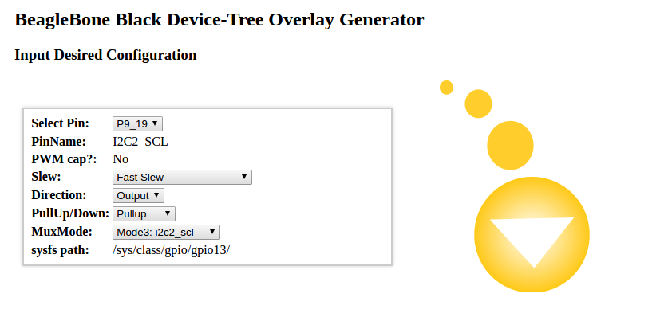
i2cdetect -r 1 shows:
