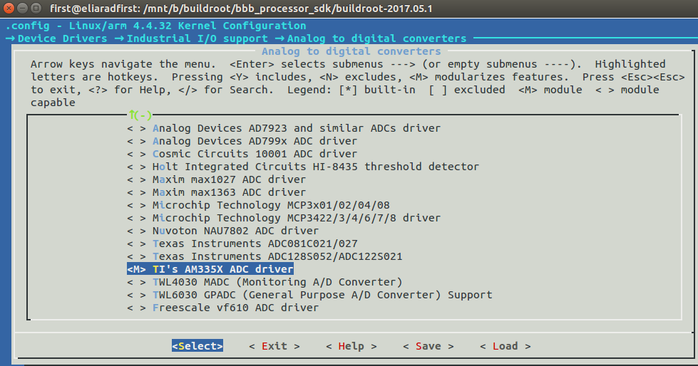
Beaglebone ADC setup in buildroot

http://processors.wiki.ti.com/index.php/Linux_Core_ADC_Users_Guide

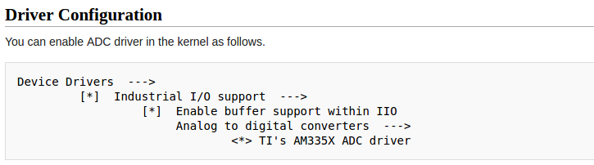

it looks like the default kernel already have all the above needed drivers selected.
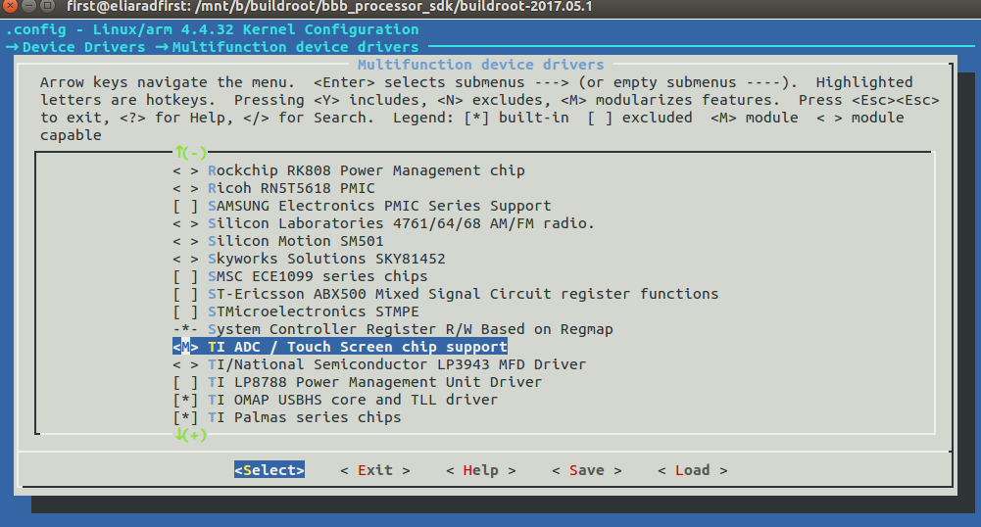
The TI ADC is already selected as module M
The module should be present in drivers/iio/adc/ti_am335x_adc.ko.

modprobe ti_am335x_adc.ko

lsmod now show:
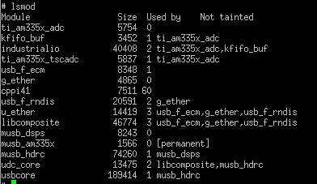

Device tree:

The device tree blob that being load by u-boot is:
fdtfile=am335x-boneblack.dtb
and not
am335x-evm.dts

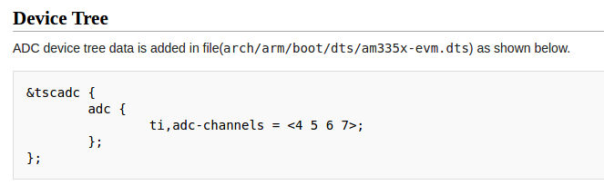
&tscadc {
status = "okay";
tsc {
ti,wires = <4>;
ti,x-plate-resistance = <200>;
ti,coordinate-readouts = <5>;
ti,wire-config = <0x00 0x11 0x22 0x33>;
ti,charge-delay = <0x400>;
};

adc {
ti,adc-channels = <4 5 6 7>;
};
};
Confirm at:

output/build/linux-adde2ca9f86797071f6e7b2b9e779fa5e4a8f3cd/arch/arm/boot/dts/am335x-evm.dts

This example is using channels AIN4, AIN5, AIN6, and AIN7 are used by ADC. The remaining channels (0 to 3) are used by TSC. ( touch screen)

the ADC pins:
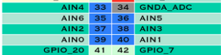

Currently I don't see AIN7
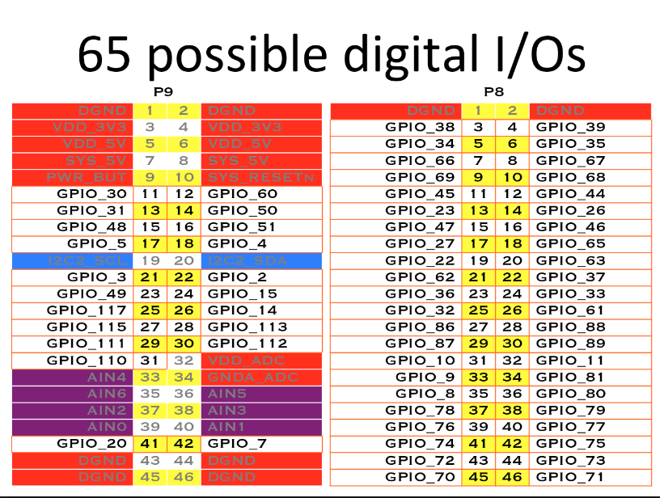
https://www.linux.com/learn/how-get-analog-input-beaglebone-black

Cape manager:

buildroot for beaglebone black does not have cape manager.
Cape manager is a way to load device tree overlays from the user space.

To enable adc we need to add the following code into the device tree overlays
am335x_boneblack.dts

edit the file:
output/build/linux-adde2ca9f86797071f6e7b2b9e779fa5e4a8f3cd/arch/arm/boot/dts/am335x-boneblack.dts

&tscadc {
status = "okay";
};

&am335x_adc {
ti,adc-channels = <0 1 2 3 4 5 6 7>;
};

/sys/bus/iio/devices/iio\:device0

or
/sys/bus/platform/devices
are empty

lets delete the file:

output/build/linux-adde2ca9f86797071f6e7b2b9e779fa5e4a8f3cd/.stamp_built

where the
adde2ca9f86797071f6e7b2b9e779fa5e4a8f3cd is the commit github hash number.

And do make again.
It should configure and build the linux kernel again.

make[3]: `arch/arm/boot/dts/am335x-bone.dtb' is up to date.
make[3]: `arch/arm/boot/dts/am335x-bonegreen.dtb' is up to date.
make[3]: `arch/arm/boot/dts/am335x-evmsk.dtb' is up to date.
make[3]: `arch/arm/boot/dts/am335x-evm.dtb' is up to date.
DTC arch/arm/boot/dts/am335x-boneblack.dtb

but It did not build the device tree again

so lets delete the file:
./output/build/uboot-2016.09.01/arch/arm/dts/am335x-boneblack.dtb

To force the dtc compiler to build the dts → dtb again

and we we can see in the make log:
make[3]: `arch/arm/boot/dts/am335x-evm.dtb' is up to date.
make[3]: `arch/arm/boot/dts/am335x-bone.dtb' is up to date.
DTC arch/arm/boot/dts/am335x-boneblack.dtb
make[3]: `arch/arm/boot/dts/am335x-bonegreen.dtb' is up to date.
make[3]: `arch/arm/boot/dts/am335x-evmsk.dtb' is up to date.
That's it. DTC did compiled the new changes in am335x-boneblack.dts
burn the image again..

And now
http://processors.wiki.ti.com/index.php/Linux_Core_ADC_Users_Guide

We do have iio device created:

ls -al /sys/bus/iio/devices/iio\:device0/

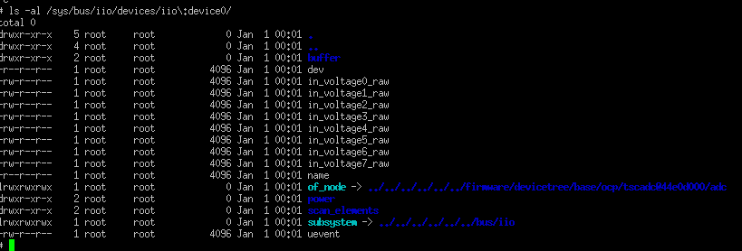
one shot mode:

cat /sys/bus/iio/devices/iio\:device0/in_voltage4_raw

IIO sub system overview

https://wiki.analog.com/software/linux/docs/iio/iio

Userspace Sample Application
The user space application is located in the buildroot as generic_buffer.c

output/build/linux-adde2ca9f86797071f6e7b2b9e779fa5e4a8f3cd/tools/iio/generic_buffer.c

I download theThe iioutils package

“The iioutils package (http://sourceforge.net/projects/iioutils/) does all of this for you, so that's probably the best place to copy the code from.”

the library is using automake

lets configure to cross compile it to our arm BBB:

./configure --host=arm-linux-gnueabihf -prefix=/mnt/b/buildroot/bbb_processor_sdk/buildroot-2017.05.1/io_utils/iioutils/out --target=arm-linux

libsysfs 2.0.1 is missing..

Using simple program:
https://stackoverflow.com/questions/22818751/beagle-bone-adc-read-values

Running on the start:
To make the configurations run at the boot sequence:

create a script in /etc/init.d.Smystart

The script should start with Capital S, which being load by the rcS script

put the following lines there and reboot.

printf "starting my script"

modprobe musb_am335x.ko
modprobe musb_hdrc.ko
modprobe musb_dsps.ko
modprobe cppi41.ko
modprobe g_ether.ko
modprobe ti_am335x_adc.ko

HOST_USB_IP=10.0.0.13
TARGET_USB_IP=10.0.0.12
ifconfig usb0 $TARGET_USB_IP netmask 255.255.255.0
route add default gw $HOST_USB_IP
route

Write c program to read ADC

although from command line we issue the following command:

cat /sys/bus/iio/devices/iio\:device0/in_voltage4_raw

with the iio/:

when trying to open from C program we use it without the forward slash:

#define SYSFS_ADC_DIR "/sys/bus/iio/devices/iio:device0/in_voltage4_raw"

The whole c program:

#include <stdio.h>
#include <stdlib.h>
#include <sys/types.h>
#include <sys/stat.h>
#include <fcntl.h>
#include <unistd.h>

#define MAX_BUF 200

#define SYSFS_ADC_DIR "/sys/bus/iio/devices/iio:device0/in_voltage4_raw"

int adc_read(unsigned int pin)
{
int fd, len, j;
char buf[MAX_BUF];
char val[4];

//len = snprintf(buf, sizeof(buf), "/sys/bus/iio/devices/iio\\:device0/in_voltage%d_raw", pin);
snprintf(buf, sizeof(buf), SYSFS_ADC_DIR);
printf("opening file: %s\n" , buf);

fd = open(buf, O_RDONLY);
if (fd < 0)
{
perror("adc/get-value");
}

read(fd, &val, 4);
close(fd);

return atoi(val);
}

void main()
{

printf("adc: %d\n" , adc_read(4));

}

The Makefile that I used:

CC = arm-linux-gnueabihf-gcc

SRC=$(wildcard *.c)

adc_test: $(SRC)
$(CC) -o $@ $^ $(CFLAGS) -I$(INCLUDE) -L$(LIBS)

clean:
rm *.o adc_test

And the ACTIVATE.sh script to put the compile in path:

BBB_C_COMP=/mnt/b/buildroot/bbb_processor_sdk/buildroot-2017.05.1/output/host/usr/bin
export PATH=$PATH:$BBB_C_COMP

source ACTIVATE.sh

I connected a circuit like the following

Taking potentiometer

The vcc line through a 4.7Khm to pin 3 in BBB
ground to pin 1 in BBB
the middle of the potentiometer to pin 33 to read AIN 4

