Prepare buildroot image with Qt5 , examples , and external tool chain

In this document I will show how to setup buildroot with external compiler that was built for the raspberry pi 3 with crosstool-ng.
Add QT plus examples and run it on my raspberry pi 3.
I will use linux frame buffer first , with the 64 bit version of the raspberry pi 3 def config in buildroot.

Buildroot has three options to use toolchain
1. internal – download and compile
2. external – download and install – no compile
3. external – custom – use pre toolchain

The first options can take an hour or more depend on your computer just to prepare the tool chain
We want to avoid this option

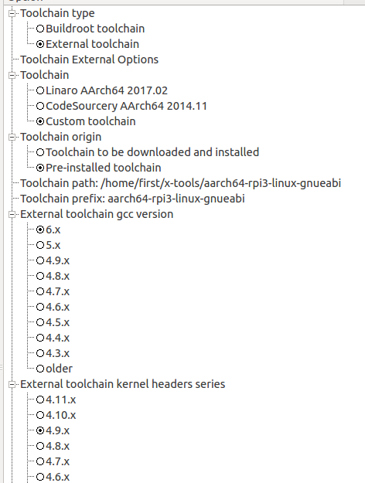
The external download and install is a very good options , but here we want to use a toolchain that we configured using crosstool-ng.

crosstool-ng has already a raspberry pi 3 configuration.

ct-ng aarch64-rpi3-linux-gnueabi

The only thing I changed is the kernel version , from 4.10 to 4.9
due the fact that raspberry pi 3 configuration form buildroot uses kernel 4.9

when I selected 4.9 as it was I got kernel panic – init not syncing. ( dont know If its actaul problem)
but it is better to match the kernel headers from the toolchain and the buildroot.

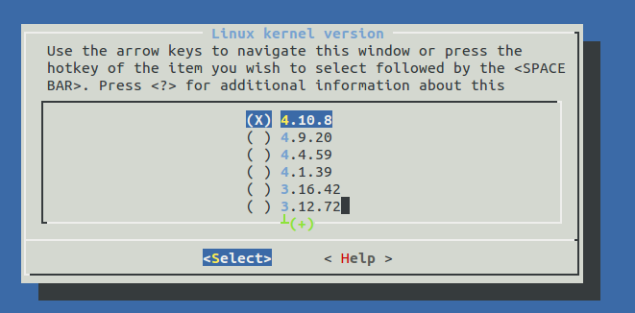
You should match the gcc version
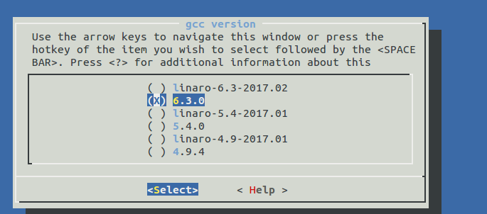

the toolchain path is a full path to the toolchain without the bin directory
the prefix is the name of the compiler without the – or -g++

There are tools that prefix is with the – and here it is without.

QT5 buildroot setup

http://doc.qt.io/qt-5/embedded-linux.html

There are several plug-ins that can be used with QT
* Linux frame buffer
* EGLFS
* Direct FB
* Wayland

In this trial I will use Linux fb, qt of course , qt examples.

I am using the 64 bit version in this build
I started from
make raspberrypi3_64_defconfig

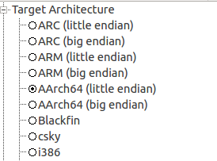

I changed the download directory and savedefconfig

I did not enabled compile cache, if things does not work, try make clean and clean again.

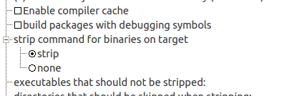

Im am using the external pre build compiler from croos tool ng

In system configuration I needed to enable eudev in order to get libinput support

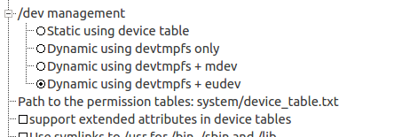

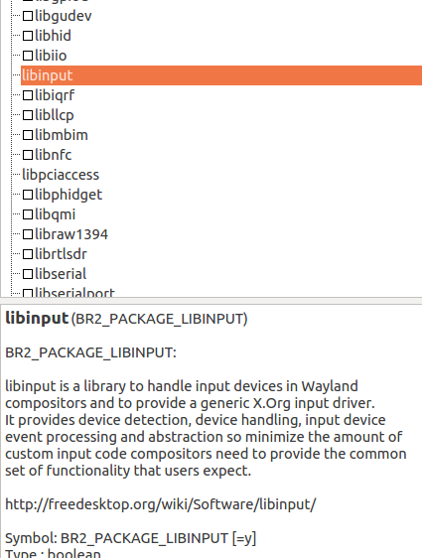

I enabled all the drivers in x.org

actually we need xf86-input-libinput and the video fbdev
but who care for now.

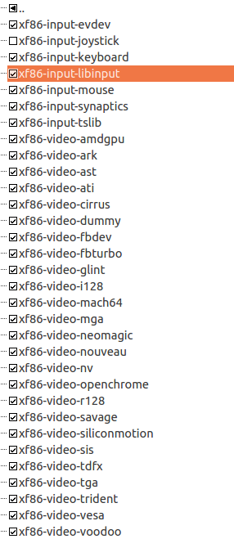

Enable mesa software drivers:

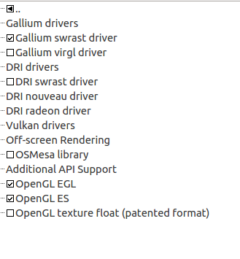

Just a note, the open-GL VC4 driver from Broadcom will not appear in the 64 bit version
* I don't know yet , need to check if it just a build root setting or the driver does not supports 64 bit

For now we want to work with the Linux frame buffer and not open gl.

Qt5:
enable Linux frame buffer support
also add examples , it will helps us to quickly check if QT works or not.

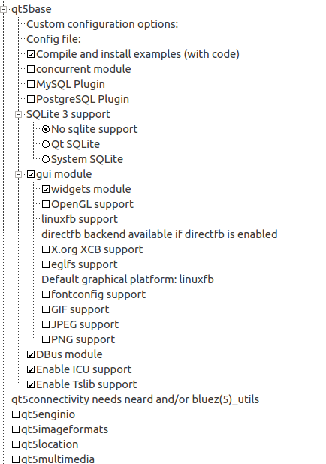

We will need to increase the default block size for the root file system:

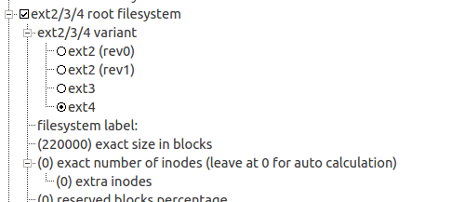

You can determine the actual size with block to giga and giga to block ( search in Google)

always include Joe editor – my favorite.

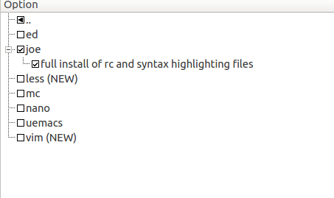

Exit x config and save.
Run
make

The QT5 compilation takes lots of time.

Notes:

1. I am flashing the sdcard.img with Etcher
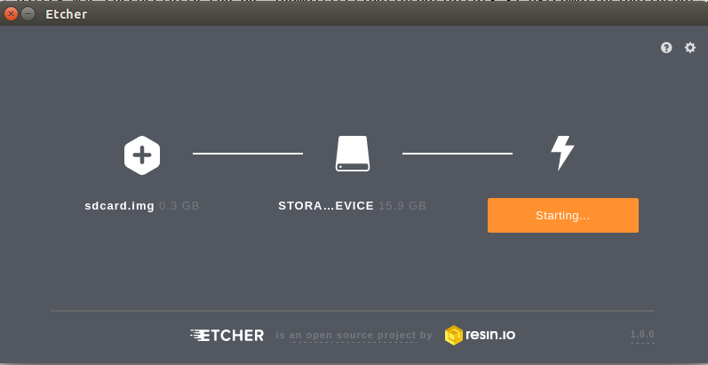

Etcher already make partitions according to the image , format the sd card and make sure you dont select your main /dev/sda hard drive.

2. the example that was compiled are located in the target in

/usr/lib/qt/examples

3. in the target , the plugins are installed at:

/usr/lib/qt/plugins/platforms/

4.

