Beaglebone black – wireless with buildroot

To start with beaglebone black , just select
beaglebone_defconfig from buildroot configs

make beaglebone_defconfig

It will work, but dont wait like I did to see the result on the HDMI like in disto like angstrom.
After the build completed , hold the S2 button and after u-boot completed and the kernel start running , leave the button and let the system finished booting.
The u-boot and the kernel in that stage will be already burned into nand.

Following this:
https://codechief.wordpress.com/2013/11/11/beaglebone-black-serial-debug-connection/

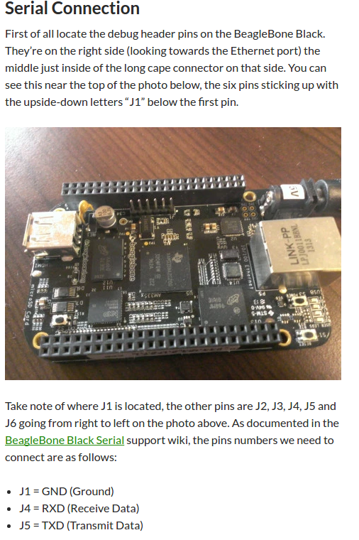

Just the rx and tx do need to be swapped.

Linux dmesg tells us that the device driver is now attached as:
FTDI USB Serial Device converter now attached to ttyUSB1

Just create putty with /dev/ttyUSB1

The working uEnv.txt:

bootpart=0:1
bootargs=console=ttyO0,115200n8 root=/dev/mmcblk0p2 rw rootfstype=ext4 rootwait
bootdir=
bootfile=zImage
fdtfile=am335x-boneblack.dtb
loadaddr=0x80007fc0
fdtaddr=0x80F80000
loadfdt=fatload mmc 0:1 ${fdtaddr} ${fdtfile}
loaduimage=fatload mmc 0:1 ${loadaddr} ${bootfile}
uenvcmd=mmc rescan; run loaduimage; run loadfdt; run fdtboot
fdtboot=run mmc_args; bootz ${loadaddr} - ${fdtaddr}
mmc_args=setenv bootargs console=${console} ${optargs} root=/dev/mmcblk0p2 rootfstype=ext4

And after connecting serial and building the beaglebon_defconfig as it it , without modifiing anything I got linux prompt.
So the conclusion is not wait for HDMI.

BBB enable USB OTG as network device

In order to get a USB OTG for the beaglebone black , we need to refer to this wiki

http://processors.wiki.ti.com/index.php/MUSB_Linux_Driver_Configuration

The configuartion table , tells us which drivers needs to be enable in the kerner.
If its as a module ( loadable by modprob) or kernel driver.

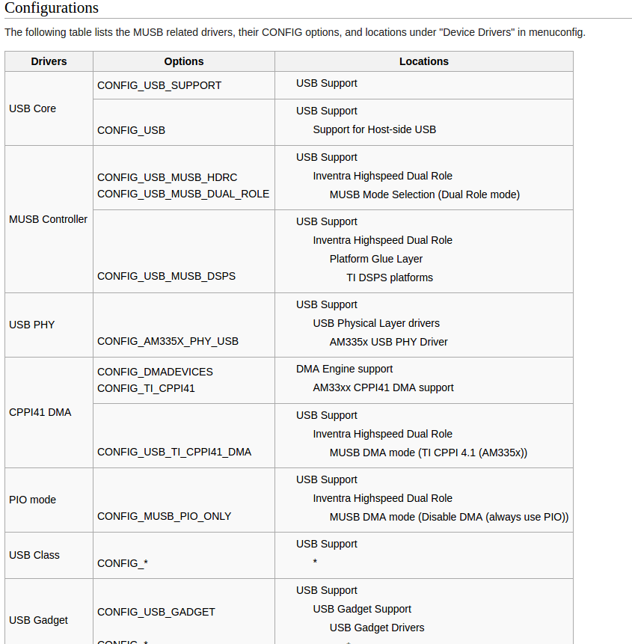

Most of the drivers are enabled by buildroot , but you could find that one or two are not.
So using
make linux-menuconfig
in buildroot , go over each CONFIG_ and check if specified as M ( modue) or Y

The next thing is to correlate between the driver and the module name.

All modules are located for each linux in
/lib/modules/... kernel version..

For beaglebone processor SDK , the modules are located at:

/lib/modules/4.4.32/kernel

Those are the modules names that correlate to the kernel configurations above:

modprobe musb_am335x.ko
modprobe musb_hdrc.ko
modprobe musb_dsps.ko
modprobe cppi41.ko
modprobe g_ether.ko

where g_ether.ko is a host side Ethernet gadget.

The same way, we can enable many of the OTG gadgets like ( printer , serial , mass storage and more)

lsmod:

Module Size Used by Not tainted
usb_f_ecm 8348 1
g_ether 4865 0
usb_f_rndis 20591 2 g_ether
u_ether 14419 3 usb_f_ecm,g_ether,usb_f_rndis
libcomposite 46774 3 usb_f_ecm,g_ether,usb_f_rndis
cppi41 7511 60
musb_dsps 8243 0
musb_hdrc 74260 1 musb_dsps
udc_core 13475 2 libcomposite,musb_hdrc
usbcore 189414 1 musb_hdrc
musb_am335x 1566 0 [permanent]

Then we need to follow this article:

https://developer.ridgerun.com/wiki/index.php/How_to_use_USB_device_networking

On the host
HOST_USB_IP=10.0.0.12
sudo ifconfig usb0 $HOST_USB_IP netmask 255.255.255.0
route

On the target device
HOST_USB_IP=10.0.0.13
TARGET_USB_IP=10.0.0.12
ifconfig usb0 $TARGET_USB_IP netmask 255.255.255.0
route add default gw $HOST_USB_IP
route
Here we should have ping between host and the target , we can then copy files.
Please note that in case there is not a root password (left blank) the scp will fail.
So better to change root password ( using passwd for now, also in buildroot for later flashes)

Continue the article
https://developer.ridgerun.com/wiki/index.php/How_to_use_USB_device_networking

and you will be also connected to the internet from the target through the host

To make the configurations run at the boot sequence:

create a script in /etc/init.d.Smystart

The script shuold start with Capital S, which being load by the rcS script

put the following lines there and reboot.

modprobe musb_am335x.ko
modprobe musb_hdrc.ko
modprobe musb_dsps.ko
modprobe cppi41.ko
modprobe g_ether.ko

HOST_USB_IP=10.0.0.13
sudo ifconfig usb0 $HOST_USB_IP netmask 255.255.255.0
route

The host should call again the lines:

HOST_USB_IP=10.0.0.12
sudo ifconfig usb0 $HOST_USB_IP netmask 255.255.255.0
route

better to add in /etc/network/interfaces

auto usb0
iface usb0 inet static
address 192.168.7.3
netmask 255.255.255.0

