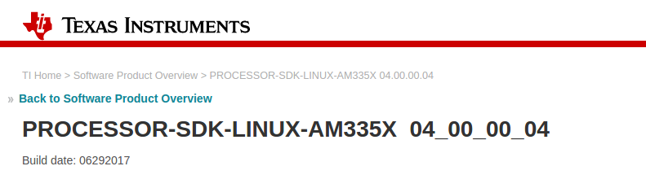

http://software-dl.ti.com/processor-sdk-linux/esd/AM335X/latest/index_FDS.html

The build image:
am335x-evm-linux-04.00.00.04.img.zip

looks like start flashing it self to eMMC after holding the S2 button before inserting power.

The image does have two partitions , no uEnv.txt file in the first partitions.
After burning this image with Etcher in linux , and holding the S2 button in beaglebone
I got
Please wait... on screen.

The image is huge , 2 giga at least.

My problem is that buildroot out of the box def config does not work.

The idea is to go back to the manufactors ( TI Sitara) and start from there.

Several notes
1. Can we burn the uboot using CCS7 and JTAG?
2. Why this image does work and the buildroot does not , is it because of the uboot image?

I will try replace uboot images and combine rootfs to see what is the main problem.

