Beagle bone debian images files:

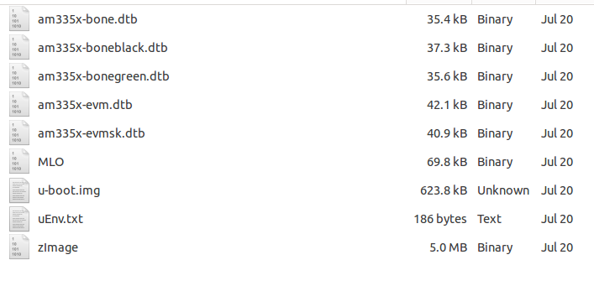
uEnv.txt

bootpart=0:1
bootdir=
bootargs=console=ttyO0,115200n8 root=/dev/mmcblk0p2 rw rootfstype=ext4 rootwait
uenvcmd=run loadimage;run loadfdt;printenv bootargs;bootz ${loadaddr} - ${fdtaddr};

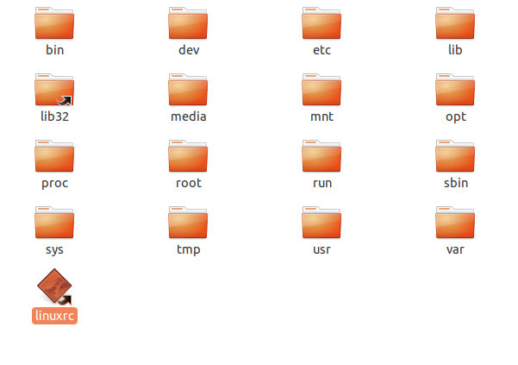
Also:

Ubuntu image does start:
wget https://rcn-ee.com/rootfs/2017-07-14/flasher/BBB-eMMC-flasher-ubuntu-16.04.2-console-armhf-2017-07-14-2gb.img.xz

from (http://elinux.org/BeagleBoardUbuntu)

