Beaglebone uEnv

##This will work with: Angstrom's 2013.06.20 u-boot.

loadaddr=0x82000000
fdtaddr=0x88000000
rdaddr=0x88080000

initrd_high=0xffffffff
fdt_high=0xffffffff

#for single partitions:
mmcroot=/dev/mmcblk0p1

loadximage=load mmc 0:1 ${loadaddr} /boot/vmlinuz-${uname_r}
loadxfdt=load mmc 0:1 ${fdtaddr} /boot/dtbs/${uname_r}/${fdtfile}
loadxrd=load mmc 0:1 ${rdaddr} /boot/initrd.img-${uname_r}; setenv rdsize ${filesize}
loaduEnvtxt=load mmc 0:1 ${loadaddr} /boot/uEnv.txt ; env import -t ${loadaddr} ${filesize};
loadall=run loaduEnvtxt; run loadximage; run loadxfdt;

mmcargs=setenv bootargs console=tty0 console=${console} ${optargs} ${cape_disable} ${cape_enable} root=${mmcroot} rootfstype=${mmcrootfstype} ${cmdline}

uenvcmd=run loadall; run mmcargs; bootz ${loadaddr} - ${fdtaddr};

From Debian Image:

##These are needed to be compliant with Angstrom's 2013.06.20 u-boot.

loadaddr=0x82000000
fdtaddr=0x88000000
rdaddr=0x88080000

initrd_high=0xffffffff
fdt_high=0xffffffff

##These are needed to be compliant with Debian 2014-05-14 u-boot.

loadximage=echo debug: [/boot/vmlinuz-${uname_r}] ... ; load mmc 0:1 ${loadaddr} /boot/vmlinuz-${uname_r}
loadxfdt=echo debug: [/boot/dtbs/${uname_r}/${fdtfile}] ... ;load mmc 0:1 ${fdtaddr} /boot/dtbs/${uname_r}/${fdtfile}
loadxrd=echo debug: [/boot/initrd.img-${uname_r}] ... ; load mmc 0:1 ${rdaddr} /boot/initrd.img-${uname_r}; setenv rdsize ${filesize}
loaduEnvtxt=load mmc 0:1 ${loadaddr} /boot/uEnv.txt ; env import -t ${loadaddr} ${filesize};
check_dtb=if test -n ${dtb}; then setenv fdtfile ${dtb};fi;
loadall=run loaduEnvtxt; run check_dtb; run loadximage; run loadxrd; run loadxfdt;

mmcargs=setenv bootargs console=tty0 console=${console} ${optargs} ${cape_disable} ${cape_enable} root=/dev/mmcblk0p1 rootfstype=${mmcrootfstype} ${cmdline}

uenvcmd=run loadall; run mmcargs; echo debug: [${bootargs}] ... ; echo debug: [bootz ${loadaddr} ${rdaddr}:${rdsize} ${fdtaddr}] ... ; bootz ${loadaddr} ${rdaddr}:${rdsize} ${fdtaddr};

Buildroot uEnv:

bootpart=0:1
bootargs=console=ttyO0,115200n8 root=/dev/mmcblk0p2 rw rootfstype=ext4 rootwait
bootdir=
bootfile=zImage
fdtfile=am335x-boneblack-wireless.dtb
loadaddr=0x80007fc0
fdtaddr=0x80F80000
loadfdt=fatload mmc 0:1 ${fdtaddr} ${fdtfile}
loaduimage=fatload mmc 0:1 ${loadaddr} ${bootfile}
uenvcmd=mmc rescan; run loaduimage; run loadfdt; run fdtboot
#uenvcmd=run loadimage;run loadfdt;printenv bootargs;bootz ${loadaddr} - ${fdtaddr};
fdtboot=run mmc_args; bootz ${loadaddr} - ${fdtaddr}
mmc_args=setenv bootargs console=${console} ${optargs} root=/dev/mmcblk0p2 rootfstype=ext4

Change buildroot Address to debian address

bootpart=0:1
bootargs=console=ttyO0,115200n8 root=/dev/mmcblk0p2 rw rootfstype=ext4 rootwait
bootdir=
bootfile=zImage
fdtfile=am335x-boneblack-wireless.dtb
loadaddr= 0x82000000
fdtaddr= 0x88000000
loadfdt=fatload mmc 0:1 ${fdtaddr} ${fdtfile}
loaduimage=fatload mmc 0:1 ${loadaddr} ${bootfile}
uenvcmd=mmc rescan; run loaduimage; run loadfdt; run fdtboot
#uenvcmd=run loadimage;run loadfdt;printenv bootargs;bootz ${loadaddr} - ${fdtaddr};
fdtboot=run mmc_args; bootz ${loadaddr} - ${fdtaddr}
mmc_args=setenv bootargs console=${console} ${optargs} root=/dev/mmcblk0p2 rootfstype=ext4

Buildroot u boot partitions

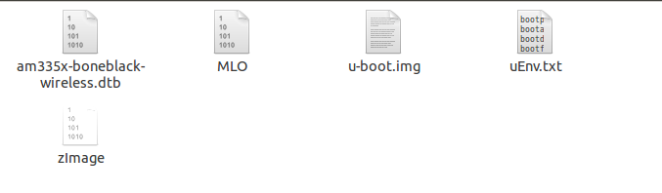
Buildroot Linux partitions

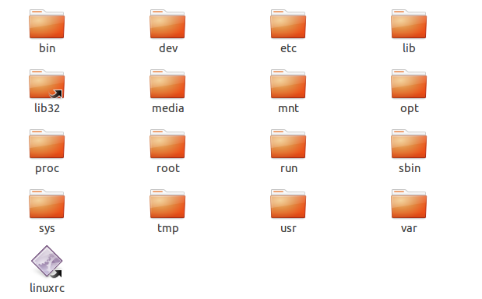

Debian Image is one partition

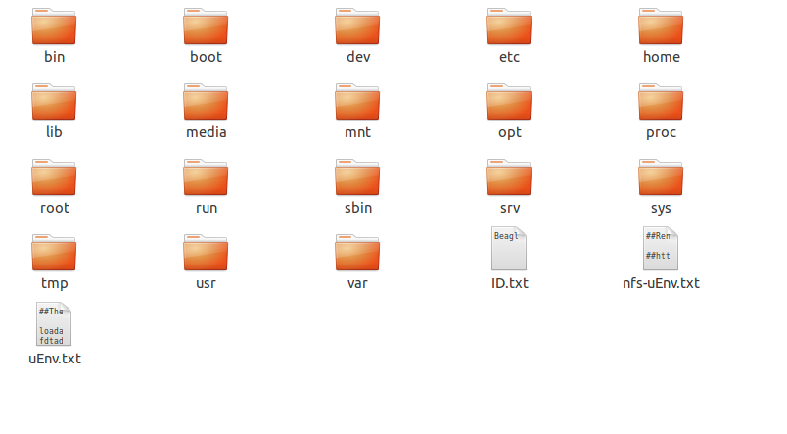
That's mean that the boot will always be from the SD Card
If there is no first partition for uboot it will boot from SD card even without holding the S2 user button.

More code for uEnv.txt:
https://gist.github.com/17twenty/6925066

