Buildroot – root file system overlay

a Common question:

https://stackoverflow.com/questions/37046170/static-network-interface

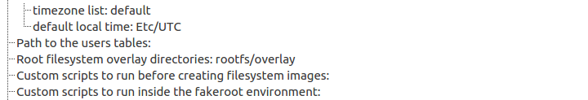

I created the directory
and add:

# This file describes the network interfaces available on your system
# and how to activate them. For more information, see interfaces(5).

# The loopback network interface
auto lo
iface lo inet loopback

# The primary network interface
auto eth0
iface eth0 inet static
address 10.0.0.122
netmask 255.255.255.0

after perform makefile

We can see that the

output/target/etc/network/interface

also contains the above script. Which mean that our roofs will contain the right change for our network interface file

We can:
1. burn the image again with Etcher

2. Copy the network/interface file into the already burned sd card

