Build root – User top level of understanding

This document will go over many of the buildroot menu configurations and try to explain some of the choices.
At the end , I will create a raspberry pi 3 img , burn it SD Card and replace the raspbian OS that I started with.

I think build-root is the place to start learning Linux.
The x config , Linux kernel and busy box utilities give us almost the entire Linux topic to learn.
It is like a index of a huge Liunx book which tell you , go learn everything before you click me.
So this is exactly what did, at least in very high perspective.
Knowing most of the terms give you the strength to build Linux.
And I think it will help to learn Yocto eventually better in case I need.

I want to load an image that I will not need to do any apt-get or use any package install which will have everything I need:
1.SSH
2. QT5
3.JAVA
4.Python 2.7
5.node js
6.MySql
7. basic browse
8. xterm
9. basic browsing folders.
and more.

in this tutorial , I will not build a package of my own and the QT Gui will still be copied from host to target via SSH.which mean it will not be included I the rootfs yet.

Let’s get started:

Compiling buildroot for raspberry pi 3 or any other existing defconfig is easy.

Just download buildroot https://buildroot.org/
after extracting the tar.gz file: (buildroot is about 6 mega byte only)

I am downloading the 2017 02
tar xzfv buildroot-2017.02-rc2.tar.gz
I will do also 2017 05

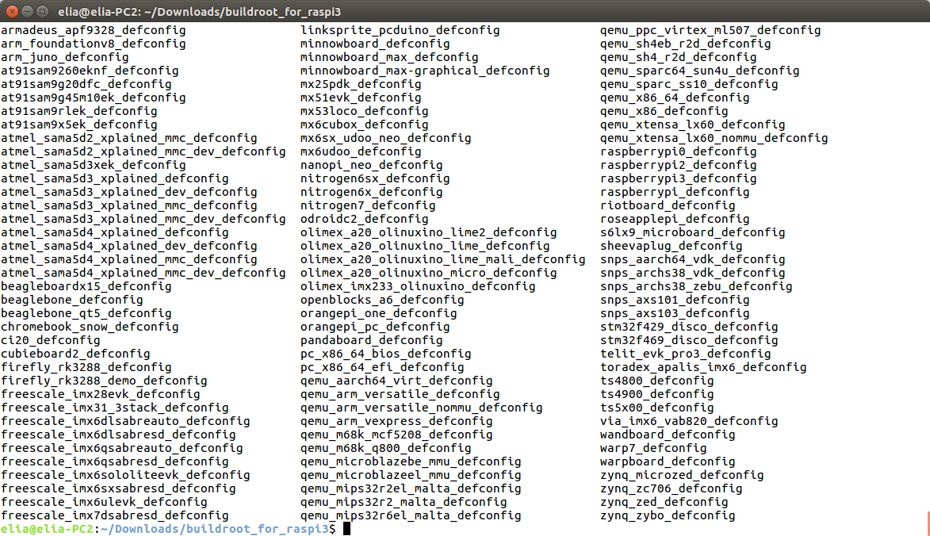
type ls -l to view all the defconfig:
Check in configs for raspberry pi 3
ls configs/raspberrypi3*

There are two configurations
1. For 32 bit - raspberrypi3_defconfig ARM architecture
2. For 64 bit – raspberrypi3_64_defconfig ARM architecture

This manual will go through the 32 bit version.

make raspberrypi3_defconfig
#
# configuration written to /home/elia/Downloads/buildroot_for_raspi3/.config
#

This will copy the default configuration for raspberry pi 3 into .config , the configuration file that Linux kernel needs.

It is important to note that many errors during happened because of not doing make clean.
When changing , adding or removing , configurations , we need to do make clean for most of the cases, otherwise we will get not a real errors.

From here you can do make and wait 2 hours.
Once the build will finished the binary image to copy to SD card will be there.
We will come back to them later to explain what we have there (kernel , dtb and more)

because we have to go deeper to understand build-root and later on to create our own BSP
lets div inside build root to understand what it configure for raspberry pi 3.

I am using make xconfig – which is a nice qt gui ,
we can use make menuconfig( ncurses blue text screen) or make config which is text base yes not
questions.
Because it is a learning curve I will change some settings, do a make clean and then make ,
burn the image to SD card and check it on the raspberry pi 3.

The first compilation has finished, this stage is just taking the default, compile it and burn:

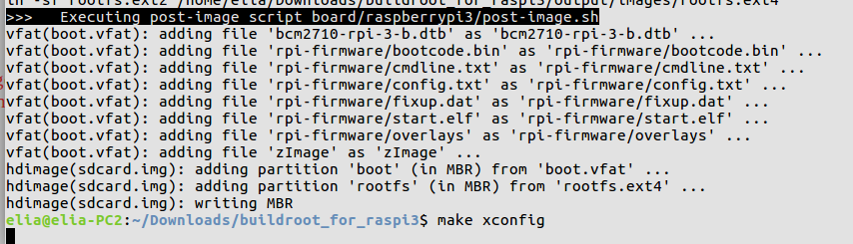

once we have the image, we can burn it like following:

Prepare SD card:

For beagle bone we can follow the instruction at:
http://free-electrons.com/doc/training/buildroot/buildroot-labs.pdf the prepare SD card

For raspberry pi 3:

http://qdosmsq.dunbar-it.co.uk/blog/2013/06/noobs-for-raspberry-pi/

run fdisk -l
to view the partitions

also we can use gparted which is graphical app for partitions.
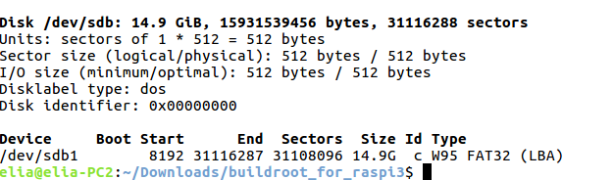
lets use gparted:
gparted can create partitions and also format to ext1 to 4 fat32
Don’t forget to press apply all operation!

sudo gparted
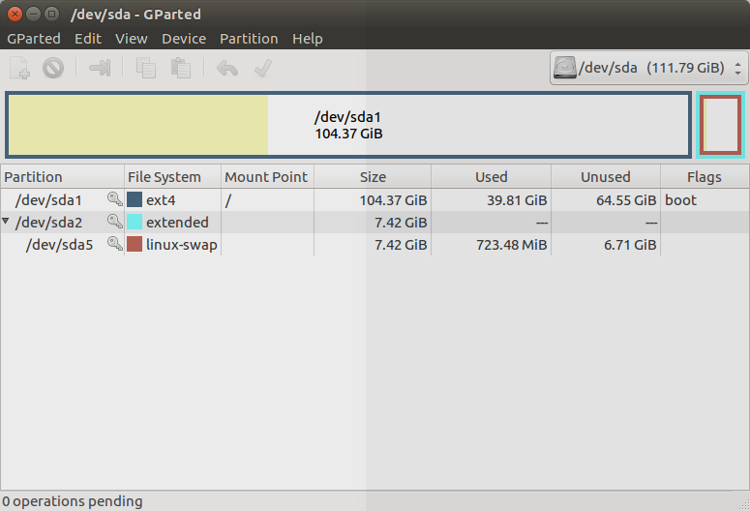

When gparted is showing up , you will see your hard drive.
You will want immediate to go to Gparted→Devices and select the SDX
SDA is you primary hard drive.
Make sure that SDX is the actual SD card. You need a USB Card reader to connect it to your computer

Gparted can create partitions, delete and formated to Linux and dos file systems, ext4 , FAT16 , FAT32
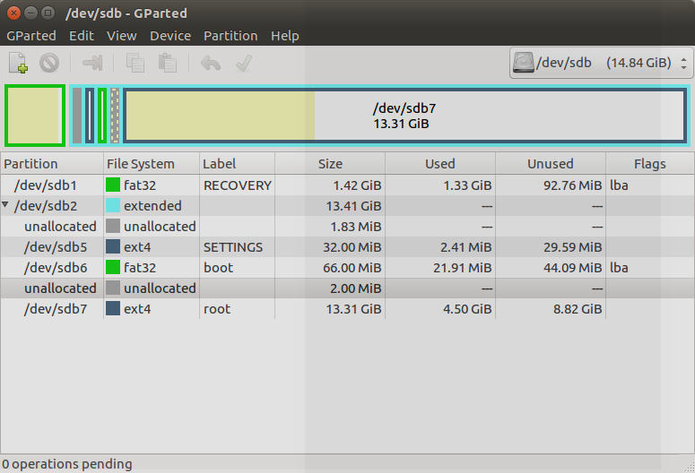

Don't forget to press the apply operation once you choose operation to perform.
Gparted runs parted , the command line utility internally for us.

To burn the sdcard.img , located at output/images into the sd card , we can use dd command or Ether graphical utility

Etcher will format the SD Card each time it start the operation. Also it will not let you select the primary disk ( where you host OS is located) only in safe mode.

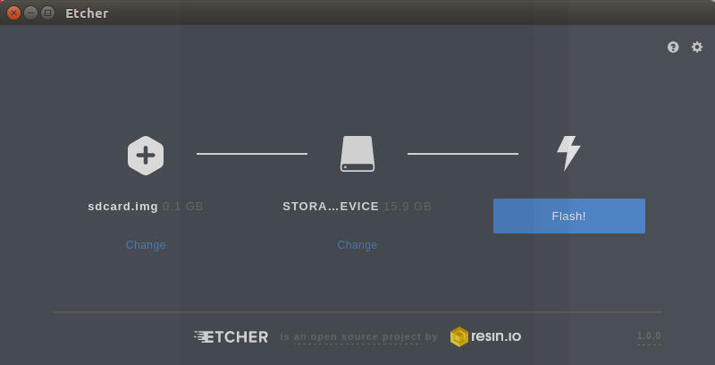

Once done, plug it in your raspberry pi 3.

Some notes about xconfig gui:
You need Qt4 and some more , but don't worry, you will get all errors telling you what to install , so just follow it.

You can use make xconfig
make meunconfig ( the ncourses gui)
make config (text base yes no questions)

In a place that there is need to change a name or edit , press enter and you will be able to edit the text.

To search in xconfig press CTRL +F , and in ncurses menuconfig press /

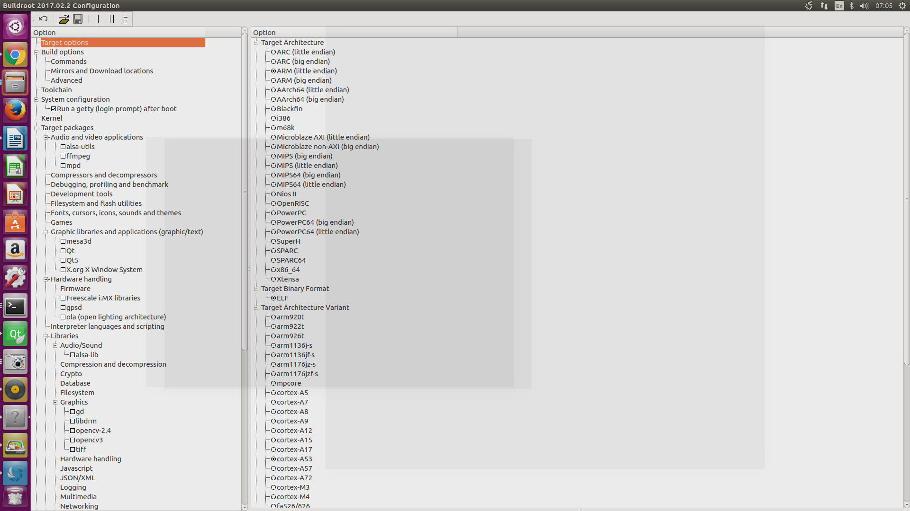
*buildroot xconfig qt gui

Let’s continue.

Although it should do at the beginning, lets change the destination down directory now:

It will save us time in the make clean, build root will not need to download what it already did.

* I change the compiler to external tool chain , to save the time of building the tool chain each time
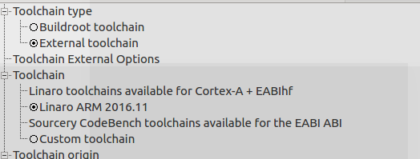

The compiler is EABI HF – hardware floating point


Changed the architecture to Cortext A-53

Which is more correct , because if we search to find which arm is exists in raspberry pi 3
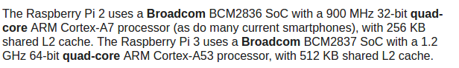
So the raspberry PI 2 is Cortext A7 and the PI 3 is Cortext-A53

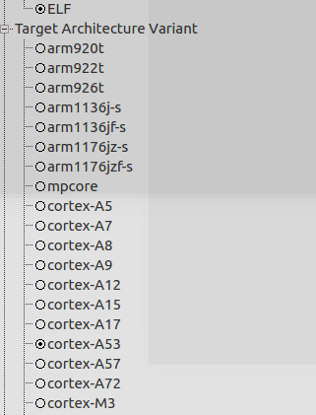

This tutorial will focus on the 32 bit ARM version,which is possible to run on a 64 bit raspberry pi 3
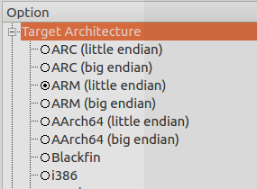

The next tutorial will follow the same for the 64 bit version

Next image will contains:
1. dropbear for SSH

Networking and applications:

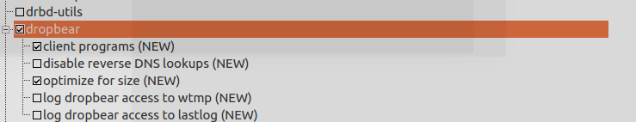
2. tftp

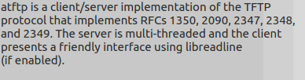

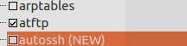

More options:
http://free-electrons.com/~thomas/buildroot/manual/html/ch09.html
Enable compiler cache:
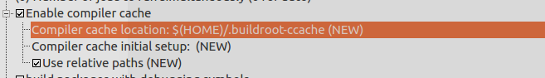

X.Org
The X.Org project provides an open source implementation of the X Window System


X is the server and 11 is the versions
Lets enable the server
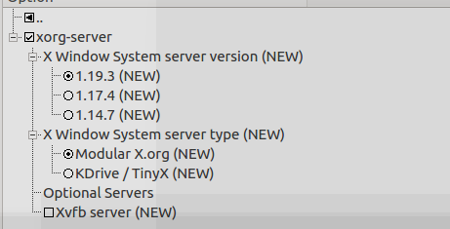

Xvfb − virtual frame buffer X server for X Version 11
we don't need it

I read the x window system, several times.
https://en.wikipedia.org/wiki/X_Window_System
it help to put order in this huge system.

XFree86®?
Before you click on stuff , you need to know what it does.
https://www.xfree86.org/
https://en.wikipedia.org/wiki/XFree86



Yes old (22 years old) but it is also gives
XFree86 was an implementation of the X Window System
buildroot does not use it , it use x.org implementation of the x window server
Its uses the x.org server and not the XFree86 server

I think the name xf86 was adopted by x.org so
In X11 R7 Drivers we can find many by that prefix name:
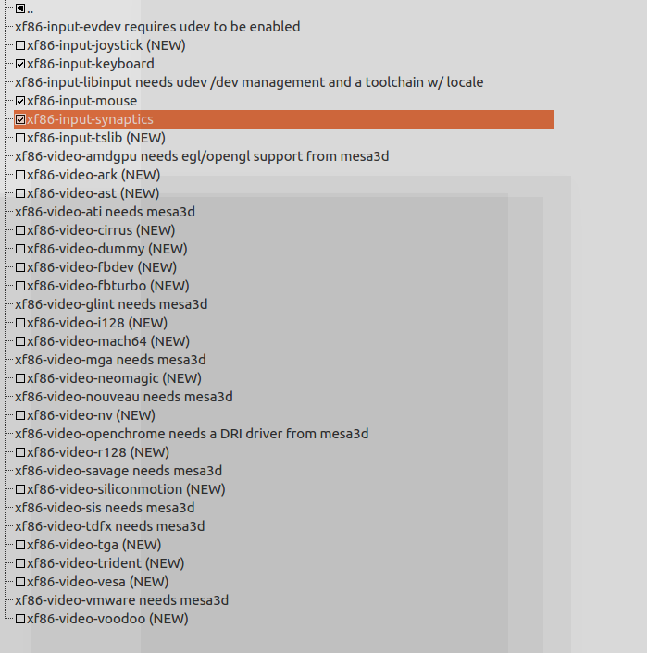
The list of the drivers
https://packages.gentoo.org/categories/x11-drivers

xf86-input-mouse - X.Org driver for mouse input devices

xf86-input-keyboard - Keyboard input driver

xf86-input-synaptics – Driver for synaptics touchpad
http://www.synaptics.com/

does it fit to any touchpad? I dont know yet , I will check my element 14 touch screen.

More drivers to load:

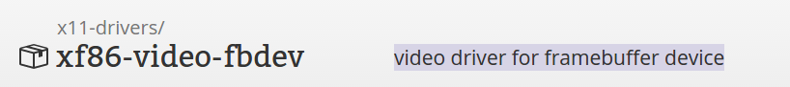


vesa (xf86-video-vesa), the generic driver, which handles a large number of chipsets but does not include any 2D or 3D acceleration.



Adding more video drivers is like shooting in the dark.
I have the 7 inch element 14 LCD touchscreen.
I need to find the driver for it , or does it already exist in the kernel?

According to this thread:
https://github.com/raspberrypi/linux/issues/1147

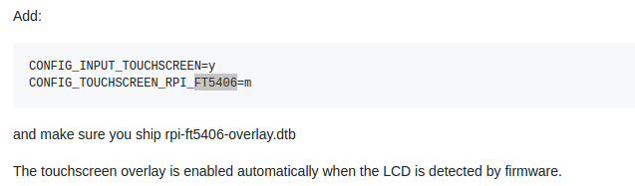

lets check:
doing make linux-menuconfig

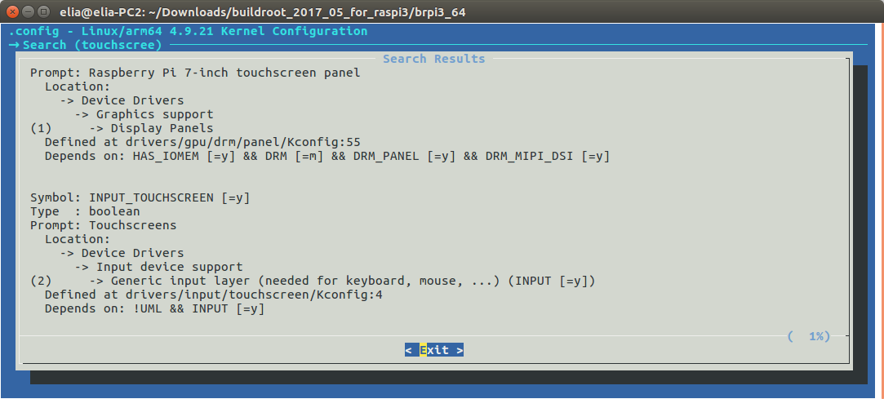
input_touchscreen - yes it activate

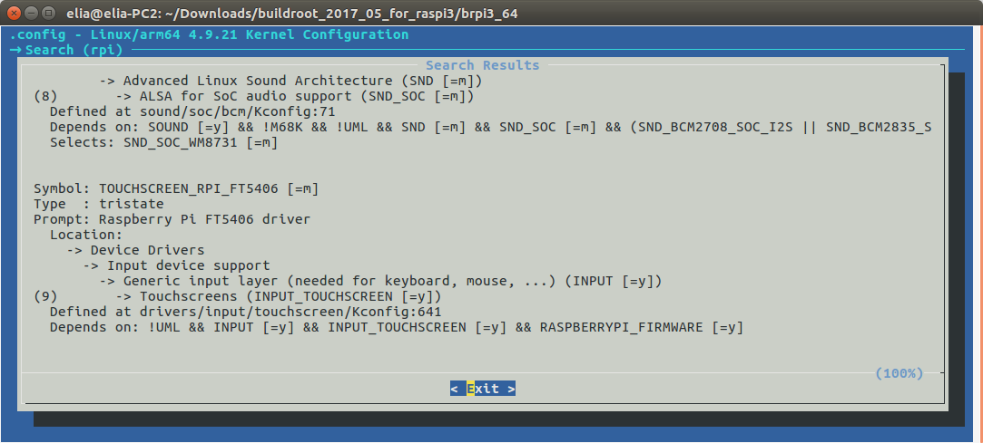
the RPI_FT5406 is configure as =m means a module
which mean it will not statically compiled in the kernel , but will dynamically load when needed ( detected )

we can see that this driver depends on RASPBERRY_FIRMWARE
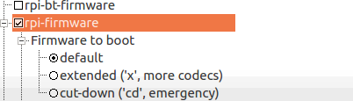

which is enabled in build-root menu config. ( Hardware handling->firmware)

Its possible that I only need the above two drivers and not the xf86.

X11 R7 applications
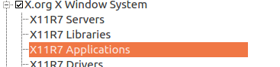

There are a lot of them.

For example:

xinit
The xinit program allows a user to manually start an X display server.
The startx script is a front-end forxinit.

Xconsole:
The xconsole program displays messages which are usually sent to /dev/console.

Xdm
X display manager
is a graphical login manager which starts a session on an X server from the same or another computer

xkill
Xkill is a utility program distributed with the X Window System that instructs the X server to forcefully terminate its connection to a client, thus "killing" the client.

because I am not familiar to all of the names in the list,
complete here :)

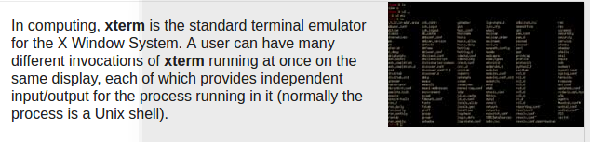
We are going to have a small ubunto.

PcManFM

When we are enabling the x windows , why not use a graphical file manager:
https://wiki.lxde.org/en/PCManFM

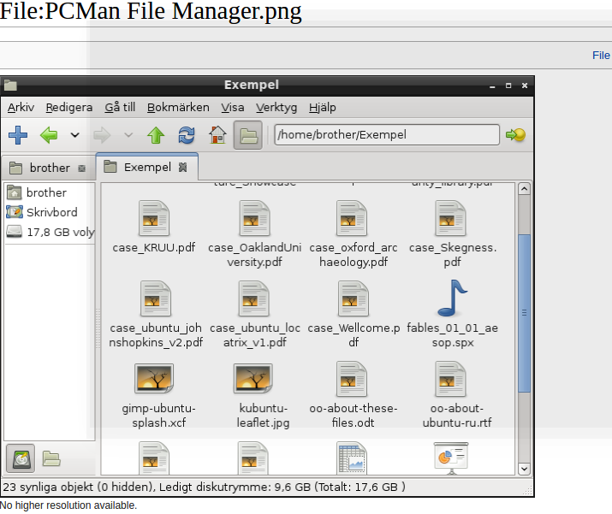

Midori
http://midori-browser.org/

And also , if have have INTERNET , we can surfe with Midori internet browser.



According to what it said , it is a light but killer browser.

Midori requires libgtk3
When I am adding it it break the compilation

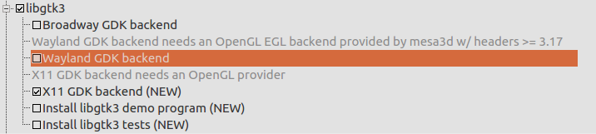

QT5 - QT5.8

QT Gui will require the X window system.
X windows system is maintained today by the x.org as open source collaboration.

QT can run also with its own window system the QWS ( QT window system)

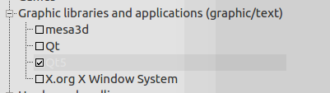

The QT above QT5 is QT 4.8.7
If we go to the packages folder of qt:

buildroot_for_raspi3/package/qt

We can see in file qt.mk
the version:
QT_VERSION_MAJOR = 4.8
QT_VERSION = $(QT_VERSION_MAJOR).7

When we go to qt5 package qt5.mk

We can see the versions:

ifeq ($(BR2_PACKAGE_QT5_VERSION_LATEST),y)
QT5_VERSION_MAJOR = 5.8
QT5_VERSION = $(QT5_VERSION_MAJOR).0
QT5_SITE = http://download.qt.io/official_releases/qt/$(QT5_VERSION_MAJOR)/$(QT5_VERSION)/submodules
QT5_SNAPSHOTS_SITE = http://download.qt.io/snapshots/qt/$(QT5_VERSION_MAJOR)/$(QT5_VERSION)/latest_src/su
else
QT5_VERSION_MAJOR = 5.6
QT5_VERSION = $(QT5_VERSION_MAJOR).2

latest is 5.8.0
and older is 5.6.2

Qt for Embedded Linux
http://doc.qt.io/qt-5/embedded-linux.html

I read it couple of times and did not understand it well,
but now I got it.

QT need an engine to display it widget on an x window.
So instead of using the x window server from x.org for , QT has several options:

EGLFS, LinuxFB, KMS, DirectFB, Wayland

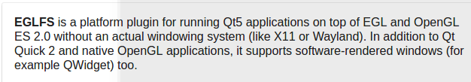

on many boards eglfs is chosen as the default one.
But it depends how we configure QT

to ask QMAKE to produce for us a makefile( like I explained in the cross compile QT for RASPI3)
we need to run configure

./configure -opengl es2 …. more parameters here ...

here we select that the platform plugin will be opengl es2

back to build root
when we search for eglfs , we can see that it is not enabled by default
some dependencies are missing:

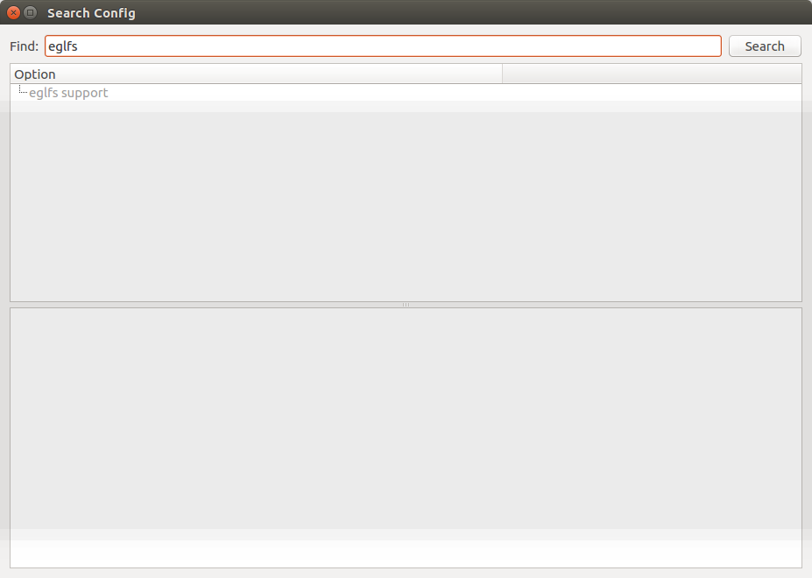
activate mesa3d


https://www.mesa3d.org/intro.html
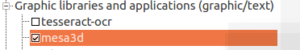

Introduction
The Mesa project began as an open-source implementation of the OpenGL specification - a system for rendering interactive 3D graphics.
Over the years the project has grown to implement more graphics APIs, including OpenGL ES (versions 1, 2, 3), OpenCL,OpenMAX,VDPAU,VA API, XvMC and Vulkan.
A variety of device drivers allows the Mesa libraries to be used in many different environments ranging from software emulation to complete hardware acceleration for modern GPUs.

Open Graphics Library(OpenGL)[3][4] is across-language,cross-platform application programming interface (API) for rendering 2D and 3D vector graphics. The API is typically used to interact with a graphics processing unit(GPU), to achieve hardware-accelerated rendering.


https://www.khronos.org/opengles/

OpenGL® ES is a royalty-free, cross-platform API for full-function 2D and 3D graphics on embedded systems - including consoles, phones, appliances and vehicles. It consists of well-defined subsets of desktop OpenGL, creating a flexible and powerful low-level interface between software and graphics acceleration. OpenGL ES includes profiles for floating-point and fixed-point systems and the EGL™ specification for portably binding to native windowing systems

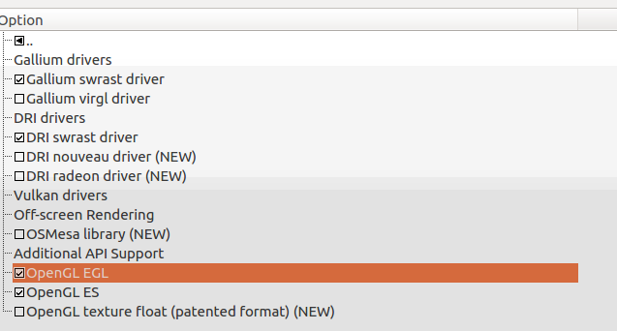

DRI drivers:


https://dri.freedesktop.org/wiki/

The two drivers that activated are a software drivers:
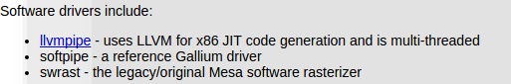

back to this in build-root
EGLFS, LinuxFB, KMS, DirectFB, Wayland

we want to enable QT GUI , not only command line.
So we need first to enable:

Gui module
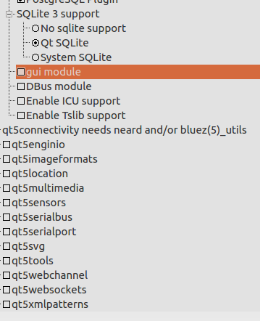

it is not enabled yet , lets enable it and see what happens:

some of the QT platform plugins opened:
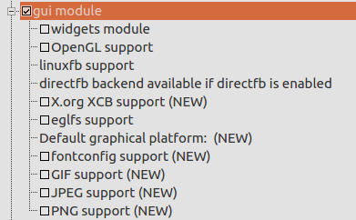

KMS we d’ont have in the list

The default its linux frame buffer not egls

lets check the widget module
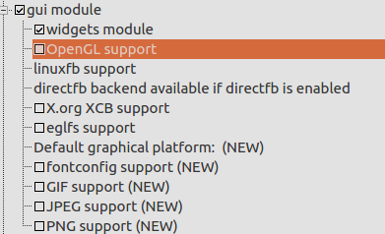

if we check eglfs support:

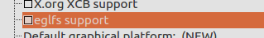

we get open gl selected

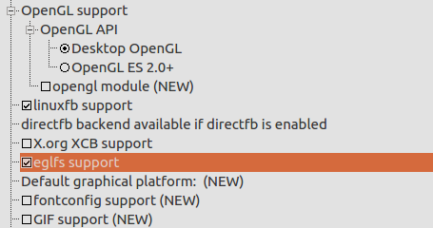

lets select Open Gl ES for embedded systems instead of desktop

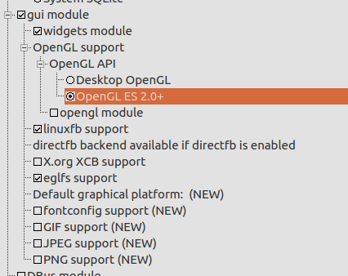

We can select the X.org XCB support also as a plugin
but what is it?

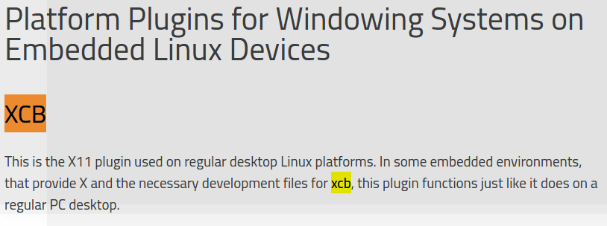

According to that , it is not suitable for embedded systems , although we define x.org server for x windows system.

So now we have both linux frame buffer and egls checked.
But QT needs only one to work , so which one is the default?

BTW, the default will be set in QT_QPA_PLATFORM by buildroot

it will create qmake with the configure -platform of the default that we select.

One option is to select only one qt rendering plugin

The another option is to double click here:

and write the default graphical platform
for example:
linuxfb

More qt packages

OpenBox
Openbox is a free, stacking window manager for the X Window System
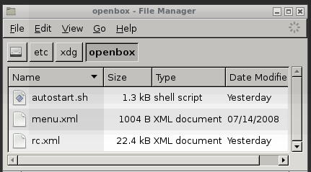

https://en.wikipedia.org/wiki/Openbox

File system

let you select your root files system

ext 2/3/4 for MMC , sd card
jffs2 , ubif2, yaff2 for nand flash mostly

When we add more and more packages , the default block size will not be enough.
If we dont change it we will get an error.
We need to specify the size in block

we can use the giga bytes to block and block to giga bytes converters:

http://www.unitconversion.org/data-storage/blocks-to-gigabytes-conversion.html
http://www.unitconversion.org/data-storage/gigabytes-to-blocks-conversion.html

here is 1 giga byte in blocks size
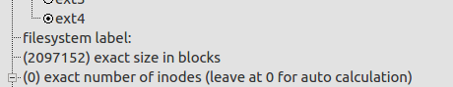

if we need less then giga we can use the block to giga bytes as better way to determine the block count.

Text editors:

Nice to know that build root add Joe editor to the makefiles because I am using Joe editor:
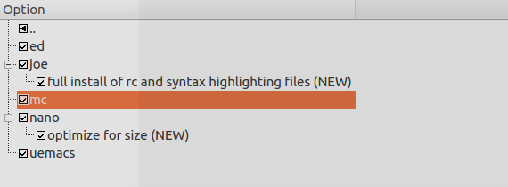

Testing the above image:

For SSH:
We need to activate dropbear at the targeted
Later on we will create overlay script that will initiate it on startup

Using putty:

The image is working , so I save it to my own def config
using
make savedefconfig

The file will be save by the name:
later we will restore it and try to compile and produce the image again.

Testing putty and ssh

Note , if the root password is empty , putty ssh and scp will failed to connect ( access Is denied)
to solve it is with a public key

So the best is just to enter a root password and then dropbear will work.

Drop bear is running already on startup.
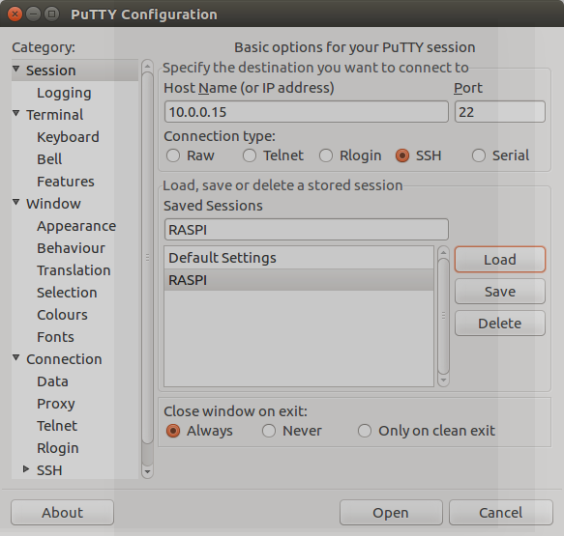

And also we can do copy using SCP

sudo scp myfile.txt pi@10.0.0.15:/home/pi
We can use sshpass -p to provide a password for the copy , to avoid enter password for each copy.

https://www.cyberciti.biz/faq/noninteractive-shell-script-ssh-password-provider/

sudo sshpass -p ‘raspberry’ scp myfile.txt pi@10.0.0.15:/home/pi

A Word about the kernel

For kernel option
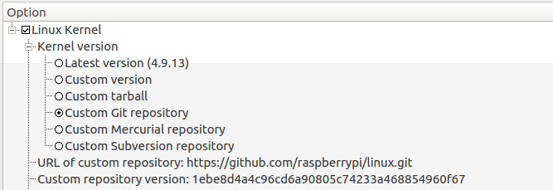
the raspberry pi 3 will be fetch from github.
Note the custom repository version is the commit number
you can look at github for this commit version ( long sha number)

Note , then when it will be fetch , it will be store in the DL director

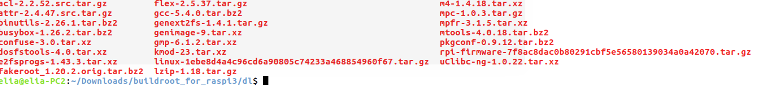
as it specifically in the build options.

It is recommended to locate the download location outside buildroot top folder in-case you switch between configuration. It can avoid download time.
Like I did just now.

Kernel configuration
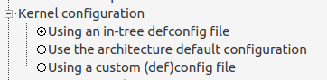

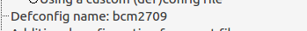

One of the important key points in the kernel is the defconfig name.

It determine which machine in the kernel will be build:

the bcm2709 bring us to the following folder:
output/build/linux-1ebe8d4a4c96cd6a90805c74233a468854960f67/arch/arm/mach-bcm2709

the configuration it self can be found here:

output/build/linux-1ebe8d4a4c96cd6a90805c74233a468854960f67/arch/arm/configs
( again, after running make where the download, extract and all is done)

if we open the file with joe editor , we can see which is the configuration will be used in the kernel
CONFIG_ARCH_BCM2709=y
sometimes there are more then one , mostly because of inhertiance and from the same family.

One of the mission in this tutorial is to go inside the kernel and understand how to build a new BSP by
how this one its build.
By comparing between Raspberry pi3 and NXP kinetis twr120 we can understand better how and why the arch is build.
We can understand the flow, the drivers in use, device tree.
Hope that it will bring us to understanding how to build our own BSP for a new chip in the kernel.

Kernel binary format:
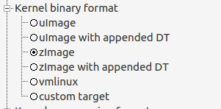

compress or not , with u-boot or no , this is the place to determine the image type of the kernel to be build.
Raspberry pi use its video core GPU for stage one and stage 2 boot loading and and there for does not use u-boot or any other standard bootloader.
There for no uImage is needed.
Device tree:

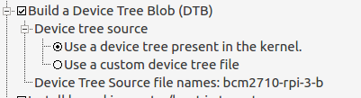

One of the main features is the device tree.
We can blame ARM for that.
There was a need to standardize how to configure device driver rather then create many device drivers and BSP for each family of boards.

So a device tree block format with dtsi description files were created to pass information to the kernel which can use using of functions which we will explore later on.

Here the buildroot tell use that the device tree name is bcm2710-rpi-3-b

First we can see in output/images that a block device tree was created:
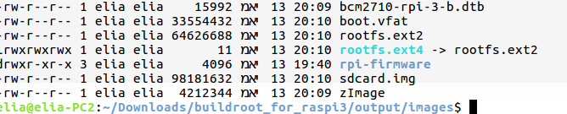

the block device was created using a DTC – device tree compiler , which compile the dtsi , and include file in the bcm2710-rpi-3-b directory:

All the DTS files are located in the linux-1ebe8d4a4c96cd6a90805c74233a468854960f67 directory:

output/build/linux-1ebe8d4a4c96cd6a90805c74233a468854960f67/arch/arm/boot/dts

this is just ls bcm , showing how many different dts file the kernel has:

bcm11351.dtsi bcm2710-rpi-cm3.dts bcm4708-asus-rt-ac56u.dts bcm59056.dtsi
bcm21664.dtsi bcm28155-ap.dts bcm4708-asus-rt-ac68u.dts bcm63138.dtsi
bcm21664-garnet.dts bcm2835.dtsi bcm4708-buffalo-wzr-1750dhp.dts bcm7445-bcm97445svmb.dts
bcm2708_common.dtsi bcm2835-rpi-a-plus.dts bcm4708.dtsi bcm7445.dtsi
bcm2708.dtsi bcm2835-rpi-b.dts bcm4708-luxul-xwc-1000.dts bcm911360_entphn.dts
bcm2708-rpi-b.dts bcm2835-rpi-b-plus.dts bcm4708-netgear-r6250.dts bcm911360k.dts
bcm2708-rpi-b-plus.dts bcm2835-rpi-b-rev2.dts bcm4708-netgear-r6300-v2.dts bcm958300k.dts
bcm2708-rpi-cm.dts bcm2835-rpi-cm.dts bcm4708-smartrg-sr400ac.dts bcm958305k.dts
bcm2708-rpi-cm.dtsi bcm2835-rpi-cm.dtsi bcm4709-asus-rt-ac87u.dts bcm958625k.dts
bcm2709.dtsi bcm2835-rpi.dtsi bcm4709-buffalo-wxr-1900dhp.dts bcm963138dvt.dts
bcm2709-rpi-2-b.dts bcm47081-asus-rt-n18u.dts bcm4709-netgear-r7000.dts bcm9hmidc.dtsi
bcm2710.dtsi bcm47081-buffalo-wzr-600dhp2.dts bcm4709-netgear-r8000.dts bcm-cygnus-clock.dtsi
bcm2710-rpi-3-b.dtb bcm47081-buffalo-wzr-900dhp.dts bcm5301x.dtsi bcm-cygnus.dtsi
bcm2710-rpi-3-b.dts bcm47081.dtsi bcm5301x-nand-cs0-bch8.dtsi bcm-nsp.dtsi

And the file under this directory:
bcm2710-rpi-3-b.dts

Is the file that buildroot configure to build and use.

Here is small screen shot of the file:
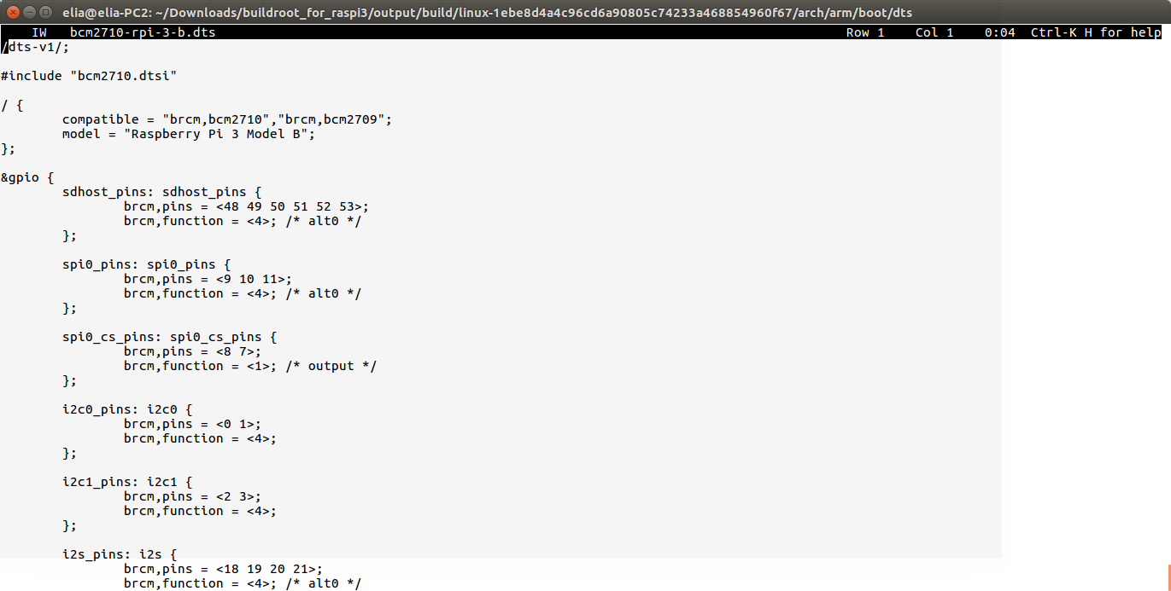

We will try understand better this file in later tutorials, and especially the connection to each driver.

Boot loaders:
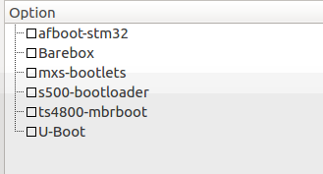

As we said , in raspberry pi 3 the video core GPU is the actual stage 1 and 2 bootloader , so no boot loader needed here.

Here is a bootloader section for imx28 cpu, there we know that has u-boot as bootloader:

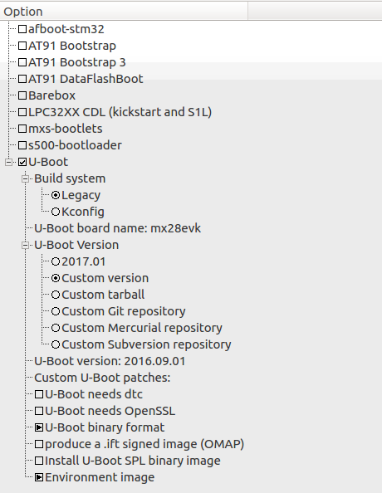

you can find here
https://github.com/lentinj/u-boot/blob/master/boards.cfg
A list of supported board name ( this is how I searched in google, u-boot boards name)

When we search in the page for the mx28evk

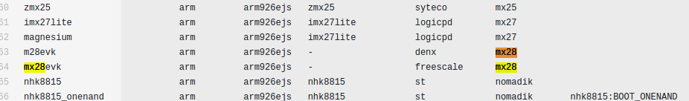

We can see it in the list of supported u-boot BSP.
U-boot contains lots of BSP and It is like the defconfig in linux kernel , we enable one of them.

I will go over imx28 configuration in buildroot in later tutorials.

File systems

This is why I love build root – it is easy to add file system:

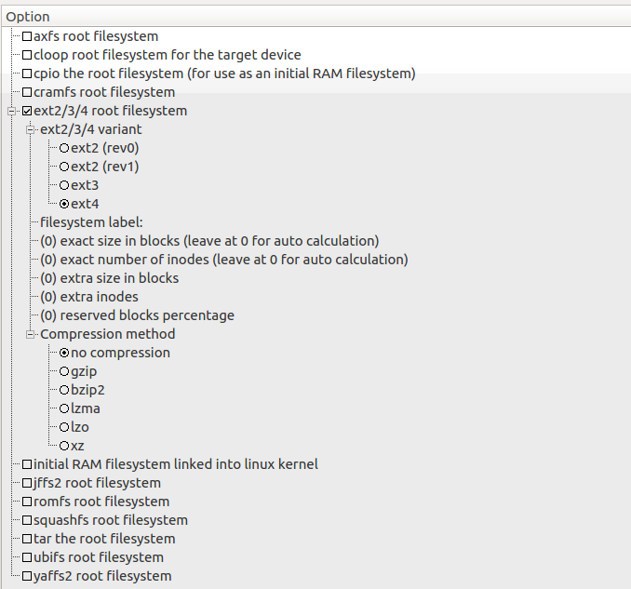
We can add the ext family for SD , MultiMediaCard (MMC)
or nand IMX 28 can work with SD and nand
so it is better to use ubifs or yaffs2.

Here we can see good presentation about file systems in linux:
http://events.linuxfoundation.org/sites/events/files/slides/fs-for-embedded-full_0.pdf

More options:
nginx – I installed and worked with nginx on ubunto
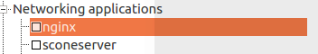

Not on embedded,
For embedded I recommended mongoose web server , light c http server which supports open ssl as well.

I have a complete web site in angular js, nodejs my sql
https://github.com/EliArad/house4sale360
which it will be intersting to make it work in raspberry pi 3 buldroot image.

System configuration

We can read better in buildroot manual 6.3:

The init program is the first userspace program started by the kernel (it carries the PID number 1), and is responsible for starting the userspace services and programs (for example: web server, graphical applications, other network servers, etc.).
Buildroot allows to use three different types of init systems, which can be chosen from System configuration, Init system:
- The first solution is BusyBox. Amongst many programs, BusyBox has an implementation of a basic init program, which is sufficient for most embedded systems. Enabling the BR2_INIT_BUSYBOX will ensure BusyBox will build and install its init program. This is the default solution in Buildroot. The BusyBox init program will read the /etc/inittab file at boot to know what to do. The syntax of this file can be found in http://git.busybox.net/busybox/tree/examples/inittab (note that BusyBox inittab syntax is special: do not use a random inittab documentation from the Internet to learn about BusyBox inittab). The default inittab in Buildroot is stored in system/skeleton/etc/inittab. Apart from mounting a few important filesystems, the main job the default inittab does is to start the /etc/init.d/rcS shell script, and start a getty program (which provides a login prompt).
- The second solution is systemV. This solution uses the old traditional sysvinit program, packed in Buildroot in package/sysvinit. This was the solution used in most desktop Linux distributions, until they switched to more recent alternatives such as Upstart or Systemd. sysvinit also works with an inittab file (which has a slightly different syntax than the one from BusyBox). The default inittab installed with this init solution is located in package/sysvinit/inittab.
- The third solution is systemd. systemd is the new generation init system for Linux. It does far more than traditional init programs: aggressive parallelization capabilities, uses socket and D-Bus activation for starting services, offers on-demand starting of daemons, keeps track of processes using Linux control groups, supports snapshotting and restoring of the system state, etc. systemd will be useful on relatively complex embedded systems, for example the ones requiring D-Bus and services communicating between each other. It is worth noting that systemd brings a fairly big number of large dependencies: dbus, udev and more. For more details about systemd, see http://www.freedesktop.org/wiki/Software/systemd.
The solution recommended by Buildroot developers is to use the BusyBox init as it is sufficient for most embedded systems. systemd can be used for more complex situations.

in PI3:
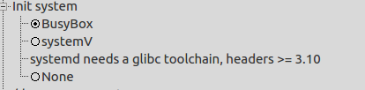

Busybox will load init which will load inittab.
Systemd require glibc.

The root password ( empty by default) is also here:

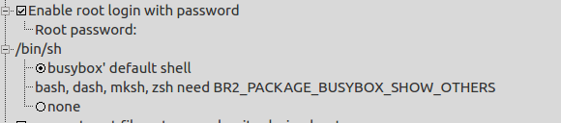

The shell to be used.

We can change the hostname
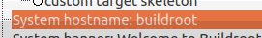

and the localization ( languages) – but need to check if it really works.

Busybox:

BusyBox: The Swiss Army Knife of Embedded Linux
https://www.busybox.net/

Buildroot ofcourse let us to configure busybox utilities:

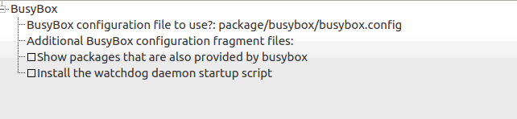
First, it tell us where the configuration file of busybox is located:

we don't edit this file in regular editor , but using a config

make busybox-menuconfig
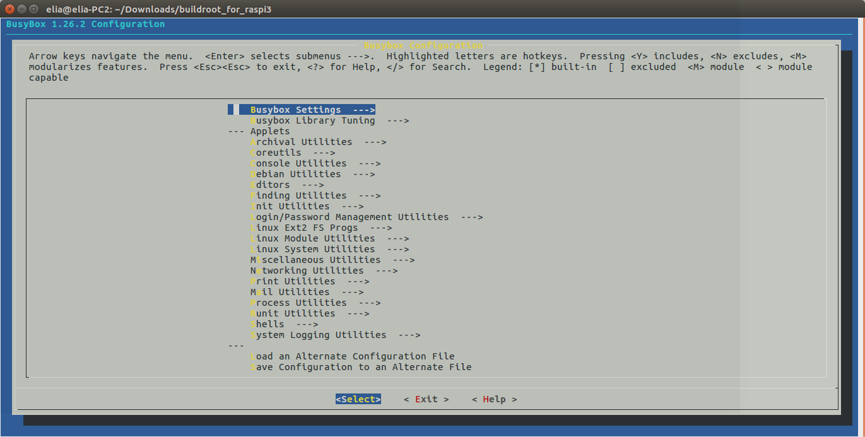

Just small reminder to whom that not familiar:
press / to search utilities.

Some make tips worth mention ( buildroot section 8.1)

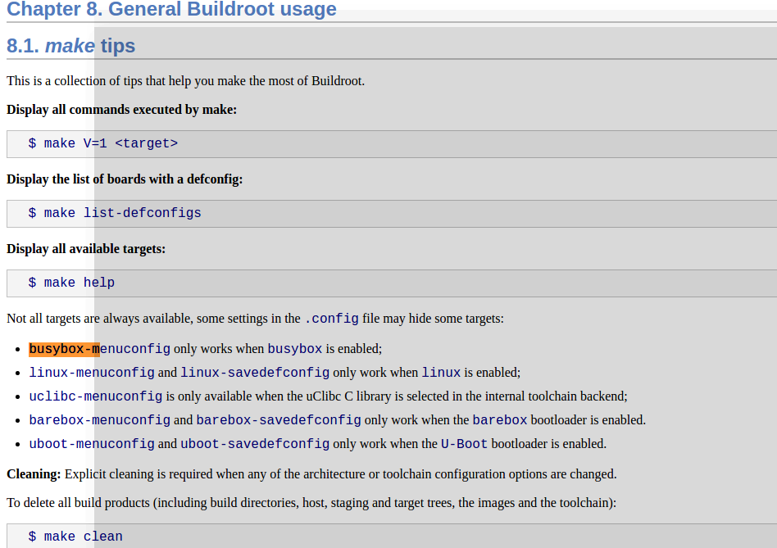

Node js

I want to install also node js
buildroot 2017 05 gives us version 7.10:
to search nodejs just type ctrl+f in xconfig

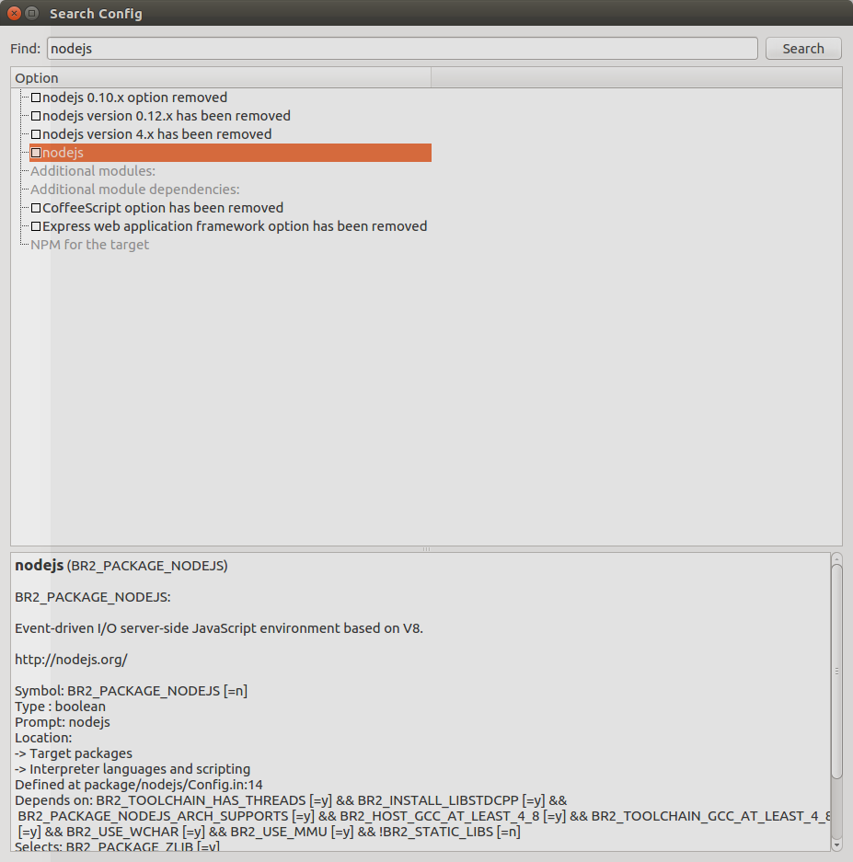
and select nodejs
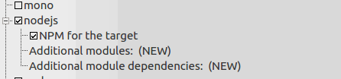

it does not tell us the version
So I edit the Config.in file in nodejs packages directory and added the version to display in xconfig:
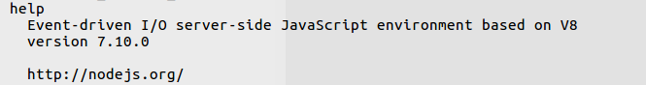
And now when we select nodejs in xconfig we can see the version also
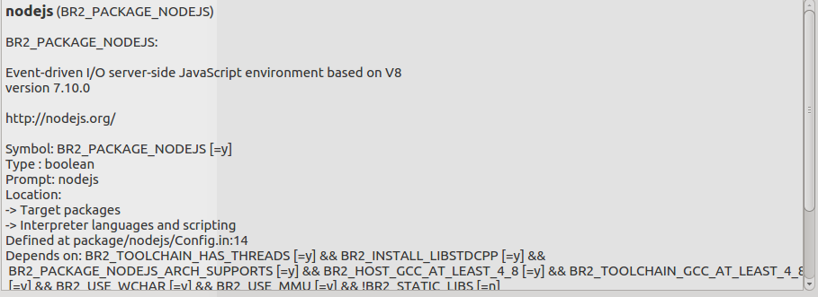

rootfs overlay

We want to override the default network configuration that will take over each time we build the system and flash the SD card

There for , we need to create a root file system overlay directories

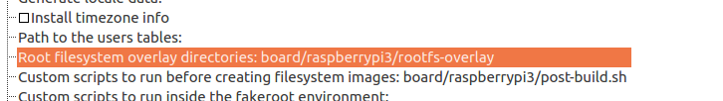

we create a new file etc/network/interfaces
auto lo
iface lo inet loopback
auto eth0
iface eth0 inet static
address 192.168.0.2
netmask 255.255.255.0

To check:
if we change the files at:
output/target/etc/network/interfaces

All the etc init.d inittab and more are in
output/target/etc

Generate a defconfig
Now that our system is already in a good shape, let’s make sure its configuration is properly saved and cannot be lost. Go in menuconfig, and in the Build options menu. There is an option called Location to save buildroot config which indicates where Buildroot will save the defconfig file generated by make savedefconfig. Adjust this value to $(TOPDIR)/configs/felabs_defconfig. Then, exit menuconfig, and run: make savedefconfig

buildroot did not change the file from the place it came
but we want to create a slight new version.
If we overwrite it we will need to get a new version or the original in case we want
So lets change the name for example:

make savedefconfig

and we have the config saved in configs:

Creating hello world app.

We need a crose compiler, so why not used build root cross compiler?

For that we know that the compiler is located at:

output/host/usr/bin

so lets create a shell script called ACTIVATE.sh
and write those lines there:

export PATH=~/Downloads/buildroot_for_raspi3/output/host/usr/bin:$PATH

to activate use source ACTIVATE.sh

now we can access the compiler from any place ( on the window that we issue the source command)
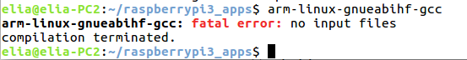

lets create main.c with stuff in it and compile

arm-linux-gnueabihf-gcc -o myapp main.c

we can create a better makefile to compile a whole project.

Now we can do simple copy paste.

The first image we will burn to SD card formated as fat32 is the noobs.
The noos is a bounch of several OS that can be selected which to install.
The noobs need to be copy as all files into the SD.

*** when the board come , update result

Next we will burn raspbian OS

*** when the board come , update result

Next Ubunto Mate

*** when the board come , update result

sources:

A good training for beaglebone:
http://free-electrons.com/doc/training/buildroot/buildroot-labs.pdf

Buildroot manual
https://buildroot.org/downloads/manual/manual.html

