Bluetooth introduction

The best way to start understand bluetooth is digging from wikipedia.

The target of learning bluetooth here are:
1. understand and setup bluetooth as a user
2. compile and build bluetooth program for raspberry pi 3 as linux device
3. compiler and build QT for bluetooth
4. compile and run python for bluetooth on linux
5.compile and run c# windows bluetooth.

Terms that we need to know when dealing with bluetooth:

Piconet
https://en.wikipedia.org/wiki/Piconet

This summarize perfectly the piconet bluetooth network:

A piconet consists of two up to 8 devices using synchronize to the same clock.
It allows onemaster device to interconnect with up to seven active slave devices.
Up to 255 further slave devices can be inactive, or parked, which the master device can bring into active status at any time, but an active station must go into parked first.

Data transfer rates vary between about 200 and 2100 kilobits per second.

List of Bluetooth protocols

https://en.wikipedia.org/wiki/List_of_Bluetooth_protocols#HCI

The Bluetooth protocol stack is split in two parts:
* controller stack
* host stack

Host controller interface (HCI)

Bluetooth defines several HCI standards
Those several standards can be found here:

file:///home/first/Downloads/Volume%204_SPEC.pdf
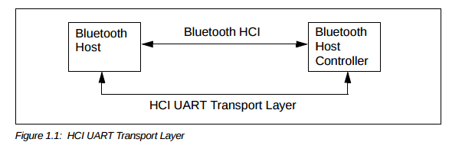

1.UART TRANSPORT LAYER
2.SECURE DIGITAL (SD) TRANSPORT LAYER
3.USB TRANSPORT LAYER
4.THREE-WIRE UART TRANSPORT LAYER

