Build root - make root FS only

Build root can help us to generate only a root file system:

before we start:
We want to use xconfig , for that we need to install QT 4

we need QT4 dev tools:
https://askubuntu.com/questions/520864/how-to-install-needed-qt-packages-to-build-kernel-on-14-04

sudo apt-get update
sudo apt-get install libqt4-dev pkg-config

or full:
sudo apt-get install -y build-essential kernel-package libncurses5-dev bzip2 bin86 qt4-dev-tools wget libncurses5 git-core nautilus-open-terminal
I will start with the raspberry pi 3 defconfig , for the 32 bit arm
make raspberrypi3_defconfig
#
# configuration written to /home/first/buildroot/buildroot-2017.05/.config
#
it will copy the config to the current directory as .config
and this is the file make xconfig or make menuconfig will work on.

Run
make xconfig
and in kernel , uncheck the linux kernel-package

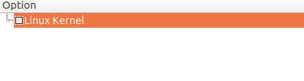

two changes to build options:

for savedef config and a common place for the downloads.

We learned already how to build a compiler using crosstool-ng and
how to tell buildroot to use this compiler as external pre built compiler:

When I built the cross tool ng for arm hf compiler it was for 32 bit compiler.
It must match the settings of the buildroot
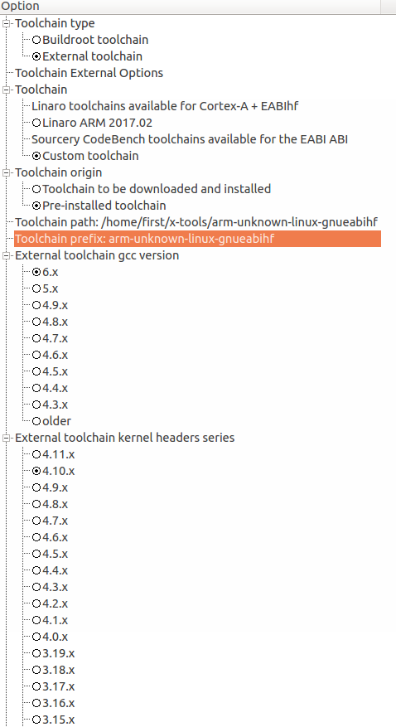

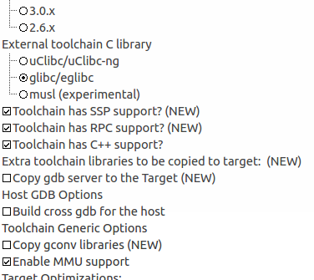

some notes:

prefix is the name of the compiler without the -gcc or -g++, just the name
the path is without the bin directory

in hardware and handling
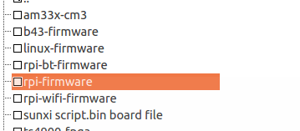

we can remove the rpi-firmware

and we are ready to start the build:

type
make

using external pre-build cross compile will save us about an hour in the build.

We can see how much time it takes:

8.9.Graphing the build duration (from buildroot manual)
make graph-build

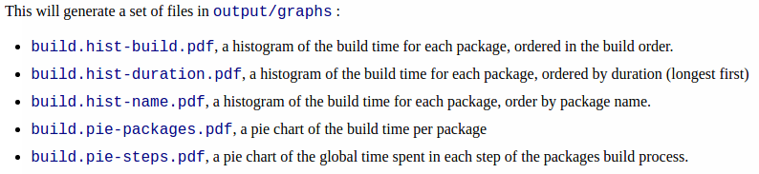
see prerequisites in 8.9
https://buildroot.org/downloads/manual/manual.html#_graphing_the_build_duration

install python:
https://askubuntu.com/questions/101591/how-do-i-install-the-latest-python-2-7-x-or-3-x-on-ubuntu

install matplotlib
https://matplotlib.org/users/installing.html

The root fs file is about 63 mega:
rw-r--r-- 1 first first 62914560 Jun 2 01:17 output/images/rootfs.ext2

Using gparted ( sudo apt-get install gparted)
we can see the partitions on the sd card

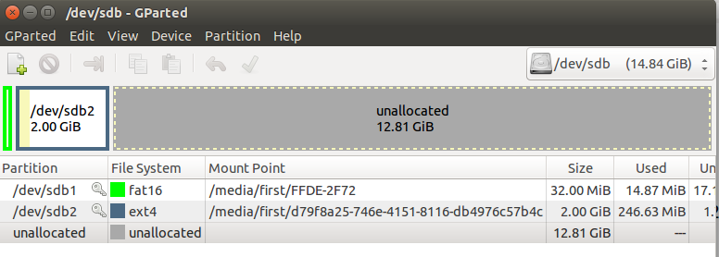
the partition was created before when I did a full image build with buildroot.

Now lets copy using dd command , the file system that we built into the second partition and replace the existing one:

let's move to output/images

sudo dd if=rootfs.ext4 of=/dev/sdb2

if = is the source
of = the destination
122880+0 records in
122880+0 records out
62914560 bytes (63 MB) copied, 52.5073 s, 1.2 MB/s

