Crosstool-ng addition to doc:

the faster way is just do
./configure

without any –prefix

make && make install

it will install it to :
/usr/local/bin/ct-ng

it will be immidiate in the path so we can use it.

Cross tool ng select the c library:

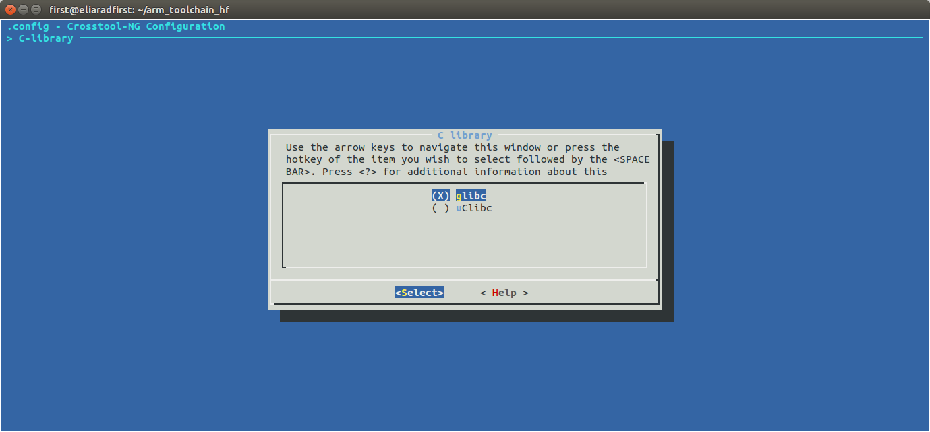
we can select the gcc version:

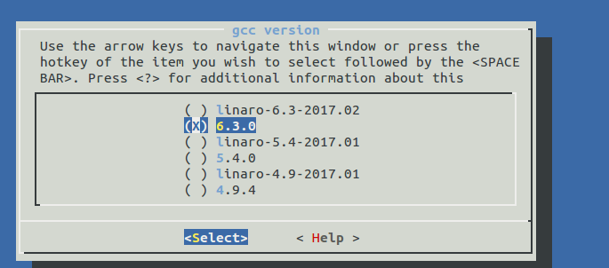
not too much options

target architecture:

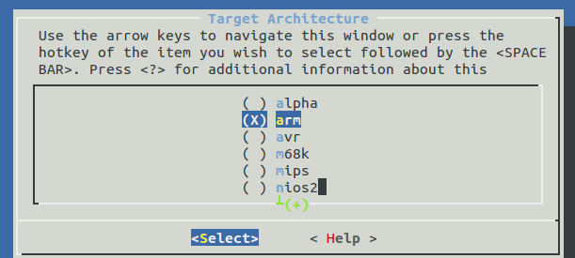
endiannes:


bitness , 32 or 64 ?

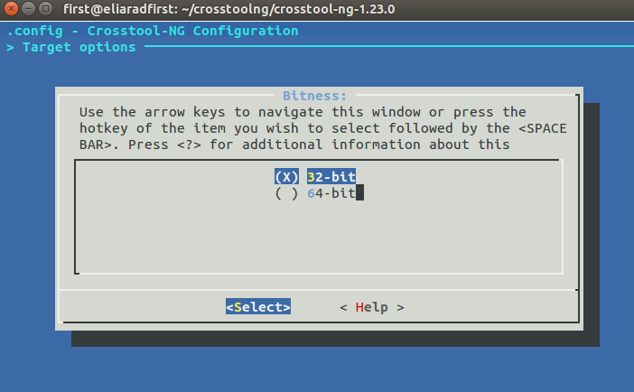

floating point , or not?

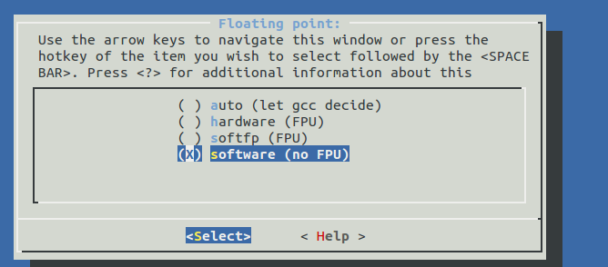

Linux kernel version:
for kernel headers

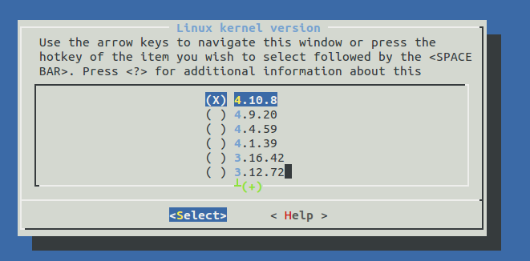

and build shared libraries yes or no.

The select C++ and Java:

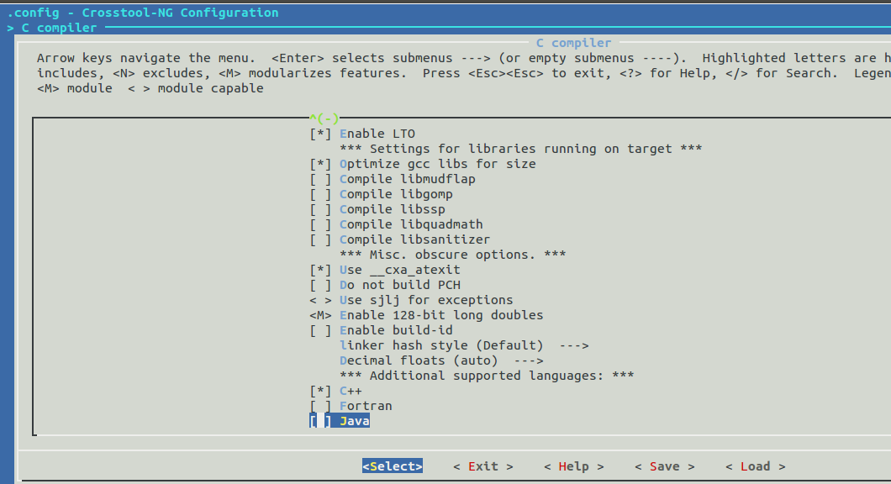

more libraries like GMP, MPFR ..

