<https://www.keysight.com/en/pdx-2916419-pn-P9374A/keysight-streamline-series-usb-vector-network-analyzer?cc=US&lc=eng>

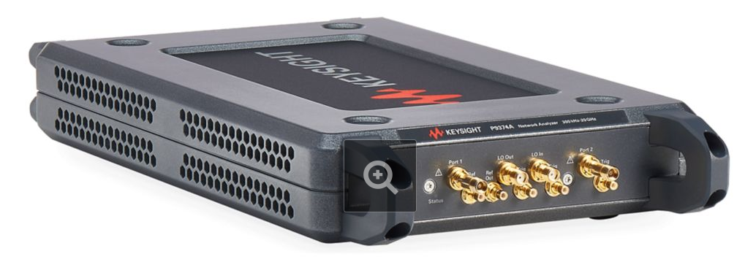

Drivers:

<https://www.keysight.com/main/techSupport.jspx?nid=-31920.1243805&pid=2916419&cc=IL&lc=eng&pageMode=DS>

AgNA3.3.0-x64.msi

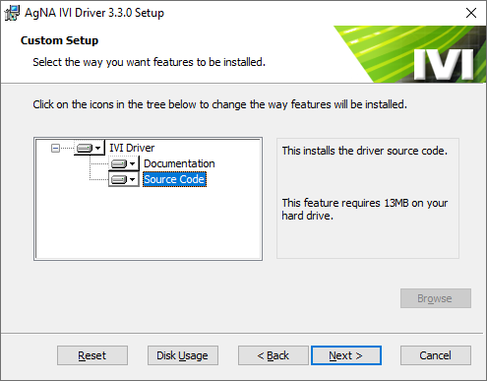

Include sources of course

It will be installed at

C:\Program Files\IVI Foundation\IVI\Drivers\AgNA

C:\Program Files\IVI Foundation\IVI\Drivers\AgNA\Examples\VS.NET\CSharp

