EZBL – upload the muze_evb project using external bootloader application.

Java – a cross platform environment, is the built-in loader tool for loading the firmware

**In ezbl_integration there is a batch file:**

upload_app.bat

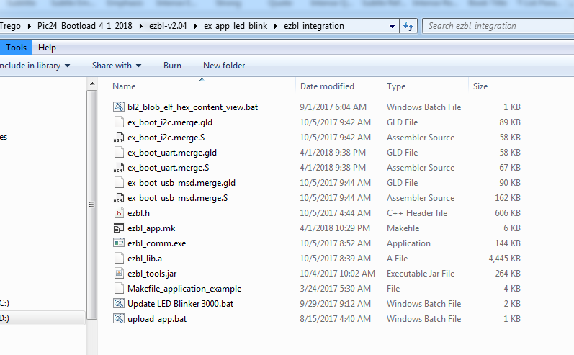

it required some arguments.

We can take for example the command line argument from the makefile: (ezbl_app.mk)

${MP_JAVA_PATH}java -jar "${thisMakefileDir}ezbl_tools.jar" --communicator -com=COM6 -baud=230400 -timeout=1100 -artifact="${DISTDIR}/${PROJECTNAME}.${IMAGE_TYPE}"

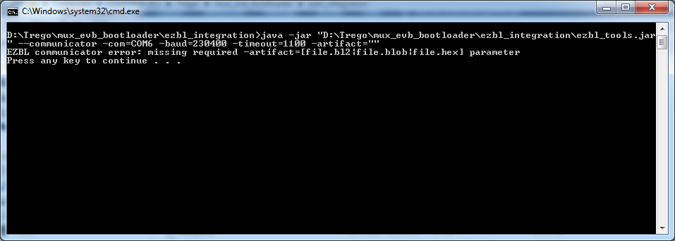

We need to supply the artifact as file.hex

So the upload_app.bat can be changed to:

java -jar "%~dp0ezbl_tools.jar" --communicator -com=COM6 -baud=230400 -timeout=1100 -artifact="D:\Trego\mux_evb_bootloader\dist\uart\production\mux_evb_bootloader.production"

artifact -> is your production hex file

The result is like we run it from the IDE:

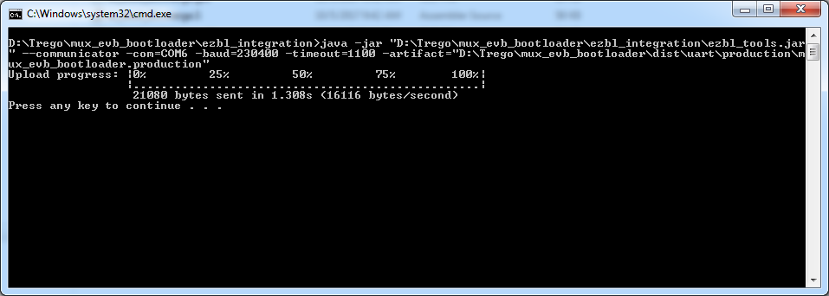

And that’s it , the project has been updated.