Running QT5 QML App on raspberry pi 3 7 Inch LCD screen with buildroot image

I tried sometime to get it work! But it did not.
The answer was in front , dont use mesa drivers , use rpi userland,
mesa driver works fine with the HDMI monitor, but with the official element 14 7 inch LCD touch screen it does not.
What I saw when I built a buildroot image with mesa driver is that the console was not even working when the HDMI was not connected.

I post a question long time ago:
https://stackoverflow.com/questions/46020999/lcd-7-inch-on-raspberry-pi-3-without-hdmi-cable-using-buildroot-no-console-print/46653099#46653099

but not one answered.
Could be it was a stupid question that everyone knows the answer of it.

In this Github repository I have gadded all the solution in one please
https://github.com/EliArad/QTGui_Raspi3

1. Download QT Creator

https://info.qt.io/download-qt-for-application-development



Add SSH: dropbear to buildroot
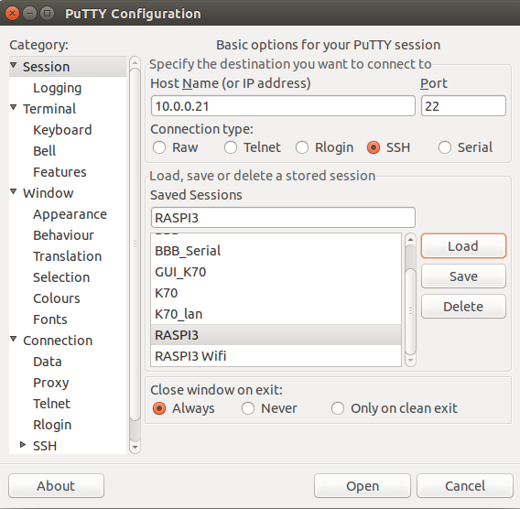

To compile QT Creator program:

I did several videos on the QT Compilation , eventually my way is to work with QT Creator on Ubuntu , develop there and cross compile using some script that uses the qmake that was generated by buildroot.

Buildroot compile QT 5 for me and it is save me all the configuration steps.

If I want to summarize how the build is perform
I can say that qmake will create a Makefile that make can run.

Let's start:

Create activate script or source the following:

export PATH=$PATH:/home/first/Qt/5.9/Src/qtbase
export PATH=/mnt/b/buildroot/raspi_qt5/buildroot-2017.05.1/output/host/usr/bin/:$PATH

I am using buildroot that create for me the qmake

This is my compile script:

/mnt/b/buildroot/raspi_qt5/buildroot-2017.05.1/output/host/usr/bin/qmake HelloWorld.pro -spec /home/first/Qt/5.9/Src/qtbase/mkspecs/arm-linux-gnueabihf-g++ CONFIG+=debug CONFIG+=qml_debug

You need to create mkspecs for the buildroot gnueabihf-g++ compiler

arm-linux-gnueabihf-g++

Just cp -r one mkspecs and change all naming to hf

This is the new mkspecs:

# qmake configuration for building with arm-linux-gnueabihf-g++
#

MAKEFILE_GENERATOR = UNIX
CONFIG += incremental
QMAKE_INCREMENTAL_STYLE = sublib

include(../common/linux.conf)
include(../common/gcc-base-unix.conf)
include(../common/g++-unix.conf)

# modifications to g++.conf
QMAKE_CC = arm-linux-gnueabihf-gcc
QMAKE_CXX = arm-linux-gnueabihf-g++
QMAKE_LINK = arm-linux-gnueabihf-g++
QMAKE_LINK_SHLIB = arm-linux-gnueabihf-g++

# modifications to linux.conf
QMAKE_AR = arm-linux-gnueabihf-ar cqs
QMAKE_OBJCOPY = arm-linux-gnueabihf-objcopy
QMAKE_NM = arm-linux-gnueabihf-nm -P
QMAKE_STRIP = arm-linux-gnueabihf-strip
load(qt_config)

We can use more environment variables:
export QT_SELECT=5
export QT_QPA_PLATFORM=eglfs
#export LD_LIBRARY_PATH=/opt/vc/lib
export QT_QPA_EGLFS_DEBUG=1
#export QT_QPA_EGLFS_FB=/dev/fb0
#export QT_QPA_EGLFS_WIDTH=320
#export QT_QPA_EGLFS_HEIGHT=240
#export QT_QPA_EGLFS_PHYSICAL_WIDTH=
#export QT_QPA_EGLFS_PHYSICAL_HEIGHT=350

The QT quick control 2 applications works now on raspbian

need to change the main.cpp
QQmlApplicationEngine engine;
//engine.load(QUrl(QLatin1String("qrc:/main.qml")));
engine.load(QUrl::fromLocalFile("main.qml"));

Build QT gui with the environment of the RPI-userland drivers.

When we select rpi-userland instead of meas driver QT will work on the LCD.

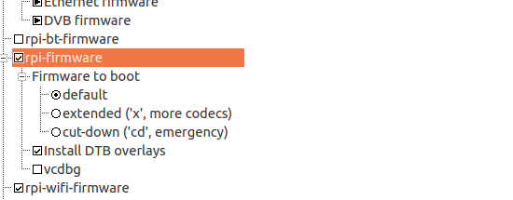

When using RPI-Userland instead of mesa drivers the LCD does boot in console
and we we can see four PI on the left top screen

After enable rpi-userland and disable mesa QT start working on the LCD.
Conclusion:
Don't use mesa drivers to get the LCD working with QT , use the rpi-userland!!!
The process of create the buildroot is simple from here:
We compile and meet our qhash.cpp problem

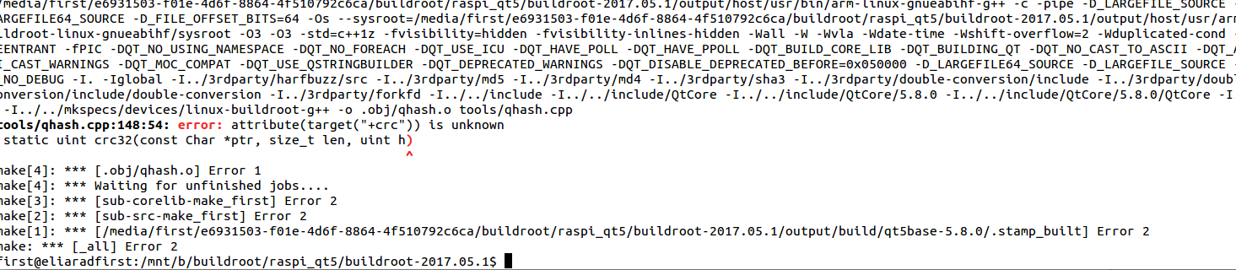
search the file:
find -name qhash.cpp
and edit it:

Add #undef __ARM_FEATURE_CRC32
at the beginning of the file:
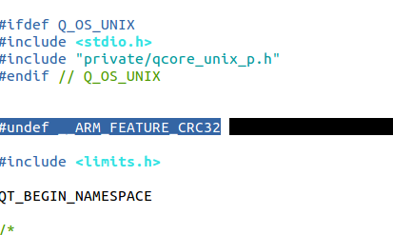

BTW , if you do changes in buildroot config from mesa to rpi-userland , do make clean.

save and continue with make.
The image will be created and you can burn it to SD card and run.
To remember of the QT settings in buildroot:
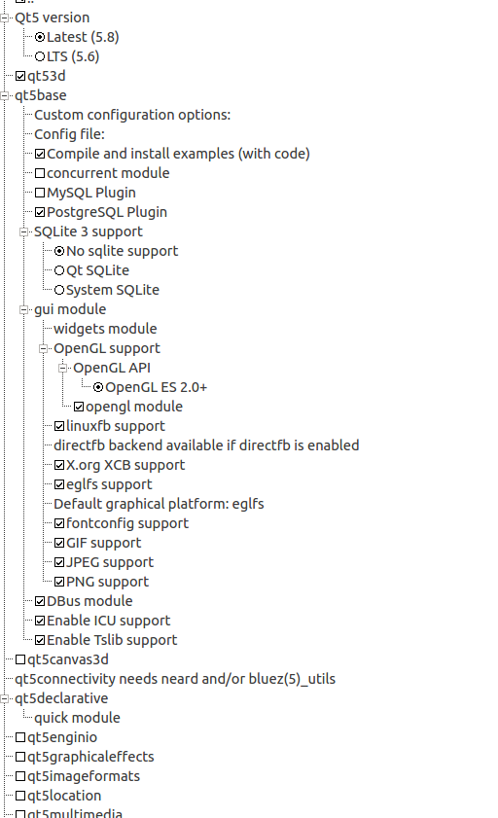

Some pictures:
We can see here at the top left cornet the four PI's , that we dont see in case of mesa driver.
This is a good indication that our LCD will start work,
Also in rpi-userland the LCD works as console , not like in the mesa driver.

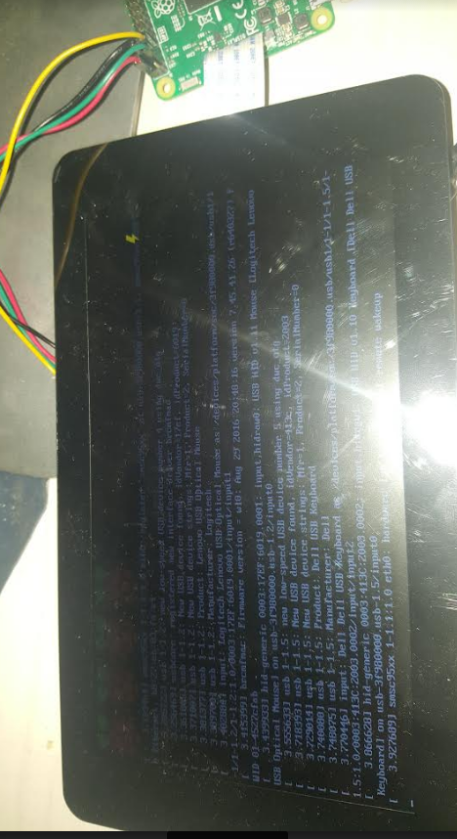

We can see that the qt quickcontrol2 gallery is working on the raspberry pi 3 with buildroot rpi-userland.
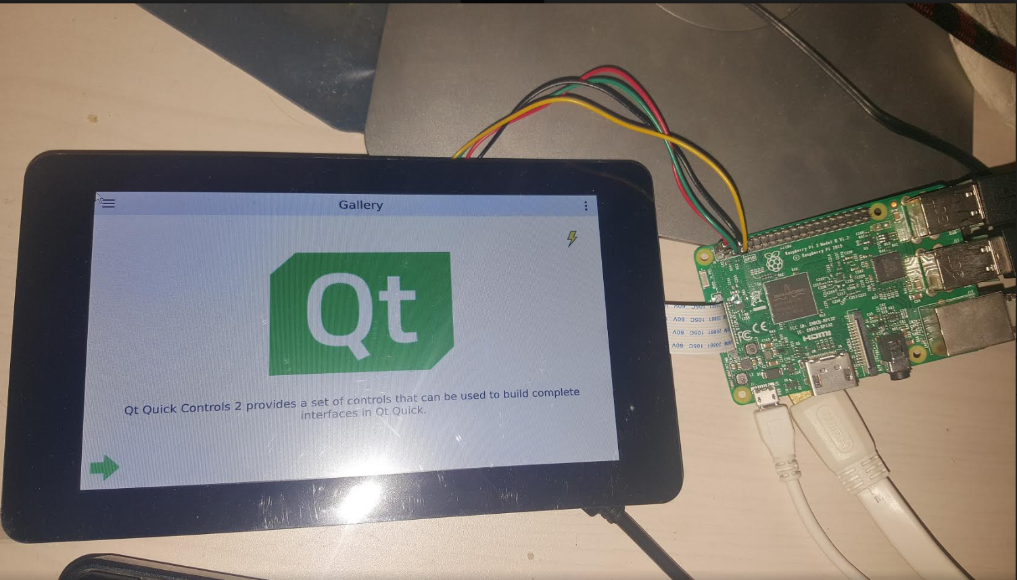

This is the example PITEST1 that I compiled in QT Creator in Ubuntu:
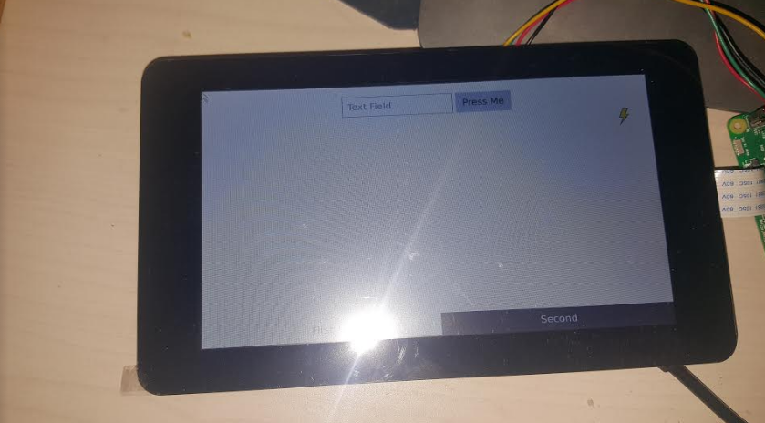

Now we can start develop QT apps using QML in ubunto and run it on the raspberry pi 3 with am image that was built using buildroot.

