# Keil overview

## Creating a new h, cpp or c file

Click on the group (it’s not a folder) that you need to create the file in:

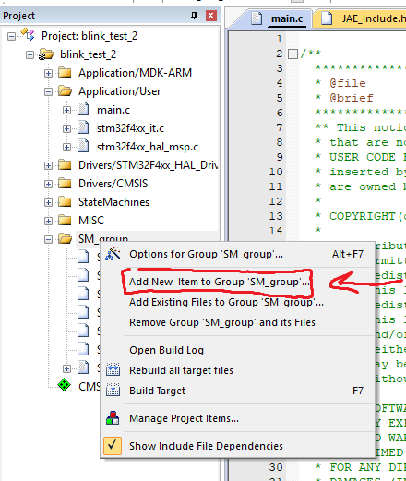

We use SM_group for every StateMachine we use, MISC is for functions or alike and User are for essensitial files.