Via Command:

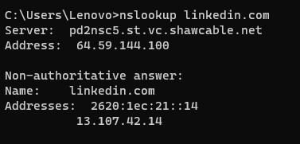

Via ping.eu

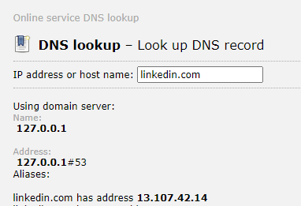

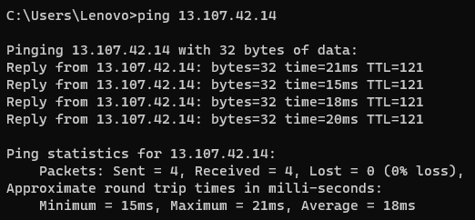

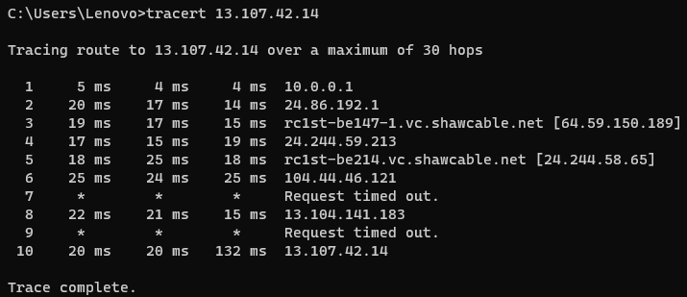

|  |  |  |  |
| --- | --- | --- | --- |
| Router No. | Local/global | Location | Ownership |
| 1 | Local | Vancouver |  |
| 2 | Local | Vancouver |  |
| 3 | Local | Vancouver |  |
| 4 | Local | Vancouver | Shaw |
| 5 | Local | Vancouver | Shaw |
| 6 | Global | Washington | Microsoft |
| 7,9 |  |  |  |
| 8 | Golabl | California | Microsoft |
| 10 | Global | Washington | Microsoft |

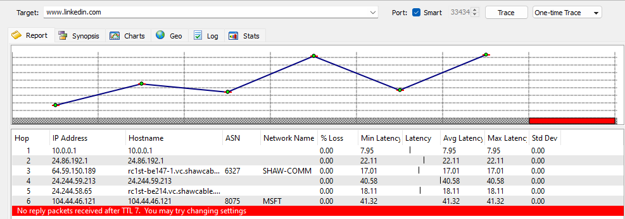

3. HTTP/2 and HTTP/1.1 are two versions of the Hypertext Transfer Protocol (HTTP) used in client-server communication. HTTP/2 uses the binary framing layer to encapsulate all messages in binary format, while still maintaining HTTP semantics, such as verbs, methods, and headers.**HTTP/2 is faster and more efficient than HTTP/1.1**, as it prioritizes content during the loading process and reduces the complexities that had crept into HTTP/1.1. It achieves faster webpage loading without performance optimizations that require extensive human efforts in terms of development. HTTP/2 uses binary commands to execute the same tasks, easing complications with framing and simplifying implementation of commands that were confusingly intermixed due to commands containing text and optional spaces.

Part2. HTTP/3 and HTTP/2 are two different web protocols.**HTTP/3 uses QUIC as its network transport layer, which eliminates head-of-line blocking between requests and responses**. This enables web applications to perform faster, especially over slow networks and latency-sensitive connections. HTTP/3 streams are multiplexed independently to eliminate head-of-line blocking between requests and responses. With HTTP/2, any interruption (packet loss) in the TCP connection blocks all streams (Head of line blocking). HTTP/3 is UDP-based, so if a packet gets dropped, it only interrupts that one stream, not all of them. HTTP/3 aims to provide a faster and more efficient internet experience without compromising security.

Part3. The 3xx (Redirection) class of status code indicates that further action needs to be taken by the user agent in order to fulfill the request

Part4.

|  |  |  |
| --- | --- | --- |
| Header | Send/Receive | Application |
| Host | Send |  |
| Refer |  |  |
| Accept-Encoding |  |  |
| Content –Type |  |  |
| Content – length |  |  |
| Content –range |  |  |
| Location |  |  |
| Last –Modified |  |  |
| Catch -Control |  |  |

.