**Milestone 3:**

**For Milestone 3 we have completed the Technical Design, External Style Sheet, Prototype Page, and Remaining Pages Sections. We have planned out our site and created the prototypes for its pages. We have tested our pages so that they function in Chrome, Firefox, and Internet Explorer. All pages have been validated for both html and css. We have not completed the form submission as we do not understand php. We also need to work out issues concerning the zoom in, zoom out function, as our site does not render properly.**

**We have made changes to the plans for our site. The colours of our site are being changed. We felt these colours fit better with our design than the previous ones.**

**The red is being replaced by:**



**The grey is being replaced with:**



**The forum will be replaced by articles written by us or others with tips and tricks on fitness. We felt this would be better for a site like this than a forum due to the low entry level we have intended for our site. Forums can incite competitiveness on sites like this.**

**Links to site:**

[**www.sjcomp1510.webuda.com/g2**](http://www.sjcomp1536.webuda.com/g2)

[**www.sjcomp1536.webuda.com/g2/html/member.html**](http://www.sjcomp1536.webuda.com/g2/html/member.html)

**Documentation:**

[**http://sjcomp1536.webuda.com/g2/css/base.css**](http://sjcomp1536.webuda.com/g2/css/base.css)

**Images:**

**Home page/ form (login)**

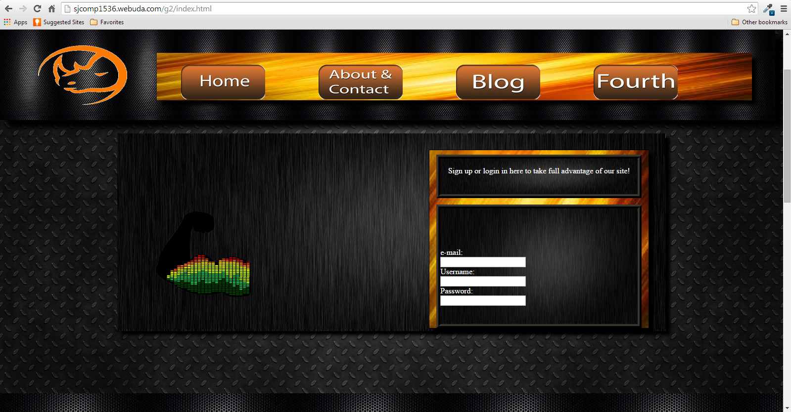

**(Lower half)**

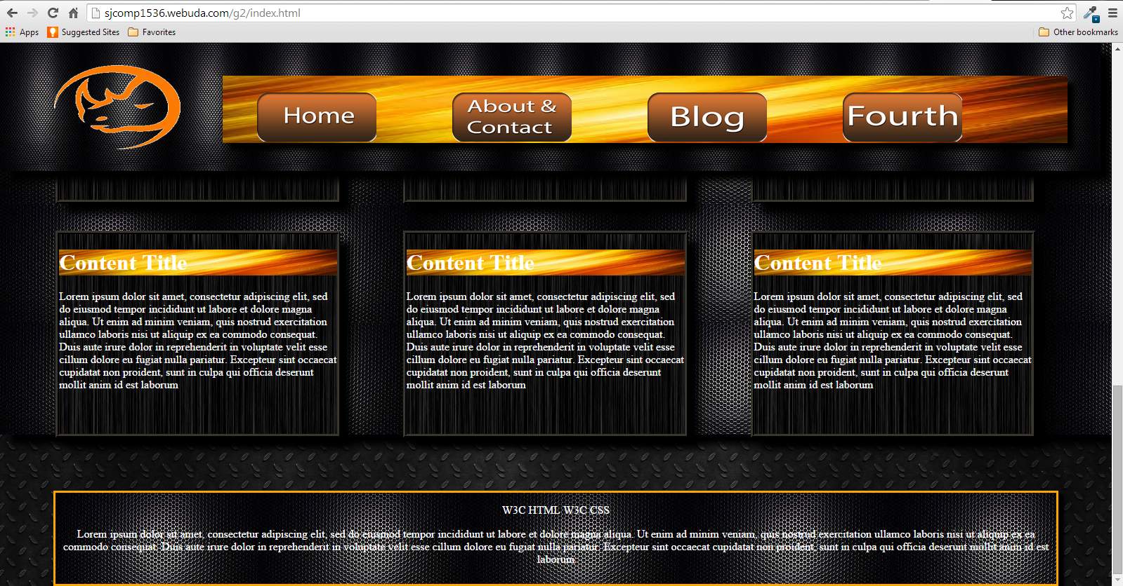

**Table page/ workout page:**



