**Milestone 5:**

For this milestone, we decided to alter a few things. We began by adding content to our two main pages (index and blog) with connecting links to allow the user to be presented with different articles recently published under different topics on the first page, while keeping the content at a different location, so as to not overload the user. The about section was also filled with content to match the match widget previously installed. In terms of appearance, the logo was edited to show our site’s name, we changed the background to eliminate our previous “holed steel” and introduce more colour also with the help of a new border. The same can be observed around the footer. Colours were also added to allow for our website to display its general layout and eliminate the user’s ability to only see white as images load onto the background. Additionally, we fixed the issue we had with the sizes and margins of objects on our site, as they were not staying in position if the browser window was resized. In the css files for all of the pages, some of the margins and padding of these objects were changed from percentages to pixels, which stopped their position from being moved with the browser.

Users will now be able to register on our site. Once they are registered, their user-name will be displayed, and on the member page they can find the date they joined. What we were unable to complete was the user deregistration, and we failed to make anything for users to submit. This was due to trouble we had with the php for our workout table, which was supposed to save user inputted workout and progress information. To allow for some usability, our alternative was to make the table content editable directly by clicking and typing.

You can find our content here:

Home Page: <http://sjcomp1536.webuda.com/g2/>

About/Contact Page: <http://sjcomp1536.webuda.com/g2/html/about.html>

Blog Page: <http://sjcomp1536.webuda.com/g2/html/blog.html>

Member Page: <http://sjcomp1536.webuda.com/g2/html/member.php>

Workout Page: <http://sjcomp1536.webuda.com/g2/html/workout.html>

**Milestone 4:**

For this milestone, we worked on updating our form to allow the user to either sign in or log in. We did so through the use of a radio button which allows the form to react to the users input by adding or removing the additional email field required only for signing up. We also made sure that the input given on the homepage would be validated as to assure that they fill in the proper requirements.

Additionally,  we added a 3rd party widget… We decided to add a Google maps widget to the about page, which will also contain our contact info such as a phone number, email, and an address. The Google maps widget works very well with the layout of the page, and more importantly displays the location of the address from the contact info, as well as giving the user access to things like a map and directions.

All items for this milestone were completed, yet we are still encountering a few issues which need additional work. One of these is the inability for our page to render properly when zoomed in or out. We are currently looking into whether bootstrap or another method is better suited to our needs. Another restriction is the inability for inputted data to be placed where we require it so that it allows for the main functionality of our site to operate as desired (both the progress bar and table).

On a separate note, a few changes have been made from our past milestones. The layout of the workout page has been changed to allow for the input form to be properly rendered. We also changed the navigation buttons for a better visual effect.

Our site can be found here : http://sjcomp1536.webuda.com/g2/index.html

|  |  |  |  |
| --- | --- | --- | --- |
| Form on: | Field ID | Data Format | Explanation |
| index.html | e-mail | email | User inputs their email for their account. Must be unique. Email must be of valid format. |
| index.html | username | text | User inputs their unique id for their account. Used for signing up or logging in. |
| index.html | password | text | User inputs their password for their account. Used for signing up or logging n. |
| index.html | sign-up | radio buttons | User can select whether to sign-up or log-in which will change the required forms. |

|  |  |  |  |
| --- | --- | --- | --- |
| Form on page#: | field ID/ form flow | Problem | Improvement |
| index.html | email_holder | Email didn’t ask for or require ‘@’ symbol | Input must be validated, input invalid without ‘@’ |
| workout.html | workout | Date and rep inputs not number based | Made date and rep number inputs |
| index.html | loginboxes | Sign up and login options both showed email input | Email input now only shows when sign up is selected |

**Milestone 3:**

For Milestone 3 we have completed the Technical Design, External Style Sheet, Prototype Page, and Remaining Pages Sections. We have planned out our site and created the prototypes for its pages. We have tested our pages so that they function in Chrome, Firefox, and Internet Explorer. All pages have been validated for both html and css. We have not completed the form submission as we do not understand php. We also need to work out issues concerning the zoom in, zoom out function, as our site does not render properly.

We have made changes to the plans for our site. The colours of our site are being changed. We felt these colours fit better with our design than the previous ones.

The red is being replaced by:



The grey is being replaced with:



The forum will be replaced by articles written by us or others with tips and tricks on fitness. We felt this would be better for a site like this than a forum due to the low entry level we have intended for our site. Forums can incite competitiveness on sites like this.

Links to site:

[www.sjcomp1510.webuda.com/g2](http://www.sjcomp1536.webuda.com/g2)

[www.sjcomp1536.webuda.com/g2/html/member.html](http://www.sjcomp1536.webuda.com/g2/html/member.html)

Documentation:

<http://sjcomp1536.webuda.com/g2/css/base.css>

Images:

Home page/ form (login)

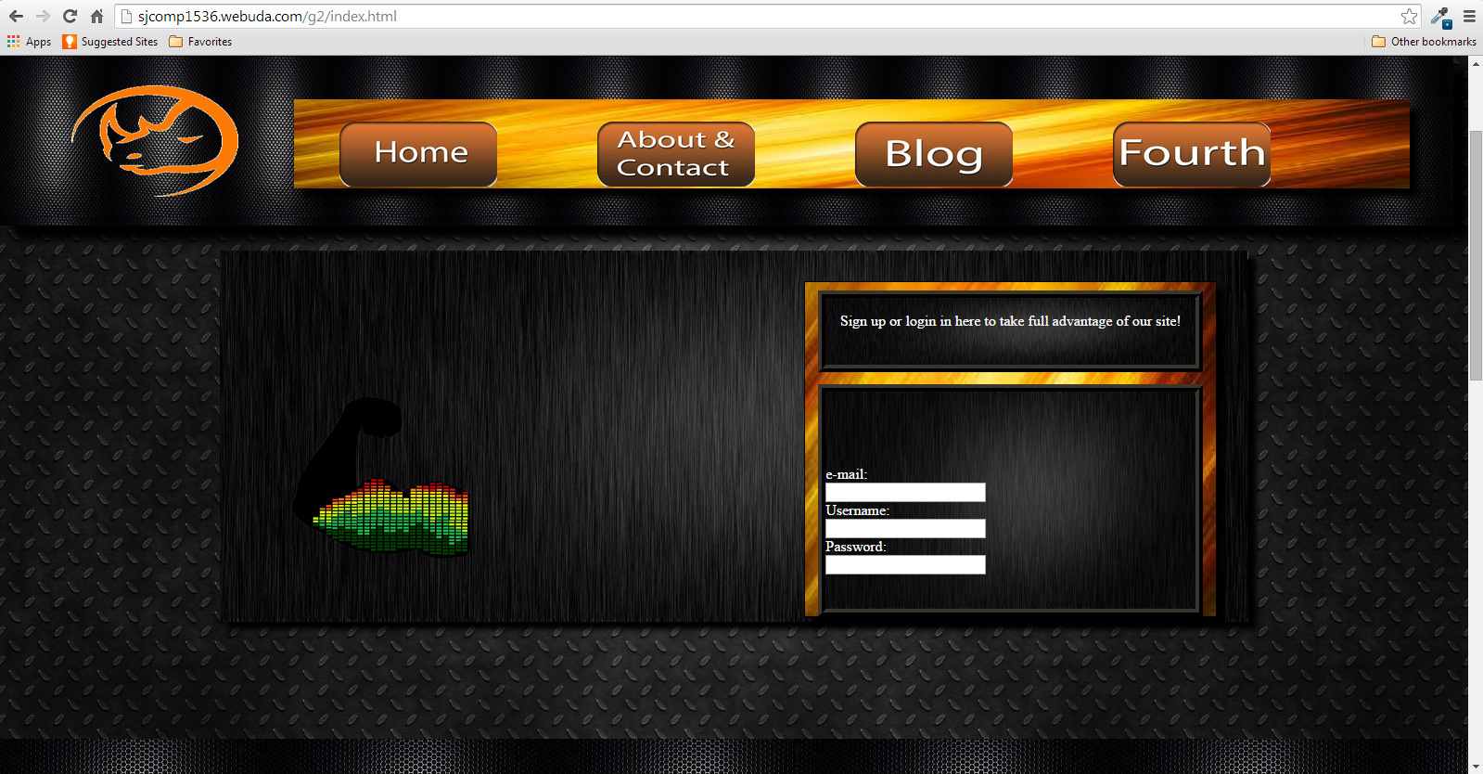

(Lower half)

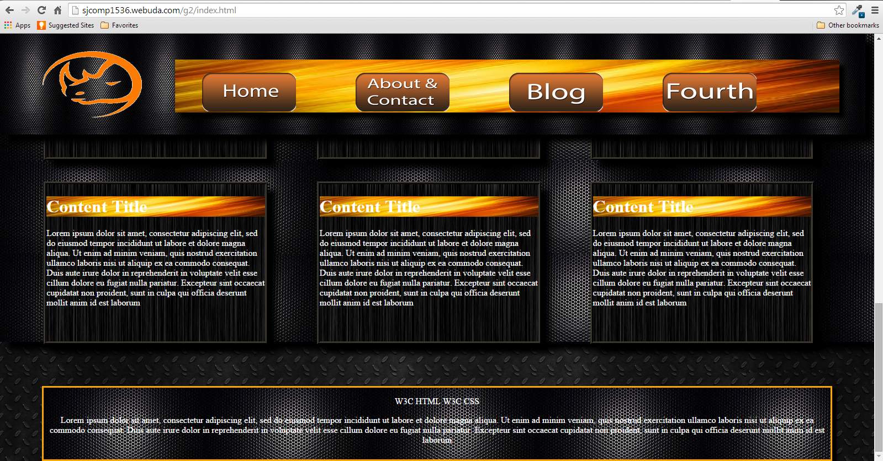

Table page/ workout page:

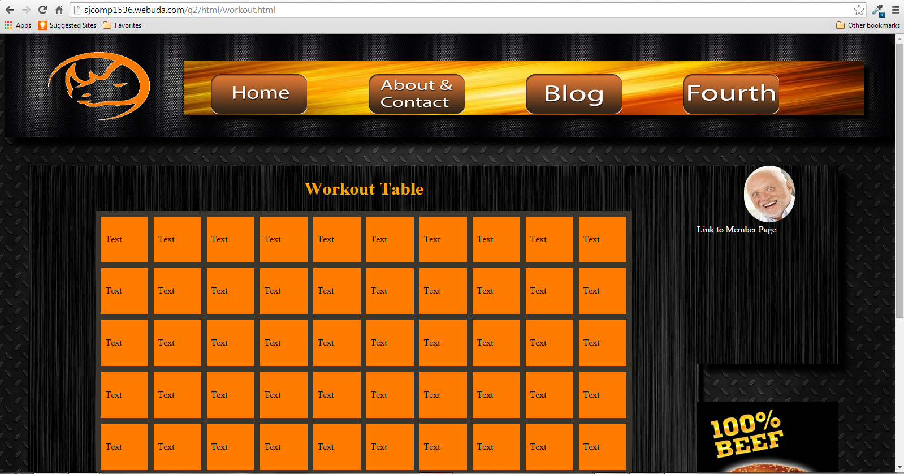

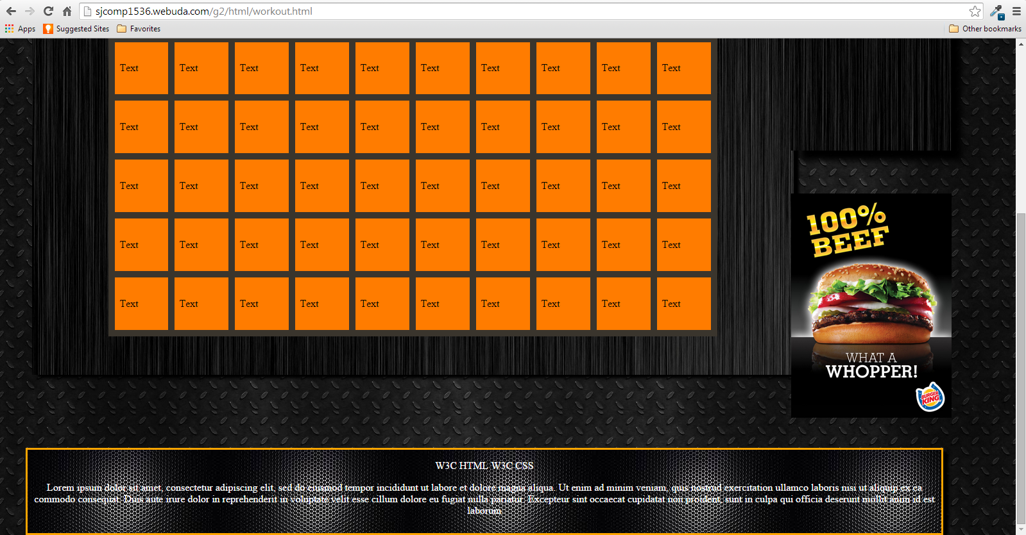

**Milestone# 2**

We pick fluid design, because of all the different screen sizes these days, we feel that it would be better for users as it would always be the same on their screens regardless of the resolution. It could also allow users to view it on their mobile devices instead of going on a computer and connecting to the site.

The colour that we have decided to use is an orange/red with grey and white. We feel that these colours look fabulous together, and we believe that they will help to really draw the users into the site and keep their attention.

https://lh3.googleusercontent.com/_u5jFQS00VURr_OMXT26EyoqhaRDcGQwohTcpq6_Aif_SgzbRuwkndajmIOGkT6HbiGVkYi3_XlauYULbaudo3MFYh-aFh0yfsrw9Dgrpf7PYEwGTFngCOsqSu2tFnjC5WLy7x4



https://lh4.googleusercontent.com/iEe5yBPBX-5LG-Y6nq3YQXCVHv6brQ8V1b2P9CqI1B9fKKh-_mcLzMqdVrjKumwzUSRX0QRMUbCiSUZZ55oXr2F_xmMQ5bGlVA5bIiq1YNqfnOL8yqlQ84fEdF4uBtwQIK26sKY

https://lh5.googleusercontent.com/D8At3QAvTnOYktXzbU3L5EKEMxCRo9rpxfXLwLtyW-S_dV6wrU3Lyrq545NqSVQ2ZU4ejgUsnJ-xOx7qGgpU-XXDEcr5tFzE-91U8JdRzvUfiK59fcRTqV5fOzqDDqzDjmiYnpg

For columns, our pages are going to vary, depending on the content per page. A majority of our pages will be 1-2 columns with exceptions for pages with more content which will contain 3 columns.

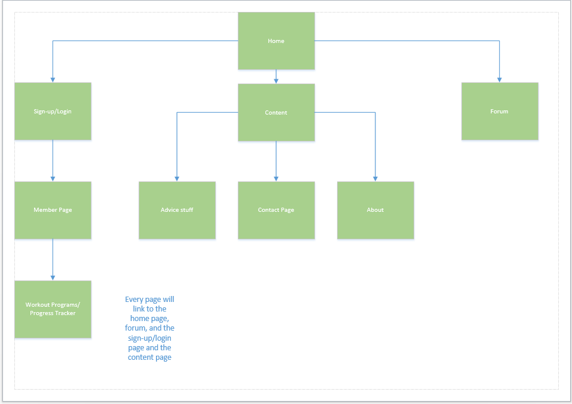

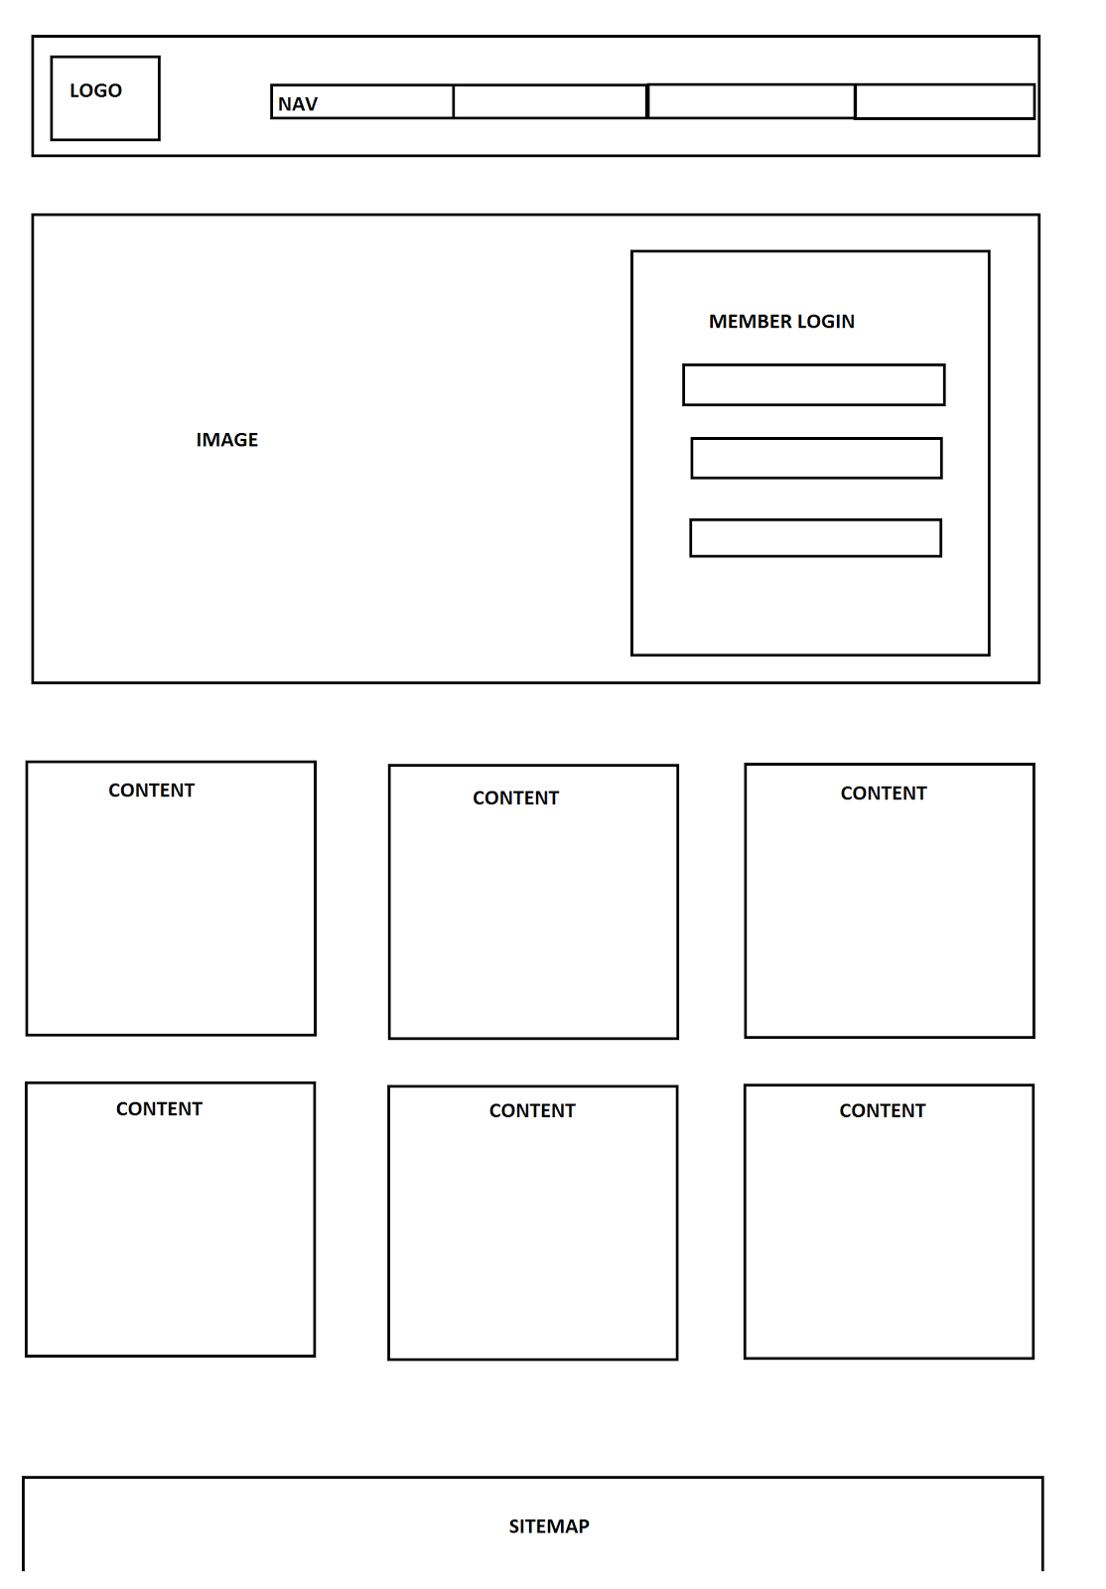

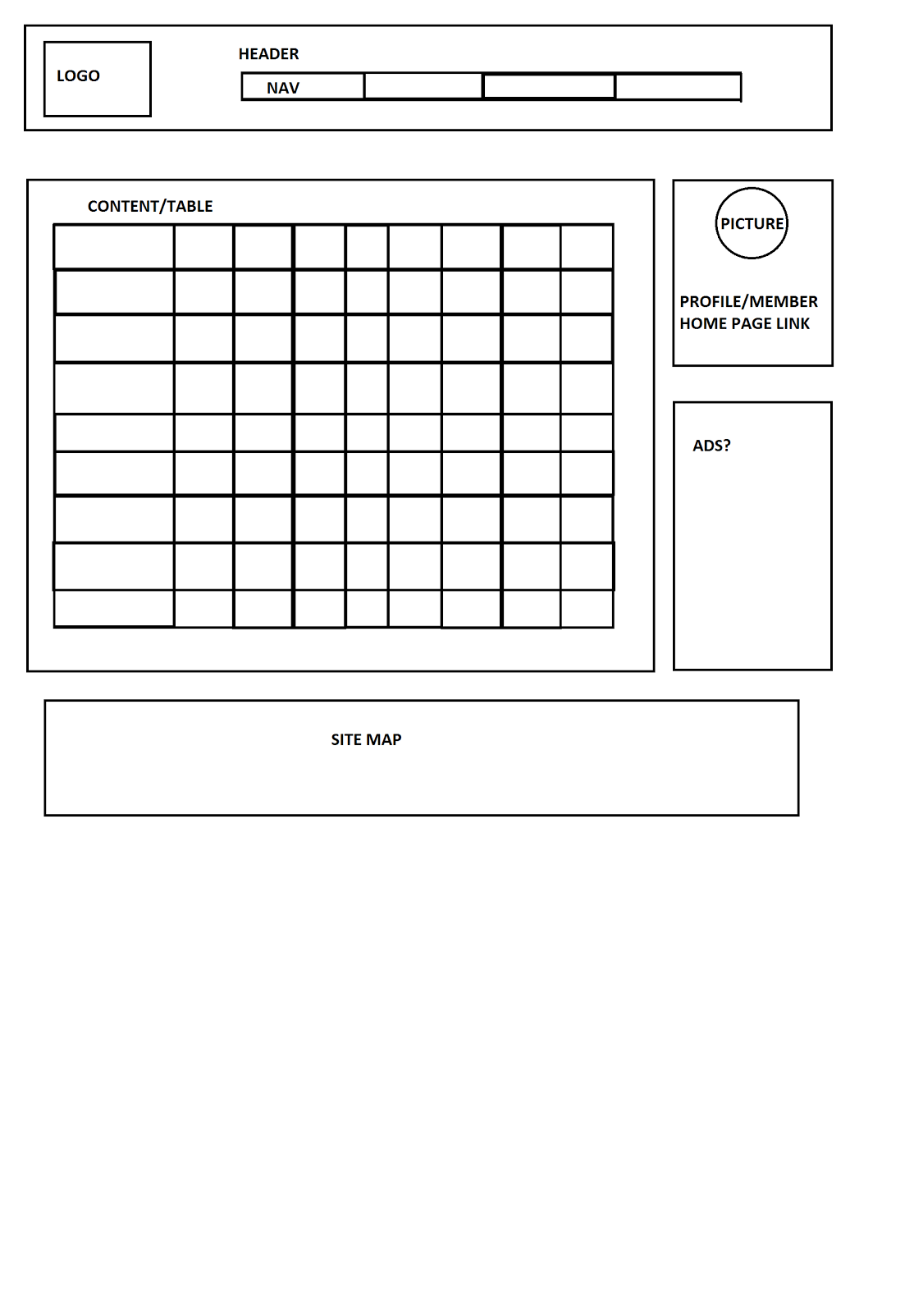

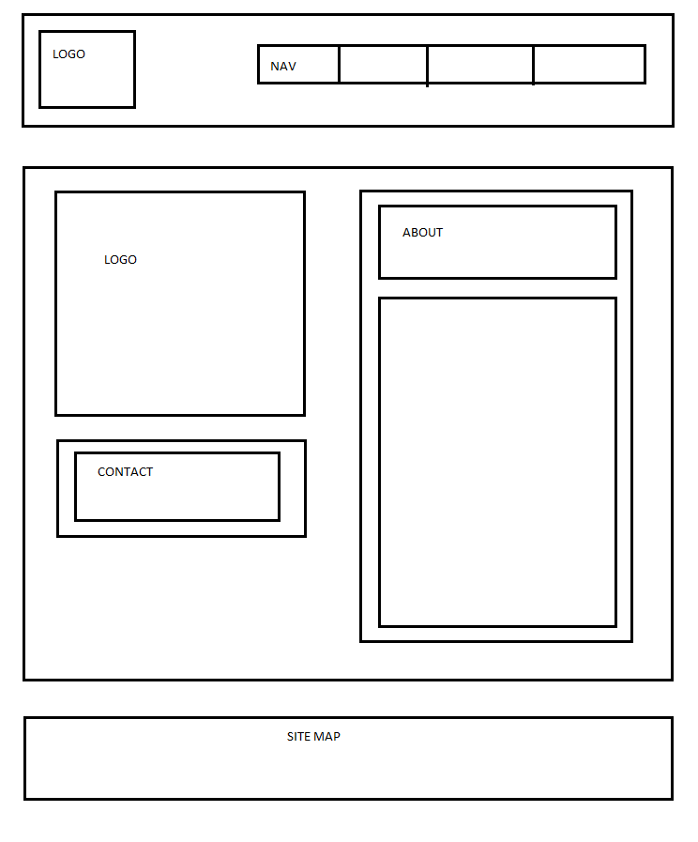

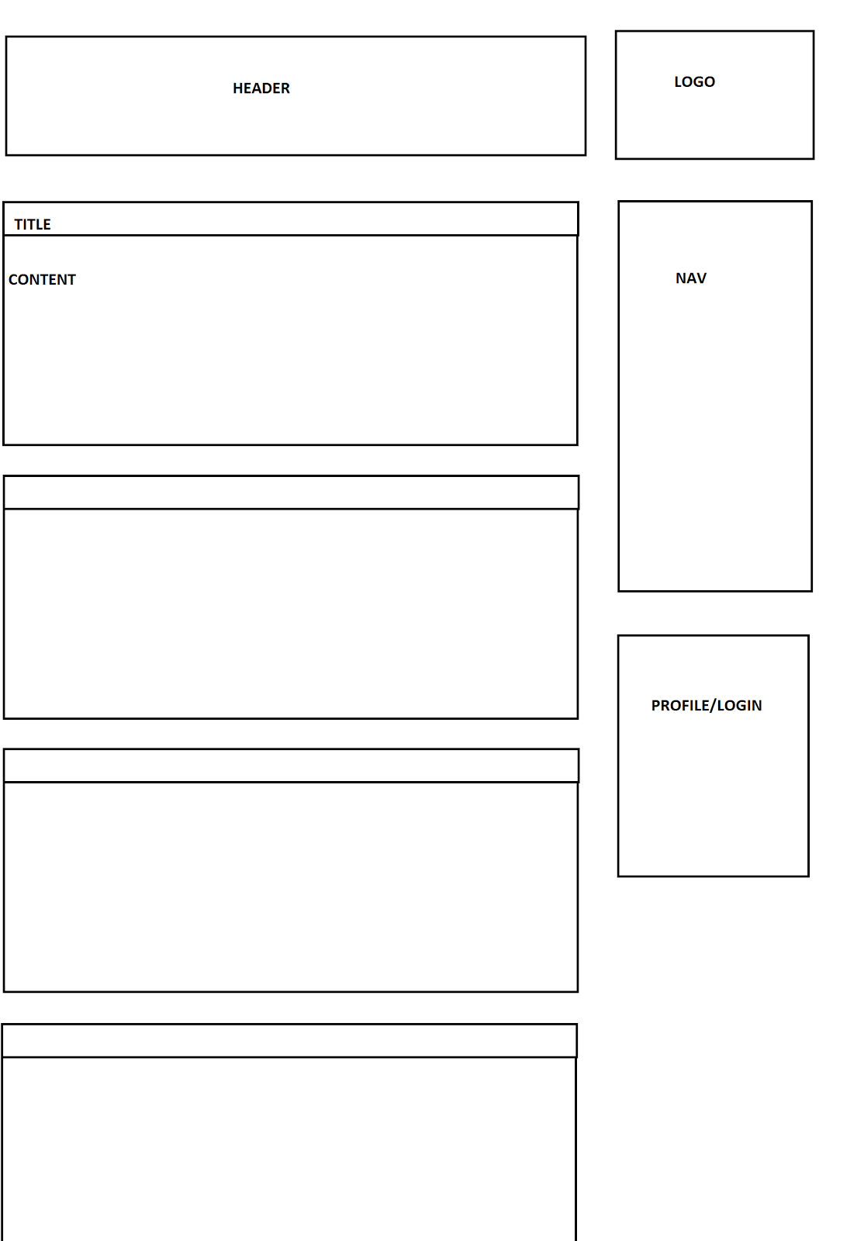

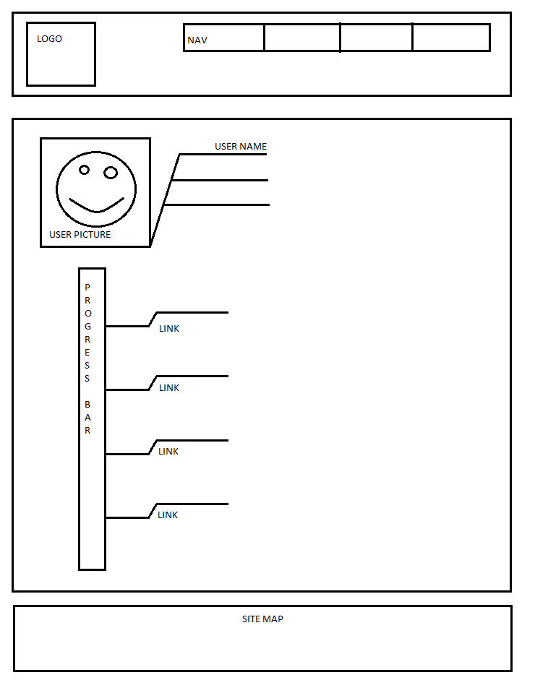

MEMBER 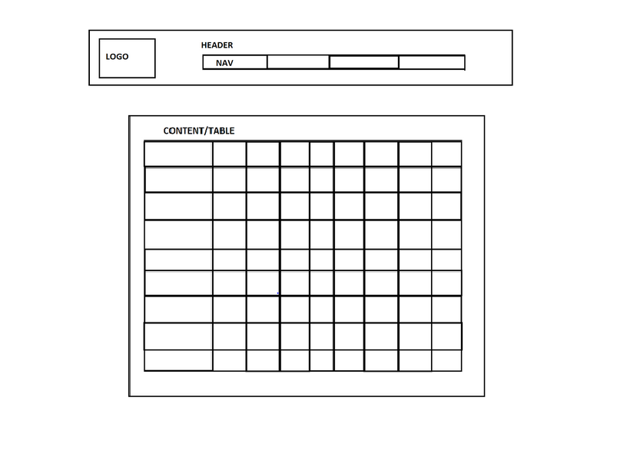

**Milestone #1**

The purpose of our site, NeverBetterFitness.com, is to give people a more convenient way to record and keep track of their workouts. It will be a place where people can look for new workouts, post their own, and review what our other users are doing to stay fit. This website would create an efficient place for users to keep track of their workout’s weights and exercises while sharing with others, creating a motivational environment. This would both eliminate the use of pen and paper in the gym, while combining a forum based environment to expand the repertory or ask questions.

We would like for our users to be able have a place to post and keep track of all of their progress while working out with the help of a profile page which resembles a spreadsheet. This way, users could track and monitor their workouts, set goals and outline a time frame in which they hope to complete said goals. We would also like to incorporate a section where users can post about workouts/diet or really anything, and have other users comment and give them feedback.

This site would target a wide age range, typically between the ages of 14 to 60. Many forums that already exist are focused towards the ‘body building’ type. Unlike these forums and web sites, our page would focus on a more moderate user, looking for advice or knowledge on how to begin exercising, or on moving beyond their current plateaux.

Although you are allowed to simply browse the site, once someone has created a membership they will instantly have access to numerous tools we are sure that our target audience should find very useful.  Some of these things include a forum, where our users can post their own workouts and their thoughts, as well as review and comment on what others have posted. They will also have access to an advice column, which is written and regularly updated every week by an experienced trainer. Along with this, there will be multiple ways our users can record and monitor their fitness, such as a weight monitor, which they can use to track their progress towards their target weight, whether it be gaining or losing it. One of the main functions of our site will be the workout recorder, which is what our users will use to record their workouts and routines for personal use. You will be able to go back and review these previously recorded workouts, or post them for others to review.

Websites have done similar things in the past such as [onlinefitnesslog.com](http://www.onlinefitnesslog.com/) and [bodybuilding.com](http://www.bodybuilding.com/). The former has a smaller community and an imperfect website. It does have nice simple trackers which would be a good style to aim for. The latter has a very large community and a robust website. We’ll have to keep their blogging style in mind when we create our website. Both sites have useful information for the user and we will aim to do the same for our website.

The success factors for our website are establishing a good and convenient space online, that users are comfortable using to post about their workouts, and monitor and keep track of their progress. We feel that if our site is able to help people keep track of their workouts and increase the efficiency, that we will consider our site a success. Of course we will consider our site to be more successful by the number of users that find it and decide to use it.

Goals:

* Create a quick and effective way for people to plan their workouts
* Allow users to track their progress from their inputs
* Create an easy to navigate forum
* Create a responsive weight monitor
* Ability to create an account
* Access to see previous workouts
* Comment section
* Professional looking Logo/Banner
* Easy to manoeuvre website through glossary
* Well established site map
* Easy user interface

Arrangement of this project would be carefully maintained through a variety of meeting, including but not limited to face to face , skype, communal document (google docs) and file sharing via FTP. With explicit delegation of tasks and responsibilities, each team member would gain direct motivation to meet each milestone.