***Sheep pneumonia*:**Wild sheep populations in the mountain West are limited mainly by pneumonia contracted from domestic sheep. How is that currently managed? How might that best be managed?

Group Members: Will Parker, Kevin Henry, FaithAnn Vanderwalker, Chelsea Priest, Mara Bugler, Maggie Carroll

Intro: Bighorn Sheep (*Ovis canadensis*) of the western United States have been listed by the US Fish and Wildlife Service as an endangered species. Efforts to increase the numbers of bighorn populations have been impeded by factors such as habitat loss, human disturbance, and most importantly interspecific diseases such as sheep pneumonia; which is spread from domesticated sheep (commonly *Ovis aries*) farms in the western US to the wild bighorn populations.

Thesis Statement: What management practices can be implemented to best prevent the spread of sheep pneumonia from domestic to non domestic bighorn sheep populations in order to aid in the reestablishment of stable wild populations.

Background:

Domesticated sheep are vectors that contribute to the spread of pneumonia to wild bighorn sheep. The *O. aries* populations have innate genetic defenses/resistance against pneumonia that their wild counterparts do not (Cao et al. 2020). Originally sheep were domesticated in Eurasia, these originally wild populations had resistances that were not present in the North American historically wild populations (Chessa et al. 2009).

Main Points:

* Pneumonia epizootics have long-term effects on bighorn sheep populations and tracking the spread is difficult, making management a challenge (Sells et al. 2016).
* Management techniques of pneumonia related mortality are constrained given an overall lack of understanding of the disease in general (Cassirer et al. 2013).
* 880 died in the winter between 2009 and 2010 due to pneumonia in 9 different herds (Wild Sheep Working Group 2012)
* Recent court rulings (e.g., U.S. District Court, Idaho Case 09-0507-BLW) have mandated separation of wild and domestic sheep populations (Wild Sheep Working Group 2012)
* Wildlife managers have administered antibiotics, mineral supplements, anthelmintic treatment, selective culling, and partial or complete depopulation. (Cassirer et al. 2018)
* Strategies that directly aim to increase individual resistance or herd resilience, including improving nutritional condition, increasing genetic diversity, managing co-infection, or modifying spatial structuring. (Cassirer et al. 2018)
* Outreach efforts on private and public lands have encouraged landowner or public lands grazing permittee cooperation in double-fencing domestic sheep flocks in wild sheep habitat, using additional guard dogs, penning domestic sheep at night, and counting domestic sheep more frequently to better detect and gather strays. (Cassirer et al. 2018)
* wild sheep movement monitoring and GPS collar deployment/tracking?

Conclusion: In conclusion, not much can be done to prevent sheep pneumonia besides vaccinations and separation of populations. Adaptive management and structured decision making are the strongest options

References:

Cao, Y.-H., S.-S. Xu, M. Shen, Z.-H. Chen, L. Gao, F.-H. Lv, X.-L. Xie, X.-H. Wang, H. Yang, C.-B. Liu, P.

Zhou, P.-C. Wan, Y.-S. Zhang, J.-Q. Yang, W.-H. Pi, Ee. Hehua, D. P. Berry, M. Barbato, A. Esmailizadeh, M. Nosrati, H. Salehian-Dehkordi, M. Dehghani-Qanatqestani, A. V. Dotsev, T. E. Deniskova, N. A. Zinovieva, G. Brem, O. Štěpánek, E. Ciani, C. Weimann, G. Erhardt, J. M. Mwacharo, A. Ahbara, J.-L. Han, O. Hanotte, J. M. Miller, Z. Sim, D. Coltman, J. Kantanen, M. W. Bruford, J. A. Lenstra, J. Kijas, and M.-H. Li. 2021. Historical Introgression from Wild Relatives Enhanced Climatic Adaptation and Resistance to Pneumonia in Sheep. *Molecular Biology and Evolution 38:838–855.*

Cassirer, E. F., K. R. Manlove, E. S. Almberg, P. L. Kamath, M. Cox, P. Wolff, A. Roug, J. Shannon, R.

Robinson, R. B. Harris, B. J. Gonzales, R. K. Plowright, P. J. Hudson, P. C. Cross, A. Dobson, & T. e. Besser. 2018. Pneumonia in Bighorn Sheep: Risk and Resilience. *The Journal of Wildlife Management*, *82*(1), 32–45.

Chessa, B., F. Pereira, F. Arnaud, A. Amorim, F. Goyache, I. Mainland, R. R. Kao, J. M. Pemberton, D.

Beraldi, M. J. Stear, A. Alberti, M. Pittau, L. Iannuzzi, M. H. Banabazi, R. R. Kazwala, Y. Zhang, J. J. Arranz, B. A. Ali, Z. Wang, M. Uzun, M. M. Dione, I. Olsaker, L.-E. Holm, U. Saarma, S. Ahmad, N. Marzanov, E. Eythorsdottir, M. J. Holland, P. Ajmone-Marsan, M. W. Bruford, J. Kantanen, T. E. Spencer, and M. Palmarini. 2009. Revealing the History of Sheep Domestication Using Retrovirus Integrations. Science 324:532–536.<https://www.science.org/doi/full/10.1126/science.1170587>

Sells, S. N., M. S. Mitchell, V. L. Edwards, J. A. Gude, and N. J. Anderson. 2016. Structured Decision Making for Managing Pneumonia Epizootics in Bighorn Sheep. *The Journal of Wildlife Management, 80:957–969.*

Mcclintock, B. T. and G. C. White. 2007. Bighorn sheep abundance following a suspected pneumonia epidemic in Rocky Mountain National Park. *Journal of Wildlife Management 71:183–189.*

<https://www.bighorninstitute.org/endangered-peninsular-bighorn>

<https://www.fs.usda.gov/Internet/FSE_DOCUMENTS/stelprdb5385708.pdf> - management of domestic and wild herds- includes “effective separation”

* Wild Sheep Working Group. 2012. Recommendations for Domestic Sheep and Goat Management in Wild Sheep Habitat. Western Association of Fish and Wildlife Agencies.

Spatio-temporal dynamics of pneumonia in bighorn sheep

Author(s): E. Frances Cassirer, Raina K. Plowright, Kezia R. Manlove, Paul C. Cross,

Andrew P. Dobson, Kathleen A. Potter and Peter J. Hudson

Source: Journal of Animal Ecology , May 2013, Vol. 82, No. 3 (May 2013), pp. 518-528

Published by: British Ecological Society

Stable URL: <https://www.jstor.org/stable/24034620>

Pneumonia in Bighorn Sheep

Author(s): E. FRANCES CASSIRER, KEZIA R. MANLOVE, EMILY S. ALMBERG, PAULINE L.

KAMATH, MIKE COX, PEREGRINE WOLFF, ANNETTE ROUG, JUSTIN SHANNON, RUSTY

ROBINSON, RICHARD B. HARRIS, BEN J. GONZALES, RAINA K. PLOWRIGHT, PETER J.

HUDSON, PAUL C. CROSS, ANDREW DOBSON and THOMAS E. BESSER

Source: The Journal of Wildlife Management , January 2018, Vol. 82, No. 1, Special

Section: Mountain Sheep Management (January 2018), pp. 32-45

Published by: Wiley on behalf of the Wildlife Society

Stable URL: <https://www.jstor.org/stable/10.2307/26609130>

Modeling Risk of Pneumonia Epizootics in Bighorn Sheep

Author(s): SARAH N. SELLS, MICHAEL S. MITCHELL, J. JOSHUA NOWAK, PAUL M.

LUKACS, NEIL J. ANDERSON, JENNIFER M. RAMSEY, JUSTIN A. GUDE, PAUL R.

KRAUSMAN and Terry Shaffer

Source:

The Journal of Wildlife Management , February 2015, Vol. 79, No. 2 (February

2015), pp. 195-210

Published by: Wiley on behalf of the Wildlife Society

Stable URL: <https://www.jstor.org/stable/43188323>

Interview:

* **[frances.cassirer@idfg.idaho.gov](mailto:frances.cassirer@idfg.idaho.gov)**
* **Mike Cox- Wild Sheep Working Group Coordinator**
  + [**mike.cox@wafwa.org**](mailto:mike.cox@wafwa.org)
  + **(775) 688-1556**
  + 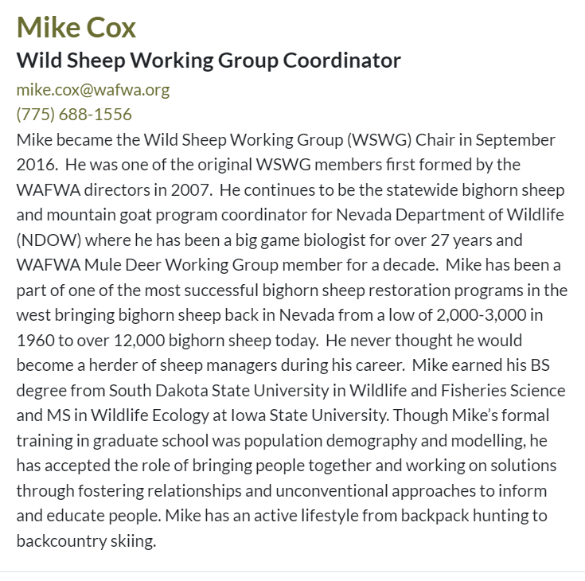
* **Kevin Hurley (Past Chair) Wild Sheep Foundation- NWSGC Executive Director**
  + **(307) 899-9375**
  + **khurley@wildsheepfoundation.org**

Planning and Logistics:

* Slideshow Rough Plan:
  + Title / Introductory Slides
  + What is Sheep Pneumonia?
  + How does this Disease negatively impact populations?
  + What is the best strategy for stopping the spread?
  + What is currently being done?
  + Have Current strategies been effective, is there a positive outlook?
  + General Conclusions / References
* Communications: **Snapchat group**
* Schedule:
  + Follow up with Chloe- Week of 11/14
  + Reach out for an interview after consolidating questions and focus.
  + Have all parts of the presentation finished by group members by 12/2- allow for comments from others over the weekend before presentation.