Modeling memory and taxis to analyze migrations

E. Gurarie, S. Potluri, B. Fagan, others

2021-07-08

# Introduction

Seasonal migrations are extremely widespread among terrestrial, aquatic, avian and invertebrate species (Dingle 2014). For many species, migration is an extremely successful strategy, allowing a far greater number of individuals to inhabit landscape which might not otherwise be able to support large numbers year round (Fryxell et al. 1988). The ultimate evolutionary cause of seasonal migration, essentially, is that the energetic and survival related costs of migration are outweighed by the fitness benefits of accessing suitable seasonal resources, whether those are for energetic gain, predator avoidance, a suitable physical, biotic or social environment for reproduction (Avgar et al. 2014).

Much as the ultimate causes of migration vary across species, the proximate causes, drivers and mechanism can vary considerably across and even within species (Shaw 2016). Some migrants follow a “green wave” of spring vegetation as it flowers across altitudinal or latitudinal gradients (Bischof et al. 2012, Kölzsch et al. 2015). These migrations can be considered “tactical,” as they can occur - as an extreme simplification - purely as response to local conditions. Other migrants perform long-distance migrations in anticipation that critical resources will be available at the time of arrival at the end point of migration (**refs**). This second behavior involves the greatest trade-off between the costs of migration against the benefits of accessing resources, whether food, suitable habitat for breeding, or predator refuge, that are highly seasonal and localized (**refs**). This approach can be considered “strategic” in the sense that it is driven not by immediate cues but by a remembered anticipation (Bracis and Mueller 2017).

Migratory species are often considered to be more vulnerable to environmental change, as a disruption in either of the seasonal ranges or along a migratory corridor can have significant negative impacts (Wilcove and Wikelski 2008, Kauffman et al. 2021). On the other hand, it has been argued that migratory species might be more resilient to disruptions due to their wide-ranging mobility (Robinson et al. 2009). Clearly, the ability to perform a migration without local cues is only possible if the behavior is hard-programmed or remembered. On the other hand, a strictly programmed behavior can be maladaptive if conditions change. Because the scenarios underlying migration are multifold and complex, mathematical modeling may provide some insights and help clarify where, when, and under what conditions we might expect different kinds of migrations to operate.

Diffusion-advection models have a long pedigree in animal movement modeling (Skellam 1951, Turchin 1998, Okubo and Levin 2001). These models are grounded in the general idea that animal movements - somewhat like movements of physical particles - combine a random (diffusive) component with a directed (advective) component. While direct relationships between diffusion models and movement data are somewhat tenuous (Gurarie and Ovaskainen 2011), as a theoretical tool for exploring processes they are invaluable for their versatility and the relative ease of numeric computation of the partial differential equations (PDEs) that are used to describe diffusion-advection models mathematically. Thus, much theoretical and some applied work has been done on refining the basic assumptions of diffusion models, e.g. by including heterogeneity in populations (Skalski and Gilliam 2003, Gurarie et al. 2009), fat-tailed dispersal kernels (Kot et al. 1996), non-linear or otherwise complex responses to resources and consepecifics (**refs**).

Perhaps the greatest difference between animals and randomly moving passive particles described by diffusion models is cognition, including social behavior and memory. Refinements to diffusion-advection equations have revealed conditions under which non-local information gathering (Fagan et al. 2017) and behavioral switching may confer foraging advantages (Fagan et al. 2019), in particular when resources are dynamic and patchy. The interacting role of memory and sociality, in contrast, has been comparatively little studied.

Here, we develop a diffusion-advection model with memory to explore the resilience of a migratory population under various dynamic, seasonal resource distributions. In formulating the model, our goal is to identify the minimum set of movement and memory parameters required to generate an adaptive, migratory behavior. This includes the ability to learn to migrate from non-migratory initial conditions, simulating the release of naive animals in a seasonal environment (Jesmer et al. 2018), or to lose the propensity to migrate if the resource distribution does not require it, which is also a commonly observed phenomenon (**refs**). Our ultimate goal is to assess the role of long and short-term memory in the resilience (or fragility) of a migratory population against changing resource distribution dynamics, whether inter-annual variability or trends in resource distribution or phenology reflecting climate change.

We further anticipate that under many conditions a blending of *tactical* (i.e. direct response to resource availability or perception) and *strategic* (i.e. memory-driven and forward-thinking) behavior will help foragers navigate dynamic, seasonal environments. Over-reliance on either strategy should be maladaptive. We further anticipate that a shorter-term memory updating is needed to navigate trends in resource spatial distribution and temporal distribution (phenology), but that a longer-term reference memory is needed to navigate resource distributions that are stochastic (see also Lin et al. (2021)).

# Methods

## Memory movement model

In designing our study, our goal was to develop a minimal heuristic in which the following processes were explicitly modeled: (1) Random or exploratory movement, (2) attraction to resources, (3) a long-term (or *reference*) memory of large-scale movement behavior, (4) a short-term (or *working*) memory that updates movement behavior based on recent experience, and (5) some social aspect to the learned behavior.  
A diffusion-advection equation provided a computationally efficient and versatile framework for examining just such a system. We consider a population moving in one dimension in a constrained domain and distributing itself according to the following equation:

$$\frac{∂u(x,t)}{∂t}=−ε\frac{∂^{2}u(x,t)}{∂x^{2}}+α\frac{∂}{∂x}\left(u(x,t)\frac{∂h(x,t)}{∂x}\right)+v_{m}(x,t,y)$$

where $u(x,t)$ represents the population distributed in time and space. The first term is the diffusion term, capturing the fast time-scale exploration and “random” movements of individuals, with is the diffusion rate.

The second term represents the attraction to a dynamic resource , with the proportionality of the advection to the gradient of the resource given by the parameter (note, the population and resource distributions are functions of both space and time and - we omit the dependent variables in the notation for brevity). This is the well-studied standard chemotaxic resource-following behavior. We borrow the general notation from our earlier related work (Fagan et al. 2017, 2019).

The third term captures the collective or social advection term of the population via a non-local, density dependent function . If this function takes the form of a convolution around a non-local kernel , i.e.~

and that kernel is odd, an attractive or “swarming” behavior can be generated (Mogilner and Edelstein-Keshet 1999). We use the kernel analyzed by Mogilner and Edelstein-Keshet (1999):

The convolution of with this kernel has the property of pushing the population in a positive direction when , and in a negative direction when . The parameter is a length scale of sociality - roughly one-half the size of the “swarm,” where is a parameter that quantifies the overall strength of sociality.

Finally, the last term captures the direct advection that emerges from a memory-driven migratory behavior. This term evolves with a set of parameters that slowly change each year , i.e. the count of periods : .

The migration speed is specified by six parameters : the timing of the start and duration of two anticipated seasons (nominally, winter and summer) , , , , and the spatial coordinates of the population centroid for each season and . Thus the remembered migratory speed term is a simple step function given by:

where the migration speeds and from the respective ranges are set such that they arrive at at , leave at , arrive at at , i.e.  and . This step-like migration function is a one-dimensional version of the migration parameters estimated in empirical studies for individuals (Gurarie et al. 2017) and, more relevantly, for populations (Gurarie et al. 2019) in empirical studies.

We consider these six parameters to be the known or remembered determinants of the migratory behavior, with an initial set determining the reference migration behavior. This reference migration is updated each year by the experience of the population. To perform this updating, we estimate a new set of parameters after each year, and combine these new parameters with the reference parameters according to the following weighted mean:

where each of the six parameters is updated identically. The estimates are obtained via a least-squares minimization of the migration track () against the spatial mean of the population process in year (i.e. ). The parameter captures the reliance on that long-term memory. When $κ=0$, all of the actionable memory is from the preceding year. When , the actionable memory is entirely the reference memory.

The model is confined to a one-dimensional bounded domain $[−χ,χ]$, with no flux outside of the boundaries i.e. . As there are no birth or death processes, the total population remains fixed and constant, for convenience integrating to 1. Furthermore, the parameters remain constant throughout time, with no adaptation or mutation-selection process. Our interest is entirely in the ability of a fixed set of memory and movement parameters to ``navigate’’ an intra- and interannually dynamic, seasonal environment.

## Seasonal resource

We solved the model numerically on a spatial domain $x∈[−100,100]$, and a periodicity (i.e.~years of 100 days). We were interested in an approximately periodic resource dynamic, i.e. one in which $h(x,t≈h(x,t−τ))$. We generated two types of resource distributions. A “non-surfable” resource (*island resource*), and weakly surfable resource (*drifting resource*). Both are characterized by a peak in time and space centered at $M_{x}$ at $m_{t}$, and $−m_{x}$ at $τ−m_{t}$ (for example, locations 30 and -30 at times 25 and 75, respectively). These pulses have a shared time scale of duration $s_{t}$ and a spatial scale of extent $s_{x}$, the standard deviation in the time and space dimension respectively. The island resource is simply two uncorrelated bivariate normal distributions

where is the bivariate Gaussian distribution function, and the normalizing constant $K$ is selected such that the average total amount of resource throughout the year is 1, i.e. .

The drifting resource differs from the island resource in that the total amount of resource at any given time point is 1 (). This property is attained by distributing the resource as a re-scaled beta distribution, where the shape and scale parameters vary sinusoidally in such a way as to make the standard deviations and means match the desired values of $m_{x},m_{t},s_{x},s_{t}$ (see appendix for details). Both types of resources are illustrated in Figure 1.

Within a given year, the resource is entirely symmetric: $h(x,t)=h(−x,τ−t)$. However, in scenarios exploring climate change we allow the peaks to vary with drift and stochasticity according to: $m_x(y) \sim {\cal N}(\mu_x + \beta_x\,y, \sigma_x)$ and $m_t(y) \sim {\cal N}(\mu_t + \beta_t\,y, \sigma_t)$, where the $μ$, $β$ and $σ$ terms are the mean, slope and variance, respectively, for the location and time duration of the pulse. Thus, if $β=0$ and $σ=0$, the conditions are constant across years, if there is a drift of the resource towards extremes, if $β_{t}<0$ there is a shift towards earlier resource pulses. These trends mirror the pole-ward shift of peak resources and the earlier spring phenology occurring with a warming global climate. The spatial scales ( $s_{x}$ and $s_{t}$) remain constant in all of our simulations.

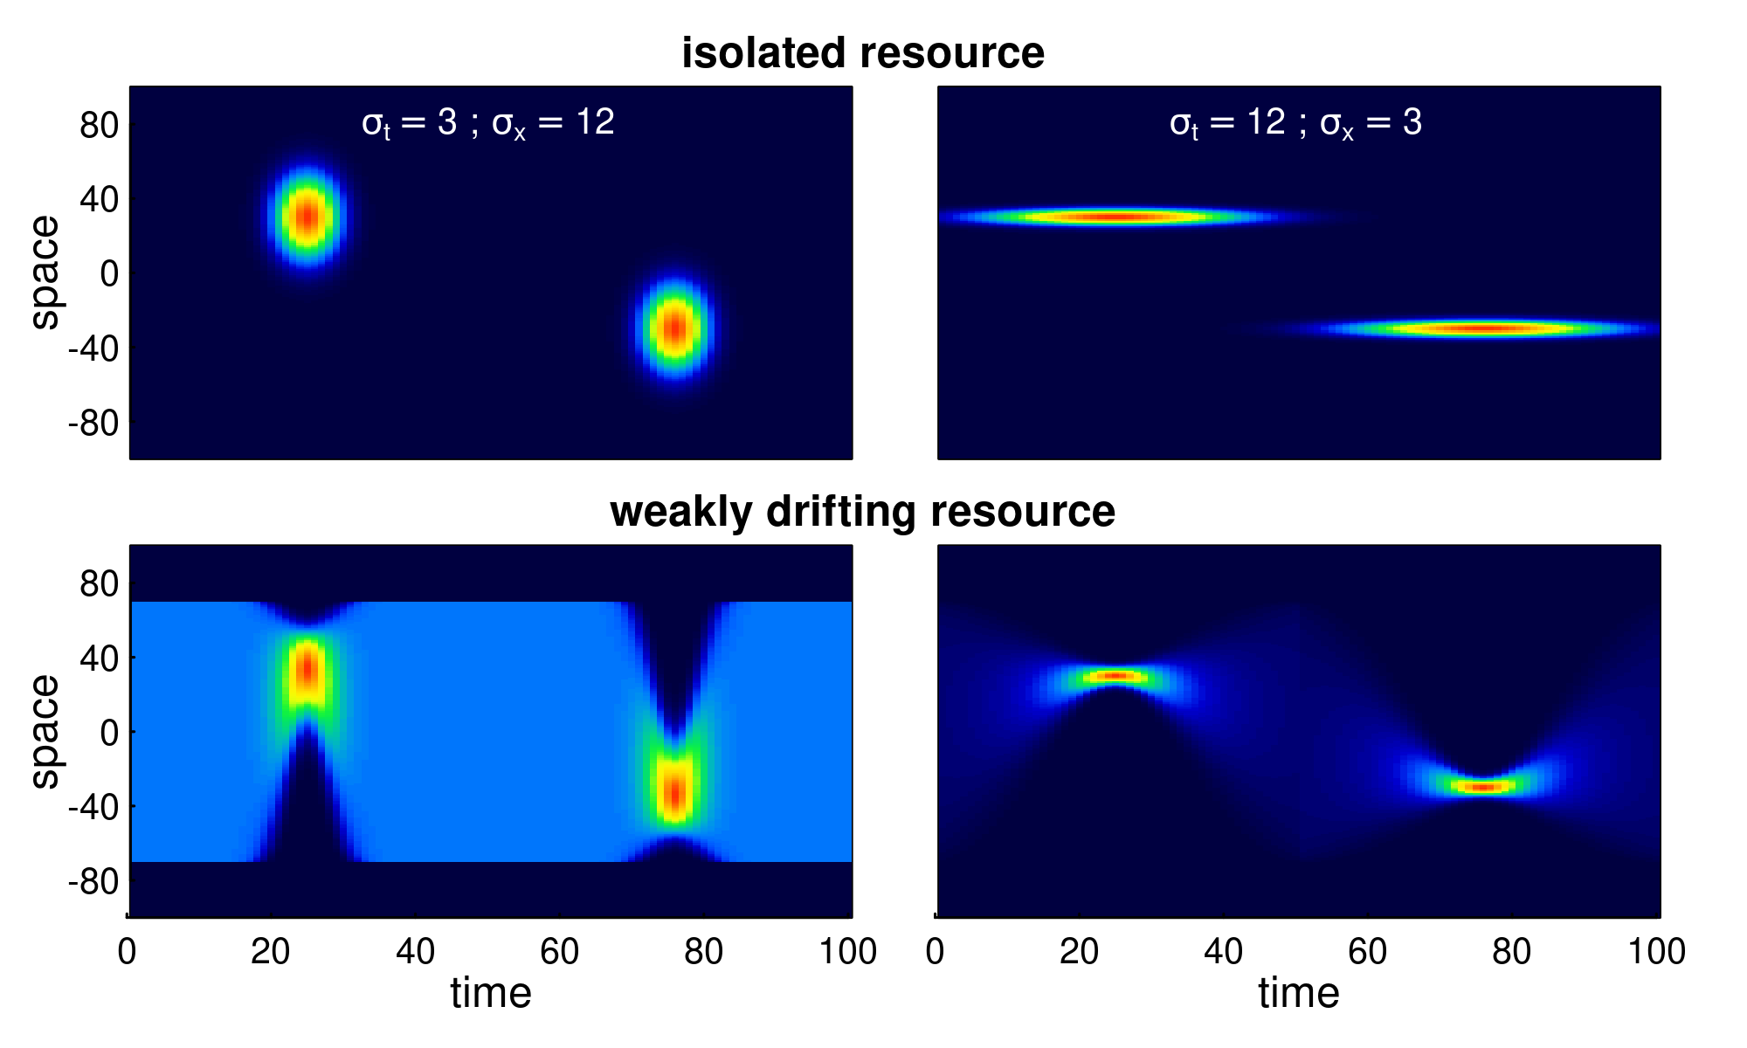

**Figure 1. Examples of various seasonal resource distribution functions, contrasting short duration, but wide pulses (; left panels), long duration but spatially concentrated pulses (; right panels), and isolated resource pulses (upper panels) from the weakly drifting resource (lower panels). The total amount of resource is identical across all scenarios. In the weakly drifting resources, the total amount is constant at all times, and uniform in the middle of the phase (time = 0, 50, 100).**

## Metrics

The main metrics we are interested in are *migration mismatch*, *foraging efficiency* and *adaptation to trends*.

Migration mismatch captures the similarity between the migration phenology and the resource phenology. To do this, we compute the total mismatch, i.e. is a sum of the difference between the migration coefficients and the resource peaks. Thus, the spatial mismatch is given by the absolute difference between the migration targets and the resource peaks, i.e. . The temporal mismatch is the difference between the arrival time and the peak of the resource if arrival is post-peak, the difference between the departure time and the peak of the resource if departure is pre-peak, and 0 if the seasonal duration spans the peak, i.e. . The total mismatch is the sum of and . A mismatch of less than 1 is essentially perfect, we consider a mismatch of 1-5 to be “good,” and beyond 30 the system can be said to have failed to keep up with climate change.

To quantify the foraging efficiency, i.e., the organisms’ ability to track the distribution of the resources over space and time, we use a continuous form of the Bhattacharyya Coefficient (Bhattacharyya 1943) which quantifies the similarity between two distributions. We compute this coefficient at every time point in a given year, and take the mean across the equilibrium year to determine foraging efficiency (FE). Thus, the foraging efficiency index is:

where the spatial integral is taken over the domain. This metric is constrained to be between 0 and 1.

For simulations with a constant resource, we ran the model until a quasi-equilibrium state was achieved, i.e. where the Bhattacharya index of the population distribution across subsequent years reached a value of 0.9999. Once that state was attained, we computed the migration mismatch and foraging efficiency metrics, as well as the number of years required to reach stationarity.

For numerical runs with climate change, we first run a simulation for 20 years to attain an equilibrium, and then begin shifting the location of the resource with a trend (slow 0.25, medium 0.5, or rapid 1 units per year), or by adding stochasticity (s.d. 3, 6, 12). For the trend analyses, we then compute the slope of the migration location parameter against the resource drift and refer to this index as the *spatial adaptation* (SA) index.

## Simulation studies

We explored this model using numerical differencing of a system of ordinary differential equations (ODE’s) approximating the PDE in equation (2) with the Runge-Kutte algorithm using the deSolve (Soetaert et al. 2010) and ReacTran (Soetaert and Meysman 2012) packages in R. We additionally used the nlsLM function in package minpack.LM (Elzhov et al. 2016) for robust and fast annual estimation of the migration parameters. The complete code is available as an R package (memorymigration) available on GitHub at <https://github.com/EliGurarie/memorymigration> and as an interactive Shiny application at <https://url.to.be.determined>.

We assessed a wide range of parameter values and resource geometries and dynamics with the goal of answering the four main questions:

1. Can this model adapt to a discrete shift in peak resource location and timing? What is the relative role of memory and sociality for adaptation?
2. Can this model acquire a migratory behavior from a non-migratory initial condition?
3. What is the role of a reference memory for dealing with stochastic resource dynamics?
4. Can this model adapt when the resource peaks shifts in space?

# Results

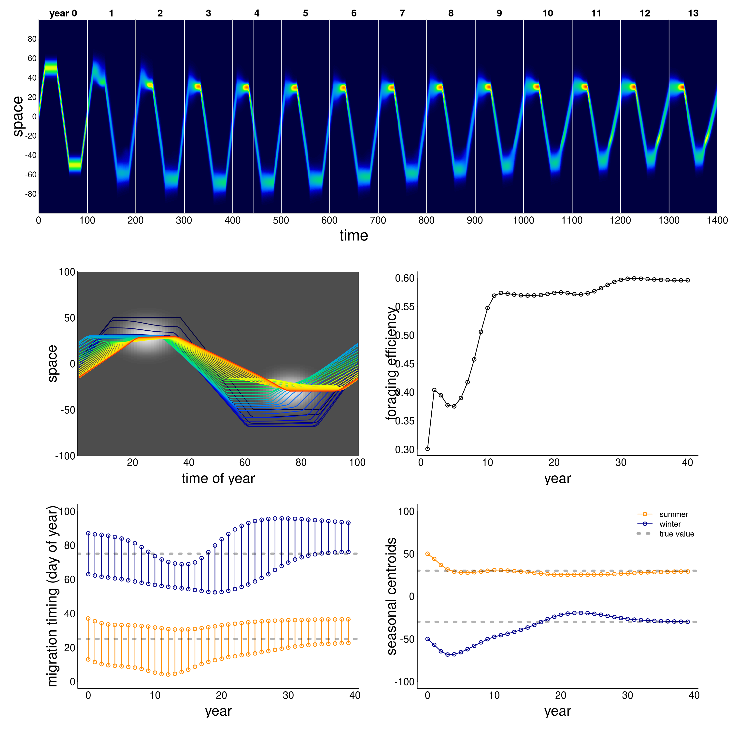

**Figure 2.** *Example of adaptation to a shift in resource peak. The initial (year 0) behavior migrates to locations 50 and -50 at days 15 and 60, whereas the resource peak is at 30 and -30, peaking at times 25 and 75. The panels show (a) the first 14 years of the simulation; (b) the centroid of the annual movement of the population is shown in panel b, with dark blue to red colors indicating year 0 to year 40; (c) annual foraging efficiency across years; (d) migration timing parameters for each year, with orange segments indicating arrival and departure from the summering (northern) grounds, and the blue segments indicating timing of arrival and departure at the wintering grounds; (e) migration arrival and departure location across years, with blue and orange indicating winter (southern) and summer (northern) locations.*

## Adaptation to resource phenology

The ability of this system to attain stable, migratory state that matches the dynamics of the resource is illustrated in Figure 2. In the illustrated scenario, it takes nearly 40 years to attain an equilibrium, and the eventual steady state is one where the centroid of the migration lines up exactly with the centroid of the resource, and the arrival timing coincides with the *peak* of resource availability. Notably, the path to this equilibrium is somewhat indirect, with the later winter range taking more time to stabilize than the earlier summer range. The eventual steady state is one where the foraging efficiency is relatively high.

We ran this process for 8100 parameter combinations (Figure 3). The fundamental dynamic of attaining and maintaining a well-matched migration phenology, can occur under many combinations of parameter values, but all parameters play a role. Among the more intuitive results are that greater values of (resource following) lead to an improved ability to match the migration. Resource peaks with larger spatial extent (higher ) are generally better for migration matching. A larger set of parameters matched migration with low diffusion than high diffusion.

Less intuitive was the high importance of the sociality parameters, in particular the spatial scale of the swarming. Higher levels of social attraction () led to improved migration matching except in those cases where the sociality scale was high. Thus, for example, at , no simulations at managed to acquire or maintain a matched migration. However, at or , the migration was slightly better matched at high values of . (Fig. **X**) The spatial extent of the swarm was a remarkably significant variable. Smaller swarms were able to match migration only at low values of social attraction (), and relatively high values of resource attraction ().

Random forest analyses, whether on the log of total mismatch or on the classification of a perfect match, uniformly show that the most important variables (Breiman 2001) were and (4.14 and 4.02 proportional increase in MSE), and the least important was , with a 0.5 proportional increase (table **X**).

Overall, foraging efficiency was strongly correlated with migration matching, as expected. At high mismatch (> 50), foraging efficiency was low (mean 0.29, s.d. 0.16) compared to the near-perfect matching migrations (mean 0.58, s.d. 0.14). However, somewhat higher mismatch (1 to 5) showed an even higher overall foraging efficiency (mean 0.62, s.d. 0.18 - see also Figure **X**).

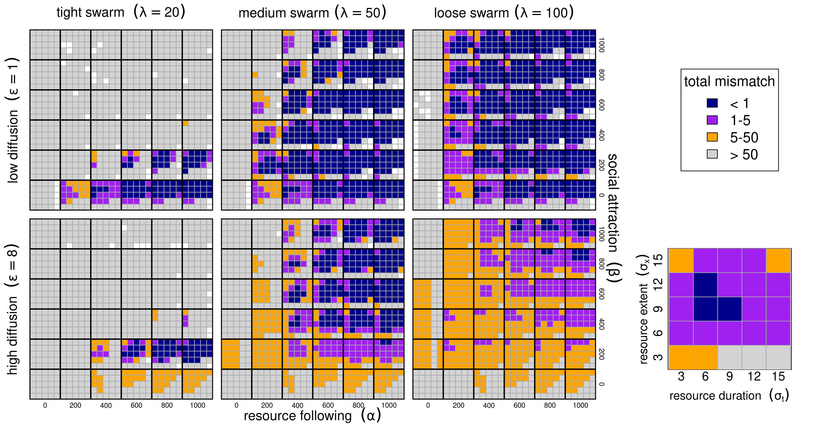 **Figure 3.** *Migration phenology matching across six model parameters. Low and high diffusion ( and in upper and lower panel blocks), tight, medium and loose swarms () left to right panels. Within each of these blocks, high values of the resource following parmaeters from 0 to 1000 are left to right, and higher values of the sociality parameter are bottom to top. Finally, within each of the combinations of , we show results ranging across 6 values of resource duration (, 3-15 left to right), and 6 values of resource extent (, 3-15 bottom to top), as in the zoomed in panel at bottom right. Finally, the color scheme reflects the total mismatch, i.e. the sum of the absolute differences between the migration timing and locations from the resource peak. White squares represent runs that numerically failed to estimate migration parameters.*

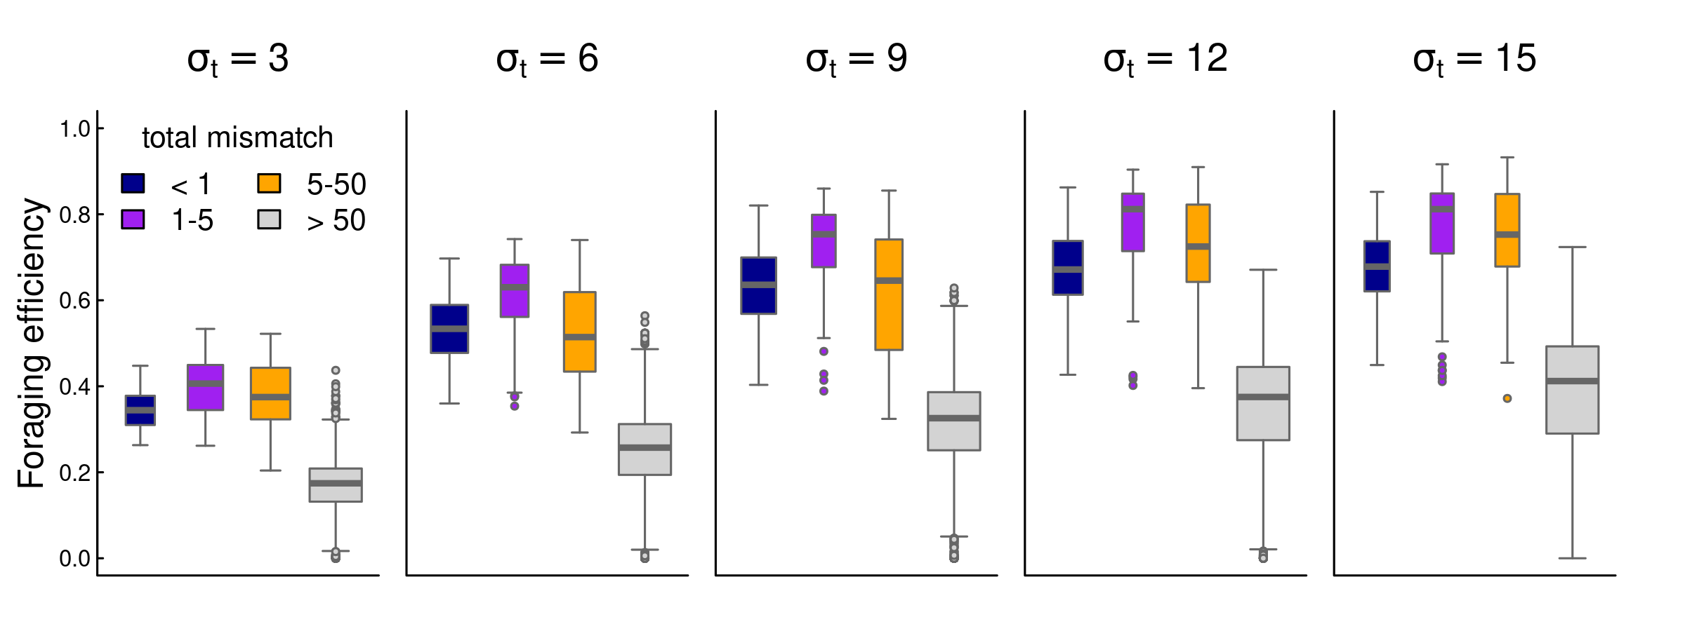

**Figure 4.** *Box-plots of foraging efficiency against mismatch across several values of foraging patch duration.*

## Learning to migrate

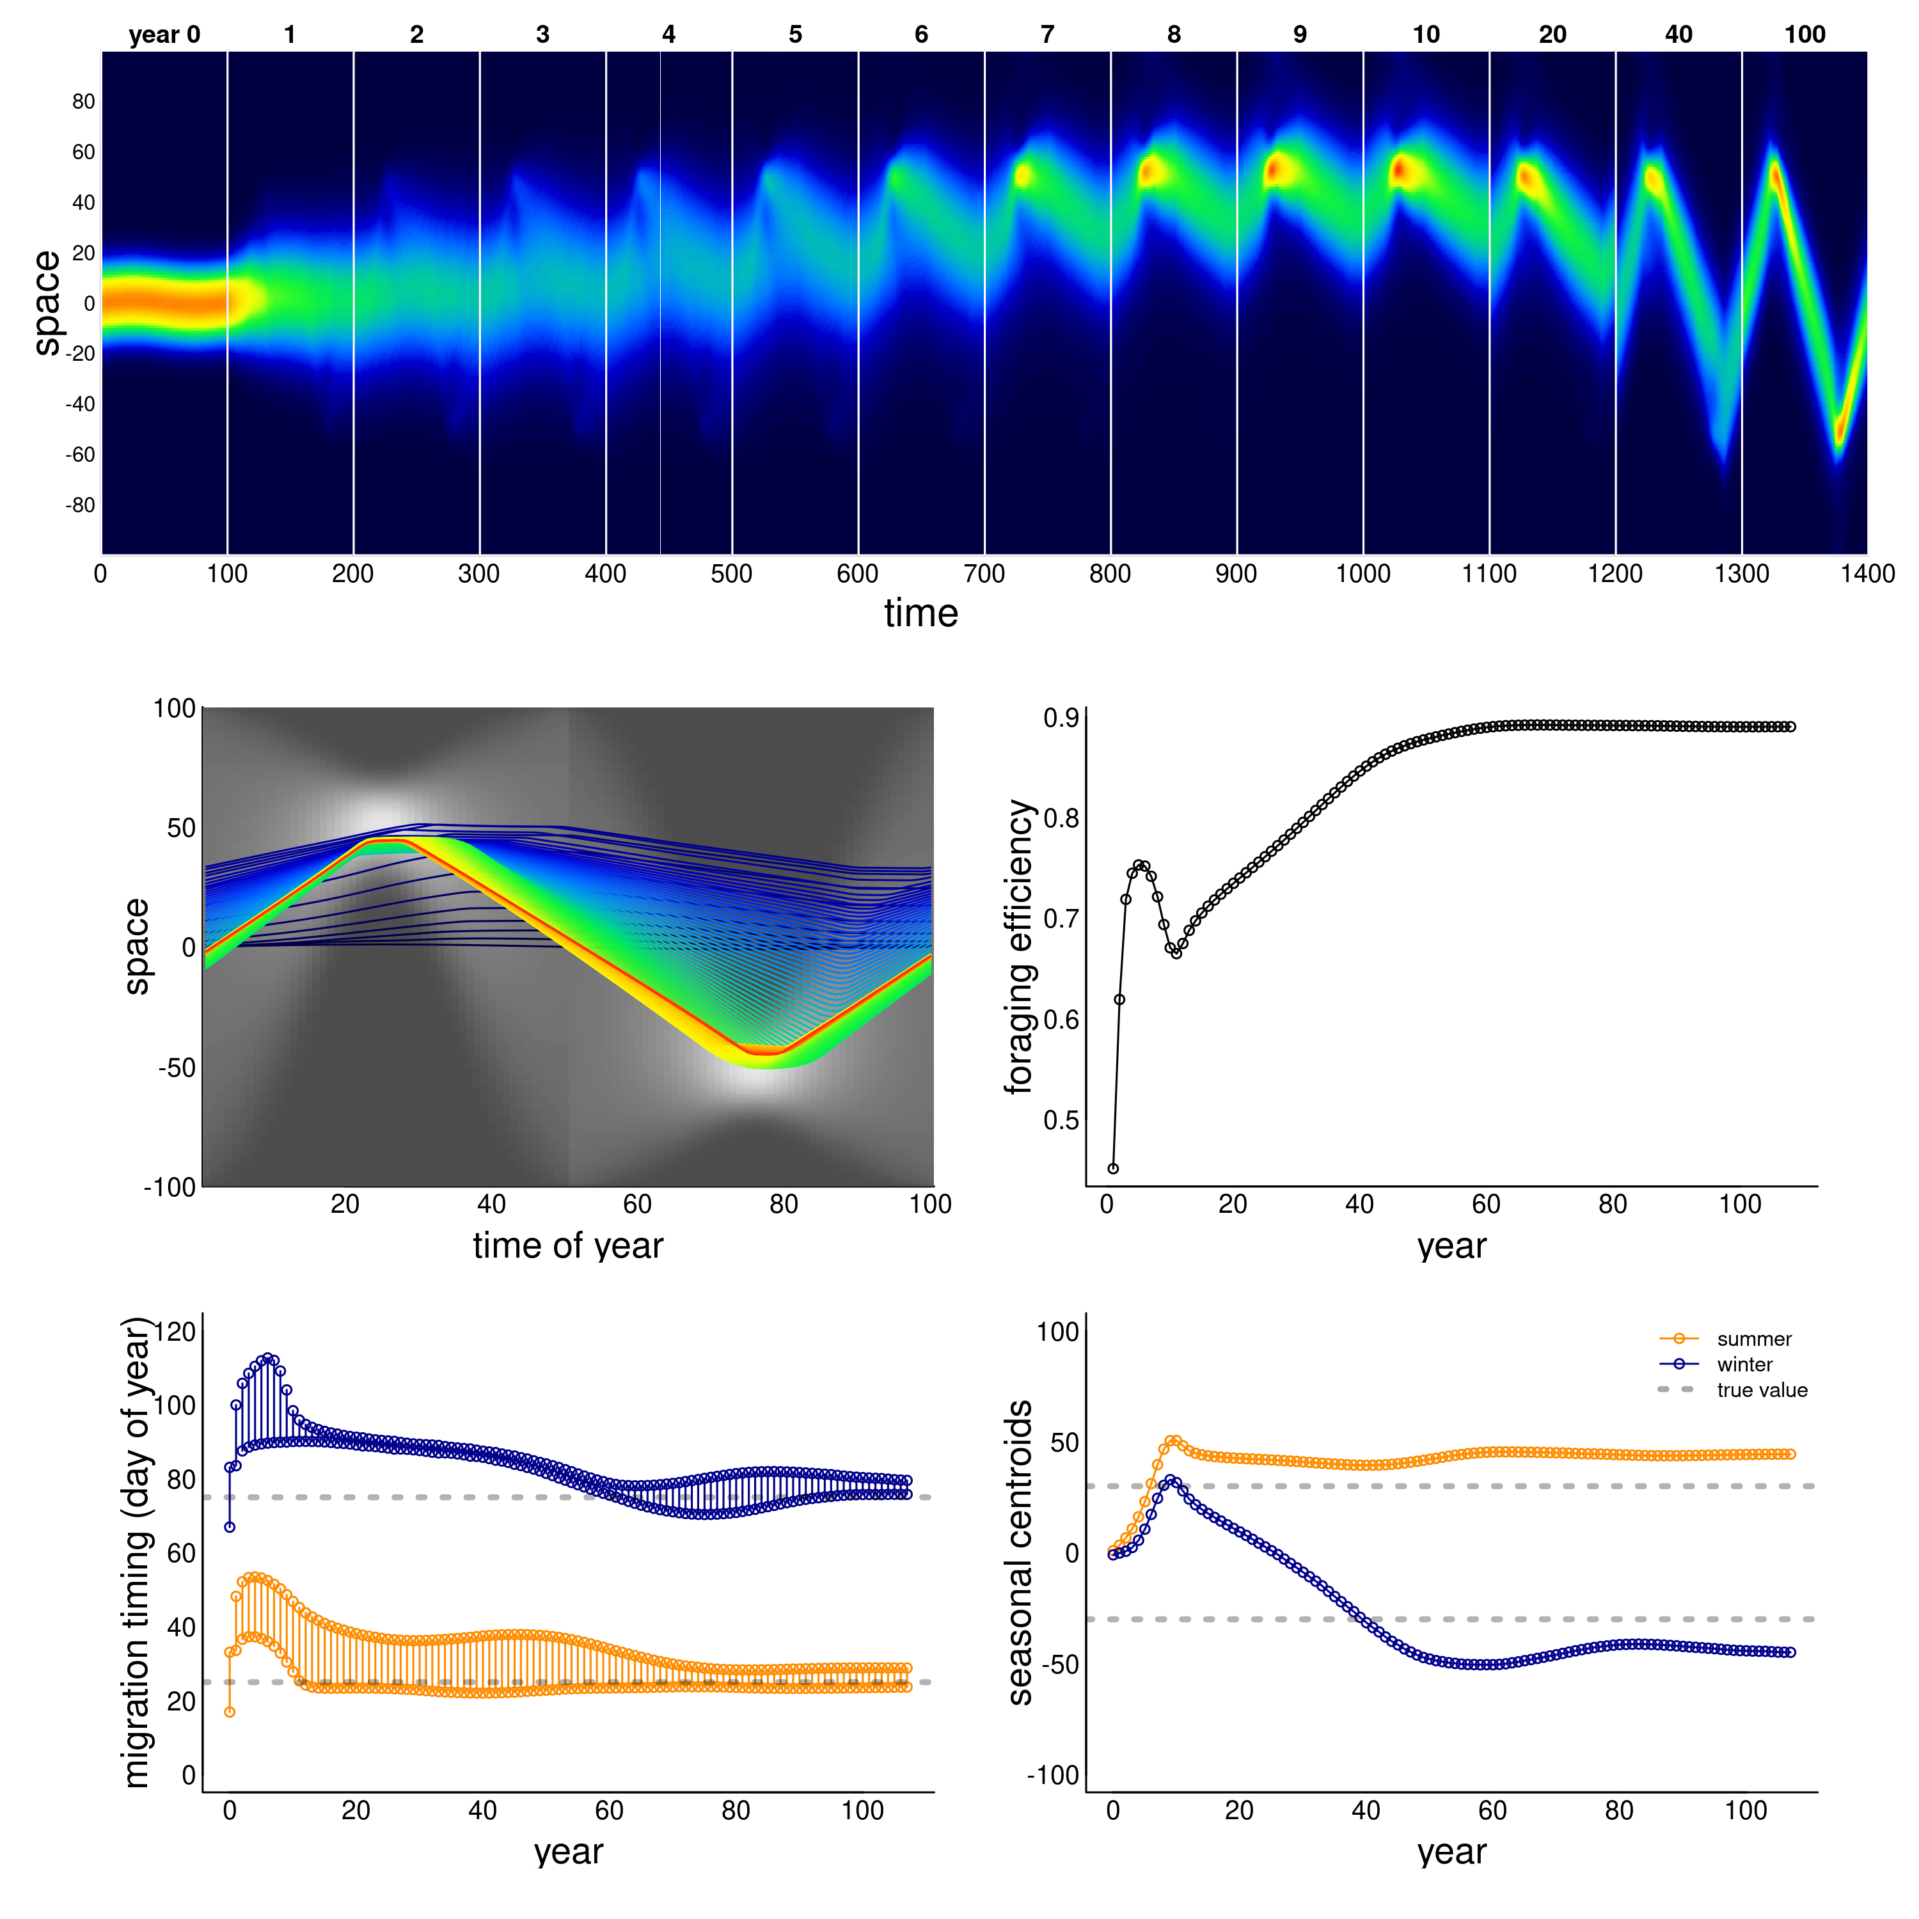 **Figure X.** *Example of model learning to migrate. The resource is a “weakly drifting” resource and the initial (year 0) condition is non migratory. The simulation was run for 100 years, and a sampling of those years (labeled) are presented in panel a: all years from 0 to 10, followerd by 20, 40 and 100. Otherwise, panels are as in Figure 1. Parameter values were , and .*

Figure **X** illustrates the ability of the model animals to learn to migrate in a weakly drifting resource environment with a narrow pulse of resource peaking at 30 and -30 (at days 25 and 75), but a uniform distribution of resource at times 0 and 50. In order to learn to migrate, the system needed to have a higher exploratory impulse (higher diffusion constant ), a stronger resource advection (higher ) and somewhat weaker sociality (lower ). The qualitative behavior of this process was to start drifting towards the summer resource, while slowly developing a weak pulse towards the winter resource as well. After first locking in on the summer resource, the winter migration, driven both by high diffusion and high resource following, slowly extended itself until both narrow peaks of resource can be consistently reached.

The model had, in general, a difficult time learning migration from a non-migratory initial condition. Thus, out of 4047 successful runs, only 4 attained mismatch below 1, and 130 below 5 (Appendix Figure **Z**). Conditions that were more conducive to learning migration were pulses of *longer* duration (high ), but *smaller* in scope (low ), suggesting that the feedback that encourages migration needs to be compact in space but long enough in duration to lock in to the memory.

## Adapting to climate change

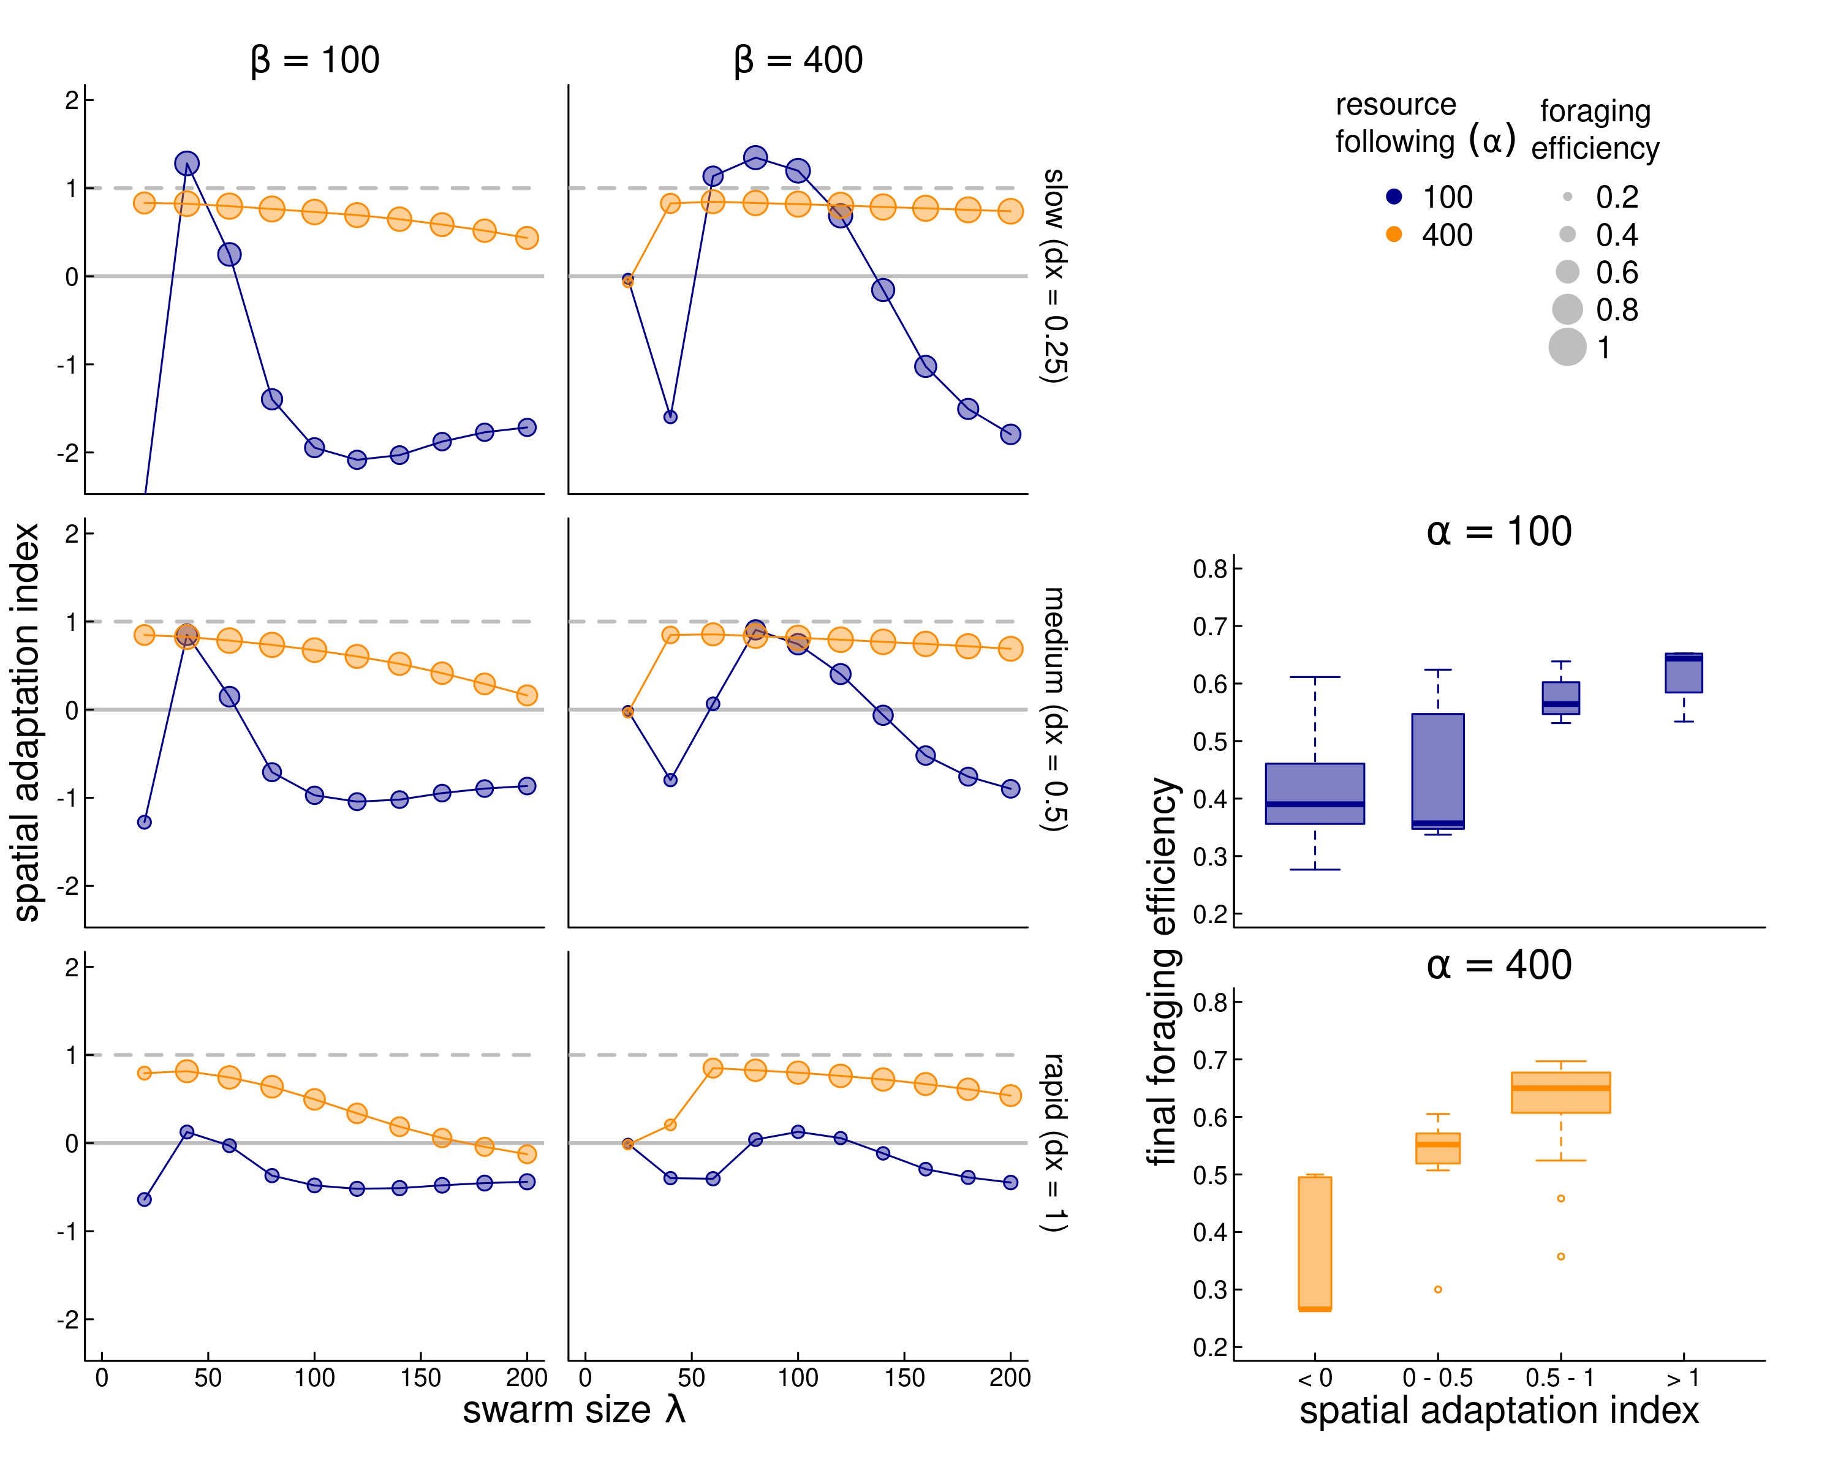

**Figure Z.** *Adaptation to a steadily drifting resource. In three scenarios, the spatial coordinates of the resource drift by 0.25, 0.5, and 1 unit per year (top to bottom, respectively). The y-axis is the index of spatial adaptation (SA), i.e. the trend of the memory-driven migration divided by the resource drift trend. Values near 1 indicate a behavior that keeps up with climate change, values near indicate no change in migration behavior, and negative values indicate a trend that is opposite to the climate trend. We compare across spatial scales of sociality ( - x-axis), for low and high values resource following ( and - orange and blue dots) and low and high values of sociality ( and 400, left and right panels). The size of the circles is proportional to the foraging efficiency of the resulting parameter combinations. Finally, the bottom-right boxplots indicate the final year foraging efficiency against the SA index; purple and blue boxes indicate the highest values, orange and gray lower values.*

To assess the ability of the system to adapt to a trending climate, we generated scenarios with slow (0.25 units / year), medium (0.5 units / year), and fast (1 unit / year) drift outward of the two resource pulses. We then assessed 40 parameter combinations for each of those scenarios, a high and low value of resource following ( and ) crossed with a high and low value of sociality ( and ) crossed with 10 values of the spatial scale of sociality ( to ). The spatial and temporal scale of the resource pulses were fixed to a relatively “easy” to adapt to and . We computed the adaptation index and foraging efficiency for each of the 120 runs (figure **Z**). We were interested in the dynamics against due to the uniformly high importance of this parameter for determining the success of this process to match migration in steady states.

As figure Z shows, higher values of resource following (; orange circles) are nearly universally better for keeping up with climate change (SA values near 1). Furthermore, when combined with high sociality (; right panels), nearly all parameter combinations do a good job keeping up with climate change (SA values ranging between 0.53 and 0.85 for a swarm size greater than 50). However, that maximum value is still less than 1, suggesting that truly matching a steadily drifting trend is very difficult. Small swarms () have a very hard time adapting when the social attraction is high, but do fairly well when social attraction is lower. But larger sized swarms do progressively worse across more parameterizations, e.g. in the most rapid climate change scenario, the SA drops from 0.83 to -0.13 as the swarm increases in size from 40 to 200 (essentially, the entire spatial domain).

A rather more dramatic pattern is visible for the lower foraging attraction scenario (; blue circles). Notably, no parameter combination at this value comes close to keeping up with the rapid climate change (SA range -0.64 to 0.13). For slower climate change, however, there is a window of values for the swarm size - relatively small, between 40 and 80, where the SA *exceeds* 1, and then crashing quite rapidly to negative values of SA as that swarm size increases. These “super-adapting” processes indicate a unique sweet spot where a swarm is large enough to capture and adapt to the drifting resource, but not so large that the information gathered in a given year is too weak to adjust the migratory behavior in a following year.

As anticipated, better adaptation to the drifting resource correlated strongly with higher foraging efficiency (inset boxplots).

## Role of reference memory in adapting to stochasticity

*This section still rough*

We ran simulations with various levels of stochasticity (inter-annual standard deviation in location of resource pulse 3, 6, and 12) notably against various values of reference memory , where refers to only recent memory, and refers to all reference memory, i.e. that never updates. We ran simulations for 20 years with constant resource to stabilize, and then for 30 more years to let the process evolve. In all cases, unsurprisingly, the conservative limit yielded the highest interannual foraging efficiency (see figure ZZ below).

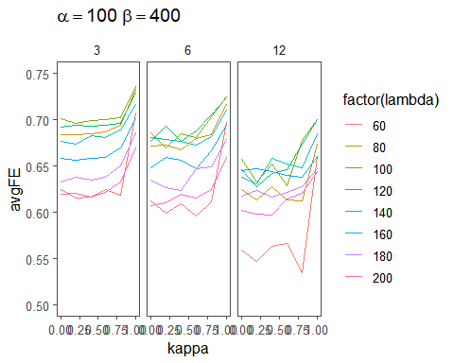 **Figure ZZ.** (*to be refined*) *Results of foraging efficiency against kappa. Higher stochasticity leads to generally lower efficiency. Higher use of reference memory leads to higher resource efficiency as well.*

The final question (simulations currently runnning) is for a system to deal with BOTH trend AND stochasticity, does an intermediate blending of recent and reference memory improve the outcome?

# Discussion

*Highly sketchy and incomplete. Some odd thoughts here and there.*

We found that the relatively straightforward inclusion of a migration-specific memory in a social diffusion-advection framework was sufficient to capture many fundamental phenomena related to migration. In essence, our model allowed a population with a hybrid migratory and resource following behavior to adjust the migratory behavior based on recent experiences with the resource location. The model, while simple, was able to emulate the successful navigation of an environment with temporally and spatially isolated seasonal resource patches, the spontaneous emergence of a migratory behavior, and intrinsic robustness to changes in those environmental resources, whether as trends or inter-annual stochasticity.

Note, we are interested here in a process that do *not* correspond to the “green wave surfing” mechanism, as there is very little trend to surf, but consider only a necessarily strategic, long-scaled displacements and the way those displacements are modified by experience.

The ability to migrate depended on the nature of the resource dynamics. In particular, the reinforcement of memory and foraging is strongest when patches are concentrated in time, but relatively large in space. Interestingly, in most essentially stable patterns, the eventual targeted migration arrival time coincided with the *peak*, rather than the beginning, of the resource dynamic. Ecologically, this indicates that the long-distance social migration behavior may be particularly reinforced when the targeted resource is very sudden (explosive), which is very much the case for the rapid green-up that occurs in high latitudes as the snow recedes even as day length is high, leading to a rapid and intense green-up.

It is worth considering the assumptions of our model with respect to a biological population. The population is explicitly social and collective, and the memory is a memory that belongs to the entire population. The importance of the spatial scale of the collective was an unexpected and very strong result, suggesting that for a population to adequately learn socially, it must have a large enough exploratory radius to find new information to adapt to, while being small enough that the entire population can then learn from this.

Our model is somewhat similar to an evolutionary individual-based model (Anderson et al. 2013), which showed that some inherent phenotypic plasticity is required to hedge both against persistent trends and increased stochasticity of resource distributions, but at the risk of sub-optimal access to resources (Anderson et al. 2013).

*Discussion of mechanisms for collective knowledge*. Collective knowledge has been shown to be important, if not essential, to the evolution and process of migration [[Shaw2013;@Guttal2010](mailto:Shaw2013;@Guttal2010);(**Bergdal2018?**)]. In our model, we assume that the migration process itself is driven by a collective trigger for the timing and locations of seasonal ranges and migration behavior. Synchrony of mgiration timing and high site fidelity are well documented for migratory species (e.g. Gurarie et al. (2019);Joly et al. (2021)).

*Some comments on systems that may or may not be more resilient to climate change based on our results*.

# References

Anderson, J. J., E. Gurarie, C. Bracis, B. J. Burke, and K. L. Laidre. 2013. Modeling climate change impacts on phenology and population dynamics of migratory marine species. Ecological Modelling 264:83–97.

Avgar, T., G. Street, and J. M. Fryxell. 2014. On the adaptive benefits of mammal migration. Canadian Journal of Zoology 92:481–490.

Bhattacharyya, A. 1943. On a measure of divergence between two statistical populations defined by their probability distributions. Bull. Calcutta Math. Soc. 35:99–109.

Bischof, R., L. E. Loe, E. L. Meisingset, B. Zimmermann, B. Van Moorter, and A. Mysterud. 2012. A migratory northern ungulate in the pursuit of spring: Jumping or surfing the green wave? The American Naturalist 180:407–424.

Bracis, C., and T. Mueller. 2017. Memory, not just perception, plays an important role in terrestrial mammalian migration. Proceedings of the Royal Society B: Biological Sciences 284:20170449.

Breiman, L. 2001. Random forests. Machine learning 45:5–32.

Dingle, H. 2014. Migration: The biology of life on the move. Oxford University Press, USA.

Elzhov, T. V., K. M. Mullen, A.-N. Spiess, and B. Bolker. 2016. Minpack.lm: R interface to the levenberg-marquardt nonlinear least-squares algorithm found in MINPACK, plus support for bounds.

Fagan, W., E Gurarie, S. Bewick, A. Howard, R. Cantrell, and C. Cosner. 2017. Perceptual ranges, information gathering, and foraging success in dynamic landscapes. The American Naturalist 189:474–489.

Fagan, W., T. Hoffman, D. Dahiya, E Gurarie, R. Cantrell, and C. Cosner. 2019. Improved foraging by switching between diffusion and advection: Benefits from movement that depends on spatial context. Theoretical Ecology 13:127–136.

Fryxell, J. M., J. Greever, and A. Sinclair. 1988. Why are migratory ungulates so abundant? The American Naturalist 131:781–798.

Gurarie, E., J. J. Anderson, and R. W. Zabel. 2009. Continuous models of population-level heterogeneity inform analysis of animal dispersal and migration. Ecology 90:2233–2242.

Gurarie, E., F. Cagnacci, W. Peters, C. H. Fleming, J. M. Calabrese, T. Mueller, and W. F. Fagan. 2017. A framework for modelling range shifts and migrations: Asking when, whither, whether and will it return. Journal of Animal Ecology 86:943–959.

Gurarie, E., M. Hebblewhite, K. Joly, A. P. Kelly, J. Adamczewski, S. C. Davidson, T. Davison, A. Gunn, M. J. Suitor, W. F. Fagan, and others. 2019. Tactical departures and strategic arrivals: Divergent effects of climate and weather on caribou spring migrations. Ecosphere 10:e02971.

Gurarie, E., and O. Ovaskainen. 2011. Characteristic spatial and temporal scales unify models of animal movement. The American Naturalist 178:113–123.

Jesmer, B. R., J. A. Merkle, J. R. Goheen, E. O. Aikens, J. L. Beck, A. B. Courtemanch, M. A. Hurley, D. E. McWhirter, H. M. Miyasaki, K. L. Monteith, and others. 2018. Is ungulate migration culturally transmitted? Evidence of social learning from translocated animals. Science 361:1023–1025.

Joly, K., E. Gurarie, D. A. Hansen, and M. D. Cameron. 2021. Seasonal patterns of spatial fidelity and temporal consistency in the distribution and movements of a migratory ungulate. Ecology and Evolution 11:8183–8200.

Kauffman, M. J., F. Cagnacci, S. Chamaillé-Jammes, M. Hebblewhite, J. G. C. Hopcraft, J. A. Merkle, T. Mueller, A. Mysterud, W. Peters, C. Roettger, A. Steingisser, J. E. Meacham, K. Abera, J. Adamczewski, E. O. Aikens, H. Bartlam-Brooks, E. Bennitt, J. Berger, C. Boyd, S. D. Côté, L. Debeffe, A. S. Dekrout, N. Dejid, E. Donadio, L. Dziba, W. F. Fagan, C. Fischer, S. Focardi, J. M. Fryxell, R. W. S. Fynn, C. Geremia, B. A. González, A. Gunn, E. Gurarie, M. Heurich, J. Hilty, M. Hurley, A. Johnson, K. Joly, P. Kaczensky, C. J. Kendall, P. Kochkarev, L. Kolpaschikov, R. Kowalczyk, F. van Langevelde, B. V. Li, A. L. Lobora, A. Loison, T. H. Madiri, D. Mallon, P. Marchand, R. A. Medellin, E. Meisingset, E. Merrill, A. D. Middleton, K. L. Monteith, M. Morjan, T. A. Morrison, S. Mumme, R. Naidoo, A. Novaro, J. O. Ogutu, K. A. Olson, A. Oteng-Yeboah, R. J. A. Ovejero, N. Owen-Smith, A. Paasivaara, C. Packer, D. Panchenko, L. Pedrotti, A. J. Plumptre, C. M. Rolandsen, S. Said, A. Salemgareyev, A. Savchenko, P. Savchenko, H. Sawyer, M. Selebatso, M. Skroch, E. Solberg, J. A. Stabach, O. Strand, M. J. Suitor, Y. Tachiki, A. Trainor, A. Tshipa, M. Z. Virani, C. Vynne, S. Ward, G. Wittemyer, W. Xu, and S. Zuther. 2021. Mapping out a future for ungulate migrations. Science 372:566–569.

Kot, M., M. A. Lewis, and P. van der Driessche. 1996. Dispersal data and the spread of invading organisms. Ecology 77:2027–2042.

Kölzsch, A., S. Bauer, R. De Boer, L. Griffin, D. Cabot, K.-M. Exo, H. P. Van der Jeugd, and B. A. Nolet. 2015. Forecasting spring from afar? Timing of migration and predictability of phenology along different migration routes of an avian herbivore. Journal of Animal Ecology 84:272–283.

Lin, H.-Y., W. F. Fagan, and P.-E. Jabin. 2021. Memory-driven movement model for periodic migrations. Journal of Theoretical Biology 508:110486.

Mogilner, A., and L. Edelstein-Keshet. 1999. A non-local model for a swarm. Journal of Mathematical Biology 38:534–570.

Okubo, A., and S. Levin. 2001. Diffusion and Ecological Problems: Modern Perspectives. Springer Verlag, New York.

Robinson, R., H. Crick, J. Learmonth, I. Maclean, C. Thomas, F. Bairlein, M. Forchhammer, C. Francis, J. Gill, B. Godley, J. Harwood, G. Hays, B. Huntley, A. Hutson, G. Pierce, M. Rehfisch, D. Sims, B. Santos, T. Sparks, D. Stroud, and M. Visser. 2009. Travelling through a warming world: Climate change and migratory species. Endangered Species Research 7:87–99.

Shaw, A. K. 2016. Drivers of animal migration and implications in changing environments. Evolutionary Ecology 30:991–1007.

Skalski, G. T., and J. F. Gilliam. 2003. A diffusion-based theory of organism dispersal in heterogeneous populations. The American Naturalist 161:441–458.

Skellam, J. G. 1951. Random dispersal in theoretical populations. Biometrika 38:196–218.

Soetaert, K., and F. Meysman. 2012. Reactive transport in aquatic ecosystems: Rapid model prototyping in the open source software R. Environmental Modelling & Software 32:49–60.

Soetaert, K., T. Petzoldt, and R. W. Setzer. 2010. Solving differential equations in R: Package deSolve. Journal of Statistical Software 33:1–25.

Turchin, P. 1998. Quantitative analysis of movement: Measuring and modeling population redistribution in animals and plants. Sinauer Associates.

Wilcove, D. S., and M. Wikelski. 2008. Going, going, gone: Is animal migration disappearing. PLoS Biology 6:e188.