We have:

$$P\left[\left|E_{\text{in}}\left(g\right)-E_{\text{out}}\left(g\right)\right|>ϵ\right]≤4m_{H}\left(2N\right)e^{-\frac{1}{8}ϵ^{2}N}$$

We approximate:

$$m_{H}(N)≈N^{d_{\text{VC}}}$$

So we have:

$$P\left[\left|E_{\text{in}}\left(g\right)-E_{\text{out}}\left(g\right)\right|>ϵ\right]≤4N^{d_{\text{VC}}}\left(2N\right)e^{-\frac{1}{8}ϵ^{2}N}$$

And we want:

$$P\left[\left|E_{\text{in}}\left(g\right)-E_{\text{out}}\left(g\right)\right|>ϵ\right]≤0.05$$

With $ϵ=0.05$

# Problem 1

We look to solve for $N$

$$0.05=4{(2N)}^{10}e^{-\frac{1}{8}⋅{0.05}^{2}N}$$

we have $ϵ=0.05$

Solving with mathematica:

$$N=452,957$$

Which is closest to $460,000$ which is D

# Problem 2

We take $m_{H}\left(N\right)≤N^{d_{\text{VC}}}$

See attached code and plots.

For $N=10000$ we have the following bounds:

A:

$$ϵ≤0.632$$

B:

$$ϵ≤0.331$$

C:

$$ϵ≤0.224$$

D:

$$ϵ≤0.215$$

So the answer is D

# Problem 3

$d_{\text{VC}}=50$ so the first breakpoint is $k=51$. So we know that for $N=10$ we have $m_{H}\left(N\right)=2^{N}$

See attached code.

For $N=5$ we have the following bounds:

A:

$$ϵ≤4.25$$

B:

$$ϵ≤2.81$$

C:

$$ϵ≤1.76$$

D:

$$ϵ≤2.264$$

So the answer is C

# Problem 4

For any to point data set $D=\left\{x_{1},x_{2}\right\}$ We know the mean squared error is:

$$e_{D}=\frac{{\left(f\left(x_{1}\right)-ax_{1}\right)}^{2}+{\left(f\left(x_{2}\right)-ax_{2}\right)}^{2}}{2}$$

We differentiate w.r.t. $a$ looking to minimize the error:

$$\frac{de_{D}}{da}=-x_{1}\left(f\left(x_{1}\right)-ax_{1}\right)-x_{2}\left(f\left(x_{2}\right)-ax_{2}\right)=0$$

$$⇒a=\frac{x_{2}f\left(x_{2}\right)+x_{1}f\left(x_{1}\right)}{x_{1}^{2}+x_{2}^{2}}$$

We substitute in $f\left(x\right)=\sin{(πx)}$ and simulate 1,000,000 randomly sampled data sets (see code): Result is $a≈1.43$ which makes the answer E

# Problem 5

In order to approximate the bias relative to $\overline{g}$ we integrate ${\left(\overline{g}\left(x\right)-\sin\left(πx\right)\right)}^{2}$ over $[0,1]$

This is valid due to the odd symetry of $\sin{x}$

$$\int_{0}^{1}{{\left(\overline{g}\left(x\right)-f\left(x\right)\right)}^{2} dx=\int_{0}^{1}{{\left(1.43x-\sin\left(πx\right)\right)}^{2} dx}}≈0.27$$

Which is closest to 0.3 out of the options thus the answer is B.

# Problem 6

We are looking for:

$$E_{x}\left[E_{D}\left[{\left(g^{\left(D\right)}\left(x\right)-\overline{g}\left(x\right)\right)}^{2}\right]\right]$$

We approximate this in a simulation as shown in the code

The simulation returned a variance of $≈0.23$ which is closest to 0.2 so the answer is A

# Problem 7

(a)

we know from the book (p65) that hypotheses of this form have $\text{bias}≈0.50$ and $\text{var}≈0.25$, for a total expected $E_{\text{out}}≈0.50+0.25=0.75$

(b)

We know from the previous questions that hypotheses of this form have $\text{bias}≈0.27$ and $\text{var}≈.23$ for a total expected $E_{\text{out}}≈0.27+0.23=0.50$

(c)

We know from the book (p65) that hypotheses of this form have $\text{bias}≈0.21$ and $\text{var}≈1.69$ for a total expected $E_{\text{out}}≈0.21+1.69=1.90$

(d)

The model we are working with is $h\left(x\right)=ax^{2}$

we have the error for a given 2 point dataset:

$$e\left(D\right)=\frac{{\left(f\left(x_{1}\right)-ax_{1}^{2}\right)}^{2}+{\left(f\left(x_{2}\right)-ax_{2}^{2}\right)}^{2}}{2}$$

differentiating:

$$\frac{de}{da}=-x_{1}^{2}\left(f\left(x_{1}\right)-ax_{1}^{2}\right)-x_{2}^{2}\left(f\left(x_{2}\right)-ax_{2}^{2}\right)=0$$

$$⇒a=\frac{x_{2}^{2}f\left(x_{2}\right)+x_{1}^{2}f\left(x_{1}\right)}{x_{1}^{4}+x_{2}^{4}}$$

we look to estimate $\overline{g}$ via simulation substituting $f\left(x\right)=\sin{πx}$

The simulation (run a couple times) is approximately $a≈0$ which means that $\overline{g}\left(x\right)≈0$. So we know that we have approximately the same $\text{bias}$ as $H_{0}$ from p65 of the book which is $\text{bias}=0.50$

Simulation returns $\text{var}≈24$ so the expected $E_{\text{out}}$ is unreasonably high.

(e)

Knowing the performance for the model $y=ax^{2}$, we can see that the model $y=ax^{2}+b$ will also be high variance because the model that will minimize expected mean squared error would be similar as that of (d) which means that it would have the same $\text{bias}$ as (d) but strictly greater $\text{var}$ so it is expected to be the highest expect out of sample error.

The model $h\left(x\right)=ax$ has the least expected out of sample error thus the answer is B

# Problem 8

If $m_{H}\left(1\right)=2$ and $m_{H}\left(N+1\right)=2m_{H}\left(N\right)-\left(\begin{matrix}N \\ q\end{matrix}\right)$, so since $m_{H}\left(1\right)=2^{1}$, as long as $\left(\begin{matrix}N \\ q\end{matrix}\right)=0$, $m_{H}\left(N\right)=2^{N}$ since the recursive definition is multiplying the previous by 2 and then subtracting $\left(\begin{matrix}N \\ q\end{matrix}\right)$. We know that $\left(\begin{matrix}N \\ q\end{matrix}\right)$ is 0 when $q>N$, thus the growth function will stop being $2^{N}$ once $\left(\begin{matrix}N \\ q\end{matrix}\right)≠0$ which occurs when $N≥q$ which occurs when calculating $m_{H}\left(q+1\right)=2^{N}-\left(\begin{matrix}q \\ q\end{matrix}\right)=2^{N}-1$. So the breakpoint, k, is $q+1$ and $d_{\text{VC}}=k-1=q$ so the answer is C.

# Problem 9

We can dismiss options D and E immediately by considering the case in which $H_{1},…,H_{K}$ are all disjoint from one another. In this case, the intersection would be the empty set which have $d_{\text{VC}}=1$ despite the fact that the $d_{\text{VC}}$ of any $H∈\{H_{1},…,H_{K}\}$ need not be 0 which would mean that the minimum $d_{\text{VC}}$ would be greater than 0 which would be in violation of the bound.

1. is clearly a valid bound, albeit a loose bound, since we are taking the sums of the $d_{\text{VC}}'s$ despite knowing that the intersection hypothesis set is no more complex than the least complex set in $\{H_{1},…,H_{K}\}$.
2. Is also a valid bound because the intersection hypothesis is no more complex the the least complex set in $\{H_{1},…,H_{K}\}$. Thus, the $d_{\text{VC}}$ is properly bounded
3. Since (b) is a valid bound than (c) must also be a valid, but looser bound because the max $d_{\text{VC}}$ cannot be less than the min $d_{\text{VC}}$.

We also know that (b) is tighter than (a) because $\min{{\left\{d_{\text{VC}}\left(H_{k}\right)\right\}}_{k=1}^{K}}$ is necessarily an element in the summation: $\sum_{k=1}^{K}{d_{\text{VC}}(H_{k})}$.

So the tightest bound is B

# Problem 10

We know that $\max{{\left\{d_{\text{VC}}\left(H\right)\right\}}_{k=1}^{K}}$ is a valid lower bound since the set $H_{k}$ with the greatest $d_{\text{VC}}$ is, by definition of union, a subset of the union of $H_{1},…,H_{K}$ and we know that a hypothesis set that is a subset of another can’t have a greater $d_{\text{VC}}$ than the other.

So we can eliminate a,b, and c because their lower bounds are not the tightest even if they are valid bounds.

So we compare the following upper bounds:

$$\sum_{k=1}^{K}{d_{\text{VC}}\left(H_{k}\right)}$$

and

$$K-1+\sum_{k=1}^{K}{d_{\text{VC}}\left(H_{k}\right)}$$

Consider $H_{1}$ with breakpoint $k=2$ and $d_{\text{VC1}}=1$ defined as follows:

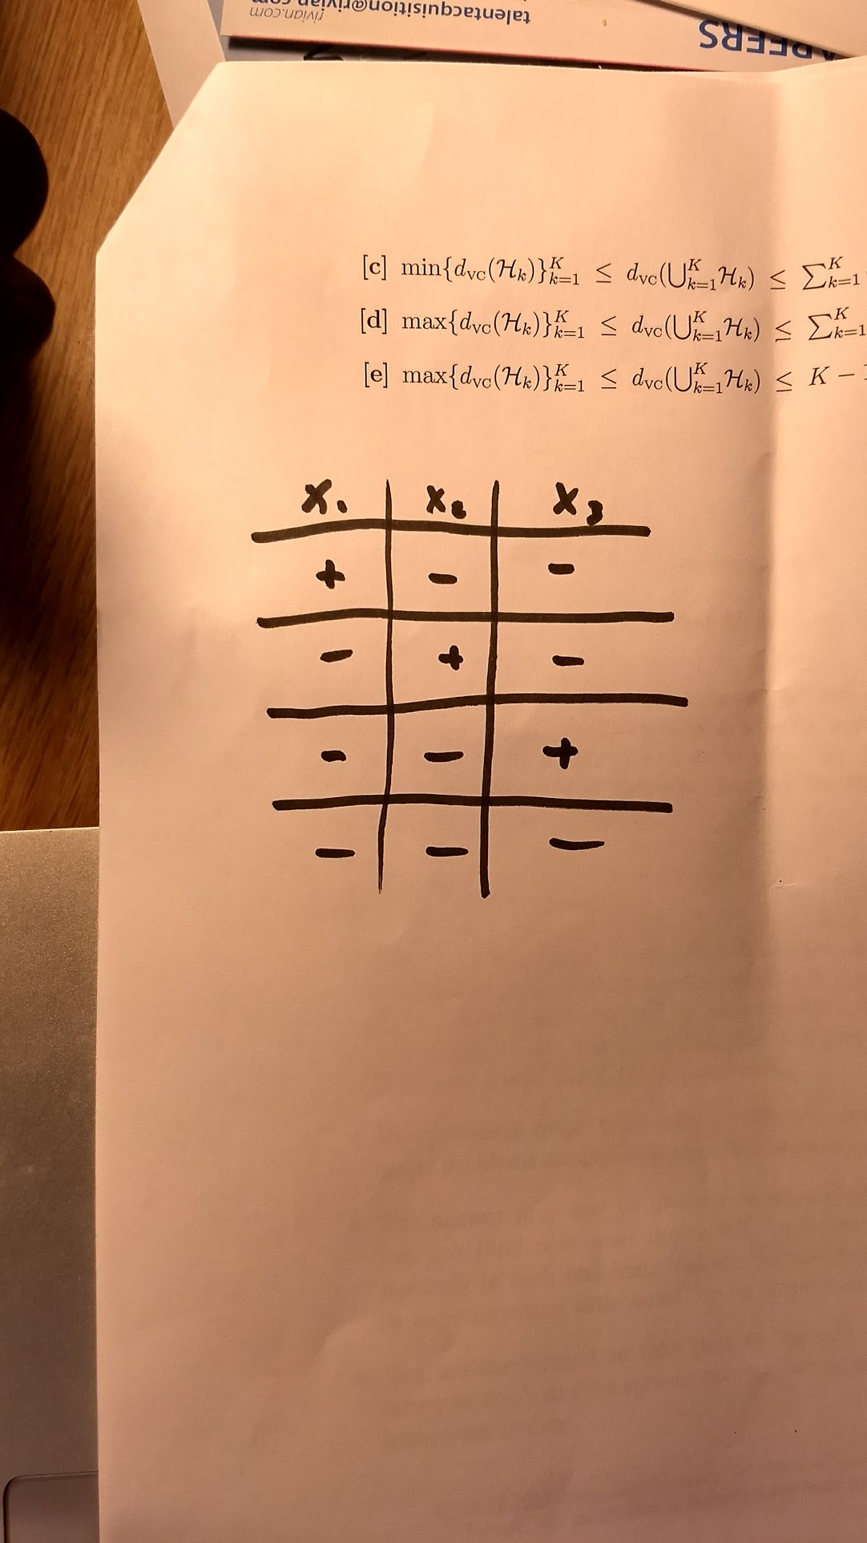

and $H_{2}$ with breakpoint $k=2$ and $d_{\text{VC2}}=1$ defined distinctly from $H_{1}$ as such: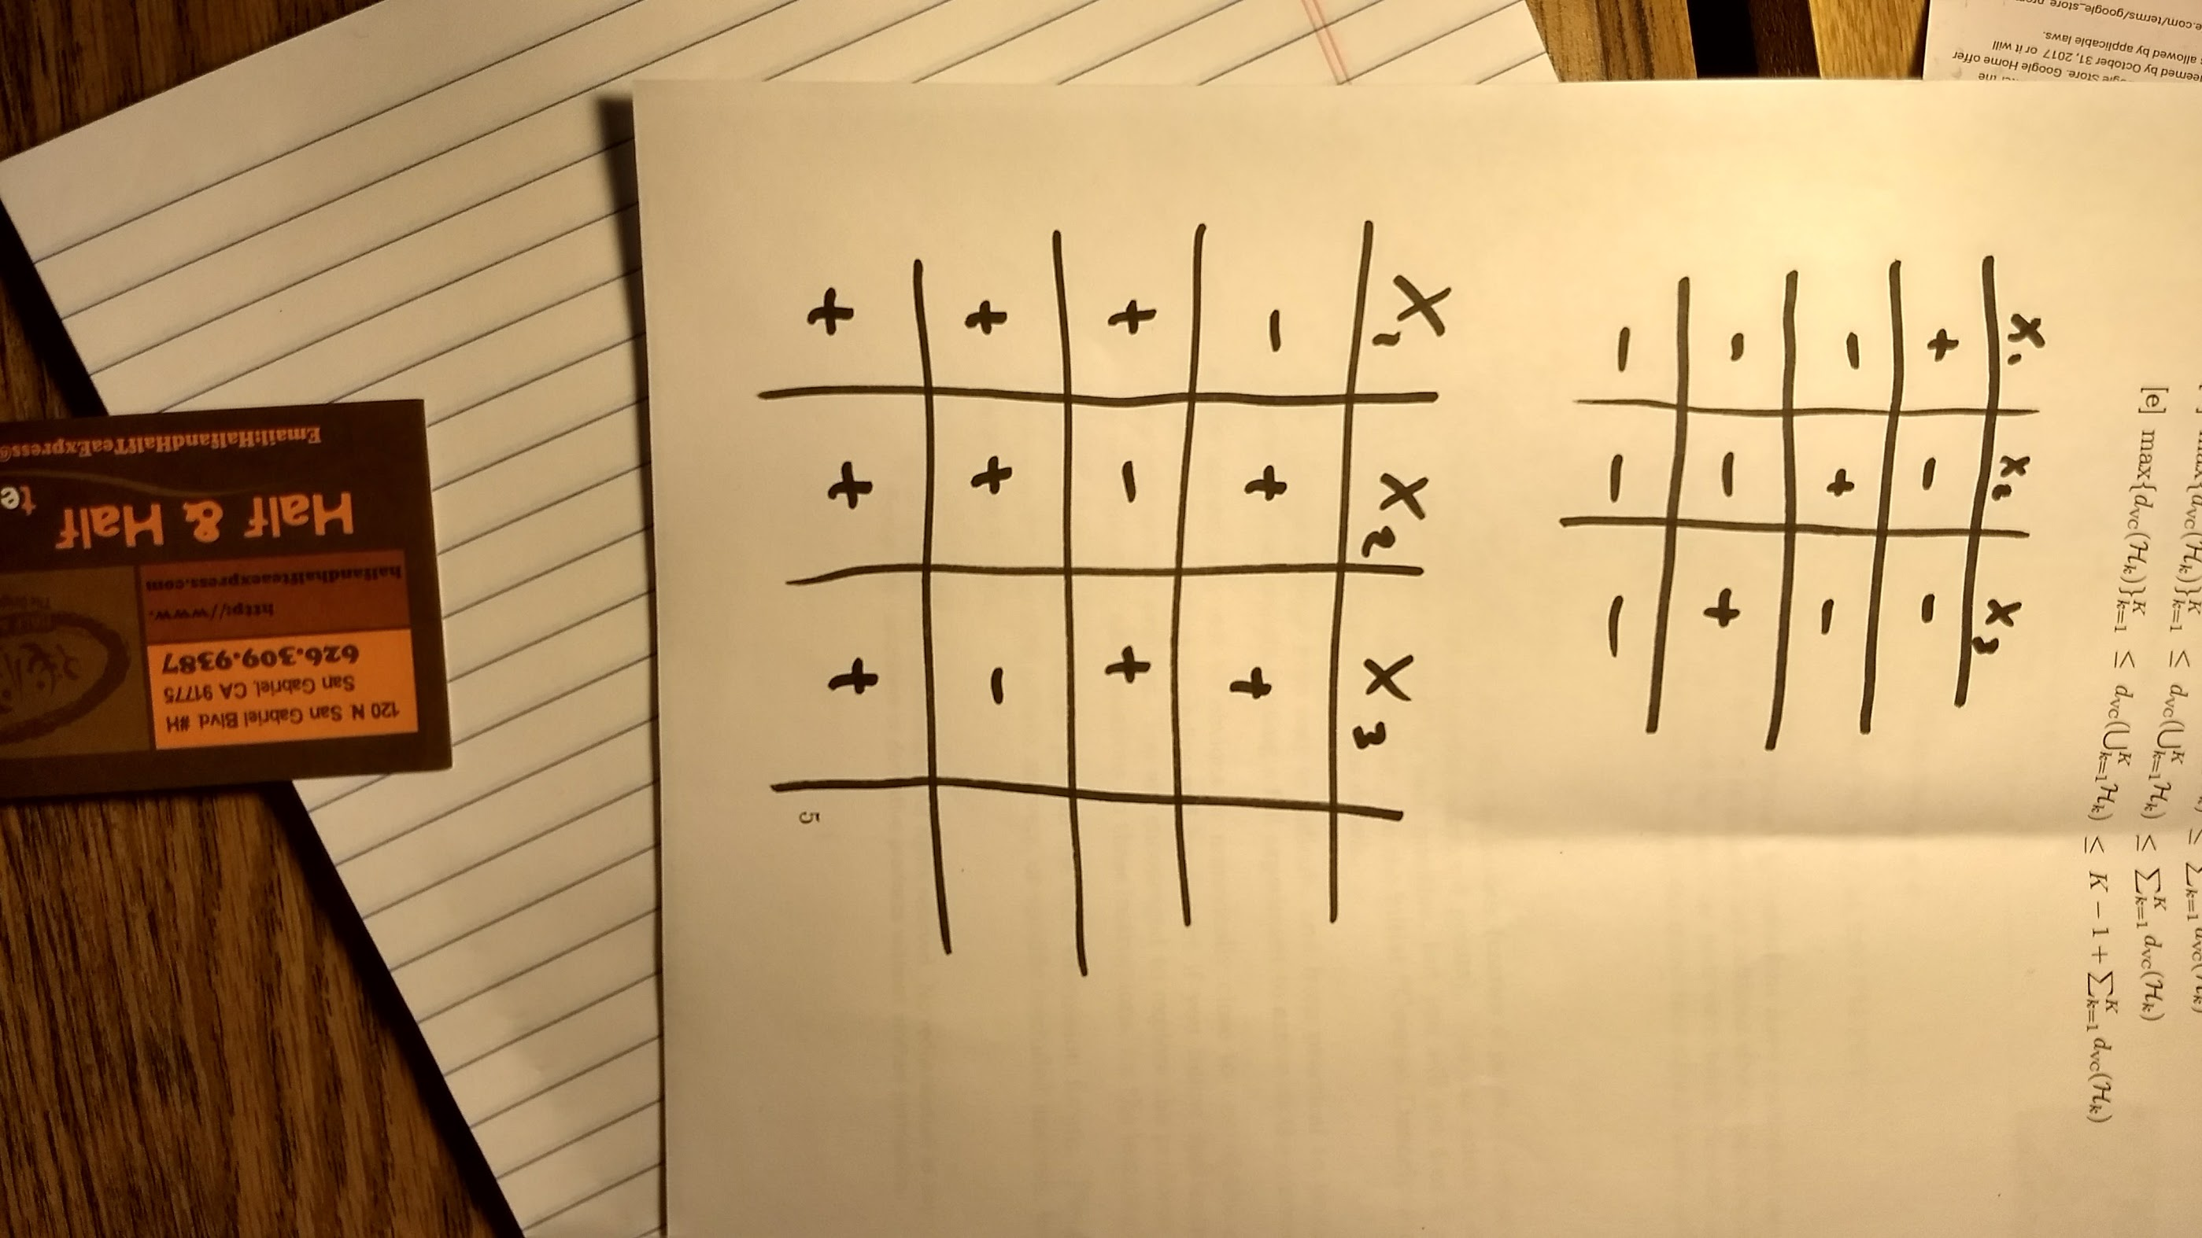

We can see that $H=H_{1}∪H_{2}$ has $k=4$ and $d_{\text{VC}}=3≠d_{\text{VC}1}+d_{\text{VC2}}$

Furthermore we know that we have $K=2$

$$K-1+\sum_{k=1}^{K}{d_{\text{VC}}\left(H_{k}\right)}=2-1+d_{\text{VC}1}+d_{\text{VC2}}=2-1+1+1=3=d_{\text{VC}}$$

Thus the proper upper bound is given by $K-1+\sum_{k=1}^{K}{d_{\text{VC}}\left(H_{k}\right)}$ and the answer is E