# Problem 1

Deterministic noise is the part of the target function that cannot be modeled due to a lack of hypothesis set complexity.

Deterministic noise arises from a models failure to properly fit a target function. So in general deterministic noise goes down as model complexity increases. If $H^{'}⊂H$, in general, it is more difficult for $H'$ to fit a target function properly which means that the deterministic noise will trend upwards so the answer is B

# Problem 2

The simulation resulted in $E_{\text{in}}≈0.0286$ and $E_{\text{out}}≈0.084$ so the answer is A

# Problem 3

The simulation resulted in $E_{\text{in}}≈0.028$ and $E_{\text{out}}≈0.08$ so the answer is D

# Problem 4

The simulation resulting in $E_{\text{in}}≈0.37$ and $E_{\text{out}}≈0.436$ so the answer is E

# Problem 5

The simulation says that $k=-1$ gives $\min{(E_{\text{out}}\left(k\right))}$ so the answer is D

# Problem 6

The simulation gives $\min{(}E_{\text{out}}(k))≈0.056$ so the answer is B

# Problem 7

A

We can see that $H\left(10,0,3\right)$ is a proper subset of of $H\left(10,0,4\right)≠H_{4}$

This is because $H\left(10,0,3\right)$ requires that all $w_{q}=0$ for $q>3$ whereas $H\left(10,0,4\right)$ requires that all $w_{q}=0$ for $q>4>3$ so $H\left(10,0,4\right)$ includes $H\left(10,0,3\right)$ if we consider that in $H\left(10,0,4\right)$ we **can** (although we aren’t restricted to it) have $w_{3}=0$ which accounts for all $h∈H\left(10,0,4\right)$. This means that $H\left(10,0,4\right)∪H\left(10,0,3\right)=H\left(10,0,4\right)$

We know that $w_{q}=0$ for $q≥4$ so we have $w_{q}$ free for $q∈[0,1,2,3]$ so we have $H_{3}$ and not $H_{4}$.

B

By the same reasoning as above we know that $H\left(10,1,3\right)⊂H\left(10,1,4\right)$

We can also see that $H\left(10,1,4\right)∪H\left(10,1,3\right)=H\left(10,1,4\right)≠H_{3}$ since we are restricted to $w_{q}=1$ for $q>4$ which is not allowed in $H_{3}$.

C

We know from (A) that $H\left(10,0,3\right)⊂H\left(10,0,4\right)⊂H_{4}$. Thus, $H\left(10,0,4\right)∩H\left(10,0,3\right)=H\left(10,0,3\right)$ thus we know that $w_{q}=0$ for $q≥3$ and $w_{q}$ is free for $0≤q≤2$ which is the same set of hypotheses as $H_{2}$ so the statement is correct and the answer is C

D

We know that if we force $w_{q}=1≠0$ for $q_{3},…,q_{10}$ as required in $H\left(10,1,4\right)∪H\left(10,1,3\right)=H\left(10,1,4\right)$, we know we don’t have $H_{1}$.

The answer is C

# Problem 8

In forward propagation we must get $w_{ij}^{T}x^{\left(l\right)}$ for $i$ and $j$ with $l=0$ and $l=1$. So, in the first layer, we take 3 such inner products, each with 6 multiplications of some $w$ by some $x$. So, the first layer requires 18 operations. The second layer we take 1 such inner product of depth 4 so that layer contributes 4 operations. The final layer does not require a product as we are just applying a non-linearity to an already calculated signal. So, forward propagation requires 22 operations

We don’t count computing the final delta as an operation and we also don’t calculate deltas for the constant inputs in the first layer. We also don’t compute deltas for $x_{0}$’s. We only compute deltas three times, once for each of the nodes in the second layer.

We also need to update in a symmetrical way compared to how we did forward propagation which requires another 22 operations bringing the total to 47 so the answer is D

# Problem 9

We have a budget of exactly 36 units.

We know that the number of weights is

$$\sum_{l=1}^{L-1}{d^{\left(l\right)}\left(d^{\left(l-1\right)}+1\right)}$$

So it makes sense that the easiest way to reduce the number of weights is to keep the dimensionality of layers as low as possible.

We are given that $d^{\left(0\right)}=10$, thus is we construct:

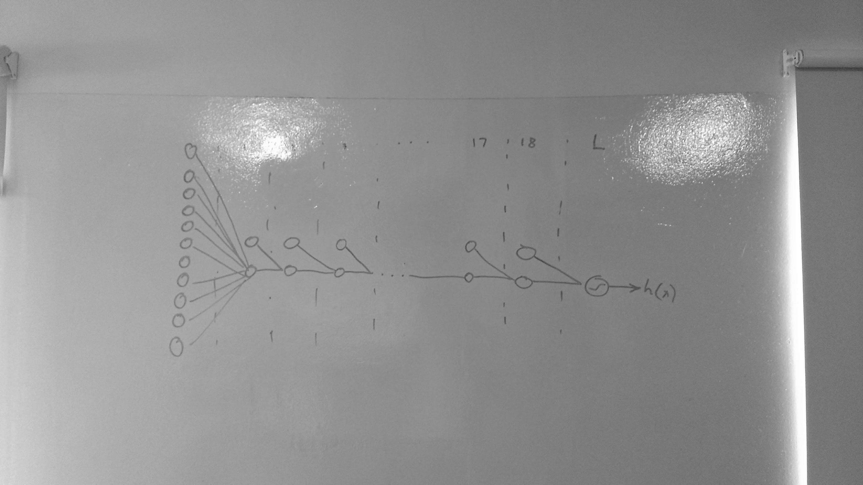

Which has 18 hidden layers consisting of a constant $x_{0}$ and one element $x_{1}$. Each layer has 2 weights that influence the $x_{1}$ in the following layer

So we have: $10+2⋅18=46$ weights

So the answer is A

# Problem 10

We look to do the opposite arrangement to maximize:

Consider a network with $L=3$ that has 10 input units connected to $n$ second layer units which are in turn connected to $m$ third layer units. We know that $m=36-n$.

We also know that the number of weights is:

$$\text{weights}=10⋅\left(n-1\right)+n⋅\left(m-1\right)+m=10⋅\left(n-1\right)+n⋅\left(35-n\right)+36-n$$

$$=44n-n^{2}+26$$

This is a downward facing parabola so the max is easily found at the vertex.

so we have $\max{(\text{weights})}=\text{weights}\left(-\frac{b}{2a}\right)$ where $b=44$ and $a=-1$

$$\text{weights}\left(22\right)=44⋅22-{22}^{2}+26=510$$

Which is the largest option and the answer is E