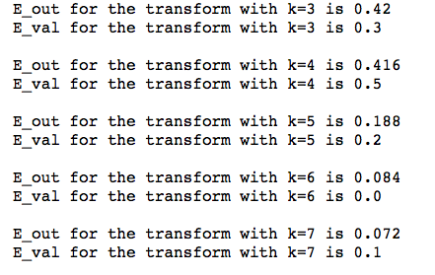

The simulation returned the above output:

So we have the following answers for questions 1 and 2

1. D
2. E

After switching the validation set and the training set we get

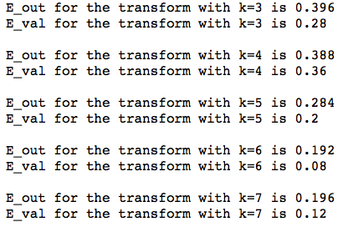

So we have the following answers for questions 3,4, and 5

1. D
2. D
3. We have (.084,.196) so the answer is B

# Problem 6

We must get a weighted average of all possible values of $e_{1}$ depending on how likely it is for $e_{1}=\min{(e_{1},e_{2})}$ vs how likely it is for $e_{2}=\min{(e_{1},e_{2})}$. We know that if $e_{2}<e_{1}$, then since $e_{2}$ is uniformly distributed and less than $e_{1}$, we can say that it is uniformly distributed over $[0,e_{1}]$

This considered we arrive at the following integral which I will write in two separate forms that are equal:

$$E\left[e\right]=\int_{0}^{1}{\left[P\left[e_{2}>e_{1}\right]⋅e_{1}+\left(1-P\left[e_{2}>e_{1}\right]\right)⋅E\left(e_{2}\right)\right]de_{1}}$$

Where we know for some $e_{1}$ we have:

$$P\left[e_{2}>e_{1}\right]=1-e_{1}$$

And

$$1-P\left[e_{2}>e_{1}\right]=P\left[e_{1}>e_{2}\right]=e_{1}$$

and

$$E\left[e_{2}\right]=\frac{e_{1}}{2}$$

so we have:

$$E\left[e\right]=\int_{e_{1}=0}^{e_{1}=1}{\left[\left(1-e_{1}\right)e_{1}+\frac{e_{1}^{2}}{2}\right]de_{1}}=\frac{1}{3}≈0.333…$$

$$E\left(e\right)=\int_{e_{1}=0}^{e_{1}=1}{\left[\int_{e_{2}=0}^{e_{2}=e_{1}}{e_{2}de_{2}}+\int_{e_{2}=e_{1}}^{e_{2}=1}{e_{1}de_{2}}\right]de_{1}}=\frac{1}{3}≈0.333…$$

Which is closest to 0.4 so the answer is

# Problem 7

Cross validation error:

$$E_{\text{CV}}=\frac{1}{N}\sum_{n=1}^{N}{e_{n}}$$

and

$$E_{\text{CV}}=\frac{1}{N}\sum_{n=1}^{N}{e_{n}}=\frac{1}{N}\sum_{n=1}^{N}{{\left(h_{n}(x)-y_{n}\right)}^{2}}$$

for the constant model we know that for any two points the hypothesis $h_{1}\left(x\right)=\frac{y_{1}+y_{2}}{2}$

so we have

$$E_{\text{CV}}=\frac{1}{3}\left[{\left(\frac{1}{2}-0\right)}^{2}+{\left(0-1\right)}^{2}+{\left(\frac{1}{2}-0\right)}^{2}\right]=\frac{1}{4}+1+\frac{1}{4}=\frac{1}{3}⋅\frac{3}{2}=\frac{1}{2}$$

For the linear model we have, given $\left(x_{1},y_{1}\right),(x_{2},y_{2})$:

$$\left(h\left(x\right)-y_{1}\right)=\frac{y_{2}-y_{1}}{x_{2}-x_{1}}\left(x-x_{1}\right)$$

$$⇒h\left(x\right)=\frac{y_{2}-y_{1}}{x_{2}-x_{1}}\left(x-x_{1}\right)+y_{1}$$

$$⇒h_{n}\left(x\right)=\frac{y_{2}-y_{1}}{x_{2}-x_{1}}⋅x-\frac{y_{2}-y_{1}}{x_{2}-x_{1}}⋅x_{1}+y_{1}$$

and

$$E_{\text{CV}}=\frac{1}{N}\sum_{n=1}^{N}{e_{n}}=\frac{1}{N}\sum_{n=1}^{N}{{\left(h_{n}(x)-y_{n}\right)}^{2}}$$

for leaving out $(-1,0)$ we have:

$$\left(x,y\right)=(-1,0)$$

$$\left(x_{1},y_{1}\right)=\left(ρ,1\right), {(x}_{2},y_{2})=(1,0)$$

$$e_{1}={\left(\frac{y_{2}-y_{1}}{x_{2}-x_{1}}\left(x-x_{1}\right)+y_{1}-y\right)}^{2}={\left(\frac{-1}{1-ρ}\left(-1-ρ\right)+1\right)}^{2}={\left(\frac{1+ρ}{1-ρ}+1\right)}^{2}$$

for leaving out $\left(ρ,1\right)$ we have:

$$\left(x,y\right)=(ρ,1)$$

$$\left(x_{1},y_{1}\right)=\left(-1,0\right), \left(x_{2},y_{2}\right)=(1,0)$$

$$e_{2}={\left(\frac{y_{2}-y_{1}}{x_{2}-x_{1}}\left(x-x_{1}\right)+y_{1}-y\right)}^{2}={\left(\left(0+0\right)-1\right)}^{2}=1$$

for leaving out $\left(1,0\right)$ we have:

$$\left(x,y\right)=\left(1,0\right)$$

$$\left(x_{1},y_{1}\right)=\left(-1,0\right), \left(x_{2},y_{2}\right)=(ρ,1)$$

$$e_{2}$$

$$e_{3}={\left(\frac{y_{2}-y_{1}}{x_{2}-x_{1}}\left(x-x_{1}\right)+y_{1}-y\right)}^{2}={\left(\frac{1-0}{ρ+1}\left(1+1\right)+0-0\right)}^{2}={\left(\frac{2}{ρ+1}\right)}^{2}$$

so we want:

$$E_{\text{CV}}\left(h_{0}\right)=E_{\text{CV}}(h_{1})$$

$$\frac{1}{3}\left[{\left(\frac{2}{ρ+1}\right)}^{2}+1+{\left(\frac{1+ρ}{1-ρ}+1\right)}^{2}\right]=\frac{1}{2}$$

$$⇒ρ=\sqrt{9+4\sqrt{6}}$$

by computer algebra system

So the answer is C

# Question 8

The simulation returned SVM performing better 62.5% of the time so the answer is C

# Question 9

The simulation returned SVM performing better 59.7% of the time so the answer is D

# Question 10

The simulation returned an average number of support vectors 2.998 so the answer is B