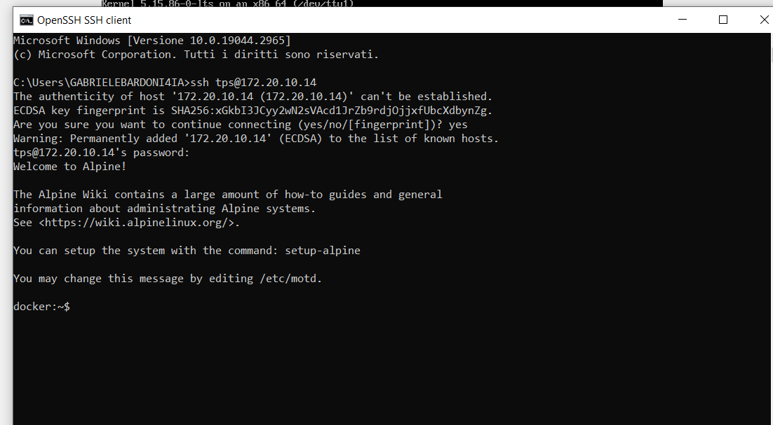

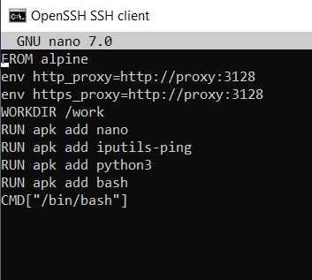



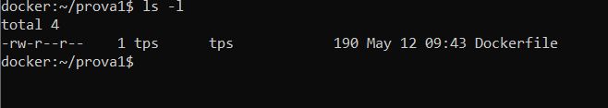

ISPEZIONE IMMAGINE:

docker:~/prova1$ docker image inspect img4

[

{

"Id": "sha256:1fcc26d3d6a9ddabf28e170593104b6a4f22e5fae264a2a2103d4123fe4cbe45",

"RepoTags": [

"img4:latest"

],

"RepoDigests": [],

"Parent": "sha256:1a381e63ec62294b874b93f8799915eab3d6c02181c2cd294dedd32c73319473",

"Comment": "",

"Created": "2023-05-12T07:43:23.146272662Z",

"Container": "0226d27cb17eceb300121deaea091a2f392e7247b2f1e375ac6a9cfe5efd53eb",

"ContainerConfig": {

"Hostname": "0226d27cb17e",

"Domainname": "",

"User": "",

"AttachStdin": false,

"AttachStdout": false,

"AttachStderr": false,

"Tty": false,

"OpenStdin": false,

"StdinOnce": false,

"Env": [

"PATH=/usr/local/sbin:/usr/local/bin:/usr/sbin:/usr/bin:/sbin:/bin",

"http_proxy=http://proxy:3128",

"https_proxy=http://proxy:3128"

],

"Cmd": [

"/bin/sh",

"-c",

"#(nop) ",

"CMD [\"/bin/bash\"]"

],

"Image": "sha256:1a381e63ec62294b874b93f8799915eab3d6c02181c2cd294dedd32c73319473",

"Volumes": null,

"WorkingDir": "/work",

"Entrypoint": null,

"OnBuild": null,

"Labels": {}

},

"DockerVersion": "20.10.20",

"Author": "",

"Config": {

"Hostname": "",

"Domainname": "",

"User": "",

"AttachStdin": false,

"AttachStdout": false,

"AttachStderr": false,

"Tty": false,

"OpenStdin": false,

"StdinOnce": false,

"Env": [

"PATH=/usr/local/sbin:/usr/local/bin:/usr/sbin:/usr/bin:/sbin:/bin",

"http_proxy=http://proxy:3128",

"https_proxy=http://proxy:3128"

],

"Cmd": [

"/bin/bash"

],

"Image": "sha256:1a381e63ec62294b874b93f8799915eab3d6c02181c2cd294dedd32c73319473",

"Volumes": null,

"WorkingDir": "/work",

"Entrypoint": null,

"OnBuild": null,

"Labels": null

},

"Architecture": "amd64",

"Os": "linux",

"Size": 52487651,

"VirtualSize": 52487651,

"GraphDriver": {

"Data": {

"LowerDir": "/var/lib/docker/overlay2/1f70842b77a0fadd6b581ebbd396df3765e2abdbddc65ddc6d07d69260bec28c/diff:/var/lib/docker/overlay2/c7c72be9a4c8853e8689cf10a73f5af54762b1fb97c6f35668193f69eac32b5d/diff:/var/lib/docker/overlay2/899d42e08beb7e471f3584381d42572e0a7aeb4a55abfd6e7d9d4b6e0f8b19d5/diff:/var/lib/docker/overlay2/339e67ca655d0dc3ae7da08742c44c11e036baf55186e909d3e46fd8652ed4cf/diff:/var/lib/docker/overlay2/c8d755123fdcdf4de4f9f695ce734b7f5c88332f28d9eb6fb1a0ec512c102913/diff",

"MergedDir": "/var/lib/docker/overlay2/d9576fbfd888d13bd2fda06e5f9dad9a414c65abdfa6173beaacda68554e5979/merged",

"UpperDir": "/var/lib/docker/overlay2/d9576fbfd888d13bd2fda06e5f9dad9a414c65abdfa6173beaacda68554e5979/diff",

"WorkDir": "/var/lib/docker/overlay2/d9576fbfd888d13bd2fda06e5f9dad9a414c65abdfa6173beaacda68554e5979/work"

},

"Name": "overlay2"

},

"RootFS": {

"Type": "layers",

"Layers": [

"sha256:bb01bd7e32b58b6694c8c3622c230171f1cec24001a82068a8d30d338f420d6c",

"sha256:4b8f2a15ef4445e547700a625ef5d71cb6e21711a1c59e81fec2bdf7c5250eaa",

"sha256:b1b34c1dbedf031e1068e32a0375e030fc9feb49bf4da2c78675085f46724d91",

"sha256:c0a100bb618012006c9988e72d40dedc2db09b403287b6fc3217a87e38d0fd95",

"sha256:286910b63d806b0f5e6f135fe3dadca6b1b311553bdbbc23d00c31222c673a12",

"sha256:8bbff41fa6aeb8881b2e1b922cb1c53121a9d4212197d9b6e0fea84d94e7c162"

]

},

"Metadata": {

"LastTagTime": "2023-05-12T09:43:23.204084586+02:00"

}

}

]