.

CERTIFICATION

The undersigned certify that they have read and hereby recommend acceptance by the University of Dar es Salaam a thesis entitled:
Business Cycles in Tanzania: A Monetary or Real Phenomenon?, in partial fulfillment of the requirements for the Degree of Doctor of Philosophy (Economics).

…………………………………….
Prof. Fidelis P. Mtatifikolo
SUPERVISOR

……………………………………...
Dr. Amon V. Y. Mbelle
SUPERVISOR

Date:………………………………

DECLRATION AND COPYRIGHT

I, Eliab Godfrey Luvanda, declare that this thesis is my own original work and that it has not been presented and will not be presented to any other University for a similar or any other degree award.

Signature……………………………

This thesis is copyright protected under the Berne Convention, the Copyright Act 1966 and other international and national enactments, in that behalf, on intellectual property. It may not be reproduced by any means, in full or in part, except for short extracts in fair dealing, for research or private study, critical scholarly review or discourse with an acknowledgement, without written permission of the Directorate of Postgraduate Studies, on behalf of both the author and the University of Dar es Salaam.

LIST OF TABLES
Table 5.2.1 Volatility Measures of Economic Fluctuations in Tanzania
Table 5.2.2 Correlation of Macroeconomic Variables with GDP
Table 5.2.3 Volatility Measures of Macroeconomic Variables Over Time
Table 5.3.1 Volatility Measures: Comparison with Selected Studies
Table 5.3.2 Correlation of Macroeconomic Variables with GDP: Comparison with Selected Studies
Table 6.2.1 ADF Unit Root Test for Variables
Table 6.3.1 Stepwise Regression of Δgdp on Δpop, Δopn, Δriv, Δprice, Δms2 and d.
Table 6.3.2 Stepwise Regression Results of Δgdp on Δpop, Δopn, Δms2, and d.
Table 6.3.3 Stepwise Regression Results of Δgdp on Δopn, Δriv, Δtot and d.
Table 6.4.1 Test for Lag length
Table 6.4.2 Tests for Residuals’ Autocorrelation and Autoregressive Conditional Heteroscedasticity.
Table 6.4.3 Variance Decomposition.

LIST OF FIGURES
Figure 4.2.1 Actual, HP Trend and Cyclical Component of GDP
Figure 4.2.2 Actual, HP Trend and Cyclical Component of Agricultural Output
Figure 4.2.3 Actual, HP Trend and Cyclical Component of Manufacturing Output
Figure 4.3.1 Actual, HP Trend and Cyclical Component of Private Consumption
Figure 4.3.1 Actual, HP Trend and Cyclical Component of Government Consumption
Figure (a) Actual, HP Trend and Cyclical Component of Price Level
Figure 3.4.1(b) Actual, HP Trend and Cyclical Component of Inflation

Figure 3.4.2(a) Actual, HP Trend and Cyclical Component of Money Stock (M2)
Figure 3.4.2(b) Actual, HP Trend and Cyclical Component of Growth of Money Stock (M2)
Figure 3.4.3 Actual, HP Trend and Cyclical Component of Nominal Budget Deficit
Figure 3.5.1 Actual, HP Trend and Cyclical Component of Investment
Figure 3.5.2 Actual, HP Trend and Cyclical Component of Grants and Foreign Aid
Figure 3.6.1 Actual, HP Trend and Cyclical Component of Exports
Figure 3.6.2 Actual, HP Trend and Cyclical Component of Imports
Figure 3.6.3 Actual, HP Trend and Cyclical Component of Terms of Trade

ACKNOWLEDGEMENT

I would like to express my sincere gratitude to my supervisors Prof. Björn Thalberg of the University of Lund; and Prof. Fidelis Mtatifikolo and Dr. Amon Mbelle of the University of Dar Es Salaam for their valuable guidance from the stage of writing a research proposal to the stage of writing this thesis. Their comments have tremendously contributed to the improvement of this study. I have also benefited from the guidance of Prof. Gote Hansson, the academic coordinator of the Dar-Lund co-operation.

I am very grateful to my employer, the University of Dar Es Salaam, for facilitating my studies. I would also like to express my profound appreciation to the Swedish International Development Agency (SIDA) for financing my scholarship for Ph.D. studies in Sweden, the African Economic Research Consortium (AERC) for financing most of the research, and the Crofoords Foundation in Sweden for providing me with a grant to buy a computer and a printer for this research.

My special thanks are due to Ulla Olofsson who, as a caring person and administrator of the Dar-Lund co-operation, made me feel very comfortable during all the time of my Ph.D. studies in Sweden. I am very grateful to Michael Bergman and Jesper Hansson who tirelessly helped me to understand how to use statistical software particularly RATS. From them and others like Fregert, Hans Falck, and Knut Odegaard to mention only a few, I have benefited from their valuable comments during my seminar presentations at the department of Economics, University of Lund.

Thanks to my colleagues and friends Servacius Likwelile, Innocent Karamagi, Festus Limbu, Michael Ndanshau, Timothy Nyoni, Longinus Rutasitara, Joseph Shitundu, Godwin Mjema, Oswald Mashindano and Adolf Mkenda for their various support. The co-operation of all my colleagues in ERB and Economics Department of the University of Dar es Salaam is highly appreciated.

I also wish to express my sincere appreciation to Stephen and Annette Munga and Charles and Flora Musonda and their families for their support. Last but not least, I wish to express my sincere thanks to my wife, Anna, and our two children, Herrieth and Elizabeth for their patience and encouragement.

E. G. Luvanda

ABSTRACT

Tanzania is a poor country whose economic performance has generally not been satisfactory. Between 1965 and 1995, her average (trend) economic growth rate was only 3 percent. The situation is even worse when it is also noted that, over the period, Tanzania’s annual economic growth rates have been fluctuating around the trend. For example, while the average annual growth rate in the 1960s and 1970s was about 4 percent, the average annual growth rate in the first half of 1980s was only 0.6 percent. This pattern of economic growth indicates that the economy of Tanzania has not been stable. Using the monetary and real business cycle theories, this study investigates one aspect of macroeconomic instability in Tanzania, namely the problem of output fluctuations (or business cycles). It examines the nature, main features, and causes of the fluctuations.
Decomposing Tanzania’s macroeconomic time series reveals that the series have been subject to fluctuations. Measurement of volatility and co-movement of the macroeconomic series further confirm that Tanzania’s macroeconomic variables have not been stable, and that the pattern of volatility and co-variation more or less resembles the ‘stylized facts’.
The vector autoregression (VAR) results show that the contribution of monetary disturbances to fluctuations in GDP is negligible. They account for less than one percent of the fluctuations in output. Real disturbances, which include terms of trade shocks, shocks to the price level and disturbances to GDP account for most of the fluctuations. It appears that business cycles in Tanzania are a real rather than a monetary phenomenon.

TABLE OF CONTENTS
CERTIFICATION i
DECLRATION AND COPYRIGHT iii
LIST OF TABLES v
LIST OF FIGURES vi
ACKNOWLEDGEMENT vii
ABSTRACT ix
TABLE OF CONTENTS x
CHAPTER I: Introduction 1
1.1 Statement of the Problem 1
1.2.Objectives of the Study 3
1.2 Significance of the Study 3
1.4 Theoretical Background and Hypotheses 4
1.5 Conceptual Framework 4
1.6 Methodology Error! Bookmark not defined.
1.7 Limitations 4
1.8 Organization of the Study 4
CHAPTER II: Business Cycles: A Review of the Literature 4
2.1 Introduction 4
2.2 Statistical Description of Cycles and Definitions 4
2.3 Business Cycle Theories 4
2.3.1 The Monetary Theories of Business Cycle 4
2.3.2 Real Business Cycle Theory 4
2.4 Empirical Studies 4
CHAPTER III: Trend and Cyclical Patterns of Tanzania’s Macroeconomic Variables 4
3.1 Introduction 4
3.2 Decomposition of Time Series into Trend and Cyclical Components 4
3.3 Gross Domestic Product. 4
3.3.1 Agricultural Output. 4
3.2.2 Manufacturing Output 4
3.3.3 Private Consumption 4
3.3.4 Government Consumption 4
3.4 Inflation, Money Stock and Government Budget Deficit 4
3.4.1 General Price Level and Inflation 4
3.4.2 Nominal Money Stock (M2) 4
3.4.3 Nominal Government Budget Deficit 4
3.5 Real Investment and External Finance 4
3.5.1 Real Investment 4
3.5.2 Grants and Aid 4
3.6 Exports, Imports and Terms of Trade 4
3.6.1 Exports 4
3.6.2 Imports 4
3.6.3 Terms of Trade 4
3.7 Summary 4
CHAPTER IV: Stylized Facts of Macroeconomic Fluctuations in Tanzania 4
4.1 Introduction 4
4.2 Examples from the Literature 4
4.3 Empirical Regularities of Economic Fluctuations in Tanzania 4
4.3.1 Volatility of the Variables 4
4.3.2 Correlation of GDP with other macroeconomic variables 4
4.3.3 Instability of macroeconomic variables over time 4
4.4 Comparison of the Findings with Similar Findings from Other Studies 4
4.4.1 Volatility of Variables 4
4.4.2 Contemporaneous correlation of GDP with Other Macroeconomic Variables 4
4.4.3 The Length of Business Cycle 4
4.5 Summary 4
CHAPTER V: METHODOLOGY 4
5.1 Introduction 4
5.2 Regression Model 4
5.2.1 Model Specification Error! Bookmark not defined.
5.2.2 Stationarity of the Variables 4
5.3 Vector Autoregression 4
5.3.1 Brief Review of the Vector Autoregression (VAR) Analysis. 4
5.3.2 Impulse Response Functions: 4
5.3.3 Variance Decomposition 4
5.3.4 Specification of the VAR 4
5.3.5 Stationarity of Variables 4
5.4 Data 4
Chapter VI: Macroeconomic Fluctuations in Tanzania: Relative Importance of Monetary and Real Shocks. 4
6.1 Introduction 4
6.2 Unit Root Tests. 4
Lags 4
6.3 Regression Results 4
6.4 VAR Empirical Results. 4
6.4.1 Test for Lag Length 4
6.4.2 Significance of the dummy variable 4
6.4.3 Impulse Response Functions 4
6.4.4 Variance Decomposition 4
6.5 Summary 4
CHAPTER VII: Summary and Conclusions 4
7.1 Summary of Major Results 4
7.2 Comparison with other Studies 4
7.3 Recommendations 4
7.4 Suggested Areas for Further Research 4
BIBLIOGRAPHY 4
APPENDIX 4

CHAPTER I

Introduction

Statement of the Problem

The short and medium term objective of macroeconomic policy is to stabilize output by minimizing the deviation of actual output from potential output. Macroeconomists policy makers and even ordinary citizens are always concerned about the deviations and particularly recessions because they are associated with high rates of unemployment and significant loss in people’s welfare. In Tanzania, economic stabilization has been one of the major macroeconomic policy concerns of the government for quite some time. For example, since the early 1980s the government has formulated several programs to stabilize the economy and to ensure resumption of economic growth. The earlier two programs [National Economic Survival Program - NESP (1982), and Structural Adjustment Program - SAP (1984)] failed to achieve that goal due to two main reasons. First, external resources were not available to support the policies. Second, the policies themselves were not comprehensive enough to be effective. For example, removal of trade restrictions and devaluation of the domestic currency were only marginally effected.
Though the externally supported Economic Recovery Programs (ERP II and I) managed to stop recession, the average annual growth rate target of 5 percent has been elusive. During the ERP I (1986−88), for example, the average annual growth rate was only 3.9 percent.
Moreover, the impressive growth rate of 5.1 percent, recorded in 1987, could not be sustained for more than one year. In 1988 the growth rate went down to 4.2 per cent, and ever since the growth rate has almost been below 4 per cent. In 1993 and 1994 GDP growth rates were 3 per cent and 4 per cent respectively. These rates, besides their fluctuation, are low for a developing country that needs to grow fast to overcome poverty and backwardness.
Furthermore, economic fluctuations, definitely, are not conducive to a sustained rapid long-term growth owing to the fact that economic instability creates uncertainty, which discourages investment. In spite of intentions and efforts by the government to achieve a sustained and rapid economic growth, a low rate of economic activity, unemployment and cyclical fluctuations are still serious problems in Tanzania.
The aim of this study, is to investigate, to what extent Tanzania has experienced cyclic fluctuations, the kind of these fluctuations, and the main causes behind them. Referring to monetary and real business cycle theories, the study addresses more specifically the question of whether the problem of output fluctuations in Tanzania is essentially due to demand disturbances or supply disturbances. The kind of stabilization policy needed to control the fluctuations depends very much on the answers to this question.

1.2.Objectives of the Study

The main objective of this study is to analyze the main features and causes of macroeconomic fluctuations or business cycles in Tanzania. The specific objectives of the study are as follows:
- to decompose Tanzania’s macroeconomic time series from 1965 to 1995 into trend and cyclical components, and examine their main characteristics.
- To study the empirical regularities of macroeconomic fluctuations in Tanzania.
- to identify the main causes of output fluctuations.
- to assess the relative importance of the causes of output fluctuations.

1.2 Significance of the Study
The significance of the study is its potential usefulness in macroeconomic policy making in Tanzania. This study, apart from examining the main characteristics of output fluctuations, it also examines the relative contribution of monetary and real disturbances to output fluctuations in Tanzania. We hope that, empirical evidence that is based on better theoretical insight as provided by this study might help to provide policy makers with a clearer picture of the problem of output fluctuations.
Another significance of this study is its contribution to knowledge. Owing to the fact that the subject of business cycles is one of the areas that have been scantily studied in Tanzania in particular and perhaps in Africa in general, this study will possibly stimulate interest in the subject in Tanzania.

1.4 Theoretical Background and Hypotheses
This study is based on two strands of business cycle theories. These are the monetary and Real Business Cycle (RBC) theories. According to RBC theory of business cycles, output fluctuations are caused mainly by real shocks in the form of technological disturbances. The monetary theories on the other hand claim that monetary or nominal disturbances are the main source of output fluctuations.
This study uses Tanzania’s macroeconomic time series to test the RBC and monetary hypotheses of business cycles. The two hypotheses to be tested are as follows:
- Monetary hypothesis of business cycles: Output fluctuations are caused by shocks to the money stock.
(2) Real Business Cycle hypothesis of business cycles: Output fluctuations are caused mainly by technological shocks.

1.5 Conceptual Framework
Conventionally, the causes of output fluctuations are grouped into two broad categories of “real” disturbances and “monetary” disturbances. According to the real business cycle theory, random or stochastic technological disturbances cause fluctuations.
Some authors, however, such as Hall (1988), Hoover (1988) (see Leslie 1993, pp. 149-50) and Mankiw (1989) express reservation about this perception. They argue that ‘it is very difficult to formally identify a technological shock’. Hall (1988) for example, argues that when the Solow residual, which is used to measure technological change, is usually correlated along the cycle with other factors, such as political changes and oil price movements. He contends that since these factors do not affect technology significantly, it is very difficult to attribute output fluctuations to technological shocks (See also Romer (1996), pp. 186-87). Due to the ambiguity in defining what constitute technological shocks, the common practice in research on business cycle seems to have been to consider factors that affect the supply side of the economy generally as constituting what is referred to as real shocks. Hansen (1994) for example considers real shocks to include, together with changes in the ‘conventional’ technology that affects the production function, ‘changes in rules and regulations that govern the conduct of business’, and changes in political, social and economic institutions. This study also uses this broad view of the meaning of real shocks.
Regarding monetary theories of business cycles, this study also adopts a broad view, by which, monetary theories are defined as all those theories that attribute output fluctuations to demand, sometimes also called nominal, disturbances. Thus, monetarist, all variations of Keynesian, and the new classical rational expectations theories are construed to constitute what in this study is referred to as the monetary theories of business cycle.

1.6 Scope and Limitations

The period coverage for this study is from 1965 to 1995. One would have liked to have a longer period than this, so as to have a ‘sufficiently’ large data sample. This was not possible because in the first place, with the exception of GDP and the consumer price index (CPI) or the GDP deflator, it is very difficult to get hold of data for macroeconomic variables for the period before 1965. Second, the write up of this study began in 1996 and therefore it was not possible to go beyond 1995.
This study relies, as is usual in most developing countries, on unreliable and relatively small sample size of data. Carrying out empirical time series analysis requires a ‘sufficiently’ large data sample. Thus, in this study the quality of data is certainly a major shortcoming. However, the alternative of analyzing the problem of output fluctuations in Tanzania now is to wait perhaps at least another 20 years when by then there might be ‘sufficient’ time series observations. We believe that, carrying out this study now with the shortcoming in mind, and interpreting the results of the study with caution, is a better alternative.

1.7 Organization of the Study

The remainder of this study is organized as follows. Chapter II reviews the literature on business cycles. It begins with reviewing the concept of business cycle in relation to the trend. Review of theoretical and empirical works is carried out in the last two sections of the chapter.
Chapter III presents the methodology. The chapter also discusses the source and quality of data. Chapters IV and V present the salient features of macroeconomic fluctuations in Tanzania. Discussion of decomposition of Tanzania’s macroeconomic time series into trend and cyclical components is carried out in chapter IV. Chapter V examines the stylized facts of business cycles in Tanzania. Empirical regularities, or ‘stylized facts’ of Tanzania’s macroeconomic fluctuations and the comparison with stylized facts in other economies are presented. Chapter VI presents empirical findings of the study. The summary of the study, main findings, recommendations and suggested areas for further research are presented in Chapter VII.

CHAPTER II

Business Cycles: A Review of the Literature

2.1 Introduction

This chapter reviews the literature on both the theories and empirical studies of business cycles. Section 2.2 discusses the concept of business cycle in relation to trend. Section 2.3 reviews business cycle theories. Empirical studies are reviewed in section 2.4.

2.2 Statistical Description of Cycles and Definitions

Most economic variables vary more or less steadily over time around a trend. A trend is supposed to describe a long run tendency. It is used in a backward perspective to describe what has happened (largely seen), and it may be used in a forward-looking perspective to describe what might happen in the future. A time series that contains a trend lacks a constant mean towards which it tends to return. We may test this tendency by plotting the variable and its mean. If the variable only passes the mean once or twice, it contains a trend. If it passes the mean many times, that is, it wiggles around the mean, it does not contain a trend.
Traditionally, the long-term tendency of a variable is often described by a deterministic exponential trend. The interpretation of the exponent is very simple and straight forward, saying for example that prices have increased by on average ten per cent per year over a certain time span. However, in many cases it seems better to work with more complicated forms of trend, or with stochastic trends (Cf. Fregert 1996, p.40). We return to this question about the form and kind of the trend when discussing the calculation of cyclical components in Chapter 4.
We define trade or business cycles as more or less strongly correlated cyclical fluctuations (of variable length) in, as a rule detrended, macroeconomic variables. Some authors, for example Englund et al (1992), in a recent Swedish study, include in the definition also a certain ‘appropriate’ length of the cycles. However, in this study, we leave the question about the length of the cyclical fluctuations open. The statistical description and analysis of business cycles have long been a main task of the economics profession. Notable is the Mitchell - Persons empirical school, which was very active in the beginning of the twentieth century (1900 to late 1920s). In this period institutions for the observation and study of cycle data were established in many industrialized countries. The method was descriptive; cycles were registered and compared to a calculated average norm. In this way several “stylized facts” about the cycle phenomenon were established. For example the existence of cycles (or cyclical components) of various lengths, that is the Kitchin (3-year), Juglar (10-year), Kuznets (20 year) and Kondratiev (50-year) cycles was noted. It was also found that the volatility of investment is considerably larger than the volatility of total income and total consumption. Further, it was established that there exist a certain structure of leads and lags among central macroeconomic variables over the cycle. The idea that observed cyclical fluctuations are a combination of cycles of different lengths has now been more or less abandoned. To quote David Romer (1996, p147):

“Because output movements are not regular, modern macroeconomics has generally turned away from attempts to interpret fluctuations as combinations of deterministic cycles of different lengths; efforts to discern regular Kitchin (3-year), Juglar (10-year), Kuznets (20-year), and Kondratiev (50-year) cycles have been largely abandoned as unproductive. Instead the prevailing view is that the economy is perturbed by disturbances of various types and sizes at more or less random intervals, and that those disturbances then propagate through the economy.”

2.3 Business Cycle Theories

Modern theories of the trade or business cycle thus build, as Romer points out, on an impulse–propagation type of model or analysis. The model of propagation mechanism describes how the economy adjusts to shocks (impulses) (Cf. Fregert 1996). Economists seeking to explain the cycles may disagree o both the model of the propagation mechanism and the kind of relevant impulses or shocks. To get, firstly, into the question of shocks, two broad categories of exogenous disturbances or shocks could, according to the literature, drive the cycle. First, demand side disturbances (that is, fluctuations in money supply and fluctuations in exogenous components of aggregate demand−for example exports) may cause of output fluctuations. Monetarists and Keynesians believe that demand disturbances drive the cycle. Second, output fluctuations may be due to random supply side disturbances, particularly shocks to technology. This is the basic position of the real business cycle theorists.
Apart from the above kind of theories, there are also theories that do not consider demand and real disturbances as the driving force of the cycle. These theories assume that endogenous forces of the economic system produce (self-generated) recurrent cycles, which are kept within certain limits (ceiling and floor) by certain non-linearities.

2.3.1 The Monetary Theories of Business Cycle

In this study, we define monetary theories of business cycle broadly as including Keynesian, monetarist and new Keynesian kind of models. However, these theories differ in various respects. For instance there are disagreements on how markets operate, the mechanism through which demand disturbances bring about output fluctuations, and on policy prescriptions to control the fluctuations.

2.3.1.1 Keynesian Theory of Business Cycle

According to the Keynesian and new Keynesian perspective, output fluctuations are simply a reflection of market failures, in the sense that the market (pricing) mechanism works slowly and is not strong enough to provide the necessary price adjustment needed to restore full employment after a demand disturbance. Fluctuations in both the money supply and autonomous expenditure are considered to be the main source of economic disturbances. Fluctuations in money supply indirectly induce fluctuations in aggregate demand and particularly in investment spending through its influence on the rate of interest and availability of money. Fluctuations in autonomous consumption, autonomous investment, government spending and exports directly initiate fluctuations in aggregate demand. According to these theories, due to sticky prices or relatively slow price-adjustment, the burden of adjustment is born more by quantity changes (and thus real output) than by prices. Thus, as aggregate demand fluctuates, output also fluctuates.
New classical economists like Barro (1977) and Lucas (1975) have criticized the view that sticky prices or gradual price adjustment can explain output fluctuations. They argue that it is only the irrational economic agents who would trade at “disequilibrium” (sticky) prices. For in such trade, they argue, some agents do not exhaust the gains from trade. Generally, optimizing agents mutually maximize gains from trade only when they trade at equilibrium prices.
In response to the criticism by new classical economists, the so-called new Keynesians have attempted to construct theories that are directly based on micro–theoretic foundations (individual utility maximization and profit maximization). These theories seek to rationalize sticky prices and gradual price adjustment so as to provide a theoretically more satisfactory explanation than conventional Keynesian models of the existence and role of sticky prices in generating output fluctuations.
One strand emphasizes and rationalizes rigidity of prices in the goods’ market (see for instance Mankiw 1985; Akerlof and Janet 1985; and Greenwald and Stiglitz 1988). For example, menu (adjustment) cost is thought to be a source of price-rigidity in this market. According to this theory, risk-averse agents (traders) are usually worried by the possible response of rivals and customers in case they (agents) adjust prices following a demand fluctuation. In response to demand fluctuations, the agents would prefer to adjust the quantities they produce rather than changing the price. In general, the central point of the menu cost hypothesis is that the role of prices is more than that of clearing the markets in the Walrasian sense. Nominal prices do not change as often as there are fluctuations in demand, prices are kept ‘stable’ by economic agents as a means to retain and attract customers.
Another strand emphasizes wage rigidity in the labor market. The theories in this strand argue that wages are sticky because the role of wages is more than that of equilibrating supply and demand in the labor market. One theory is based on the efficiency wage hypothesis. According to this hypothesis, wages serve, in addition to having the role of equilibrating the labor market, also the firm’s objective of stimulating the efforts of the workers and consequently enhancing labor productivity (Weiss 1980; Akerlof 1982, 1984; and Campbell 1993; Naish 1993). Thus, in times of unemployment (excess supply of labor) employers would be reluctant to push wages down, because lower wages may reduce labor productivity.
Another source of wage-stickiness is implicit or explicit labor contracts which set wages in response to long term considerations, like job security for workers and reducing job turnover and therefore promoting efficiency for firms. In this context, wages in the labor market may not adjust to short term disturbances.
It is interesting that Keynes himself stressed the volatility of price expectations as an important cause of the cycle. He talked in this connection of the “animal spirit” of investors. According to Keynes (1936), investors’ expectations of the uncertain future may cause fluctuations in investment and consequently fluctuations in output.

2.3.1.2 Monetarist Theory of Business Cycles:

Another variant of the monetary business cycle theories is the monetarist version. Unlike most Keynesian theorists, monetarists believe that the private economy is inherently stable, and that the main source of aggregate demand fluctuations and subsequently the rate of output volatility are the fluctuations in money supply. On the basis of quantity theory of money, monetarists argue that money supply directly affects aggregate demand. As money supply increases, agents who want to hold a fixed proportion of their wealth in terms of cash, attempt to dispose off extra cash balances through increased spending on goods and services, and thus raising the nominal aggregate demand.
Monetarists, as Keynesians do, identify “sticky” or gradual price adjustment as an important part of the transmission mechanism through which aggregate demand fluctuations lead to output fluctuations (Blanchard and Fischer (1989), and Phelps (1990)). The monetarist explanation for gradual price adjustment is, however, the agents’ adaptive expectations (Naishi 1993). As agents form expectations adaptively, prices do not jump instantly to equilibrate demand and supply. Rather, they move slowly until eventually they attain equilibrium values. Thus, following a nominal demand shock output growth departs from its natural rate; but with time, it reverts to its natural rate as prices adjust towards equilibrium levels. It is partly due to such a built-in automatic tendency for output to return to its potential (or equilibrium) level that monetarists discourage government intervention to stabilize the economy.

2.3.1.3 The “Rational Expectations” Theory of Business Cycles

A third variant of the monetary business cycle theories is the new-classical school of thought. Just like the monetarists, adherents of this school, such as Barro, Lucas and Sargent, strongly argue that the private economy is stable at full employment level. However, there are two important aspects that distinguish the new classical theory from the monetarist theory.
First, new classical theorists challenge the model of adaptive expectations. They argue that adaptive expectations imply that agents do not use all the costless information in predicting future values of the economic variables. Thus, while the monetarists assume that agents’ expectations are based on past values of the variable and past prediction errors to predict its future value, new classical theorists argue that expectations are formed rationally in the sense of Muth (1961). According to Muth (1961), rational optimizing agents generally use all relevant information and a relevant economic model or relevant insight, to predict the future values of main variables. Second, new classical theorists assume that prices are flexible in the Walrasian sense and they adjust fully and instantly to clear the markets.
If markets operate according to new classical propositions, the economy will always be at full employment. Regarding the “classical dichotonomy”, Lucas rationalizes why changes in money supply may affect the real economy. He argues that as long as the future is unknown and agents do not have perfect information on the current state of the economy, agents are unable to distinguish between relative price and general price level changes following a demand disturbance. Thus, even a purely change in the general price level due to aggregate demand shock can induce agents to vary their supplies. However, the deviation of actual output from trend output is just transitory lasting only for the period in which agents have misperceptions about the state of the economy. Lucas’ idea has, however, been strongly criticized. Keynesian critics specifically argue that given today’s enormous flows of information (to a lesser extent even in developing countries), it seems too unrealistic that agents should not be able to follow very closely both the developments of the general price level and relevant relative prices.
It may also be mentioned that anticipated demand disturbances, according to Lucas and the new classical school, have no effect on real economic activity. Accordingly, the new classical policy prescription is that government’s policy will not work even in the short run as long as rational optimizing agents anticipate it.

2.3.2 Real Business Cycle Theory

Real Business Cycle (RBC) models became influential in the 1980s. Barro’s 1980 work is cited by Phelps (1990) as being the first one to make a serious and systematic inquiry along the real business cycle line of thinking. The other two influential papers (Kydland and Prescott (1982) and Long and Plosser (1983)) followed Barro’s work. Two major aspects gave motivation to the revival of the real business cycle models. First, the Keynesian research methodology which start by assuming market failure to be the source of fluctuations and then proceed to investigate the source of market failure, is disputed by the real business cycle theorists. According to RBC theorists such a research strategy is misdirected.
RBC theorists, for instance Plosser (1989), argue that a logical and proper way of investigation should proceed in two stages. First, economists should try to understand the fluctuations that could arise within “a perfectly working competitive dynamic economic system’’, and then only later should market failures in the form of externalities, asymmetric information and missing markets be incorporated in the analysis. In propounding this argument, RBC theorists draw inspiration from Hicks, who in 1933 initiated the idea in one of his classic articles: “Equilibrium and the cycle”. As of now, however, even some prominent and influential Keynesian scholars such as Blanchard and Fischer (1989, p.320) subscribe to this idea.
The other aspect that inspired a resurgence of the RBC models was what Mankiw (1986) describes as “the breakdown of the Phillips curve” in the 1970s (see also Barro, 1989). The Keynesian policy prescription that a society could buy a `permanent economic high’ by continuously printing paper money lost credibility because expansionary monetary and fiscal policies seemed to be counter–productive. They only accelerated inflation without reducing unemployment. They generated stagflation. There was awareness among macroeconomists that the “Keynesian synthesis” which focused mainly on the demand side of the economy was incapable of coping with supply disturbances that were, for example, caused by the dramatic oil price rise in the early 1970s.
In principle, the RBC school builds on the same framework that the new classical school uses. This is not surprising because most of the RBC proponents were initially strong adherents of the new classical approach (Barro 1989). Thus, like the new classical models, RBC models are within the Walrasian equilibrium framework in which rational optimizing agents operate in competitive markets that always clear. However, according to the RBC school, the only source of output fluctuations is supply disturbances, in particular more or less the random fluctuations in the rate of technological change that takes the form of fluctuations in factor productivity. Solow’s (1956, 1957) neoclassical growth model is a point of departure for the real business cycle model. It is for this reason that the RBC model is said to integrate both the growth and business cycle theories.
The RBC model starts by considering the growth of aggregate output in a perfectly competitive economy characterized with constant returns to scale technology. The growth in output can be expressed by the following equation:
where 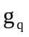, 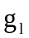 and 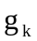 represent growth rates of output, labor and capital respectively. β represents the relative share of output of labor, and μ is the so called “Solow`s residual”, representing multi–factor productivity growth. Equation (1) can be expressed alternatively as
According to equation (2.2) the growth rate of output per capita is determined by the growth of capital-output ratio and the Solow residual. According to the RBC theorists, stochastic fluctuations in the technical progress, and hence the fluctuations in the Solow residual μ, is the main source, or the impulse mechanism that drives fluctuations in GDP. Further, RBC theorists identify consumption smoothing, lags in production of capital, variations in inventories to meet unforeseen changes in demand and intertemporal substitution of leisure as parts of the propagation mechanisms through which a real shock can have a prolonged expansionary or contractionary effect on output.
In the RBC framework, money does not play an active role. Fluctuations in the money stock are preceded by fluctuations in the actual output. Changes in the real economic activity induce changes in demand for money; that is, monetary authorities respond to changes in demand for money by accordingly changing money supply. According to RBC theorists, money supply and output are positively correlated because of this behavior of monetary authorities.

2.4 Empirical Studies

Empirical studies to investigate the relative importance of supply and demand disturbances use two main approaches. First, is the univariate time series analysis which has been used, for example, by Beveridge and Nelson (1981), Nelson and Plosser (1982) and Perron (1988). Second is the Vector Autoregression (VAR) analysis, which has been used, for example, by Leiderman (1984), Fair (1988), Shapiro and Watson (1988), Blanchard and Quah (1989), Reinhart and Reinhart (1991) and Karras (1993).
The univariate time series analysis focuses on the behavior of a single variable time series. This approach has partly been motivated by advances in the econometrics of non-stationary time series, especially the study of dynamics in terms of linear stochastic difference equations (Fitousi and Velupillai, 1987). Basically, the approach proceeds through decomposing the gross domestic product (GDP) time series into secular and cyclical components. The secular component captures economic growth that is due to real factors such as labor force growth, capital accumulation and technical progress. The cyclical component represents deviations of output from the trend output. The deviations are assumed to be temporary and to be caused by monetary or demand factors. To use the time series analysis jargon, the cyclical component is assumed to be stationary; while the trend component is assumed to be non-stationary following a random walk process with a drift.
Empirical studies employing this approach, attempt to assess the relative contribution of these components to output fluctuations. Within the univariate time series analysis, there are two methods of assessing the relative importance of the two components. First, the method employing Box−Jenkins ARIMA models. Following Beveridge and Nelson (1981), it is assumed that the (stochastic) trend innovation and the transitory component innovation are perfectly correlated, and therefore, it ‘reduces all unforeseen economic events into a single innovation’ (see Stock and Watson, 1988 p.154). Second, the method employing ‘Unobserved Components’ ARIMA (UC−ARIMA) models assumes that the two innovations are not correlated, that is, ‘the changes in trend and transitory fluctuations are unrelated, except that both affect GDP’ (see Stock and Watson, 1988 p.154).
The following studies using univariate time series analysis have been carried out using U.S. time series data: Bereridge and Nelson (1981), Nelson and Plosser (1982), Harvey (1985) and Perron (1988). These studies confirm the view that GDP contains stochastic trend, that is, supply disturbances play a role in economic fluctuations. However, according to Stock and Watson (1988 p.158), the findings do not provide an unambiguous answer as to the relative importance of the permanent and transitory component innovations in explaining fluctuations in GDP.
Stock and Watson (1988) and Blanchard and Quah (1989) argue that, ‘if GDP is, as is more likely, affected by more than one type of disturbances’, assessing the relative importance of the shocks within the univariate representation, becomes ‘more difficult’. Hence, they recommend Vector autoregression (VAR) analysis which facilitate the ‘exploitation of useful information’ regarding economic fluctuations from macroeconomic variables other than GDP.
The essence of the VAR approach in the studies of economic fluctuations is to integrate the pure statistical Box-Jenkins methods of time series analysis together with some fragments of pure economic theory. Again, most of the empirical studies that employ the VAR method have been carried out in the developed countries and particularly in the United States. Shapiro and Watson (1988), Blanchard and Quah (1989) and Karras (1993) argue that in the US output fluctuations are mainly due to supply shocks. King et al (1991) observe that their findings show that the Real Business Cycle is confirmed only when the monetary variables are excluded from the model. Ahmed and Park (1994) arrive at the same conclusion in their study of sources of economic fluctuations in seven OECD open economies (Australia, Austria, Canada, Finland, Francee, Italy and United Kingdom). Mellander et al (1992) find that permanent real shocks explain most of the fluctuations in GDP in Sweden, ‘even in the short run’.
Reinhart and Reinhart (1991) have carried out a similar study for a developing country - Colombia. Their empirical evidence suggests that demand (monetary) disturbances play an important role in output fluctuations.
Regarding empirical studies on cyclic fluctuations in Tanzania, Van Arkadie, Komba and Karamagi (1991) have carried out a study on trends and cycles in Gross Domestic Product (GDP). Their objective was to examine the main features of trend and cycles of GDP and the structural changes that have taken place in Tanzania. Their study provides a good collection of Tanzania’s GDP data (1950-90), a fairly comprehensive discussion of methodological issues of GDP data collection in Tanzania, and a general description of the behavior of GDP and inflation in Tanzania. Using what may be called “common sense empiricism”, they argue that no significant structural change has taken place, and that GDP in Tanzania has been reasonably stable.
Contrary to what Van Arkadie et al. concludes, we believe that the economy of Tanzania has experienced serious instability. Therefore, we intend in this study, to explore further the subject of macroeconomic fluctuations in Tanzania. This study differs from Van Arkadie et al in three main aspects. First, we intend to use more refined time series methods of separating trend and cyclic components in time series. In this way, it will be possible to examine the main features of the series more accurately. Second, besides investigating the main features of trend and cycles, we also attempt to investigate the causes of the cycles in Tanzania; and this will be main task and contribution of this study.
Moreover, like the other studies that have been mentioned, we seek to examine the relative importance of demand and supply disturbances in explaining output fluctuations (in Tanzania). Apart from quantitative analysis the study will also consider the effects of some unquantifiable factors (such as, policy changes, institutional changes and war) on the economic performance.

CHAPTER III

METHODOLOGY

3.1 Introduction

In a study of business cycle such as this one, it is imperative to examine empirically both the nature and the causes of the problem. In this chapter, we present the methodology of investigating the nature and causes of business cycles in Tanzania. In Section 3.2, we present the methodology of decomposing the macroeconomic time series into trend and cyclical components. The empirical results of decomposing the series are presented in Chapter 4. In Section 3.3, methods of studying the stylized facts of business cycles are discussed. Stylized facts of business cycles in Tanzania are presented in Chapter 5. A simple regression model and vector autoregression (VAR model for examining the causes of output fluctuations are presented in Section 3.4. Simple regression and VAR results are presented in Chapter 6.

3.2 Decomposition of Time Series into Trend and Cyclical Components

In time series approach to the study of business cycles, a macroeconomic time series 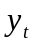 is considered to be composed of two components; the permanent (or secular) component 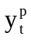, and the transitory component 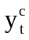. The model is generally of the type:
where 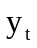 is logarithm of actual observation, is a trend or secular component and represents deviations from trend or a cyclical component. Traditionally, in Equation (3.2.1), has usually been considered to be either a linear, or exponential, or logarithmic, or polynomial function. Trend has been considered to be deterministic. In the real world, the growth rate of GDP varies over time. In some periods growth in economic activity is stronger than in other periods. In Tanzania for example, growth rates of GDP were generally higher in the 1960s than in the 1970s and even far higher than the growth rates in the 1980s. Given this fact, it is now generally accepted that estimated trends for macroeconomic variables should reflect changes in the patterns of growth. Within the class of deterministic trends, the polynomial, exponential and logarithmic trends to some extent meet this criterion.
In recent literature, methods for stochastic detrending macroeconomic time series are commonly used. Stochastic detrending methods have gained prominence following the RBC conception that random movements in trend can explain fluctuations in macroeconomic variables (see Nelson and Plosser, 1982). The idea of stochastic trends in macroeconomic time series is also plausible if one considers that growth or changes in macroeconomic variables over time are characterized by uncertainty. The most popular among the stochastic detrending methods is the Hodrick Prescott (hereafter referred to as HP) (1980) filter. The other and more recent is the Baxter–King (1995) filter.
As shown by Guay and Amant (1997), Harvey and Jaeger (1993) and King and Rebelo (1993), ‘the infinite sample version of the HP filter can be rationalized as the optimal linear filter of trend component for the following process’:
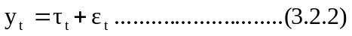
where 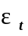 is an irregular component with a property 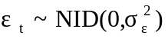 and the trend component, , is defined by:
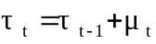,
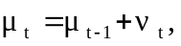
with 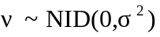. 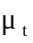 is the slope of the process and 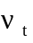 is independent of 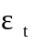.

The HP trend for a variable y is found by minimizing:

The idea behind equation 3.2.3 is to minimize the sum of two components. The first is the sum of squares of the deviation of the actual value of a variable from its trend value. The second is the sum of squares of changes in the trend growth. A series of trend values that gives the minimum value of equation 3.2.3 is the HP trend or filter.
A parameter, λ, controls the degree of smoothness in the HP trend. On the one hand, a smaller value of λ reduces the importance of change in trend growth. For λ=0, a minimum value of equation 3.2.3 is given by selecting the trend value equal to the actual value of the variable. In this case, there cannot be deviations from trend. On the other hand, a very high λ diminishes the significance of the first component. In the limit, a smooth deterministic trend yields the minimum of the total sum, and the cyclical component of a variable will be large.
To get a ‘reasonable’ variable trend, one must choose an intermediate value of λ. Hodrick and Prescott (1980) recommend λ=1600 for quarterly data, and λ=100 for annual data. However, Ravn et al (1997) recommend λ=6.75 for annual data. In this study, however, we consistently use λ=100 because of two main reasons. First, this study uses annual data, which is relatively easier to obtain in a developing country such as Tanzania. It is very difficult to get quarterly data for most of macroeconomic variables in developing countries. The second reason is that, later on in the next chapter, we will compare Tanzania’s business cycle stylized facts results with results from other studies (for example Grunfeld, 1996 and Englund et al, 1992) most of which also use λ=100 or λ=200.

3.3 Analysis of Stylized Facts of Business Cycles

In establishing empirical regularities of economic fluctuations, the general norm has been to base the analysis on detrended macroeconomic time series (see Englund et al, 1992; p.343). The main reason for doing this is to avoid drawing conclusions based on spurious correlation. Several methods are used to detrend the time series in order to derive stationary time series. Some studies, for instance Englund et al (1992), use the differencing method in which the differenced series are used to calculate the variability (standard deviation) and the correlation statistics. Other studies for example Englund (1992), Grunfeld (1996) and Danthine et al (1993) use the Hodrick–Prescott (HP) (1980) filter. The residuals, obtained from subtracting the HP growth component from the time series are used to calculate the variability and correlation statistics. According to Danthine and Donaldson (1993, p.5), the HP (1980) filter is relatively more appropriate for four reasons. First, it is simple and operational. Second, it provides an intuitive definition of trend, which is supposed to be removed to render a series stationary. Third, it renders stationary even series integrated up to the fourth order. Lastly, there is no dominating alternative that has been proposed so far.
However, Danthine and Donaldson (1993) argue that the filter being statistical in nature leads one ‘to contemplate the data from a specific angle which may distort some important facts’. They thus suggest that other alternatives should be used as well in order to derive a realistic picture of facts related to economic fluctuations. Accordingly, this study employs the HP (1980) filter method as presented in Section 3.2 above, but also as an alternative the differencing method to detrend the macroeconomic time series is used.
Englund, Persson and Svensson (1992) go farther in the treatment of data. After detrending the time series, they use the Fourier transform to decompose the stationary series’ total variance into variances attributed to different frequencies, and they pick only that part of the spectra which corresponds to cyclical component of the business cycle duration of around five years and leave out cyclical components of shorter and longer duration. The refined time series are then used to calculate the variability and correlation statistics. Given the fact that this study relies on a small sample and that the length of the cyclical fluctuations in the Tanzanian case seems more variable and uncertain, farther refinement of data by using spectral analysis (which requires relatively a large sample) will not be undertaken. As suggested, an a priori assumption of cycle duration of approximately five years seems, for the case of Tanzania, not justifiable.

3.4 Models to Examine Causes of Business Cycles in Tanzania

In this section, we specify the models that will be estimated in the Chapter 6. We intend to use both simple regression analysis and vector autoregression (VAR) models to examine factors that might have influenced the variation of real GDP in Tanzania. The models compliment each other.
One attraction of a linear regression model over the VAR method is that it is more parsimonious in the sense that it can accommodate a relatively larger number of variables and lags without over-parameterizing the model. The main limitation of the model, particularly regarding business cycle studies, is that it does not permit the analysis of dynamic interrelationship between variables. It also does not allow the assessment of relative importance of the various causes of business cycles.
The VAR model has been used widely in studies on economic fluctuations during the past decade. The main attraction of the model is its relative superiority in analyzing dynamic interrelationships between variables and ‘quantifying’ the relative importance of the various shocks to the variation of endogenous variables. One of the main drawbacks of the VAR model, especially when the sample is very small, is the limited number of variables and lags, which could be included in the model, so that it remains parsimonious. Thus, by using both models, the study intends to benefit from advantages of the two models.

3.4.1 Regression Model

In the spirit of the production function and the supply side approach, the inputs of labor and capital services, a variable describing technological or productivity changes, and perhaps also terms of trade, may together with a random term, explain the real GDP time series. This is the kind of approach initiated by Solow in the 1950s. However, in this study it is difficult to get data for supply side
Variables; in particular data for labor inputs are totally missing. We are thus prevented from estimating parameters of, and making experiments with, a macro production function. We can, however, attempt a quantitative study of factors which influence the mentioned inputs of the macro production function and thus indirectly the variations of total production. These factors include the growth rate of money stock, inflation and changes in the degree of economic openness, such as changes in policy regime, as well as a dummy variable to be defined below.
There have been apparently two main contrasting views on the effect of inflation on economic activity. According to the so-called structuralist view, inflation promotes growth. It facilitates the transfer of resources from wage earners, who have low propensity to save, to capitalists and the government, who have high propensity to save.
According to the monetarist view, however, inflation and particularly high inflation retards growth. Friedman (1977), for example, argues that increasing inflation volatility creates uncertainty, which leads to inefficient resource allocation. McKinnon (1973) contends that the high volatility of inflation induces private investors to prefer unproductive quick yielding financial assets to long-term investment necessary for economic growth.
Khan and Villanueva (1991) argue that future propensity to save decreases if economic agents anticipate an acceleration of inflation in future. McKinnon (1963) and Findlay (1984) observe that under a fixed exchange rate regime, high rate of domestic inflation comparative to the world inflation worsens the trade balance. The resulting foreign exchange shortage inhibits the importation of intermediate and capital goods, leading to the slow down of economic activity.
At present, there seems to be a consensus that at least high inflation has a negative effect on economic activity (see for example Sarel 1996, p.199). It is widely believed that a reasonably stable macroeconomic environment, that is, a macroeconomic framework characterized with price stability, is at least a necessary condition for sustainable economic growth (see Fischer, 1992, p. 485).
Trade liberalization is considered to have a positive influence on economic activity. Participation in international trade promotes efficiency (see Bella Balasa, 1978 and Krueger 1980). Export trade generates foreign exchange needed to import raw materials and capital goods for production of goods and services.
Certain events which can not be quantified, but which may be represented by dummies, may also have put their traces on the GDP time series. Particularly, there was a serious drought in 1974, the East African Community collapsed in 1977, and a war with Uganda occurred during 1978-80.
Of course, other variables may also be important in explaining output fluctuations in Tanzania. Changes in government budget deficit, government expenditure and foreign aid and grants, for example, could be important variables in explaining the variation of output in Tanzania. However, these variables are, we think, strongly correlated with the variables that will be used in the regression equation. For example, government expenditure and budget deficit is strongly correlated with real money stock. Foreign aid and grants are strongly correlated with investment. Disregarding, to begin with, the problem of multicollinearity, we may imagine the following regression equation.

where GDP is real GDP,RIV is real investment (a proxy of capital inputs), POP is population size (proxy for employment), TOT is terms of trade, MS2 is the money stock, PRICE is the general price level, and OPN is the index of the economy’s openness or trade liberalization (computed as the ratio of the sum of real imports and exports to real GDP). 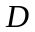 is a dummy variable which takes into account the effect of events that can not be quantified. 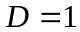 for 1974 (drought), 1977 (collapse of the East African Community), 1978-82 (the war with Uganda and its aftermath); 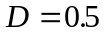 for 1983-84 (to take into account the effects–but with less intensity, of the war). Otherwise 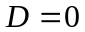. With the exception of the dummy, and the variables expressed in terms of ratios such as OPN and TOT, all the other variables are in logarithms. Moreover,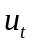 is a random error term, assumed to be normally distributed with mean zero and constant variance, 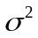.
Due to non-availability of reliable data on labor employment in Tanzania, we use the size of population as a proxy for labor employment. It can be questioned, of course, whether population as a proxy for labor makes sense. Population may be a poor proxy because, it is may not give a realistic picture of the number of people who are actually engaged in production. Furthermore, the figures for population in Tanzania are based on simple and probably crude interpolation from only four observations of the four censuses. The interpretation of the results should therefore consider this drawback.

3.4.1.1 Stationarity of the Variables

It is now widely accepted that regression of non–stationary time series may indicate significant relationship even if the actual relationship is spurious. At present, there are several formal methods to test for starionarity in the time series. These methods are referred to as unit root tests. The most commonly used of these tests are the Dickey−Fuller test and the Phillips−Perron test. In this study the Dickey–Fuller test is used. The idea behind the Dickey Fuller Unit Root Test is as follows:
Suppose, a series is generated by a process:
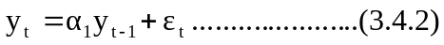
where is generated by a white noise process.
Given the fact that 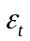 is white noise, 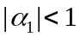 guarantees that the sequence is stationary. If 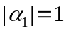, the sequence is generated by a non−stationary process. The idea thus, to test for stationary of time series, is to test the hypothesis that . However, if , classical statistical methods of estimating and testing the significance of the coefficient becomes inappropriate. In that case, the OLS estimate of equation (3.4.2) gives a biased estimate of 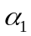. The estimated value of will be biased below its true value of unity, leading to the estimated model matching a stationary AR(1) process with a near unit root.
Because of this problem, Dickey and Fuller (1979, 1981) have devised a formal procedure to test for the presence of a unit root. Equation (3.4.2) is the starting point of the Dickey–Fuller test for unit root. Subtracting 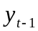 from both sides of equation (3.4.2) yields:
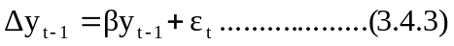
β=α₁-1
Testing for a unit root is in essence equivalent to testing the hypothesis 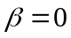. There are three forms of equations used to test for the presence of unit roots. Together with equation (3.4.3), which implies is a pure random walk; the two other equations are as follows:
Equation (3.4.4) assumes that is characterized by a random walk with drift. In equation (3.4.5), is represented as a random walk with drift plus a linear trend. Whether to use (3.4.3), or (3.4.4), or (3.4.5) depends on what one believes to be the characteristic of the time series. If for example, a time series is presumed to be characterized by a linear trend, then equation (3.4.5) will be used.
Equations (3.4.3), (3.4.4) and (3.4.5) assume that the error term is not serially correlated. To take into account possible autocorrelation of the error term, Dickey and Fuller propose to use the following equations to test for presence of unit root:
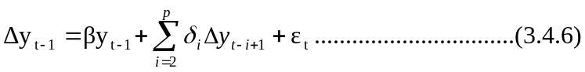
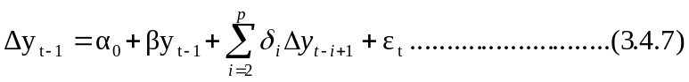
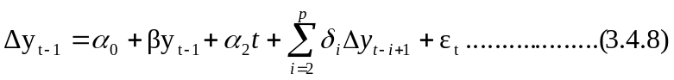
where p is the maximum number of lags.

3.4.2 Vector Autoregression

Vector autoregression is also used in this study to examine further the causes of economic fluctuations in Tanzania. By using this method, we intend to accomplish two specific objectives. First, we want to study the dynamic interrelationship between macroeconomic variables. Second, we intend to assess the importance of monetary (‘nominal’) as compared to real shocks in explaining output fluctuations in Tanzania.

5.3.1 Brief Review of the Vector Autoregression (VAR) Analysis.

The point of departure for VAR analysis is Sims’s 1980 radical idea that the ‘conventional’ macroeconometric models suffer from two main limitations. First, the ad hoc behavioral assumptions often involved in their construction are more or less consistent not with economic theory, but rather with ‘an intuitive econometrician’s version of psychological or sociological theory’. Second, ‘conventional’ macroeconometric models ‘contain too many incredible restrictions’ to the extent that they ignore possible and significant feedback relationship between variables. In view of these flaws, Sims proposed multi-equation time series models in which all variables are treated as endogenous. This is the essence of the VAR models. A simple example of a bivariate system of VAR can be written as follows:

In the system of equations (3.4.9) and (3.4.10), which is called structural or ‘primitive’ VAR, there is a mutually feedback between variables in the sense that y_{t} and x_{t} are allowed to affect each other simultaneously. ε_{yt} and ε_{xt} are pure innovations (or shocks), which are uncorrelated white−noise disturbances with standard deviations σ_{y} and σ_{x}, respectively.
The usable form, i.e. the form in which the VAR system is estimated, is the reduced form. In the reduced form, each variable is treated as an endogenous variable determined by its own lagged values and lagged values of the rest of the variables in the system. A simple transformation of equations (3.4.9) and (3.4.10) yields a reduced or standard form of the VAR:
The two reduced form shocks, η_{1t} and η_{2t}, are composites of the two shocks ε_{yt} and ε_{xt} in equations (3.4.9) and (3.4.10). Because the shocks in the equations (3.4.9) and (3.4.10) are white noise processes, η_{1t} and η_{2t} have zero means, constant variances, and are individually serially uncorrelated. However, the two shocks are correlated. The variance/covariance matrix of η_{1t} and η_{2t} is
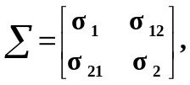
where σ₁₂ = σ₂₁.
Moving Average Representation.
Equations (3.4.11) and (3.4.12) can be written in matrix form,

where 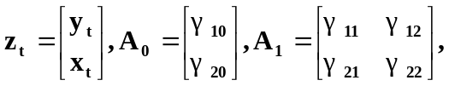and 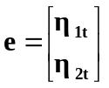

If all the characteristic roots of 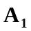 have modulus less than 1, a condition necessary for the stability of the VAR process, the VAR in equation (5.13) can be written in a moving average (MA) representation, which can be derived as follows:
Iterating (3.4.13) backward:
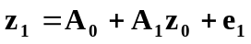
After j iterations:
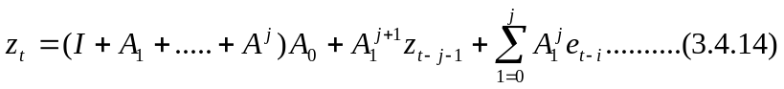

If all characteristic roots of 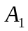 have modulus less than 1:
- the sequence 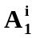 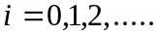 is absolutely summable,
- the infinite sum 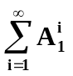 exist in infinite square,
- 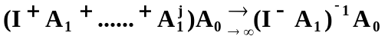,
- 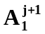 vanishes as 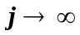, and therefore, in the limit, the term 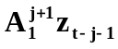 can be ignored.
Given (i)–(iv), (3.4.14) can be written alternatively as:
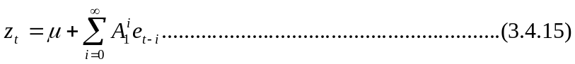
where 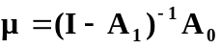.
(3.4.15) is a moving average (MA) representation of a VAR(1) process.

5.3.2 Impulse Response Functions:

The dynamic behavior of the model can be characterized by the impulse response functions. The impulse response functions measure the responsiveness over time of an endogenous variable to shocks as expressed by innovations in the system’s primitive equations, i.e. the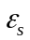. The moving average representation (3.4.15) is the essential feature that allows trailing the behavior of shocks on variables in the system. Using information in equations (3.4.9), (3.4.10), (3.4.11) and (3.4.12) in a moving average representation (3.4.15) we obtain
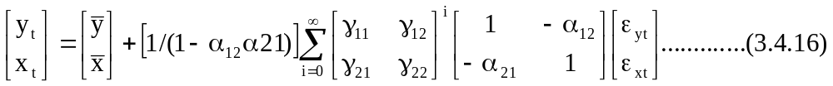
Defining a 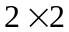 matrix 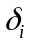 with elements 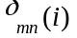:
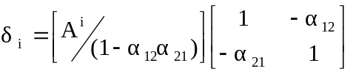
The moving representation in (3.4.16) can be written in terms of structural error terms, 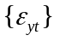 and 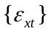 sequences:
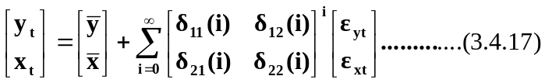
or,
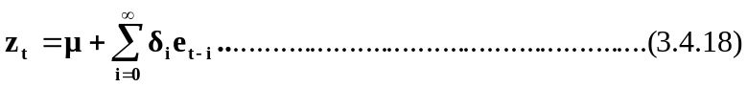
The coefficients 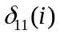, 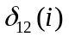, 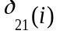 and 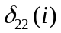 are called multipliers. The practical way to examine how the series and 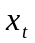 respond to the various shocks is to plot the coefficients 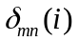 against i. However, because the VAR–estimated in reduced form, is usually underidentified, it becomes necessary to impose restrictions in the system in order to identify the impulse responses. More discussion on identification of the impulse responses is carried out in chapter 6.

5.3.3 Variance Decomposition

The variance decomposition breaks down the variance of the forecast error for each endogenous variable into components that at different periods can be attributed to innovations in each of the endogenous variable in the model. Once the reduced form parameters 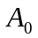and in equation (3.4.13) have been estimated, one might be interested in the i−step ahead forecast of 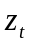 conditional on the observed value of . Updating equation (3.4.13) by one period gives a one period ahead forecast:
Taking conditional expectation of (3.4.19):
Subtracting (3.4.20) from (3.4.19) gives a one period ahead forecast error:
Generally, the l−step ahead forecast is given by:
and the l−step ahead forecast error is given by:
Moving average representation in terms of the structural error terms:
The l−step ahead forecast error of in terms of the structural error terms is given by:
Suppose we are interested in the forecast error variance decomposition of variable in the vector . The l−step ahead forecast of is:
Taking the expectation of the square of equation (3.4.26) gives the l−period ahead forecast error variance of 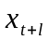:
It is possible to decompose the l−step ahead forecast error variance attributed to each one of the disturbances by dividing the expression of the l−step ahead forecast error variance of by 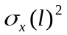:
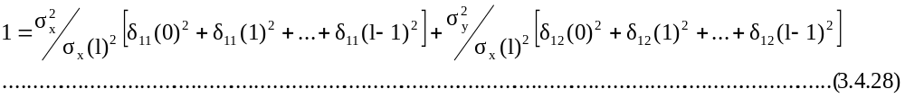

The sum of the two terms on the right hand side of (3.4.28) is equal to unity. This implies that, the forecast variance decomposition shows the proportion of the variations in the series due to innovations in the series itself, and innovations in other series. A series is usually considered exogenous if almost none of the forecast variance can be explained by innovations in other variables. It is considered entirely endogenous if almost all of its forecast variance is explained by shocks in the other series.

5.3.4 Specification of the VAR

A 4−dimension VAR model including logarithms of real GDP, nominal money stock (MS2), the general price level (PRICE), and terms of trade (TOT) is used. A dummy d2 is included to take into account specific exogenous events. The discussion of the determinants of macroeconomic fluctuations in Section 5.2 is relevant also in this analysis. Some of the variables, such as investment and the degree of openness of the economy, which are included in a simple regression model, are not included in the VAR model. One reason for this omission is to avoid over-parameterizing the model. A few variables in the model will keep the degree of freedom at a reasonable level.
One variable, the rate of interest, which has been widely used in other studies of this kind (for example, Leiderman (1984), and Reinhart et al (1991)), is not used here. However, inclusion or exclusion of the rate of interest seems, in the mentioned studies, to influence significantly empirical results. Sims (1980b) and Stock and Watson (1989b) for example, have found that the importance of money innovations in explaining output fluctuations diminishes when the rate of interest is included in the model.
The main reason for not using the interest rate in this study is that, for quite a substantial part of the period under study, interest rates in Tanzania were administratively fixed, and stayed more or less constant for long periods. It can be reasonably argued that, interest rates in Tanzania before economic reforms in 1986, did not play a significant role in resource allocation and output determination. Hence, we believe that there is more to gain than there is to lose from excluding interest rate from the model. Exclusion of interest rate makes it easier to keep the degrees of freedom at a reasonable level without depriving the model of some useful information.
All variables are treated as endogenous. Intuitively, it may seem not reasonable to treat terms of trade as an endogenous variable, as it is inconceivable to believe that a small economy like that of Tanzania can influence her terms of trade. It is treated as an endogenous variable in this study to facilitate the calculation of variance decomposition of output fluctuations attributable to all the variables, including the terms of trade, included in the model.
It may also be noted that treating terms of trade as endogenous variable is consistent with the spirit of the VAR models, the spirit of avoiding putting a priori restrictions on models. In this study thus, the data is permitted to determine whether the terms of trade is endogenous or exogenous.
The structural VAR model is of the general form:
where 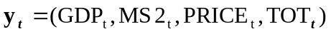 is a 4−dimensional vector of the endogenous variables (logarithms of real GDP, nominal money stock (M2), the general price level), and terms of trade (TOT) respectively). d is a dummy variable. 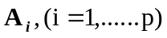 are 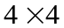 coefficient matrices, and is a 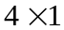 vector of coefficients. 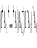 is 4−dimensional vector of random errors.
The reduced form VAR model is
where 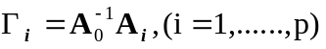, 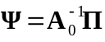 and 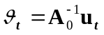 .

5.3.5 Stationarity of Variables

Whether to estimate the VAR model in levels or differences depends on results of unit root tests. If unit roots tests suggest that the variables are stationary, the model in (3.4.30) is usually estimated in levels. If on the other hand unit root tests suggest that the variables are non-stationary and they are not cointegrated, the following model, equation (3.4.31), in first differences, is usually estimated:

where , and 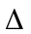 denotes the difference operator.
It should be noted, however, that using differences of the variables instead of levels might cause misspecification problem when the variables are cointegrated. Usually, when the non-stationary variables are cointegrated, it is not appropriate to estimate the VAR in differences, since such estimation throws away some useful information regarding long run (equilibrium) relationship between variables.

3.4 Data

Most of the time series data used in this study is obtained from the publications by the Bank of Tanzania (BOT), Planning Commission of the United Republic of Tanzania, the Economic Research Bureau (ERB) of the University of Dar Es Salaam, and the International Monetary Fund (IMF). Various issues of Economic and Operations Report, and the Quarterly Economic Bulletin published by the BOT, Economic Surveys published by the Planning Commission, Tanzania Economic Trends published by ERB, and the International Financial Statistics (IFS) by the IMF are the main sources of the data.
Explanations of economic fluctuations need relatively long time series data. The data used in this study cover the years 1965-95, a rather limited period. Only by restricting the study to this period, we were able to get data for all the variables. Of course, data for some of the variables can be found even for the period before 1965. The GDP data for instance, can be found in the ERB´s Tanzanian Economic Trends (1991, Vol. 4, No. 1) for the period as far back as 1952. However, for most of the variables, for example the money stock and terms of trade, it is not possible to get “reliable” data for the period before 1965. Furthermore, in studies of economic fluctuations it might for certain purposes be useful, or even necessary to use quarterly data (for example to show certain lead–lag structures). Clark (1987, p.797) points out that, ‘annual averages blur the pattern of economic activity apparent in quarterly or monthly data, and can even obliterate a sharp recession and recovery’. Because, except for the money stock and inflation, it has been impossible to get quarterly or monthly data, this study uses annual data.
The degree of reliability of the data is difficult to judge. However, it should be noted that most of the data has been revised several times by the Tanzania’s Central Bureau of Statistics. The most important drawback that Van Arkadie et al (1991) also observe is the statistical bias that tends to smooth out to some extent fluctuations of output in the subsistence sector. Another problem that is inherent in the macroeconomic data for Tanzania is inconsistency. It is common to find from different sources different values for the same variable and period. One can even find different data sets compiled at different periods (for the same period) by the same source having different values. According to Van Arkadie et al (1988), this problem arises mainly because different definitions are used for the same variable, for example the definition may be “narrow” or “broad”.
In these circumstances, the choice of which data set to use is a matter of judgement. In order to have a consistent data set, this study identified one specific source, the International Financial Statistics (IFS) to be the base. The main reason for the choice is that the IFS, unlike the other sources, every year consistently updates its database from the beginning period (in the case of Tanzania’s data, 1966). For this reason its data can be considered as relatively more consistent. The other sources have been used as back up sources, supplying data for variables for which data can not be obtained from the IFS. In this regard for instance, the shares of agriculture and manufacturing in total GDP obtained from Economic Surveys have been multiplied by the GDP series from the IFS to obtain the agricultural and manufacturing output series. In cases where the IFS data were not updated, growth rates from other sources were applied to the IFS series to update its data.
Some macroeconomic variables of central importance in studies on trend and cycles are missing in this study, as they are not available. This fact limits the scope of the study to some extent, and causes a number of problems regarding the question of finding useful proxies. Important missing variables are aggregate labor input and aggregate capital input. Without these variables, it is difficult to explain trend and fluctuation of output; and difficult to explain productivity changes, a central variable in most modern studies of economic fluctuations.

CHAPTER IV

Trend and Cyclical Patterns of Tanzania’s Macroeconomic Variables

4.1 Introduction

In this chapter, we inspect time series for basic macroeconomic variables, i.e. gross domestic product, consumption, inflation, money supply, exports, imports, government budget deficit, terms of trade, fixed capital formation and foreign finance. The inspection of the time series is designed to accomplish two main objectives. First, we seek to describe both the short run and long run behavior of the variables as represented by estimated trends and deviations of actual observations from trend. Second, we attempt to relate certain “outliers” or other conspicuous observations of the variables to qualitative events (such as policy changes, extreme weather conditions and war) that occurred in Tanzania during the period under study. This may help to assess the importance of these events in explaining the time pattern of the macroeconomic variables. The remainder of this chapter is organized as follows. Decomposition of Tanzania’s macroeconomic time series and description of their main features is presented in sections 4.2−4.6. Concluding remarks are presented in section 4.7.

4.2 Gross Domestic Product.

Figures 4.2.1 below shows real GDP (GDP deflated by 1985 prices), HP trend of GDP and deviation of GDP from trend. Trend GDP increased continuously over the whole period. With the exception of the years 1981 and 1983, which showed negative growth rates of -0.5 percent and -2.4 percent respectively, all the years registered positive growth rates. The deviations from trend show some significant fluctuations, which seem to contradict the observation by Van Arkadie, Komba and Karamagi (1991) that GDP growth in Tanzania “has been stable”. The length of fluctuations or cycles, however, seems to have varied over the time span considered.

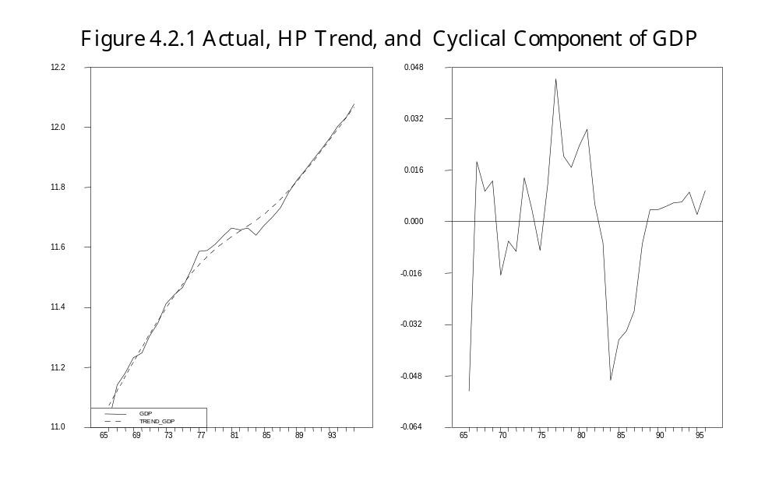

Inspection of Figure 4.2.1 suggests that the period 1965-95 had a total of roughly three main ‘cycles’. The length of the first cycle, from 1966 to 1972 was about six years. The second cycle, from 1972 to 1976 took about 4 years. The third one, from 1976 to 1992, was conspicuously long, taking about sixteen years. A close examination of Figures 4.2.1 further indicates that, during the period under consideration, deviation of GDP from trend attained its peak in 1976 with a deviation of 3.9 per cent above the trend. On the opposite extreme, the deviation was at the lowest point in 1983, when the deviation was below trend by 4.2 per cent. These magnitudes strongly indicate that the level of economic activity has not developed smoothly in Tanzania. Over the period under study, the highest actual growth rate of 12.8 percent was registered in 1966.
The 1960s were generally a period of sustained growth, except during 1967-69 when there was a slow down of economic activity. This slow down of economic activity happened exactly at the time when the government, in its move to implement the newly declared Arusha declaration (a blueprint of Tanzania’s socialism) of 1967, nationalized key economic enterprises such as industries, banks and large scale farms (plantations). It can be argued that such a radical change in economic policy definitely had a negative impact on economic activity, especially happening as it did when the world price of sisal, by then the major foreign exchange earner was falling. The economy reached a low point in 1969 with the growth rate of 1.8 percent. A recovery started in 1970 with the growth rate of 5.6 percent and reached a peak in 1972 when the economy registered a growth rate of 6.5 percent.
This high level of growth was short lived. In 1973 another slow down in economic activity, caused mainly by the 1973-74-world oil price rise and drought, started. This down turn, however, was short perhaps because it was weakened by an expansive monetary policy as the growth rate of money stock increased from 17.4 per cent in 1972 to 18.6 per cent in 1973, and further to 22.8 per cent in 1974.
From 1977 to 1983, GDP growth deteriorated seriously as GDP grew at a
compound rate of only 1.0 per cent, compared to 4.6 percent during 1965-76. Both external and domestic factors were responsible for the poor performance. Regarding external factors, the collapse of the East African Community resulted into the deterioration of important economic services such as transport. Moreover, the war with Uganda during 1978-80 cost the about country US dollars 500 million (Somogyi, 1990); and the second oil price rise which raised the price from US $ 13 per barrel to US $ 30 per barrel in 1979, severely reduced the country’s capacity to import. The world slow down of economic activity in the early 1980s also contributed to the slow down of economic activity in Tanzania in these years.
The economic crisis worsened in the first half of 1980s. Negative growth rates of -0.5 per cent and -2.4 per cent were recorded in 1981 and 1983 respectively. A main feature of the growth pattern during this critical period of the long slow down of economic activity, was a notable decrease of output in the goods-producing sectors. The output of agriculture, manufacturing and mining together decreased by 21 per cent between 1980 and 1982. During the same period, however, the output of the service sectors increased. Public administration for instance grew at 15.6 per cent and 8.8 per cent in 1981 and 1982 respectively. Wholesale and retail trade and restaurant services grew at 10.7 per cent in 1982.
In 1984, there was a slight improvement in economic performance, following the government’s decision to introduce, on a mild scale, some economic reforms such as trade liberalization and devaluation. As a result of these mild reforms, GDP grew by 3.4 per cent in 1984. However, because the reforms were not comprehensive enough, and could not secure the necessary inflow of external resources, the improvement was short lived. In 1985 the growth rate slowed down to 2.6 percent.
The government’s import substitution and basic industrialization policies of the 1960s and 1970s, were not a success (according to most observers). It can be argued that these policies contributed significantly to economic slow down and prolonged the slow down of economic activity. The policies produced two conflicting outcomes, which are not conducive to economic growth. While on the one hand they discouraged export and generation of foreign exchange, on the other hand they created an industrial structure critically dependent on imported capital and intermediate goods. It is not surprising therefore, that the long slow down of economic activity in Tanzania was largely a story of serious shortage of foreign exchange that undermined production.
Besides severely constraining the economy’s capacity to import, these ‘inward looking’ development policies reduced the country’s capacity to adjust to external shocks. It is documented in the literature on economic development that developing countries like Tanzania, which adopted inward looking development policies in the 1960s and 1970s, found it more difficult to adjust to external shocks than countries which embraced export oriented development strategy.
GDP started to grow steadily again in 1986 and the average growth rate between 1986 and 1995 rose to 3.8 per cent, compared to only 1 per cent during 1977-83. Improved performance was mainly attributed to economic reforms that started at a low pace in 1984, and gained momentum in 1986, after the government had agreed with the International Monetary Fund (IMF). These reforms worked to improve efficiency in resource allocation. Together with the economic reforms, increase in inflow of foreign finance stimulated economic growth.

4.2.1 Agricultural Output.

In Tanzania agricultural production comprises nearly a half of the GDP. During 1965-95, its average contribution has been about 43 per cent. Due to its importance, we examine also the trend and deviation from trend of agricultural output.
Figures 4.2.2 shows trend and cyclical components of agricultural output in Tanzania. Trend output over the period 1965-95 increased at the rate of 3.6 per cent per year. The positive trend of agricultural output can be explained by growing rural population (labor force) and increased area under cultivation (Ödegaard, 1985 p.90). However, capital accumulation and technical progress in agriculture have apparently been almost insignificant in Tanzania. A close inspection of figure 4.2.2 reveals that over the period 1965-95, just like in the case of GDP, one can locate three main cycles. The timing and length of the cycles are quite similar to those of GDP. This is not surprising given the fact that among all the sectors, agriculture contributes the largest share, above 40 percent, in total GDP. Thus the pattern of fluctuations of output in the sector would be reflected by the pattern of fluctuations in total GDP.
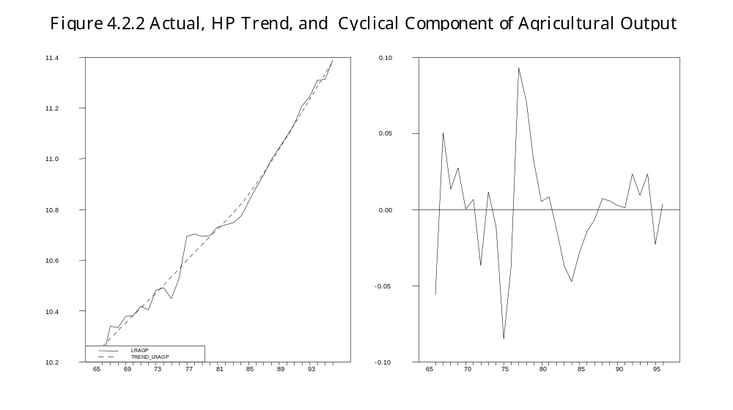
Changes in weather conditions and policies may explain most of the fluctuations in agricultural output. As one would expect agricultural output, being dependent on weather dropped considerably in 1974 due to a serious drought. The shortfall, however, did not last long, the sector recovered fast and output increased continuously during 1975-77 due to conducive weather conditions and possibly also political campaigns which were launched in the wake of the drought.
Policy changes also seem to have conditioned fluctuations of agricultural output. For example, poor performance in the late 1960s and early 1970s took place at a time when the government nationalized large-scale sisal and wheat farms (Ödegaard, 1985). According to Ödegaard, the decline of the comparatively more efficient large-scale farming, relative to small scale farming in the peasant sector contributed to stagnant volume of production.
Policy changes also seem to explain the poor performance in the sector that began in 1977 and lasted until 1984. First, the socialist villagization program carried out in the early 1970s (Rutasitara, 1996), and the introduction of inefficient marketing system for agricultural produce in mid 1970s (Ödegaard, 1985), disrupted and discouraged production. Second, the socialization of rural retail trade, which dislocated the distribution of incentive goods, discouraged production. Third, trade and pricing policies turned the terms of trade against agriculture and discouraged production (Ellis, 1982; Ödegaard, 1985; Ndulu, 1986 and Rutasitara, 1996). Fourth, the Import Substitution and Basic Industrialization strategies implemented in the 1960s and 1970s, reduced the country’s capacity to import consumer goods needed to stimulate peasants to increase production (Ödegaard, 1985).
Several factors related to policy changes improved the performance in the sector beginning in 1985. These include trade liberalization (which increased the availability of incentive (consumer) goods in the rural areas), liberalization of marketing of food crops and higher producer prices. These policy changes encouraged farmers to increase production.

4.2.2 Manufacturing Output

Figures 4.2.3 below shows trend and deviations from trend of manufacturing output in Tanzania. Over the period 1965-95, trend-manufacturing output increased at the rate of 2.1 per cent per year. Just as in the cases of total GDP and agricultural output, one can observe fluctuations in the manufacturing output. The pattern of fluctuations more or less resembles those in total GDP. The annual growth rates were relatively high during the second half of 1960s. Except for 1969, annual growth rates for the sector’s output were above 10 per cent. The increase can be attributed to investment in the import substitution industries in the 1960s.

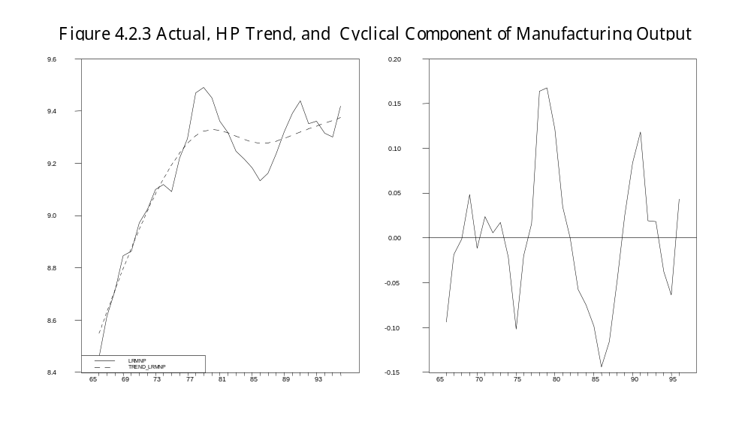
Increase in manufactured output continued during 1970-78, with the exception of 1973-74, when the performance deteriorated probably due to oil price rise. The output of the manufacturing sector reached its peak in 1978, and decreased continuously up to 1985 as a result of acute shortage of foreign exchange. Shortage of foreign exchange was a very serious problem because the sector, itself heavily dependent on foreign exchange, expanded at the expense of the foreign exchange generating sectors.
Growth in the manufacturing sector resumed in 1986 as a result of two main factors. First, increased availability of foreign exchange obtained through import support arrangement under the economic recovery program increased the supply of imported inputs to the manufacturing sector. Second, the improvements in the administration of export incentives also encouraged the manufacturers to increase output (Rutasitara, 1996). However the performance of the sector deteriorated again during 1991-94 due to a number of factors. First, the suspension of the import support assistance by the donors in the early 1990s reduced the supply of imported inputs to the sector. Second, erratic supply of power, particularly during 1993-94, adversely affected the performance of the manufacturing sector. Third, it is also argued (see for instance Bol, 1993) that the introduction of Bureau de Changes reduced the incentive to produce particularly for export.

4.3.1 Private Consumption

Figure 4.3.1 shows actual, trend and cyclical components of private consumption in Tanzania. Over the period 1965-95, trend private consumption increased at an average annual rate of 2 per cent apparently due to the rising trend income. Private consumption also fluctuated considerably around the trend. These fluctuations can be associated with some specific events. For example, during 1974-76, private consumption decreased probably due to the oil price shock in 1973 and the drought in 1974.
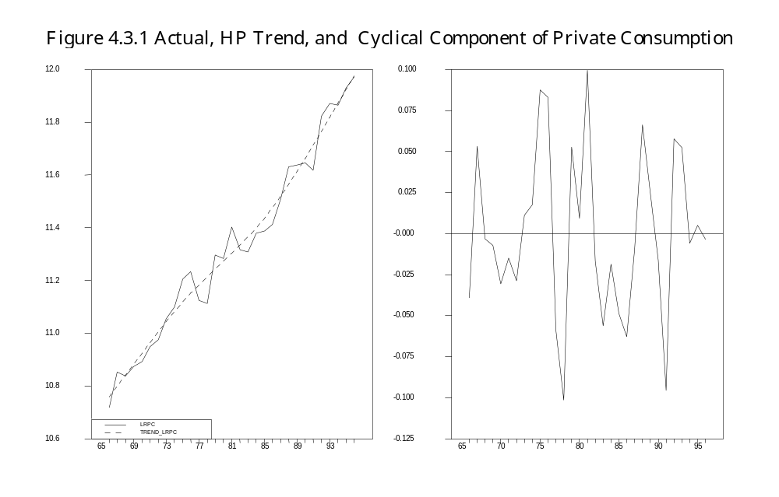

Private consumption increased again during 1978-80, certainly because of the 1976-77 coffee boom which among other things lead to relaxation of trade policy that consequently lead to an increase in imported consumer goods. Prolonged decrease in private consumption during 1981-85 might, to a certain extent, be explained by the long 1977-85 economic slowdown. Following economic reforms and economic recovery, which lead to an increase in income, private consumption increased in 1987.

4.3.2 Government Consumption

Figure 4.3.2 shows actual and trend real government consumption and deviation from trend of real government consumption in Tanzania. Over the entire period, trend real government consumption increased at an average rate of 1.6 per cent per year. The trend of government consumption rose sharply and consistently during 1965-80, when the government increased its activity in social service provision, and also became active in other areas of the economy (such as owning and controlling industry, commerce, banking etc.) which are usually thought to be the preserve of the private sector.

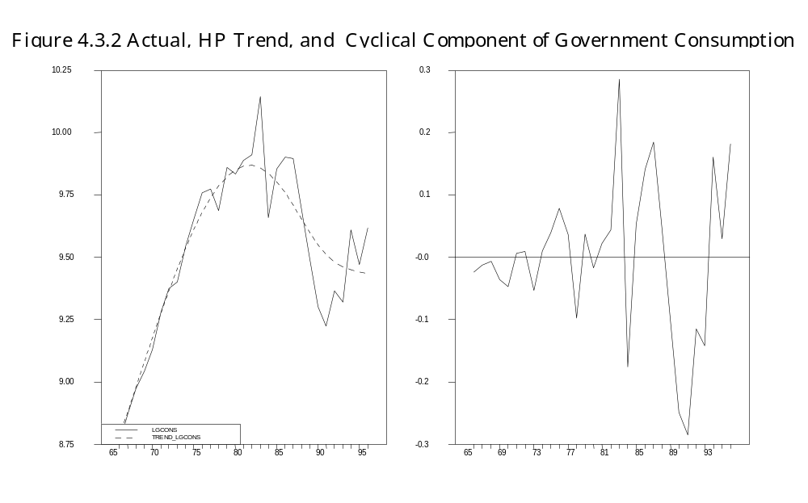

The trend of real government consumption started to decline following the adoption of economic reforms in 1986. The downsizing of the government and the public sector aimed at improving efficiency and reducing government budget deficit is the main reason for the declining trend of real government consumption.
The increase in real government consumption was more or less stable with no significant fluctuations during 1965-80. The only significant fluctuations took place during 1981-82 when government consumption increased, apparently to finance post-war obligations; and during the late 1980s when real government consumption was on the decrease. Real government consumption increased above trend during 1992-95 due to weaknesses in government expenditure controls (IMF, 1996).

4.4 Inflation, Money Stock and Government Budget Deficit

4.4.1 General Price Level and Inflation

Figures 4.4.1(a) and 4.4.1(b) below show actual, trend and deviation from trend of the general price level and of inflation during 1965-95. Rising trend and considerable fluctuations characterize both series. Doriye (1990) attributes the rising trend in the general price level and inflation to government’s excessive expansionary monetary policy since late 1960’s.

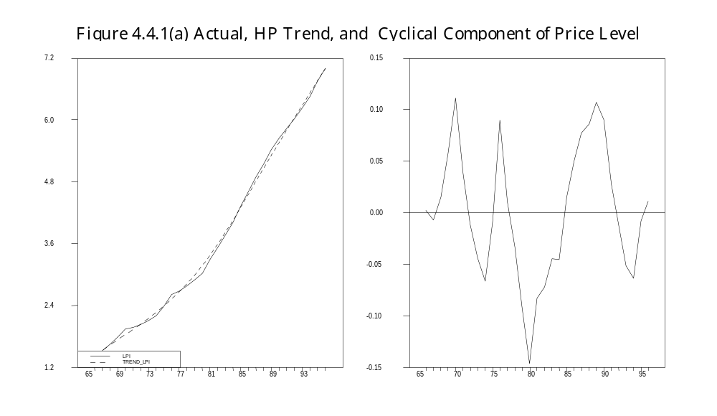

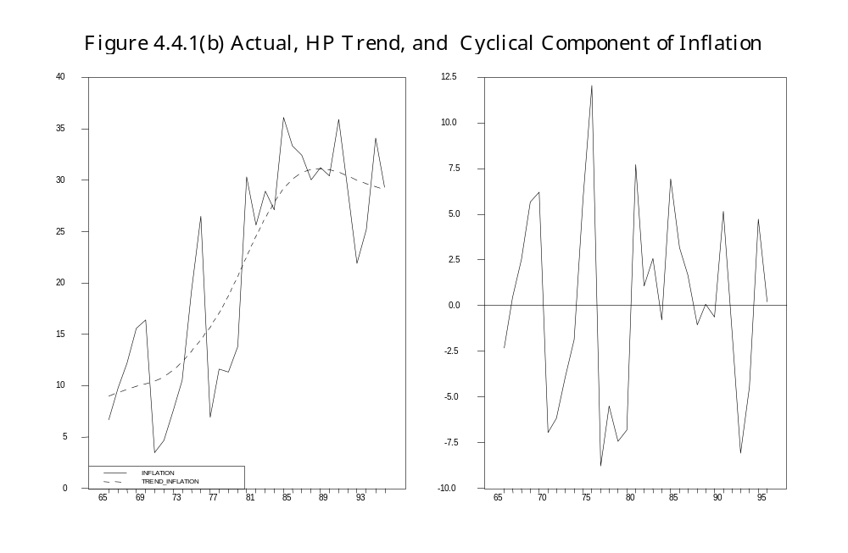
The inflation trend may roughly be divided into two major periods. The first period is from 1965 to 1980 when the trend rose at an increasing rate. The second one is from 1981 to 1995 when the trend rose at a decreasing rate and then attained a turning point, reflecting the government’s gradual recourse to an anti inflationary policy stance in the late 1980s and early 1990s.
The sharp rise in the inflation rate in 1979 and onwards, may in large part be explained by rapid increase in the growth rate of the money stock that started in 1978, together with the second oil price rise in 1979. High rates of inflation between 1983 and 1985 occurred when there was widespread shortage of goods and services. In addition, the removal of subsidies on food in 1984 might have contributed to the high rate of inflation during that particular period.
Major policy changes, particularly the phasing out of price controls that began in mid 1985, can partly explain the sharp rise in inflation in 1987. Furthermore, a substantial decrease in the growth rate of the money stock in 1990 might explain the sharp reduction of inflation in the 1990s.

4.4.2 Nominal Money Stock (M2)

Figures 4.4.2(a) and 4.4.2(b) below show actual, trend and deviation from trend of nominal money stock and its growth rate. The long-term trend for both the money stock and its growth rate has been positive. The growth of the money stock, as in the case of inflation, can roughly be divided into two major periods. The first period is 1965-78 when the trend rose sharply. The second part is 1979-95 when the growth rate was still high, but stabilizing.
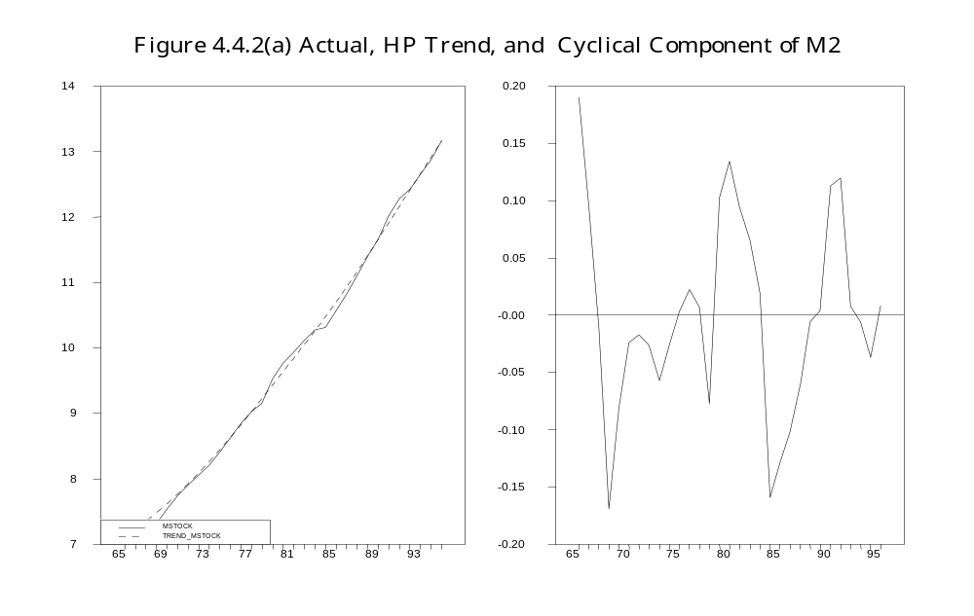

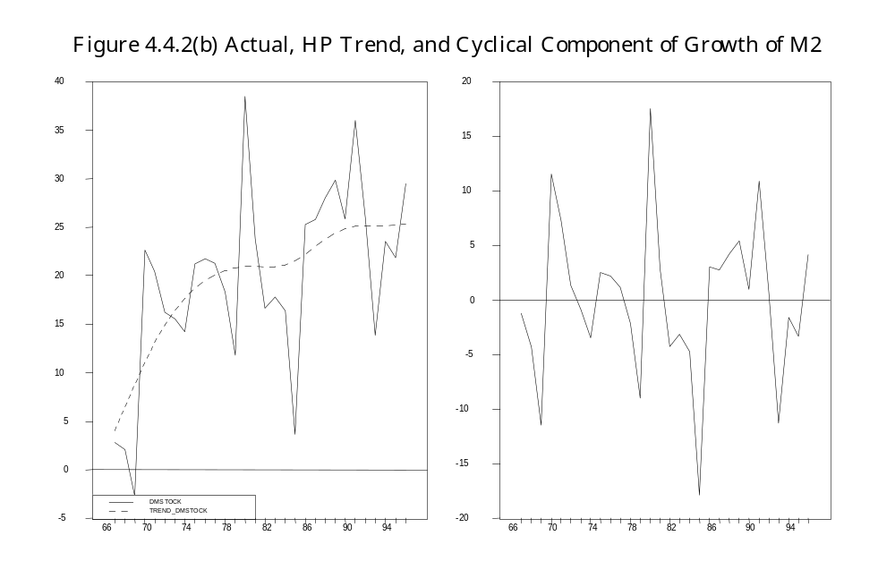
This trend pattern confirms Doriye’s (1990) observation about an overly expansive monetary policy in the 1970s. It also suggests that, in the 1980s and later, the government became aware of the need to moderate the growth of money stock. Before 1968, the growth rate of the nominal money stock was low, apparently reflecting strict monetary policy discipline inherited by the Tanzania Central Bank from the East African Currency Board (EACB) that ceased to exist in 1966.
As mentioned earlier, Tanzania pursued expansionary monetary policy between 1967 and mid 1970s. The growth rate of money stock rose sharply particularly during the late 1960s. The rate, interestingly enough, declined in 1976 and 1977, when the economy experienced a coffee boom. One might have expected the rate to increase, following an increase of foreign exchange reserves due to the boom. One possible reason is that the sharp rise in inflation during 1973-75 might have made the government cautious in its monetary policy execution.
Dramatic increase in money stock occurred during 1978 and 1979 when Tanzania was at war with Uganda. This suggests that the government increased its borrowing from the banking system to finance the war. In the early 1980s, the growth rate of money stock decreased substantially. This partly reflects the government determination to control the growth rate of the money stock. It also reflects the mounting pressure on the government to keep its house in order to convince the IMF, World Bank and other donors to resume assisting Tanzania to recover from slow down of economic activity.
From the mid 1980s however, the rate started to increase rapidly due three reasons. First, the institutional framework that was in place could not permit a sustained reduction in the growth rate of money stock without hampering economic activity as ‘key’ parastatal organizations such as cooperatives and marketing boards were heavily dependent on bank credit for their operations.
Second, some of the reform measures such as devaluation and raising producer prices paid to farmers that were instituted in the second half of the 1980s, increased the working capital requirements by cooperatives, crop marketing boards and parastatal organizations. Given the weaknesses of these institutions, increased borrowing from the banking system was seemingly the only alternative for them to continue operating. This in a way underscores the point that institutional reforms are often necessary for successful economic stabilization. The third possible reason is fiscal laxity. When resources started flowing in 1986, it seems the government was in a mood of irrational exuberance. It more or less relaxed its efforts in collecting tax revenue, controlling its expenditure, budget deficits and the growth of money stock.

4.4.3 Nominal Government Budget Deficit

Figure 4.4.3 below shows the actual, trend and deviation from trend of government budget deficit in Tanzania.
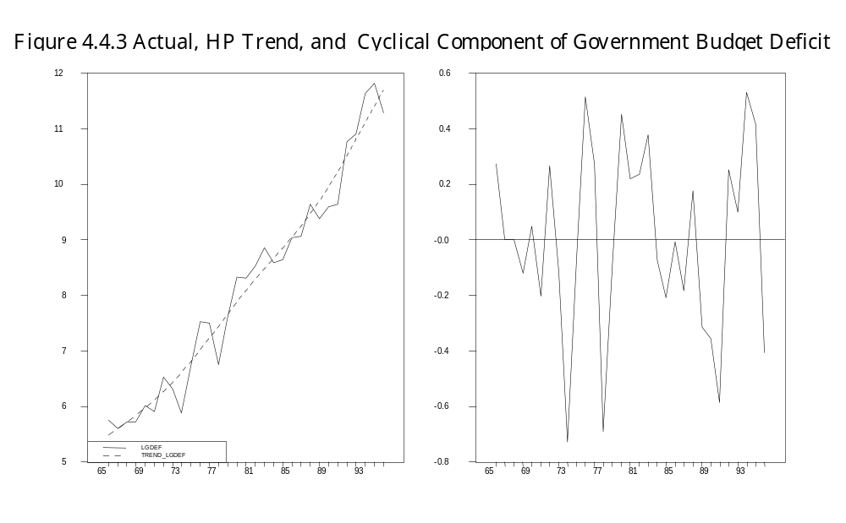
Over the period 1965-95 trend budget deficits increased at the rate of 21.7 percent per year. It may be noted that this rate is very close to that of the nominal money stock (20.5 percent). The deficit rose gradually during 1979-85, mainly due the war with Uganda and a severe slow down of economic activity during the first half of the 1980s. Despite the economic reform measures adopted in 1986, the budget deficit continued to increase, and in fact rose rapidly during 1989-1994 because of the rising inflation, devaluation of the Tanzanian shilling and laxity in tax revenue collection.

4.5 Real Investment and External Finance

4.5.1 Real Investment

An important characteristic of capital formation in Tanzania is its dependency on foreign finance. During most of the 1970s, capital formation was above trend–which increased on average rate of 3 percent per year. Exceptions are the years 1968-71 when investment decreased, most probably due to nationalization of private property, which began in 1967. Investment also decreased during 1973-75 apparently due to the oil price rise in 1973 and drought in 1974. Investments in the 1970s were mainly in infrastructure, for instance the construction of the Tanzania-Zambia Railway line; and basic-import substitution industries. Most of investment in basic industries took place in the second half of 1970s. These were mainly financed by external finance that increased substantially during this period but also by the proceeds from the 1976-77 coffee boom (see Musonda and Luvanda, 1991 and Van Arkadie et al, 1988).

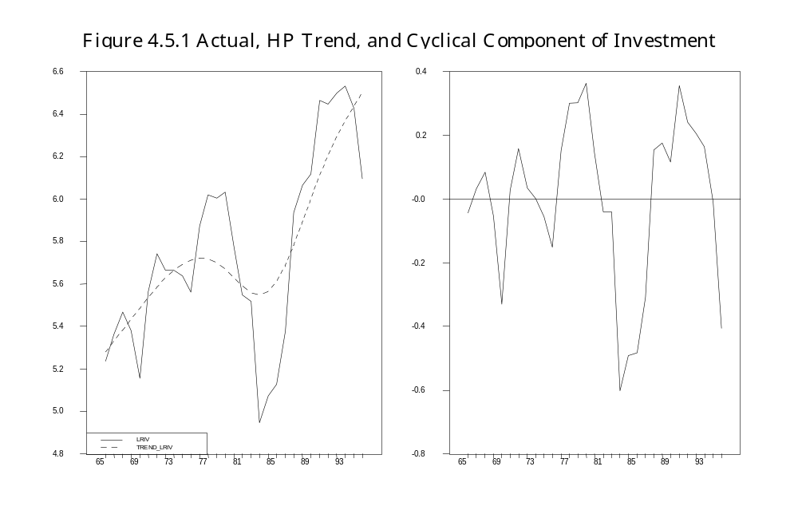

Real capital formation started a steady decline in 1979, possibly due to war and oil price increase in the late 1970s. The Early 1980s witnessed capital formation falling below the trend, and reaching its lowest point in 1985 mainly because of slow down of economic activity and decrease in inflow of foreign finance.
Real investment increased steadily after the inflow of foreign finance increased following the government’s agreement with the IMF in 1986. Most of the investments during this period went into rehabilitation of economic infrastructure. Investment decreased suddenly in 1993 because donors suspended external finance inflow following the government’s failure to observe fiscal discipline according to the IMF agreement.

4.5.2 Grants and Aid

Figure 4.5.2 below shows actual, trend and deviation from trend of real external finance (grants and aid). The trend has been rising over the period, and the deviations show a cyclic pattern fairly similar to that of capital formation.

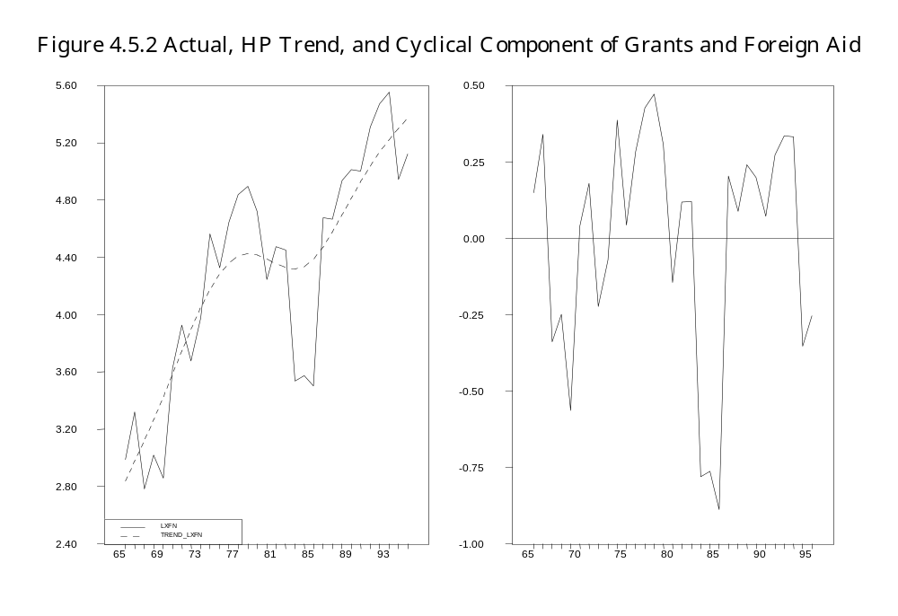
The figure indicates that real external finance decreased in the second half of 1960s mainly because the then Tanzania’s traditional donors−Britain and West Germany reduced their assistance in protest of Tanzania’s foreign and economic policies.
In 1970s real external finance increased. The Scandinavian countries, probably impressed by the Arusha Declaration that seemed to proclaim a Scandinavian type of welfare policy, increased significantly their economic assistance to Tanzania. China also increased her economic assistance to Tanzania during this period.
In the early 1980s, the period, which Falk (1997) refers as “aid reduction period”, external finance inflow dropped significantly. This was mainly due to suspension by donors of grants after the government refused to implement the necessary structural adjustment and stabilization policies as recommended by the IMF and the World Bank. The inflow resumed in 1986 after the government agreed to implement the prescribed policies. A sharp decrease in inflows occurred again in 1994 when donors suspended grants and aid after the government’s failure to observe fiscal discipline.

4.6 Exports, Imports and Terms of Trade

4.6.1 Exports

The trend of exports can be divided into roughly two parts. During 1965-86 the trend fell continuously mainly due to the falling world price in the 1960s of sisal (then the leading export commodity) and the anti−export policy bias which dominated the Tanzania’s development strategy during the 1960s and 1970s. In 1986, there was a turn around and the trend started rising fairly strongly.
Apart from the changing export trend, exports also fluctuated markedly around trend. During 1967-71, for example, exports fell below trend mainly because of the falling price of sisal in the world market. Certainly, the nationalization of sisal estates also contributed to the decrease. However, during 1972-74 exports were again above trend as a result of export diversification efforts that facilitated the increase in the output of other export crops such as cashew nuts, coffee, cotton, tea and tobacco.

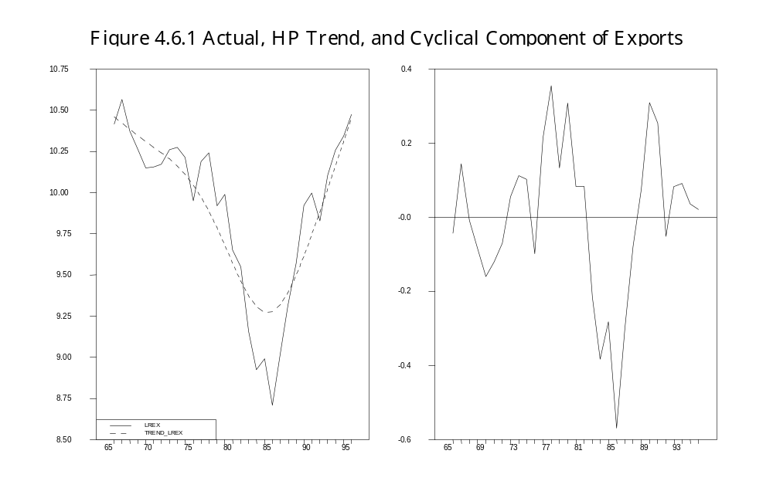

Exports were reasonably stable and above trend between 1972 and 1977, except during 1974-75, when they decreased somewhat, apparently due to drought in 1974. The 1972-74 ‘export sector recovery’ from the effects of falling world sisal price was short lived. From the mid 1970s actual exports persistently declined due mainly to government policies such as villagization programs, pricing of agricultural crops and over-involvement of the state in the marketing of the agricultural produce.
The mid 1980s saw a positive turning point for real exports. Due to economic reforms, exports increased again. Increase in producer prices and availability of consumer goods that came with reforms, a large devaluation of the Tanzanian shilling, and the introduction of certain schemes (such as Seed Capital Revolving Fund, Export Retention Scheme, Duty Draw-back and Export Credit Guarantee) to correct the earlier anti- export bias, appear also to have stimulated exports (Bol; 1993).

4.6.2 Imports

Figures 4.6.2 shows actual trend and deviation from trend of imports in Tanzania. The trend of imports rose slightly during 1965-77, fell slightly during 1978-1983, but rose sharply during 1984-95. Actual imports fluctuated fairly strongly around the trend. Real imports increased almost continuously from the late 1960s to 1974, mainly due to increasing income (GDP) and external finance (foreign aid and grants).

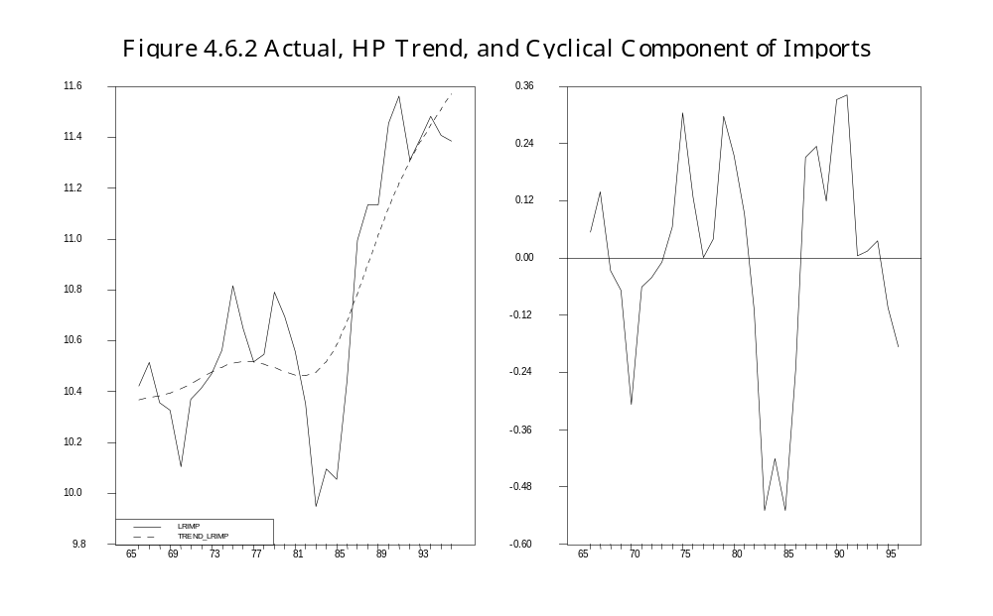

Imports decreased during 1975-78 apparently because of the 1973–oil price rise. Real imports went up during 1977-78 probably due to the 1976-77-coffee boom and investment boom in basic industries launched in mid 1970s. Imports declined during 1979-84 as a result of the long economic slowdown and decrease in inflow of external finance. Imports began to increase again in 1987 as a result of trade liberalization and increased inflow of external finance. The growth of imports slowed down in the first half of 1990s seemingly due to government’s efforts to control imports in order to reduce the balance payments deficit. During 1994-95, imports decreased particularly because donors, displeased with government’s management of reforms, suspended balance of payments support (Bank of Tanzania, 1995).

4.6.3 Terms of Trade

The actual and trend terms of trade as well as the deviation from the trend of terms of trade are shown in Figure 4.6.3 below. Over the period, trend of terms of trade declined slightly on an average by 0.6 per cent per year, but did not decrease steadily over the entire period.

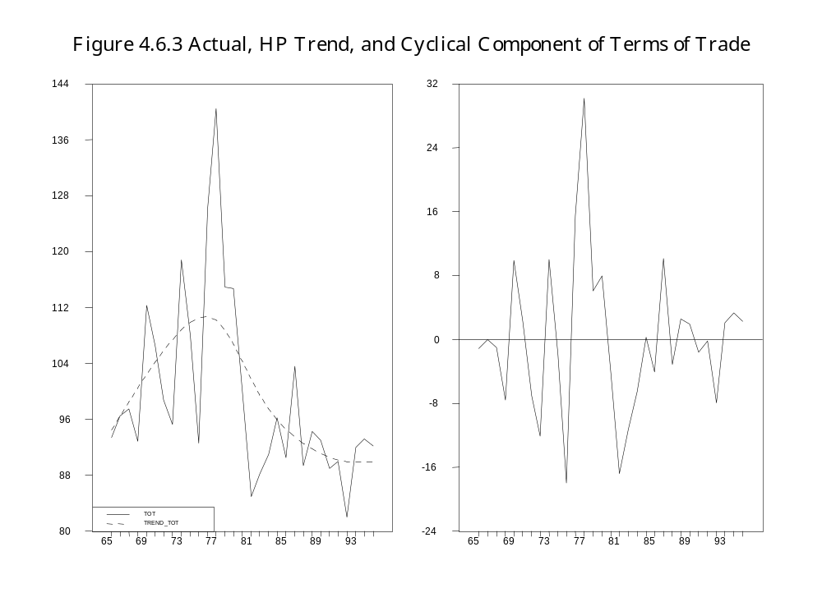

As the figure shows, the computed terms of trade trend actually increased during 1965-77, but declined during 1978-95. Like other non-oil exporting developing countries, Tanzania’s terms of trade have, as Figure 4.5.3 shows, been volatile. This is mainly a result of the instability of primary commodity export prices.
However, certain episodes of terms of trade fluctuations deserve specific comment. The deterioration in terms of trade during 1974-75 can be attributed to a sharp increase in the oil price in 1973 and the rise in world grain prices in 1974-75 when Tanzania increased her imports of grains to meet domestic food shortages. In 1976 and 1977 the terms of trade improved dramatically in favor of Tanzania because the coffee price in the world market rose sharply. The terms of trade deteriorated in 1979-80 due to increase in oil price in the late 1970s. The terms of trade improved in favor of Tanzania in 1986 following an increase in the world price of coffee in that year.

4.7 Summary

The main objective in this chapter has been to describe the trends and the fluctuation patterns of the major macroeconomic variables. The Hodrick−Prescott filter, which fairly satisfactorily takes into account stochastic changes in the trend, has been used to detrend the variables. Detrending the variables have produced results which raise some important points.
First, it can be argued that the Tanzanian economy has sometimes been subject to severe fluctuations. The real GDP together with its components such as private consumption, investment, exports and government expenditure has been subject to fluctuations. Other variables that usually influence GDP, such as the money stock, terms of trade, and external finance, have also fluctuated.
Second, there are notable similarities in the patterns of trends and fluctuations across some variables. For example, for most economic variables, mid 1970s can be considered to be a crucial turning point. Highest peaks of deviation from trend of actual real GDP, investment, exports and external finance can be located in this period. The other crucial turning point on the low side for these variables is 1983−85 when the economy started to recover from deep economic slowdown. There is similarity in the patterns of trends and fluctuations of growth in the money stock on the one hand, and inflation on the other.
Third, one can also make a tentative observation on the seeming relationship between real GDP and some other variables. For example, during 1965−77 when GDP grew fairly satisfactorily, the deviation of actual inflation from trend seem to have been fairly symmetric. In contrast, during 1978−85, when GDP growth deteriorated, inflation was consistently rising and for the most part of that period, it was rising above trend. This seems to suggest an inverse relationship between growth of real GDP and inflation.
One can also make a casual observation on a discernible relationship between real GDP and the terms of trade. It seems the rising trend of terms of trade during 1965−77 coincides with a fairly satisfactory growth of real GDP, and a sharp decline in the trend of terms of trade during 1977−84 is associated with low growth in real GDP. However, these apparent relationships are just casual observations. They will be studied more closely in chapters 5 and 6.

CHAPTER V

Stylized Facts of Macroeconomic Fluctuations in Tanzania

5.1 Introduction

Empirical studies on economic fluctuations or business cycles are naturally concerned with establishing robust stylized facts about the fluctuations. Similar “robust facts” or empirical regularities do to some extent characterize economic fluctuations across countries and historical periods. In most recent studies, the focus has been on comovement of GDP and other macroeconomic variables and the variability (or volatility) of individual macroeconomic variables. In fact, the comovement of macroeconomic variables seems to have been so central to studies of business cycles that Englund et al (1992, p.343) contend that the traditional a priori definition of business cycles is the “cyclical comovement between important macroeconomic variables”, adding more specifically, “with periods of around five years”.

Given the importance of the subject, we seek in this chapter to establish the main empirical regularities of macroeconomic fluctuations in Tanzania during 1965-95, and indicate how these characteristics compare with similar characteristics in other countries. To some extent, this discussion may as well shed some light on the nature of the underlying causes of economic fluctuations in Tanzania.
The remainder of this chapter is divided into three main sections. Section 5.2 presents the empirical regularities of economic fluctuations in Tanzania. Section 5.3 compares the results with similar results from studies of other countries. Section 5.4 summarizes the main points and draws some conclusions as to the stylized facts of economic fluctuations in Tanzania.

5.2 Empirical Regularities of Economic Fluctuations in Tanzania

In this section we examine the empirical regularities of economic fluctuations in Tanzania. As a common tradition in the studies of economic fluctuations, we focus on three main issues of regularities. These are, the measures of volatility (standard deviation) of the individual macroeconomic variables, the measure of correlation between real GDP and the other macroeconomic variables, and the change in the level of volatility of variables over time. Another interesting question is of course the approximate length of the fluctuations. We shall attempt to say something on this matter as well. Generally, it is important at this point also to mention the limitation of this kind of analysis. Because this study relies on a relatively small sample of observations, generalizations and conclusions have to be done with caution.

5.2.1 Volatility of the Variables

Table 5.2.1 below presents the volatility measures of economic fluctuations in Tanzania. Except for real money stock, real imports, real investment and real manufacturing output, the standard deviation of the macroeconomic variables based on the HP series is lower than in the differenced series. However, the two sets of series give more or less the same ranking of the magnitude of volatility of the variables.
It appears that the internationally exposed sectors of the economy, real exports and real imports, together with real investment (which depends to a large extent on real external finance), are by far the most volatile parts of the economy, about ten times as volatile as GDP; and even much more volatile than nominal variables such as the money stock and prices. According to the HP series, real investment is twelve times more volatile than GDP. Real imports and real exports are ten times more volatile than GDP.

Table 5.2.1 Volatility^{(a)} Measures of Economic Fluctuations in Tanzania: 1965-95

 | Differenced series |  | HP series (λ=100)
Variable | Standard deviation | Standard deviation relative to GDP | Standard deviation | Standard deviation relative to GDP
Real GDP | 2.5 | 1.0 | 2.2 | 1.0
Price index | 8.2 | 3.3 | 6.4 | 2.9
Nominal money stock (M2) | 9.5 | 3.8 | 8.5 | 3.9
Real money stock (M2) | 10.7 | 4.3 | 12.5 | 5.7
Real exports | 21.0 | 8.4 | 20.7 | 9.4
Real imports | 14.4 | 5.8 | 22.9 | 10.4
Real investment | 22.7 | 9.1 | 25.5 | 11.6
Government consumption | 15.8 | 6.3 | 12.2 | 5.5
Private consumption | 7.0 | 2.8 | 5.1 | 2.3
Terms of trade | 11.7 | 4.7 | 8.9 | 5.7
Agricultural output | 4.3 | 1.7 | 3.6 | 2.1
Manufacturing output | 7.5 | 3.0 | 7.7 | 3.5

Source: Own computations.
Note: (a) Volatility is measured by sample standard deviation defined as:
standard deviation =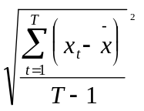,
where is the arithmetic mean of variable x.

Also, agricultural output and particularly manufacturing output oscillate considerably. Their standard deviations are about two times and four times as large as that of GDP. This implies that the rest of the sectors, specifically the service sector which is relatively large and has expanded over the period, has been much less volatile than aggregate GDP. A surprising result is that the standard deviation of the real money stock is greater than that of the nominal money stock. The level of the standard deviation of GDP of 2.5 seems about as high as one might expect, given the fact that during 1965-95 the growth rate of GDP varied between -2.3 percent and 12.8 percent, but was otherwise fairly well concentrated around the average of 3 percent.
Private consumption, while far less volatile than investment, exports and imports, is more volatile than real GDP. This seems to contradict the consumption-smoothing hypothesis, according to which private consumption is expected to be less volatile than GDP (see Danthine and Donaldson, p.5). This fluctuation characteristic may suggest that the households in Tanzania either do not plan consumption over multiple periods, or do not have the means to transfer resources across periods or both. A number of empirical studies on consumption behavior in developing countries (see for example (Haque, 1988; and Haque and Montiel, 1989) have found that households in developing countries plan consumption over multiple periods. It is argued that, while households have strong motives for consumption smoothing and hence to plan consumption intertemporarily, the absence of well-developed financial institutions and the prevalence of financial repression restrict households in their ability to move resources intertemporarily.

5.2.2 Correlation of GDP with other macroeconomic variables

An outstanding feature of the correlation statistics as presented in Table 5.2.2 below, is the big difference between the statistics based on the differenced series and those based on the HP series. With the exception of the price index, private consumption, agricultural output and manufacturing output, the difference in the two sets of statistics is surprisingly large. Generally, the HP series gives higher correlation coefficients. However, it is, as mentioned earlier, important to note that the two sets of series have largely the same ranking of the coefficients.

Table 5.2.2 Correlation of Macroeconomic Variables with GDP*: 1965-95

 | Differenced series |  |  | HP series (λ=100)
Variable | Y(t-1) | Y(t) | Y(t+1) | Y(t-1) | Y(t) | Y(t+1)
Price index | -0.41 | -0.36 | -0.12 | -0.42 | -0.28 | -0.06
Nominal money stock (M2) | -0.12 | -0.20 | 0.05 | 0.34 | 0.19 | 0.33
Real money stock (M2) | o.21 | 0.10 | 0.13 | 0.44 | 0.27 | 0.23
Real exports | 0.17 | 0.39 | 0.24 | 0.56 | 0.73 | 0.64
Real imports | -0.08 | 0.09 | 0.38 | 0.14 | 0.41 | 0.73
Real investment | 0.16 | 0.46 | 0.17 | 0.47 | 0.67 | 0.62
Government consumption | -0.41 | 0.30 | -0.17 | -0.20 | -0.06 | -0.22
Real private consumption | -0.23 | 0.18 | 0.26 | -0.07 | 0.25 | 0.37
Terms of trade | 0.28 | 0.06 | -0.12 | 0.21 | 0.17 | 0.19
Real agricultural output | -0.07 | 0.66 | -0.14 | 0.21 | 0.69 | 0.25
Real manufacturing output | 0.43 | 0.54 | 0.33 | 0.60 | 0.67 | 0.45

Source: Own computations.
Note: *Y(t) refers to real GDP in period t.

Real agricultural output and real manufacturing output are, as expected, fairly strongly correlated with real GDP. The same applies, interestingly enough, to real exports and real investment. These two variables have also very high standard deviations. Thus, to the extent that the oscillation of exports and investment are exogenously determined, the level of the GDP volatility seems, to a large extent, to be due to the internationally exposed part of the economy, particularly exports.
Contemporaneous correlation between real GDP and the rest of the variables is on the whole low, but real money stock and real private consumption are fairly contemporaneously correlated with real GDP. Real imports are particularly strongly correlated with GDP after one lead period; indicating imports are a leading variable in the pattern of cyclical fluctuations. The general price index and the nominal money stock have very low correlation with real GDP. In addition, the general price index tends to be (weakly) negatively correlated with GDP.

5.2.3 Instability of macroeconomic variables over time

In order to examine the pattern of instability of the macroeconomic variables in Tanzania, the period under study (1965-95) is divided into three sub periods. In subdividing the period, two main factors have been taken into consideration. First, to ensure each sub-period has a ‘fairly sufficient’ sample size. Second, is to ensure a relatively unchanging environment in each period, which at the same time is different from the environment of the other sub periods. In this study, the environment that has been taken into consideration is the nature or kind of economic policy strategy that was in place in each sub-period. For these two reasons, the period under study (1965-95) is divided into three sub periods: 1965-75, 1976-1985 and 1986-95.
The period 1965-75 was characterized by a fairly liberal economic policy; while strict state economic regulation and control was predominant during 1976-85; and far reaching economic liberalization was attempted during 1986-95. Table 5.2.3 below presents measures of volatility for the macroeconomic variables in Tanzania over time. The general picture that emerges from the table is, according to the HP series, that the period 1976-85 was characterized by the highest degree of instability for all the macroeconomic variables, while the period 1986-95 is characterized by a low degree of instability for all macroeconomic variables.

Table 5.2.3 Volatility Measures of Macroeconomic Variables over time

 | Differenced series |  |  | HP series (λ=100)
Variable | 1965-75 | 1976-85 | 1986-95 | 1965-75 | 1976-85 | 1986-95
GDP | 2.9 | 2.4 | 0.6 | 2.0 | 3.2 | 1.1
Price index | 6.2 | 8.7 | 3.9 | 5.4 | 5.8 | 6.1
Nominal money stock (M2) | 9.3 | 9.1 | 5.8 | 9.2 | 10.0 | 6.9
Real money stock (M2 | 10.4 | 14.3 | 7.0 | 11.8 | 14.6 | 10.6
Real exports | 12.6 | 21.8 | 15.7 | 10.4 | 31.4 | 17.1
Real imports | 16.9 | 23.1 | 22.0 | 15.4 | 30.0 | 17.9
Real investment | 17.9 | 25.1 | 24.6 | 12.9 | 36.3 | 24.4
Government consumption | 3.6 | 20.2 | 17.1 | 3.9 | 12.4 | 17.5
Private consumption | 4.4 | 8.9 | 7.0 | 4.5 | 6.0 | 4.7
Terms of trade | 12.0 | 15.0 | 8.6 | 8.7 | 12.5 | 5.2
Agricultural output | 5.4 | 5.0 | 2.1 | 4.0 | 4.6 | 1.4
Manufacturing output | 6.0 | 8.0 | 6.4 | 4.6 | 11.0 | 7.1

Source: Own computations.

Following closely the evolution of economic policy making in Tanzania, one can note that the period of relatively higher degree of state regulation and control of the economy (1976-85) is generally associated with the highest degree of volatility for most of the macroeconomic variables. This however, does not necessarily mean that economic instability during this time can be attributed to high degree of state intervention in the economy. It should be borne in mind that other factors such as high volatility of real investment, due to variability of real external finance, were predominant during the same period.

5.3 Comparison of the Findings with Similar Findings from Other Studies

In this section, we compare the findings on empirical regularities in Tanzania with similar findings from other studies. Unfortunately, we could not come across studies on empirical regularities in other countries whose economies and institutional features are relatively similar with those of Tanzania. It would have been interesting to compare the findings of this study with similar findings related to economies of other developing countries. Particularly, it might have been valuable to look at figures from neighboring African countries. Nevertheless, the comparison with similar findings in developed countries is also interesting in the sense that it might shed some light on how the differences in institutional features between developed and developing countries could have a bearing on the nature of the stylized facts of economic fluctuations.
Four studies have been selected for the purpose of comparison. These studies are: Danthine and Donaldson (1993), Englund, Persson, and Svensson (1992) and Grunfeld (1996). Danthine and Donaldson report the stylized facts for twelve economies (Australia, Austria, Canada, France, Germany, Italy, Japan, South Africa, Switzerland, UK, U.S.A and the European Community). From this study (Danthine and Donaldson, 1993) however, we choose South Africa, the only case study from Africa that was found, for comparison. The study by Englund, Persson and Svensson examines empirical regularities in the case of Sweden. Grunfeld studies empirical regularities of the Norwegian economy. Compared to the present study, all these studies rely on relatively better quality and larger sample size of data. The comparison, hence, should be interpreted with this fact in mind.

5.3.1 Volatility of Variables

Table 5.3.1 shows standard deviations relative to GDP and standard deviations of GDP from the selected studies.

Table 5.3.1: Standard Deviations of Macroeconomic Variables Relative to GDP from Selected Studies.

Variable | Tanzania (this study) 1965−95 (λ=100) | South Africa (Danthine et al) 1960−89 (λ=1600) | Sweden (Englund et al) 1861−1988 (λ=100) | Norway (Grunfeld)  1900−92 (λ=200)
Standard deviation of GDP | 2.2 | 1.64 | 3.55 | 1.23
GDP | 1.0 | 1.0 | 1.0 | 1.0
Price index | 2.9 | N.A | N.A | 3.13
Nominal money stock (M2) | 3.9 | 4.61 | N.A | 2.66
Real money stock (M2) | 5.7 | N.A | N.A | 1.57
Real exports | 9.4 | 4.25 | 4.42 | N.A
Real imports | 10.4 | 6.39 | 4.75 | N.A
Real investment | 11.6 | 4.13 | 3.62 | N.A
Government consumption | 5.5 | 3.47 | N.A | N.A
Private consumption | 2.3 | 2.06 | 1.09 | N.A
Terms of trade | 5.7 | N.A | N.A | N.A
Agricultural output | 2.1 | N.A | N.A | N.A
Manufacturing output | 3.5 | N.A | 2.34 | N.A

Source: Own computations; Danthine et al (1993), p.6, Table 2; Englund et al (1992) pp. 360-61, Tables 1 and 2 and Grunfeld (1966) p.57, Table 5.

Note: (a) the study by Danthine et al uses quarterly data, all the other studies use annual data.

With the exception of Sweden, the absolute magnitude of volatility of GDP seems to be somewhat stronger in Tanzania than in most other countries. Also, with the exception of the relative standard deviation of the price index for Norway, it applies to all countries that the volatility in relation to GDP of other macroeconomic variables are less and often far less than those in Tanzania. This observation suggests that the

volatility of aggregate economic variables is likely to be larger in developing countries than in developed countries.
These disparities, however, may not be surprising. As Danthine and Donaldson (1993, p.5) note, unique regularities can probably be explained with reference to ‘national institutions and policy practices’.

5.3.2 Contemporaneous correlation of GDP with Other Macroeconomic Variables

Table 5.3.2 below presents the contemporaneous correlation coefficients of GDP with other macroeconomic variables from selected studies. Just as in the case of Tanzania, real exports, real imports, real investment manufacturing output seems to vary fairly strongly with GDP in Sweden. In South Africa real imports, but not real exports, vary strongly with GDP. Danthine et al (1993, p7) also report strong correlation between investment and GDP in Australia, Canada, Germany, Switzerland, and US.

Table 5.3.2 Contemporaneous Correlation between GDP and Other Macroeconomic Variablesfrom selected Studies

Variable | Tanzania (this study), 1965-95 (λ=100) | South Africa (Danthine et al) 1960-89 (λ=1600) | Sweden (Englund et al) 1861-1988 (λ=400) | Norway (Grunfeld) 1900-92 (λ=200)
Price index | -0.28 | N.A | N.A | -0.23
Nominal money stock (M2) | 0.19 | 0.05 | N.A | -0.20
Real money stock (M2) | 0.27 | N.A | N.A | -0.16
Real exports | 0.73 | 0.02 | 0.63 | N.A
Real imports | 0.41 | 0.70 | 0.55 | N.A
Real investment | 0.67 | 0.37 | 0.56 | N.A
Government consumption | -0.06 | 0.18 | N.A | N.A
Private consumption | 0.25 | 0.31 | 0.79 | N.A
Terms of trade | 0.17 | N.A | N.A | N.A
Agricultural output | 0.69 | N.A | N.A | N.A
Manufacturing output | 0.67 | N.A | 0.76 | N.A

Source: Own computations; Danthine et al (1993), p.7, Table 3; Englund et al (1992) pp. 362, Table 3 and Grunfeld (1966) p.52, Table 1.
Note: (a) With the exception of the study by Danthine et al, which uses quarterly, all the studies, use annual data.

The correlation between private consumption and GDP is far greater in Sweden than in Tanzania and South Africa. The price index in Norway is, just like in the case of Tanzania, negatively correlated with GDP. Similarly, Danthine et al (1993, p.10) observe that in all economies in his study except South Africa, the price index is contemporaneously correlated with GDP. Thus, in this study just like in some others that have been cited, one of the previously established regularities of macroeconomic fluctuations, i.e. that prices are pro cyclical seems to be contradicted.

5.3.3 The Length of Business Cycle

According to Englund et al (1992, p.343), the ‘standard’ length of the cycle is generally around 5 years, and their findings regarding the length of the cycle in Sweden seem to concur with their perception. However, the idea that there is generally a ‘standard’ duration of the cycle across countries and over time is, of course, open to debate. Even though an up- or downturn in one country may, through trade, affect other counties, it can be argued that due to differences in national institutions and policy practices, the length of the cycle is likely to vary across countries, and even over time.
A close inspection of Figure 4.3.1 in Chapter Four indicates that during 1965-95, Tanzania experienced three main cycles, each with a different length. The cycles appear during 1966-73, 1973-77 and 1977-92, with an approximate duration of seven, four and fifteen years respectively. It is interesting to compare this behavior to that of the world economy. As Figure 4.3.1 below indicates, peaks for the world economy appeared around 1973 and 1976-86, and 1986-94. The similarity is striking with the exception that, while during the cycle which started in 1976, the world economy recovered in 1983 and reached a peak in 1986, the down turn in Tanzania was prolonged, the recovery which started in 1984 was slow, and a peak was not attained before 1992.

Figure 5.3.11 (a) Growth of World Real GDP (in %)

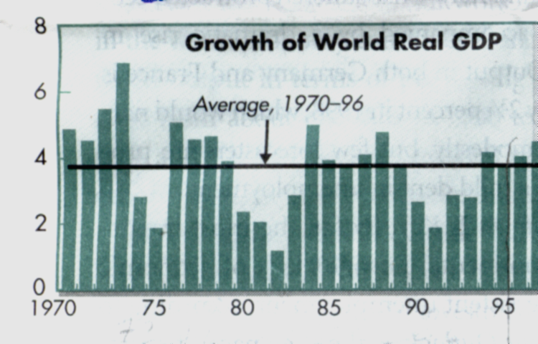
Source: International Monetary Fund (1997) “World Economic Outlook”, IMF Survey, Vol. 126 No. 17, p.27

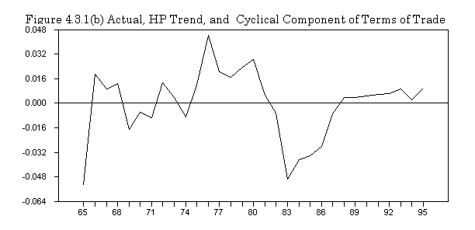

It seems, as suggested, difficult to explain this observation of the varying lengths of the cyclical fluctuations on the basis of the general business cycle theory, rather the particular lengths may be explained by factors such as changes of economic policy and other exogenous events.

5.5 Summary

In this chapter, we have attempted to establish some stylized facts of macroeconomic fluctuations in Tanzania during 1965-95. It has been found that the internationally exposed sectors−real exports and real imports−together with investment, have been the most volatile parts of the economy. Fluctuations of these variables are also highly correlated with fluctuations of GDP. Hence, disturbances in these sectors might have played an important role in driving the cyclic fluctuations in Tanzania.
The findings also show that the degree of volatility has changed over time. The period of relatively high degree of state economic control and regulation (1976-85) is characterized by relatively higher degree of macroeconomic instability. Otherwise, macroeconomic fluctuations in Tanzania seem to resemble fluctuations in other selected countries in terms of the pattern of correlation between GDP and other macroeconomic variables. However, the fluctuations tend, it seems, to be relatively more volatile in Tanzania, and the pattern seems to some extent to be country specific.

Chapter VI

Macroeconomic Fluctuations in Tanzania: Relative Importance of Monetary and Real Shocks.

6.1 Introduction

In chapter 5, we presented the regression and the VAR models that this study uses to examine the causes of output fluctuations in Tanzania. In this chapter, we present some empirical results based on those models. Section 6.2 presents unit root tests for the variables used in the models. Empirical results based on a regression model are presented in Section 6.3. Section 6.4 presents the vector autoregression (VAR) results. A summary of the chapter is presented in Section 6.5.

6.2 Unit Root Tests.

Table 6.2.1 below reports Augmented Dickey Fuller (ADF) unit root tests for the variables. The tests indicate that, for all the variables, we can not reject the null hypothesis that there is unit root in the series.

Table 6.2.1 ADF Unit Root Test for Variables

Variable | ADF-test for I(0) | Lags | ADF-test for I(1) | Lags | DF-test for I(2) | Lags | Order of Integration
GDP | -3.267 | 0 | -5.642 | 0 | - |  | 1
RIV | -1.526 | 1 | -5.826 |  | - |  | 1
POP | 1.797 | 0 | -4.878 | 0 | - | 0 | 1
TOT | -3.382 | 0 | -5.862 | 1 | - |  | 1
MS2 | -2.004 | 1 | -3.707 | 0 | - |  | 1
PRICE | -3.312 | 0 | -6.067 | 0 | - |  | 1
OPN | -1.711 | 1 | -3.558 | 0 | - |  | 1

Note:
For I(0): * at level 0.05 (no lag), the tabulated critical value = -3.567, at level 0.05 (one lag), the tabulated critical value = -3.5731.
For I(1) and I(2): * at level 0.05 (no lag) the tabulated Critical value = -2.967, at level 0.05 (one lag), the tabulated critical value = -2.9705

According to Hamilton (1994, p.561), there are three methods of overcoming the problem of spurious regression arising from using non-stationary time series. These are: 1) using the Cochrane–Orcutt procedure in regression, 2) using a lagged endogenous variable as an explanatory variable, and 3) differencing the non–stationary time series (until they become stationary) before the variables are used in regression. Hamilton (1994, p.562) argues that, “because the differencing method avoids the spurious regression problem as well as the nonstandard distributions, it is recommended by many researchers”. For this reason, we use the differencing method. To achieve stationarity, all variables are differenced once. However, one important limitation of differencing time series is that sometimes differencing may ‘throw away’ important information concerning long run relationship between variables.

6.3 Regression Results

We make the assumption, which we believe is reasonable, that the effect of the changes in exogenous variables on the endogenous variable may be subject to, and only observed, after some time lag. Because of this possibility we, for each variable, except population, in the equation to be estimated, use a current and three lagged values. Given the small sample size and the fact that serious multicollinearity may arise because of using ‘too many’ lags, we shall use full stepwise regression. This method employs both the forward and backward selection algorithms. The forward selection algorithm sequentially add variables to the model until none of the remaining variables have t−statistic with a value larger than a threshold value. The backward selection algorithm deletes variables, which at each new step have small t−statistics.
Table 6.3.1 below presents regression results of growth of real GDP on growth of population and capital inputs, openness of the economy, growth rate of money stock, and inflation. Both the coefficient of determination and the Durbin−Watson statistic are reasonably satisfactory.

Table 6.3.1 Stepwise Regression of gdp on pop, opn, riv, price, ms2 and d.
R²(BAR)=0.76 | DW=2.25 | DF=18

Variable | Coefficient | T−Statistic | Significance
Constant | 0.576 | 4.656 | 0.0001
pop(t) | 0.953 | 4.027 | 0.0008
Δriv(t) | 0.048 | 3.678 | 0.0002
Δprice(t-2) | -0.015 | -2.672 | 0.016
Δms2(t-1) | 0.046 | 2.316 | 0.033
Δms2(t-3) | 0.027 | 1.372 | 0.187
d | -0.01 | -1.872 | 0.078

Note: A prefix Δ refers to first difference of the relevant variable.

Results in table 6.3.1 above indicate that current population, a proxy for labor input, has an expected positive effect on real GDP. Investment, a proxy for capital inputs is significant at conventional levels and has an expected positive sign. Real money supply is significant at conventional levels and has the expected positive sign.
Inflation is significant and has a negative sign, seemingly confirming the long held monetarist view and the currently emerging concesus that inflation, or at least high inflation, has a negative effect on economic activity. A dummy for the exogenous events (war, droughts, and the collapse of the East African Community), d, is significant at 10 percent level and has the expected negative sign, indicating that exogenous events had adverse effects on economic activity.
The variable for changes in trade policy regime (degree of openness of the economy, Δopn) does not appear in the stepwise regression results apparently because it is not significant. This may partly be due to serious multicollinearity, partly arising out of including in the equation relatively ‘too many’ lags for the variables. To investigate more closely whether the apparent insignificance of the change in the trade policy regime arises from the suspected problem, the two variables−Δriv and Δprice are excluded in the equation. The results are reported in Table 6.3.2.

Table 6.3.2 Stepwise Regression Results of gdp on pop, opn, ms2, and d.
R²(BAR)=0.62 | DW=2.49 | DF=21

Variable | Coefficient | T−Statistic | Significance
Constant | 0.0.37 | 2.766 | 0.012
Δpop(t) | 1.006 | 4.444 | 0.002
Δopn(t-1) | 0.039 | 2.409 | 0.025
Δms(t-1) | 0.067 | 2.835 | 0.01
d | -0.02 | -3.516 | 0.002

Excluding inflation and investment has, as expected, lead to the changes in the coefficient of trade policy regime, which now appears significant. The coefficient of the variable has the expected positive sign, indicating that trade liberalization stimulates economic activity. The dummy for exogenous events, d, is now significant at 5 percent level, further confirming the suspicion of serious multicollinearity in the previous regression. However, the fact that the adjusted coefficient of determination has dropped substantially further confirms the importance of changes in the price level and in investment as determinants of the variation of GDP in Tanzania.
Next, examine further the effect of terms of trade on real GDP variation. A stepwise regression of changes in real GDP on changes in terms of trade, changes in the trade policy regime and change in investment is carried out and the results are reported in Table 6.3.3.

Table 6.3.3 Stepwise Regression Results of gdp on opn, riv, tot and d.
R²(BAR)=0.52 | DW=1.78 | DF=22

Variable | Coefficient | T−Statistic | Significance
Constant | 0.003 | 10.21 | 0.0
Δriv(t) | 0.027 | 2.129 | 0.045
Δtot(t-2) | 0.051 | 2.201 | 0.039
Δtot(t-3) | 0.073 | 3.102 | 0.005
d | -0.012 | -1.826 | 0.0815

The changes in the terms of trade (lagged two and three years) are significant at 5 percent level, and have the expected positive sign. This suggests that favorable terms of trade promote economic activity and deteriorating terms of trade impede economic activity. Hoffmaister, Roldos and Wickham (1997) have come up with a similar finding for Sub−Saharan CFA franc countries in Africa. The variable for the changes in trade policy regime does not appear in the stepwise regression results perhaps because of the multicollinearity problem that probably render the coefficient of the variable to be statistically insignificant. The dummy d is now statistically significant at only 10 percent level, suggesting that there is probably some degree of multicollinearity between d and changes in the terms of trade.

6.4 VAR Empirical Results.

Since each equation in the VAR model has identical variables on the right hand side, ordinary least squares (OLS), which in this case produce consistent and asymptotically efficient estimates, is used.

6.4.1 Test for Lag Length

Tests to determine the appropriate order (or lag length−p) of the VAR were carried out. Due to the small size of the sample, a maximum of three lags was allowed. The likelihood ratio test suggested that two lags are most appropriate (reducing the lag length from 3 to 2 had a 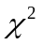 that was significant at 0.30 level, whereas reducing the lag length to 1 had a that was significant at 0.033). The multivariate generalization of the Akaike Information Criterion (AIC) and the Schwarz Criterion (SC) were also used and the test results are reported in Table 6.4.1 below.

Table 6.4.1 Test for Lag length
Test | 1 lags | 2 lags | 3 lags
AIC | -19.168 | -19.166 | -19.66*
SC | -18.31* | -17.35 | -16.80

Note: AIC = Akaike Information Criterion, SC = Schwarz Criterion.

While the SC criteria selects one lag, the AIC criterion picks three lags. Because we are dealing with a very small sample (31 observations), using three lags will definitely lead to ‘overparametarization’ of the model. This, however, does not imply that the SC’s choice of one lag is automatically appropriate. It is worthwhile to note that although the SC criterion is consistent, it often tend to underestimate the ‘true’ order of VAR (see Lutkepohl, 1993). As a compromise, two lags are used. Table 6.4.2 below shows that residuals from the two-order VAR are white noise. The Ljung–Box test for autocorrelation reject the null hypothesis of the presence of autocorrelation in the residuals. The Lagrange multiplier test of heteroskedasticity rejects the null hypothesis that the residuals are heteroskedastic. These tests suggest that the choice of two lags is reasonable.

Table 6.4.2 Tests for Residuals’ Autocorrelation and Autoregressive Conditional Heteroscedasticity.
Equation | LB(4) P−Value | ARCH(4) P−Value
GDP | 0.86 | 0.78
Money Stock | 0.56 | 0.38
Price Level | 0.42 | 0.90
Terms of Trade | 0.30 | 0.90

Note: LB is the Ljung−Box test for autocorrelation, ARCH is the Lagrange multiplier test for residual Autoregressive conditional heteroscedasticity.

6.4.2 Significance of the dummy variable

Likelihood ratio test for the dummy is Chi square (4) = 7.89 with p–value=0.0217. The dummy is statistically significant at 5 percent level in the system and in the GDP equation, it is significant at 5 percent level with the expected negative sign. In the price level equation the dummy is significant at 10 percent level and has the expected positive sign. This result seemingly supports our finding in Section 6.3 that; war, drought and the collapse of the East African Community had distinct negative effects on economic performance in Tanzania.

6.4.3 Impulse Response Functions

In order to obtain impulse response functions which trace out the effects of shocks in the structural equations on the endogenous time series, one has to look at innovations in the structural system and not the reduced form (or forecast) errors. This is, however, possible only if one can identify the structural (or primitive) system. For this reason, the parameters in the structural system have to be restricted in order to make possible the ‘recovery’ of information concerning the structural innovations from the information concerning the reduced form errors (see Enders 1995,p. 302). Two widely used methods of constraining the structural system are the recursive (or Cholesky) decomposition and the non-recursive procedure.
Cholesky decomposition involves constraining all elements above the principal diagonal of the contemporaneous structural coefficient matrix, , equal to zero. This renders the system exactly identified. The non-recursive decomposition procedure involves using economic theory to identify structural relationship between variables. There are two broad types of this procedure. The first one associated with Bernanke (1986) and Sims (1986) uses ‘theory’ to impose a set of restrictions in order to identify contemporaneous structural relationship between variables. The second type associated with Blanchard and Quah (1989), King et al (1991) and Shapiro and Watson (1989), uses long run restrictions instead of the contemporaneous restrictions to identify the structure of the model. Often the Cholesky decomposition procedure is considered to be ad hoc (see for example Enders, 1995). The reason behind this skepticism is that, unlike the non-recursive procedures, this procedure relies on restrictions that are usually not based on economic theory.

6.4.3.1 Ordering of the Variables
In Cholesky factorization, the ordering of the variables does influence the impulse response functions and variance decomposition results. The influence can be particularly substantial if there is high correlation between innovations in variables. Therefore, the choice of ordering in Cholesky decomposition is very important. Doan (1995, p.8-14) suggests some ways of choosing the ordering. For example, he suggests that variables that are not expected to have any predictive value for other variables should be put last. He also notes that when the variable is put first in the order it is implied that own innovation accounts for its entire first step variance.
As the correlation matrix for the reduced form innovations shows, correlation coefficients between reduced form innovations are low. Hence, the variance decomposition results are likely to be robust to changes in the ordering.

Correlation Matrix of Reduced Form Residuals:
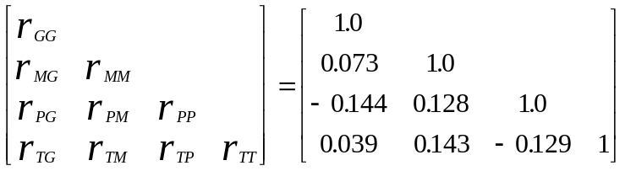
Note: G, M, P and T refer to GDP, money stock, price level and terms of trade respectively.

The F tests indicated that the lags of price and terms of trade have relatively the least predictive value in the system. For this reason, the price level and terms of trade may be put in the last place in the ordering of the variables. This means that either GDP or money stock will be first in the order, with the other two variables being put in the last two places in the order. One criterion to determine the variable to be put first in the order is to look for the variable whose innovations are more likely to disturb the other variables instantly. We believe it is reasonable to assume that terms of trade shocks affect other variables in the system only after a lag. For this reason, terms of trade can not be ordered first.
Taking into consideration real GDP and money stock, we believe it is reasonable in our case, to assume that a shock in real GDP affects the money stock instantly; rather than innovations in the money stock disturbing real GDP immediately. An increase in real GDP, for example, can instantly lead to an increase in the demand for money for transaction purposes to which the monetary authorities can respond by increasing money supply more or less automatically. In contrast, due to long gestation period of production, it may take real GDP a relatively longer period to respond to an increase in money supply. Real GDP is therefore put first in the order.
Figure 6.1 below presents impulse response functions together with upper and lower one standard deviation bands. The bands have been constructed using the Monte Carlo integration procedure in the RATS program. We tried 100 draws and 500 draws and we found no significant changes in the impulse responses in those two cases. Here, we report impulse response functions based on 500 draws.
Figure 6.1 below is read as follows. The impulse response function over a given horizon is significant if both the upper and lower bands containing the impulse response curve are either above or below zero over that horizon. In this case, the relevant variable is said to respond to the shock. Otherwise, the impulse response is not significant. Taking the first row of the Figure as an example, we can say that, with the exception of real GDP (income), the effect of the innovations in real GDP (income) on the other variables is not significant. The other variables do not respond to shock in GDP.
A one standard deviation innovation in the money stock seems to induce an increase in GDP, money stock and the price level. However, only for the first four periods the GDP responses are statistically significant. The price level seems to increase permanently following a shock in the money stock, further confirming findings by earlier studies (for example, Gerdes (1986), Hyuha and Osoro (1984), and Kilindo (1981) and (1992)) that expansion in the money stock in Tanzania significantly accounts for the rising inflation in Tanzania.
A positive shock in the price level, or increase in inflation, leads to a decrease in GDP and an increase in the money stock. However, in both cases only the initial two or three responses are statistically significant. The negative response of real GDP to a shock in the price level was also observed in the ordinary least squares results in Section 6.3, where it was noted that this kind of relationship seem to be typical of the high inflation economies.

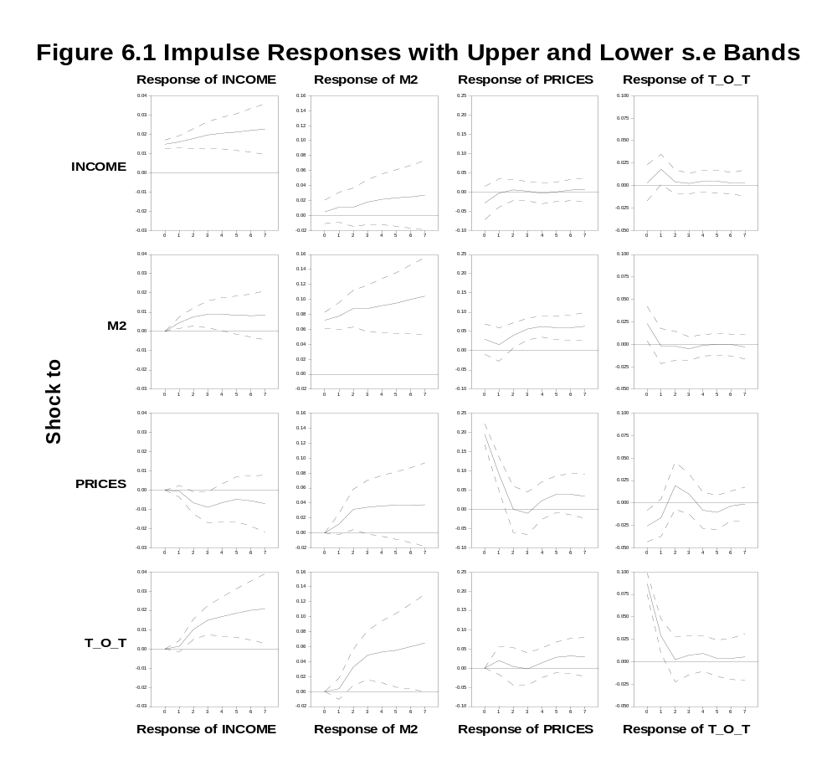

The positive response of the money stock to a shock in the price level suggest that expansion in the money stock in Tanzania may have been partly motivated by the central authorities’ desire to maintain ‘adequate’ real balances in the face of rising inflation. A one standard deviation shock in the terms of trade leads to an increase in real GDP and money stock. It seems terms of trade shocks play a significant role in explaining output fluctuations in Tanzania. This was also observed in Section 6.3, where it was noted that Roldos and Wickham (1997) also found terms of trade to be significant in explaining output fluctuations in Sub Saharan African CFA franc countries. The positive response of the money stock to the innovation in the terms of trade suggests that foreign exchange reserves, which increased with improvements in the terms of trade, were not sterilized and thus leading to an increase in money supply.
The terms of trade does not respond to innovations in any other variable. This confirms the contention that the terms of trade are an exogenous variable in the system. The explanation is, of course, that Tanzania is a very small economy in the world, whose exports and imports can hardly influence her terms of trade.

6.4.4 Variance Decomposition

Table 6.4.3 below shows variance decomposition for the variables in the model. The table is read row-wise. For example Row 5 of the GDP panel is read as follows: in the third step, almost 96 percent of variations in GDP can be explained by variations in GDP itself, and by 2.2 percent, 0.9 percent and 0.9 percent variations in the money stock, price level and terms of trade respectively.
Regarding variations in observed real GDP, it appears that most of the variations could be accounted for by disturbances in GDP itself and the terms of trade. Disturbances in real GDP and terms of trade account for about 58 percent and 36 percent respectively. The contribution of monetary shocks to fluctuations in real GDP is almost negligible. Disturbances in the price level explain about 4 percent of the variations in real GDP.
Most of the variations in the money stock are explained by shocks in the money stock itself. The shocks in the money stock accounts for about 74 percent of the variations in the money stock, while shocks in real GDP, the price level and terms of trade accounts for about 10 percent, 4 percent and 12 percent respectively. Again, it is interesting to note the importance of terms of trade shocks in explaining the variations in the money stock. It appears that developments in the world market and particularly the movements in the terms of trade have a significant influence on the Tanzania’s money market.

Table 6.4.3 Variance Decomposition.

 | GDP |  |  |  | Money Stock (M2)
 | Shock to |  |  |  | Shock to
Step | GDP | M2 | Prices | TOT | GDP | M2 | Prices | TOT
1 | 100.0 | 0.0 | 0.0 | 0.0 | 1.45 | 98.55 | 0.0 | 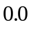
3 | 95.98 | 2.24 | 0.91 | 0.87 | 4.84 | 89.47 | 3.82 | 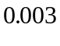
6 | 80.91 | 2.45 | 3.74 | 12.90 | 7.64 | 78.01 | 5.86 | 8.49
9 | 67.41 | 1.52 | 4.14 | 26.93 | 9.14 | 71.66 | 4.67 | 14.53
12 | 58.36 | 0.84 | 4.32 | 36.48 | 9.85 | 74.52 | 3.71 | 11.91

 | Prices |  |  |  | Terms of Trade
 | Shock to |  |  |  | Shock to
Step | GDP | M2 | Prices | TOT | GDP | M2 | Prices | TOT
1 | 2.59 | 3.73 | 93.68 | 0.0 | 0.93 | 1.46 | 4.15 | 93.46
3 | 2.81 | 7.39 | 88.62 | 1.19 | 0.02 | 0.28 | 2.66 | 96.86
6 | 2.59 | 23.50 | 70.42 | 3.48 | 0.50 | 0.09 | 0.74 | 98.68
9 | 1.63 | 33.18 | 55.25 | 9.93 | 1.67 | 0.06 | 0.46 | 97.81
12 | 1.07 | 36.68 | 46.80 | 15.46 | 4.15 | 0.11 | 0.69 | 95.05

Shocks in the price level and the money stock explain most of the variations in the price level. These shocks account for about 37 percent and 47 percent respectively of the variations in the price level. These results, once more stress the point that has been raised in other studies (see for example Hyuha and Osoro 1986, Gerdes 1986 and Kilindo 1992) that the growth in money stock has contributed significantly to the rise of inflation in Tanzania. As expected, most of the variations in the terms of trade are explained by innovations in the terms of trade itself, again, suggesting that terms of trade should be considered an exogenous variable in the system.

6.5 Summary

The main objective in this chapter has been to examine the possible determinants of output fluctuations and assess the relative importance of monetary and real shocks in explaining business cycles in Tanzania. Based on theory and intuition, a number of variables have been considered. Using simple regression analysis, it has been found, as expected, that growth in real money stock, changes in the terms of trade, changes in trade policy regime and investment are positively related to real GDP. The effect of population as proxy for labor input, on real GDP is as expected positive and significant; however, the proxy is obviously not quite adequate as such.
Inflation appears to have had a negative effect on economic activity in Tanzania. This finding concurs with the currently emerging consensus that at least high inflation is detrimental to economic activity. Exogenous events, namely the war with Uganda, drought and the collapse of the East African Community also appear to have had a negative effect on real GDP.
Considering shocks to terms of trade as well as shocks to GDP as real shocks, it seems that real shocks can explain a large part of the fluctuations of GDP in Tanzania. To the extent that shocks in GDP and the terms of trade account for about 95 percent, it would seem reasonable to argue that Business Cycles in Tanzania is mainly a Real Phenomenon. About 58 percent of GDP variations are explained by shocks to GDP itself. These do not include monetary shocks, but they are shocks related to supply side factors, such as productivity changes. The terms of trade shocks, which account for about 36 percent of the variations in GDP, also affect the supply side of the economy. This is because changes in terms of trade affect the import capacity and subsequently the productive capacity of the economy. The contribution of innovations in the price level is very small. The influence of monetary factors seems to be almost negligible. Moreover, a dummy, representing the effects of war, drought and the demise of the East African Community, also factors affecting the supply side of the economy, seem to have played an important part. However, it should be noted that the assessment of the relative importance of these events is limited to the inference of the significance of the dummy in the VAR model. One can not say much about these events based on impulse response and variance decomposition.

CHAPTER VII

Summary and Conclusions

7.1 Summary of Major Results

The main objective of this study has been to study the main features of economic fluctuations and trends in Tanzania and to examine the causes of the fluctuations. The main focus of the study has been on output fluctuations. Two competing perspectives of macroeconomic fluctuations, the monetary perspective and the real business cycle perspective have provided the theoretical basis of the study. While the monetary theories attribute macroeconomic fluctuations to monetary or demand disturbances, the real business school attributes the fluctuations to real or supply disturbances.
The study has attempted to decompose Tanzania’s macroeconomic time series into trend and cyclical components. The Hodrick-Prescott (1980) has been employed because its premise that a stochastic process generates a trend of a variable seems to conform to the fact that the evolution or growth of the macroeconomic time series is not a smooth process. The other methods such as the linear, exponential and polynomial detrending techniques assume that the evolution or growth of the macroeconomic time series is a smooth process. In addition to the decomposition, measurements of volatility and co-movement of the macroeconomic time series have been derived.
The results from decomposition of the series demonstrate that the Tanzanian economy has not been stable. There have been fluctuations in the macroeconomic time series. The GDP together with its components such as private consumption, investment, and exports, all are characterized by cyclical fluctuations around the long-term trends. It has also been established that there is much resemblance of patterns of trends and fluctuations among the main macroeconomic variables.
The study on the volatility of the macroeconomic time series suggests that the internationally exposed sectors such as real exports, real imports, and real investment which is influenced by foreign funds, have been the most volatile parts of the economy. Since these variables are highly correlated with real GDP, disturbances to them seem to have played a significant role in the generation of business cycles in Tanzania.
The degree of volatility has varied over time. While a relatively high degree of volatility among the macroeconomic variables is found during 197685, the period of relatively strict state control, a relatively low degree of volatility is found during 198695. There is, thus, certainly no evidence that state regulation and control of the economy helped to stabilize the economy.
The study has also examined the causes of business cycles (output fluctuations). Both the ordinary least squares (OLS) and vector autoregression (VAR) techniques have been used. In this study, these techniques compliment each other. Given the small size of the sample, the OLS technique has one main attraction. It can accommodate a relatively larger number of lags that can capture the dynamics of the process without over-parameterizing the model. The usefulness of VAR is limited in this respect. The main attraction of the VAR is that it facilitates, through the use of variance decomposition, the assessment of relative importance of various causes of the fluctuations. This advantage cannot be exploited in OLS. Growth in the money stock, changes in the terms of trade, changes in trade policy, changes in investment, inflation, and exogenous events namely the war with Uganda, drought and the collapse of the East African Community are treated as explanatory variables in the model.
A number of factors appear to have influenced the fluctuation of output in Tanzania. Simple regression analysis results suggest that variations in the money stock, the price level, terms of trade and investments are determinants of output fluctuations. Changes in trade policy regime, and exogenous events such as the war with Uganda, droughts and the collapse of the East African Community have also influenced the rate of output. High rates of inflation seem to have affected the rate of economic activity negatively.
Vector autoregression analysis results suggest that real shocks rather than monetary shocks have been the main source of cyclic fluctuations in Tanzania. Pure monetary shocks probably have played a very small role. Terms of trade disturbances, which are considered as real shocks, appear to have played a significant role, explaining about 37 percent of output fluctuations.
The analysis of business cycles in this study covered the period from 1965 to 1995. Profound institutional changes have taken place in Tanzania, especially since 1986. The economy is no longer under state control. Market forces are now playing a more important role in the allocation of resources, and the private sector, rather than the public sector, is now playing an important role in the production of goods and services. In spite of all these changes, the analysis of business cycles remains relevant for the period after 1995. Business cycle is not dead. This is mainly because, monetary and real shocks are not dead. The intensity of the problem of output fluctuations will in future depend on how effective will be the macroeconomic stabilization policies, and particularly on how the authorities will be capable of monitoring the performance of the economy and acting accordingly to stabilize the economy.

7.2 Comparison with other Studies
A previous study on business cycles in Tanzania (Van Arkadie et al, 1991) maintains that the Tanzanian economy has been stable. Empirical evidence in this study appears to disprove this assertion. The empirical evidence suggests that the Tanzanian economy on the contrary, has been volatile. For example, from 1977 to 1985 there was a prolonged economic slowdown. However, it should be mentioned that while Van Arkadie et al (1991) view the business cycles to be characterized by alternating periods of positive and negative economic growth rates, business cycles are seen as a process whereby GDP and other macroeconomic variables fluctuate around their long-term trends.
A study of the empirical regularities of macroeconomic fluctuations indicates that the main features of business cycles in Tanzania to a large extent resemble those in other selected countries. For example, the pattern of correlation between GDP and other macroeconomic variables in this study appears to be fairly similar to those in other countries like South Africa, Sweden, Norway and the United States.
Some notable differences have however been observed between the pattern of business cycles in Tanzania and those in other countries. For example, it seems that fluctuations in Tanzania have been somewhat more volatile than those in other countries. The differences may be attributed to different levels of development and different institutional set up. It is likely that a relatively higher degree of market imperfections, relatively weak monetary and fiscal institutions, and the prevalence of rudimentary financial institutions and financial repression in Tanzania as compared to other countries, prevents the economy from adjusting more or less ‘automatically’ and fast to shocks.
Just as in other studies (for example Shapiro and Watson (1988), Blanchard and Quah (1989), Karras (1993), King et al (1991) and Mellander et al 1992)) that have been carried out in developed countries, it has been found also in this study that real disturbances, rather than monetary shocks play a substantial role in driving the cycle. The other important comparable finding is the importance of terms of trade variations in explaining output fluctuations. Roldos and Wickham (1997) also found terms of trade to be significant in explaining output fluctuations in Sub Saharan franc countries.

7.3 Recommendations

A major finding in this study is that output fluctuations in Tanzania are, rather than a monetary phenomenon, a real phenomenon. This raises two important points. First, stabilization policies should focus mainly on the supply side of the economy. While there is very little that can be done to control terms of trade shocks and other unforeseen events, there are a number of policy matters that need particular attention. One of these is trade policy. Since changes in trade policy regime appear to be a significant determinant of output variation, and as fluctuations in exports seem to have substantially influenced fluctuations in output, a consistent trade policy that promotes exports should be an important ingredient of stabilization policy.
Second, Keynesian demand management policies to stabilize output may not be appropriate. According to the Keynesian view, the economy can be pulled out of recession by pursuing expansionary monetary and fiscal policies. In the case of Tanzania such a policy is more likely to accelerate inflation which. Since in this study it has been found that high inflation is negatively correlated with output, expansionary monetary and fiscal policies may have a negative effect on output. Monetary and fiscal policies in Tanzania therefore, should augment supply side policies. Restrictive monetary and fiscal policies should be put in place in order to control inflation.

7.4 Suggested Areas for Further Research

This study has identified real shocks as the main source of output fluctuations in Tanzania. At this relatively general level, this finding does not warrant the drawing of definitive and specific implications for stabilization policy. Further research is needed to study the influence of specific supply disturbances on the rate of economic activity; the main focus being on policy induced disturbances. Specific and detailed research on areas such as government regulations and controls, changes in trade policy, technical progress and inflation; and the study of the influence of such changes on the rate of economic activity, are important tasks for future research.

BIBLIOGRAPHY

Agenor, P. R. and P. J. Montiel (1996) Development Macroeconomics, Princeton University Press, Princeton.
Baxter, M. and R. G. King (1995) “Measuring Business Cycles: Approximate Band–Pass Filters for Economic Time Series,” Working Paper No. 5022. National Bureau of Economic Research.
Bevan, Paul Collier and J. W. Gunning (1993) “Trade Shocks in Developing Countries Consequences and Policy Responses” Journal Economic of European Review, 37 pp. 557−565.
Burns A. M. and W. C. Mitchell (1946) Measuring Business Cycles.
Canova, F. (1994) “Detrending and Turing–Points”, European Economic Review, vol. 38, nos. 3 / 4 pp.614–623.
Canova, F. (1997) “Detrending and Business Cycle Facts”, Journal of Monetary Economics
Canova, F. (1999) “Does Detrending Matter for the Determination of the Reference Cycle and the Selection of Turning Points?” Economic Journal, Vol. 109, No. 452, pp. 126−150.
Cochrane J. H. (1991) “A Critique of the Application of Unit Root Tests” Journal of Economic Dynamics and Control, 15 pp. 275−284.
Cochrane, J. H. (1994) “Permanent and Transitory Components of GNP and Stock Prices.” Quarterly Journal of Economics, Vol. 61 pp. 241–265.
Cogley T. and J. M. Nason (1995) “Effects of the Hodrick−Prescott Filter on Trend and Difference Stationary Time Series Implications for Business Cycle Research” Journal of Economic Dynamics and Control, 19 pp. 253−278.
Cogley, T. J. and J. M. Nason (1995) “Effects of the Hodrick–Prescott Filter on Trend and Difference Stationary Time Series: Implications for Business Cycle Research”, Journal of Economic Dynamcs and Control vol. 19 , pp. 253–278.
Cuddington J. T. and L. A. Winters (1987) “The Beveridge−Nelson Decomposition of Economic Time Series & A Quick Computational Method” A. (1996) “Monetary Aspects of Norwegian Business Cycle: An Exploratory Study Based on Historical Data” Journal of Economic History Review, Vol. 44, pp. 43−65.
Danthine, Jean–Pierre and J. B. Donaldson (1993) “Methodological and Empirical Issues in Real Business Cycle Theory”, European Economic Review vol. 37, pp. 1–35.
Diebold F. X. and G. D. Rudebusch (1989) “Long Memory and Persistence in Aggregate Output” Journal of Monetary Economics Vol. 24, pp. 189−209.
Doan, T. A. (1995) RATS User’s Manual: Version 4, Estima, Envaston, IL.
Enders, W. (1995) Applied Econometric Time Series, John Wiley & Sons,Inc.; New York.
Enders, W. (1996) RATS Handbook for Econometric Time Series, John Wiley & Sons,Inc.; New York.
Englund P, T. Person and L. E. O. Svensson (1992) “Swedish Business Cycles: 1861−1988” Journal of Monetary Economics 30 pp. 343−371.
Friedman B. M. and K. N. Kuttner (1993) “Another Look at the Evidence on Money−Income Causality” Journal of Econometrics, 57 pp. 189−203.
Glasner, D. (1997) Business Cycles and Depressions: An Encyclopedia, Garland Publishing, Inc., New York.
Granger, C. W. J (1966) “The Typical Spectral Shape of an Economic Variable”. Econometrica, vol. 37 pp.424–438.
Greene, W. H. (1997) Econometric Analysis, Prentice−Hall International, Inc., New Jersey.
Gregory A. W. and G. W. Smith (1996) “Measuring Business Cycle Model”, Journal of Economic Dynamics and Control, 20 pp. 1007−1025.
Guay, A. and P. St–Amant (1997) “Do the Hodrick–Prescott and Baxter–King Filters Provide a Good Approximation of Business Cycles?”, Working Paper No. 53, Bank of Canada.
Hamilton J. (1989) “A New Approach to the Economic Analysis of Nonstationary Time Series and the Business Cycle” Journal of Econometrica, Vol.57, No. 2, pp. 357−384.
Hamilton, J. D. (1994) Time Series Analysis, Princeton University Press, Princeton.
Harvey, A. C. and A. Jaeger (1993) “Detrending, Stylized Facts and the Business Cycle”, Journal of Applied Econometrics, vol. 8, pp. 231–247.
Hendry D. F. (1986) “Econometric Modelling with Cointegrated Variables: An Overview” Journal of Economics and Statistics, 48, 3, pp. 201−212.
Hsiao C. (1981) “Autoregressive Modelling and Money−Income causality Detection”, Journal of Monetary Economics 7, pp. 83−106.
Journal of Monetary Economics 19 pp. 125−127.
Kadiyala K. R. and S. Karlsson (1997)”Numerical Methods for Estimation and Inference in Bayesian Var−Models” Journal of Applied Econometrics, Vol. 12, pp. 99−132.
King, R. G., Plosser, C. I, Stock, J. H. and Watson, M. W. (1991) “Stochastic Trends and Economic Fluctuations”, American Economic Review, 81, September 819-840.

King R. G. and S. T. Rebelo (1993) “Low Frequency Filtering and Real Business Cycles”, Journal of Economic Dynamics and Control, Vol. 17 pp. 207−231.
King, Robert G. and S. T. Rebelo (1993) “Low Frequency Filtering and Real Business Cycles,” Journal of Economic Dynamics and Control vol. 17, no. 1–2, pp. 207–231.
Koop G. (1992) “Aggregate Shocks and Macroeconomic Fluctuations: A Bayesian Approach” Journal of Applied Econometrics, Vol. 7, pp. 395−411.
Landreth, H. and D. C. Colander (1994) History of Economic Thought, Houghton Mifflin Company, Boston.
Lutkepohl, H. (1993) Introduction to Multiple Time Series Analysis, Springer−Verlag, Berlin.
McCallum B. T. (1986) “On “Real” and “Sticky−Price” Theories of the Business Cycle” Journal of Money, Credit, and Banking, Vol.18, No. 4 pp. 397−414.
Obstfeld, M. and K. Rogoff (1996) Foundations of International Macroeconomics, MIT, Cambridge, Massachusetts.
Perron P. (1989) “The Great Crash, The Oil Price Shock, and the Unit Root Hypothesis” Journal Econometrics, Vol. 57, No.6 pp. 1361−1401.
Raj B. (1992) “International Evidence on Persistence in Output in the Presence of an Episodic Chance” Journal of Applied Econometrics, Vol. 7, pp. 281−293.
Ravson, M. O and H. Uhlig (1997) “On Adjusting the HP–Filter for the Frequency of Observations”, Unpublished manuscript.
Romer, D. (1996) Advanced Macroeconomics, McGraw−Hill Companies, Inc., New York.
Rutasitara, L. (1996) Real Exchange Rate Behavior and Merchandise Exports in Tanzania, Unpublished Ph.D. Thesis, University of Dar Es Salaam.
Schwert G. W. (1987) “Effects of Model Specification on Tests for Unit Roots in Macroeconomic Data” Journal of Monetary Economics 20, pp. 73−103.
Sims C. A. (1980) “Macroeconomics and Reality”, Econometrica, Vol. 48 pp 1−48.
Sims C. A. and T. Zha (1996) “Bayesian Methods for Dynamic Multivariate Models”, Unpublished manuscript, pp. 1−22.
Sims, C. A. and T. Zha (1995) “Error Bands for Impulse Responses”, Unpublished manuscript.
Watson M. W. “Univariate Detrending Methods with Stochastic Trends”, Journal of Monetary Economics 18, pp. 49−75.

APPENDIX
Table 3A 1 Real GDP (1985 Prices)

 | Mil. Tshs |  |  | Percent
Year | Real GDP | Trend real GDP | Deviation from trend | GDP growth rate | % of deviation from trend
1965 | 61107 | 63067.54 | -1960.5 | 3.2 | -3.11
1966 | 68950 | 67038.29 | 1911.7 | 12.08 | 2.85
1967 | 71734 | 70899.9 | 834.1 | 3.96 | 1.18
1968 | 75499 | 74564.71 | 934.3 | 5.12 | 1.25
1969 | 76836 | 78083.32 | -1247.3 | 1.76 | -1.60
1970 | 81292 | 81687.9 | -395.9 | 5.64 | -0.48
1971 | 84690 | 85437.82 | -747.8 | 4.09 | -0.88
1972 | 90384 | 89333.94 | 1050.1 | 6.51 | 1.18
1973 | 93147 | 93245.22 | -98.2 | 3.01 | -0.11
1974 | 95476 | 97199.14 | -1723.1 | 2.47 | -1.77
1975 | 100906 | 101212.2 | -306.2 | 5.53 | -0.30
1976 | 107574 | 105003.4 | 2570.6 | 6.40 | 2.45
1977 | 108006 | 108200.6 | -194.6 | 0.40 | -0.18
1978 | 110307 | 110827.5 | -520.5 | 2.11 | -0.47
1979 | 113521 | 112893.2 | 627.8 | 2.87 | 0.56
1980 | 116353 | 114333.6 | 2019.4 | 2.46 | 1.77
1981 | 115767 | 115195.4 | 571.6 | -0.50 | 0.50
1982 | 116453 | 115861 | 592.0 | 0.59 | 0.51
1983 | 113685 | 116818 | -3133.0 | -2.41 | -2.68
1984 | 117531 | 118668.8 | -1137.8 | 3.33 | -0.96
1985 | 120621 | 121537.9 | -916.9 | 2.60 | -0.75
1986 | 124556 | 125389.6 | -833.6 | 3.21 | -0.66
1987 | 130891 | 130042.2 | 848.8 | 4.96 | 0.65
1988 | 136430 | 135150 | 1280.0 | 4.14 | 0.95
1989 | 140981 | 140457.1 | 523.9 | 3.28 | 0.37
1990 | 146049 | 145885 | 164.0 | 3.53 | 0.11
1991 | 151454 | 151432 | 22.0 | 3.63 | 0.01
1992 | 157029 | 157124.7 | -95.7 | 3.61 | -0.06
1993 | 163340 | 162997.3 | 342.7 | 3.94 | 0.21
1994 | 168241 | 169072.4 | -831.4 | 2.96 | -0.49
1995 | 175812 | 175434.3 | 377.7 | 4.40 | 0.22

Source: International Financial Statistics (various issues), Bank of Tanzania Economic Operations Report (various issues) and own computations.
Table 3A 2 Real Agricultural Output (1985 Prices) (Mil. Tshs.)

Year | Actual | Trend | Deviation
1965 | 27033.7 | 28288.6 | -1254.9
1966 | 31027.5 | 29594.0 | 1433.5
1967 | 30831.3 | 30735.6 | 95.7
1968 | 32230.5 | 31700.1 | 530.4
1969 | 32317.2 | 32494.6 | -177.4
1970 | 33492.3 | 33219.8 | 272.5
1971 | 33037.6 | 33957.8 | -920.2
1972 | 35737.8 | 34844.2 | 893.7
1973 | 36038.6 | 35871.5 | 167.0
1974 | 34552.8 | 37182.7 | -2629.9
1975 | 37426.0 | 38973.2 | -1547.1
1976 | 44083.8 | 41000.8 | 3083.0
1977 | 44509.3 | 42694.6 | 1814.7
1978 | 44144.9 | 43903.3 | 241.5
1979 | 44284.5 | 44776.3 | -491.7
1980 | 45761.6 | 45529.0 | 232.6
1981 | 46167.9 | 46314.2 | -146.4
1982 | 46569.6 | 47334.5 | -764.9
1983 | 47747.7 | 48787.4 | -1039.7
1984 | 50538.3 | 50769.5 | -231.2
1985 | 53411.0 | 53218.9 | 192.1
1986 | 56199.7 | 56024.8 | 174.9
1987 | 59686.3 | 59085.5 | 600.8
1988 | 62484.9 | 62304.5 | 180.4
1989 | 65429.3 | 65667.6 | -238.3
1990 | 68643.0 | 69188.0 | -544.9
1991 | 73758.1 | 72838.4 | 919.7
1992 | 76473.1 | 76488.2 | -15.1
1993 | 81506.7 | 80141.5 | 1365.1
1994 | 81765.1 | 83803.4 | -2038.2
1995 | 88257.6 | 87718.5 | 539.2

Source: International Financial Statistics (various issues), Bank of Tanzania Economic Operations Report (various issues) and own computations.
Table 3A 3 Real Manufacturing Output (1985 Prices) (Mil. Tshs.)

Year | Actual | Trend | Deviation
1965 | 4705.2 | 4883.8 | -178.6
1966 | 5516.0 | 5455.2 | 60.8
1967 | 6097.4 | 6057.3 | 40.1
1968 | 6945.9 | 6657.9 | 288.0
1969 | 7068.9 | 7221.6 | -152.7
1970 | 7885.3 | 7757.9 | 127.4
1971 | 8299.6 | 8256.1 | 43.5
1972 | 8948.0 | 8728.8 | 219.2
1973 | 9128.4 | 9201.9 | -73.5
1974 | 8879.3 | 9746.8 | -867.6
1975 | 10090.6 | 10439.4 | -348.8
1976 | 10865.0 | 11209.9 | -344.9
1977 | 12960.7 | 11900.3 | 1060.4
1978 | 13236.8 | 12254.8 | 982.1
1979 | 12714.4 | 12176.4 | 537.9
1980 | 11623.7 | 11755.6 | -131.9
1981 | 11113.6 | 11182.0 | -68.4
1982 | 10364.3 | 10607.4 | -243.0
1983 | 10061.1 | 10147.1 | -85.9
1984 | 9731.6 | 9861.4 | -129.9
1985 | 9251.6 | 9795.8 | -544.2
1986 | 9528.5 | 9985.0 | -456.5
1987 | 10274.9 | 10389.8 | -114.8
1988 | 11160.0 | 10896.8 | 263.2
1989 | 11983.4 | 11353.8 | 629.6
1990 | 12560.2 | 11628.0 | 932.2
1991 | 11510.5 | 11682.1 | -171.6
1992 | 11620.1 | 11632.2 | -12.1
1993 | 11107.1 | 11571.4 | -464.3
1994 | 10935.7 | 11589.8 | -654.1
1995 | 12306.8 | 11702.2 | 604.7

Source: International Financial Statistics (various issues), Bank of Tanzania Economic Operations Report (various issues) and own computations.
Table 3A 4 Real Private Consumption (1985 Prices) (Mil. Tshs)

Year | Actual | Trend | Deviation
1965 | 45219.2 | 46801.6 | -1582.5
1966 | 51712.5 | 48951.7 | 2760.8
1967 | 50931.1 | 50919.5 | 11.6
1968 | 52849.3 | 52848.5 | 0.8
1969 | 53785.2 | 54910.0 | -1124.8
1970 | 56904.4 | 57303.4 | -399.0
1971 | 58436.1 | 60064.7 | -1628.6
1972 | 63268.8 | 63166.2 | 102.6
1973 | 66134.4 | 66279.9 | -145.5
1974 | 73516.5 | 69028.4 | 4488.1
1975 | 75679.5 | 70956.0 | 4723.5
1976 | 67771.6 | 72311.5 | -4539.9
1977 | 66963.7 | 74148.9 | -7185.2
1978 | 80524.1 | 76841.4 | 3682.7
1979 | 79464.7 | 79526.6 | -61.9
1980 | 89591.8 | 81835.6 | 7756.2
1981 | 82194.6 | 83351.9 | -1157.3
1982 | 81517.1 | 84870.5 | -3353.4
1983 | 87537.5 | 87059.8 | 477.7
1984 | 88148.3 | 90084.3 | -1936.1
1985 | 90465.8 | 94228.6 | -3762.9
1986 | 99644.8 | 99503.9 | 140.9
1987 | 112566.3 | 105247.1 | 7319.2
1988 | 113236.9 | 110657.7 | 2579.2
1989 | 114194.6 | 116014.8 | -1820.2
1990 | 110997.2 | 122114.5 | -11117.2
1991 | 136308.6 | 129599.8 | 6708.8
1992 | 142896.4 | 137168.3 | 5728.1
1993 | 142105.8 | 144361.7 | -2255.9
1994 | 151416.9 | 151627.4 | -210.5
1995 | 158230.8 | 159116.7 | -885.9

Source: International Financial Statistics (various issues), Bank of Tanzania Economic Operations Report (various issues) and own computations.
Table 3A 5 Real Government Consumption (1985 Prices) (Mil. Tshs.)

Year | Actual | Trend | Deviation
1965 | 6355.1 | 6389.0 | -33.8
1966 | 7101.9 | 7054.9 | 47.0
1967 | 7890.7 | 7783.5 | 107.2
1968 | 8455.9 | 8582.0 | -126.1
1969 | 9220.3 | 9479.1 | -258.8
1970 | 10704.2 | 10488.7 | 215.5
1971 | 11779.3 | 11575.7 | 203.6
1972 | 12086.8 | 12727.6 | -640.8
1973 | 13990.2 | 13964.8 | 25.4
1974 | 15544.5 | 15189.2 | 355.3
1975 | 17298.0 | 16274.2 | 1023.8
1976 | 17572.9 | 17131.3 | 441.6
1977 | 16117.8 | 17844.3 | -1726.5
1978 | 19150.9 | 18599.3 | 551.5
1979 | 18634.9 | 19300.9 | -666.0
1980 | 19677.5 | 19932.7 | -255.2
1981 | 20168.3 | 20363.4 | -195.1
1982 | 25430.0 | 20413.5 | 5016.5
1983 | 15666.9 | 19888.0 | -4221.1
1984 | 19054.5 | 19318.0 | -263.5
1985 | 19945.3 | 18473.2 | 1472.1
1986 | 19826.9 | 17135.1 | 2691.8
1987 | 16326.3 | 15377.5 | 948.8
1988 | 13324.0 | 13632.1 | -308.2
1989 | 10947.7 | 12305.6 | -1357.9
1990 | 10141.3 | 11617.2 | -1476.0
1991 | 11672.7 | 11562.0 | 110.7
1992 | 11147.6 | 11965.2 | -817.6
1993 | 14908.8 | 12719.3 | 2189.5
1994 | 12983.4 | 13565.3 | -581.9
1995 | 15017.9 | 14542.3 | 475.6

Source: International Financial Statistics (various issues), Bank of Tanzania Economic Operations Report (various issues) and own computations.
Table 3A 6 The General Price Index (CPI) (1985=100)

Year | Actual | Trend | Deviation
1965 | 4.2 | 4.20 | 0.00
1966 | 4.6 | 4.70 | -0.10
1967 | 5.2 | 5.27 | -0.07
1968 | 6 | 5.89 | 0.11
1969 | 7 | 6.51 | 0.49
1970 | 7.2 | 7.12 | 0.08
1971 | 7.6 | 7.77 | -0.17
1972 | 8.2 | 8.55 | -0.35
1973 | 9 | 9.55 | -0.55
1974 | 10.8 | 10.83 | -0.03
1975 | 13.6 | 12.37 | 1.23
1976 | 14.5 | 14.09 | 0.41
1977 | 16.2 | 16.09 | 0.11
1978 | 18.1 | 18.60 | -0.50
1979 | 20.6 | 22.03 | -1.43
1980 | 26.8 | 26.91 | -0.11
1981 | 33.6 | 33.76 | -0.16
1982 | 43.4 | 43.31 | 0.09
1983 | 55.1 | 56.51 | -1.41
1984 | 75 | 74.64 | 0.36
1985 | 100 | 98.89 | 1.11
1986 | 132.4 | 130.35 | 2.05
1987 | 172.1 | 169.82 | 2.28
1988 | 225.8 | 217.83 | 7.97
1989 | 284.1 | 274.59 | 9.51
1990 | 340.1 | 341.50 | -1.40
1991 | 415.9 | 422.96 | -7.06
1992 | 507 | 526.26 | -19.26
1993 | 635.6 | 661.76 | -26.16
1994 | 852.5 | 841.05 | 11.45
1995 | 1102.3 | 1073.47 | 28.83

Source: International Financial Statistics (various issues), Bank of Tanzania Economic Operations Report (various issues) and own computations.
Table 3A 7 Inflation (in percentage)

Year | Actual | Trend | Deviation
1965 | 6.7 | 8.8 | -2.1
1966 | 9.8 | 10.1 | -0.3
1967 | 12.2 | 11.1 | 1.1
1968 | 15.6 | 11.4 | 4.2
1969 | 16.4 | 10.8 | 5.6
1970 | 3.5 | 9.6 | -6.1
1971 | 4.7 | 9.3 | -4.6
1972 | 7.6 | 10.2 | -2.6
1973 | 10.5 | 12.0 | -1.5
1974 | 19.2 | 13.7 | 5.5
1975 | 26.5 | 14.5 | 12.0
1976 | 6.9 | 14.1 | -7.2
1977 | 11.6 | 14.3 | -2.7
1978 | 11.3 | 15.8 | -4.5
1979 | 13.8 | 18.6 | -4.8
1980 | 30.3 | 22.3 | 8.0
1981 | 25.6 | 25.5 | 0.1
1982 | 28.9 | 28.2 | 0.7
1983 | 27.1 | 30.3 | -3.2
1984 | 36.1 | 31.9 | 4.2
1985 | 33.3 | 32.6 | 0.7
1986 | 32.4 | 32.6 | -0.2
1987 | 30.0 | 32.1 | -2.1
1988 | 31.2 | 31.6 | -0.4
1989 | 30.4 | 31.0 | -0.6
1990 | 35.9 | 30.2 | 5.7
1991 | 28.8 | 29.0 | -0.2
1992 | 21.9 | 28.1 | -6.2
1993 | 25.2 | 28.1 | -2.9
1994 | 34.1 | 28.9 | 5.2
1995 | 29.3 | 29.7 | -0.4

Source: International Financial Statistics (various issues), Bank of Tanzania Economic Operations Report (various issues) and own computations.
Table 3A 8 Nominal Money Stock (M2) (Mil. Tshs)

Year | Actual | Trend | Deviation
1965 | 1466 | 1385.1 | 80.9
1966 | 1508 | 1462.8 | 45.2
1967 | 1540 | 1558.9 | -18.9
1968 | 1499 | 1700.0 | -201.0
1969 | 1880 | 1920.0 | -40.0
1970 | 2306 | 2227.4 | 78.6
1971 | 2713 | 2624.0 | 89.0
1972 | 3169 | 3120.4 | 48.6
1973 | 3653 | 3743.2 | -90.2
1974 | 4518 | 4538.0 | -20.0
1975 | 5615 | 5548.7 | 66.3
1976 | 6947 | 6823.4 | 123.6
1977 | 8347 | 8431.9 | -84.9
1978 | 9396 | 10491.2 | -1095.2
1979 | 13807 | 13148.4 | 658.6
1980 | 17520 | 16314.1 | 1205.9
1981 | 20695 | 19852.0 | 843.0
1982 | 24729 | 23738.2 | 990.8
1983 | 29127 | 28134.4 | 992.6
1984 | 30218 | 33555.4 | -3337.4
1985 | 38911 | 41116.5 | -2205.5
1986 | 50353 | 51965.8 | -1612.8
1987 | 66643 | 67414.1 | -771.1
1988 | 89809 | 88881.3 | 927.7
1989 | 116295 | 117704.4 | -1409.4
1990 | 166675 | 154993.7 | 11681.3
1991 | 215790 | 200518.3 | 15271.7
1992 | 247830 | 254766.3 | -6936.3
1993 | 313705 | 321519.0 | -7814.0
1994 | 390428 | 405844.2 | -15416.2
1995 | 524307 | 513927.1 | 10379.9

Source: International Financial Statistics (various issues), Bank of Tanzania Economic Operations Report (various issues) and own computations.
Table 3A 9 Growth Rate of Money Stock (M2) (in percentage)

Year | Actual | Trend | Deviation
1965
1966 | 3.0 | 1.0 | 2.0
1967 | 2.0 | 4.0 | -2.0
1968 | -3.0 | 8.0 | -11.0
1969 | 23.0 | 12.0 | 10.0
1970 | 20.0 | 15.0 | 5.0
1971 | 16.0 | 17.0 | -1.0
1972 | 16.0 | 18.0 | -2.0
1973 | 14.0 | 18.0 | -4.0
1974 | 21.0 | 19.0 | 2.0
1975 | 22.0 | 20.0 | 2.0
1976 | 21.0 | 21.0 | 1.0
1977 | 18.0 | 21.0 | -3.0
1978 | 12.0 | 22.0 | -10.0
1979 | 38.0 | 23.0 | 16.0
1980 | 24.0 | 22.0 | 2.0
1981 | 17.0 | 20.0 | -3.0
1982 | 18.0 | 18.0 | 0.0
1983 | 16.0 | 17.0 | -1.0
1984 | 4.0 | 18.0 | -14.0
1985 | 25.0 | 20.0 | 5.0
1986 | 26.0 | 23.0 | 3.0
1987 | 28.0 | 26.0 | 2.0
1988 | 30.0 | 28.0 | 2.0
1989 | 26.0 | 28.0 | -2.0
1990 | 36.0 | 27.0 | 9.0
1991 | 26.0 | 26.0 | 0.0
1992 | 14.0 | 24.0 | -10.0
1993 | 24.0 | 23.0 | 0.0
1994 | 22.0 | 24.0 | -2.0
1995 | 29.0 | 25.0 | 4.0

Source: International Financial Statistics (various issues), Bank of Tanzania Economic Operations Report (various issues) and own computations.
Table 3A 10 Real Government Budget Deficit (Mil. Tshs, 1985 Prices)

Year | Actual | Trend | Deviation
1965 | 317.0 | 282.7 | 34.4
1966 | 271.0 | 293.4 | -22.5
1967 | 304.8 | 310.2 | -5.5
1968 | 305.0 | 336.0 | -31.0
1969 | 412.0 | 373.7 | 38.3
1970 | 369.0 | 421.5 | -52.5
1971 | 688.0 | 483.5 | 204.5
1972 | 555.0 | 553.9 | 1.1
1973 | 360.0 | 658.3 | -298.3
1974 | 851.0 | 843.1 | 7.9
1975 | 1865.0 | 1098.2 | 766.8
1976 | 1805.0 | 1374.6 | 430.4
1977 | 855.0 | 1700.1 | -845.1
1978 | 1936.0 | 2232.1 | -296.1
1979 | 4134.0 | 2994.0 | 1140.0
1980 | 4046.0 | 3859.2 | 186.8
1981 | 5026.0 | 4735.4 | 290.6
1982 | 7024.0 | 5520.2 | 1503.8
1983 | 5383.0 | 6160.4 | -777.4
1984 | 5669.0 | 6891.9 | -1222.9
1985 | 8408.0 | 7921.4 | 486.6
1986 | 8643.0 | 9291.6 | -648.6
1987 | 15406.0 | 11154.2 | 4251.8
1988 | 11908.0 | 13584.3 | -1676.3
1989 | 14698.0 | 17520.0 | -2822.0
1990 | 15340.0 | 24457.8 | -9117.8
1991 | 47324.0 | 36725.9 | 10598.1
1992 | 54687.0 | 54710.5 | -23.5
1993 | 113592.0 | 77660.4 | 35931.6
1994 | 135982.0 | 100883.2 | 35098.8
1995 | 79916.0 | 122408.0 | -42492.0

Source: International Financial Statistics (various issues), Bank of Tanzania Economic Operations Report (various issues) and own computations.
Table 3A 11 Real Investment (1985 Prices) (Mil. Tshs)

Year | Actual | Trend | Deviation
1965 | 187.9 | 195.6 | -7.8
1966 | 213.5 | 204.5 | 9.0
1967 | 236.9 | 212.3 | 24.6
1968 | 217.0 | 219.1 | -2.1
1969 | 173.3 | 228.9 | -55.6
1970 | 260.8 | 245.9 | 15.0
1971 | 312.1 | 264.2 | 47.9
1972 | 288.3 | 278.6 | 9.7
1973 | 288.9 | 290.8 | -1.9
1974 | 280.7 | 304.3 | -23.6
1975 | 260.3 | 323.4 | -63.1
1976 | 355.8 | 348.9 | 6.9
1977 | 411.3 | 368.7 | 42.6
1978 | 405.0 | 369.8 | 35.2
1979 | 417.1 | 346.8 | 70.3
1980 | 322.0 | 304.2 | 17.8
1981 | 256.9 | 257.0 | -0.1
1982 | 249.4 | 217.3 | 32.1
1983 | 140.7 | 191.2 | -50.5
1984 | 159.6 | 186.0 | -26.4
1985 | 168.7 | 202.3 | -33.6
1986 | 216.6 | 242.8 | -26.2
1987 | 378.7 | 308.4 | 70.3
1988 | 430.9 | 390.3 | 40.6
1989 | 454.1 | 478.9 | -24.8
1990 | 642.2 | 563.2 | 79.0
1991 | 630.9 | 622.0 | 8.9
1992 | 665.3 | 645.9 | 19.4
1993 | 687.7 | 632.6 | 55.1
1994 | 618.9 | 589.0 | 29.9
1995 | 443.7 | 532.6 | -89.0

Source: International Financial Statistics (various issues), Bank of Tanzania Economic Operations Report (various issues) and own computations.
Table 3A 12 Real External Finance (1985 Prices) (Mil. Tshs).

Year | Actual | Trend | Deviation
1965 | 19.9 | 19.8 | 0.1
1966 | 27.7 | 20.1 | 7.6
1967 | 16.2 | 20.4 | -4.3
1968 | 20.5 | 21.9 | -1.5
1969 | 17.4 | 25.2 | -7.8
1970 | 37.5 | 31.1 | 6.4
1971 | 50.7 | 38.9 | 11.7
1972 | 39.6 | 48.4 | -8.7
1973 | 53.4 | 60.6 | -7.2
1974 | 96.1 | 75.4 | 20.7
1975 | 75.8 | 90.1 | -14.3
1976 | 104.1 | 103.6 | 0.6
1977 | 126.2 | 112.0 | 14.2
1978 | 134.1 | 111.3 | 22.8
1979 | 112.6 | 101.3 | 11.3
1980 | 69.9 | 86.7 | -16.8
1981 | 87.9 | 72.7 | 15.2
1982 | 85.7 | 60.4 | 25.3
1983 | 34.4 | 51.6 | -17.2
1984 | 35.7 | 49.8 | -14.2
1985 | 33.2 | 56.1 | -22.9
1986 | 107.5 | 71.8 | 35.7
1987 | 106.4 | 93.9 | 12.5
1988 | 139.4 | 120.2 | 19.2
1989 | 150.4 | 147.0 | 3.4
1990 | 148.8 | 172.0 | -23.2
1991 | 202.8 | 193.3 | 9.5
1992 | 237.8 | 204.7 | 33.2
1993 | 258.5 | 201.9 | 56.6
1994 | 140.7 | 187.9 | -47.3
1995 | 167.6 | 173.9 | -6.3

Source: International Financial Statistics (various issues), Bank of Tanzania Economic Operations Report (various issues) and own computations.
Table 3A 13 Real Exports (1985 Prices) (Mil. Tshs.)

Year | Actual | Trend | Deviation
1965 | 33393 | 35748.7 | -2355.7
1966 | 38804 | 33729.7 | 5074.3
1967 | 32071 | 31479.5 | 591.5
1968 | 28628 | 29397.3 | -769.3
1969 | 25608 | 27870.6 | -2262.6
1970 | 25722 | 27101.8 | -1379.8
1971 | 26168 | 26942.1 | -774.1
1972 | 28597 | 27063.4 | 1533.6
1973 | 28978 | 27025.1 | 1952.9
1974 | 27263 | 26627.1 | 635.9
1975 | 20949 | 25980.4 | -5031.4
1976 | 26593 | 25290.8 | 1302.2
1977 | 28058 | 23908.2 | 4149.8
1978 | 20361 | 21535.9 | -1174.9
1979 | 21768 | 18607.7 | 3160.3
1980 | 15551 | 15385.9 | 165.1
1981 | 14005 | 12454.9 | 1550.1
1982 | 9488 | 10115.2 | -627.2
1983 | 7512 | 8605.9 | -1093.9
1984 | 8037 | 7927.6 | 109.4
1985 | 6048 | 7996.4 | -1948.4
1986 | 8236 | 8951.4 | -715.4
1987 | 11100 | 10778.6 | 321.4
1988 | 14331 | 13352.0 | 979.0
1989 | 20404 | 16350.5 | 4053.5
1990 | 22002 | 19236.1 | 2765.9
1991 | 18566 | 21892.3 | -3326.3
1992 | 24456 | 24795.9 | -339.9
1993 | 28500 | 28006.4 | 493.6
1994 | 31106 | 31538.2 | -432.2
1995 | 35415 | 35501.5 | -86.5

Source: International Financial Statistics (various issues), Bank of Tanzania Economic Operations Report (various issues) and own computations.
Table 3A 14 Real Imports (1985 Prices) (Mil. Tshs)

Year | Actual | Trend | Deviation
1965 | 33571 | 34276.4 | -705.4
1966 | 36826 | 32851.6 | 3974.4
1967 | 31481 | 31381.5 | 99.5
1968 | 30550 | 30327.4 | 222.6
1969 | 24430 | 30113.1 | -5683.1
1970 | 31886 | 31235.6 | 650.4
1971 | 33258 | 33281.7 | -23.7
1972 | 35173 | 35937.0 | -764.0
1973 | 38654 | 38790.5 | -136.5
1974 | 49787 | 41146.5 | 8640.5
1975 | 41981 | 42139.9 | -158.9
1976 | 36893 | 42206.8 | -5313.8
1977 | 38033 | 41851.8 | -3818.8
1978 | 48551 | 40705.3 | 7845.7
1979 | 44044 | 37888.5 | 6155.5
1980 | 38463 | 33872.2 | 4590.8
1981 | 31295 | 29900.9 | 1394.1
1982 | 20908 | 27345.4 | -6437.4
1983 | 24254 | 27381.8 | -3127.8
1984 | 23275 | 30394.0 | -7119.0
1985 | 34327 | 37136.8 | -2809.8
1986 | 59591 | 47523.3 | 12067.7
1987 | 68502 | 59844.8 | 8657.2
1988 | 68493 | 72246.7 | -3753.7
1989 | 94327 | 83238.2 | 11088.8
1990 | 104947 | 90339.1 | 14607.9
1991 | 81508 | 93004.3 | -11496.3
1992 | 88655 | 93679.3 | -5024.3
1993 | 96915 | 93233.1 | 3681.9
1994 | 89825 | 91774.8 | -1949.8
1995 | 87899 | 89998.8 | -2099.8

Source: International Financial Statistics (various issues), Bank of Tanzania Economic Operations Report (various issues) and own computations.
Table 3A 15 Terms of Trade (Barter) (1980=100).

Year | Actual | Trend | Deviation
1965 | 93.4 | 93.8 | -0.4
1966 | 96.5 | 95.7 | 0.8
1967 | 97.5 | 97.6 | -0.1
1968 | 92.9 | 99.6 | -6.7
1969 | 112.3 | 101.7 | 10.6
1970 | 106.5 | 102.8 | 3.7
1971 | 98.8 | 103.4 | -4.6
1972 | 95.3 | 104.8 | -9.5
1973 | 118.8 | 107.2 | 11.6
1974 | 108.0 | 109.7 | -1.7
1975 | 92.6 | 112.7 | -20.1
1976 | 126.2 | 116.5 | 9.7
1977 | 140.4 | 117.8 | 22.6
1978 | 114.9 | 114.7 | 0.2
1979 | 114.7 | 108.8 | 5.9
1980 | 100.0 | 101.8 | -1.8
1981 | 85.0 | 96.0 | -11.0
1982 | 88.2 | 92.8 | -4.6
1983 | 91.0 | 91.9 | -0.9
1984 | 96.2 | 92.4 | 3.8
1985 | 90.5 | 93.1 | -2.6
1986 | 103.6 | 93.7 | 9.9
1987 | 89.4 | 93.4 | -4.0
1988 | 94.3 | 92.6 | 1.7
1989 | 93.0 | 91.4 | 1.6
1990 | 89.0 | 90.1 | -1.1
1991 | 90.0 | 89.2 | 0.8
1992 | 82.0 | 88.9 | -6.9
1993 | 92.0 | 89.7 | 2.3
1994 | 93.2 | 90.9 | 2.3
1995 | 92.2 | 92.1 | 0.1

Source: International Financial Statistics (various issues), Bank of Tanzania Economic Operations Report (various issues) and own computations.

Englund et al.(1992) define business cycles as cyclical co-movements between important macroeconomic variables with periods of around five years.
According to Klas Fregert (1996, p128), Ragnar Frisch coined these terms after being inspired by Knut Wiksell’s analog of the rocking horse exposed to unsystematic strikes. “The rocking horse illustrates the propagation mechanism and the hammer strikes, the impulses”.
See also Romer (1996), p. 150.
According to Harvey’s (1985) characterization.
Landreth, H and David C. Holander(1994) History of Economic Thought; define commonsense empiricism as an approach “that relate theory to reality through direct observation of real world events with a minimum of statistical aids."
For a detailed discussion on stochastic detrending macroeconomic time series see Guay and St–Amant (1997) and Ravn, et al (1997).
Fregert (1996) Practical Macroeconomics: A Manual with Spreadsheet Exercises; pp.44-45, gives a concise and comprehensible explanation of the Hodrick−Prescott filter.
Ravn et al (1997) derives this value analytically using both the frequency domain and time domain perspectives. Using λ=6.75, they find that U.S business cycle stylized facts results is consistent with the ‘conventional wisdom’.
This kind of analysis belongs to the frequency domain or spectral analysis of time series. Hamilton (1994) Time Series Analysis, pp.152-172 and Harvey (1993) Time Series Models, pp.166-230, give a comprehensive discussion of the spectral analysis of time series.
Spectral analysis requires a sufficiently large sample size, more than 100 observations.
See for example Leiderman (1984) ‘On the Monetary Macro Dynamics of Columbia and Mexico’ Journal of Development Economics, Vol. 14, pp. 183-201; Reinhart C. and Reinhart R.(1991) (Output Fluctuations and Monetary Shocks: Evidence from Columbia, IMF Staff Papers, Vol. 38 (4) pp.705-35; Blanchard and Quah (1989) ‘Dynamic Effects of Aggregate Demand and Supply Disturbances, American Economic Review, Vol. 79. No. 4,pp. 655-73; King et al (1991) ‘Stochastic Trends and Economic Fluctuations, American Economic Review, Vol. 81 No. 4 pp. 819-40, and Mellander et al (1992) ‘Stochastic Trends and Economic Fluctuations in a Small Economy’, Journal of Applied Econometrics, Vol. 7 pp. 369-94.
Changes in terms of trade arising from, for example, oil price changes, are usually considered as supply side shocks.
Mjema (1993) for example, specifically argues that foreign aid has a positive effect on real GDP in Tanzania.
Kilindo (1992) for example, argues that the growth of money stock in Tanzania is caused by among other things, the growth in government budget deficit.
Since independence, there have been 3 population censuses in Tanzania; 1967, 1977 and 1988. Given the actual count during census, population figures for the years between census are obtained by simple interpolation; using the exponential growth rate formula.
It has been demonstrated by Granger and Newbold (1974) that when dependent and independent variables have unit roots (i.e. their series are non-stationary), their regression can indicate statistically significant relationship even if the actual relationship is spurious. See also Phillips (1986).
For a detailed explanation of this see Enders (1995) pp. 166-68 and p. 213.
See Enders (1995) p. 221.
According to Sims (1980 p.3), ‘What ‘economic theory’ tells us about multi–equation macroeconomic models is mainly that any variable that appears on the right–hand side of one of the equations belong in principle on the right–hand side of all of them. To the extent that models end up with very different sets of variables on the right–hand side of the equations, they do so not by invoking economic theory’. Cf. also Enders (1995, pp.292-93).
See Sims (1980, p.14).
The exception is the case of the ‘near−VAR’, in which some variables, based on theory or intuition, are treated as exogenous.
For a detailed proof of this claim see Enders (1995, p. 296).
When we tried to estimate a VAR, which included the rate of interest the results were not ‘satisfactory’.
Of course, one may argue that, by using the quarterly data that exist for some of the variables, such as the money stock, one can interpolate quarterly data for other variables, such as GDP, that do not have quarterly data. However, interpolation is improper when the data being sought is for variables that are treated as endogenous in the study (see Adam, 1993).
Whenever any variable is reported in real terms it should, in this study, be interpreted to mean the value of a variable at 1985 constant prices.
Over the period 1965-95 real GDP increased at a constant exponential rate of 3.0 percent per year.
See table 3A.1 in the Appendix.
High rates of economic growth were a common feature in the early 1960s. Annual rates during this period, except in 1961 and 1965 when growth rates were -9.2 percent and 3.2 percent respectively, were about 10 percent.
For more discussion on economic crisis in Tanzania see Lipumba et al (Eds.) (1984) Economic Stabilization Policies in Tanzania.
See Jamhuri ya Muungano wa Tanzania (1980) Hali ya Uchumi wa Taifa katika Mwaka 1979-80. p.3.
For a discussion on the implications of different trade regimes on economic adjustment and growth see for example Dollar David (1991) ‘Outward–oriented Developing Countries Really Do Grow Rapidly: Evidence From 95 LCD’s, 1976-85’ Economic Development and Cultural Change, Vol.40 pp. 523-44;Krueger (1980) ‘Trade Policy as an Input to Development’, American Economic Review, Vol.70 pp.288-92, and Bella Belassa (1978) ‘Exports and Economic Growth: Further Evidence, Journal of Development Economics, Vol.55, pp.181-89.
Skarstein and Wangwe(1986) Industrial Development in Tanzania: Some Critical Issues, argue that agriculture in Tanzania has been starved of investment. The Task Force of the United Republic of Tanzania on the National Agricultural Policy notes in its 1982 report that agriculture has been not only starved of investment but also foreign exchange allocation. The World Bank in its 1990 country (Tanzania) report, points out that resource allocation for research and extension services in Tanzania has been negligible. Ödegaard (1985) Cash Crop versus Food Crop Production in Tanzania notes that mechanical innovation generally, and biological innovation particularly, in food crop production has not been seriously adopted in Tanzania (pp. 81-87). See also Rutasitara (1996) Real Exchange Rate Behavior and Merchandise Exports in Tanzania; (pp.120-121) on the discussion of declining output of agricultural export commodities.
For more discussion on the effects of the country’s decreasing export orientation on the performance of the manufacturing sector see Rutasitara (1996) Real Exchange Rate and Merchandise Exports in Tanzania, pp. 122-123.
Shops that buy and sell foreign currency.
Doriye(1990) argues that the government, in striking a balance between the conflicting objectives of growth and price stability, ignored and almost abandoned the later aim in the 1970s. Thus, unable to mobilize resources through taxation and other non-inflationary means, the government resorted to borrowing from the banking system (central bank) to finance its ambitious development programs. Other studies such as Hyuha and Osoro (1982), Gerdes (1989) and Kilindo (1992) have all also found the growth of money stock to be a main cause of inflation in Tanzania.
However, there were some obstacles. For one thing, the institutional framework certainly constrained the government’s efforts to effectively reduce the growth of money stock. Loss making cooperatives, crop marketing boards and other parastatal organizations all depended on credit from the banking system for their survival and functioning. In such a situation, the most the government could do was to prevent the growth rate from increasing even further.
It is important to note that, one of the reasons for the dissolution of the EACB was a desire by member states, and particularly Tanzania, to have autonomy in monetary policy making. Individual countries thought the autonomy was necessary to pursue easy monetary policy to stimulate post-independence economic growth.
See Economic Trends: A Quarterly Review of the Economy; Vol. 1 No. 1, April 1988, p.6 for an account of how the marketing boards and cooperative unions contributed to monetary expansion. It is noteworthy that most of these institutions, besides their weaknesses, held a strategic position in the economy. Cooperatives were almost the sole distributors of agricultural inputs. Crop marketing boards were the exclusive dealers in traditional exports. Other parastatal organizations were producing nearly all of manufactured goods.
See also Kilindo, A. (1992) “Inflationary Finance and the Dynamics of Inflation in Tanzania”. Kilindo argues that growth in the money stock in Tanzania is partly attributed to increasing government budget deficit.
In 1964, Tanzania recognized and established diplomatic links with the then communist German Democratic Republic (GDR), a move that offended West Germany. In 1965, Tanzania condemned Britain for recognizing Unilateral Declaration of Independence (UDI) in Zimbabwe. Far reaching nationalization of foreign owned commercial, banking and industrial enterprises in 1967 lead to even further reduction of foreign grants.
Hans Falck (1997) Aid and Economic Performance: The Case of Tanzania; p.19 calls 1970-79 as the period of the “First Aid Boom”.
According to Hans Falck (1997), 1986-93 is the period of the “Second Aid Boom”.
The output of cashew nuts increased particularly rapidly during the late 1960s. This increase and that of other crops, was mainly due to government’s policy to diversify exports, to avoid economic instability arising from depending too much on one or two single export commodities.
For more discussion on the effects of government policies on agriculture and exports in Tanzania see Ellis (1980) ‘Agricultural Economic Policy in Tanzania 1970-1979: Implications for Agricultural Output, Rural Incomes and Marketing Costs’ Economic Research Bureau Paper No 80.4, also Ellis (1982) ‘Agricultural Price Policy in Tanzania’, World Development, pp263-83; Ödegaard (1985), and Rutasitara (1996)
The decline in the overall terms of trade is common for most of non-oil exporting developing countries that depend very much on exports of primary commodities. It should also be noted that the period during which the trend of terms of trade was rising was also the period in which Tanzania’s economic performance, measured in terms of growth of real GDP, was fairly satisfactory.
Perhaps due to the strong influence of Lucas’ (1990) work–Understanding Business Cycles, Grunfeld (1996 p.58) refers to the regularities of macroeconomic fluctuations as the Lucas’ cyclic “laws”.
Lucas (1990) argues the view that the comovement of macroeconomic variables constitutes the central theme of the study of business cycles, p.217.
In the literature of business cycles, certain observed patterns of covariation between macroeconomic variables are sometimes taken to support a particular view of the causes of economic fluctuations. For example, a positive correlation between the growth in the money stock and GDP is interpreted as an evidence that fluctuations are driven by monetary or demand disturbances; and the absence of correlation is taken as an evidence in favor of the Real Business Cycle perspective that the significance of monetary or demand disturbances is a myth, only real factors or supply disturbances drive the cycles. See Blanchard and Fischer (1989), p.20; Danthine and Donaldson (1993), and Kydland and Prescott (1990).
It is argued for instance by Grunfeld (1996), among others, that in order to generate ‘more reliable results’, studies on stylized facts of economic fluctuations should choose a ‘sufficiently long time range’.
According to the consumption-smoothing hypothesis, consumption smoothing over periods is possible if households plan consumption over multiple periods and have the means to transfer resources intertemporarily. See Agenor and Montiel (1996) Development Macroeconomics; p.77.
It is argued by for instance Deaton (1989) “Saving in Developing Countries: Theory and Review” in World Bank Economic Review (see Agenor and Montiel (1996), p. 76) that the uncertainty of income which originate mostly from primary activities such as agriculture, and the instability arising from the terms of trade shocks and domestic macroeconomic policy shocks are factors sufficiently strong to motivate households in developing countries to plan consumption over multiple periods.
For a comprehensive discussion of consumption behavior in developing countries and why is likely to be different from consumption behavior in industrialized countries see Gersovitz, Mark (1988) “Saving and Development” in Handbook of Development Economics, edited by Hollis B. Chenery and T. N. Srinivasan. Amsterdam: North Holland; Deaton, Angus (1989) “Saving in Developing Countries: Theory and Review”, and Agenor P. R. and P. J Montiel (1996) Development Macroeconomics, pp. 73-81.
The dependency of the over all activity in Tanzania on her internationally exposed part has been stressed by several commentators. See for example Eriksson and M. Lundahl (1990) ‘Economisk Återhamtning och Strukturall Problem i Tanzania’, Ekonomisk Debatt , 2, p. 137.
Although the Arusha declaration, a blue print of socialism in Tanzania was proclaimed in 1967 and foreign and private assets nationalized a little later, strict state control of the economy was not in place until roughly the mid 1970s. Joining ‘ujamaa’ (collective) villages, for example was still voluntary before mid 1970s. Strict economic regulation and control took place from the mid 1970s. Compulsory collectivization of the rural areas (villagization policy), the implementation of the inward looking basic industrialization policy, abolition of private retail and wholesale trade, imposition of strict import controls among other things all were carried out from the mid 1970s to the mid 1980s. For more discussion see Ödegaard (1985) and Rutasitara (1996).
Looking at the statistics based on the differenced series, it might seem that this observation does not apply to real GDP, agricultural output and nominal money stock. However, I prefer to focus on the statistics based on the HP series, which are, I think, more in line with intuition. Also, the HP method is currently used in most other studies.
The surprisingly high standard deviation of GDP in the case of Sweden may partly be explained by the long period considered. However, it seems pretty high also compared to the Norweigian figure which applies to more or less the same period.
This result once more contradicts the claim of van Arkadie et al that growth of GDP in Tanzania has been stable.
It is widely believed that developing economies are characterized by relatively higher degree of market imperfections, which hamper ‘automatic’ adjustment to shocks. These economies are also characterized by weak institutions (such as monetary and fiscal authorities). These institutions sometimes are too ‘weak’ to pursue economic stabilization policies. These factors may, to some extent, explain the claimed relative high degree of macroeconomic fluctuations in developing countries. Also, as it has been observed in section 5.2 above, the prevalence of rudimentary financial institutions and financial repression in developing counties renders private consumption in developing countries to be more volatile relative to private consumption in industrial countries.
The emphasis is mine.
The idea that business cycles tend to be of some characteristic length (or lengths) might have had support in theory in older days which operated with ‘Kitchin cycles’ (about 3 years), ‘Juglar cycles’ (about 8-10 years), ‘Kuznets cycles’, (about 20 years), and ‘Kondratiev cycles’ (about 50 years). But as expressed by David Romer (1996, pp. 147-48), modern macroeconomics has turned away from such attempts. According to the modern ‘impulse–response’ approach, the length of the cycle would depend upon the values of the parameters of the model of the propagation mechanism, which may vary considerably from country to country.
See T. A. Doan (1992) Rats User’s Manual: Version 4. p.1-24
Openness is defined as the ratio of the sum of imports and exports to GDP.
See Hoffmaister, A. W., J. E. Roldos and P. Wickham (1997) ‘Macroeconomic Fluctuations in Sub−Saharan Africa, International Monetary Fund Series.
Lutkepohl (1993) Introduction to Multiple Time Series Analysis, pp.131−134, shows that ‘the AIC criterion asymptotically overestimate the true order of VAR with positive probability and underestimate the true order with probability zero’.
For a detailed discussion see Enders (1995), pp.300-342.
For a detailed discussion see Enders (1995), Hamilton (1994), pp.327−331 and Keating (1990), pp. 453−455.
One may use a rule of thumb to determine if correlation is significant. According to Enders (1995), p. 305, if ‘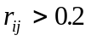, the correlation is deemed to be significant’.
See Sims (1980) p.21, and Doan (1995), p. 8−14.

