Lecture 21 – The Hodrick-Prescott Filter
Hodrick and Prescott, JMCB, 1997

In contrast to the trend-cycle decompositions we have talked about so far, the Hodrick-Prescott filter is a model-free based approach to decomposing a time tseries into its trend and cyclical components.

The H-P filter is an algorithm that “smooths” the original time series y_{t} to estimate its trend component, τ_{t}. The cyclical component is, as usual, the difference between the original series and its trend, i.e.,

y_{t} = τ_{t} + c_{t}

where τ_{t} is constructed to minimize:

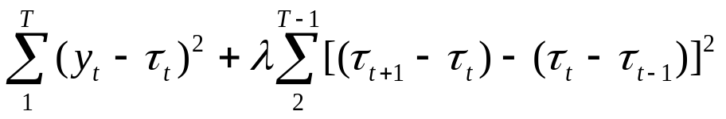

The first term is the sum of the squared deviations of y_{t} from the trend and the second term, which is the sum of squared second differences in the trend, is a penalty for changes in the trend’s growth rate. The larger the value of the positive parameter λ, the greater the penalty and the smoother the resulting trend will be.

If, e.g., λ = 0, then τ_{t} = y_{t} , t = 1,…,t.
If λ→∞, then τ_{t} is the linear trend obtained by fitting y_{t} to a linear trend model by OLS.

Hodrick and Prescott suggest that λ = 1600 is a reasonable choice for quarterly data and that suggestion is usually followed in applied work. Monthly data? Annual data? (The greater the frequency of the data the larger the value of λ; for monthly data a value in the range of 100,000-150,000 has been suggestd; for annual data a value in the range of 5-15 has been suggested.)
It can be shown (from the first order conditions) that the solution to the minimization problem is:

τ = (λF+I_{T})⁻¹y

where τ = [τ₁ … τ_{T}]’, y = [y₁ … y_{T}]’ and

1 -2 1 0 0 0 0 … 0
-2 5 -4 1 0 0 0 … 0
1 -4 6 -4 1 0 0 … 0
0 1 -4 6 -4 1 0 … 0
F =
…

0 0 1 -4 6 -4 1 0
0 0 0 1 -4 6 -4 1
0 0 0 0 1 -4 5 -2
0 0 0 0 0 1 -2 1

