| **Module Title:** | Artificial Intelligence  Data Visualisation & Comms |
| --- | --- |
| **Assessment Title:** | AI_DV _Lv8_ICA_v5 |
| **Lecturer Name:** | David McQuaid  Sam Weiss |
| **Student Full Name:** | Eliabe Baliero De Moura |
| **Student Number:** | 2022474 |
| **Assessment Due Date:** | 05/Jan/2024 |
| **Date of Submission:** | 05/Jan/2024 |

**Declaration**

| By submitting this assessment, I confirm that I have read the CCT policy on Academic Misconduct and understand the implications of submitting work that is not my own or does not appropriately reference material taken from a third party or other source. I declare it to be my own work and that all material from third parties has been appropriately referenced. I further confirm that this work has not previously been submitted for assessment by myself or someone else in CCT College Dublin or any other higher education institution. |
| --- |

**Introduction:**

Students are expected to showcase their skills in two main areas: Artificial Intelligence and Data Visualization & Communication. In the Artificial Intelligence domain, they should distinguish between different agents and environments in current AI, taking into account perception/action and potential environmental changes. Additionally, they are required to comprehend the challenges involved in developing various levels of AI and apply problem-solving strategies related to search, non-classical search, Adversarial Search, and Constraint Satisfaction Problem. Concerning Data Visualization & Communication, students are tasked with explaining the fundamental concepts, techniques, and processes underlying data visualization. They are also expected to suggest, design, develop, and implement solutions for data visualization and demonstrate effective presentation skills for communication with peers, team members, and project stakeholders. These tasks are directly linked to program learning objectives (PLOs) and stage-specific student learning outcomes (SLOs). The assessment task outlined on the following page serves as a measure of their accomplishment in these areas.

**Artificial Intelligence:**

**Discussing Constraint Satisfaction (CSP):**

“A constraint is a way of specifying a relation that must hold between certain variables” (Cruz, Jorge 2005 p.11). For this assessment, I was looking for in a way to work in an easiest way with Constraint Satisfaction Problems (CSP). With constrain I could realize that it can offer me an efficient approach in my project to artificial intelligence, where I will be talking more. In my opinion and what I could realize and learn with CSP, is working with combinations to troubleshoot, I mean we need to combine our variable in many different ways to reach our goals and try to solve our problem. CSP basically will work with variables, domains, and constraints. In CSP our variables could be defined as elements in our list task, our domains we can consider the values that each variable will receive, and our constraints are the relationships between our variables or the conditions that we choose. In my knowledge, I would say that a CSP differences from standard algorithmic solutions is In essence, Constraint Satisfaction stands out from traditional algorithms by offering flexibility through a declarative problem approach, utilizing non-deterministic search methods, enabling abstract representation for complex problems, showcasing expressiveness in real-world modelling, and displaying versatility in finding valid solutions or enumerating all possible solutions as required. In my code for example, my list of people is my variables where I have all names for them, I have created a list for each one of them and put the skills related for each one. In this case the skills would be my domain, and my constraints would be my conditions, for example one of conditions in my first task is “if is not equals 2 AI equals false”, as I need 2 AI professional people., but of course I detailed every step taken in my code in my ipynb file.

**Discussing Backtracking Algorithms:**

In my code I used a Backtracking Algorithm, as I start my code thinking about all possible combinations that I had in my people list, for example. For this code I had to find 7 people besides Ciara, but as the problem was given, I was in need of: AI Engineer,2 Python Programmers, 3 AI Engineers, 1 Web Designer, 1 Database Admin, and 1 Systems Engineer, but to fill those positions I need Ciara and 3 more people from my list, therefore I used a method to combines more 3 people from my list that could fill up those positions, therefore the CSP backtracking function uses backtracking to generate combinations of three people from a given list of people **(**people skills**)**. The picture that I provide below is just a piece of my code to show how I did my desired skills or a list for desired skills. I used a function to ensure that Cira would be in my output with more 3 people, and how I could implement the Backtracking function algorithm to solve my problem.

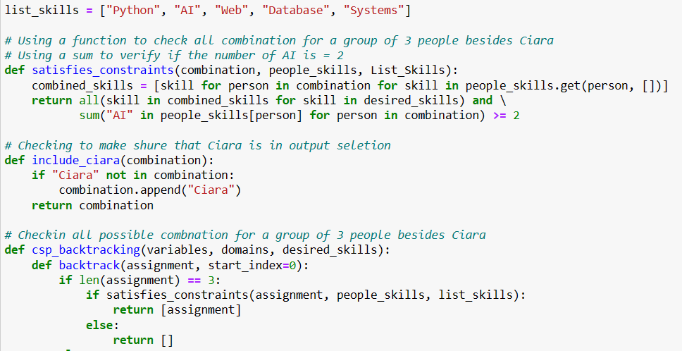

As I said previously the goal is to find combinations that satisfy the constraints defined in the satisfies constraints function. Backtracking is a helpful approach when dealing with problems where the solution space is vast, and it's not practical to check all possibilities one by one. This method is commonly used for solving puzzles, optimization challenges, constraint satisfaction problems, and situations where decisions have to be made step by step. The picture above is from my first task, but it will be similar for the second as well.

A well-known problem that we can give as a good example with backtracking is the N-Queens problem. In this puzzle, the goal is to place N chess queens on an N×N chessboard in such a way that no two queens threaten each other. The backtracking algorithm tries out various queen placements until it discovers a valid solution.

**Data Visualisation:** Andy Kirk

Data visualisation it's not easy, it demands time and patience (Andy, Kirk 2012). For my first task for Data Visualisation, I was looking for something easy for me to explain and detail and simpler at the same time. I decided to do a matrix to show my output and the combinations that I got for my (CSP). To start my code, I just create a loop where it will run all my combinations in my (CSP). In this matrix, which is a binary matrix, I could define a colour for those people that have desired skill for my combination, the colour blue represents each person that switch with that positions that Ciara was looking for, and of course I put down of it a label for each one of them with their skills, this is how my output looks like:

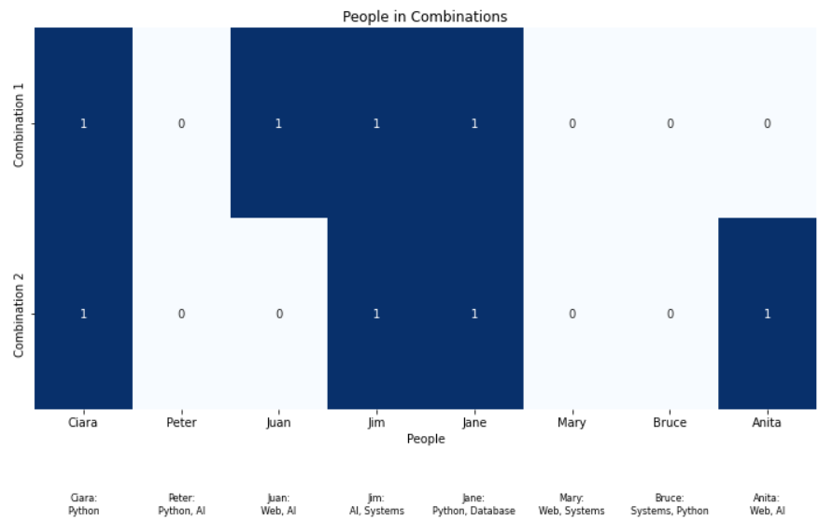

About My interactive visualisation. “Standard graphs, like bar charts, are so common because they are perceptually more accurate, familiar to people” (Jonathan, Schwabish 2021 p.15). I found it would be easier for me to try something quite easier for me work with and for someone else understand my approach, basically I just create an output where it will be plot showing the colours for each skill and people related with those colours and skills, so it will show all people that could be part Ciara’s team, by creating separate Data Frames for each combinations by selecting rows corresponding the people in each combination. Below we can see how it looks like:

**Interactive visualization:**  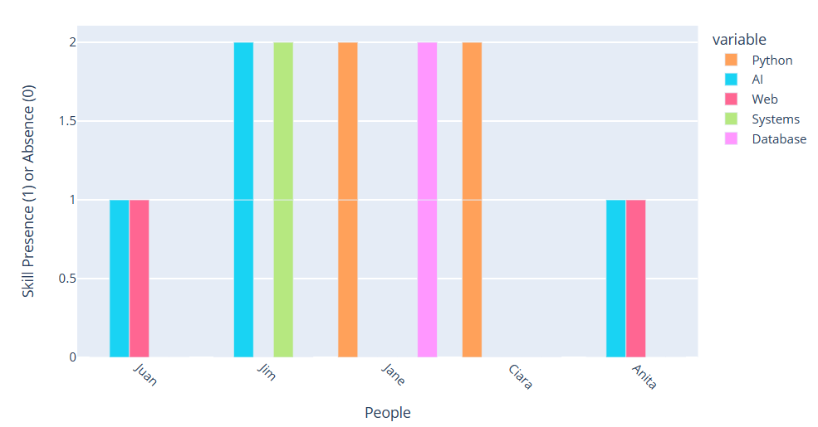

**How Interactive Features works:**

**Hover Info:**

When you hover over a bar, it shows details like the person's name, the skill, and whether they have that skill (1) or not (0).

**Zoom and Pan:**

You can zoom in to see things more closely or move around the chart to explore different parts of the data.

**Legend Click:**

Clicking on a legend item turns on or off the bars for that person. This helps focus on specific individuals.

The interactive features in this chart make it engage. Users can explore and analyse the skills matrix for various combinations by interacting with the chart elements. The picture above represents my first task output, and for the second one I did similar. The people shown below are only the people that fill up the required skill.

**Gui:** I have created a Gui based on my output combinations, it means that for each combination it will have a statement to check the user choice. A window that has size of 200 X 200 will be opened once you run the program. The program checks the conditions and gives the answer to the user. If the user’s choice meets the requirements, it will be ok, if not the user must try again until they meet the right people. Gui windows showing below.

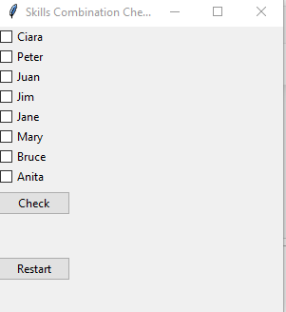

**Summary:**

By doing this project I could understand better how to use constrain (CSP) and Data Visualization through some research. Trought this integrated project, I could realize better how I could apply my visualisation into my constrain problem, and this challenge for my point of view was a good one, because at the end of my project I was able to see how Visualisation can make a easy way for people see and without difficulties understand the output, specially people whose do not have knowledge in this. As I mentioned in this report, I tried to do this assignment in a way that I was able to understand and a way that I was able to explain in more detail what I have done. My GitHub link is below and I have sent an invitation for Sam Weiss and David McQuaid to be collaborators.

GitHub Link: [Eliabe2022474/Eliabe_2022474_AI_DV_-ICA (github.com)](https://github.com/Eliabe2022474/Eliabe_2022474_AI_DV_-ICA) Student Email: 2022474@student.cct.ie

Bibliography

*Cruz, Jorge. (2005) ‘Constraint Reasoning for Differential Models [online] Available at:* [*Constraint Reasoning for Differential Models (ebscohost.com)*](https://eds.p.ebscohost.com/eds/ebookviewer/ebook/ZTAyMG13d19fMTY0MDA3X19BTg2?sid=6651fdac-b5d1-46f0-a2f0-9d9c321ef2d9@redis&vid=6&format=EB&rid=4) *[Accessed 27 Dezember 2023].*

*Jonathan, Schwabish (2021) ‘Better Data Visualisation [online] Available at:*[Better Data Visualizations : A Guide for Scholars, Researchers, and Wonks (ebscohost.com)](https://eds.p.ebscohost.com/eds/ebookviewer/ebook/ZTAyMG13d19fMjQ1MzQ4NF9fQU41?sid=a67820b9-f788-45df-8e99-9c16c5101f09%40redis&vid=0&format=EB&rid=2) *[Accessed 30 Dezember 2023].*

*Andy, Kirk (2012) ‘Data Visualisation: A successful Design Project [online] Available at:*[Data Visualization: a Successful Design Process : Data Visualization: a Successful Design Process (ebscohost.com)](https://eds.p.ebscohost.com/eds/ebookviewer/ebook/ZTI1MHh3d19fNTI2MTczX19BTg2?sid=a67820b9-f788-45df-8e99-9c16c5101f09@redis&vid=21&format=EB&rid=2) *[Accessed 2 January 2024].*

Some Links of resources for study and research

[How to Solve Constraint Satisfaction Problems | Baeldung on Computer Science](https://www.baeldung.com/cs/csp)

[Constraint-satisfaction problems (and how to solve them) (racket-lang.org)](https://docs.racket-lang.org/csp/index.html)

[Constraint Satisfaction Problems (CSP) in Artificial Intelligence - GeeksforGeeks](https://www.geeksforgeeks.org/constraint-satisfaction-problems-csp-in-artificial-intelligence/)

[Matrix Plots — Data Visualization with Python (hossainlab.github.io)](https://hossainlab.github.io/dataviz/notebooks/SB03-Matrix%20Plots.html)