OSOCIO FORM AUTOMATION
Software Architecture & Operations Documentation
Desktop application — Python · Tkinter · Selenium WebDriver

PROJECT | GDCP Chevrolet Latam — Formularios
DOCUMENT OWNER | Elián Zás
DOCUMENT VERSION | 2.1.0
DOCUMENT DATE | August 4, 2026
SOFTWARE BASELINE VERSION | 2.0
STATUS | Active — in production use
CLASSIFICATION | Internal Use
REPOSITORY | github.com/ElianZas2-MRM/Ocioso_Update (private)
MARKETS COVERED | Argentina · Bolivia · Brazil · Chile · Colombia · Ecuador · Paraguay · Peru · Uruguay
AUDIENCE | QA operators and inheriting developers
ORIGINAL AUTHOR (V1) | Ariel Melgratti
SUPERSEDES | Documentation – Osocio Form Automation (Technical & Operational Overview), authored by Ariel Melgratti — referred to throughout this document as “v1”

This document describes the architecture, per-module behaviour, inputs and outputs, dependencies, failure modes, risks and security posture of the application at software baseline 2.0. It is written to be read both by the QA team that operates the tool and by any developer who inherits it.

Osocio Form Automation
Software Architecture & Operations Documentation
Desktop Application — Python / Tkinter / Selenium WebDriver

Table of Contents
1. Executive Summary
2. Purpose of This Document and Relationship to Version 1
3. Architecture Overview
4. Operational Flow
5. How It Works
6. Main Components
7. Functional Modules in Detail
7.1 Lead Submission
7.2 Excel Data Generation
7.3 Scheduled Testing (Testeo Programado)
7.4 Field Validation
7.5 Dealer Comparator
7.6 Massive Form Review
7.7 LambdaTest Execution (Mac / Android)
7.8 Dynamic ID Manager
7.9 Autonomous Runner
7.10 Email Reporting
7.11 Execution Monitor Windows
8. Inputs and Outputs
9. Market Coverage and Country-Specific Rules
10. Current Functional Scope
11. Out of Scope
12. Assumptions and Dependencies
13. Error Handling and System States
14. Risk Register
15. Security and Privacy Considerations
16. Version 1 to Version 2: Changes and Rationale
17. Strengths and Limitations
18. User Manual (Short)
19. Technical Manual (Short)
20. Known Issues and Recommended Next Steps
21. Versioning and Change Log
22. Forward Plan: Security Hardening and Target Infrastructure

1. Executive Summary
Project context. This baseline of the application is in active use on the GDCP Chevrolet Latam — Formularios project, covering the lead-capture forms of the nine Chevrolet Latin American markets listed below.
Osocio Form Automation is a portable Windows desktop application that automates the submission and quality validation of Chevrolet lead-capture web forms across nine Latin American markets: Argentina, Bolivia, Brazil, Chile, Colombia, Ecuador, Paraguay, Peru and Uruguay. It drives real browsers through Selenium WebDriver and exposes the whole workflow through a Tkinter interface, so the QA team operates it without touching code.
The application covers six operational areas, each on its own tab: Lead Submission, Test Scheduling, Field Validation, Excel Data Generation, Dealer Comparator and Massive Form Review. Beyond the local browsers (Chrome, Firefox, Edge), it can execute the same lead flow on remote real devices through LambdaTest, both macOS/Safari and Android/Chrome.
Version 2 is a substantial evolution of the tool documented in v1. The per-country runner files were consolidated into a single configuration-driven engine, four functional modules were added, the data generation model changed from one shared spreadsheet to one per device, and the packaging mode was changed to reduce application start-up time from tens of seconds to under three. Section 16 details every change and the reasoning behind it.
This document describes the architecture, per-module behaviour, inputs and outputs, dependencies, failure modes, risks and security posture of the application as it stands at baseline 2.0. It is written to be read both by the QA team that operates the tool and by any developer who inherits it.

1.1 Enterprise-readiness working document (in progress)
A separate document & Demo is currently being prepared jointly with Vladimir Titov, Jesús Contreras, Ariel Melgratti and Elián Zás. Its purpose is to define how this application could be moved from its present form — a tool built and maintained inside the QA team — into an enterprise development effort operating in a more formal working environment.
That document is the appropriate place for decisions on team structure, ownership, development and release process, environment strategy and the level of infrastructure the tool should ultimately sit on. The proposals in 22.1 to 22.3 are inputs to that discussion, not conclusions of it.
Until it is published, this section should be read as a technical recommendation from the current maintainer. Once the joint document is issued, its conclusions take precedence and this section will be revised to reference it.

2. Purpose of This Document and Relationship to Version 1
Version 1 of this documentation, authored by Ariel Melgratti, described the original tool: a lead-submission engine with a QA field-validation module, scheduling and email reporting, built around one runner file per country. That description remains accurate for the parts of the system it covered, and this document does not contradict it.
This document differs from v1 in three respects:
- Coverage. v1 documented the system at the level of the engine and its supporting modules. This version documents every user-facing module individually, including what each one explicitly does *not* do, the dependencies it relies on and the operational risks it carries.
- Baseline. v1 describes software that no longer exists in that shape. The nine Formulario_<Country>_Main.py runners and nine Formulario_<Country>_Base.py classes it references were replaced by a configuration-driven engine. Four modules that did not exist in v1 are now in production use.
- Traceability. Section 16 maps each change from v1 to v2 against the problem it was meant to solve, so the rationale survives the people involved.
Where v1 and this document disagree on a factual detail — file names, folder layout, Excel naming — this document reflects the current codebase and supersedes v1.

3. Architecture Overview

3.1 Layer Model
The application is organised in four layers. The separation is enforced by module boundaries rather than by a framework, and the dependency direction is strictly downward: the presentation layer knows about the orchestration layer, which knows about the engine, which knows about the integration layer. Nothing points back up.
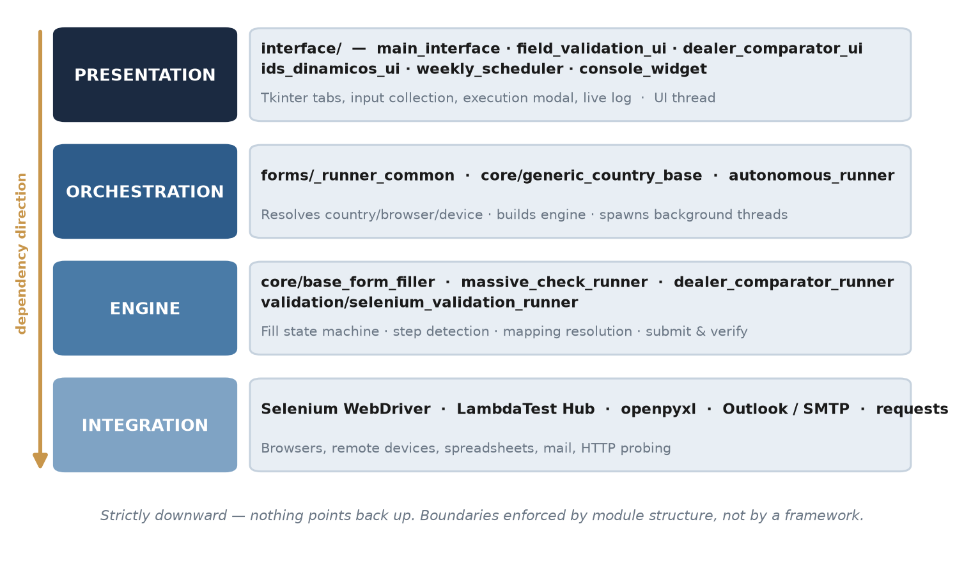
Figure 1 — Layer model. Four layers with a strictly downward dependency direction.
Layer | Modules | Responsibility
Presentation | interface/main_interface.py, field_validation_ui.py, dealer_comparator_ui.py, ids_dinamicos_ui.py, weekly_scheduler.py, console_widget.py | Tkinter tabs, user input collection, execution modal, live log. Runs on the UI thread.
Orchestration | forms/_runner_common.py, core/generic_country_base.py, autonomous_runner.py | Resolves which country/browser/device combination to run, builds the engine instance, spawns background threads, coordinates sequential vs parallel execution.
Engine | core/base_form_filler.py, core/massive_check_runner.py, core/dealer_comparator_runner.py, validation/selenium_validation_runner.py | Form filling state machine, step detection, field mapping resolution, submission and result verification.
Integration | core/browser_manager.py, core/screenshot_manager.py, lambdatest_mac/, lambdatest_android/, utils/url_status.py, interface/helpers_interface.py | Browser instantiation with local drivers, remote LambdaTest sessions, screenshot capture, HTTP status probing, Outlook/SMTP email dispatch.

3.2 Component Interaction
The end-to-end path of a lead submission, from the interface down to the browser and back out to the reports:
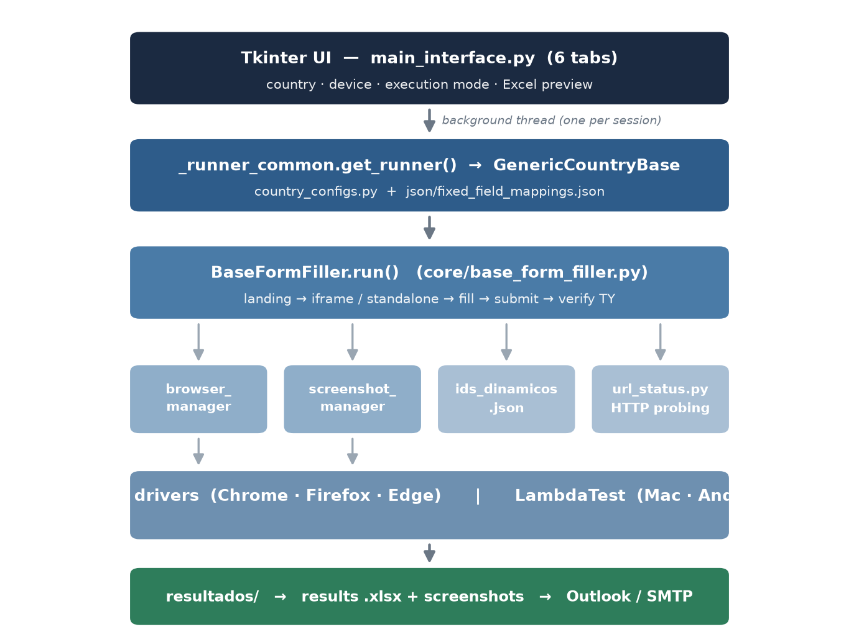
Figure 2 — Component interaction: from the interface down to the browser and back out to the reports.

3.3 Repository Layout
Path | Contents
core/ | Automation engine, browser and screenshot management, country configuration, dealer comparator and massive review runners.
interface/ | One module per UI tab plus shared helpers (email queue, global config).
utils/ | Test-data generation, field mapping persistence, AEM form handling, thank-you CTA inspection, HTTP status probing, Excel layout, scheduling persistence, path resolution.
validation/ | Independent QA module: field rule validation, error-message validation, result export.
lambdatest_mac/, lambdatest_android/ | Remote execution runners and controllers, plus the shared Excel reader used by both.
forms/ | _runner_common.py only — the dynamic runner factory.
json/ | Field mappings, dynamic IDs, per-country validation rules, discovered-field reports, global config.
data/ | Input spreadsheets: lead data per country/device, dealer lists, URL matrices.
drivers/ | Pinned local WebDriver binaries (chromedriver, geckodriver, msedgedriver).
resultados/ | Output: result spreadsheets and screenshot folders per run.

4. Operational Flow
All execution-oriented tabs follow the same pattern: the user configures inputs, the application validates that the required spreadsheets exist and are non-empty, execution is delegated to background threads while a modal reports progress, and results are written to disk and optionally emailed. The interface never performs browser work on the UI thread.
- Preparation. The user generates the input spreadsheet on the Excel Data Generation tab, pasting the URLs to test. One spreadsheet is produced per selected device.
- Configuration. On the Lead Submission tab the user selects markets, devices, and whether markets and device spreadsheets run sequentially or in parallel.
- Pre-flight validation. Before opening any browser the application verifies that a spreadsheet with at least one lead exists for every market and device combination selected. If any is missing or empty, nothing runs.
- Session dispatch. One background thread per session. A session is normally a whole spreadsheet; in per-URL parallel mode it is a single row, with a configurable concurrency ceiling.
- Per-row processing. For each row the engine opens the landing page, resolves the form (inside an iframe or as a standalone page), captures the empty state, fills the fields, submits and verifies the outcome.
- Evidence capture. Local browsers save screenshots at each stage. LambdaTest sessions do not: the evidence is the session video, linked from the results spreadsheet.
- Reporting. Per-row status, the values actually submitted, the resolved form URL and a short failure reason are written to the results spreadsheet. If enabled, an email is queued with the spreadsheet and, optionally, the screenshots.
- Scheduled execution. Independently, the weekly scheduler polls every five seconds while the application is open, and the autonomous runner polls every sixty seconds without a UI, launching the same flow unattended.

5. How It Works
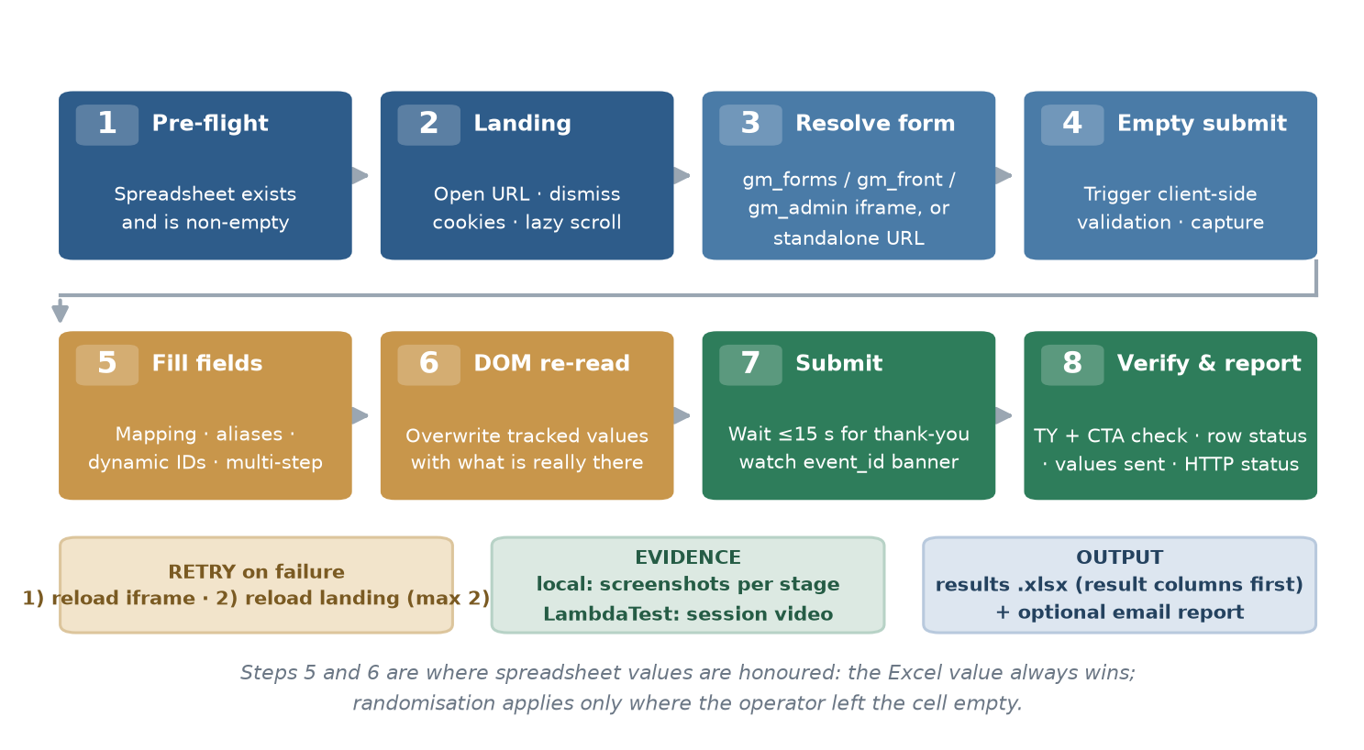
Figure 3 — End-to-end path of a single lead submission.
The following describes one lead submission end to end, which is the path most of the application shares.
- The user launches run.py or the packaged executable. Before any other import, truststore is injected so that Python validates TLS certificates against the Windows trust store rather than its own bundled list.
- interface.main_interface.iniciar_interfaz() builds the six tabs and restores the persisted UI state from json/config_global.json.
- On execution, forms/_runner_common.get_runner(country) returns a runner that instantiates GenericCountryBase, which loads the country entry from core/country_configs.py and injects the browser, viewport and device-specific spreadsheet name.
- utils/fixed_field_mapping_store.py merges the base country configuration with any user overrides stored in json/fixed_field_mappings.json, producing the effective field mapping for the run.
- BaseFormFiller.run() starts the browser through core/browser_manager.py using the pinned local driver, positions the window off-screen without stealing focus, opens the spreadsheet and iterates row by row.
- Column A holds the landing URL and column B the form URL. If column A is empty, the form URL is treated as the page to navigate to and no iframe is searched — this is the standalone (loose URL) path.
- The landing page is opened, cookie banners are dismissed, a lazy-load scroll pass is performed and the initial screenshot is taken. A 404 or “page not found” heuristic marks the row if the landing is broken.
- When a form URL is present, find_and_position_to_form() locates the correct iframe. Candidates whose src contains gm_forms, gm_front or gm_admin, gm_frontend/chevrolet/t3 are always preferred over any other visible iframe, so landings carrying several iframes do not resolve to the wrong one.
- The empty form is submitted once to trigger client-side validation, and the resulting error messages are captured as evidence. This step is skipped for the Complaints Book form, which is filled first and submitted afterwards.
- Fields are filled following the effective mapping, dynamic IDs and inter-field dependencies. Multi-step forms are advanced automatically by fill_form_fields_auto_step(), which detects the next-step control and confirms the DOM actually changed before continuing.
- Visible selects and inputs not present in the mapping are detected, reported to json/nuevos_campos_<country>.json and filled with synthetic values when required, so a DOM change does not necessarily break the run.
- Required checkboxes and radio buttons are marked, including custom controls rendered with opacity: 0 over a styled label, which need a synthetic click or a direct DOM state change.
- Immediately before submission the DOM is re-read in a single script call and the tracked values are overwritten with what is actually present in the fields, so the report reflects what was really sent rather than what was intended.
- The form is submitted. The engine then waits up to fifteen seconds for the thank-you state, while simultaneously watching for the transient server-side event_id error banner, which disappears after roughly six seconds.
- On success the thank-you page is captured and any call-to-action link on it is followed and verified. On failure the engine retries — reloading only the form iframe first, then the whole landing — up to two attempts.
- Row status, failure reason, submitted values, resolved form URL and HTTP status of both URLs are written to the results spreadsheet, with the result columns ordered first.
- When all rows are processed the browser is closed and, if enabled, an email with the spreadsheet and compressed screenshots is queued for dispatch through Outlook, falling back to SMTP.

6. Main Components
Component | Responsibility | Technology
Graphical interface | Six operational tabs, execution modal, live log, system-tray minimisation | Tkinter / ttk, Pillow
Runner factory | Resolves the country runner dynamically; no per-country source files | Python (forms/_runner_common.py)
Country configuration | Field mapping, required fields and spreadsheet name for the nine markets | Python dict (core/country_configs.py)
Automation engine | Form filling state machine, step detection, submission and verification (~6,280 lines) | core/base_form_filler.py + Selenium
Browser management | Instantiates Chrome/Firefox/Edge from pinned local drivers; off-screen positioning | Selenium WebDriver, Win32 API
Evidence capture | Landing, empty form, validation errors, completed form and thank-you screenshots | core/screenshot_manager.py, Pillow
Test-data generation | Synthetic identities, documents, phones and emails per country and device | utils/data_generator.py
Configuration persistence | Field mappings and dynamic IDs editable without touching code | JSON + utils/fixed_field_mapping_store.py
Field validation (QA) | Regex, length and required-field rule checks against the live form | validation/selenium_validation_runner.py
Dealer comparator | Region → City → Dealer set comparison against an expected spreadsheet | core/dealer_comparator_runner.py
Massive form review | Bulk URL and embedded-form verification without submitting leads | core/massive_check_runner.py, requests
Remote execution | Same lead flow on real macOS/Safari and Android/Chrome devices | lambdatest_mac/, lambdatest_android/
Scheduling | Weekly calendar with UI open; autonomous polling runner without UI | utils/scheduling.py, autonomous_runner.py
Notifications | Asynchronous email queue with per-message status callbacks | interface/helpers_interface.py, pywin32 / smtplib
Data export | Reads input spreadsheets and writes result spreadsheets with conditional formatting | openpyxl, pandas
Packaging | Portable Windows distribution in one-directory mode | PyInstaller

7. Functional Modules in Detail
Each module below is described with the same structure: what it is for, what it does, what it explicitly does not do, the user flow, the dependencies it relies on and the operational risks it carries. The sections on what a module does not do are deliberate: most incidents with this tool have come from assuming a module covers something it does not.
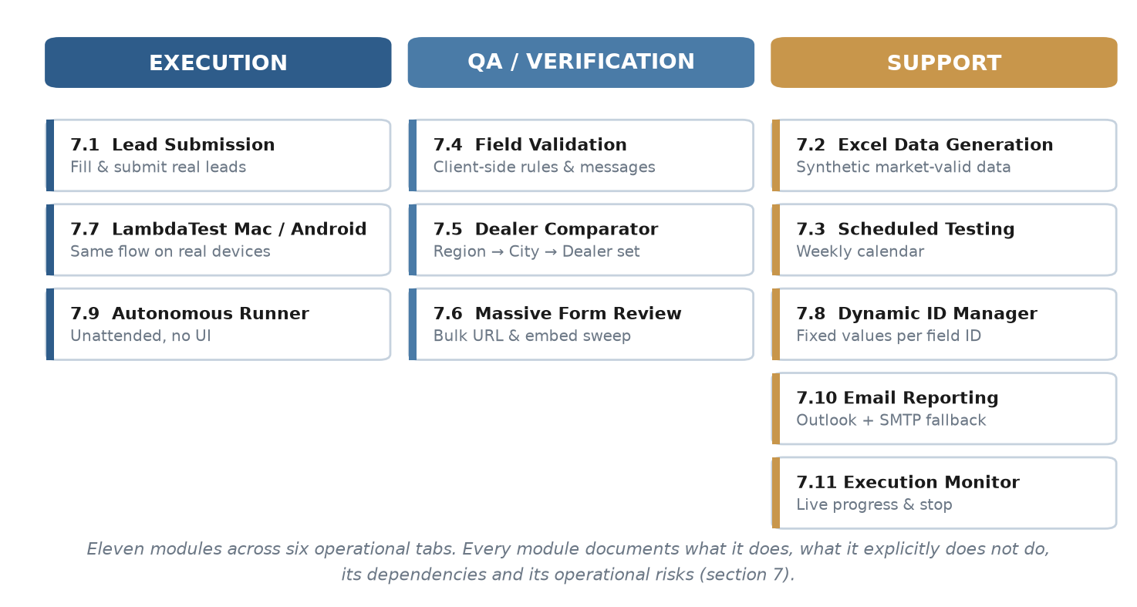
Figure 4 — The eleven functional modules, grouped by role.

7.1 Lead Submission
Purpose. Fill and submit real lead forms across the selected markets and devices, producing a per-row result spreadsheet and a screenshot audit trail. This is the primary function of the application.

What it does
- Runs any combination of the nine markets against Chrome, Firefox, Edge, LambdaTest macOS and LambdaTest Android.
- Handles embedded forms (inside a gm_forms / gm_front / gm_admin, gm_frontend/chevrolet/t3 iframe on a landing page) and standalone forms reached directly by their own URL.
- Detects and advances multi-step forms without configuration, confirming the DOM changed before moving on.
- Resolves field IDs through the country mapping, a visid alias table for renamed IDs, and per-form dynamic IDs.
- Auto-fills visible fields absent from the mapping and reports them to json/nuevos_campos_<country>.json.
- Marks required checkboxes and radio buttons, including custom controls rendered with zero opacity.
- Captures landing, empty form, validation error, completed form and thank-you screenshots (local browsers only).
- Follows and verifies the call-to-action link on the thank-you page, flagging broken or suspicious targets.
- Retries a failed submission twice: first reloading only the form iframe, then the whole landing.
- Records the values actually present in the DOM at submission time rather than the values intended from the spreadsheet, so a retry that re-randomises a dropdown is reported accurately.
- Honours the value typed into the spreadsheet for every choice field. Matching ignores accents and non-breaking spaces, covers fields the form renders as radio buttons and selects absent from the country mapping, and accepts equivalent column names. A random option is drawn only where the cell was left empty; when a requested value is not offered by the form, the run logs it and the Datos vs Excel column records the difference.
- Supports sequential or parallel execution across markets, across device spreadsheets, and per URL (one browser window per row, with a configurable ceiling between 1 and 20).
- Optionally pauses before the first form so the operator can complete a manual SSO or MFA login.

What it does not do
- Does not solve CAPTCHAs or bypass anti-bot protection.
- Does not download or update browser drivers; the pinned binaries in drivers/ are used deliberately.
- Does not push leads to a CRM or API. Output is limited to spreadsheets and email.
- Does not capture screenshots on LambdaTest runs; the session video is the evidence there.
- Does not detect semantic layout changes beyond unmapped selects and inputs. A field that moves but keeps its ID is filled correctly; a field renamed outside the alias table is not.
- Does not confirm the lead reached the destination database. It confirms the form reported success.
- Per-URL parallel mode does not apply to LambdaTest, and is force-disabled for scheduled runs.

User flow
- Generate the input spreadsheet on the Excel Data Generation tab, or edit an existing one in the preview table.
- Select markets, devices, and the sequential or parallel mode for markets and for device spreadsheets.
- Optionally enable per-URL parallelism, T3 2.0 spreadsheets, a visible browser, or the manual-login pause.
- Enter the recipient address and tick the mail option if an emailed report is wanted.
- Press EJECUTAR ENVIO. The application verifies that every market and device spreadsheet exists and is non-empty.
- Follow the execution modal: per-form progress, markets in flight, and failing rows with a short reason.
- Open Ver Resultados to inspect the spreadsheet and screenshots in resultados/.

Dependencies
Dependency | Used for
Selenium WebDriver | Browser control for every supported browser and device
Local WebDriver binaries | Chrome, Firefox and Edge sessions without runtime driver downloads
openpyxl | Reading the input spreadsheet and writing the formatted results spreadsheet
pandas | Spreadsheet slicing for per-URL parallel mode and preview table operations
Pillow | Screenshot stitching for full-page captures and URL banner overlays
requests | HTTP status probing of landing and form URLs (utils/url_status.py)
pywin32 | Off-screen window positioning without focus theft, and Outlook dispatch

Risks
Risk | Impact | Mitigation / current status
Target DOM changes: renamed IDs, new required fields | High. Rows fail in bulk | The alias table, unmapped-field auto-fill and discovery reporting absorb part of this. The remainder requires a mapping update. Discovered fields are written to json/nuevos_campos_<country>.json for review.
Browser auto-updates past the pinned driver | High. The browser will not start | A deliberate trade-off for security policy compliance. The driver in drivers/ must be replaced manually. The failure is explicit and immediate rather than silent.
Site-side submission failures counted as tool failures | Medium. Misleading QA reports | Server event_id errors are detected during the wait window and reported distinctly from client-side validation failures.
Per-URL parallelism saturating the workstation | Medium. Timeouts and false negatives | Concurrency is capped at 6 by default with a hard limit of 20, and disabled for scheduled runs.
Synthetic data rejected by market-specific validation | Medium. False failures | Country-specific generators are in place. Peru couples document type and number; other markets rely on generic rules and would need equivalent treatment if their forms tighten.

7.2 Excel Data Generation
Purpose. Produce the input spreadsheets consumed by Lead Submission and Test Scheduling, populated with synthetic but market-valid personal data.

What it does
- Generates one spreadsheet per selected device (_Chrome, _Firefox, _Edge, _Mac, _Android), each with independently randomised data, so parallel runs do not submit duplicate leads.
- Offers a shared-spreadsheet mode when identical data across devices is wanted, with an explicit duplicate warning.
- Accepts URLs in two formats: landing and form pairs, or form URLs only for standalone forms.
- Builds the column set from the country configuration, so a mapping change is reflected in the spreadsheet.
- Generates names, surnames, identity documents, phone numbers and email addresses following per-country rules. The email encodes country and device, which makes any lead traceable back to the run that produced it.
- Applies fixed per-form values where a form requires a real vehicle, such as a matching model and VIN.
- Produces _T3 variants for Adobe AEM forms.
- Warns when the pasted URLs appear to belong to a market other than the one selected.

What it does not do
- Does not verify that the URLs are reachable. That is the Massive Form Review module's role.
- Does not generate real or verifiable identity documents. Values are synthetic and intended for test environments.
- Does not deduplicate against previously generated spreadsheets or against the destination database.
- Does not generate region, city or dealer values. These are intentionally left empty and drawn at random from the live form, so each run exercises the real dropdown contents.

User flow
- Select the target market.
- Select the devices to generate for, or switch to shared-spreadsheet mode.
- Choose the URL format and paste the URLs.
- Press GENERAR EXCELS. The calculation panel states in advance how many rows and which files will be written.
- Use REGENERAR DATOS to refresh the identities while keeping the same URLs.

Dependencies
Dependency | Used for
pandas | Building the data frame and writing the .xlsx file
openpyxl | Excel engine behind pandas for the .xlsx format
utils/data_generator.py | Per-country identity, document, phone and email generation
utils/fixed_field_mapping_store.py | Deriving the column set from the effective country mapping

Risks
Risk | Impact | Mitigation / current status
Generated data violating a market's validation rules | High. Every row fails downstream | Peru's document type and number are coupled and were verified against the live form's rules. Other markets use generic length rules and have not been audited to the same depth.
Column name drift between generator and mapping | Medium. Silently empty columns | Column names derive from country_configs.py. A mismatch produces an empty column rather than an error. This exact defect caused the Peru document-type failure and merits a periodic check.
Shared-spreadsheet mode producing duplicate leads | Low. Rejected or duplicated records | The mode is opt-in and displays a warning before generating.

7.3 Scheduled Testing (Testeo Programado)
Purpose. Run the Lead Submission flow, or the Massive Form Review sweep, automatically on a weekly calendar without an operator present. The tab is named Testeo Programado and is split into two sub-tabs — Envío de Leads Normales and Revisión Masiva de Inserción (Smoke Test) — each of which keeps its own markets, browsers, execution mode and weekly calendar.

What it does
- Weekly calendar with fifteen-minute granularity plus arbitrary HH:MM entries.
- Both sub-tabs share the same configuration card: markets to run, browsers, sequential or parallel execution, and the Configurar Días y Horarios button. A summary strip under the card restates the resulting configuration and names anything still missing before the schedule can be armed.
- Copies a day's schedule to selected days or to all days at once.
- Validates that every required spreadsheet exists before the configuration can be saved.
- Fires while the application is open through a monitor polling every five seconds. A slot missed earlier the same day is executed when the application is reopened.
- Writes results with an Automatizacion_ prefix, so scheduled runs are distinguishable from manual ones.
- Supports local browsers and LambdaTest, sequential or parallel across markets.

What it does not do
- Does not run while the application is closed. That is the Autonomous Runner's role, described in 7.9.
- Does not honour per-URL parallel mode. Scheduled runs are always sequential per spreadsheet.
- Does not regenerate test data before firing. The same spreadsheet is reused on every run unless regenerated manually, which will submit the same identities repeatedly.
- Does not retry a slot that failed for environmental reasons such as a missing browser or a network outage.

User flow
- Select markets and devices, as in Lead Submission.
- Open the automation configuration panel and select days and times.
- Save the configuration. Missing spreadsheets are reported and block the save.
- Arm the schedule. The immediate-run action fires it at once for verification.

Dependencies
Dependency | Used for
utils/scheduling.py | Persisting the calendar to json/programacion_test.json
Python threading | The five-second monitor loop, running as a daemon thread
json/scheduler_triggered.json | Recording which slots already fired today, to avoid repeats

Risks
Risk | Impact | Mitigation / current status
Stale test data reused on every run | Medium. Duplicate leads and false rejections | Not currently mitigated. Regenerating data before a scheduled campaign is a manual step.
Application closed at the scheduled time | Medium. The run is skipped | A same-day missed slot runs on reopen; a slot missed for a full day is lost. The Autonomous Runner covers the unattended case.

7.4 Field Validation
Purpose. Verify that a live form's client-side validation rules, including regular expressions, length limits, required flags and error messages, match the specification, without submitting a lead.
Maturity note. This module is implemented and functional, but it has not yet been explored in sufficient depth to be adopted as part of daily testing. Its rule set has been exercised on specific forms rather than across the full catalogue, and no market has a complete, reviewed rule base. Before it can replace manual validation checks, the rules need to be built out per market and reconciled against the field specification. Until then it should be treated as an available capability rather than an established part of the routine.

What it does
- Drives a real browser and types configured test values into each mapped field.
- Checks full-value and per-character regular expressions, minimum and maximum length, and required flags.
- Verifies the exact error message the form displays, supporting several regex-to-message rules per field.
- Models inter-field dependencies, such as City only being meaningful once Region has a value.
- Scopes each rule to specific markets, so a single rule set covers all nine countries.
- Includes a regex builder that composes expressions from checkboxes for letters, accents, digits, symbols, length bounds and similar conditions, instead of requiring hand-written expressions.
- Exports results to a spreadsheet with failures highlighted.

What it does not do
- Does not submit the form or create a lead.
- Does not discover validation rules automatically. Every rule is declared by the operator.
- Does not test server-side validation, only what the browser enforces.
- Does not cover fields absent from the rule table. An undeclared field is simply not checked.
- Accepts standalone form URLs and resolves field IDs across form generations. A rule written for firstname, telephone, ci, models or estimated-date-purchase also matches a form that names those fields name, phone, document, model or estimated-day, so the same Peru rule set runs against both the classic forms and the newer gm_frontend/t3 ones. The alias table is utils/field_id_aliases.py, shared with Lead Submission.

User flow
- Load or edit the URL spreadsheet with country, landing and form columns.
- Open the ID configuration panel and declare each field: ID, type, expressions, test value and applicable markets.
- Optionally declare expected error messages and field dependencies.
- Run the validation and open the results folder.

Dependencies
Dependency | Used for
Selenium WebDriver | Typing into and reading the live form
json/field_validation_rules_<country>.json | Per-market rule storage
validation/error_message_validator.py | Comparing displayed error text against expectations
openpyxl | Exporting highlighted results

Risks
Risk | Impact | Mitigation / current status
Rules drifting from the current specification | Medium. False passes | Rules are maintained manually and are not linked to an authoritative source for the expected specification.
Undeclared fields silently unchecked | Medium. Coverage gaps | No completeness check exists between the rule table and the fields actually present in the form.

7.5 Dealer Comparator
Purpose. Confirm that the dealer network exposed by a live form matches an expected dealer spreadsheet, validating the Region, City and Dealer combination as a set rather than as individual names.

What it does
- Compares hierarchically. A dealer name that exists under a different province is not treated as a match, which removes a common class of false positive.
- Supports include and exclude semantics: verifying that filtered dealers are present, or that they are absent.
- Works with or without a filter column, allowing the whole spreadsheet to be compared.
- Allows the header row to be declared, since real dealer spreadsheets rarely begin on row one.
- Maps arbitrary spreadsheet columns to form field IDs, with optional extra fields beyond region, city and dealer.
- Optionally verifies the data-bac attribute where the form exposes it.
- Repeats the comparison per vehicle model when the dealer list depends on the model.
- Runs in two phases, comparison first and screenshots second, so the spreadsheet survives an interrupted run.
- Reports PASS, FAIL, EXTRA, DUPLICATE, HIDDEN and NOTE states, and stores named configuration presets per market.
Result states. The comparison classifies every combination into one of the following states. They are not all failures: EXTRA, HIDDEN and NOTE describe differences that need a human decision rather than an outright defect.
State | Meaning | Typical cause
PASS | The expected Region → City → Dealer combination was found in the form. | Correct configuration.
FAIL / MISSING | A combination present in the expected spreadsheet is not offered by the form. | The dealer was never loaded, or was loaded under a different region or city.
EXTRA | The form offers a combination that does not appear in the expected spreadsheet. | A dealer that should have been removed, or a spreadsheet that is out of date.
DUPLICATE | The same option appears more than once in the form's dropdown. | The dealer was loaded twice into the platform.
HIDDEN | The form offers a combination that is only declared in spreadsheet rows that are hidden or excluded by the filter. | The dealer should not be published, because the row that authorises it is not active. Reported in orange.
NOTE | The form option matches an expected dealer, but the name differs in minor details. | Spacing, punctuation, abbreviations or accents. Usually cosmetic, but worth confirming.

Why the comparison is hierarchical. Dealer names repeat across the country. Checking a name on its own would report a dealer as present when it exists under the wrong province, and would report duplicates that are legitimately the same brand in two cities. The comparator therefore validates the full path: a dealer counts as found only when it appears under the same Region and City declared in the spreadsheet. Levels that a given form does not expose can be switched off, in which case the remaining levels are compared with the same logic.

What it does not do
- Does not run on LambdaTest. Local browsers only.
- Does not submit leads.
- Does not correct the form or the spreadsheet. It reports differences.
- Does not infer which spreadsheet column is which. The mapping is declared by the operator.

User flow
- Select the market and browser.
- Load the URL spreadsheet and the expected dealer spreadsheet, declaring the header row.
- Choose the filter mode and map the columns to region, city and dealer.
- Select the output mode: spreadsheet only, or spreadsheet plus screenshots.
- Run, then review the per-form report folder.

Dependencies
Dependency | Used for
Selenium WebDriver | Reading the live dropdown contents level by level
openpyxl and pandas | Reading the dealer spreadsheet and writing the comparison report
Pillow | Screenshot capture during the second phase
json/dealer_comparator_settings.json | Named presets per market

Risks
Risk | Impact | Mitigation / current status
Dealer dropdowns loading asynchronously | Medium. False missing-dealer results | Dependent-dropdown readiness is awaited before reading, but a slow network can still truncate a list.
Column mapping declared incorrectly | Medium. Meaningless report | Only rows whose form column holds a real URL are processed, which prevents reports being generated from an entirely wrong file.
Long runs on markets with large dealer networks | Low. Time cost | Two-phase execution means the spreadsheet is written before the slower screenshot phase begins.

7.6 Massive Form Review
Purpose. Sweep the master form matrix and verify, without submitting any lead, that each URL responds correctly and that the expected form is genuinely embedded in its landing page.

What it does
- Reads the master spreadsheet, one sheet per market.
- Probes the HTTP status of both the landing and the secure form URL, reporting redirects distinctly from errors.
- Validates TLS certificates. An expired, self-signed or wrong-host certificate is reported as a failure rather than silently accepted.
- Opens each landing in a real browser and confirms the expected form is embedded, comparing the resolved iframe against the URL declared in the spreadsheet.
- Fills a minimum set of fields, one text input and one dropdown, to prove the form is interactive.
- Counts how many GM form iframes are present on the page.
- Skips rows flagged OFF, marking them as skipped.
- Can re-check only the failures (Rerun fails previos). A row is skipped as already passing only when every result column has a value and none of them reads FAIL or SKIPPED, so a failure in any single column — including statusInserted or Secure_Inserted — brings the row back into the run.
- Produces exactly one output file per run: a copy of the master spreadsheet, already edited with the results, saved as resultados/resultado_urlsinsertas/Resultados_Revision_Masiva_<matrix>_<timestamp>.xlsx. In each reviewed market sheet the result columns (currentUrl, LandingStatus, Secure_Inserted, Excel==Inserted?, Displayed?, statusInserted, formsCount) are placed as the first columns, with the original matrix columns following unchanged, and a Comentarios column reused if the sheet already has one.
- Never modifies the master spreadsheet the operator points at. It is read, copied in memory and left untouched on disk, so the matrix can stay open in Excel while a review runs.
- Adds a RESUMEN REVISIÓN sheet to the report holding the run timestamp, duration, global counters and a per-market breakdown. Market sheets that were not selected are carried over unchanged.
- Keeps one dated report per run, so successive reviews can be compared and the Comparar y Sincronizar Reportes action autodetects the most recent one.
- Waits up to five seconds per landing for a GM form iframe to appear before deciding the form is missing. Landings that load the iframe lazily were previously reported as failures even though the form was present.
- Recognises the GM form iframe by the markers gm_forms, gm_formns, gm_front and gm_admin, matched as substrings, so gm_frontend is covered by the same gm_front marker and every previously supported iframe keeps working. The marker list lives on BaseFormFiller.GM_FORM_URL_MARKERS and is shared with Lead Submission.
- Processes the selected markets one at a time. Because every market writes into the same workbook, running them in parallel threads would have the last save overwrite the others.

What it does not do
- Does not submit leads. No data reaches the destination database.
- Accepts standalone form URLs. A row whose landing column is empty, or whose landing and form columns hold the same URL, is opened directly and no iframe is looked for. This covers the newer .../gm_frontend/chevrolet/t3/<country>/form/<slug> forms, which are a full React page rather than an iframe embedded in a landing.
- Runs markets in parallel when parallel mode is selected. The run is split into three phases: the spreadsheet is read and the result columns prepared on a single thread; each market is then checked concurrently with its own browser, returning results in memory; and the workbook is written and saved once, on a single thread, at the end. openpyxl is not thread-safe and every market writes into the same workbook, so this split is what makes parallel safe — writing live from threads would let the last save overwrite the others. Concurrency is capped at three browsers, since each market opens a full Chrome instance. Measured on three markets of three URLs each, a run went from 2m 51s sequential to 1m 02s parallel, with identical results on all nine rows.
- Always writes the results spreadsheet, regardless of the screenshots option. Screenshots and their folders are only produced when that option is enabled; the report is not conditional on it. The report contains only the sheets of the markets that were actually run — sheets for unselected markets used to travel along without result columns, which read as if they had been checked and returned nothing.
- Does not validate field-level behaviour. It proves the form renders and accepts input, nothing more.
- Does not correct or modify the master spreadsheet. Differences are reported in the generated report only.

User flow
- Select the markets to review.
- Point the tab at the master spreadsheet and confirm the four column names.
- Choose the options: screenshots, clear comments, failures only. Sequential or parallel is chosen in the configuration card above, and parallel now runs for real: markets are checked concurrently, up to three browsers at a time.
- Run. The report is written to resultados/resultado_urlsinsertas/Resultados_Revision_Masiva_*.xlsx, alongside the screenshots. The master spreadsheet is left as it was.

Dependencies
Dependency | Used for
requests | HTTP status and TLS validation of both URLs
truststore | Certificate validation against the Windows trust store, so TLS-inspecting corporate proxies do not produce false failures
Selenium WebDriver | Rendering the landing and locating the embedded form
openpyxl | Consolidated and per-market report generation with conditional formatting

Risks
Risk | Impact | Mitigation / current status
This module is not yet fully tested | High. Results may be unreliable | Only the main path has been validated end to end (Peru, two rows, both passing). The remaining markets, parallel mode, failures-only mode, matrix synchronisation and consolidated reporting are unverified. Treat its output as indicative until that validation is completed.
Sheet name not matching the market name | High. Market silently skipped | Resolved. The sheet is matched through the normalised country name, and a run matching no sheet now returns an explicit message instead of failing with an unhandled error.
Transient HTTP errors reported as failures | Medium. Noise in the report | A single probe per URL with an eight-second timeout and no retry. A 502 from a momentarily loaded server is reported as a failure.

7.7 LambdaTest Execution (Mac / Android)
Purpose. Run the same lead flow on real remote devices, macOS with Safari and Android with Chrome, to catch defects that do not reproduce on Windows desktop browsers.

What it does
- Reads the same spreadsheet format as local execution, including the standalone-URL convention.
- Reproduces the local engine's behaviour: iframe selection, multi-step handling, terms checkboxes, model resolution from the URL, and Peru's document rules.
- Handles iOS Safari's inability to switch into a cross-origin iframe by scrolling the iframe into the viewport and operating through native coordinates.
- Returns the session video link, which is written into the results spreadsheet as evidence.
- Reads credentials from environment variables first, falling back to the local credentials file.

What it does not do
- Does not capture screenshots. Screenshots against remote devices are slow and add nothing the video does not show.
- Does not run the Dealer Comparator or Field Validation modules.
- Does not honour per-URL parallel mode. A LambdaTest run is always a single session.
- Does not manage the LambdaTest plan's concurrency limit.

User flow
- Generate the _Mac or _Android spreadsheet.
- Provide credentials by environment variable, or through the LT credentials panel.
- Select Mac LT or Android LT as the device and run.
- Open the results spreadsheet and follow the Video LT column to review the session.

Dependencies
Dependency | Used for
Selenium Remote WebDriver | Driving the remote session through the LambdaTest hub
LambdaTest account | Real device capacity. Each run consumes plan minutes
truststore | TLS trust alignment so the hub connection succeeds behind corporate proxies
requests | Retrieving the session video URL from the LambdaTest API

Risks
Risk | Impact | Mitigation / current status
Expired or rotated access key | High. Every run fails at session start | The failure is explicit. Credentials can now be supplied by environment variable, which suits rotation better than editing a file on disk.
Session video link carries an authentication token | Medium. Unintended access sharing | The link is written to the results spreadsheet and printed to the log. Anyone receiving the spreadsheet can open the recorded session. Not currently mitigated.
Remote engine drifting from the local engine | Medium. Inconsistent results across devices | lt_runner.py is a parallel implementation rather than a shared one, so fixes must be applied twice. This has already produced duplicated defects and is the strongest candidate for future consolidation.
Plan concurrency exceeded under parallel markets | Medium. Rejected sessions | Warned in the interface, not enforced.

7.8 Dynamic ID Manager
Purpose. Assign fixed values to specific form field IDs without editing JSON by hand, covering fields outside the standard country mapping.

What it does
- Lists field IDs discovered on real forms and allows a fixed value, or a set of candidate values, to be assigned.
- Persists to json/ids_dinamicos.json, which the engine consults during filling.
- Applies to selects, text inputs and text areas.

What it does not do
- Does not change the country field mapping, which is separate configuration.
- Does not validate that the assigned value is accepted by the form.
- Does not discover fields on its own. Discovery happens during a lead run and is reported to json/nuevos_campos_<country>.json.

User flow
- Open the Dynamic IDs panel from the Lead Submission tab.
- Add the field ID and the value or values to use.
- Save. The next run picks the configuration up.

Dependencies
Dependency | Used for
json/ids_dinamicos.json | Persistent storage read by the engine at fill time
Tkinter | The editor interface

Risks
Risk | Impact | Mitigation / current status
Assigned value rejected by the form | Low. That field fails | No validation at save time. The failure surfaces on the next run with the field named in the report.
Stale IDs accumulating after a site redesign | Low. Dead configuration | Entries are never expired automatically.

7.9 Autonomous Runner
Purpose. Execute scheduled runs without the graphical interface open, for unattended overnight campaigns.

What it does
- Polls every sixty seconds for pending scheduled runs.
- Uses a Windows mutex so two instances cannot run at the same time.
- Launches the same country runners as the interface, through a thread pool.
- Sends a consolidated email once all markets have finished.

What it does not do
- Does not provide a user interface or live progress.
- Does not regenerate test data.
- Does not run the Dealer Comparator, Field Validation or Massive Review modules.

User flow
- Configure and save the schedule from the interface.
- Start run.py --autonomous, or the packaged equivalent, and leave it running.
- Collect the consolidated email and the Automatizacion_ spreadsheets.

Dependencies
Dependency | Used for
utils/scheduling.py | Reading the persisted calendar
concurrent.futures.ThreadPoolExecutor | Running several markets concurrently
Windows mutex through ctypes | Single-instance enforcement
pywin32 and smtplib | Consolidated email dispatch

Risks
Risk | Impact | Mitigation / current status
Silent failure with no operator present | High. A campaign is lost unnoticed | The consolidated email is the only signal. If email dispatch itself fails, the run is silent.
Workstation asleep or locked | Medium. Schedule missed | Not mitigated in software. This is a workstation power-policy matter.

7.10 Email Reporting
Purpose. Deliver run results to stakeholders without requiring them to have access to the workstation.

What it does
- Queues messages asynchronously so dispatch never blocks a run.
- Sends through the local Outlook profile, keeping a single instance open across messages.
- Falls back to direct SMTP when Outlook is unavailable.
- Attaches the results spreadsheet and the screenshots as an archive, each governed by its own switch in Configuration: Adjuntar resultados and Adjuntar screenshots. Both switches are honoured identically by every tab that sends mail — Lead Submission, the consolidated report, Massive Form Review, Field Validation and Dealer Comparator — and are read from the same config_global.json keys, so a preference set once applies everywhere.
- Reports per-message status back to the interface: sending, sent or failed.
- Formats the body as HTML so status icons render correctly in classic Outlook.
- Every report carries an explicit verdict. The subject is prefixed [PASS] or [FAILED] and the body opens with RESULTADO GLOBAL, so a run can be triaged from the inbox list without opening the message. This applies to Lead Submission, the consolidated multi-market report, Massive Form Review and Field Validation.
- Turning an attachment off never suppresses the mail itself. Field Validation used to skip the send entirely when Adjuntar resultados was off, leaving the operator with no report at all; it now sends the summary and the per-URL table, and notes where the spreadsheet was left on disk.
- Dealer Comparator honours the global attachment switches too. Its own Excel + Capturas mode now only attaches screenshots when Adjuntar screenshots is also enabled — previously the tab mode overrode the global preference and sent them regardless.
- Massive Form Review attaches only the screenshots of the markets in the current run. The results folder keeps the screenshot folders of previous runs, so an unfiltered scan attached captures from markets that were not even selected.
- The per-URL table shows one row per form with a PASS/FAIL status column, the landing URL and the form URL. Rows that came from a standalone form URL (no landing) say "(form suelto)" rather than leaving an unexplained dash, so an empty cell is never ambiguous.
- Every failing row is followed by the reason, assembled from what the results spreadsheet already recorded: the Motivo column, the Resultado text, and the HTTP status of the landing or form URL when either is not 200. Massive Form Review lists every column that failed rather than only the first one.
- Column lookup in the results spreadsheet is by name with an explicit preference order, never by position. This was a real defect: once the results spreadsheet started being reordered with the result columns first, "Form URL esperada" began appearing before "Formulario" in the document, and a first-match lookup picked the empty one, so the URL FORM column of every email rendered as a dash.

What it does not do
- Does not encrypt attachments.
- Does not verify that the recipient received or opened the message.
- Does not throttle or batch beyond its internal queue.

User flow
- Enter the recipient and enable the mail option in the top bar. The flag applies to whichever tab is executed.
- Choose whether to attach results and screenshots.
- Run. Dispatch happens at the end of each market or form, depending on the module.

Dependencies
Dependency | Used for
pywin32 (win32com) | Driving the local Outlook profile
smtplib | Fallback dispatch when Outlook is not available
zipfile | Compressing screenshot folders before attaching

Risks
Risk | Impact | Mitigation / current status
Attachments containing test data leaving the workstation | Low. Synthetic data only | Records are synthetic. No real customer data is processed by the tool.
Outlook COM failing under a locked session | Medium. Reports not delivered | An SMTP fallback exists, and the real error message is surfaced rather than a generic one.
LambdaTest video links inside attached spreadsheets | Medium. Access sharing | See 7.7. Recipients of the spreadsheet can open the session recordings.

7.11 Execution Monitor Windows
Purpose. Give the operator visibility of a run while it is happening. Browser windows are deliberately positioned off-screen so a run does not take over the workstation, which means the execution window is the only place where progress is visible. It doubles as the control used to stop a run.
The window opens automatically when a run starts and reports, from top to bottom:
- Overall progress across the run, expressed as markets completed out of the total.
- A Stop control. Stopping asks for confirmation and is cooperative: sessions are told to finish and unwind cleanly, so closing can take a few seconds. The run is not killed mid-lead.
- Three badges recording the configuration this particular run started with — markets mode, spreadsheets mode and number of markets — so changing the selectors behind the window cannot cause confusion about what is executing.
- A closing verdict banner: RESULTADO GLOBAL PASS or FAIL, with the count of failing forms. Each market line also states PASS or FAIL explicitly instead of a tick that appeared even when the market had failures, and failing forms are listed with their row number, short reason and URL, so they can be located without opening the spreadsheet.
- One progress bar per market and device combination, each advancing independently. While running, the bar is amber and shows leads completed; on finishing it turns green and shows the outcome as successes and errors.
While the window is open the main interface is locked and the execute button reads as in progress. This is intentional: the selectors behind it feed the run that is already executing, and changing them mid-flight would produce a report that does not match what was actually run. To launch a second run in parallel, a second instance of the application is opened.
The window does not close by itself when the run ends. It adds the email dispatch status — queued, or the reason it was not sent — the consolidated success and error totals across all markets, and a close control. Requiring an explicit close means the summary is not lost by a window disappearing unattended.
The Dealer Comparator and the Massive Form Review modules use equivalent windows, reporting the combination or URL currently being checked and a running PASS and FAIL tally.

8. Inputs and Outputs
Module | Inputs | Outputs
Lead Submission | data/Lead_information_Formulario_<Country>_<Device>[_T3].xlsx; market, device and execution mode selection; json/fixed_field_mappings.json; json/ids_dinamicos.json | resultados/resultados_<Country>_<Device><N>.xlsx; screenshot folder per run; optional email; json/nuevos_campos_<country>.json
Excel Data Generation | Market, device selection, URL list, T3 flag | One .xlsx per device in data/
Test Scheduling | Weekly calendar, markets, devices | json/programacion_test.json; Automatizacion_* spreadsheets and screenshot folders
Field Validation | URL spreadsheet; json/field_validation_rules_<country>.json | Validation results spreadsheet with highlighted failures
Dealer Comparator | URL spreadsheet; expected dealer spreadsheet; column mapping; optional preset | One report folder per form, with spreadsheet and optional screenshots; optional email
Massive Form Review | data/GM Forms - <year>.xlsx; market selection; column names | resultados/resultado_urlsinsertas/ with a consolidated spreadsheet and one per market
LambdaTest | …_Mac.xlsx / …_Android.xlsx; credentials from environment or file | resultados_lambdatestmac/ or resultados_lambdatest_android/ spreadsheet, including the session video link

The results spreadsheet produced by Lead Submission contains the following reporting columns:
Column | Meaning
Resultado | Outcome of the row: lead submitted, or the failure text
Motivo | Short failure cause: form not embedded, mismatch, form validation, no thank-you page, event_id, 404
Formulario Inserto | Three states: embedded and correct; embedded but different from expected (lead still submitted); not embedded at all
Form coincide | Whether the resolved form URL matches the one declared in the spreadsheet
Estado URL landing / Estado URL form | Real HTTP status of each URL. Selenium does not expose this, so a down landing previously looked only like a missing form
Datos vs Excel | Whether the dropdown values that were submitted match those requested
TYP con CTA / LINK ISSUE TYP | Whether the thank-you page carries a call to action, and whether its target looks broken
Paso<N>::<field> | The value actually submitted for each field, per form step
Video LT | LambdaTest session recording link, on remote runs only

9. Market Coverage and Country-Specific Rules
The nine markets share one engine and differ only in configuration: the field mapping, the required-field list and the data generation rules. Adding a market means adding an entry to core/country_configs.py, not a source file.
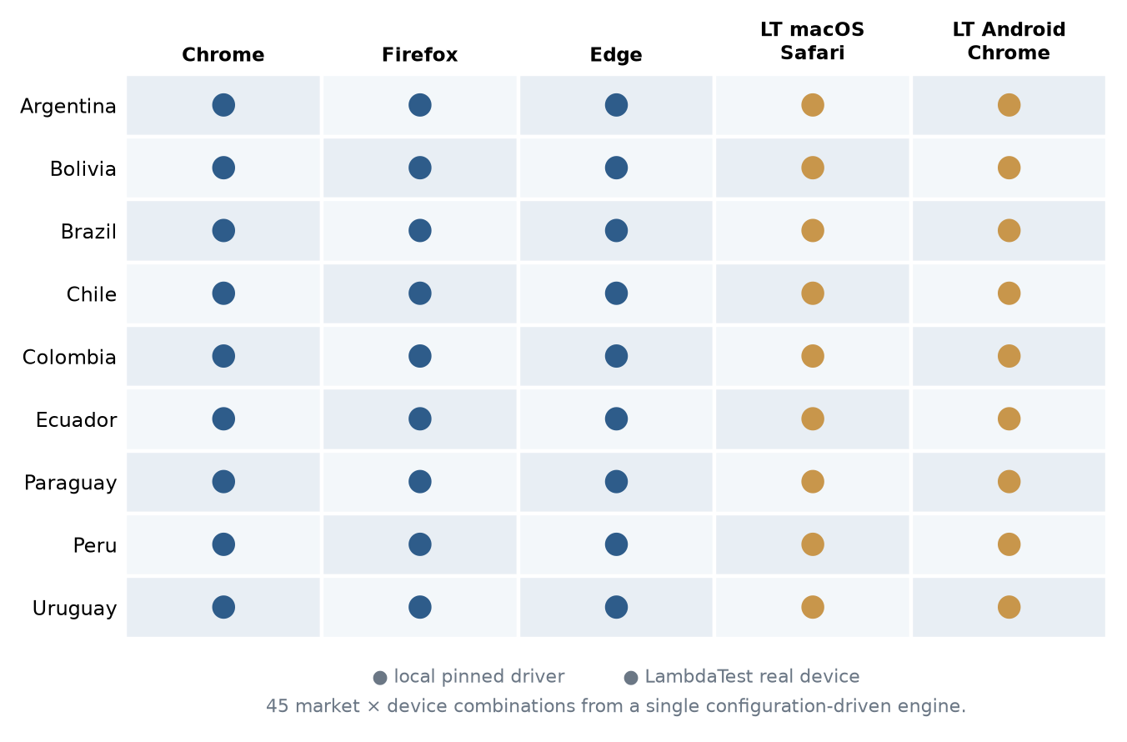
Figure 5 — Market and device coverage matrix.
Market | Document field | Notable specifics
Argentina | ci | Patent, event, chassis and adviser fields available
Bolivia | document | Standard mapping
Brazil | cpf, cnpj, cep | Several document fields at once, generated through an external service with a local fallback; character-by-character re-entry to defeat input masks; the RAQ flow requires clicking a channel selector before the form appears
Chile | rut | RUT with check digit
Colombia | ci | Standard mapping
Ecuador | ci | Identity number with check digit
Paraguay | ci | Exactly seven digits; the form truncates the eighth
Peru | ci (document on visid forms) | Document type and number are coupled — see the table below
Uruguay | ci | Standard mapping

9.1 Peru document rules example:
Peru is the only market where the form asks for a document type and enforces a different rule per type. The values below were read from the live form's document field attributes and confirmed against its validation messages:
Document type | Length | Alphabet | Field `inputmode`
DNI | 8 | Digits only | numeric
RUC | 11 | Digits only, prefixed 10 (individual) or 20 (company) | numeric
Carné de Extranjería | 12 | Digits only | numeric
Pasaporte | 12 | Alphanumeric — the only type that accepts letters | text

The generator draws the type at random and produces a number that satisfies it. Generating the two independently causes the form to reject the lead with a minimum-length error, which is precisely the defect corrected in this baseline.

10. Current Functional Scope
- Lead submission across nine Latin American markets, on Chrome, Firefox and Edge locally, and on real macOS and Android devices through LambdaTest.
- Support for both embedded forms and standalone form URLs.
- Multi-step form handling with inter-field dependencies, without per-form configuration.
- Resilient auto-filling of visible fields absent from the mapping, with reporting of what was discovered.
- Adobe AEM (T3 2.0) form support, including its distinct submit and checkbox structure.
- Screenshot evidence at every stage on local browsers; session video on remote devices.
- Thank-you page detection, plus verification of the call-to-action link it carries.
- Per-row result reporting including the values actually submitted and the real HTTP status of both URLs.
- Test-data generation per country and device, with market-valid identity documents.
- Field mapping and dynamic ID configuration editable from the interface, without code changes.
- Independent QA field-validation module with a regex builder and expected error messages.
- Dealer network comparison validated as a Region-City-Dealer set.
- Bulk URL and embedded-form verification without submitting leads.
- Weekly scheduling with the interface open, and unattended execution without it.
- Email reporting through Outlook with an SMTP fallback.
- Sequential or parallel execution across markets, device spreadsheets and individual URLs.
- Portable Windows packaging in one-directory mode.

11. Out of Scope
- Operating systems other than Windows.
- Automatic download or update of browser drivers. Local pinned drivers are enforced for security policy compliance.
- Direct integration with a CRM or lead API. Output is limited to spreadsheets and email.
- CAPTCHA solving or anti-bot circumvention.
- Verification that a submitted lead reached the destination database.
- Semantic detection of layout changes beyond unmapped selects and inputs.
- A web-based or cross-platform interface.
- Load or performance testing of the target sites.
- Standalone form URLs inside the Massive Form Review module.
- Encryption of result files or email attachments.

12. Assumptions and Dependencies

12.1 Assumptions
- The workstation runs Windows, with Outlook installed and configured if email reporting is required.
- Chrome, Firefox and Edge are installed at versions compatible with the drivers pinned in drivers/.
- Input spreadsheets follow the column structure produced by the Excel Data Generation tab.
- Target landings and forms keep their expected iframe and field structure. DOM changes may require updating the field mapping or the dynamic IDs.
- Network access to the target sites and, for remote execution, to the LambdaTest hub.
- Where a TLS-inspecting proxy is in use, its certificate authority is present in the Windows trust store.

12.2 Runtime dependencies
Dependency | Pinned range | Purpose | Consequence if unavailable
selenium | ~=4.46 | Browser automation, local and remote | No module that touches a browser can run
openpyxl | ~=3.1 | Reading and writing .xlsx with formatting | No input can be read and no report written
pandas | ~=3.0 | Data frames for generation, preview and per-URL slicing | Excel generation and per-URL parallel mode fail
pillow | ~=12.3 | Screenshot stitching and interface icons | No visual evidence; the interface degrades
pytz | ~=2026.3 | Time zone handling for scheduling | Schedules may fire at the wrong local time
pywin32 | ~=312.0 | Outlook dispatch, off-screen window positioning, system tray | No email through Outlook; the browser may steal focus
requests | ~=2.34 | HTTP status probing and the LambdaTest API | URL status columns and video links are unavailable
truststore | ~=0.10 | TLS validation against the Windows trust store | Behind an inspecting proxy, HTTPS calls fail and the review module reports false failures
PyInstaller | build only | Portable Windows packaging | The application still runs from source
Local WebDriver binaries | pinned in drivers/ | Chrome, Firefox and Edge sessions | The corresponding browser cannot start
LambdaTest account | external service | Remote real-device execution | Remote runs fail at session start
Microsoft Outlook | external | Primary email channel | Dispatch falls back to SMTP

Versions are constrained with compatible-release ranges rather than left open. build.bat recreates the virtual environment from scratch on every build, so unconstrained requirements meant two builds of identical source code could ship different dependency versions.

13. Error Handling and System States
State / condition | System behaviour
Input spreadsheet missing or empty | Detected before any browser opens. Execution is refused and the exact market and device combination is named.
Landing page returns 404 or does not load | Detected by title and heading heuristics plus a real HTTP probe. The row is marked and the form columns state that the form was never searched, rather than reporting a mismatch.
Form iframe not found | Any GM iframe is used as a fallback and the row is flagged as a mismatch. If none exists, the row is reported as FORM ABSENT.
Several iframes on one landing | Candidates whose src matches a GM marker are always preferred; the first visible iframe is a last resort and is flagged.
Standalone URL, no landing | The form URL becomes the page to navigate to, no iframe is searched, and the engine waits for the SPA components to mount before scanning the DOM.
Visible field not present in the mapping | Filled with a synthetic value when required, and reported to json/nuevos_campos_<country>.json.
Client-side validation rejects a value | The visible error text is captured per field and written to the result row, naming the field and the message.
Server returns the transient event_id error | Detected during the thank-you wait window, since the banner disappears after roughly six seconds. The row is reported as a server error and retried once.
Submission produces no thank-you page | Two retries: reloading only the form iframe, then the whole landing. If both fail, evidence is captured and the row is reported as unconfirmed.
TLS certificate invalid during massive review | Reported as a failure with the certificate error, rather than silently accepted.
Browser driver outdated | The browser fails to start and the run stops with an explicit error. The driver must be replaced manually.
LambdaTest credentials rejected | The session fails at start with an authorisation error, and the run is reported as zero of N successful.
User stops a run | A cooperative stop flag is checked between rows. The result spreadsheet keeps what completed, and no failure email is sent.
Scheduled slot missed while the app was closed | A slot missed earlier the same day runs when the application reopens. A slot missed for a full day is lost.
Email dispatch fails | The real error is surfaced instead of a generic message. Results remain on disk in resultados/.

14. Risk Register
The risks below are consolidated across modules and ordered by the impact they would have on the reliability of QA reporting. Section 7 lists the risks specific to each module.
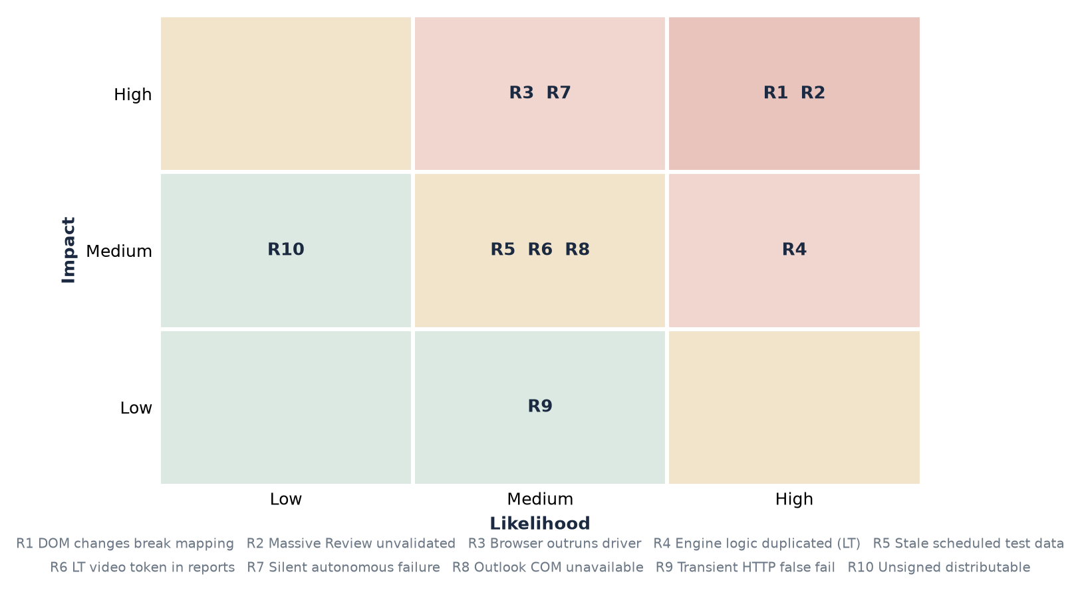
Figure 6 — Consolidated risk register positioned by likelihood and impact.
# | Risk | Likelihood | Impact | Mitigation / status
R1 | Target site DOM changes break field mapping | High | High | Partly absorbed by alias resolution and unmapped-field auto-fill; discovered fields are reported for review. Residual risk accepted.
R2 | Massive Form Review has not been fully validated | Certain | High | Documented as a known limitation. Its output should be treated as indicative until the remaining paths are tested.
R3 | Browser auto-update outruns the pinned driver | Medium | High | Accepted trade-off for policy compliance. Failure is immediate and explicit.
R4 | Two parallel engines (local and LambdaTest) drift apart | Medium | Medium | Fixes must be applied in both. Consolidation is the recommended next structural change.
R6 | Site-side failures misattributed to the tool | Medium | Medium | Server errors are now distinguished from client-side validation failures in the report.
R7 | LambdaTest video links share session access | Medium | Medium | Open. The token travels in the results spreadsheet and any email carrying it.
R8 | Credentials (Api Key of LambdaTest) stored in plain text on disk | Medium | Medium | Environment variables are now the preferred source; the file remains as a fallback.
R9 | Unattended runs fail silently | Low | High | The consolidated email is the only signal, and it is itself a point of failure.
R10 | Scheduled runs reuse stale test data | Medium | Low | Open. Data regeneration before a campaign is a manual step.
R11 | Portable distribution carries readable source code | Low | Low | The LambdaTest packages ship as .py inside _internal/. Acceptable while distribution stays internal.

15. Security and Privacy Considerations
- All lead data processed by the tool is synthetic. Names, documents, telephone numbers and email addresses are generated locally for test purposes; no real customer data is handled.
- Processing is local. Data leaves the workstation only towards the target form under test, the LambdaTest hub on remote runs, and the configured email recipient.
- TLS certificates are validated on every outbound HTTP call made by the application. Certificate verification is not disabled anywhere in the codebase.
- truststore aligns Python's trust decisions with the Windows certificate store. This does not weaken validation: it validates against the same authorities the operating system and its browsers already trust, including a corporate inspecting proxy where one is deployed by policy. It is materially different from disabling verification, which would accept any certificate from any party.
- LambdaTest credentials are read from environment variables when present, and from lambdatest_credentials.txt otherwise. That file and json/config_global.json are excluded from version control and from the portable build.
- json/config_global.json stores the recipient address and interface preferences. It does not store the LambdaTest access key.
- Result spreadsheets and screenshots are written unencrypted to resultados/. Access control relies on the operating system's file permissions.
- LambdaTest session video links contain an authentication token. Anyone who receives a results spreadsheet can open the corresponding recording. This is an open item.
- The portable build ships the LambdaTest runner packages as readable .py files bundled inside the executable. Distribution should remain internal.
- Browser automation runs from the operator's workstation and is subject to corporate network policy. The tool does not scrape or modify target pages beyond filling and submitting the forms under test.

16. Version 1 to Version 2: Changes and Rationale
This section records what changed between the baseline documented by Ariel Melgratti in v1 and the current baseline, and why. Each change is stated with the problem it addresses, so the reasoning is available to whoever maintains the tool next.

16.1 Architectural consolidation
What changed. v1 described nine forms/Formulario_<Country>_Main.py runner files and nine core/Formulario_<Country>_Base.py classes — eighteen source files whose content was largely identical. These were replaced by three: core/country_configs.py holds the per-market configuration as data, core/generic_country_base.py injects it, and forms/_runner_common.py builds the runner dynamically.
Why. Every engine change had to be replicated eighteen times, and in practice markets drifted apart because a fix landed in some files and not others. Turning the differences into data removed the duplication: adding or adjusting a market is now an entry in a dictionary, and an engine fix applies everywhere at once.
Trade-off. Per-country behaviour that genuinely differs — Brazil's multiple document fields, Peru's document types — now lives as conditional logic inside the shared engine. This concentrates complexity in base_form_filler.py, which is large. The alternative was accepting eighteen files that drift.

16.2 Data generation model
What changed. v1 used a single Lead_information_Formulario_<Country>_Main.xlsx per market. v2 generates one spreadsheet per device, each with independently randomised data, plus _T3 variants for AEM forms and an optional shared-spreadsheet mode.
Why. Running the same market on several browsers concurrently submitted identical identities several times, which produced duplicate leads and rejections that looked like tool defects. Independent data per device removed that class of false failure. The generated email address encodes country and device, so any lead in the destination database can be traced back to the run that produced it.

16.3 New functional modules
Module | Purpose | Problem it addresses
Dealer Comparator | Validate the dealer network exposed by a form against an expected spreadsheet | Replaces a manual bookmarklet pasted into the browser console. Set-based Region-City-Dealer comparison also removed the false positives that name-only checking produced.
Massive Form Review | Verify URLs and embedded forms in bulk without submitting leads | Confirming that hundreds of matrix entries still pointed at a live, correctly embedded form was a manual task.
LambdaTest execution | Run the lead flow on real macOS and Android devices | v1 covered only Windows desktop browsers. Defects specific to iOS Safari and Android Chrome were invisible.
Excel Data Generation tab | Produce input spreadsheets from a pasted URL list | v1 required editing spreadsheets by hand, which was slow and error-prone.

16.4 Reliability and correctness improvements
Area | Change | Objective
Iframe selection | GM markers (gm_forms, gm_front, gm_admin) always take priority over any other visible iframe | Landings carrying several iframes were resolving to the wrong one
Standalone forms | Rows with no landing URL navigate directly to the form and skip iframe search | Loose form URLs were previously skipped or mishandled
Reported values | The DOM is re-read immediately before submission and the tracked values overwritten | A retry re-randomised dropdowns, so the report did not match the destination database
Failure reasons | A dedicated Motivo column plus real HTTP status for both URLs | A down landing was indistinguishable from a missing form
Server errors | The transient event_id banner is detected during the wait window rather than after it | It disappears after about six seconds, so a site-side failure was being reported as a form still on screen
Complaints Book | Detected by DOM and by URL, on both the landing and the form URL | Detection by URL slug alone missed the standalone variant and fields were filled one slot out of place
Retry strategy | Reload only the form iframe first, then the whole landing | Reloading the entire landing for every retry was slow and reset unrelated state
Evidence naming | Screenshots named by form slug and stage | Runs with many forms produced files that could not be told apart
Spreadsheet values vs randomisation | Choice fields resolve the spreadsheet value first — accent- and NBSP-insensitive — and fall back to a random option only when the operator left the cell empty. Radio-rendered fields, unmapped selects and alternate column names are covered on both the local and the LambdaTest engines. | A value typed into the spreadsheet was silently replaced by a random choice when the form rendered the field as radio buttons, when the option text differed by an accent, or when the select was absent from the country mapping.

The effect of the correctness work is measurable. On the same eight standalone Peru URLs, the run went from two successful submissions to seven, and total runtime fell from 6.8 to 2.0 minutes. The engine is not faster per form: each failure previously triggered two full retries, so eliminating the failures removed the wasted work. The single remaining failure is a server-side fault on the target form, now reported as such.

16.5 Build and packaging
What changed. PyInstaller packaging went to one-directory mode in July 2026 and back to one-file in August 2026. The current build produces a single OsocioFormAutomation.exe with everything compressed inside it, and build.bat zips the assembled portable folder, so the whole distribution is one compressed artefact.
Why it went back. One-directory mode left an _internal/ folder of loose libraries beside the executable, which is confusing to hand over and easy to break by copying only the .exe. One-file trades that for start-up time: the bootloader extracts the bundle to %TEMP% on every launch, so the application takes a few seconds longer to open than the 0.8 to 2.9 seconds measured in one-directory mode. That trade was accepted deliberately in favour of shipping a single file.
Consequence for distribution. The .exe is self-contained, but it still expects data/, json/, drivers/ and the output folders beside it, so what is handed over is the portable folder (or its ZIP), not the .exe on its own.

16.6 Security improvements
Change | Objective
TLS verification enabled on all HTTP probing in the Massive Form Review module | Certificate validation had been disabled and its warning silenced, so an expired, self-signed or wrong-host certificate still reported a passing status. In a tool whose purpose is validating that URLs are healthy, a broken certificate must be a failure.
truststore injected in the module performing the HTTP calls, not only in run.py | Enabling verification would otherwise produce false failures behind a TLS-inspecting corporate proxy.
LambdaTest credentials read from environment variables, with the file as fallback | Removes the need to keep an access key in plain text on disk, and suits key rotation. Existing installations continue to work unchanged.
Dependency versions constrained to compatible ranges | build.bat rebuilds the virtual environment on every build, so unconstrained requirements allowed identical source to ship with different dependency versions.
Documentation corrected regarding credential storage | The previous text stated that config_global.json held the LambdaTest access key. It does not. Inaccurate security documentation leads to wrong assumptions in both directions.

16.7 Summary comparison
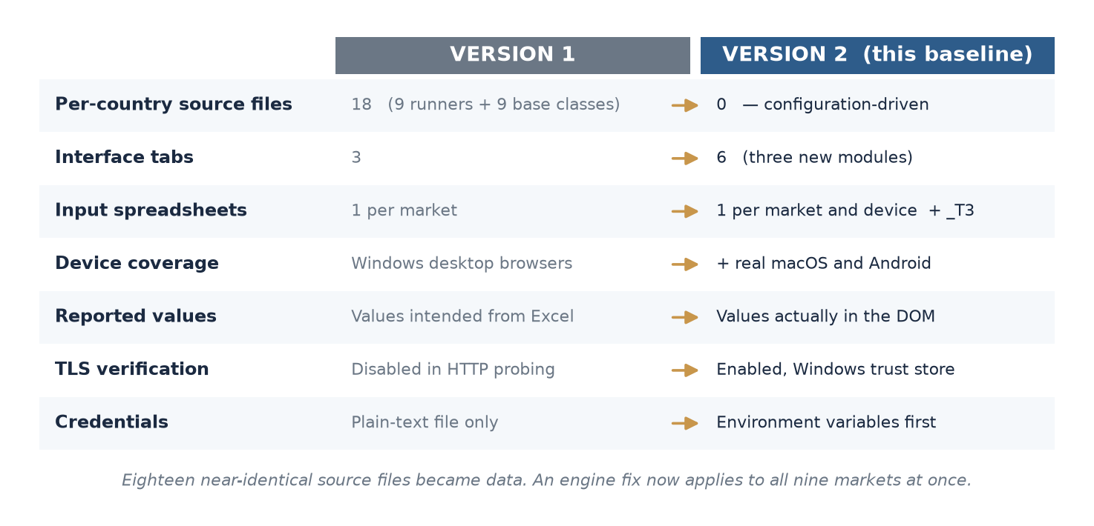
Figure 7 — Version 1 to version 2 at a glance.
Aspect | Version 1 | Version 2
Per-country source files | 18 (9 runners + 9 base classes) | 0 — configuration-driven
Interface tabs | Lead submission, validation, scheduling | Six tabs, including three new modules
Input spreadsheets | One per market | One per market and device, plus _T3 variants
Execution targets | Chrome, Firefox, Edge (Windows) | The same three plus real macOS and Android devices
Standalone form URLs | Not supported | Supported end to end, including LambdaTest
Parallelism | Not described | Across markets, device spreadsheets and individual URLs
Failure diagnostics | Row status text | Status, short cause, HTTP status of both URLs, submitted values
Packaging | One-file executable | One-directory; window visible in under three seconds
TLS verification | Disabled in bulk URL checking | Enabled, with corporate-proxy trust alignment
Credential handling | Plain-text file only | Environment variables preferred, file as fallback
Dependency pinning | Unconstrained | Compatible-release ranges

16.8 Authorship of the changes in this baseline
The original application, its automation engine and the modules documented in v1 were built by Ariel Melgratti. The work that produced baseline 2.0 — the new modules, the architectural consolidation and the reliability fixes recorded in this section — was carried out by Elián Zás. The table below states, area by area, what is new, what was reworked and what was left substantially as it was, so that both credit and maintenance responsibility are traceable.
Area | Status in v1 | Change in this baseline | Author
Excel Data Generation | Did not exist | New tab and generator. Produces the input spreadsheets from a pasted URL list, one per device, with market-valid synthetic identities. | Elián Zás
Dealer Comparator | Did not exist | New tab and runner. Replaces the manual browser-console bookmarklet with a set-based Region → City → Dealer comparison, presets and reporting. | Elián Zás
Massive Form Review | Did not exist | New tab and runner. Bulk verification of the form matrix without submitting leads. | Elián Zás
Lead Submission | Core module, documented in v1 | Substantially improved: standalone form URLs, parallel execution across markets, spreadsheets and individual URLs, per-device data, richer failure diagnostics, submitted-value tracking, thank-you CTA verification and the retry strategy. | Elián Zás, over the original engine by Ariel Melgratti
Test Scheduling | Existed in v1 | Adjusted and extended: weekly calendar interface, spreadsheet pre-validation before a schedule can be saved, same-day missed-slot recovery, and separate output naming for scheduled runs. | Elián Zás, over the original engine by Ariel Melgratti
Field Validation | Existed in v1 | Left substantially untouched. One improvement: fields discovered during a lead run are now written into the per-market rule file, so the operator can define, from this tab, the data to randomise whenever that field appears in that market. | Module by Ariel Melgratti; improvement by Elián Zás
Engine architecture | 18 per-country source files | Consolidated into a configuration-driven engine: country_configs.py, generic_country_base.py and _runner_common.py. | Module by Ariel Melgratti; improvement by Elián Zás
LambdaTest execution | Not described in v1 | Remote execution on real macOS and Android devices, sharing the spreadsheet format with local runs. | Elián Zás
Security hardening | Not addressed in v1 | TLS verification enabled in bulk URL checking, credentials Lambdatest Api-key read from environment variables, dependency versions constrained. | Elián Zás

Where an area is marked as improved rather than new, the original design and its authorship remain those recorded in v1. The intent of this table is to make the boundary explicit, not to reassign ownership of the work it builds on.

17. Strengths and Limitations

17.1 Strengths
- One engine covers nine markets. A fix applies everywhere at once, and a new market is a configuration entry.
- The tool degrades rather than breaking when a form changes: unmapped fields are filled and reported instead of aborting the run.
- Evidence is thorough. Every stage is captured, and the report states the values actually submitted rather than those intended.
- Failures are attributable. The report distinguishes a broken landing, a missing form, a validation rejection and a server-side error, which is what makes the output usable as QA evidence.
- Operable without development skills. Field mappings, dynamic IDs, validation rules and dealer column mappings are all editable from the interface.
- Real-device coverage through LambdaTest catches defects that Windows desktop browsers do not reproduce.
- The portable build runs without installation, which suits distribution to QA workstations.

17.2 Limitations
- core/base_form_filler.py is approximately 6,280 lines. It concentrates the engine's complexity and is the hardest part of the system to modify safely.
- The LambdaTest runner duplicates the local engine's logic rather than sharing it. Fixes must be applied twice, and in practice defects have been fixed in one and not the other.
- The Massive Form Review module is not fully validated.
- Automated test coverage of the tool itself is minimal. Verification is performed by running it against live forms, which makes results dependent on the target sites being available and unchanged.
- pandas and numpy account for roughly 113 MB of dependency weight, used only for spreadsheet reading and writing that openpyxl, already a dependency, could perform.
- Windows only, by design and by dependency (pywin32, Outlook COM, Windows mutex).
- There is no verification that a submitted lead reached the destination database. The tool validates the form's response, not the outcome.

18. User Manual (Short)
A typical QA cycle runs as follows.

18.1 Submitting leads
- Open the Excel Data Generation tab, select the market and the devices, paste the URLs and press GENERAR EXCELS.
- Move to Lead Submission, select the same market and devices, and choose sequential or parallel execution.
- Enter a recipient address if a report by email is wanted.
- Press EJECUTAR ENVIO and follow the execution modal.
- Open Ver Resultados. Start from the Resultado and Motivo columns; the screenshots explain the rest.

18.2 Reviewing the form matrix
- Open Massive Form Review and select the markets.
- Confirm the master spreadsheet path and the four column names.
- Run, then open resultados/resultado_urlsinsertas/.
- Treat the output as indicative: this module is not yet fully validated.

18.3 Comparing dealers
- Open Dealer Comparator and select the market and browser.
- Load the URL spreadsheet and the expected dealer spreadsheet, stating the header row.
- Map the region, city and dealer columns, then choose the output mode.
- Run and review the report folder for each form. Save the mapping as a preset for reuse.

18.4 Scheduling
- Configure markets and devices in Test Scheduling.
- Open the automation panel, select days and times, and save.
- Arm the schedule. Leave the application open, or run the autonomous runner for unattended execution.
- Regenerate the test data before a scheduled campaign; the scheduler does not do it.

19. Technical Manual (Short)

19.1 Stack
- Language and runtime: Python 3.x on Windows.
- Interface: Tkinter and ttk, with Pillow for icons and screenshot composition.
- Concurrency: threading, one background thread per session, plus a thread pool in the autonomous runner.
- Browser automation: Selenium WebDriver with pinned local drivers, and Selenium Remote WebDriver for LambdaTest.
- Spreadsheets: openpyxl for reading and formatted writing, pandas for generation and slicing.
- Email: pywin32 COM against Outlook, with an smtplib fallback.
- Packaging: PyInstaller in one-file mode, portable folder plus ZIP.

19.2 Runtime behaviour
- The Tkinter main loop stays on the UI thread. Every run is dispatched to a background thread, so the interface remains responsive and can report progress.
- Stopping is cooperative: a flag is checked between rows and the worker exits cleanly rather than being terminated.
- The browser window is positioned off-screen through the Win32 API using SW_SHOWNOACTIVATE, so a run does not steal focus. This is not headless mode; the browser is real and fully rendered.
- Result numbering is serialised with a lock, so concurrent sessions cannot claim the same output folder.
- truststore is injected before any other import in run.py, and again in the module that performs HTTP probing.

19.3 Building the portable distribution
.\build.bat
# Recreates venv from scratch, installs requirements, runs PyInstaller
# with FormAutomation.spec, and assembles:
# dist/OsocioFormAutomation_portable/
# OsocioFormAutomation.exe (self-contained, everything bundled inside)
# data/ (only Field_Validation_URLs.xlsx)
# drivers/ (chromedriver, geckodriver, msedgedriver)
# json/ (rules and mappings, no local state)
# resultados/ temporales/ Dealerscheck_resultados/
# resultados_lambdatestmac/ resultados_lambdatest_android/ (all empty)
# dist/OsocioFormAutomation_portable.zip
build.bat deletes the existing virtual environment before rebuilding. The portable is assembled clean: the output folders are created empty rather than copied, so no results, screenshots or massive-review reports from the build machine travel with it. No data spreadsheet is shipped either - lead spreadsheets are generated from the application itself, the Massive Form Review matrix is chosen by the operator, and dealer listings are real client data; the only exception is data/Field_Validation_URLs.xlsx, which the Field Validation tab expects to find there. The browser drivers do ship, since the portable pins them. json/ excludes the scheduler state files (programacion_test/leads/masivo.json, scheduler_triggered.json), dealer_comparator_settings.json and config_global.json, which holds the operator email and the LambdaTest access key in clear text. The portable also starts with no schedule armed, for either Envío de Leads Programados or Massive Form Review: the scheduler state files are both excluded by name and deleted by pattern from the assembled json/ folder, so a schedule file with a new name cannot slip through the exclusion list.

19.4 Command line
Command | Effect
python run.py | Launches the graphical interface
python run.py --run-country <Country> --environment chrome_desktop | Runs one market without the interface
python run.py --run-country <Country> --scheduled --no-email | Same, marked as a scheduled run (Automatizacion_ prefix), without email
python run.py --run-lambdatest mac --pais <Country> | Runs the market on LambdaTest macOS
python run.py --run-lambdatest android --pais <Country> | Runs the market on LambdaTest Android
python run.py --autonomous | Starts the unattended scheduler

20. Known Issues and Recommended Next Steps

20.1 Known issues
Item | Description | Status
Massive Form Review validation | Only the main path has been verified end to end. Remaining markets, parallel mode, failures-only mode and matrix synchronisation are untested. | Open — treat output as indicative
Duplicated engine logic | lt_runner.py reimplements the local engine rather than sharing it. | Open
Complaints Book optional radios | Two non-mandatory radio groups are left unselected. Leads are accepted. | Open — cosmetic
kits[] selector | An unescaped CSS selector raises a handled exception on every form, adding log noise without affecting results. | Open — cosmetic
Field Validation depth | The module works, but its rule base has not been developed far enough to be used as part of daily testing. No market has a complete, reviewed set of rules. | Open — capability available, not yet routine

20.2 Recommended next steps
- Complete the validation of the Massive Form Review module across all markets and execution modes, then remove the caveat from this document.
- Consolidate the LambdaTest runner and the local engine so a fix only has to be written once. This is the single largest structural risk remaining.
- Evaluate replacing pandas with openpyxl for the spreadsheet operations, which would remove roughly 113 MB of dependency weight. This requires a dedicated regression pass across four modules.
- Introduce automated tests for the pure logic — document generation, URL classification, mapping resolution — which can be verified without a browser.

21. Versioning and Change Log
Documentation follows semantic versioning (MAJOR.MINOR.PATCH) and tracks the software baseline it describes.
Version | Date | Author | Description
1.0.0 | 2026 | Ariel Melgratti | Initial technical and operational overview: architecture, operational flow, main components, inputs and outputs, functional scope, assumptions, error handling and security considerations for the original per-country runner architecture.
2.0.0 | 2026-08-02 | Elián Zás | Rewritten for software baseline 2.0. Adds per-module detail including explicit non-goals, dependencies and risks; documents the Dealer Comparator, Massive Form Review, LambdaTest execution and Excel Data Generation modules; records the configuration-driven architecture that replaced the per-country runners; adds a risk register, a version 1 to version 2 change rationale, short user and technical manuals, and known issues with recommended next steps.
2.1.0 | 2026-08-04 | Elián Zás | Documentation restyled for readability: cover page, consistent heading and table styles, note callouts and eight diagrams replacing the previous ASCII schematic. Content updated for the spreadsheet-value correctness work recorded in 16.4 and 7.1; no other section was rewritten.

22. Forward Plan: Security Hardening and Target Infrastructure
This section sets out where the application should go next in terms of security posture and hosting. The recommendations below are proposals, not decisions already taken. They are recorded here so that the reasoning is available to the group described in 22.4, which is currently defining the formal path forward.

22.1 Current hosting model and its limits
The application runs today as a portable folder on an individual QA workstation. That model was the right choice for the tool's origin — it requires no installation, no infrastructure and no approvals — but it imposes limits that are now the main obstacle to treating the tool as a shared corporate asset:
- Execution depends on one machine being switched on, unlocked and not asleep. Scheduled campaigns are lost silently when it is not.
- Credentials, configuration and results live on a personal profile, which makes access control, backup and handover informal.
- There is no shared history. Each operator holds their own results, so trends across runs cannot be analysed.
- Concurrency is bounded by a single workstation's CPU and memory, which is what forced the per-URL concurrency ceiling.
- Updating the tool means redistributing a folder and trusting that every operator replaced it.

22.2 Recommended target infrastructure
Three progressive options are proposed. They are cumulative rather than exclusive: each is a viable stopping point, and each is a prerequisite for the next.
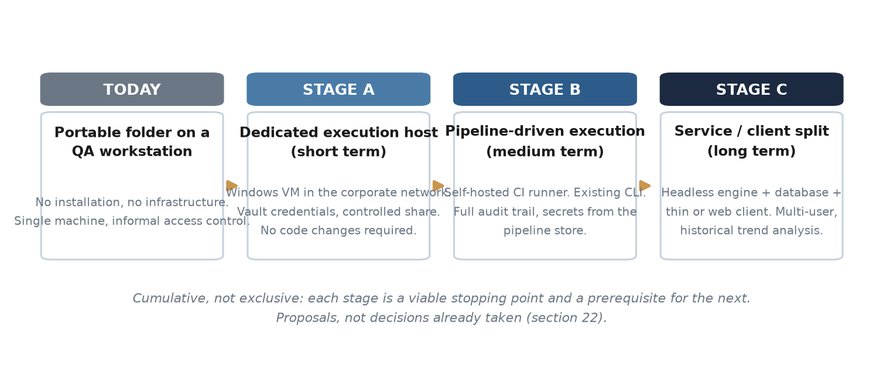
Figure 8 — Proposed infrastructure stages. Cumulative, not exclusive.
Stage | Proposal | Advantages | Trade-offs
A — Dedicated execution host (short term) | Move execution to a dedicated Windows virtual machine inside the corporate network. Runs are triggered by the Windows task scheduler or the existing autonomous runner. Credentials come from a vault; results are written to a controlled network share or document library. | Removes the dependency on a personal workstation. Gives backup, access control and a stable execution environment. Requires no code changes. | Still a single host and a single point of failure. Someone must own patching and browser version management.
B — Pipeline-driven execution (medium term) | Register the host as a self-hosted CI runner (Azure DevOps or GitHub Actions). Runs are launched from the pipeline using the existing command-line interface, which already supports per-country, scheduled and LambdaTest execution. Artefacts are published by the pipeline; secrets come from the pipeline's secret store. | Full audit trail of who ran what and when. Versioned, reproducible execution. Results retained and comparable across runs. Removes credentials from the host entirely. | Requires pipeline ownership and a defined branching and release process. The Tkinter interface remains a separate, manually distributed artefact.
C — Service and client separation (long term) | Split the engine from the interface. The engine becomes a headless service driven by the command line or an API; results are written to a database instead of spreadsheets; the interface becomes a thin client or an internal web application, with reporting served from a dashboard. | Multi-user by design. Historical trend analysis becomes possible. Removes Windows-only constraints from the engine, and the Excel-based reporting bottleneck. | A significant redevelopment effort, and the largest departure from the current design. Justified only if the tool is adopted beyond the current team.

Independently of the stage adopted, real-device coverage should remain on LambdaTest. Reproducing macOS Safari and Android Chrome in-house is not economically sensible for this volume of testing.

