AI video-generation discourse analysis
Eliana
2026-05-01

Hypotheses
H1 Discourse source is associated with realism/authenticity framing.
H2 Discourse source is associated with human creativity/cultural value framing.
H3 Discourse source is associated with production/control framing.

Findings

Hypothesis 1
## # A tibble: 2 × 3
## discourse_source realism_benefit realism_concern
## <chr> <dbl> <dbl>
## 1 official 0.408 0.0132
## 2 user 0.0467 0.133
##
## Pearson's Chi-squared test with Yates' continuity correction
##
## data: d_ai$discourse_source and d_ai$realism_benefit_presence
## X-squared = 44.511, df = 1, p-value = 0.00000000002529
##
## Pearson's Chi-squared test with Yates' continuity correction
##
## data: d_ai$discourse_source and d_ai$realism_concern_presence
## X-squared = 7.2761, df = 1, p-value = 0.006988
We found that discourse source is associated with both realism/authenticity benefit framing, X2(df = 1, n = 226) = 44.51, p < .001, and realism/authenticity concern framing, X2(df = 1, n = 226) = 7.28, p = .007. Official discourse was more likely to benefit-frame realism/authenticity (40.8%) than user discourse (4.7%), whereas user discourse was more likely to concern-frame realism/authenticity (13.3%) than official discourse (1.3%).

Hypothesis 2
## # A tibble: 2 × 3
## discourse_source human_benefit human_concern
## <chr> <dbl> <dbl>
## 1 official 0.329 0
## 2 user 0.113 0.213
##
## Pearson's Chi-squared test with Yates' continuity correction
##
## data: d_ai$discourse_source and d_ai$human_benefit_presence
## X-squared = 14.107, df = 1, p-value = 0.0001727
##
## Pearson's Chi-squared test with Yates' continuity correction
##
## data: d_ai$discourse_source and d_ai$human_concern_presence
## X-squared = 17.173, df = 1, p-value = 0.00003412
We found that discourse source is associated with both human creativity/cultural benefit framing, X2(df = 1, n = 226) = 14.11, p < .001, and human creativity/cultural concern framing, X2(df = 1, n = 226) = 17.17, p < .001. Official discourse was more likely to benefit-frame human creativity/cultural value (32.9%) than user discourse (11.3%), whereas user discourse was more likely to concern-frame human creativity/cultural value (21.3%) than official discourse (0%).

Hypothesis 3
## # A tibble: 2 × 3
## discourse_source control_benefit control_concern
## <chr> <dbl> <dbl>
## 1 official 0.697 0.0132
## 2 user 0.147 0.127
##
## Pearson's Chi-squared test with Yates' continuity correction
##
## data: d_ai$discourse_source and d_ai$control_benefit_presence
## X-squared = 66.532, df = 1, p-value = 0.0000000000000003442
##
## Pearson's Chi-squared test with Yates' continuity correction
##
## data: d_ai$discourse_source and d_ai$control_concern_presence
## X-squared = 6.7113, df = 1, p-value = 0.00958
We found that discourse source is associated with both production/control benefit framing, X2(df = 1, n = 226) = 66.53, p < .001, and production/control concern framing, X2(df = 1, n = 226) = 6.71, p = .010. Official discourse was more likely to benefit-frame production/control (69.7%) than user discourse (14.7%), whereas user discourse was more likely to concern-frame production/control (12.7%) than official discourse (1.3%).

Robustness checks for categorical comparisons
##
## Fisher's Exact Test for Count Data
##
## data: table(d_ai$discourse_source, d_ai$realism_benefit_presence)
## p-value = 0.00000000002995
## alternative hypothesis: true odds ratio is not equal to 1
## 95 percent confidence interval:
## 0.02506104 0.18110991
## sample estimates:
## odds ratio
## 0.07211636
##
## Fisher's Exact Test for Count Data
##
## data: table(d_ai$discourse_source, d_ai$realism_concern_presence)
## p-value = 0.002676
## alternative hypothesis: true odds ratio is not equal to 1
## 95 percent confidence interval:
## 1.761601 483.485963
## sample estimates:
## odds ratio
## 11.46417
##
## Fisher's Exact Test for Count Data
##
## data: table(d_ai$discourse_source, d_ai$human_benefit_presence)
## p-value = 0.0002144
## alternative hypothesis: true odds ratio is not equal to 1
## 95 percent confidence interval:
## 0.1218826 0.5529979
## sample estimates:
## odds ratio
## 0.2625324
##
## Fisher's Exact Test for Count Data
##
## data: table(d_ai$discourse_source, d_ai$human_concern_presence)
## p-value = 0.0000008442
## alternative hypothesis: true odds ratio is not equal to 1
## 95 percent confidence interval:
## 5.042619 Inf
## sample estimates:
## odds ratio
## Inf
##
## Fisher's Exact Test for Count Data
##
## data: table(d_ai$discourse_source, d_ai$control_benefit_presence)
## p-value < 0.00000000000000022
## alternative hypothesis: true odds ratio is not equal to 1
## 95 percent confidence interval:
## 0.0362109 0.1525640
## sample estimates:
## odds ratio
## 0.07577663
##
## Fisher's Exact Test for Count Data
##
## data: table(d_ai$discourse_source, d_ai$control_concern_presence)
## p-value = 0.002753
## alternative hypothesis: true odds ratio is not equal to 1
## 95 percent confidence interval:
## 1.651453 456.990341
## sample estimates:
## odds ratio
## 10.80898
Results were substantively consistent in Fisher’s exact tests, including comparisons involving sparse cells: realism/authenticity benefit framing, p < .001; realism/authenticity concern framing, p = .003; human creativity/cultural benefit framing, p < .001; human creativity/cultural concern framing, p < .001; production/control benefit framing, p < .001; and production/control concern framing, p = .003.

Overall pattern
## # A tibble: 2 × 7
## discourse_source realism_benefit realism_concern human_benefit human_concern
## <chr> <dbl> <dbl> <dbl> <dbl>
## 1 official 0.408 0.0132 0.329 0
## 2 user 0.0467 0.133 0.113 0.213
## # ℹ 2 more variables: control_benefit <dbl>, control_concern <dbl>
## # A tibble: 12 × 3
## discourse_source frame_type proportion
## <chr> <ord> <dbl>
## 1 official realism_benefit 0.408
## 2 official realism_concern 0.0132
## 3 official human_benefit 0.329
## 4 official human_concern 0
## 5 official control_benefit 0.697
## 6 official control_concern 0.0132
## 7 user realism_benefit 0.0467
## 8 user realism_concern 0.133
## 9 user human_benefit 0.113
## 10 user human_concern 0.213
## 11 user control_benefit 0.147
## 12 user control_concern 0.127
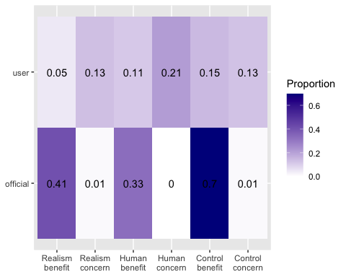
Across the six framing categories, the most prominent pattern in official discourse was production/control benefit framing (69.7%), followed by realism/authenticity benefit framing (40.8%) and human creativity/cultural benefit framing (32.9%). In user discourse, the highest proportion was human creativity/cultural concern framing (21.3%), followed by production/control benefit framing (14.7%), realism/authenticity concern framing (13.3%), and production/control concern framing (12.7%).

Additional analysis
## # A tibble: 2 × 8
## discourse_source n M_benefit SD_benefit M_concern SD_concern M_balance
## <chr> <int> <dbl> <dbl> <dbl> <dbl> <dbl>
## 1 official 76 1.43 0.806 0.0263 0.161 1.41
## 2 user 150 0.307 0.555 0.473 0.576 -0.167
## # ℹ 1 more variable: SD_balance <dbl>
##
## Welch Two Sample t-test
##
## data: benefit_score by discourse_source
## t = 10.956, df = 112.14, p-value < 0.00000000000000022
## alternative hypothesis: true difference in means between group official and group user is not equal to 0
## 95 percent confidence interval:
## 0.9236273 1.3314604
## sample estimates:
## mean in group official mean in group user
## 1.4342105 0.3066667
##
## Welch Two Sample t-test
##
## data: concern_score by discourse_source
## t = -8.8494, df = 189.63, p-value = 0.0000000000000006155
## alternative hypothesis: true difference in means between group official and group user is not equal to 0
## 95 percent confidence interval:
## -0.5466585 -0.3473765
## sample estimates:
## mean in group official mean in group user
## 0.02631579 0.47333333
##
## Welch Two Sample t-test
##
## data: balance_score by discourse_source
## t = 13.16, df = 150.06, p-value < 0.00000000000000022
## alternative hypothesis: true difference in means between group official and group user is not equal to 0
## 95 percent confidence interval:
## 1.338146 1.810977
## sample estimates:
## mean in group official mean in group user
## 1.4078947 -0.1666667
We found that official discourse had a significantly higher benefit score than user discourse, t(112.14) = 10.96, p < .001, while user discourse had a significantly higher concern score than official discourse, t(189.63) = -8.85, p < .001. Official discourse also had a significantly higher balance score than user discourse, t(150.06) = 13.16, p < .001, indicating that official texts were overall more benefit-oriented, whereas user texts were overall more concern-oriented.
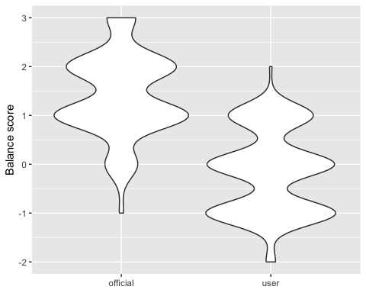
The violin plot shows that official discourse was more concentrated at positive balance scores, whereas user discourse was more concentrated around neutral or negative balance scores.

Robustness checks for score comparisons
##
## Wilcoxon rank sum test with continuity correction
##
## data: benefit_score by discourse_source
## W = 9790.5, p-value < 0.00000000000000022
## alternative hypothesis: true location shift is not equal to 0
##
## Wilcoxon rank sum test with continuity correction
##
## data: concern_score by discourse_source
## W = 3374, p-value = 0.0000000003002
## alternative hypothesis: true location shift is not equal to 0
##
## Wilcoxon rank sum test with continuity correction
##
## data: balance_score by discourse_source
## W = 10129, p-value < 0.00000000000000022
## alternative hypothesis: true location shift is not equal to 0
The same overall pattern was also observed in Wilcoxon rank-sum tests: benefit score, W = 9790.5, p < .001; concern score, W = 3374, p < .001; and balance score, W = 10129, p < .001.

Misalignment index
## dimension official_benefit_gap user_concern_gap balanced_misalignment_hm
## 1 realism 0.3612281 0.1201754 0.1803507
## 2 human 0.2156140 0.2133333 0.2144676
## 3 control 0.5507018 0.1135088 0.1882219
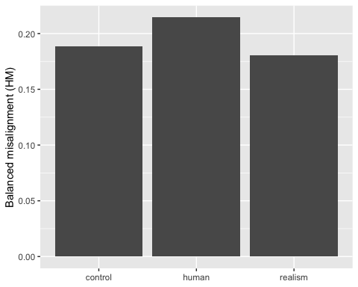
## comparison lower_95 upper_95
## 1 human_minus_control -0.08785871 0.1317328
## 2 human_minus_realism -0.06838895 0.1322825
To capture bidirectional misalignment more directly, a balanced misalignment measure was calculated using the harmonic mean of the official benefit gap and the user concern gap. By this measure, human creativity/cultural framing showed the highest balanced misalignment descriptively. However, bootstrap comparisons suggested caution in interpreting differences between dimensions, as the 95% confidence intervals for both the human-minus-control difference [-0.088, 0.132] and the human-minus-realism difference [-0.068, 0.132] crossed zero.

