# Agile Approach

## Methodical Approach

Originally proposed by Beck[1] in 1999 and refined by various authors, *user stories* are natural-language approach to expressing requirements from the point of view of a specific user of the system. User stories are kept in a *backlog* in order of priority.

Patton[2] has criticized that backlogs, like all requirements documents, tend to be flat lists and has instead proposed the *user story map* as a way of structuring requirements. A user story map is a hierarchical collection of requirements that are derived from *user activities.* User activities describe objectives that a user may have and can be further broken down into *user stories.*

Patton further argues that each system has a number of requirements which are so essential that not the system cannot function if they are missing – the *backbone*. Because missing just one of the requirements from the backbone renders the system unusable, these requirements cannot be further prioritized.

The backbone can be decomposed into smaller user stories however, some of which may be more critical than others. A small number of user stories is usually enough to satisfy the minimum of the backbone requirements. Because these stories in principle allow the system to function, Patton calls them the *walking skeleton* (see Figure 1)*.* This walking skeleton corresponds with the concept of a *minimum viable product*, which, while not ready for productive use, already covers the core functionality of the intended system.

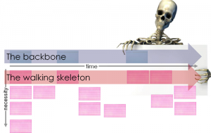

Figure 1: User Story Maps feature essential requirements in the backbone. These requirements are then decomposed into user stories. The user stories most essential for delivering the backbone are also called the “walking skeleton” (source: Jeff Patton[3]).

Subsequent user stories will then add to the functionality in increasing levels of granularity. This creates a hierarchy of user stories, where the stories most critical for delivering the backbone must be implemented first (see Figure 2). Blue boxes represent the backbone, green boxes represent use cases that make up the walking skeleton and yellow boxes are additional use cases.

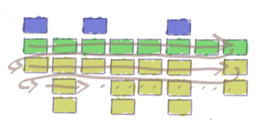

Figure 2: A user story map visualizes which user stories are absolutely critical to delivering the product, even if they are spread across multiple features. (source: Jeff Patton[4]).

## User Story Map

Figure 3 depicts how the requirements outlined in chapter 4 might be structured in a user story map. The blue boxes describe user activities, sometimes called epics or user journeys. The yellow boxes are the backbone of the system and consist of comparatively large user stories that are necessary for using the system. The white boxes are the smaller-scale user stories that collectively form the backbone. The walking skeleton is called *MVP (Minimum Viable Product)* in this map – these are all of the user stories that are strictly required for essential use of the system. Cagan claims that because the walking skeleton is intended as more of a tool for validation and testing rather than productive use, the term *minimum viable prototype* may be more adequate.[5]

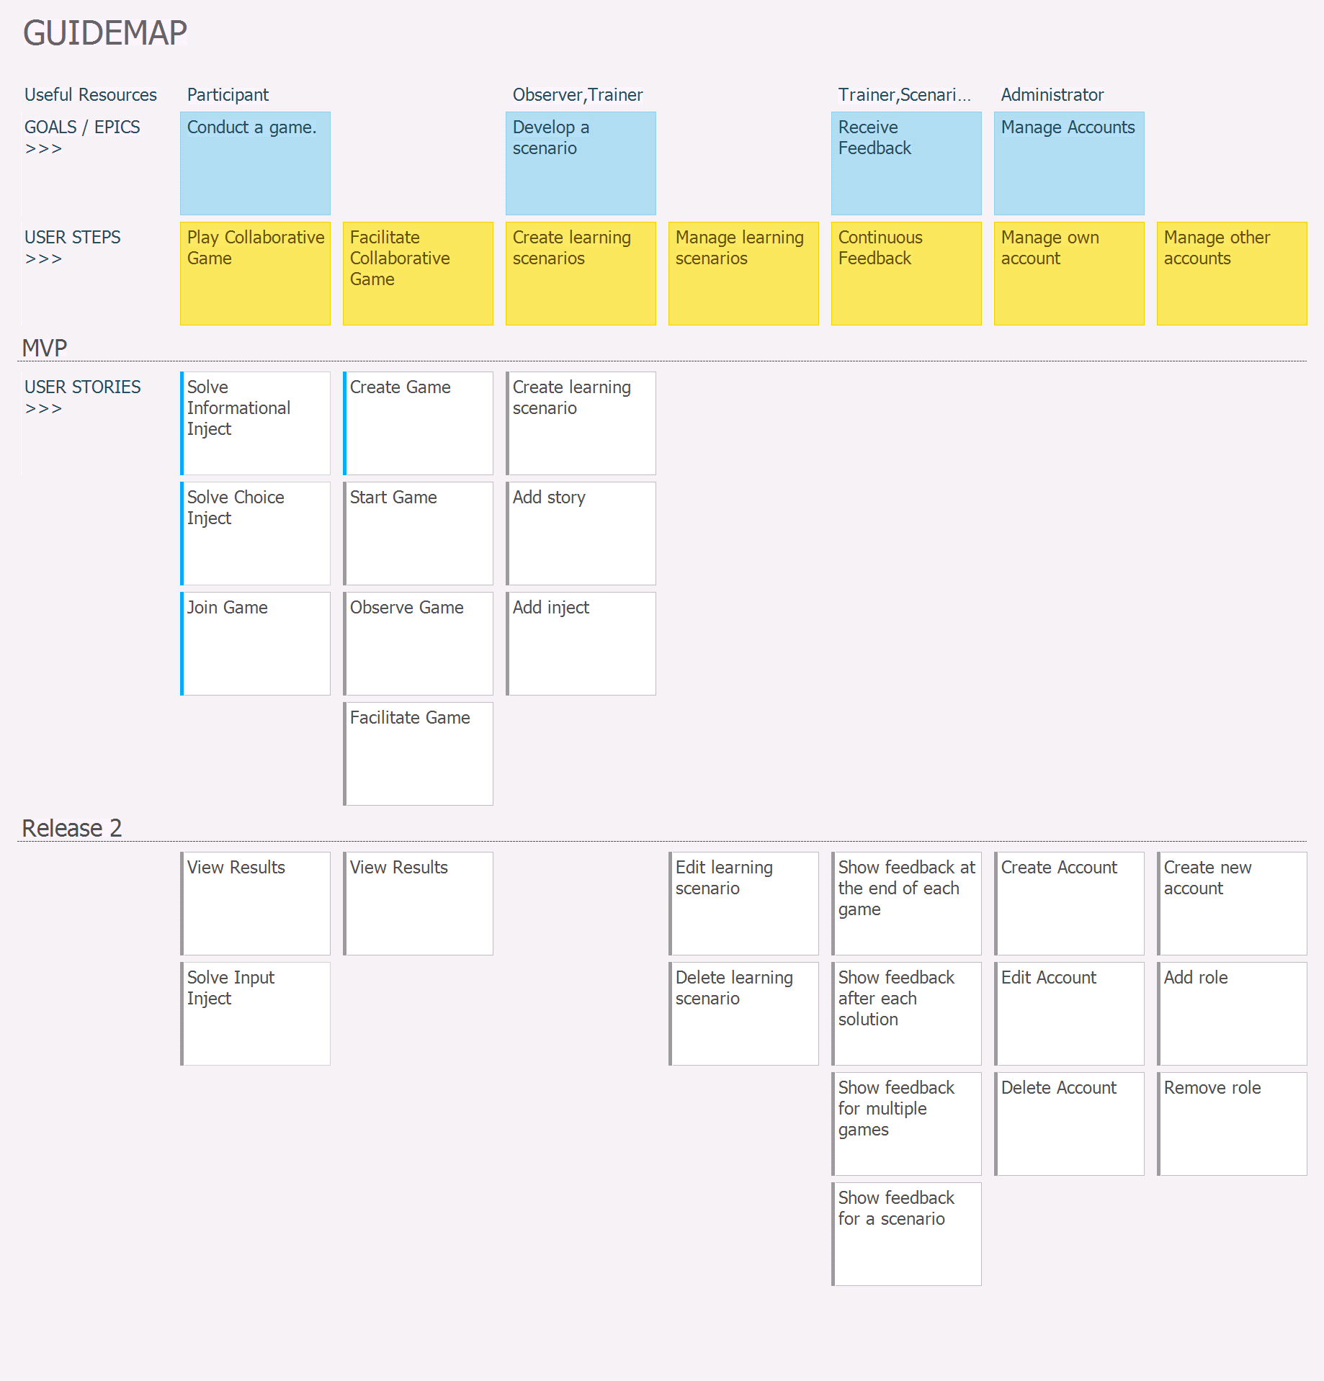

Figure 3: The user story map of the planned system (source: own work).

As is apparent from Figure 3, the user journeys “Play Collaborative Game”, “Facilitate Collaborative Game”, “Create Learning Scenarios”, “Manage Learning Scenarios” and “Continuous Feedback” must be completed to at least some extent for the release of the MVP.

The status of each of the user stories is provided by the colored line at the left. The blue line for “Solve Inject”, “Join Game” and “Create Game” indicate that these stories are currently in progress, whereas grey lines represent user stories that are still open.

## Detailed Descriptions of the User Stories

A user story map provides an excellent overview over the existing requirements and their priority with respect to the entire project. Nonetheless, more information is required to enable actual implementation and testing of these user stories. Therefore, the user stories shown in Figure 3 will be described in more detail in this chapter. The user stories follow the Connextra Template[6].

Figure 4 describes a user story from the perspective of a game participant. It has a descriptive title (“Solve Informational Inject”) and a short description of the requirement (“to solve an informational inject”). This particular story additionally comprises a definition of done (DoD), which is a checklist of hard requirements which the system must pass if this story is to be considered as “done”.

The user story also has a feature test written in the “GIVEN … WHEN … THEN …” template, which describes the feature test that will verify whether this user story functions properly.

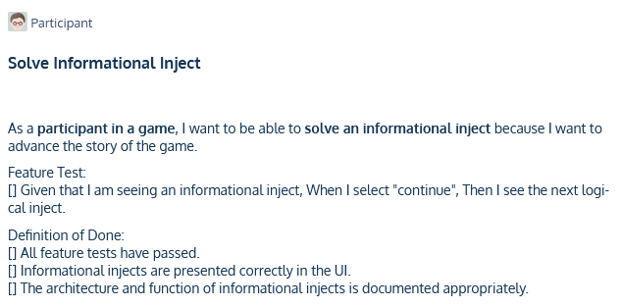

Figure 4: The user story "Solve Informational Inject".

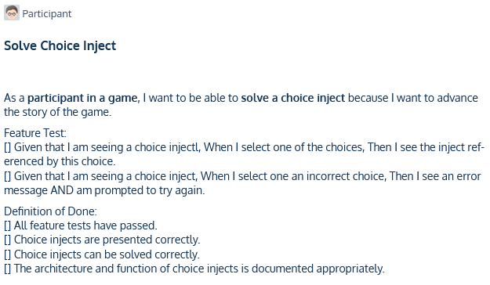

Figure 5: The user story "Solve Choice Inject"

In addition to the obligatory title, story description and DoD, the story “Join Game” (see Figure 6) also has the tag “Depends on other”, because it has a logical dependency on the story “Create Game”.

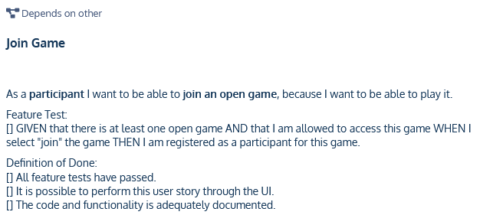

Figure 6: The user story "Join Game".

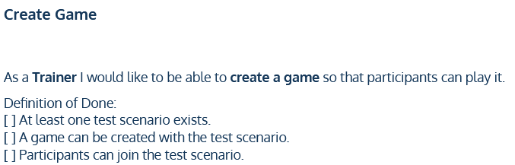

Figure 7: The user story "Create game".

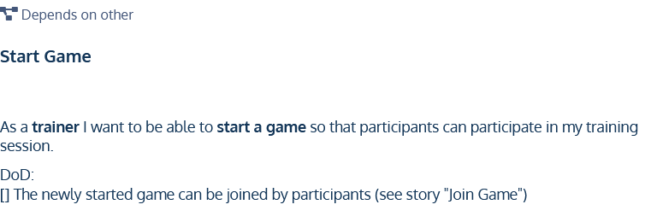

Figure 8: The user story "Start Game".

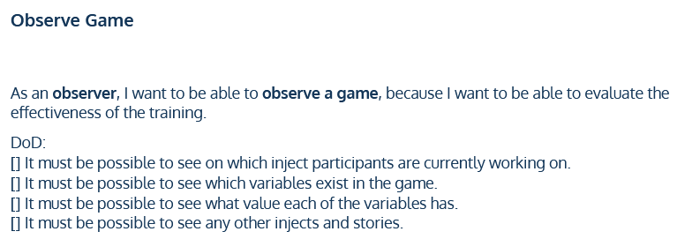

Figure 9: The user story "Observe Game".

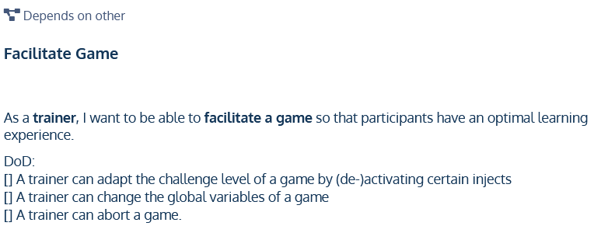

Figure 10: The user story "Facilitate Game".

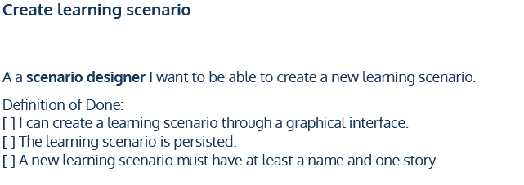

Figure 11: The user story "Create learning scenario".

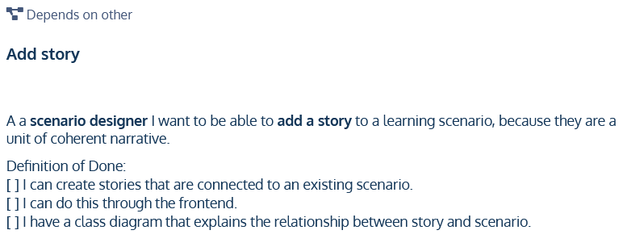

Figure 12: The user story "Add story".

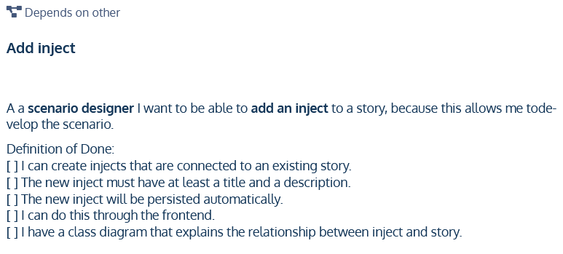

Figure 13: The user story "Add inject".

1. Beck, Kent (1999): Extreme Programming Explained: Embrace Change. Addison-Wesley.
2. Patton, Jeff (2005): It’s all in how you slice it.
3. Patton, Jeff (2008): The New User Story Backlog is a Map. Retrieved from <https://www.jpattonassociates.com/the-new-backlog/>. Last access on 2021-06-02.
4. Patton, Jeff (2008): The New User Story Backlog is a Map. Retrieved from <https://www.jpattonassociates.com/the-new-backlog/>. Last access on 2021-06-02.
5. Cagan, Marty (2017): Inspired. John Wiley & Sons, 2. Edition.
6. Agile Alliance (ed.) (2021): User Story Template. Retrieved from <https://www.agilealliance.org/glossary/user-story-template/>. Last access on 2021-06-04.