PROJECTS

SERVICES

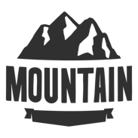Our most comprehensive and well-rounded package is the

It is exactly what it sounds like, fully customizable including all aspects of the previous packages. You may pick and choose from each package and add on whatever you would like. The full ride also comes with an integrated marketing campaign that stretches up to 5 years in the future. The full ride option is the last marketing consulting you will need for a long time to come.

Thank you for considering hiring North Mountain Consulting. We are a dedicated team of workers who are here to boost your companies’ abilities. We specialize in digital marketing and are versed in all other types which can be seen in the link above - Services. Our Projects section is not currently populated with previous clients as we are a start-up company. Being one of our first customers, however, means that we will be devoting all of our attention and energy towards you’re business. We are a hungry, creative thinking group that are dedicated to excelling your organization. We work with non-profits, local business and even personal branding needs.