# Group Assignment: Efficiency & Government Policies

List group members who attended at least 90% of the meeting:

1. Elias Maximo

2.

3.

4.

5.

6.

## **Instructions**

As a group, choose a group member to complete this document. This person will submit the document at the end of the meeting.

1. Consider the following market for widgets. The government has decided to place a tax on producers of widgets equal to $3 per widget. Please use the following instructions to evaluate the market for widgets **before** the tax and **after** the tax.
   1. On the graph on the left, please show and label the situation for the market for widgets without the tax. Be sure to label Q*, P*, consumer surplus, and producer surplus.
   2. On the graph on the right, please show and label the situation for the market for widgets with the tax. Be sure to label QT, PBuyers, PSellers, tax revenue, consumer surplus, and producer surplus.

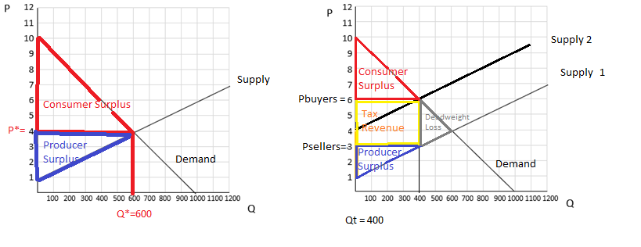

1. **Before the tax**, find the equilibrium price, quantity, consumer surplus, producer surplus, and total surplus.
   1. **P\*** = 4
   2. **Q* = 600**
   3. **Consumer Surplus** = 1800
   4. **Producer Surplus** = 900
   5. **Total Surplus** = 2700
2. **After the tax,** find the price in the market, the quantity bought and sold, the final price that buyers pay, the final price that sellers receive, the tax revenue, consumer surplus, producer surplus, and total surplus.
   1. **Price in market** = $6
   2. **Q bought and sold (QT) = 400?**
   3. **Price Buyers pay** = $6
   4. **Price Sellers receive** = $3
   5. **Tax Revenue** = 1200
   6. **Consumer Surplus** = 800
   7. **Producer Surplus** = 400
   8. **Total Surplus** = 3000 (*Hint*: did you include tax revenue in total surplus?)
3. What is the tax incidence on buyers? What is the tax incidence on sellers? Why is the tax divided in this way?
   1. Tax incidence on buyers = 66.66% (*Hint*: percentage of the tax buyers pay)
   2. Tax incidence on sellers = 33.33% (*Hint*: percentage of the tax sellers pay)
   3. Why is the tax divided this way?  
      The tax is divided this way, because when we look at the total tax revenue and compare it with the original graph, we see that originally, two thirds of the tax revenue were occupied by consumer surplus and one third of that area was occupied by producer surplus. That got changed when the government decided to apply taxes to this market. (could use rephrasing)
4. Read the article: [“The ‘Yes’ Vote That Says No to Low-Wage Workers.”](https://www.wsj.com/articles/the-yes-vote-that-says-no-to-low-wage-workers-1478215923)    
   1. This article discusses federal and state minimum wage increases. In economics, the minimum wage is an example of what? (2 words)
   2. In this article, it says that several states will vote on raising their minimum wage to what amount?
   3. In 2014, a bill tried to raise the federal minimum wage to what amount? Did it pass?
   4. What did the Congressional Budget Office estimate would happen as a result of the 2014 bill?
   5. The article mentions that Seattle had raised its minimum wage and a study was done by the University of Washington. What did the University of Washington find in their research with regards to employment and hours?
   6. Who will be the real losers from these costly campaigns?   
        
      Why?
   7. The article quotes an editorial that said “the very same people that [a $12 minimum wage] aims to help would be hurt by it.” Why would that be true?