close all

clc

disp('Elias Assaf 315284729 - Jameel Nassar 206985152')

Elias Assaf 315284729 - Jameel Nassar 206985152

## Section 1

# Section 1.1

cameraman = imread("cameraman.tif");

cameraman = double(cameraman)/256;

# Section 1.2

To filter the image, we first build 2 filters, one for the x axis and one for the y axis, we apply both filters on the image using conv2() with the 'same' argument, so we don't have to deal with the edges.

to get the magnitude we first take the filtered images to the power of 2, sum them and we take the square root of the sum, i.e:



where x is the filtered image using G_px filter, y is the filtered image using G_py filter, and the power operator applied to each element of the matrix separately, i.e matlab .^ operator.

figure;sgtitle("Cameraman filtered with prewitt edge detector with different thresh hold");

cameraman_prewitt_mag_1 = dip_prewitt_edge(cameraman, 0.1);

cameraman_prewitt_mag_2 = dip_prewitt_edge(cameraman, 0.2);

subplot(1,2,1);imshow(cameraman_prewitt_mag_1);title("thresh hold = 0.1");

subplot(1,2,2);imshow(cameraman_prewitt_mag_2);title("thresh hold = 0.2");

as we can see in the images, using the lower thresh hold doesn't remove all the edges, if for example we look under the camera we can still see some points where we have while pixel's i.e an edge, but as we increase the thresh hold we filter out those points more aggressively and we remove most of them and in doing so we make the man edges less pronounced, and in some places such right leg we lose some of the edges because they didn't pass the thresh hold.

to get the best filtration we need to look for a better thresh hold, where we remove most of the unnecessary edges but not high enough that we start losing the sharpness of the true edges.

# Section 1.3

The optional parameters of the canny edge detector (edge(I,'canny')) is the two thresh holds used to separate between weak and strong edges, where every pixel with value lower than the min thresh hold doesn't count as an edge, the pixel with values between the thresh hold is considered a weak edge, and the pixels with values greater than the max of the thresh holds are considered strong edges.

these thresh holds have no default value, when we call the function without the parameters edge function chooses them heuristically depending on the input data.

we have another optional argument sigma, where we specify the sigma of the gaussian filter used in the algorithm, its default value is  .

note that we have 2 extra options, direction and filter, but they are not used in the canny edge detector.

we can also output along with the edges the thresh holds the function used, we can see that matlab picked [0.0313, 0.0781]

figure;sgtitle("Canny edge detector")

[cameraman_canny_default, cameraman_canny_default_threshhold] = edge(cameraman, 'Canny');

canny_thresh = [0.3 0.42];

cameraman_canny_custom = edge(cameraman, 'Canny', canny_thresh);

subplot(1,2,1);imshow(cameraman_canny_default);title(["default thresh hold = " num2str(cameraman_canny_default_threshhold)]);

subplot(1,2,2);imshow(cameraman_canny_custom);title(["custom thresh hold = " num2str(canny_thresh)]);

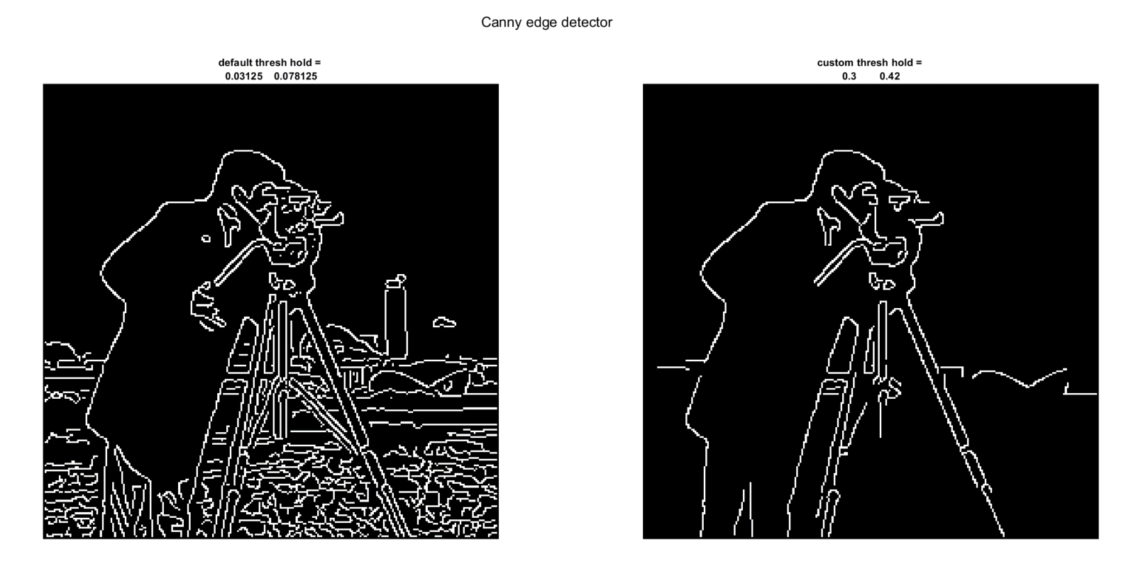

we can see that by increasing the thresh holds we can almost get a clear edge of the cameraman, the default values are not always good, they give a good base on where to start but as we have eyes and can think for ourselves we can try different edges to get better results, note that in automated tasks without any prior data on the images looking for an optimal thresh hold parameters manually is not very efficient, in that case we trust the ALGORITHM to give us good enough results.

# Section 2

# Section 2.1

floor = imread("floor.jpg");

floor = double(rgb2gray(floor))/256;

%default filter is sobel which we learned early in the course

The edge function uses the sobel method which we learned early in the course, in it we take the derivative of the images to find the images i.e where we have fast changes of magnitude of pixels we have an edge.

we have the following optional arguments:

method: which filter to use, default value is sobel.

thresh hold: any pixel lower than this number is removed from the output image, note that some detectors such as the canny detector use 2 thresh holds., we have no default values for thresh hold, the edge picks them at run time.

direction: specifies which direction to detect the images from, i.e horizontal or vertical direction, or both, its not used in all the detectors, but for example in sobel we take a different filter for the horizontal direction or the vertical (we saw in class one where we have 0 in the middle horizontal part vs 0 in the middle vertical part of the filter matrix), the default values is both as in both directions.

filter: only used by zero cross method - not in our scope.

sigma: used by canny and log detectors, specifies the sigma of the gaussian filters used in these filters.

BW_floor = edge(floor);

[hough_mat_1_1,R_vec1,theta_vec1] = dip_hough_lines(BW_floor,1,1);

[hough_mat_5_4,R_vec2,theta_vec2] = dip_hough_lines(BW_floor,5,4);

figure;sgtitle('Hough transform of floor');

subplot(1,2,1);

imshow(hough_mat_1_1, [], 'XData', theta_vec2, 'YData', R_vec2);title("R_0 = 1, \theta_0 = 1");xlabel('\theta'), ylabel('\rho');

axis on, axis normal, hold on;colormap(gca,hot);

subplot(1,2,2);

imshow(hough_mat_5_4, [], 'XData', theta_vec2, 'YData', R_vec2);title("R_0 = 5, \theta_0 = 4");xlabel('\theta'), ylabel('\rho');

axis on, axis normal, hold on;colormap(gca,hot);

each element in these graphs represents a vote on a possible line a with the parameters  of a normal representation of a line as we saw in class

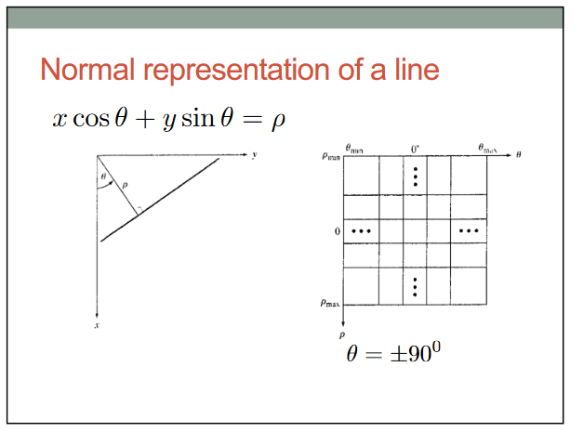

to find the lines, we first find m,n - the coordinates of the intersection between the normal and the actual line (we called them x_0 and y_0 in the code):

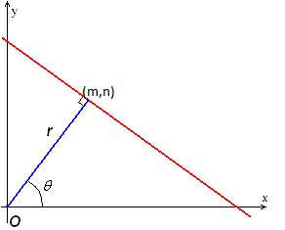

then we need to find thier value at the boundary of the image we do so by:



similarly for the y:



and we draw a line between these 2 points using matlab line function.

peaks_1_1 = houghpeaks(hough_mat_1_1, 4);

figure; imshow(floor); hold on;

dip_draw_lines(peaks_1_1, R_vec1, theta_vec1); hold off;

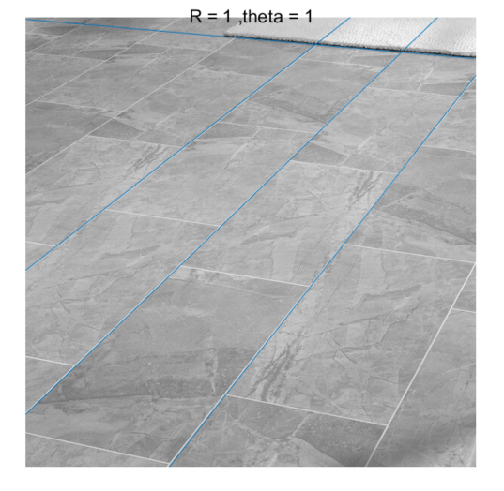

peaks_5_4 = houghpeaks(hough_mat_5_4, 4);

figure; imshow(floor); hold on;

dip_draw_lines(peaks_5_4, R_vec2, theta_vec2); hold off;

when using low R_0 we increase the density of the R vector, thus we calculate the votes for more values, and since r is the distance of the line from the (0,0) point of the image, the more values we have to pick from, the more accurately and precisely we can locate the line in the image.

if we have a higher value of R_0, we lose some accuracy because we rounded r to the closest available value we have in the R vector, for example if we look at the second photo we can see that the line is not perfectly aligned with the actual line on the floor, that is because we don’t have the right value of r that intersects with the line on the floor, i.e if we decrease the value of r, we calculate more options to choose from, then we can pick the one which represents the actual line best.

for theta, the lower the value the more accurately we can make the detected line parallel to the actual line, for example in the photos above:

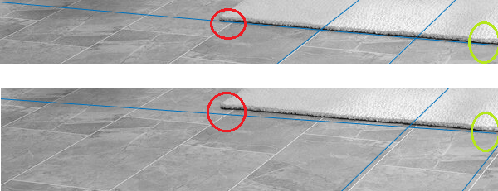

as we can see, the line starts at approximately the same location (inside the green circles), however as they propagate along the image the line the second photo starts moving away from the line of the carpet (the lines aren't aligned), because the theta presenting it is not accurate enough.

# Section 2.2

coffee = imread("coffee.jpg");

coffee = double(rgb2gray(coffee))/256;

figure;imshow(coffee);

BW_coffee = edge(coffee);

tic;[hough_mat_circ_1_1, R_circ_vec1, theta_circ_vec1] = dip_hough_circles(BW_coffee, 1, 1);circ_1_1 = toc;

[hough_mat_circ_4_10, R_circ_vec2, theta_circ_vec2] = dip_hough_circles(BW_coffee, 4, 10);

hough_circ_peaks_1_1 = dip_houghpeaks3d(hough_mat_circ_1_1);

hough_circ_peaks_4_10 = dip_houghpeaks3d(hough_mat_circ_4_10);

figure;sgtitle('')

subplot(2,2,1);imshow(hough_mat_circ_1_1(:,:, 1), []);title('R = 80');

subplot(2,2,2);imshow(hough_mat_circ_1_1(:,:, 2), []);title('R = 81');

subplot(2,2,3);imshow(hough_mat_circ_1_1(:,:, 3), []);title('R = 82');

subplot(2,2,4);imshow(hough_mat_circ_1_1(:,:, 3), []);title('R = 83');

As we can see in the figure above, the Hough matrix of circles of different radiuses are almost identical, this is because the circular edges in the original image that were detected consist of multiple pixels (we can see this in the original image, the circular edge of each cup is thick) which means that we can reduce the radius vector density. we picked 4 as the radius step.

The same assumptions also apply to the theta value, we can reduce the rotation density because the probability of adding 1 to the correct pixel in the Hough matrix is very high because the circular edges consist of multiple pixels, we picked 5 as the degree step.

tic;[hough_mat_circ_4_5, R_circ_vec3, theta_circ_vec3] = dip_hough_circles(BW_coffee, 4, 5);circ_4_5 = toc;

(fprintf("The speed up is %.4f\n",circ_1_1/circ_4_5));

The speed up is 15.1647

hough_circ_peaks_1_1_20 = dip_houghpeaks3d_custom(hough_mat_circ_1_1,20);

hough_circ_peaks_4_5_20 = dip_houghpeaks3d_custom(hough_mat_circ_4_5,20);

figure;

subplot(1,2,1);

imshow(coffee);hold on;title("R_0 = 1 , \theta_0 = 1")

viscircles(hough_circ_peaks_1_1_20 (:, 1:2), R_circ_vec1(hough_circ_peaks_1_1_20 (:, 3)),'EdgeColor','b');

subplot(1,2,2);

imshow(coffee);hold on;title("R_0 = 4 , \theta_0 = 5")

viscircles(hough_circ_peaks_4_5_20 (:, 1:2), R_circ_vec1(hough_circ_peaks_4_5_20 (:, 3)),'EdgeColor','b');

We can see in the figure above (20 most significant circles) that we detected the same shapes, and we got a significant speedup.

However, we should notice that the R and theta values control the most significant detected circles since the added ones in the Hough matrix depends on their values, but this doesn’t affect the overall detected circles.

figure;subplot(1,2,1);

imshow(coffee);hold on;title("R_0 = 1 , \theta_0 = 1")

viscircles(hough_circ_peaks_1_1(:, 1:2), R_circ_vec1(hough_circ_peaks_1_1(:, 3)),'EdgeColor','b');

subplot(1,2,2);imshow(coffee);hold on;title("R_0 = 4 , \theta_0 = 10")

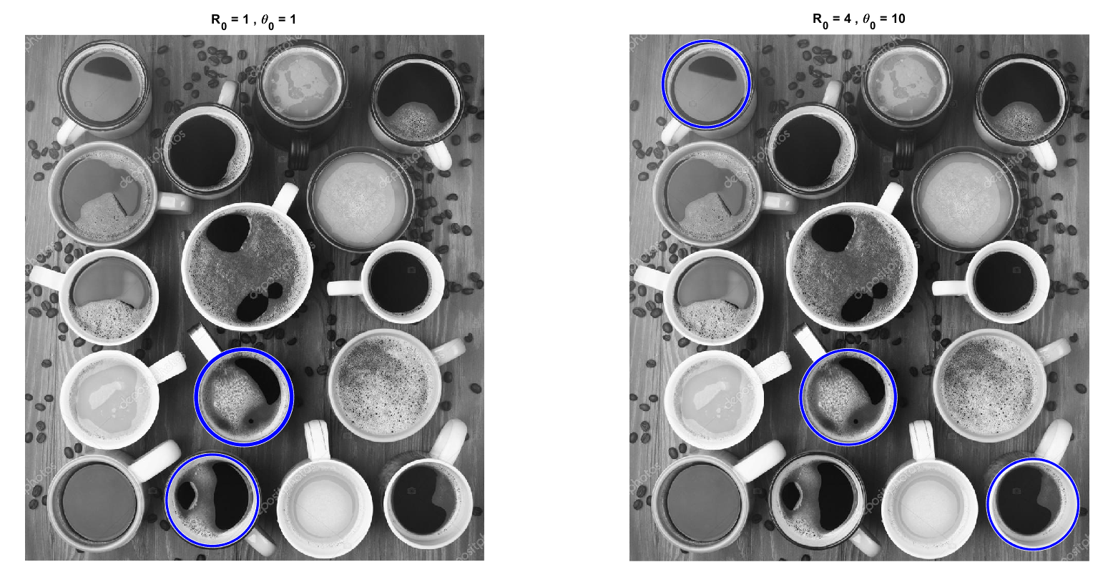viscircles(hough_circ_peaks_4_10(:, 1:2), R_circ_vec2(hough_circ_peaks_4_10(:, 3)),'EdgeColor','b');

The advantage of picking large values of R and theta is the speed up time, and that’s because the higher those values get the less dense the R and theta vectors get, which means that we reduced the number of for loops, and we can see by the function below that the time complexity is , so even a small reduction in the vector length gives a significant speedup, for example when we changed R from 1 to 4, and theta from 1 to 5 we got about x15-20 speedup which is almost their multiplied values.

The disadvantage of picking large values or R and theta is the accuracy and precision of the detected circles, the R density controls the radius of the detected circle, if we pick a large R value, the detected circles will be around the actual circles in the original image however they will be bigger/smaller than the actual circle.

Theta determines the density of the [0,360] degree victor, if we increase its value, we might not add one to the correct position in the Hough matrix which means that we increased the values around the center of the circle that we might detect, and that will make the detected circle off center, for example the top left circle in the figure above.

# Functions

function [magnitude] = dip_prewitt_edge(img, thresh)

filt_x = 1/6 * repmat([-1 0 1], 3, 1);

filt_y = rot90(filt_x);

Gx = conv2(img, filt_x, 'same');

Gy = conv2(img, filt_y, 'same');

magnitude = sqrt(Gx.^2 + Gy.^2);

magnitude = (magnitude >= thresh);

end

function [hough_mat, R_vec, theta_vec] = dip_hough_lines(BW, R_0, theta_0)

[M,N] = size(BW);

R_value = round(sqrt(M^2 + N^2));

R_vec = -R_value:R_0:R_value;

theta_vec = -90:theta_0:89;

hough_mat = zeros(length(R_vec),length(theta_vec));

[x_vec, y_vec] = find(BW == 1);

x_vec = x_vec.';

y_vec = y_vec.';

for i = 1:length(theta_vec)

theta = theta_vec(i) * (pi / 180);

r = cos(theta) .* y_vec + sin(theta) .* x_vec;

r = interp1(R_vec, R_vec, r, 'nearest');

r = round((r+R_value + 1)/R_0);

for j = r

hough_mat(j, i) = hough_mat(j, i) + 1;

end

end

end

function [hough_mat, R_vec, theta_vec] = dip_hough_circles(BW, R_0, theta_0)

[M,N] = size(BW);

R_vec = 80:R_0:100;

theta_vec = 0:theta_0:360-theta_0;

hough_mat = zeros(M, N, length(R_vec));

[x_vec, y_vec] = find(BW == 1);

x_vec = x_vec.';

y_vec = y_vec.';

for k = 1:length(R_vec)

r = R_vec(k);

for i = 1:length(theta_vec)

theta = theta_vec(i) * (pi / 180);

a = abs(round(x_vec - r*cos(theta)));

b = abs(round(y_vec - r*sin(theta)));

a_w = a(a>0 & b>0 & a<=M & b<=N);

b_w = b(a>0 & b>0 & a<=M & b<=N);

for j=1:length(a_w)

hough_mat(a_w(j), b_w(j), k) = hough_mat(a_w(j), b_w(j), k) + 1;

end

end

end

end

function [peaks] = dip_houghpeaks3d(H)

peaks = dip_houghpeaks3d_custom(H, 5);

end

function [peaks] = dip_houghpeaks3d_custom(H, numOfPeaks)

peaks = zeros(numOfPeaks, 3);

for i = 1:numOfPeaks

[~, idx] = max(H(:));

[idx1, idx2, idx3] = ind2sub(size(H), idx);

peaks(i, :) = [idx2, idx1, idx3];

H(idx1, idx2, idx3) = 0;

end

end

function dip_draw_lines(peaks, R_vec, theta_vec)

for i = 1:length(peaks)

rho = R_vec(peaks(i, 1));

theta = theta_vec(peaks(i, 2)) * pi/180;

x_0 = cos(theta)*rho;

y_0 = sin(theta)*rho;

x_1 = x_0 - 600*sin(theta);

y_1 = y_0 + 600*cos(theta);

x_2 = x_0 + 600*sin(theta);

y_2 = y_0 - 600*cos(theta);

line([x_1 x_2], [y_1 y_2]);

end

end