Report Week 39/40

# Team

Elias

Tor

# Project idea

Creating a zombie FPS game.

# Previous week status

Simple player sketch, brainstorm of what we need to do to create a map/ implement FPS, movement, materials, ai.

# Current status

Created entity sketches / thought of possibilities. Though of map type. We created the project in unity, made a simple FPS controller, movement and camera controller. Created a simple scene, implemented a simple Enemy AI with pathfinding skills. We can now bake the NavMesh for the scene

## Outcome

* Finished FPS controller, simple map, simple enemy ai with pathfinding skills. NavMesh baking.

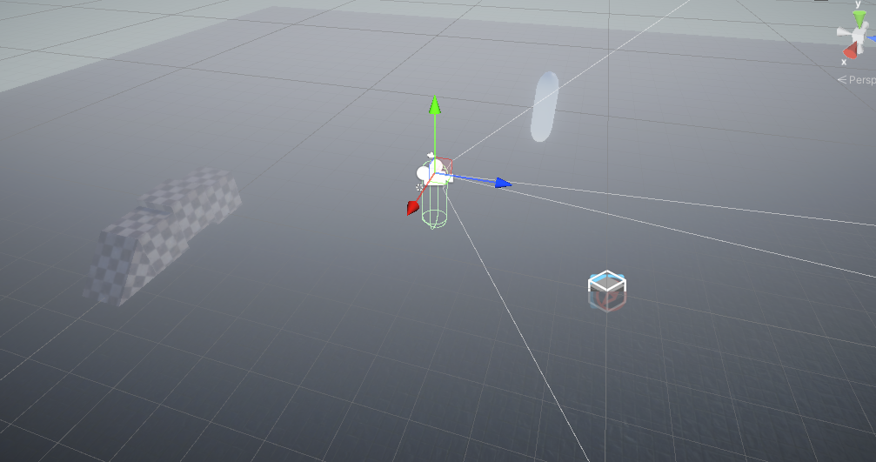

## Problems encountered

No problems so far.

# Next steps

Shooting, damage handler for Entities. Health and ammo consumption, with spawn/respawn possibilities.