Live Music Application
By Elias Kesh
Jan 15, 2012
Sep 11, 2019
Ver 1.3.4

Reason:
The fundamental reason for this application is convenience, speed and cost. Having a large pedal board full of effects is heavy and large. When there is a problem with a cable or battery it takes time to find it. When you want to change the sound it usually means purchasing and learning a new pedal and finding as well as finding place for it.

Basically the LiveMusicApp is a midi router and while is can be run standalone. The more convenient usage is to have it bundled with analog and sound font software on a boot-able USB stick. The allows virtually any PC (or Raspberry PI) with, or without, a USB audio interface to be rebooted with the USB stick and used in place of a heavy pedal board. In addition most music applications that run on linux are not really designed to be used when you have an instrument between you and the keyboard.

Before we get into the details here are a few screen shots of the current working model booted from a stick. The software currently uses an analog effects processor (guitarix), midi font player (fluidsynth). multiple channel looper (sooperlooper), drum machine (hydrogen), MP3 player (clementine) and guitar tab editor (TuxGuitar). However all of these are configurable so that they can be changed based on the preferences of the user.

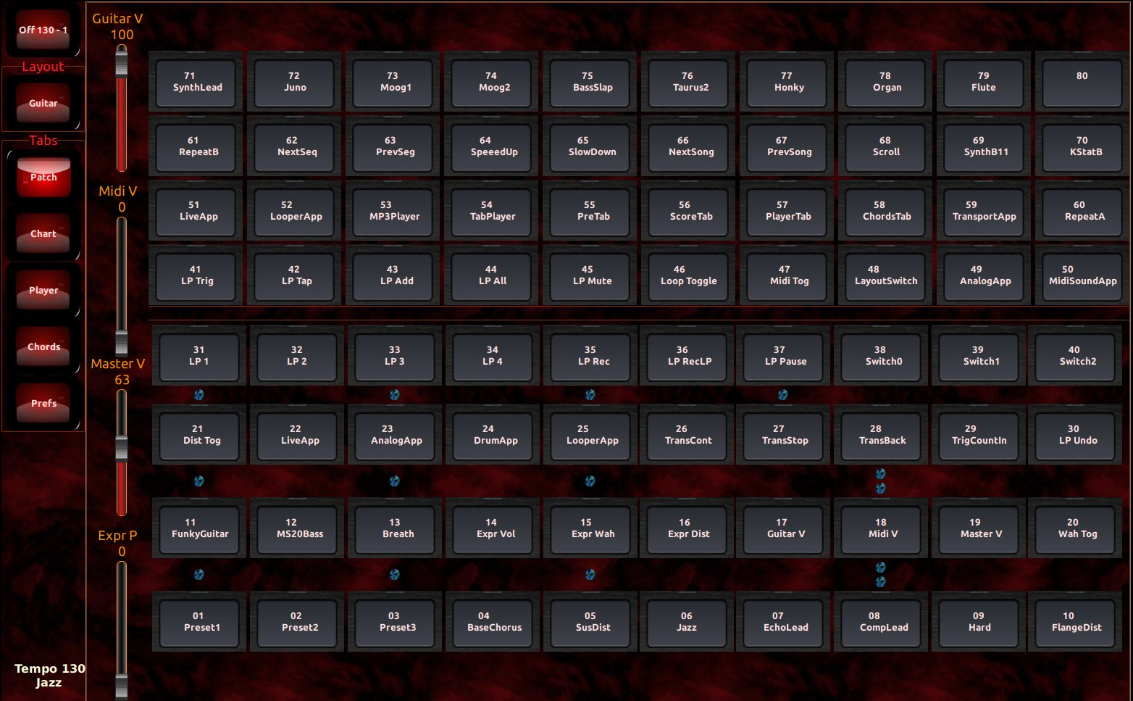

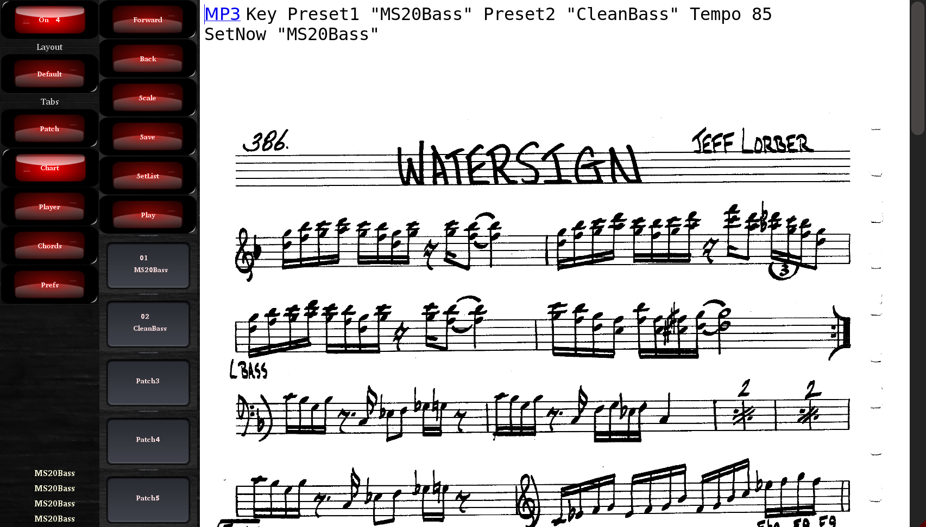  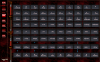 | 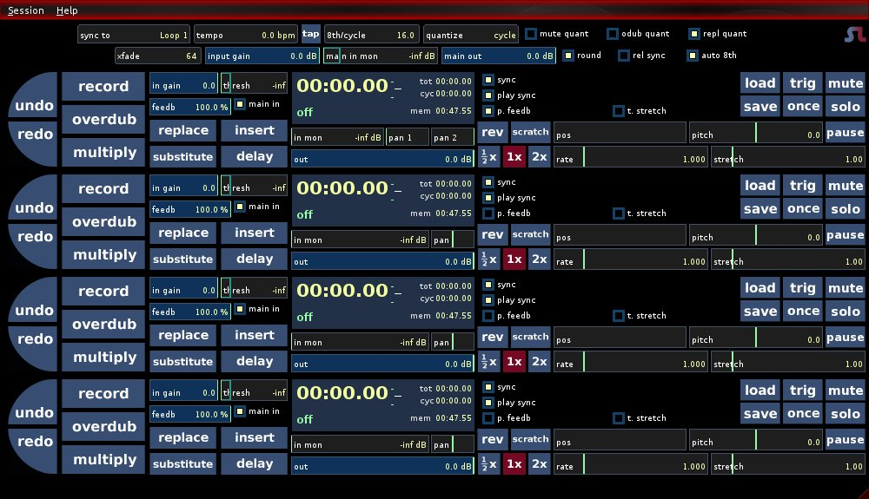
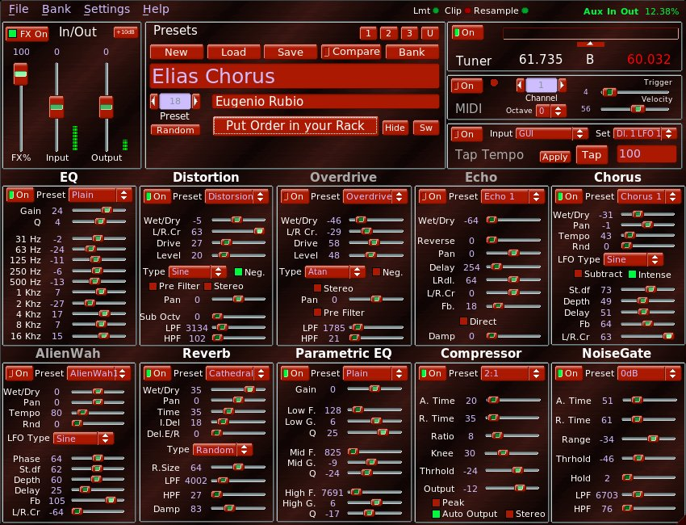 | 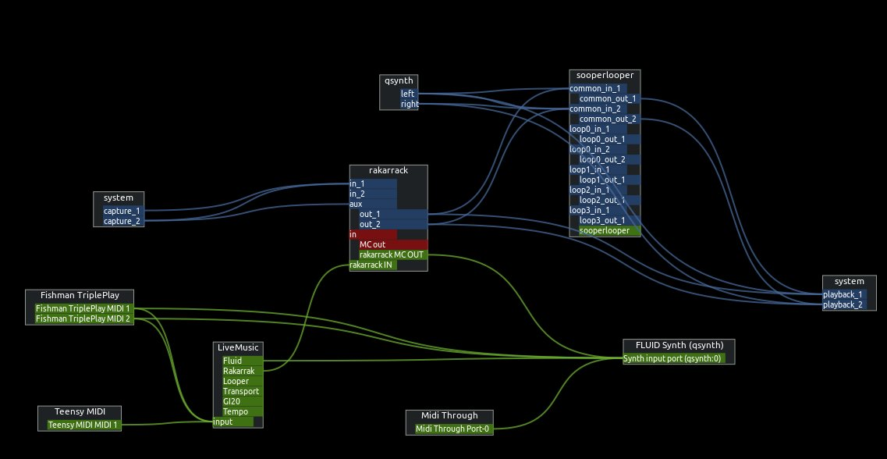
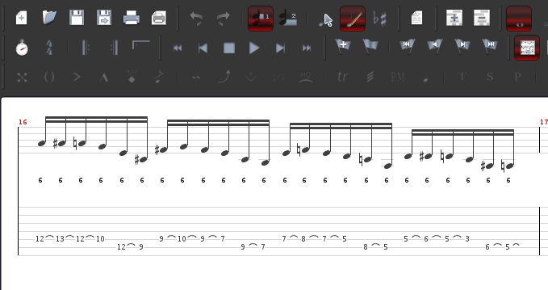 | 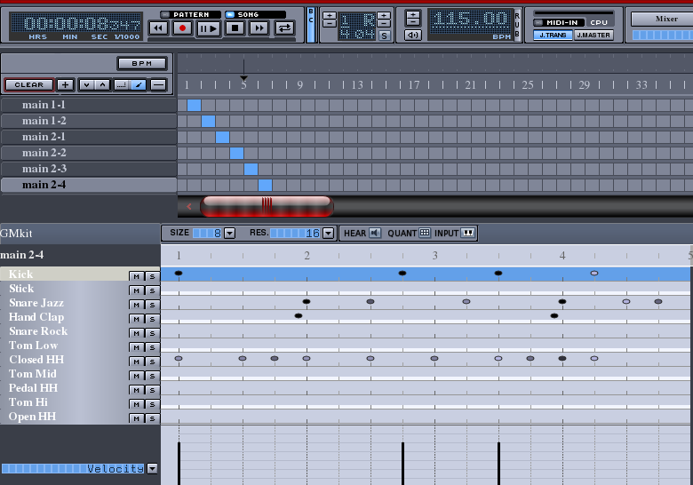

Basic Setup:
When the program is installed it stores it’s default files in “/usr/share/LiveMusicApp” or “/usr/local/share/LiveMusicApp”. On first run if the $HOME/.config/LiveMusicApp directory is not found the application will copy the files there. It will also create the LiveMusic.xml which stores all of the preferences. If it does not find a $HOME/MySongs folder it will create that as well and the path of the charts to that folder.

The application is written in GTK3 and follows the theme set for that by the system with a few exceptions. I like to have wide scroll bars since I often use this on a touchscreen laptop. The LiveMusicApp.css changes some of the appearance. In addition there are some image files in this directory that you can change as well, which is why I copy them to the $HOME/.config/LiveMusicApp directory.

In order to view PDF files in the charts tab you need to install the browser-plugin-evince. Here is a link to a deb.
http://ftp.us.debian.org/debian/pool/main/e/evince/browser-plugin-evince_3.22.1-3+deb9u1_amd64.deb

How it works:
The idea is that you create presets and manipulate them. Each preset can be send to a specific midi port. The presets can send midi controls, volume, tempo as well as perform certain actions to control the presets lists and perform varies actions on the computer as well.

Patch format:
- Patch Name – The text string that gets displayed.
- Bank Select – used mostly if you have multiple sound fonts to switch from.
- Patch number – the midi control number, like the numbers that come from a normal pedal board.
- Midi Port – The output port to send the commands.
- Channel – The midi channel.
- Custom Command – Used for computer control.
- Chain – Sometimes a single command is not enough, so you can chain commands to perform multiple actions in one shot.

Example: If you have a patch that requires an analog change (Chorus) and a midi sound, you can chain them together to that one buttons (foot pedal) can change both. Another example maybe you have 3 keyboards, you can create three patches which output to three different ports and chain them. So, selecting this patch will change all three keyboards at once.

Custom Commands:
- NoCustom – This is the standard for sending a midi control change message.
- ToNextDesktop – Switches the computer to the next desktop
- ToPrevDesktop - Switches the computer to the previous desktop
- ToDesktop - Switches the computer to the desktop number in the Patch field.
- Controller – N?A
- SwitchTab – Switch the tabs from Presets, Sheet Music, Chords and Preferences.
- RaiseApp – Raises the application listed in the Patch field
- TransStart – Sends a transport Start message
- TransCont – Sends a transport Continue message
- TransStop – Sends a transport Stop message
- TransPosition – Sends a transport Position message the location stored in Patch
- TransTempo – Sends a Tempo change message the tempo stored in Patch
- cmdPreset – This defines a button as being used by a command set in the HTML file.
  - Patch: The preset button number.
- cmdBankSelect – A command that will change the Layout Mode Presets.
- cmdMidiSelect – This is used to have a midi guitar change the patches to convert notes to control change messages.
- cmdCountIn – This is to control the count in for the looper recording.
- CmdVolume – Controls volume using switches instead of volume pedal.
  - Patch: Volume change amount, negative is down, positive is up
- cmdLnTransPort – Send Transport messages via Midi or OSC
  - Patch: SetA, SetB, Start, Loop, Next, Prev, Up, Down, SeekFw, SeekBk
- cmdSetList – Set list next and previous chart control
  - Patch: Direction next/prev
- cmdScroll – Scrolling control for sheet music
- cmdOSC – Send an Open Sound Control messsage, (Next Generation Midi)
  - Patch: Custom OSC command number
- cmdSendCC – Used to send Midi Control Change message to external devices based on command number and port.
  - Patch: New Controller number
- cmdSetExpr – Used to map an expression pedal to various devices, either internal or external via redirected Midi commands.
  - Patch: New Controller number
- cmdHardSlider – These are required to direct the 4 sliders on the main screen to output the correct output port and protocol.

The master list of presets is stored in an XML file and can be edited via the preferences tab.

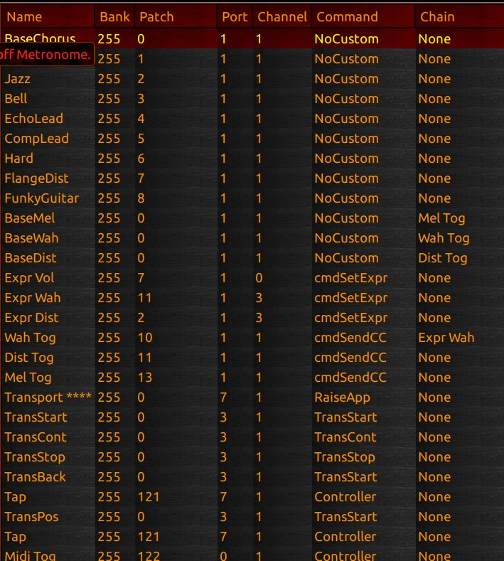
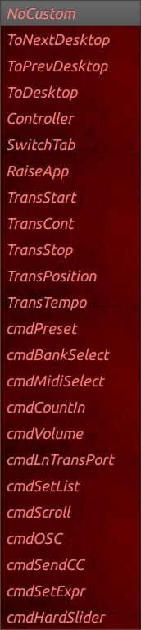

Clicking in the Command field brings up a list of options to choose from .
Score tab:
The score is used to display HTML and PDF music pages. You can organize set lists and well as keep different lists for different bands. The unique aspect is that you can have certain patches triggered by each piece of music. The example below shows that when this music is opened the patches and tempo are automatically loaded and now can be accessed via a foot switch or midi guitar notes. The Tempo can be set to link with a drum machine, a looper and even the phaser or chorus timing in the analog section. You can have as many SetNow commands as you want which will activate preset as soon as the page is loaded. The Preset1 and Preset2 will be assigned to the patches set as cmdPreset. I generally have foot switch buttons 1 and 2 set to these so for every song I will I can access the preset for each song . You can set the directory where the music files are stored in the Preferences tab. Music files can be in any order or hierarchy since they are accessed by way of HTML page links.

You can also edit the text on the pages so you can make notes or change the presets and then save the file . This is a nice feature during rehearsal and practice.

If the music file has a link to an MP3, the default player is disabled and the stretch/loop player will be run . If you are at rehearsal and for a part, you can click on the MP3 link and loop the section you want to listen to.

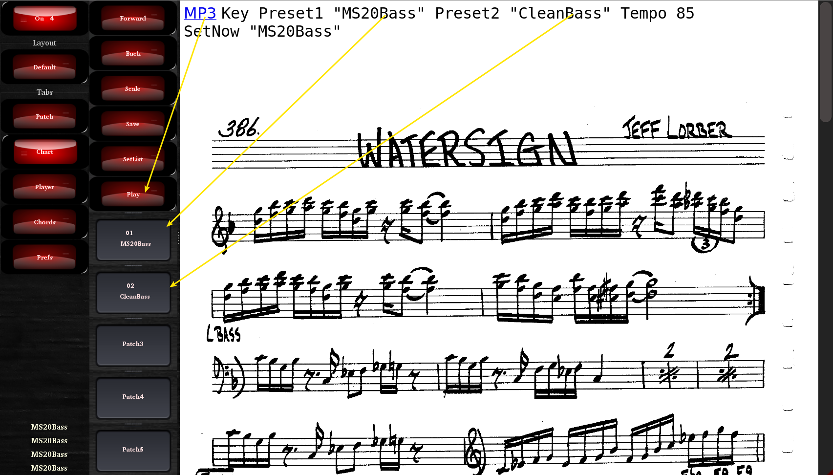

Chords Tab:

The chord tab is used to help determine available notes for scales and chords. The number of string and the tuning is configurable from the preferences tab. The buttons are used to set root note, set fret position to display, and the scale or chord. The colors represent the intervals so you can see can the root easily. Each dot has the interval number inside but the colors make it easier for quickly scanning.

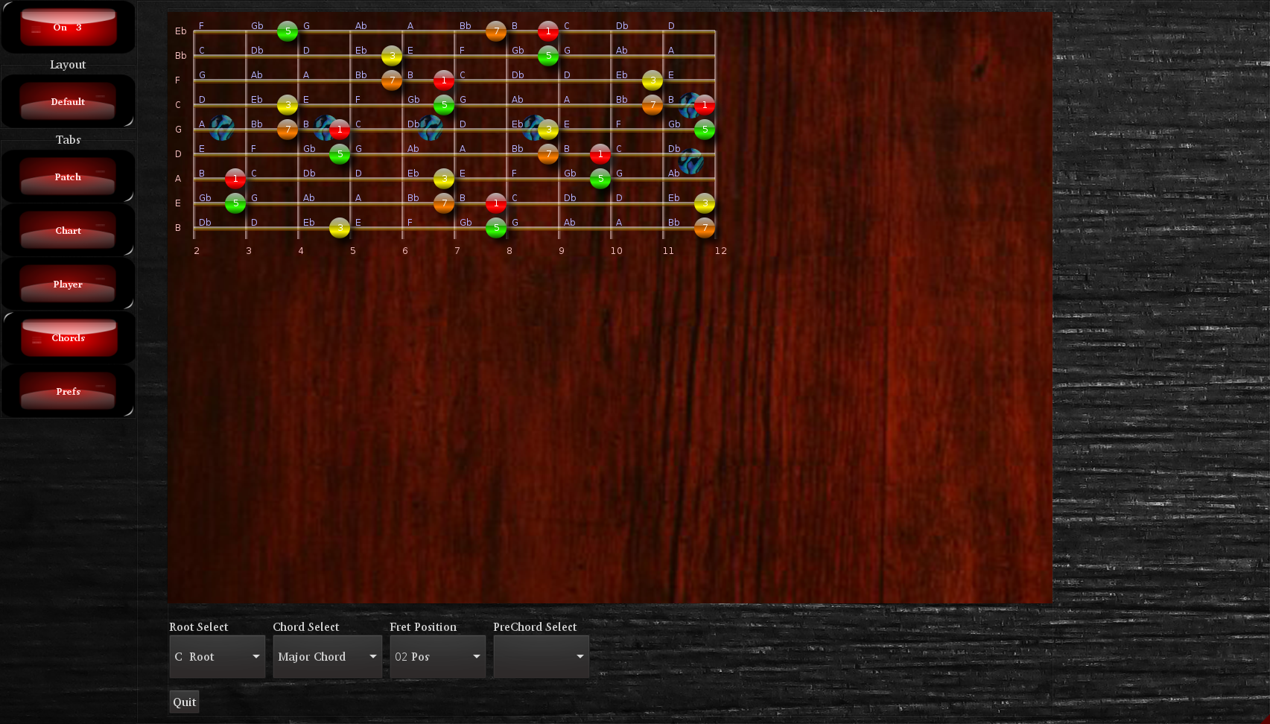
Music Player
Clicking on the MP3 link in any of the charts will load the music player with that file. The basic functions are play/pause, change tempo and looping, as well as being able to save loop marks.
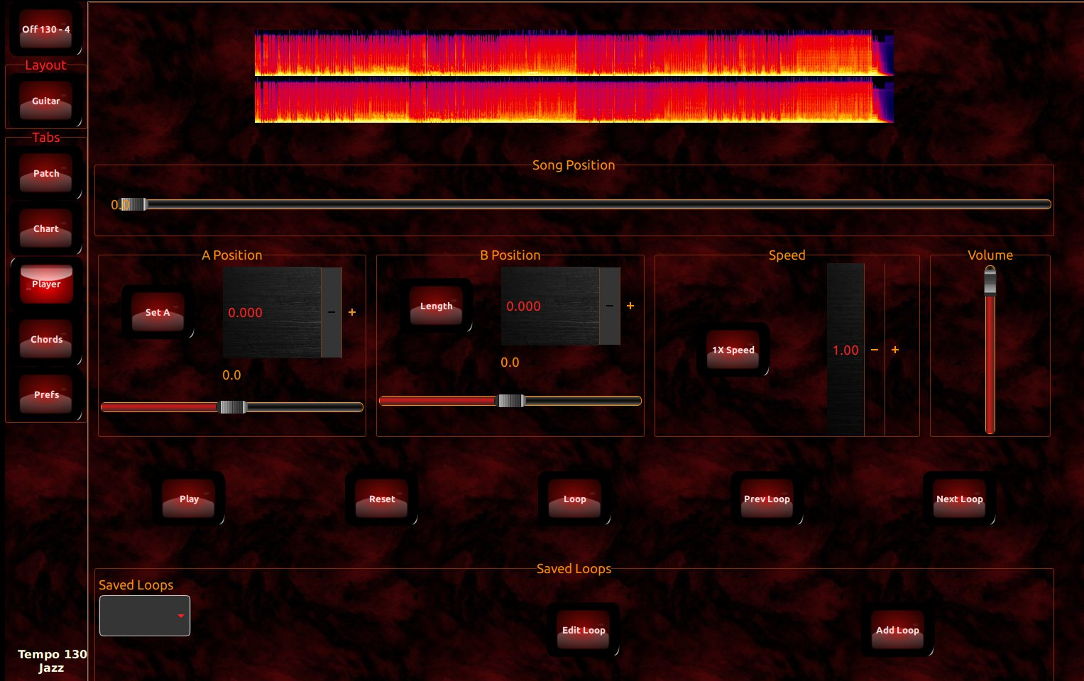
A few minor improvements however, are included in the looper. The start of the loop can be set with the Set A button, but instead of a Set B there is a length button. Both of these will be set when the button is click or but the Patch (foot pedal). However, having a length instead of a be give the ability to move the segments forward and backward. So as you practice when you are ready to learn the next part you can hit the Next Loop button and the Set A will increase by the length taking you to the next loop. This save fumbling around trying to set the next loop white holding your guitar/bass. In addition to the buttons you can increase or decrease the Start and Length via the controls so if you have a minor adjustment you do not have to go an reselect the region as most loop players have you do.
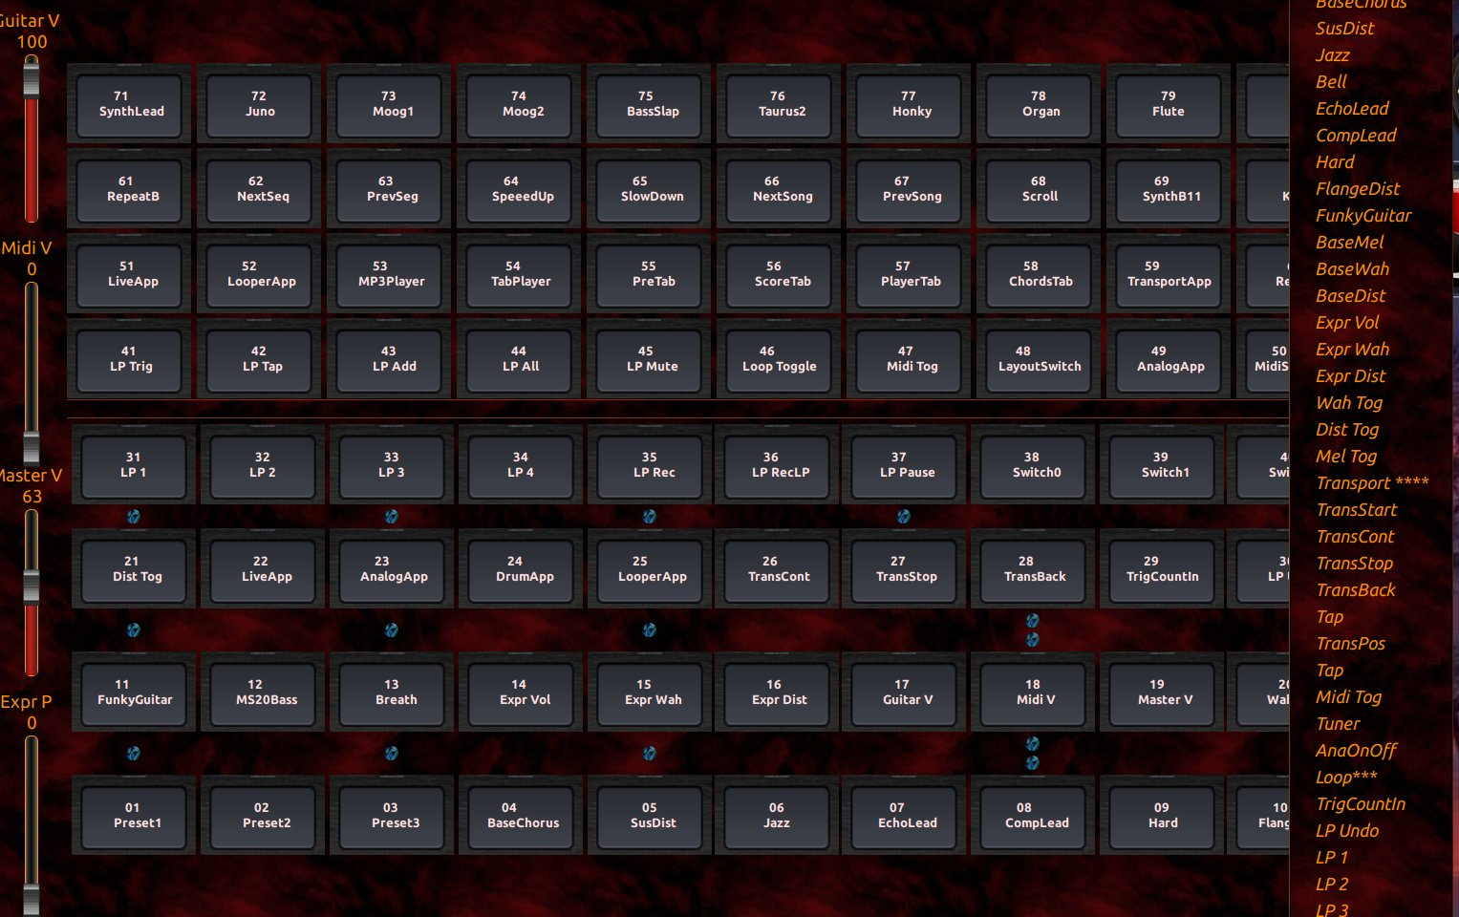
Patch Tab:

This is the main screen which shows the first 55 patches on the screen. Default is the mode where is shows the patches in the order that they are entered. This isn't always the best order for all uses so you can re-arrange the patch order several different ways depending on the conditions.

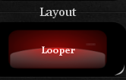

The currently defined modes are: Default, Rehearsal, Practice, Performance and Looper. You can switch modes using the Mode Switch button or the patch cmdBankSelect so that the modes can be changed via the foot switch. Since most pedals only have 10 switches being able to switch modes so that the most used patches are accessible via the foot switch is very convenient. When the mode changes the buttons update on the main screen so you always know what each foot switch button does since it is displayed on the screen.

To change the current patch just ctrl-click the buttons and a popup menu will appear with the list of patches.

