UR5e Collaborative Robotics Hands-on Exercise: Screwdriver Installation and Screwdriving Task V1.0
Objective: to gain practical, foundational skills in collaborative robotics using the Universal Robots UR5e. This includes safely installing an end-effector (a screwdriver), configuring the robot's understanding of the tool (Payload and TCP), programming movements, and executing an automated screwdriving task using built-in functions.
- Target Robot: Universal Robots UR5e
- End Effector: Generic Robot Screwdriver
- Software: Universal Robots PolyScope
Safety First!
- Workspace awareness: ensure the robot's working area is clear of obstructions and personnel before powering on motors or running programs.
- Emergency stop: locate the physical Emergency Stop buttons on the Teach Pendant and the Controller Box. Be ready to press them if needed.
- Reduced speed: when programming, testing, or making initial movements, ALWAYS operate the robot at a reduced speed (e.g., 10-25%) until you are confident the path is safe and correct.
- Pinch points: be mindful of potential pinch points between the robot arm links, the tool, and surrounding equipment.
- Power down for hardware changes: always ensure robot power (especially motor power) is OFF before physically mounting or unmounting tools or connecting/disconnecting cables at the tool flange.

Phase 1: Preparation and Hardware Setup

Install the Screwdriver
Carefully align the screwdriver's mounting plate with the UR5e's tool flange (the circular plate at the end of the wrist). Note the locating pin/socket for correct orientation.
Verification: Gently try to wiggle the screwdriver. It should feel absolutely solid with no play or movement relative to the robot's tool flange.

Power Up & Initial Check
Press the Power Button on the Teach Pendant to activate it. Wait for the system to boot up and display the main interface.
On the Teach Pendant, power ON the robot motors by tapping the red button in the left bottom part. Select ON -> START. Listen for any unusual noises and watch for any immediate errors on the screen. Address any errors before proceeding.

Phase 2: Robot Configuration (Installation Settings)
This phase tells the robot about the tool it's now holding. These settings are stored in the 'Installation' file, which is separate from your task program.

Create New Program and Installation File
Create Installation:
- Tap the Installation tab (represented by a cobot icon).
- Tap “New” > “Installation”.
- Tap “Save” > “Save Installation As”… and give it a descriptive name, e.g., Screwing_Installation. This creates a file to store settings specific to this hardware configuration (payload, TCP, safety settings).
Create Program:
- Tap the Program tab (represented by a diagram icon).
- Tap “New” > “Program”.
- Tap “Save” > “Save Program As…” and give it a descriptive name, e.g., Screwing_Program. This creates the file where you will build the sequence of robot movements and actions.
Link Program to Installation: your new program should automatically use the currently active Installation file. You can verify this in the top status bar or program settings. If it is not, tap “Open” > “Program” and select the program you just created.

Set the Payload
Why? The robot needs to know the weight (mass) and center of gravity (CoG) of the tool it's holding. Correct payload settings are crucial for:
- Accurate Motion: The robot's control algorithms compensate for the tool's weight and inertia. Incorrect payload leads to jerky movements or position errors.
- Safety: The robot's protective stop features rely on knowing the expected forces. An incorrect payload can make these features less sensitive or overly sensitive.
- Performance: Optimal performance and speed are achieved with correct payload data.

Use the Measurement Function
- Go to the Installation tab.
- Select “General” > “Payload”.
- If the screwdriver manufacturer provides the exact weight (mass in kg) and Center of Gravity (CoG) defined as X, Y, Z offset from the tool flange center in meters, you can enter it manually. If not, you can use the function provided on the UR’s teach pendant.
- Ensure the area around the robot, especially below the tool, is completely clear. If the robot is too close to some objects, you can move it from the Move tab (and change the position of the TCP with the arrows) or with the Lead Through Mode (by holding down the button above the Emergency Stop, you can manually drag the robot).
- Tap “Measure”. Follow the on-screen prompts carefully. You will be asked to provide several positions so the robot can correctly estimate the tool payload and CoG. Each time press “Set Position”, change the robot configuration and then “OK”.
- Once complete, the measured Payload and CoG will be displayed. Tap “Finish”.
Save Installation: Remember to save the Installation file after setting the payload (“Save” > “Save All”).
Verify that the values you obtained are similar to the following:
Mass: 1.100 Kg CX: -3.00 mm CY: -40.00 mm CZ: 26.00 mm
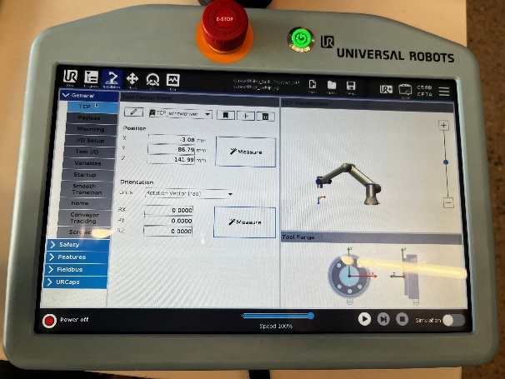

Set Tool Centre Point (TCP)
Why? The TCP is the 'working point' of your tool. For a screwdriver, this is the very tip of the screwdriver bit. All programmed movements (MoveL, MoveP) are relative to this point. Getting the TCP right is absolutely critical for precision tasks like screwdriving. An inaccurate TCP means the robot won't position the screwdriver tip exactly where you intend.

Use the Measurement Function
- Go to the Installation tab.
- Select “General” > “TCP”.
- Tap “Measure”. Follow the on-screen prompts carefully. You will be asked to move the TCP to the same position from different angles. Thus, find a stationary, sharply defined point in the robot's workspace. The tip of a screw secured in a vise, a marked crosshair on a stable surface, or a dedicated calibration fixture works well. Using a pointed calibration tool temporarily attached to the robot can also help align precisely to the reference point.
- Manually move the robot (with the Lead Through Mode) so that the very tip of the screwdriver bit touches the fixed reference point. Crucially, approach the reference point from different orientations (angles) for each taught point. Try to make these orientations significantly different (e.g., pointing straight down, angled 45 degrees in X, angled 45 degrees in Y, etc.). The more varied the angles, the better the calculation.
- For each orientation where the tip is exactly touching the reference point, tap Set Point on the Teach Pendant screen (e.g., Set Point 1, Set Point 2, etc.). You are asked to do it 4 times.
- Once you have taught the required number of points, the system will calculate the TCP's X, Y, Z offset relative to the tool flange center and its orientation. These values will appear on the screen.
- Give this TCP configuration a descriptive name, e.g., Screwing_TCP by clicking on the pencil icon just above the calculated points. You might have multiple TCPs defined later (e.g., one for the bit tip, one for the body of the screwdriver for clearance checks).
Verify that the values you obtained are similar to the following:
X: -84.78 mm Y: -0.27 mm Z: 140.67 mm

Verify TCP Accuracy
- Keep the robot tip near your fixed reference point.
- Go to the Move tab on the Teach Pendant.
- Select the TCP you just defined (Screwing_TCP) as the active TCP.
- Use the manual movement controls (arrows) in the TCP Orientation.
- Try rotating the tool around its X, Y, and Z axes (Rx, Ry, Rz buttons).
- Observation: If the TCP is accurate, the physical tip of the screwdriver should rotate in place with minimal movement away from your reference point. If the tip swings in large arcs as you rotate the tool, your TCP definition is inaccurate, and you should repeat step 4.1 more carefully.
Save Installation: Once satisfied with the TCP, save the Installation file again.
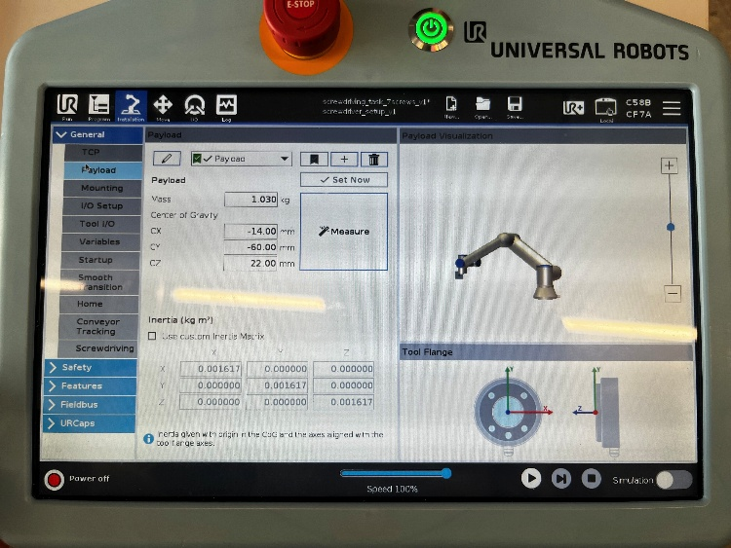

Define Safety Planes
Safety planes are virtual boundaries defined in the robot's working area to prevent motion into restricted zones. They are used to enhance operator and robot safety and avoid collisions with surrounding structures or people. Key features:
- The plane acts as a limit; the robot can be restricted from crossing it, either partially (in certain directions) or fully.
- Can be configured in the Safety settings via Polyscope.
- A point and a normal vector define each plane.
- The restriction can be set per side of the plane (e.g., allow motion only on one side).
The goal is to ensure that the Safety Plane you created is correctly configured and prevents the robot from crossing it in restricted workspace’s areas.

Define the Safety Plane
- On the robot’s teach pendant, navigate to “Installation” > “Features”. Select “Plane” as the feature type and rename it to something meaningful, such as “Plane_Table” or “Safety_Plane”.
- Tap on “Teach this plane”. The system will prompt you to define three points that represent the plane. Move the robot manually (at low speed!) to each of these points:
  - Point 1: Choose an initial point (the origin of the plane) a few mm above the working table. Use the function “Align” to position the TCP aligned with the robot base’s Z axis and perpendicular to Table.
  - Point 2: Select a second point (its position will define the plane’s X axis), maintaining the same height as Point 1.
  - Point 3: Define a third point (its position will define the plane’s Y axis), defining the Plane with Points 1 and 2.
- After setting each point, tap “Next”. A preview of the plane will appear. Verify that the plane aligns correctly with your intended safety boundary. If misaligned, redo the previous steps to adjust the points. Verify the plane is ‘looking down’.

Configure the Safety Plane Restriction
Now we need to tell the robot that it cannot cross the safety plane we created.
- On the Teach Pendant, navigate to: “Installation -> Safety -> Planes”. Enter the password to access safety settings (default: “easybot”).
- From the list of planes, select the Safety Plane you previously created (e.g., “Plane_Table”).
- Restrict movement through the plane selecting “Both”.
- Click on Apply and then, Apply and Restart.

Define the TCP in the safety configuration
- On the robot’s teach pendant, navigate to “Installation > Safety > Tool Position”. Enter the password to access safety settings (default: “easybot”).
- Click on Add Tool and name it the TCP you created in the previous steps, selecting it also from the drop-down menu “ Copy TCP”.
- Click on Apply and then, Apply and Restart.

Test the safety configuration
Save and apply these safety settings to activate the restriction.
- Test this carefully! At very low speed (10%), try to create a basic program on the Teach Pendant to move the robot from a point above the plane to a point below it.
- On the Teach Pendant, go to: “Program” > “New Program”.
- Insert a “Move” > “MoveL” command to move between waypoints.
- Manually move the robot (using Lead-Through mode or jog controls) to a safe position above the defined Safety Plane. Record this position as “Waypoint 1” by tapping “Set Waypoint”. Name it descriptively (e.g., “Above_Plane”).
- Manually move the robot to a position slightly below where you defined the Safety Plane. Name it descriptively (e.g., “Below_Plane”).
Save your program with a descriptive name (e.g., “SafetyPlane_Test”) and run it. The robot should execute movement toward Waypoint 1 without issues but when attempting to move toward Waypoint 2 (below the plane), motion should stop as soon as it reaches the defined Safety Plane boundary. If it is not, redo task 5.1, 7.1 and 7.2 before proceeding next.
Optional: create and test a safety plane to switch from normal to reduced modes.

Preparing for the Task
Now we'll tell the robot the sequence of actions to perform the screwdriving task.

Define a Workpiece Feature (Coordinate System)
Why? Defining a Feature on your workpiece makes your program adaptable and efficient. Instead of teaching absolute positions in the robot’s base coordinate system, you can teach positions relative to the workpiece. This approach ensures that if the workpiece or fixture is moved slightly, you only need to re-teach the Feature, and all programmed positions will automatically adjust. When working with two identical parts, you can define a single set of movements and simply switch between Features to apply the same program to both parts. Thus, we will now define two Features which defines the planes of the two identical pieces (Part1 and Part5).
- On the robot’s teach pendant, go to “Installation” > “Features”. Create a new “Plane” feature and give it a meaningful name (e.g., “Plane_Part1”).
- Select “Teach this plane” and manually move the robot (at low speed) to define three points on the workpiece as you did previously for the safety plane.
- Once satisfied with the alignment, tap “Finish” to save it.
- Define another Feature for the second part (e.g., “Plane_Part5”) following the same steps as above. Make sure the orientation of the planes created are the same otherwise it will not be possible to apply the same program to both parts.
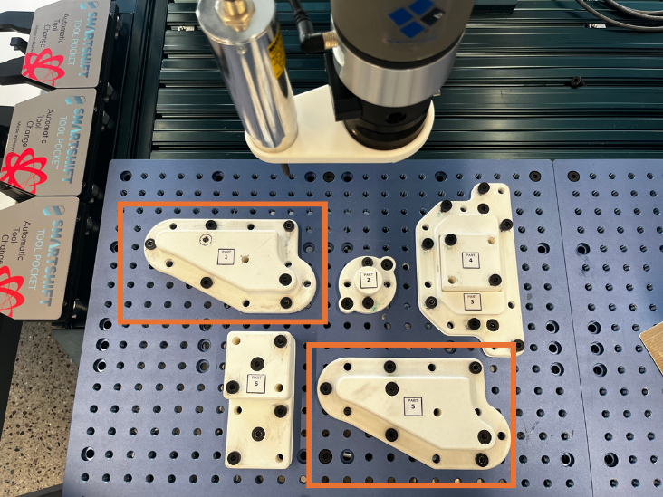
Save Installation: Save the Installation file once more.

Programming the Screwdriving Task Sequence
Your program will include:
- Moving to a safe starting position (Home).
- (For each screw) Approaching the screw.
- (For each screw) Contacting the screw head.
- (For each screw) Retracting to a safe position.
- Returning to Home.
This will be done only for one Part. The other will be automatically done when we will change the Coordinate System.
- Navigate to Installation tab, select “General” > “TCP” and select the TCP created in the previous steps with the checkmark.
- Navigate to Installation tab, select “General” > “Payload” and select the payload created in the previous steps with the checkmark.
- Navigate to “Program” > “Move” > “MoveJ” on the teach pendant. Move the robot manually to a safe position away from the workpiece (e.g., above the fixture). Tap “Set Waypoint” and name it descriptively, e.g., “Home_Position”. This waypoint will serve as both the start and end point of your program. Use the function “Align” to position the TCP aligned with the robot base’s Z axis and perpendicular to Table.
- Now, it’s time to program all the screws. Tap “Move” > “MoveL” and from the feature dropdown choose the one you created earlier for the workpiece you are working with (e.g., “Plane_Part5”). All subsequent waypoints will now be relative to this Feature.
- Move the robot manually so that the screwdriver tip is directly above the first screw head (e.g., 2–3 cm above it). Tap “Set Waypoint” and name it descriptively, e.g., “Screw1_Approach”.
- Create another waypoint, name it descriptively, e.g., “Screw1”. Lastly, create another one for going back to an exit position, which could be the same as the approach.
- Repeat the previous point, but now the screwdriver needs to retract from the screw and going back to the approach position.
Repeat the last 3 points until you processed all the screws of a single workpiece. Finally, save the program and give it a meaningful name (e.g., “Screwdriving_Task”).

Test the Program

Test the Screwdriving task Sequence
- On the Teach Pendant, go to “Program” and open your task sequence program (e.g., “Screwdriving_Task”).
- Ensure that the correct Feature is active for testing on the first workpiece. Adjust the master speed slider on the Teach Pendant to a low value (e.g., 10–20%) for safe testing.
Debugging: If anything goes wrong, press Stop. Analyze the program steps, check Waypoint positions, TCP accuracy, Feature definition, and screwdriver function parameters. Make corrections and test again at low speed.
Increase Speed Gradually: Once you are confident the program runs correctly at low speed, incrementally increase the speed slider (e.g., 25%, 50%, 75%, 100%) and test again at each stage. Observe if the increased speed affects accuracy or smoothness.
Full Speed Execution: Run the program at the desired final speed (often less than 100% for precision tasks).
Run the program by pressing “Play” on the Teach Pendant. Verify that:
- The robot moves to each waypoint accurately.
- The screwdriver aligns properly with each screw.
- The robot returns to its Home position at the end of the sequence.
Optional: if everything works as intended, create a new Plane in Features for the second workpiece, duplicate the MoveJ instruction list, changing the feature, and test the replicability.
Optional: test the move until contact function to detect the screwing position.
Optional: use the screwdriving function to screwdrive a screw.

Congratulations! You've successfully installed a screwdriver, configured the essential Payload and TCP settings, implemented safety features like a safety plane, utilized Features for robustness, and programmed a functional screwdriving task on the UR5e.
Skills Learned:
- Payload and TCP Configuration Importance and Methods
- Basic PolyScope Programming (MoveJ, MoveL, Waypoints)
- Using Safety Planes for Collision Avoidance
- Using Features for Program Adaptability
- Basic Error Handling Concepts
- Testing and Debugging Robot Programs

