Text

Auto-generated description

Universidad Autónoma de Yucatán

Exact Sciences Campus

Faculty of Engineering

Mechatronics Engineering

Analog Electronics

Practice Report

Practice #5: 3-band audio equalizer.

**Jara Pinto Elías José**

Teacher: Edson G. Estrada López

Date:

Tuesday, May 28, 2024

# Objective

**GENERAL OBJECTIVE**

* Design a 3-band audio equalizer using active filters with op-amps that meet specific operating parameters.

**SPECIFIC OBJECTIVES**

* Determine and analyze the transfer function of the active filters for each frequency band (low, mid, and high) using simulation software and mathematical tools.
* Experimentally verify the operation of the equalizer in the laboratory, ensuring that the center frequencies of 81 Hz, 3 kHz, and 16.7 kHz are correctly filtered and equalized.

# Theoretical framework

Schematic

Auto-generated description**1. Fundamental Theory of Filters**

**Differentiating Filters**

* **Circuit**: A differentiating filter consists of a capacitor and resistor connected in series with an op-amp. (see Figure 1)
* **Transfer Function**: In the Laplace domain, the transfer function is expressed as , indicating that the filter amplifies the high-frequency components.

Figure 1. Schematic diagram of the differentiating filter.

* **Fourier transform**: In the Fourier domain, the transfer function is .
* Schematic

  Auto-generated description**Bode graphs**: They show that the magnitude grows with a slope of +20 dB/decade and the phase is constant at -90°.

**Integrative Filters**

* **Circuit**: An integrator filter uses a resistor and a capacitor, where the capacitor is in the feedback from the op-amp. (see Figure 2)

Figure 2. Schematic diagram of the integrator filter.

* **Transfer Function**: In the Laplace domain, it is expressed as , indicating that the filter attenuates the high-frequency components.
* **Fourier transform**: In the Fourier domain, the transfer function is .
* **Bode plots**: The magnitude decreases with a slope of -20 dB/decade and the phase is constant at 90°.

Schematic

Auto-generated description**Low Pass Filters**

* **Circuit**: A typical low-pass filter includes resistors and capacitors that form a feedback loop with an op-amp. (see Figure 3)
* **Transfer Function**: The transfer function is as follows, where is the cut-off frequency.

Figure 3. Schematic diagram of the active filter passes lows.

* **Fourier transform**: In the Fourier domain, the transfer function is
* **Bode plots**: The magnitude is constant for low frequencies and decreases with a slope of -20 dB/decade for high frequencies. The phase varies from 180° (low) to 90° (high), with 135° being at .

A more detailed analysis of these fundamental filters can be seen in the annexes section.

**2. Fourier and Laplace transforms**

**Fourier transform**

* **Utility**: It decomposes a signal into its frequency components, allowing the analysis of the system's response in the frequency domain.
* **Application in Filters**: Makes it easier to understand how a filter affects different frequency components of an input signal.

**Laplace transform**

* **Utility**: It allows to analyze circuits and systems in the frequency domain (s), facilitating the resolution of differential equations.
* **Transfer Function**: Provides an algebraic representation of the relationship between the input and output of a system.

**3. Graphic Equalizers**

**Purpose and Design**

* **Gain and Cut Control**: Graphic equalizers allow you to adjust the frequency response of an audio system in various frequency bands using knobs.
* **Frequency Bands (Sectional):** Each frequency band has its own narrow-band filter, adjustable independently because they are set by section. (see Figure 4)

Schematic

Auto-generated description

Figure 4. Section of a graphic equalizer.

**Cutoff Frequency and Gain**

* **Center Frequency**: Determined by the relationship between resistors and capacitors.
* **Center Frequency Gain**: Adjustable by circuit components.

**Circuit Behavior in Frequency**

* **In-Band Frequencies**: The circuit allows gain or cut-off control.
* **Out-of-Band Frequencies**: The circuit provides approximately unit gain.

**Bode Graphics for Equalizers**

* **Magnitude and Phase**: The frequency response of the equalizer is visualized by Bode graphs, showing how each band affects the input signal.

**N Band Equalizer**

A graphic equalizer with n bands is performed by paralleling n sections of narrow-band filters. The individual outputs of each section are summed using an adding amplifier.

***Detail of the adder and insulation.***

* **Topology:** Inverter adder **with** unit mix gain **is used**: .
* **Recommended values:** and (if there is interaction between sections, increase to **220 kΩ**).
* **Insulation:** place **1 kΩ** in **series** at the outlet of **each section** before the mixing resistor, or **follow buffers** per section if maximum independence is required.
* **Polarity and mode:** with this **inverter** adder, sections connected "in phase" to the node reference will produce **boost**; if injected with **opposite phase**, they will produce **cut**.
* **Practical observation (6310 Hz):** If an **intermediate peak/trough** appears per interaction (e.g., ~6310 Hz), check: (1) **values of** (raise them), (2) **buffers per section,**  or (3) **compensation** (small capacitor 10–47 pF in parallel with to stabilize the mixing node.

The resistors and capacitors in each section are selected so that the center frequencies are evenly distributed in the desired audio range. (see Figure 5)

Schematic

Auto-generated description

Figure 5. Graphic equalizer with n bands.

***Note — Operation mode (boost/cut).***An equalizer can operate in **boost or** **cut** depending on the **sum polarity** and **injection point of** each section:

* **Boost (peaks):** The filtered output of the band is phased **in** addition to the signal at the mix node; in Bode, **peaks** at .
* **Cut (valleys):** the filtered output is **added in opposition** (180°) or with **negative effective gain** with respect to the node; in Bode **valleys** appear in .

In this report, **Figures 6–9** (Mathematica) illustrate the **boost behavior** by band (peaks), while in **4) Simulation** (Proteus) cut-type cases are shown when varying (valleys). Both views are consistent: they represent **two modes of the same EQ** depending on the adder settings.

Graphic equalizers are essential tools in audio signal processing, providing precise control over the frequency response across multiple bands. Its design is based on narrow-band filter arrays and the use of op-amps to add up the outputs of these filters, allowing for precise graphic adjustments of gain and cutoff in different frequency bands.

# Development

**Transfer Function**

The transfer formula commonly used for narrow-web filters, for the standard representation of their behavior in terms of their fundamental components and parameters, is as follows:

Where:

* is the gain in the center frequency.
* is the central angular frequency.
* **Q** is the quality factor.
* **s** is Laplace's complex variable.

**Reasons for the Shape of the Transfer Function**

1. **Resonance**: The frequency represents the frequency at which the filter has its maximum resonance. This means that the filter gain is maximum at this frequency.
2. **Quality Factor Q**: The quality factor **Q** defines the selectivity or "sharpness" of the filter's through-band. A high **Q** means that the filter has a very narrow band, while a low **Q** means that the band is wider.
3. **Frequency Behavior**: At the bottom of the fraction, the term represents the effects of quadratic frequency, while it represents the damping proportional to the frequency and represents the natural resonance of the system. At the top of the fraction, the term shows how the frequency *s* is modulated by the parameters of the system.

**Derivation**

The derivation of this transfer function comes from the RLC circuits, where:

1. **Second-Order System**: Narrow-band filters are generally modeled as second-order systems because they have clear and defined resonant behavior.
2. **Differential Equations**: The transfer function is derived from the solution of differential equations that describe the behavior of the RLC (Resistor-Inductor-Capacitor) system in the Laplace domain.

**Transfer Function on Narrow Web Filters**

The shape of the transfer function is crucial because it captures the essence of how the filter responds to different frequencies:

* At frequencies much lower or higher than , the filter gain drops significantly, which corresponds to the dominant terms and in the denominator.
* Near the frequency, the linear s-term of the numerator and denominator are balanced to allow the passage of the center frequency while attenuating other frequencies.

**Filtered block transfer function**

Since the graphic equalizer that is designed in this practice is 3-band, then the transfer function of the filtered block is obtained by adding the transfer functions of each section of the equalizer, since each section acts as a narrow band filter. This approach allows the total response of the equalizer to be modeled as a combination of several filters centered on different frequencies, providing control over different frequency bands in the audio spectrum.

**Proposed Design**

For the calculation of the corresponding Center Frequency () of each band of the graphic equalizer and the Gain at Center Frequency (), Formula I) **and** Formula II) **are used**.

The following recommended ranges are taken into account for low, mid, and high frequencies:

* Low frequency: 50-100 Hz
* Average frequency: 1-4 kHz
* High frequency: 12-16 kHz

The recommendations of Franco, author of the book "Design with Operational Amplifiers and Analog Integrated Circuits" for the selection of resistors and capacitors, are considered:

* **Capacitors**:
* **Resistances**: ,
* **Common resistance values:**

For the calculations, an approach was taken that prioritizes the values of available commercial capacitances. Based on the recommended frequency ranges, the eligible capacitance ranges for each frequency section of the graphic equalizer are obtained.

**Section 1 (Low Frequency = 81 Hz):**

Range of possible capacitances for the low frequency range:

**Section 2 (Average Frequency = 3 kHz):**

Range of possible capacitances for the mid-frequency range:

**Section 3 (High Frequency = 16.7 kHz):**

Range of possible capacitances for the high frequency range:

**Gain at Center Frequency:**

The graphic equalizer design is based on the available commercial capacitance and resistor values, ensuring that each section of the equalizer meets the desired frequency and gain specifications. The calculations made allow to obtain an accurate center frequency and an adequate gain for each frequency band, thus achieving optimal performance of the graphic equalizer.

**Mathematica Bode Charts for Each of the Bands**

To analyze the frequency behavior of the graphic equalizer, Wolfram Mathematica software was used to generate the magnitude and phase plots (Bode plots) corresponding to each of the bands or sections of the filter.

*Note:* These isolated **band** responses show the **boost condition** (peaks in ); in **4) Simulation** the complementary **cut condition** is shown when varying .

Chart, Line Chart

Auto-generated descriptionFigure 6 shows the Bode graph corresponding to section 1 of the graphic equalizer, designed for low frequencies around 81 Hz.

Figure 6. Bode chart for band 1.

* **Center Frequency**: 81 Hz
* **Gain Analysis**: A peak in gain is observed around 81 Hz, confirming the center frequency. The gain decreases rapidly as we move away from this frequency.
* **Filter Behavior**: The graph confirms that the section is correctly designed to attenuate frequencies outside the low range, with maximum gain at the center frequency.

Chart, Line Chart

Auto-generated descriptionFigure 7 shows the Bode graph corresponding to section 2 of the graphic equalizer, designed for mid-frequencies around 3 kHz.

Figure 7. Bode chart for band 2.

* **Center Frequency**: 3037.53 Hz
* **Gain Analysis**: A peak in gain around 3 kHz is observed. The gain decreases significantly as we move away from this frequency.
* **Filter Behavior**: The graph confirms the correct attenuation of frequencies outside the midrange, with a maximum gain in the center frequency.

Chart, Line Chart

Auto-generated descriptionFigure 8 shows the Bode graph corresponding to section 3 of the graphic equalizer, designed for high frequencies around 16.7 kHz.

Figure 8. Bode chart for band 3.

* **Center Frequency**: 16352.1 Hz
* **Gain Analysis**: A peak in gain around 16.7 kHz is observed. The gain decreases rapidly outside of this frequency.
* **Filter Behavior**: The graph confirms the correct attenuation of frequencies outside the high range, with a maximum gain in the center frequency.

Graphic

Auto-generated descriptionFigure 9 shows the Bode graph of the full block of the graphic equalizer, adding up the three individual sections (low, mid, and high frequency).

* **Gain Analysis**: Three peaks are observed corresponding to the center frequencies of the three sections: low (81 Hz), medium (3 kHz) and high (16.7 kHz).
* **Equalizer Behavior**: The graph shows how the equalizer allows you to adjust the gain in different frequency bands, providing control over low, mid, and high frequencies.
* **Section Interaction**: The overlapping of the responses of the three sections shows the EQ's ability to manipulate the frequency spectrum of the audio signal precisely.

Figure 9. Bode graph for the full filtered block of the graphic equalizer.

Figure 10 shows the 3 bode graphs presented above together in the same plane.

Graphic

Auto-generated description

Figure 10. Graphic equalizer bode graphs.

**Circuit schematic**

Figure 11 shows the schematic diagram of the graphic equalizer, with each of the band sections with the proposed and calculated values of resistances and capacitors.

Schematic

Auto-generated description

Figure 11. Graphic equalizer schematic diagram.

# Simulation

The Bode graphs that will be presented in the following figures were obtained using the *Proteus 8 Professional*  simulation software, more specifically, the raw data of the simulator grapher was exported and a Python code was used to have a greater customization of the graphs. The Bode graphs obtained show the frequency responses of the graphic equalizer.

* **X-Axis (Frequency):** Represents the frequency on a logarithmic scale, from 10 Hz to 1 MHz.
* **Y-axis (Gain in dB):** Represents the gain in decibels (dB).

In the Bode graphs shown, the gain is a function of frequency (in Hz). Four points of interest are observed marked on the curves:

The reason why the points of interest are not at the exact value of calculated frequency is because these values do not match the values of the frequency matrix thrown by the simulator grapher, however, they do match quite close values.

***Clarification (boost vs cut in Proteus):***  
In the graphs in this section, by taking  **one band to 100% (≈100 kΩ)** and keeping the others at 0%, the contribution of that band enters the **adder** with **opposite polarity**, generating **a cut** (a **valley** in ). When it is at **0% (≈0 Ω),** the effect of the section is **almost unitary** (local bypass) and the global response approaches **gain ≈ 1**. That's why here you see **valleys** (cut), whereas in Mathematica, when representing the isolated band in positive sum, you see **peaks** (boost).

**Bode graph with 0%**

The Bode graph in Figure 12 corresponds to the behavior of the graphic equalizer when the variable resistances of each section are at 0% (approximately 0 Ω).

Chart, Bar Chart

Auto-generated description

Figure 12. Bode graph with 0%.

**Equalizer behavior with 0%**

1. **Low Frequency (79 Hz):**

With at 0Ω, the signal path through the capacitor is predominantly resistive, eliminating the effect of the capacitor on the lattice *.* The low frequency is in the band where the impedance is high, but with , the signal does not experience the expected attenuation, resulting in a virtually constant gain.

1. **Medium Frequency (3162 Hz):**

Similarly, in the mid-frequency band, the capacitor should introduce a filtering effect. However, with , the circuit essentially behaves as a direct pass (*bypass*) for the input signal. The gain remains virtually constant in this band also due to the absence of attenuation by .

1. **High Frequency (15849 Hz):**

In this band, the capacitive impedance begins to decrease, but again, with , the resistive path is the one that predominates. The gain begins to decrease slightly as the frequencies approach the highest values in the band.

1. **High Frequency (100000 Hz):**

At very high frequencies, the impedance of the capacitors becomes very low, allowing the signal to pass through them. However, the op-amp and other components limit the gain to these frequencies. Here, a significant drop in gain is observed due to the response of the amplifier and the reduction in gain of the overall system.

**Bode Graph with 100%**

The Bode graph in Figure 13 corresponds to the behavior of the graphic equalizer when the variable resistors of each section are at 100% (approximately 100 kΩ).

Chart, Line Chart

Auto-generated description

Figure 13. Bode graph with 100%.

**Equalizer behavior with 100%**

1. **Low Frequency (79 Hz):**

At 100 kΩ, the mains impedance becomes significant, resulting in greater attenuation at low frequencies. This is seen in the gain drop around 79 Hz.

1. **Medium Frequency (3162 Hz):**

The mid-frequency section also shows a drop in gain around 3162 Hz. This is consistent with the behavior of a narrowband filter, where the center frequency experiences the greatest attenuation.

1. **High Frequency (15849 Hz):**

In the high frequency band, there is a gain drop around 15849 Hz, demonstrating the expected behavior of the filter to attenuate high frequencies. The gain response is recovered at higher frequencies due to circuit characteristics and op-amp limitations.

1. **Very High Frequency (100000 Hz):**

At very high frequencies, the capacitive behavior allows the signal to pass through, but with a gain drop due to the response of the op-amp and other circuit components. The gain decreases again beyond 100 kHz, indicating the limitation of the circuit's high-frequency response.

**Analysis of Peak Gain at 6310 Hz**

The Bode graph shows a specific behavior with a peak gain at 6310 Hz, which is between the medium (3162 Hz) and high (15849 Hz) frequencies. This behavior can be explained by the interaction between EQ sections and resonance in the filter network.

1. **Interaction between Filter Sections**:

Each section of the graphic EQ is designed to filter out a specific band of frequencies: low, mid, and high. When the sections are configured at 100 kΩ, each of these sections acts as a narrow band filter. The 6310 Hz frequency is in the transition range between the mid-frequency and high-frequency section. The filter response is not completely independent in each band, but there may be an overlap in the frequency response.

1. **Circuit Resonance**:

The network of filters in a graphic equalizer can have resonances due to the interactions between the components and . These resonances can cause gain spikes in certain frequencies that are not the center frequencies of the individual sections. The peak at 6310 Hz may be a result of such resonance, where the combined response of the mid- and high-band filters strengthens the signal at this specific frequency.

1. **Effect of the Values of and C**:

The y-values determine the attenuation and gain characteristics of each band filter. At 100 kΩ, the impedance of the filter changes, which can lead to greater gain in transition frequencies. The specific combination of , , , and in each section of the filter influences the overall response of the equalizer, causing gain spikes at intermediate frequencies.

**Bode Graph for Low Frequency Attenuation**

The Bode graph in Figure 14 corresponds to the behavior of the graphic equalizer when only the variable resistor of section 1 (Low Frequencies) of the equalizer is at 100%, and the others of the other 2 sections are at 0%.

Graphic

Auto-generated description

Figure 14. Bode Graph for Low Frequency Attenuation.

**Equalizer Behavior for Low Frequency Attenuation**

1. **Low Frequency (82 Hz):**

With section 1 at 100 kΩ, this section acts as a narrowband filter, providing significant attenuation around 82 Hz. This is reflected in the deep valley in the graph at 82 Hz, indicating a maximum attenuation at this frequency.

1. **Mid Frequency (3282 Hz):**

With at 0 Ω in the mid and high frequency sections, these sections are not acting as effective filters. In this region, the gain remains relatively constant due to the lack of significant attenuation by the mid and high frequency sections. Gain recovers after the point of minimum gain at low frequency, specifically it recovers at 3282 Hz.

1. **High Frequency (16448 Hz):**

Similarly, gain in the high frequency shows a recovery, as the mid and high frequency sections do not provide attenuation. Gain remains high in this band due to the low impedance of the capacitors in these sections with at 0 Ω.

1. **Very High Frequency (103782 Hz):**

At very high frequencies, the gain begins to decrease again due to the response of the op-amp and the limitation of the circuit components. The drop in gain at very high frequencies is consistent with the natural behavior of the op-amp.

**Bode Graph for Mid Frequency Attenuation**

The Bode graph in Figure 15 corresponds to the behavior of the graphic equalizer when only the variable resistor of section 2 (Mid Frequencies) of the equalizer is at 100%, and the others of the other 2 sections are at 0%.

Graph, Histogram

Auto-generated description

Figure 15. Bode Graph for Mid Frequency Attenuation.

**Equalizer Behavior for Mid-Frequency Attenuation**

1. **Medium Frequency (3162 Hz):**

With section 2 at 100 kΩ, this section acts as a narrowband filter, providing significant attenuation around 3162 Hz. A deep valley is seen in the graph at 3162 Hz, indicating a maximum attenuation at this frequency.

1. **Low (79 Hz) and High (15849 Hz) Frequencies:**

The low and high frequency sections are not acting as effective filters due to at 0 Ω. This results in a constant or slightly variable gain in these bands. Gain in the low and high frequencies shows little attenuation, which is consistent with the lack of significant impedance in those sections.

1. **High Frequency (100000 Hz):**

The gain decreases again at very high frequencies due to the response of the op-amp and the natural limitations of the circuit components. The drop in gain at very high frequencies reflects the limitation of the system's response.

**Bode Graph for High Frequency Attenuation**

The Bode graph in Figure 16 corresponds to the behavior of the graphic equalizer when only the variable resistor of section 3 (High Frequencies) of the equalizer is at 100%, and the others of the other 2 sections are at 0%.

Diagram

Auto-generated description

Figure 16. Bode Graph for High Frequency Attenuation.

**Equalizer Behavior for High Frequency Attenuation**

1. **High Frequency (15849 Hz):**

With section 3 at 100 kΩ, this section acts as a narrowband filter, providing significant attenuation around 15849 Hz. This is reflected in the deep valley in the graph at 15849 Hz, indicating a maximum attenuation at this frequency.

1. **Low (79 Hz) and Mid (3162 Hz) Frequencies**:

The low and mid frequency sections are not acting as effective filters due to at 0 Ω. This results in a constant or slightly variable gain in these bands. The gain in the low and mid frequencies shows little attenuation, which is consistent with the lack of significant impedance in those sections.

1. **High Frequency (100000 Hz):**

At very high frequencies, the gain increases again due to the lower capacitive impedance and limited response of the op-amp and circuit components. The gain approaches a maximum at 100 kHz outside the attenuation band. At even higher frequencies, it falls again due to the limitation of the AO and the circuit.

# Practical results

**Physical Implementation of the Graphic Equalizer**

Figure 17 shows the physical configuration of the graphic equalizer. For this implementation, the circuit was connected to a symmetrical power supply to provide the necessary voltages (±12V) to the op-amp. In addition, an oscilloscope was used to visualize and analyze the behavior of the circuit visually and in real time, complementing the hearing evaluation through sound tests.

To protect the device playing the music, a voltage tracker (buffer) was added just before the input to the graphic equalizer. This voltage tracker acts as an insulator, preventing possible damage to the input device due to impedance variations of the equalizer circuit.

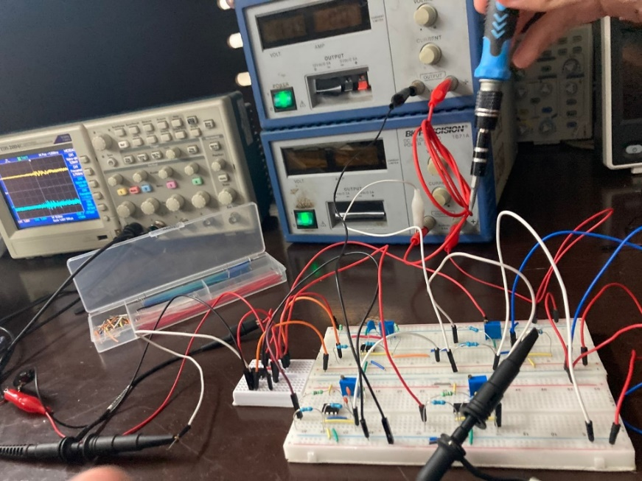

Figure 17. Physical implementation of the graphic equalizer.

Figure 18 shows the physical connection of the graphic equalizer in more detail.

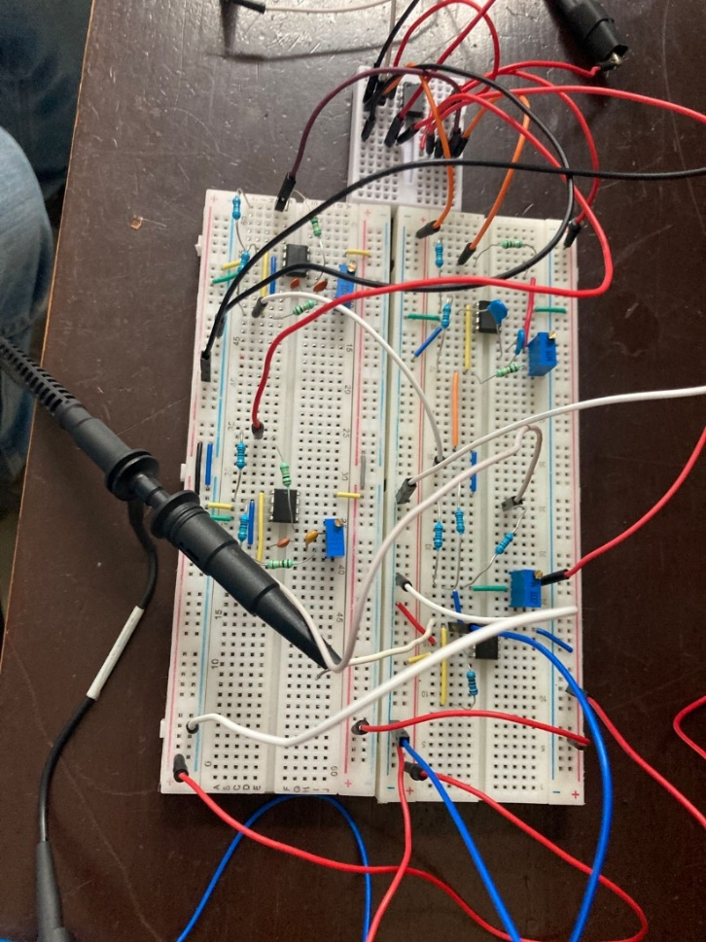

Figure 18. Physical circuit of the graphic equalizer.

**Tests and Results**

The practical tests were carried out in two stages:

**Oscilloscope Testing**:

* The oscilloscope was connected to the input and output of the graphic equalizer to observe the waveforms and frequency response.
* The input signal used was a sine wave with amplitude of 1V and low (81.0778 Hz), medium (3062.9383 Hz) and high (16706.9362 Hz) frequencies.
* It was verified that the equalizer properly adjusts the gain in Volts for the different frequency bands: low, medium and high.
* The results showed an expected behavior in each frequency band, confirming the correct implementation and operation of the circuit.

**Speaker Function Tests**:

* Audio signals were played through the graphic equalizer connected to speakers.
* The variable resistors in each EQ section were adjusted to modify the frequency bands and the effect on sound quality and characteristics was observed.
* Hearing tests showed that the equalizer could effectively manipulate the gain in dB in the different frequency bands, enhancing or attenuating certain frequencies according to the user's needs.

# Conclusions

The design and implementation of the 3-band audio equalizer was carried out successfully, allowing a thorough and detailed analysis of its technical and functional characteristics. The results obtained, both in simulations and in practical tests, confirm the effectiveness of the design and provide a deep understanding of the behavior of the circuit under various operating conditions.

1. **Accuracy in Center Frequencies:** The center frequencies of each band (81 Hz, 3 kHz and 16.7 kHz) were accurately determined by theoretical calculations. Simulations in Proteus and Bode plots obtained in Mathematica confirmed that the center frequencies are properly matched to the expected values. This fine-tuning is critical to ensuring equalizer functionality in audio applications.
2. **Gain in Center Frequencies:** The maximum gain observed in simulations and practical tests is aligned with the calculated theoretical values. For each band, it was possible to observe a peak in the gain at the center frequencies, which confirms the correct implementation of narrowband filters. The ability to adjust the gain between 0.2308 and 4.33 provides flexibility in manipulating the audio spectrum.
3. **Frequency Response:** Bode graphs obtained in Mathematica and Proteus showed that the equalizer has a predictable and controlled behavior in terms of attenuation and amplification in each frequency band. The frequency response of the equalizer behaves appropriately, attenuating frequencies outside the desired bands and maintaining a unit gain at those frequencies. This behavior ensures that the equalizer can be used effectively to enhance or modify the audio profile according to specific needs.
4. **Behavior of Variable Resistors (R₂):** It was observed that the variation of R₂ resistors has a significant impact on the frequency response of the equalizer. With R₂ at 0%, a constant gain was observed over a wide range of frequencies, while with R₂ at 100%, the equalizer showed attenuation in the center frequencies of each band. This behavior allows precise control over the EQ response, adjusting the gain based on the user's needs.
5. **Physical Implementation and Testing:** Hands-on tests with oscilloscope and horns demonstrated that the equalizer can adjust the gain of audio signals in real time, confirming the effectiveness of the theoretical design and simulations. The physical implementation of the circuit, including protection by a voltage tracker, ensured robust and safe operation of the system.

The 3-band audio equalizer designed and tested in this practice demonstrates solid technical performance, with results that validate both theoretical calculations and simulations performed. The ability to adjust and control gain in different frequency bands makes it a useful and effective tool in audio processing applications.

# References

Franco, S. (2005). *Design with op-amps and analog integrated circuits* (3rd ed.). McGraw-Hill Interamericana.

Robert F. Coughlin, Frederick F. Driscoll. (1999). Operational amplifiers and linear integrated circuits. Pearson-Prentice Hall, 5th edition. Retrieved from: [amplificadores-operacionales-y-circuitos-integrados-lineales-4c2ba-ed-r-f-coughlin-f-f-driscoll.pdf (wordpress.com)](https://analisiscd.files.wordpress.com/2014/08/amplificadores-operacionales-y-circuitos-integrados-lineales-4c2ba-ed-r-f-coughlin-f-f-driscoll.pdf)

The Band-Pass Response in Active Filters | Analog Devices. (2016). Analog.com. <https://www.analog.com/en/resources/analog-dialogue/articles/band-pass-response-in-active-filters.html>

Frequency domain analysis: what is it and how is it used? - Polaridad.es. (2023, November 11). Polaridad.es. <https://polaridad.es/analisis-en-el-dominio-de-la-frecuencia/>

eeeguide. (2017, August 20). Band Pass Filter Circuit Diagram | Types | Frequency Response. Eeeguide.com. <https://www.eeeguide.com/band-pass-filter-circuit-diagram/>

Fiore, J. (2020, June 24). 11.7: Band-Pass Filter Realizations. Engineering LibreTexts. <https://eng.libretexts.org/Bookshelves/Electrical_Engineering/Electronics/Operational_Amplifiers_and_Linear_Integrated_Circuits_-_Theory_and_Application_(Fiore)/11%3A_Active_Filters/11.07%3A_Band-Pass_Filter_Realizations>

NARROW-BAND FILTERS. (2024). Stanford.edu. <https://sepwww.stanford.edu/sep/prof/fgdp/c2/paper_html/node6.html>

# Annexes

**Table of common Fourier and Laplace transforms**

Figure 19. Table of common Fourier and Laplace transforms.

**Filter Theory Differentiator**

Schematic

Auto-generated description

Figure 20. Schematic diagram of the differentiating filter.

**Circuit**:

* A C capacitor and an R resistor are connected in series.
* The input is applied through the capacitor.
* The output is taken through the resistor connected to the op-amp's inverter terminal (op-amp).
* Negative feedback is present between the output and inverter input of the op-amp.

**Equations**:

* Kirchhoff's law of currents (L.C.K.) in the inverter entry node is established as:
* Where:
* Combining these equations:
* Solving for :

**Fourier transform**

* Applying the Fourier transform:
  + The H(jω) transfer function is:
  + If , then:

**Bode Charts**

* **Magnitude**:
  + If , then .
  + The magnitude in decibels is:
    - If ω, then .
    - If , then .
    - If , then .
    - If , then .
* **Phase**:
  + The phase is constant at −90° for all frequencies.

**Impedance Overview**

* **Resistor Impedance**:
* **Capacitor Impedance**:
* **Inductor Impedance**:

**Transfer Function in Laplace**

* In the Laplace domain, the transfer function is:

The differentiating filter amplifies the high-frequency component of the input signal and attenuates the low-frequency component. Their analysis in the time domains, Fourier and Laplace shows how it transforms input signals into output, highlighting the importance of Bode graphs to understand their behavior in frequency.

**Integrative Filter Theory**

Schematic

Auto-generated description

Figure 21. Schematic diagram of the integrator filter.

**Circuit**:

* The circuit consists of an R resistor and a C capacitor.
* The input is applied through the resistor R.
* The capacitor C is connected between the op-amp's inverter input and the output.
* Negative feedback is done through capacitor C.

**Equations:**

* **Transfer Function in the Laplace Domain**:
  + The transfer function is defined as the ratio between the output and the input:
  + Here, the capacitor impedance in the Laplace domain is .
  + The transfer function is then simplified to:
  + If we define ω0=1/RC , then:

**Fourier transform:**

* **Transfer Function in the Fourier Domain**:
  + Replacing ss with jω in the transfer function:
  + This can be expressed as:

**Bode Graphs:**

* **Magnitude**:
  + The magnitude in decibels is:
  + If , then .
  + If , then .
  + If , then .
  + If , then .
* **Phase**:
  + The phase is constant at 90° for all frequencies.

The integrative filter attenuates the high-frequency components and amplifies the low-frequency ones. In practice, the integrative filter can be used to smooth signals or to implement mathematical integration operations on input signals.

**Theory of the active filter Low-pass**

Schematic

Auto-generated description

Figure 22. Schematic diagram of the active filter passes lows.

**Circuit**:

* The circuit includes two resistors and , and a capacitor C.
* Admission is applied via R1.
* and C are connected in parallel, forming the reactive component of the circuit.
* The output is taken from the op-amp.

**Circuit Analysis**

* **Impedances**:
  + The impedance of the resistor :
  + The impedance of the parallel and capacitor C:
* **Transfer Function in the Laplace Domain**:
  + The H(s) transfer function is:
  + Simplifying:
  + Where .
* **Transfer Function in the Fourier Domain**:
  + Replacing s with jω:
  + This can be expressed as:
  + Where

**Frequency Analysis**

* **For ω≪** :
  + The magnitude:
  + In decibels:
  + The phase angle is 180° (or −180°).
* **For ω≫**:
  + The magnitude:
  + In decibels:
  + The slope of the magnitude graph is −20 dB/decade.
  + The phase angle is 90°.
* **For ω=**:
  + The magnitude:
  + In decibels:
  + The phase angle is 135°.

**Bode Charts**

* **Magnitude**:
  + The magnitude of the transfer function decreases with a slope of −20 dB/decade for frequencies greater than the cut-off frequency.
  + At low frequencies (), the magnitude is constant and depends on the ratio .
* **Phase**:
  + The phase varies from 180° (low) to 90° (high), with 135° being at .

The filter described is effectively a low-pass filter, which combines an amplifier with stable gain and the behavior of a high-frequency integrator. This filter allows low-frequency signals to pass through with stable gain and attenuates high-frequency signals. Bode's graphs provide a clear visualization of how signal magnitude and phase are affected by frequency, showing the filter's efficiency in its high-frequency attenuation task.