Deep Learning Homework 2

Submitters: Elie Abboud

Danny Medan

**Part 1**

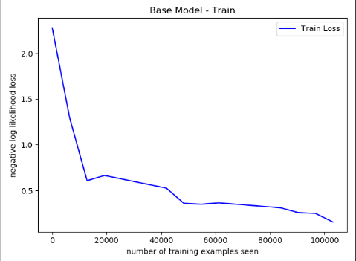

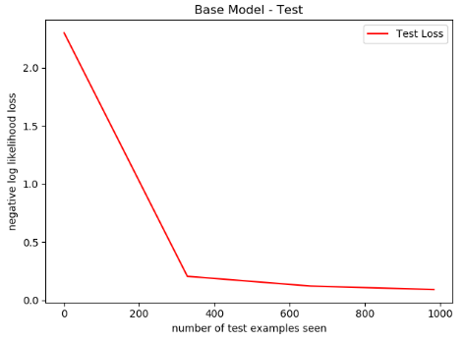

**Part 2:**

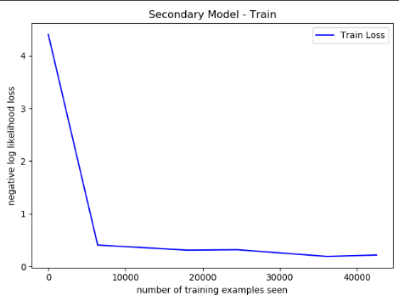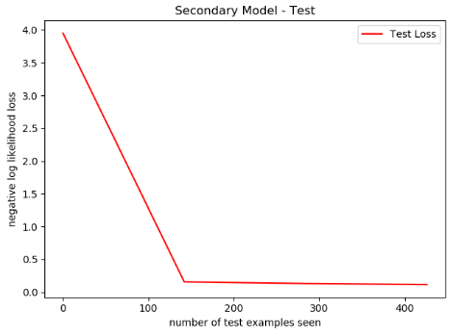

**Part 3:**

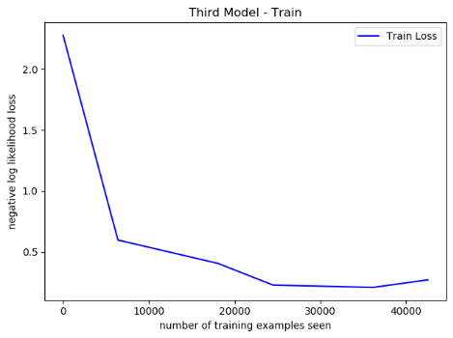

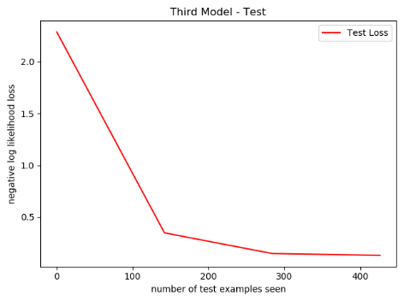

**Part 4:**

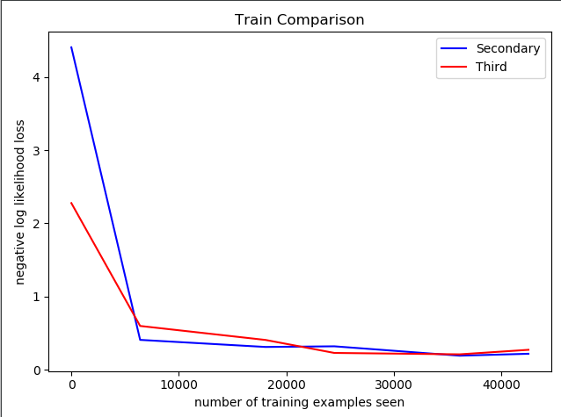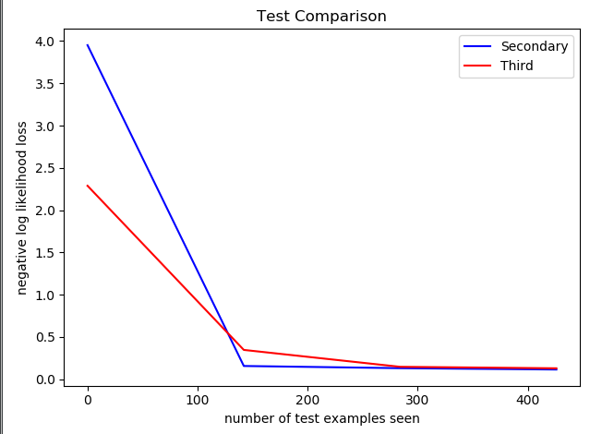

**Note:** Secondary is Item 4, and Third is Item 5.

**Conclusion:** As can be seen from the graphs, the first test (before any training) Secondary has a lot more error because it is biased towards the digits from the base model (digits 0-6), which makes it more vulnerable on new digits prior to any training whereas the Third neural network was initialized normally and thus isn’t biased towards any digits.

In contrast, Secondary has a sharper learning rate in the beginning because the initial layers (where we are generally identifying small patterns and features in the data) are frozen. Digits (whether 0-6 or 7-9) will have quite a lot of underlying similarities. This gives hope that using previously trained neural networks on similar, yet new, data speeds up the learning.

**Part 5:**

**Results:**

Time it took to train Secondary: 10.426376581192017

Time it took to train Third: 18.242616415023804

**Conclusion:** It took the Secondary considerably less time because the initial layers were frozen, which causes back-propagation to be less time-consuming.