**MNISET Classification:**

**Part 1:**

We have run the algorithm on the training set with a variety of k values

K=(from 1 till 30) and displayed the results in the graph below:

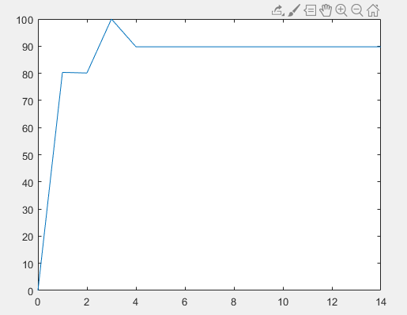

We would choose the k which gave the lowest error on the validation set (k=2), seeing as the error rate is already high as it is, we are not worried about over-fitting the data.

Classification *error* rate on k=2 is 80.1%.

**Part 2:**

We have run the algorithm with k=2 on the validation (test) data and got the *error* rate = 77.785%.

This corresponds to the validation performance, the error rate was already high meaning the features pixel-by-pixel may not be the best choice (or that there are too many features). It also means that there may not be enough training data to accurately predict examples. Additionally, the reason the error rate is so high is because we are using kNN, which theoretically converges to the true pdf when given infinite samples, but doesn’t necessarily work well in real situations.