ArcVault AI Intake Triage Pipeline – Technical Output Report
Author: Elie Nakhle
Assessment: Valsoft AI Engineer Technical Exercise

1. Overview of the Workflow
This report explains the AI automation workflow built for the ArcVault intake triage system. The system processes incoming customer support messages from multiple sources (Email, Web Form, and Support Portal) and automatically classifies, enriches, routes, and escalates them when necessary.
The pipeline uses a Large Language Model (Claude Sonnet) to perform semantic classification and information extraction. Deterministic logic then applies routing policies and escalation rules.

2. Pipeline Architecture
The workflow contains the following stages:
- Trigger – Starts workflow execution.
- Sample Inputs – Provides five example support messages.
- HTTP Request – Sends messages to Claude LLM for classification.
- Parse Response – Extracts structured JSON from the LLM output.
- Routing Logic – Maps issue categories to internal queues.
- Escalation Check – Applies policy-based escalation rules.
- Write Output – Aggregates all processed records into a final JSON output.
Insert screenshot here: Full workflow canvas showing all nodes connected.

3. Processing of Each Request

REQ‑001
User cannot log in due to a 403 error after a recent system update.
Category: Bug Report
Priority: High
Routing Decision: Engineering queue because the issue relates to application functionality.
Escalation: No escalation because the confidence score is high and no outage indicators were detected.

REQ‑002
Customer requests a bulk export feature for audit logs.
Category: Feature Request
Priority: Medium
Routing Decision: Product queue because it represents a product enhancement.
Escalation: No escalation required since this is a normal feature request.

REQ‑003
Customer reports invoice discrepancy: $1,240 charged vs contract price $980.
Category: Billing Issue
Calculation: 1240 - 980 = 260 USD difference.
Discrepancy Analysis: The system checks if the billing difference exceeds the escalation threshold of $500.
Routing Decision: Billing queue.
Escalation: Not escalated because the discrepancy ($260) is below the $500 escalation threshold.

REQ‑004
Customer asks about SSO integration with Okta.
Category: Technical Question
Priority: Medium
Routing Decision: IT/Security queue because the question relates to authentication infrastructure.
Escalation: No escalation required.

REQ‑005
Customer reports dashboard outage affecting multiple users.
Category: Incident / Outage
Keyword Detection: 'multiple users affected'.
Routing Decision: Engineering queue initially.
Escalation Rule: Outage keywords trigger automatic escalation.
Final Decision: Escalated to Escalation queue because the issue indicates a possible system-wide outage.

4. Escalation Logic Explanation
Three escalation rules were implemented in the workflow:
- Low confidence classification: if the LLM confidence score is below 70%.
- Outage detection: keywords such as 'outage', 'stopped loading', or 'multiple users affected'.
- Billing discrepancy threshold: if the difference between invoice values exceeds $500.
In the sample dataset, only REQ‑005 triggered escalation due to outage indicators. The billing case (REQ‑003) did not escalate because the discrepancy was $260, which is below the $500 threshold.

5. Output Summary
Total records processed: 5
Escalated records: 1 (REQ‑005)
Routing distribution:
- Engineering: 2
- Product: 1
- Billing: 1
- IT/Security: 1
- Escalation: 1 (after escalation rule applied)

6. Nodes Screenshots
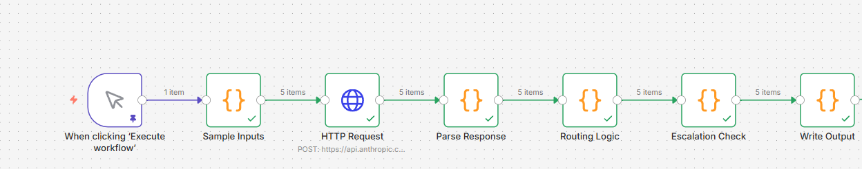

Screenshot – Full workflow canvas

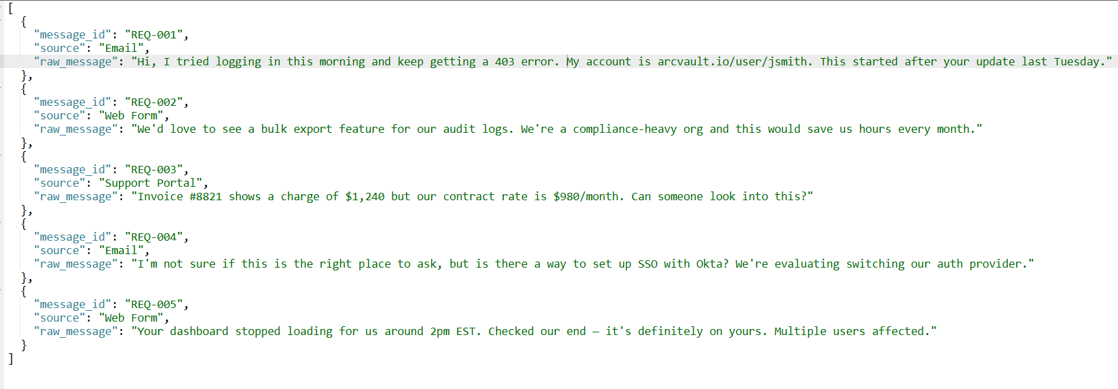

Screenshot – Sample Inputs node output : The Sample Inputs node simulates incoming support requests from different channels including Email, Web Form, and Support Portal.

HTTP – Request Node :
Inputs:

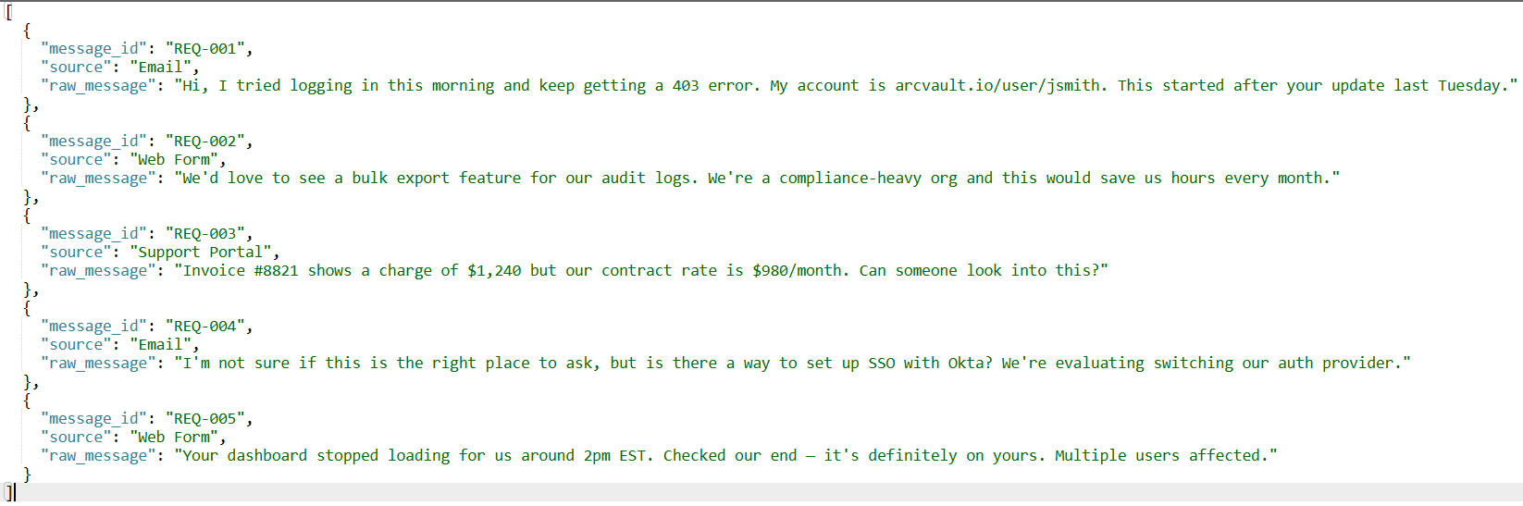

Parameters:
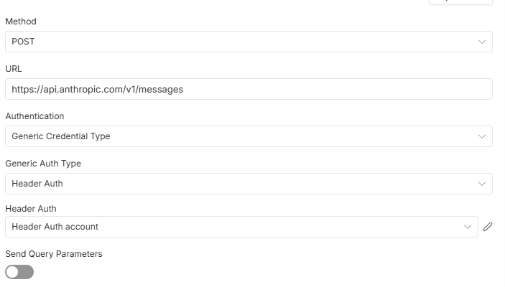

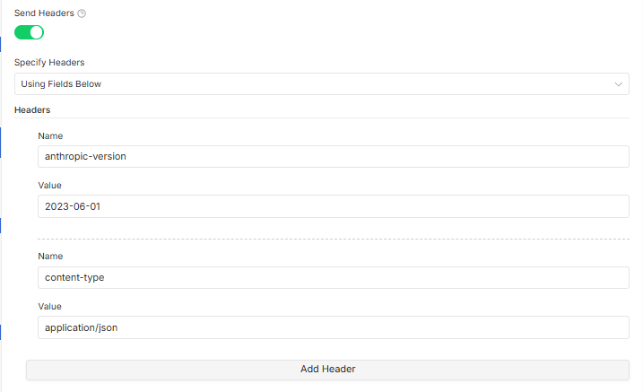

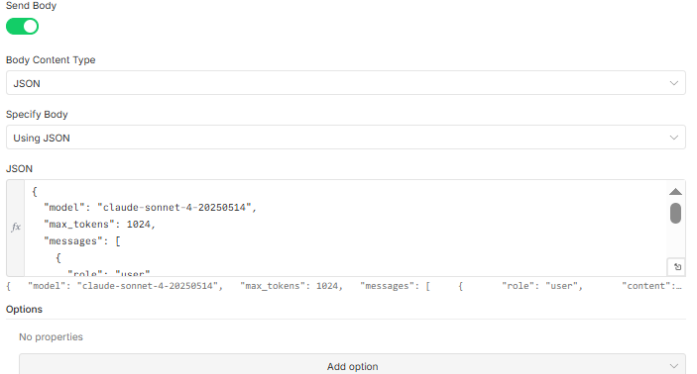

Json Body:
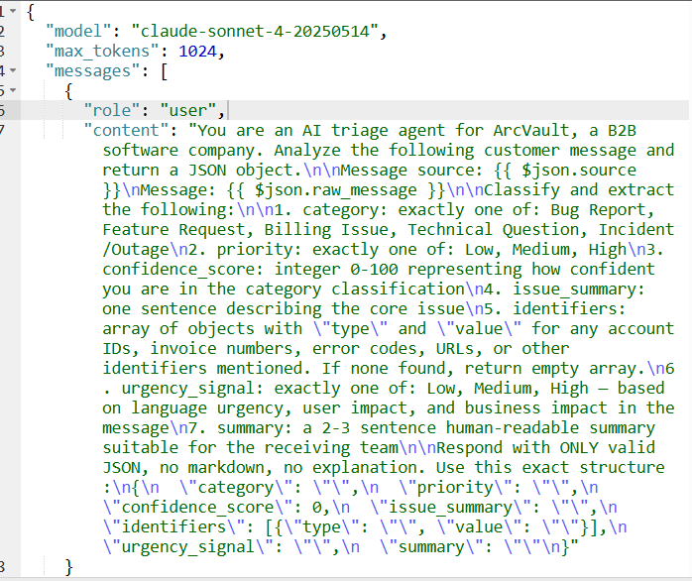

Outputs:

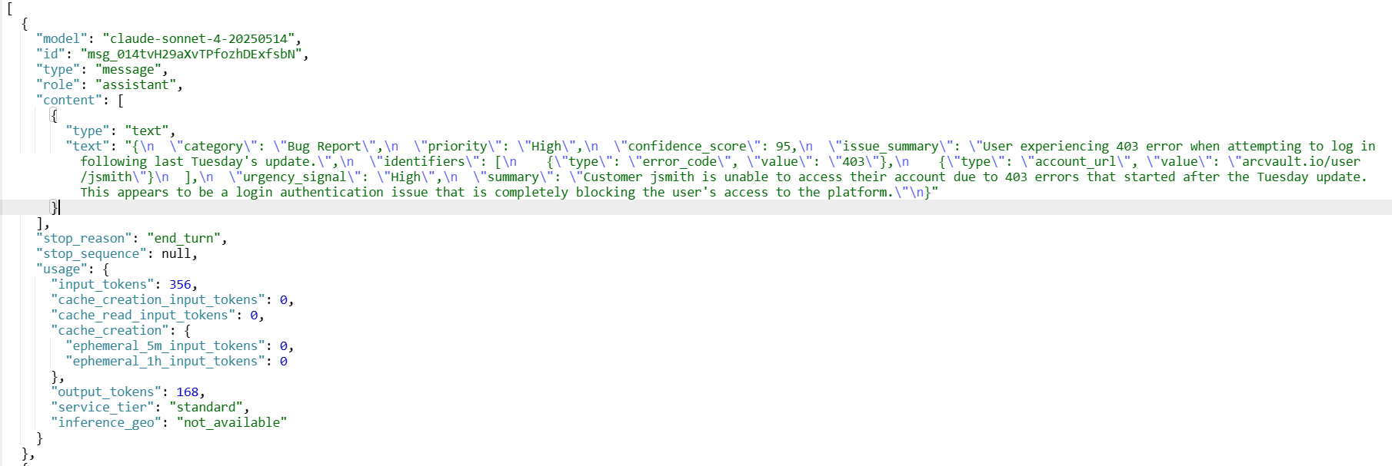

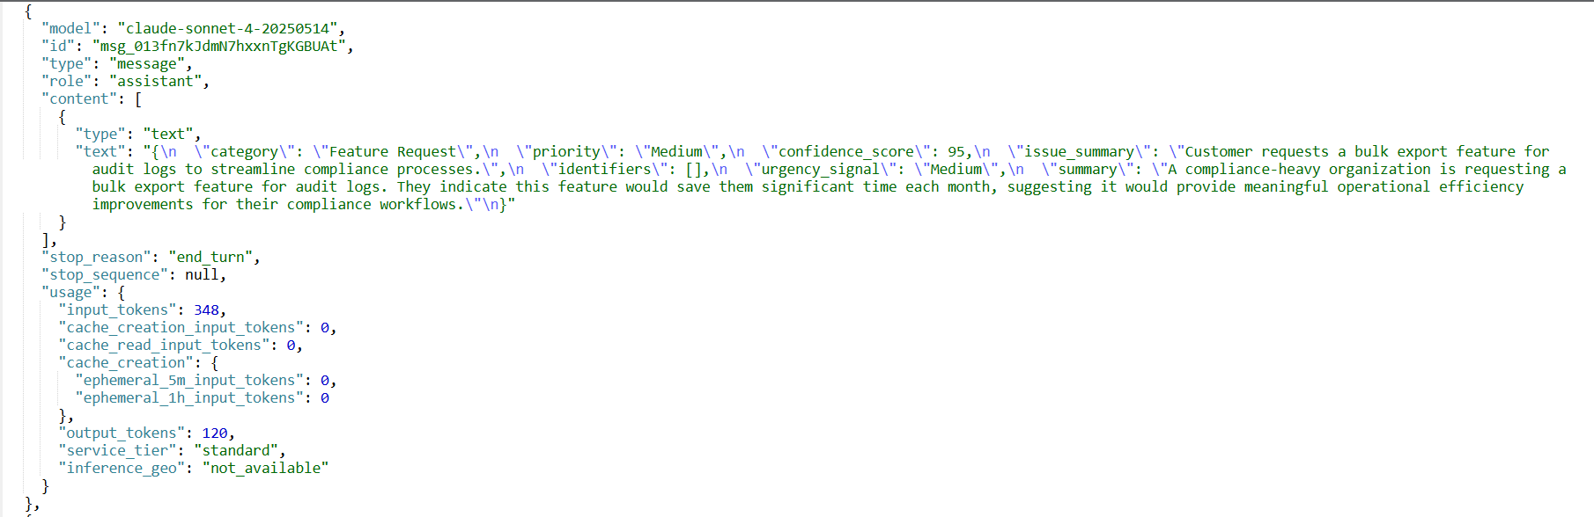

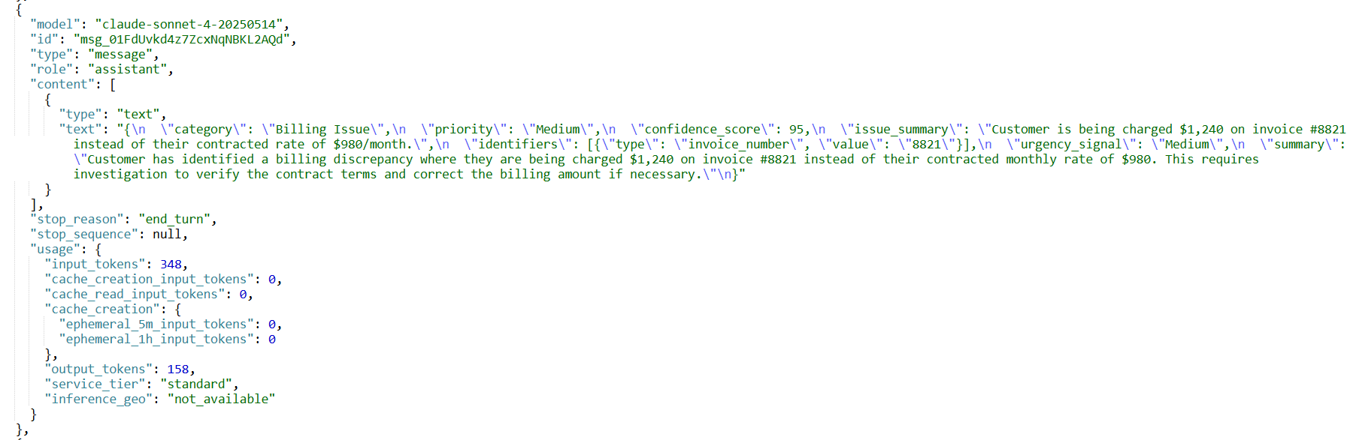

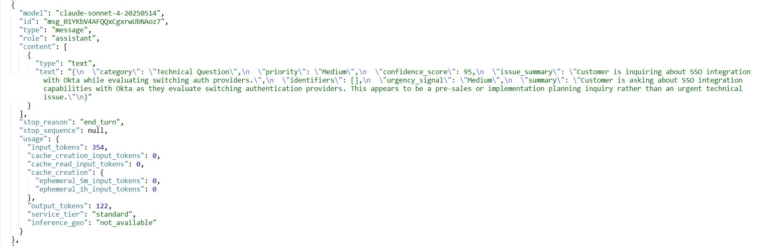

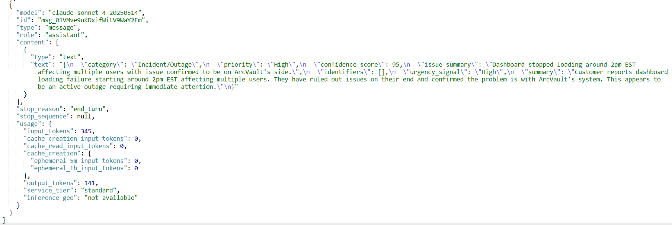

Screenshot – Parse Response node output:
Inputs: Same Output of the HTTP request Node

Output For Each message-Req:

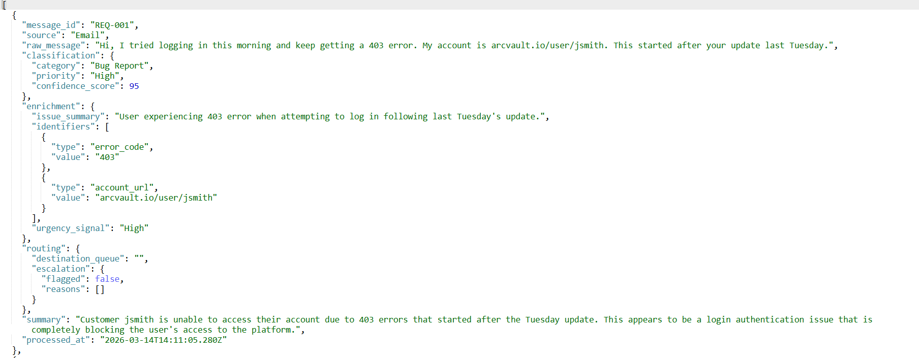

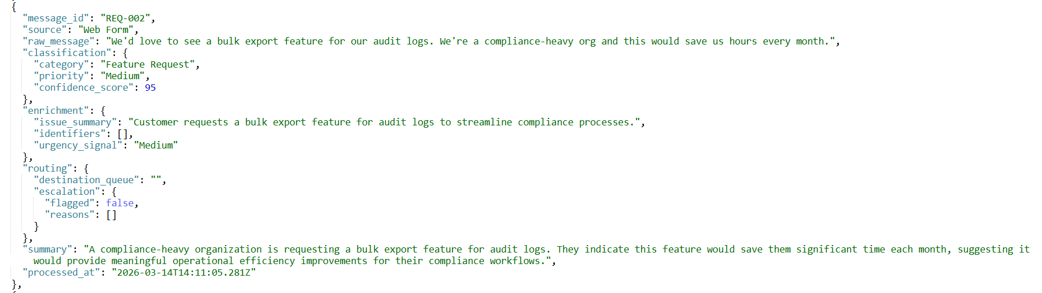

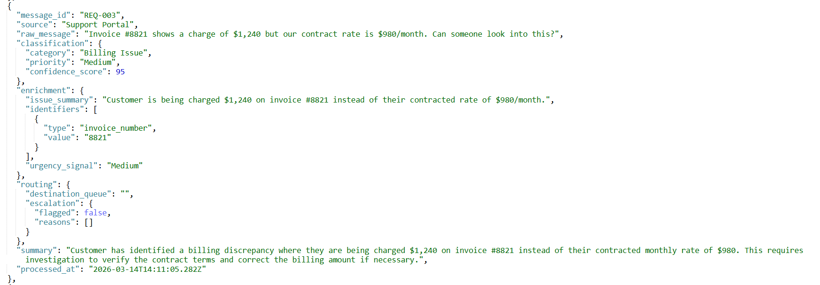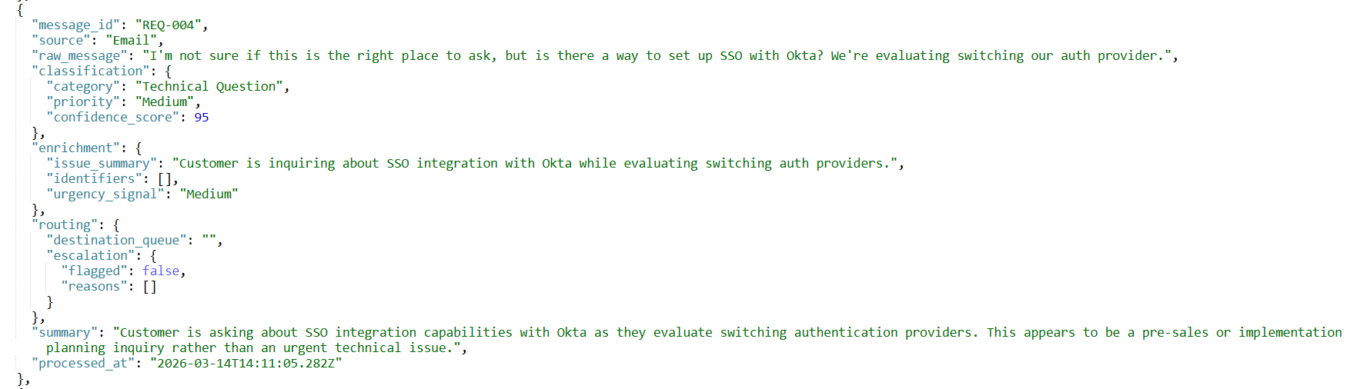

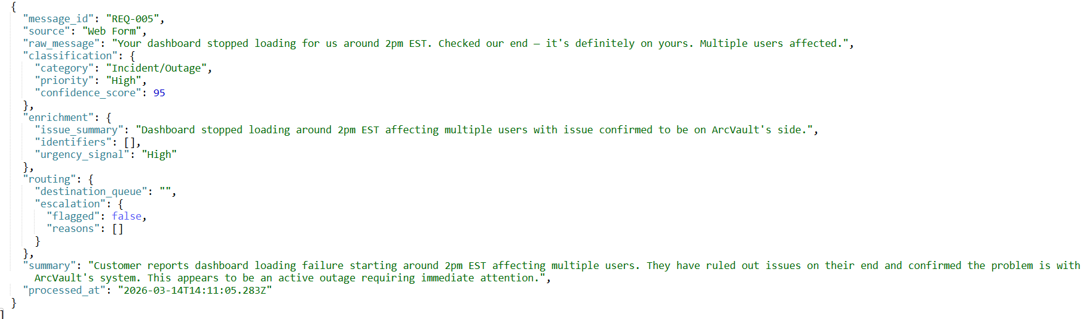

Screenshot – Routing Logic node output:

Inputs: Same Outputs of the Parse Response Node

Output:

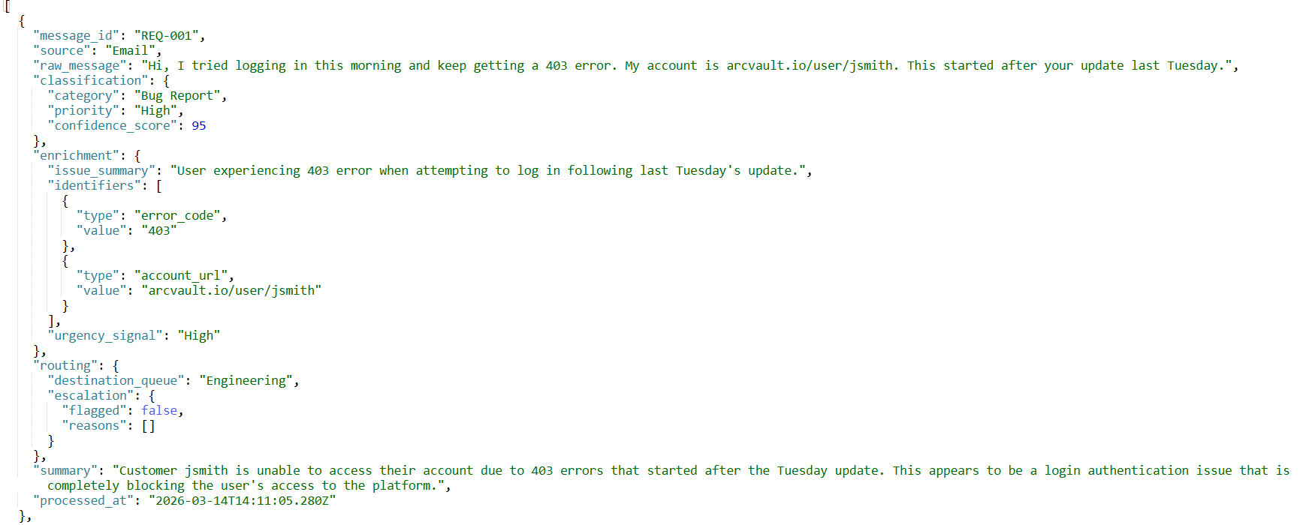

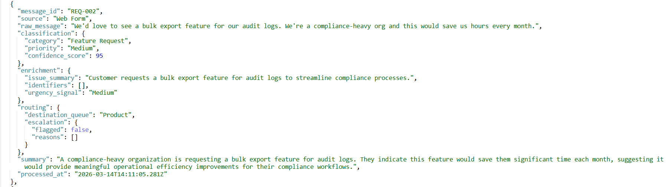

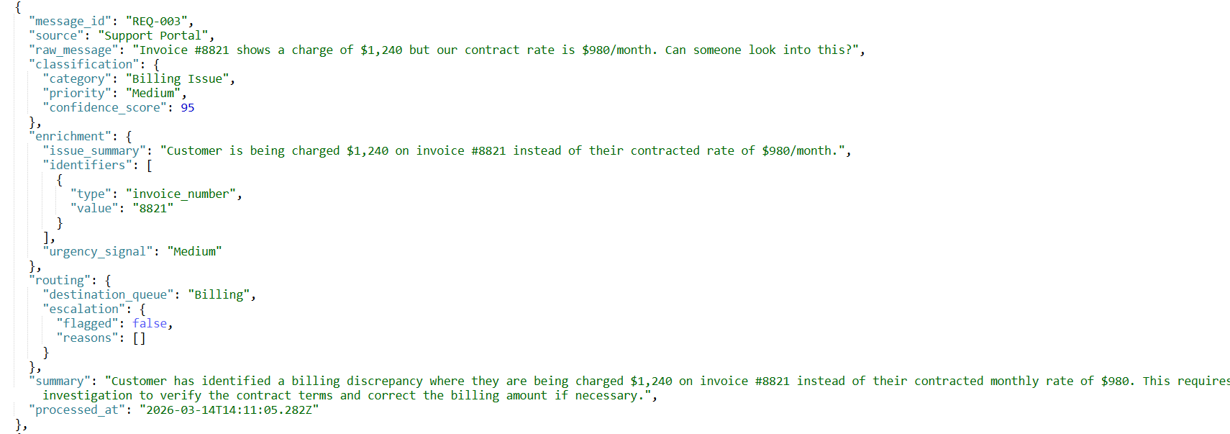

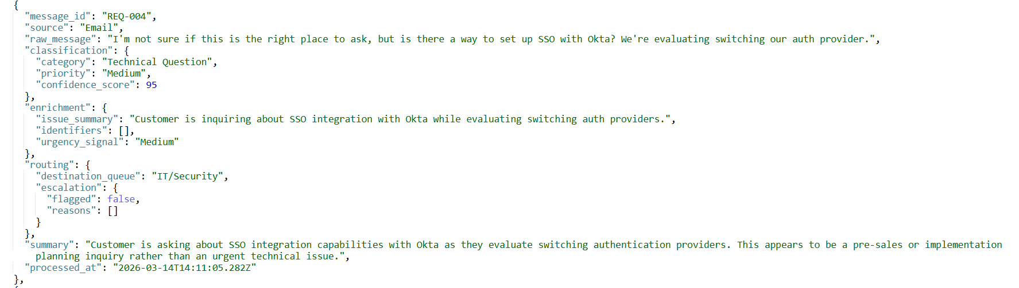
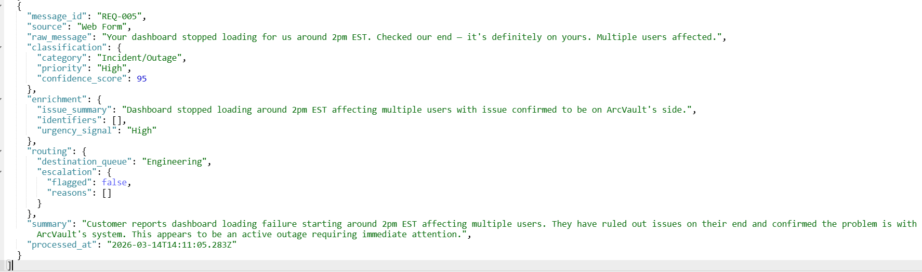

Screenshot – Escalation Check node output (showing REQ‑005 flagged true):

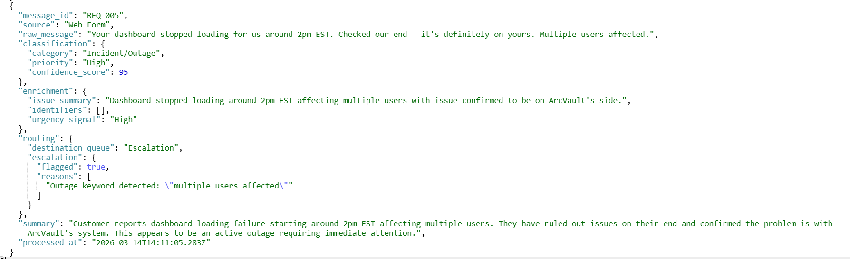

REQ-005 triggered the escalation rule because the message contains the phrase "multiple users affected", which indicates a potential system outage impacting several customers. According to the escalation policy, outage-related signals automatically escalate the request to the Escalation queue for immediate investigation by engineering.

The remaining requests were not escalated because they did not meet the escalation criteria:
- REQ-001 (Bug Report): High confidence classification with a single-user login issue. No outage indicators detected.
- REQ-002 (Feature Request): Normal product enhancement request with no urgency signals.
- REQ-003 (Billing Issue): The billing discrepancy was $260 ($1240 − $980), which is below the $500 escalation threshold defined in the policy.
- REQ-004 (Technical Question): Informational inquiry about SSO integration with no operational risk.

Screenshot – Write Output node final JSON:

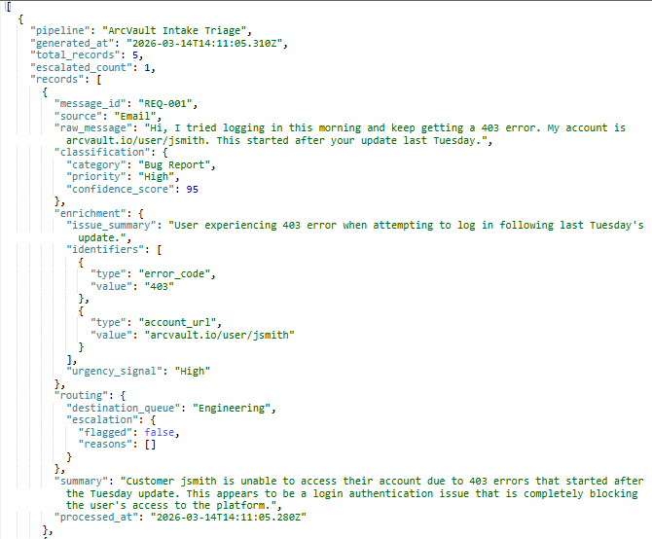
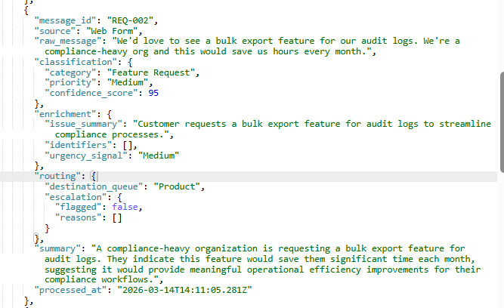
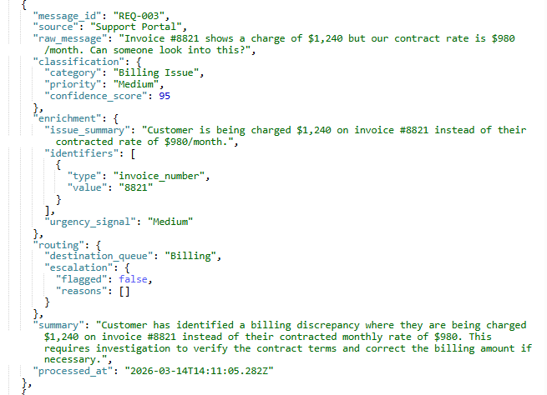
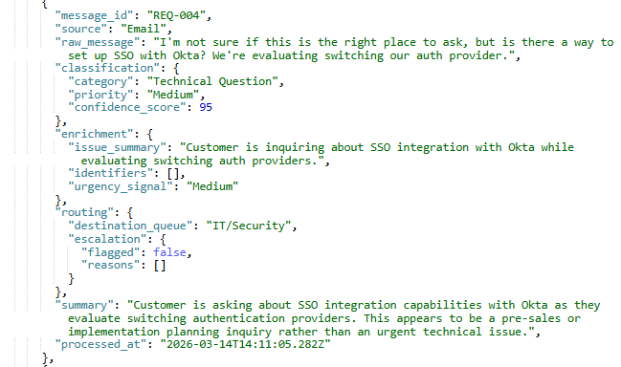
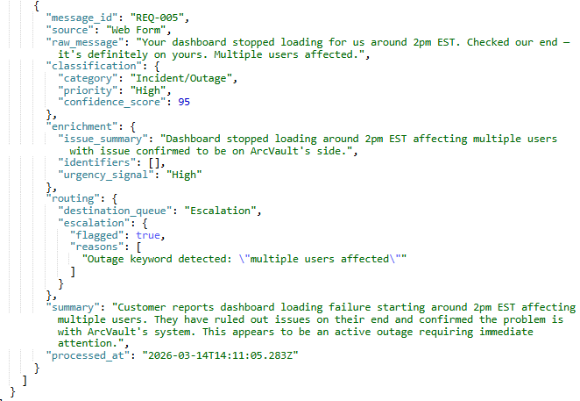

7.Limitations & Possible Improvements
This workflow was built using sample inputs to demonstrate the triage process. In a production environment, the ingestion step could be connected to live sources such as support emails, web forms, or support portals so that requests are processed automatically as they arrive.
The current escalation logic relies on simple keyword detection and thresholds. In a real system, this could be improved using historical support data or a configurable rules engine to better predict which cases require escalation.
Additional reliability measures could also be added, such as retry logic for the LLM API call and better error handling to ensure that failed requests are not lost.
Finally, instead of writing the results to a JSON file, the pipeline could be integrated directly with a ticketing system (such as Jira) or a database so that triaged requests automatically create support tickets.

8. Conclusion
The ArcVault intake triage pipeline successfully demonstrates an agentic workflow combining AI-driven classification with deterministic routing and escalation policies. The system automatically structures unstructured customer messages, extracts relevant identifiers, routes them to the correct operational teams, and escalates critical incidents such as system outages.

