Alpha Engine Platformer — Architecture Pipelines
This document captures the three control-flow views of the Project3_Platformer game built on the Alpha Engine: the game-state lifecycle, the per-frame update pipeline, and the enemy state machine.

1. Game-State Lifecycle (two nested loops)
WinMain runs two nested loops. The outer loop swaps game states; the inner loop runs a single state's frame cycle until the active state changes. Each state is driven through six swappable function pointers rebound by GameStateMgrUpdate(): Load, Init, Update, Draw, Free, and Unload.
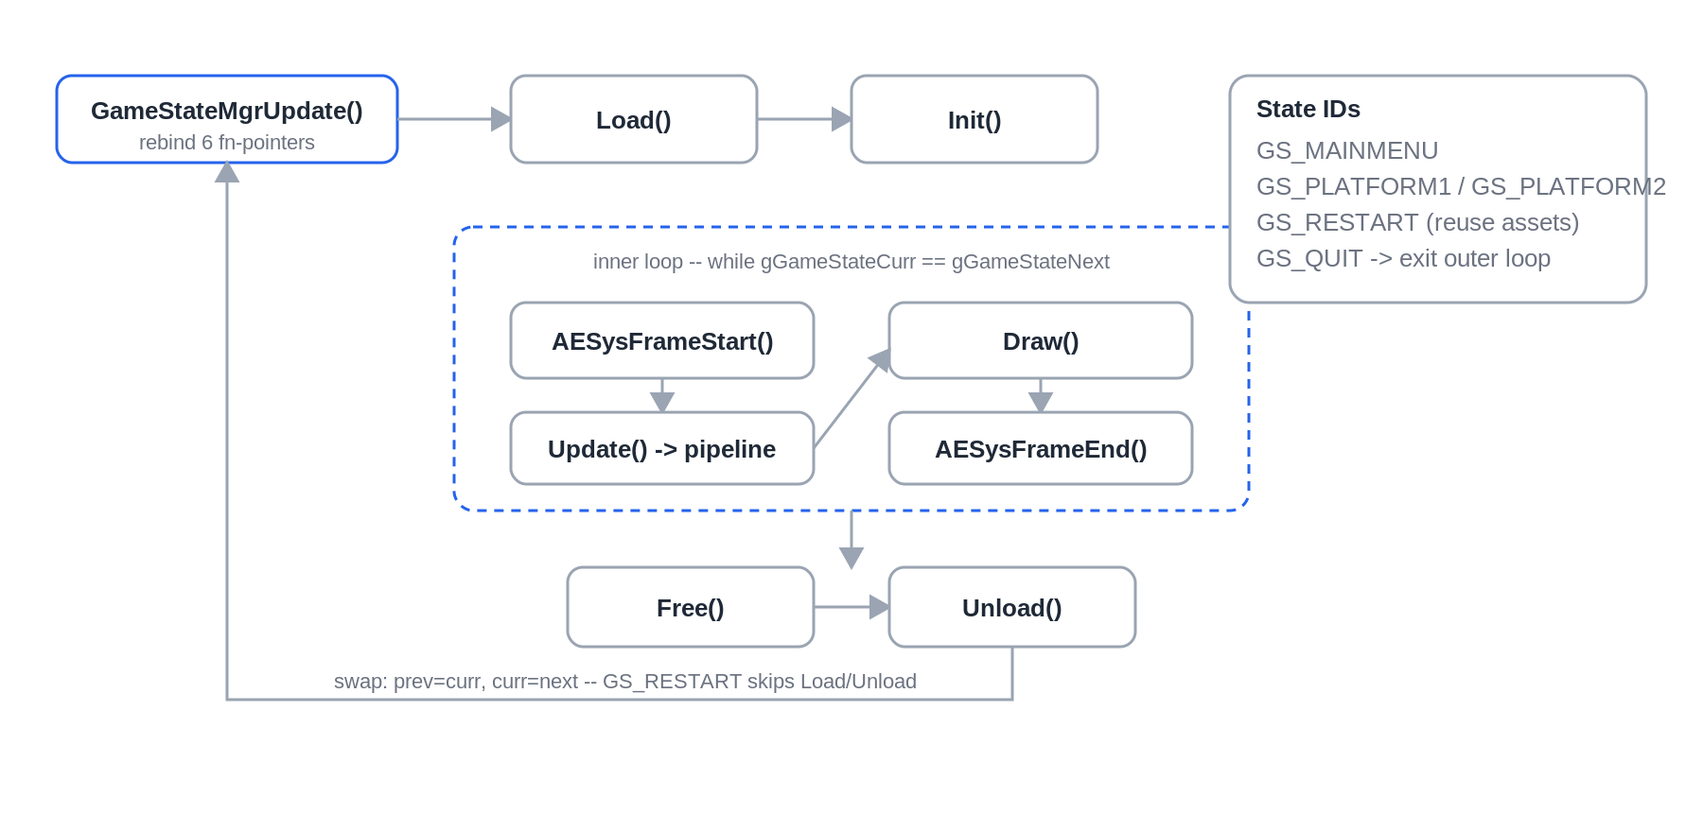
State IDs live in GameStateList.h: GS_MAINMENU, GS_PLATFORM1, GS_PLATFORM2, plus the special IDs GS_RESTART and GS_QUIT. GS_RESTART reuses already-loaded assets (skipping Load/Unload); GS_QUIT exits the outer loop and tears down the engine via AESysExit().

2. Per-Frame Update Pipeline
GameStatePlatformUpdate() runs every subsystem in a fixed order on a fixed timestep (g_dt = 0.01667, ~60 fps) for deterministic physics. The ordering is deliberate: positions are integrated first, then grid and AABB collisions resolve against the new positions, then transforms and camera update, and finally everything is drawn.
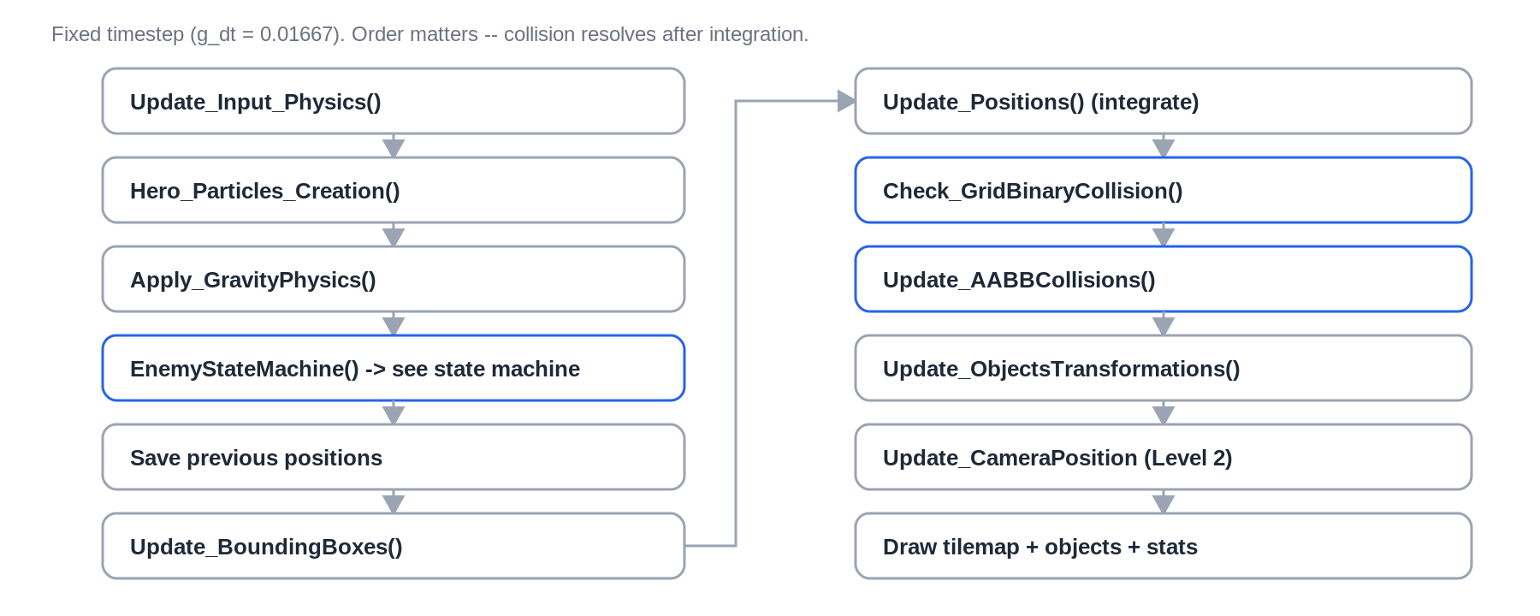
Collision is two-phase. Check_GridBinaryCollision() samples the BinaryCollisionArray tile grid for solid cells around each instance, and Update_AABBCollisions() performs swept AABB tests (a static overlap check, then a dynamic time-of-impact test) so fast movers do not tunnel through geometry.

3. Enemy State Machine
Enemies use a two-state machine — STATE_GOING_LEFT and STATE_GOING_RIGHT — with an inner-state cycle of ON_ENTER, ON_UPDATE, and ON_EXIT. Direction flips when a wall or floor edge is detected ahead, or after the enemy idles for ENEMY_IDLE_TIME (2 seconds), tracked by idle_counter.
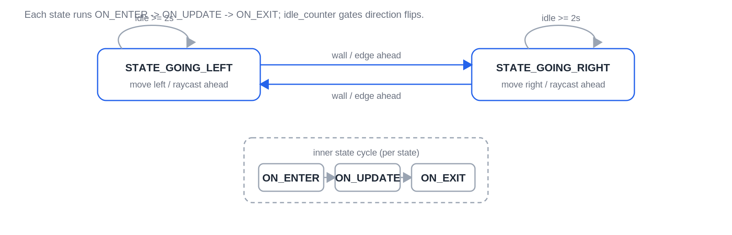
Each GameObjInst of type TYPE_OBJECT_ENEMY carries its own state, innerState, and idle_counter fields, so the machine is evaluated per-instance inside the update pipeline's enemy loop.

