EQ/MR 01: Measurement of radio frequency radiated emission test

Sample: |  |  | CRE2-2025-TP002-02
Project: | CRE2-2025-TP002 RESAC
Operator: |  | VA/FK, 17/02/2025 17:31:53
Test Configuration: |  |  |  |  | Antenna position:in front of harness, DUT Orientation:axis X, Housing connected to the ground plane:no, Configuration of the power return line LV:remotely grounded, -
Operating mode: |  |  |  | Mode 3, Conclusion : comply
GraphiqueEMIRE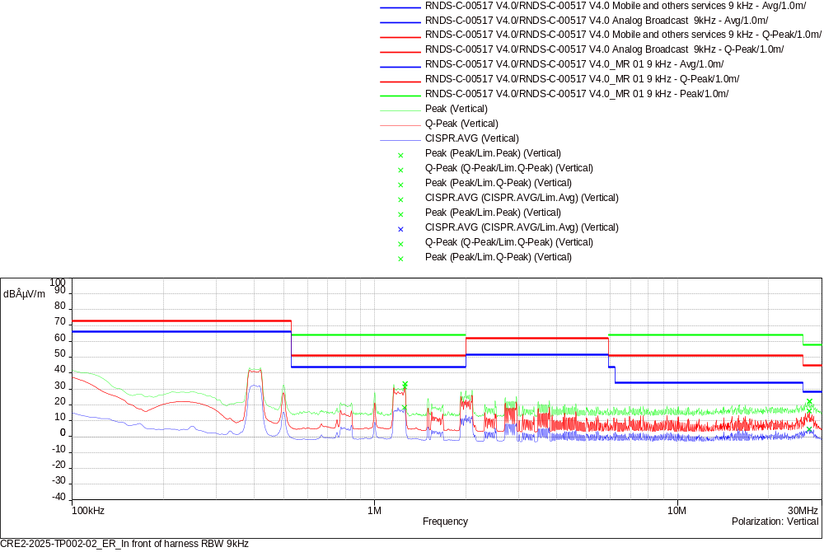
CISPR.AVG/Lim.Avg (2)
Frequency (MHz) | SR | CISPR.AVG (dBÂµV/m) | Lim.Avg (dBÂµV/m) | CISPR.AVG-Lim.Avg (dB) | Polarization | Correction (dB)
1.25425 | 1 | 18.35 | 44.00 | -25.65 | Vertical | 9.92
27.25975 | 2 | 4.57 | 28.00 | -23.43 | Vertical | 10.29

Peak/Lim.Q-Peak (2)
Frequency (MHz) | SR | Peak (dBÂµV/m) | Lim.Q-Peak (dBÂµV/m) | Peak-Lim.Q-Peak (dB) | Polarization | Correction (dB)
1.25875 | 1 | 33.25 | 51.00 | -17.75 | Vertical | 9.92
27.26875 | 2 | 22.15 | 45.00 | -22.85 | Vertical | 10.29

Q-Peak/Lim.Q-Peak (2)
Frequency (MHz) | SR | Q-Peak (dBÂµV/m) | Lim.Q-Peak (dBÂµV/m) | Q-Peak-Lim.Q-Peak (dB) | Polarization | Correction (dB)
1.2565 | 1 | 31.39 | 51.00 | -19.61 | Vertical | 9.92
27.25975 | 2 | 16.05 | 45.00 | -28.95 | Vertical | 10.29

Peak/Lim.Peak (2)
Frequency (MHz) | SR | Peak (dBÂµV/m) | Lim.Peak (dBÂµV/m) | Peak-Lim.Peak (dB) | Polarization | Correction (dB)
1.25875 | 1 | 33.25 | 64.00 | -30.75 | Vertical | 9.92
27.26875 | 2 | 22.15 | 58.00 | -35.85 | Vertical | 10.29

Test parameters
Name test: | CRE2-2025-TP002-02_ER_In front of harness RBW 9kHz

name | 100kHz-10MHz |  | filename | CRE2-2025-TP002-02_ER_In front of harness RBW 9kHz
step | 2.25kHz |  | pre-amplifier | OFF
set up | USE_CRE2_RESAC (A) 9kHz-30MHz_rod |  | number of sweeping | 3
RBW | 9kHz |  | dynamic | 120 dB
Span | 0.1 MHz |  | reference level | 70 dBµV
VBW | Auto |  | RF attenuation | 0 dB
sweep time | 1000 ms/Step |  | RF attenuation min
Maxhold | 5 s

name | 10MHz-30MHz |  | filename | CRE2-2025-TP002-02_ER_In front of harness RBW 9kHz
step | 2.25kHz |  | pre-amplifier | OFF
set up | USE_CRE2_RESAC (A) 9kHz-30MHz_rod |  | number of sweeping | 3
RBW | 9kHz |  | dynamic | 120 dB
Span | 0.1 MHz |  | reference level | 70 dBµV
VBW | Auto |  | RF attenuation | 0 dB
sweep time | 1000 ms/Step |  | RF attenuation min
Maxhold | 5 s
EQ/MR 01: Measurement of radio frequency radiated emission test

Sample: |  |  | CRE2-2025-TP002-02
Project: | CRE2-2025-TP002 RESAC
Operator: |  | NDN/WD, 17/02/2025 19:07:22
Test Configuration: |  |  |  |  | Antenna position:in front of harness, DUT Orientation:axis X, Housing connected to the ground plane:no, Configuration of the power return line LV:remotely grounded, -
Operating mode: |  |  |  | Mode 3, Conclusion : comply
GraphiqueEMIRE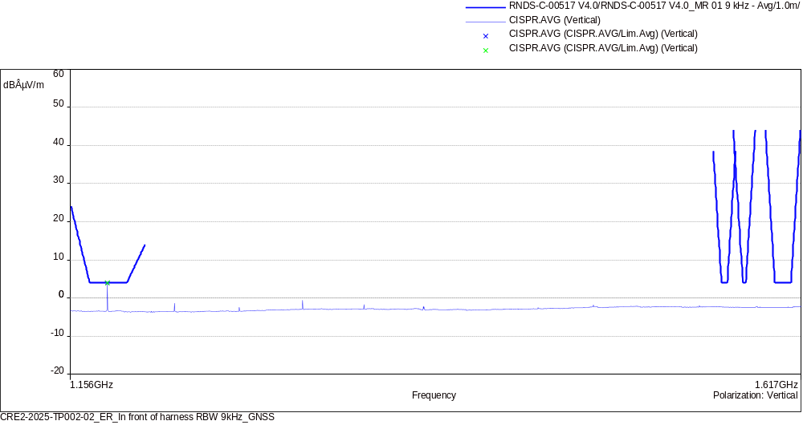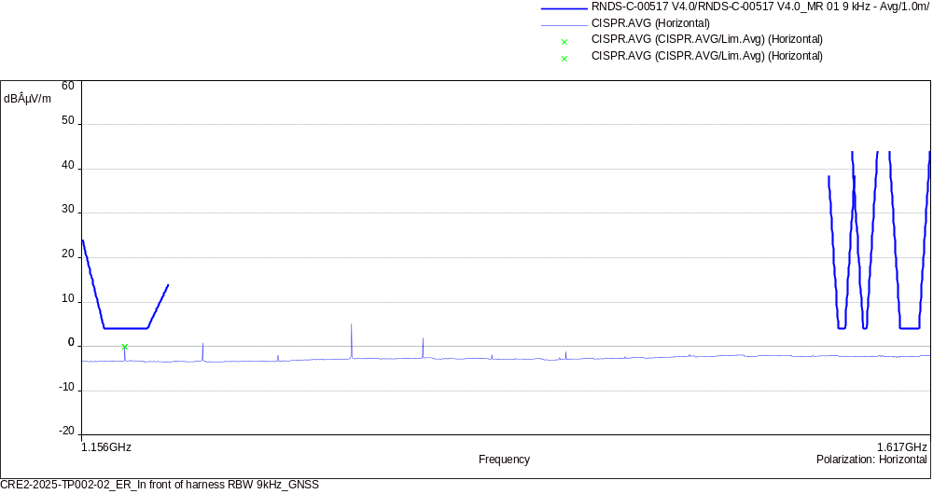
CISPR.AVG/Lim.Avg (2)
Frequency (MHz) | SR | CISPR.AVG (dBÂµV/m) | Lim.Avg (dBÂµV/m) | CISPR.AVG-Lim.Avg (dB) | Polarization | Correction (dB)
1175.91025 | 1 | 3.99 | 4.00 | -0.01 | Vertical | 20.75
1175.9125 | 2 | -0.12 | 4.00 | -4.12 | Horizontal | 20.75

Test parameters
Name test: | CRE2-2025-TP002-02_ER_In front of harness RBW 9kHz_GNSS

name | 1.156GHz-1.617GHz |  | filename | CRE2-2025-TP002-02_ER_In front of harness RBW 9kHz_GNSS
step | 2.25kHz |  | pre-amplifier | ON
set up | USE_CRE2_RESAC (A) 1.1-1.7GHz_GPS_horn |  | number of sweeping | 3
RBW | 9kHz |  | dynamic | 120 dB
Span | 0.1 MHz |  | reference level | 70 dBµV
VBW | Auto |  | RF attenuation | 0 dB
sweep time | 1000 ms/Step |  | RF attenuation min
Maxhold | 5 s

name | 1.156GHz-1.617GHz |  | filename | CRE2-2025-TP002-02_ER_In front of harness RBW 9kHz_GNSS
step | 2.25kHz |  | pre-amplifier | ON
set up | USE_CRE2_RESAC (A) 1.1-1.7GHz_GPS_horn |  | number of sweeping | 3
RBW | 9kHz |  | dynamic | 120 dB
Span | 0.1 MHz |  | reference level | 70 dBµV
VBW | Auto |  | RF attenuation | 0 dB
sweep time | 1000 ms/Step |  | RF attenuation min
Maxhold | 5 s
EQ/MR 01: Measurement of radio frequency radiated emission test

Sample: |  |  | CRE2-2025-TP002-02
Project: | CRE2-2025-TP002 RESAC
Operator: |  | NDN/WD, 17/02/2025 19:42:32
Test Configuration: |  |  |  |  | Antenna position:in front of harness, DUT Orientation:axis X, Housing connected to the ground plane:no, Configuration of the power return line LV:remotely grounded, -
Operating mode: |  |  |  | Mode 3, Conclusion : comply
GraphiqueEMIRE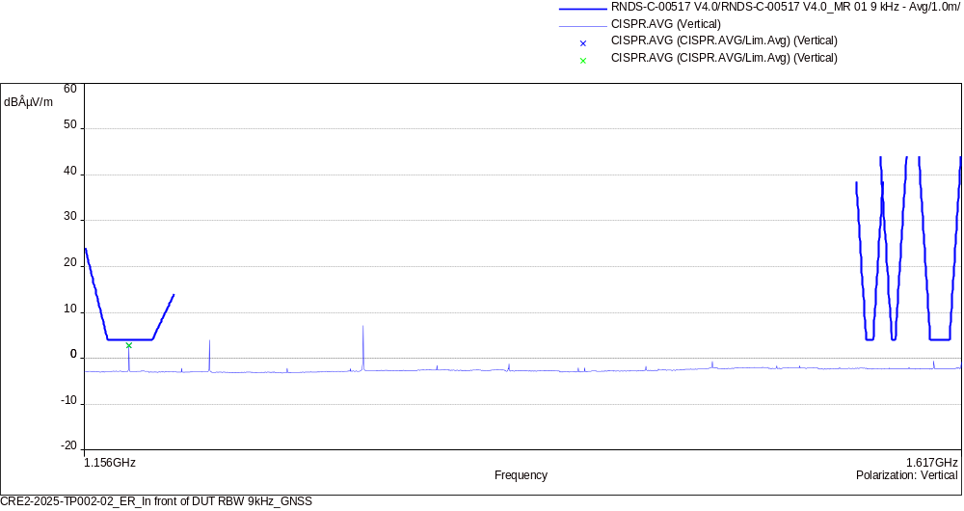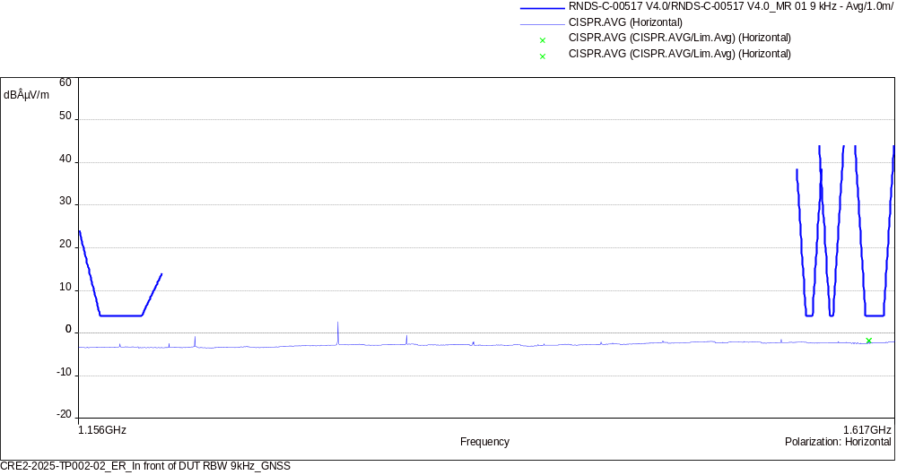
CISPR.AVG/Lim.Avg (2)
Frequency (MHz) | SR | CISPR.AVG (dBÂµV/m) | Lim.Avg (dBÂµV/m) | CISPR.AVG-Lim.Avg (dB) | Polarization | Correction (dB)
1175.908 | 1 | 2.85 | 4.00 | -1.15 | Vertical | 20.75
1599.8755 | 2 | -1.79 | 4.00 | -5.79 | Horizontal | 21.58

Test parameters
Name test: | CRE2-2025-TP002-02_ER_In front of DUT RBW 9kHz_GNSS

name | 1.156GHz-1.617GHz |  | filename | CRE2-2025-TP002-02_ER_In front of DUT RBW 9kHz_GNSS
step | 2.25kHz |  | pre-amplifier | ON
set up | USE_CRE2_RESAC (A) 1.1-1.7GHz_GPS_horn |  | number of sweeping | 3
RBW | 9kHz |  | dynamic | 120 dB
Span | 0.1 MHz |  | reference level | 70 dBµV
VBW | Auto |  | RF attenuation | 0 dB
sweep time | 1000 ms/Step |  | RF attenuation min
Maxhold | 5 s

name | 1.156GHz-1.617GHz |  | filename | CRE2-2025-TP002-02_ER_In front of DUT RBW 9kHz_GNSS
step | 2.25kHz |  | pre-amplifier | ON
set up | USE_CRE2_RESAC (A) 1.1-1.7GHz_GPS_horn |  | number of sweeping | 3
RBW | 9kHz |  | dynamic | 120 dB
Span | 0.1 MHz |  | reference level | 70 dBµV
VBW | Auto |  | RF attenuation | 0 dB
sweep time | 1000 ms/Step |  | RF attenuation min
Maxhold | 5 s
EQ/MR 01: Measurement of radio frequency radiated emission test

Sample: |  |  | CRE2-2025-TP002-02
Project: | CRE2-2025-TP002 RESAC
Operator: |  | VA/FK, 18/02/2025 16:36:12
Test Configuration: |  |  |  |  | Antenna position:in front of harness, DUT Orientation:axis X, Housing connected to the ground plane:no, Configuration of the power return line LV:remotely grounded, -
Operating mode: |  |  |  | Mode 3, Conclusion : comply
GraphiqueEMIRE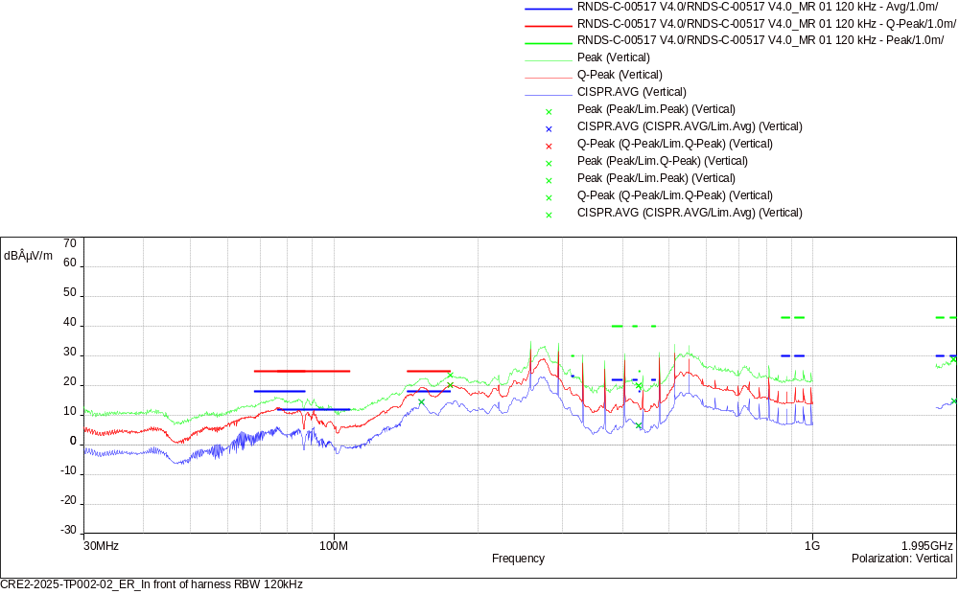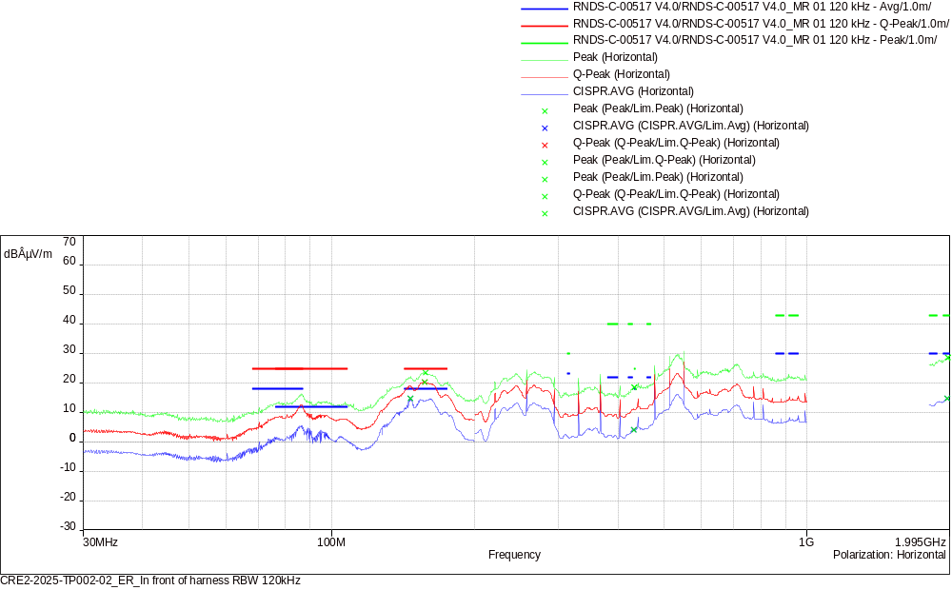
CISPR.AVG/Lim.Avg (6)
Frequency (MHz) | SR | CISPR.AVG (dBÂµV/m) | Lim.Avg (dBÂµV/m) | CISPR.AVG-Lim.Avg (dB) | Polarization | Correction (dB)
152.22 | 1 | 14.43 | 18.00 | -3.57 | Vertical | -15.19
146.31 | 2 | 14.69 | 18.00 | -3.31 | Horizontal | -15.49
432.02 | 3 | 6.42 | 18.00 | -11.58 | Vertical | -10.22
432.2 | 4 | 4.06 | 18.00 | -13.94 | Horizontal | -10.21
1972.04 | 5 | 14.69 | 30.00 | -15.31 | Vertical | 6.12
1971.77 | 6 | 14.62 | 30.00 | -15.38 | Horizontal | 6.12

Q-Peak/Lim.Q-Peak (2)
Frequency (MHz) | SR | Q-Peak (dBÂµV/m) | Lim.Q-Peak (dBÂµV/m) | Q-Peak-Lim.Q-Peak (dB) | Polarization | Correction (dB)
174.9 | 1 | 20.12 | 25.00 | -4.88 | Vertical | -14.22
156.81 | 2 | 20.23 | 25.00 | -4.77 | Horizontal | -14.95

Peak/Lim.Peak (4)
Frequency (MHz) | SR | Peak (dBÂµV/m) | Lim.Peak (dBÂµV/m) | Peak-Lim.Peak (dB) | Polarization | Correction (dB)
432.11 | 3 | 19.97 | 25.00 | -5.03 | Vertical | -10.21
432.92 | 4 | 18.50 | 25.00 | -6.50 | Horizontal | -10.17
1966.31 | 5 | 28.85 | 43.00 | -14.15 | Vertical | 6.07
1980.17 | 6 | 28.54 | 43.00 | -14.46 | Horizontal | 6.19

Test parameters
Name test: | CRE2-2025-TP002-02_ER_In front of harness RBW 120kHz

name | 30MHz-200MHz |  | filename | CRE2-2025-TP002-02_ER_In front of harness RBW 120kHz
step | 30kHz |  | pre-amplifier | OFF
set up | USE_CRE2_RESAC (A) 20MHz-300MHz_biconical with preamp |  | number of sweeping | 3
RBW | 120kHz |  | dynamic | 120 dB
Span | 0.1 MHz |  | reference level | 70 dBµV
VBW | Auto |  | RF attenuation | 0 dB
sweep time | 1000 ms/Step |  | RF attenuation min
Maxhold | 5 s

name | 30MHz-200MHz |  | filename | CRE2-2025-TP002-02_ER_In front of harness RBW 120kHz
step | 30kHz |  | pre-amplifier | OFF
set up | USE_CRE2_RESAC (A) 20MHz-300MHz_biconical with preamp |  | number of sweeping | 3
RBW | 120kHz |  | dynamic | 120 dB
Span | 0.1 MHz |  | reference level | 70 dBµV
VBW | Auto |  | RF attenuation | 0 dB
sweep time | 1000 ms/Step |  | RF attenuation min
Maxhold | 5 s

name | 200MHz-1GHz |  | filename | CRE2-2025-TP002-02_ER_In front of harness RBW 120kHz
step | 30kHz |  | pre-amplifier | OFF
set up | USE_CRE2_RESAC (A) 200MHz-2GHz_log-periodic with preamp |  | number of sweeping | 3
RBW | 120kHz |  | dynamic | 120 dB
Span | 0.1 MHz |  | reference level | 70 dBµV
VBW | Auto |  | RF attenuation | 0 dB
sweep time | 1000 ms/Step |  | RF attenuation min
Maxhold | 5 s

name | 200MHz-1GHz |  | filename | CRE2-2025-TP002-02_ER_In front of harness RBW 120kHz
step | 30kHz |  | pre-amplifier | OFF
set up | USE_CRE2_RESAC (A) 200MHz-2GHz_log-periodic with preamp |  | number of sweeping | 3
RBW | 120kHz |  | dynamic | 120 dB
Span | 0.1 MHz |  | reference level | 70 dBµV
VBW | Auto |  | RF attenuation | 0 dB
sweep time | 1000 ms/Step |  | RF attenuation min
Maxhold | 5 s

name | 1.805GHz-1.995GHz |  | filename | CRE2-2025-TP002-02_ER_In front of harness RBW 120kHz
step | 30kHz |  | pre-amplifier | OFF
set up | USE_CRE2_RESAC (A) 200MHz-2GHz_log-periodic with preamp |  | number of sweeping | 3
RBW | 120kHz |  | dynamic | 120 dB
Span | 0.1 MHz |  | reference level | 70 dBµV
VBW | Auto |  | RF attenuation | 0 dB
sweep time | 1000 ms/Step |  | RF attenuation min
Maxhold | 5 s

name | 1.805GHz-1.995GHz |  | filename | CRE2-2025-TP002-02_ER_In front of harness RBW 120kHz
step | 30kHz |  | pre-amplifier | OFF
set up | USE_CRE2_RESAC (A) 200MHz-2GHz_log-periodic with preamp |  | number of sweeping | 3
RBW | 120kHz |  | dynamic | 120 dB
Span | 0.1 MHz |  | reference level | 70 dBµV
VBW | Auto |  | RF attenuation | 0 dB
sweep time | 1000 ms/Step |  | RF attenuation min
Maxhold | 5 s
EQ/MR 01: Measurement of radio frequency radiated emission test

Sample: |  |  | CRE2-2025-TP002-02
Project: | CRE2-2025-TP002 RESAC
Operator: |  | VA/FK, 18/02/2025 16:40:27
Test Configuration: |  |  |  |  | Antenna position:in front of harness, DUT Orientation:axis X, Housing connected to the ground plane:no, Configuration of the power return line LV:remotely grounded, -
Operating mode: |  |  |  | Mode 3, Conclusion : not comply
GraphiqueEMIRE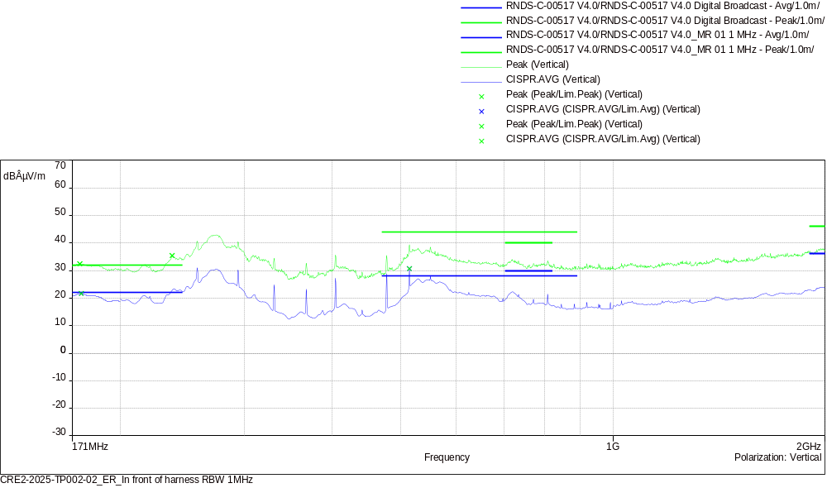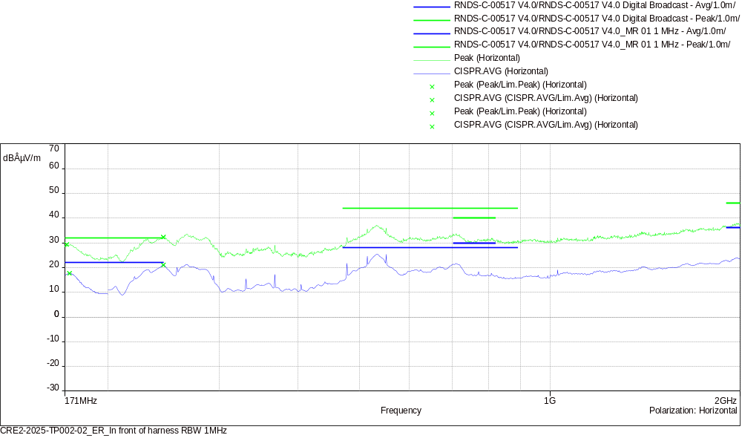
CISPR.AVG/Lim.Avg (4)
Frequency (MHz) | SR | CISPR.AVG (dBÂµV/m) | Lim.Avg (dBÂµV/m) | CISPR.AVG-Lim.Avg (dB) | Polarization | Correction (dB)
176 | 1 | 21.63 | 22.00 | -0.37 | Vertical | -14.18
174 | 2 | 17.68 | 22.00 | -4.32 | Horizontal | -14.25
514.5 | 3 | 30.69 | 28.00 | 2.69 | Vertical | -8.37
244.75 | 4 | 21.00 | 22.00 | -1.00 | Horizontal | -14.50

Peak/Lim.Peak (4)
Frequency (MHz) | SR | Peak (dBÂµV/m) | Lim.Peak (dBÂµV/m) | Peak-Lim.Peak (dB) | Polarization | Correction (dB)
175.25 | 1 | 32.46 | 32.00 | 0.46 | Vertical | -14.21
172.25 | 2 | 29.33 | 32.00 | -2.67 | Horizontal | -14.32
237 | 3 | 35.40 | 32.00 | 3.40 | Vertical | -14.25
244.75 | 4 | 32.32 | 32.00 | 0.32 | Horizontal | -14.50

Test parameters
Name test: | CRE2-2025-TP002-02_ER_In front of harness RBW 1MHz

name | 171MHz-200MHz |  | filename | CRE2-2025-TP002-02_ER_In front of harness RBW 1MHz
step | 250kHz |  | pre-amplifier | OFF
set up | USE_CRE2_RESAC (A) 20MHz-300MHz_biconical with preamp |  | number of sweeping | 3
RBW | 1MHz |  | dynamic | 120 dB
Span | 0.1 MHz |  | reference level | 70 dBµV
VBW | Auto |  | RF attenuation | 0 dB
sweep time | 1000 ms/Step |  | RF attenuation min
Maxhold | 5 s

name | 171MHz-200MHz |  | filename | CRE2-2025-TP002-02_ER_In front of harness RBW 1MHz
step | 250kHz |  | pre-amplifier | OFF
set up | USE_CRE2_RESAC (A) 20MHz-300MHz_biconical with preamp |  | number of sweeping | 3
RBW | 1MHz |  | dynamic | 120 dB
Span | 0.1 MHz |  | reference level | 70 dBµV
VBW | Auto |  | RF attenuation | 0 dB
sweep time | 1000 ms/Step |  | RF attenuation min
Maxhold | 5 s

name | 200MHz-2GHz |  | filename | CRE2-2025-TP002-02_ER_In front of harness RBW 1MHz
step | 250kHz |  | pre-amplifier | OFF
set up | USE_CRE2_RESAC (A) 200MHz-2GHz_log-periodic with preamp |  | number of sweeping | 3
RBW | 1MHz |  | dynamic | 120 dB
Span | 0.1 MHz |  | reference level | 70 dBµV
VBW | Auto |  | RF attenuation | 0 dB
sweep time | 1000 ms/Step |  | RF attenuation min
Maxhold | 5 s

name | 200MHz-2GHz |  | filename | CRE2-2025-TP002-02_ER_In front of harness RBW 1MHz
step | 250kHz |  | pre-amplifier | OFF
set up | USE_CRE2_RESAC (A) 200MHz-2GHz_log-periodic with preamp |  | number of sweeping | 3
RBW | 1MHz |  | dynamic | 120 dB
Span | 0.1 MHz |  | reference level | 70 dBµV
VBW | Auto |  | RF attenuation | 0 dB
sweep time | 1000 ms/Step |  | RF attenuation min
Maxhold | 5 s
EQ/MR 01: Measurement of radio frequency radiated emission test

Sample: |  |  | CRE2-2025-TP002-02
Project: | CRE2-2025-TP002 RESAC
Operator: |  | VA/FK, 18/02/2025 16:13:21
Test Configuration: |  |  |  |  | Antenna position:in front of DUT, DUT Orientation:axis X, Housing connected to the ground plane:no, Configuration of the power return line LV:remotely grounded, -
Operating mode: |  |  |  | Mode 3, Conclusion : not comply
GraphiqueEMIRE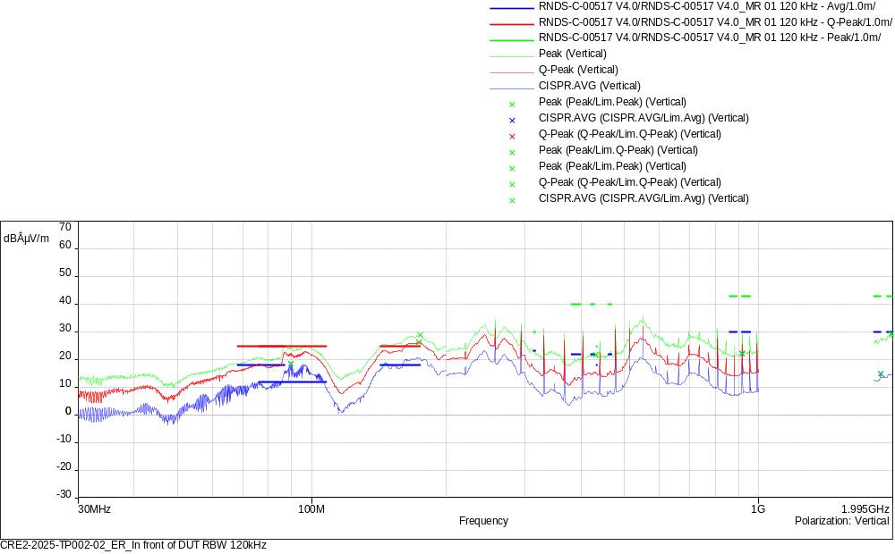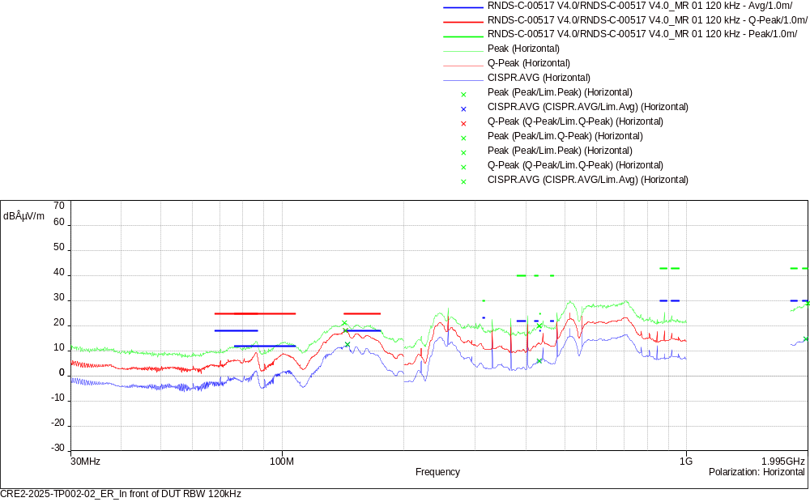
CISPR.AVG/Lim.Avg (6)
Frequency (MHz) | SR | CISPR.AVG (dBÂµV/m) | Lim.Avg (dBÂµV/m) | CISPR.AVG-Lim.Avg (dB) | Polarization | Correction (dB)
89.7 | 1 | 18.52 | 12.00 | 6.52 | Vertical | -18.58
145.05 | 2 | 12.50 | 18.00 | -5.50 | Horizontal | -15.56
918.68 | 3 | 22.13 | 30.00 | -7.87 | Vertical | -2.65
432.11 | 4 | 5.95 | 18.00 | -12.05 | Horizontal | -10.21
1874.12 | 5 | 14.77 | 30.00 | -15.23 | Vertical | 4.63
1972.19 | 6 | 14.66 | 30.00 | -15.34 | Horizontal | 6.12

Q-Peak/Lim.Q-Peak (2)
Frequency (MHz) | SR | Q-Peak (dBÂµV/m) | Lim.Q-Peak (dBÂµV/m) | Q-Peak-Lim.Q-Peak (dB) | Polarization | Correction (dB)
173.91 | 1 | 26.17 | 25.00 | 1.17 | Vertical | -14.26
143.34 | 2 | 17.99 | 25.00 | -7.01 | Horizontal | -15.65

Peak/Lim.Peak (4)
Frequency (MHz) | SR | Peak (dBÂµV/m) | Lim.Peak (dBÂµV/m) | Peak-Lim.Peak (dB) | Polarization | Correction (dB)
432.47 | 3 | 21.76 | 25.00 | -3.24 | Vertical | -10.20
432.38 | 4 | 19.98 | 25.00 | -5.02 | Horizontal | -10.20
1978.79 | 5 | 29.31 | 43.00 | -13.69 | Vertical | 6.18
1994.54 | 6 | 28.95 | 43.00 | -14.05 | Horizontal | 6.32

Test parameters
Name test: | CRE2-2025-TP002-02_ER_In front of DUT RBW 120kHz

name | 30MHz-200MHz |  | filename | CRE2-2025-TP002-02_ER_In front of DUT RBW 120kHz
step | 30kHz |  | pre-amplifier | OFF
set up | USE_CRE2_RESAC (A) 20MHz-300MHz_biconical with preamp |  | number of sweeping | 3
RBW | 120kHz |  | dynamic | 120 dB
Span | 0.1 MHz |  | reference level | 70 dBµV
VBW | Auto |  | RF attenuation | 0 dB
sweep time | 1000 ms/Step |  | RF attenuation min
Maxhold | 5 s

name | 30MHz-200MHz |  | filename | CRE2-2025-TP002-02_ER_In front of DUT RBW 120kHz
step | 30kHz |  | pre-amplifier | OFF
set up | USE_CRE2_RESAC (A) 20MHz-300MHz_biconical with preamp |  | number of sweeping | 3
RBW | 120kHz |  | dynamic | 120 dB
Span | 0.1 MHz |  | reference level | 70 dBµV
VBW | Auto |  | RF attenuation | 0 dB
sweep time | 1000 ms/Step |  | RF attenuation min
Maxhold | 5 s

name | 200MHz-1GHz |  | filename | CRE2-2025-TP002-02_ER_In front of DUT RBW 120kHz
step | 30kHz |  | pre-amplifier | OFF
set up | USE_CRE2_RESAC (A) 200MHz-2GHz_log-periodic with preamp |  | number of sweeping | 3
RBW | 120kHz |  | dynamic | 120 dB
Span | 0.1 MHz |  | reference level | 70 dBµV
VBW | Auto |  | RF attenuation | 0 dB
sweep time | 1000 ms/Step |  | RF attenuation min
Maxhold | 5 s

name | 200MHz-1GHz |  | filename | CRE2-2025-TP002-02_ER_In front of DUT RBW 120kHz
step | 30kHz |  | pre-amplifier | OFF
set up | USE_CRE2_RESAC (A) 200MHz-2GHz_log-periodic with preamp |  | number of sweeping | 3
RBW | 120kHz |  | dynamic | 120 dB
Span | 0.1 MHz |  | reference level | 70 dBµV
VBW | Auto |  | RF attenuation | 0 dB
sweep time | 1000 ms/Step |  | RF attenuation min
Maxhold | 5 s

name | 1.805GHz-1.995GHz |  | filename | CRE2-2025-TP002-02_ER_In front of DUT RBW 120kHz
step | 30kHz |  | pre-amplifier | OFF
set up | USE_CRE2_RESAC (A) 200MHz-2GHz_log-periodic with preamp |  | number of sweeping | 3
RBW | 120kHz |  | dynamic | 120 dB
Span | 0.1 MHz |  | reference level | 70 dBµV
VBW | Auto |  | RF attenuation | 0 dB
sweep time | 1000 ms/Step |  | RF attenuation min
Maxhold | 5 s

name | 1.805GHz-1.995GHz |  | filename | CRE2-2025-TP002-02_ER_In front of DUT RBW 120kHz
step | 30kHz |  | pre-amplifier | OFF
set up | USE_CRE2_RESAC (A) 200MHz-2GHz_log-periodic with preamp |  | number of sweeping | 3
RBW | 120kHz |  | dynamic | 120 dB
Span | 0.1 MHz |  | reference level | 70 dBµV
VBW | Auto |  | RF attenuation | 0 dB
sweep time | 1000 ms/Step |  | RF attenuation min
Maxhold | 5 s
EQ/MR 01: Measurement of radio frequency radiated emission test

Sample: |  |  | CRE2-2025-TP002-02
Project: | CRE2-2025-TP002 RESAC
Operator: |  | NDN/WD, 18/02/2025 16:30:13
Test Configuration: |  |  |  |  | Antenna position:in front of DUT, DUT Orientation:axis X, Housing connected to the ground plane:no, Configuration of the power return line LV:remotely grounded, -
Operating mode: |  |  |  | Mode 3, Conclusion : not comply
GraphiqueEMIRE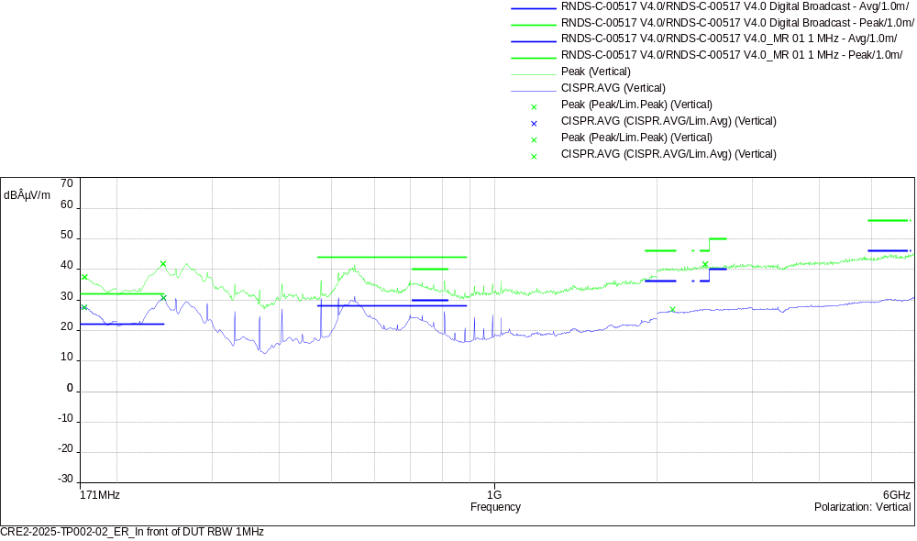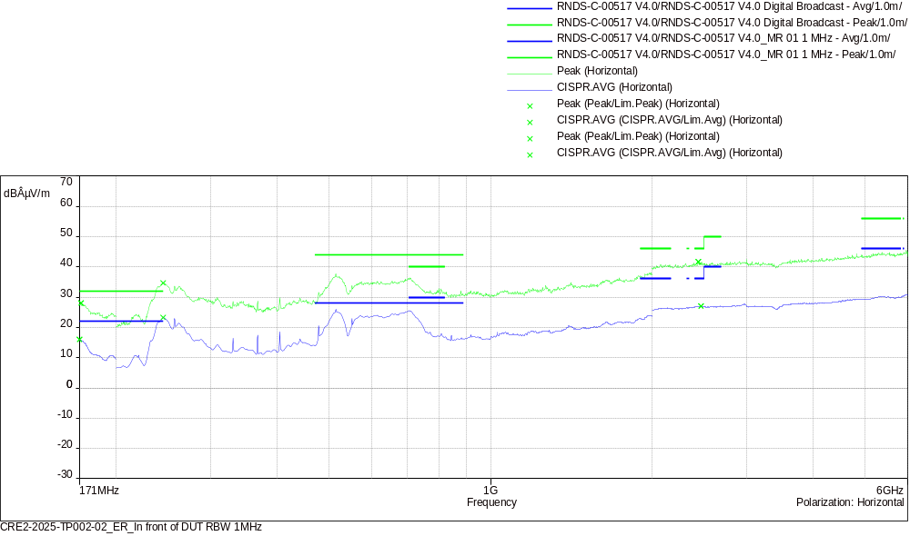
CISPR.AVG/Lim.Avg (6)
Frequency (MHz) | SR | CISPR.AVG (dBÂµV/m) | Lim.Avg (dBÂµV/m) | CISPR.AVG-Lim.Avg (dB) | Polarization | Correction (dB)
174 | 1 | 27.58 | 22.00 | 5.58 | Vertical | -14.25
171 | 2 | 15.98 | 22.00 | -6.02 | Horizontal | -14.36
244 | 3 | 30.70 | 22.00 | 8.70 | Vertical | -14.47
245 | 4 | 23.23 | 22.00 | 1.23 | Horizontal | -14.52
2137.5 | 5 | 26.96 | 36.00 | -9.04 | Vertical | 8.85
2467.25 | 6 | 26.99 | 36.00 | -9.01 | Horizontal | 9.85

Peak/Lim.Peak (6)
Frequency (MHz) | SR | Peak (dBÂµV/m) | Lim.Peak (dBÂµV/m) | Peak-Lim.Peak (dB) | Polarization | Correction (dB)
174.25 | 1 | 37.38 | 32.00 | 5.38 | Vertical | -14.24
172 | 2 | 28.02 | 32.00 | -3.98 | Horizontal | -14.32
243.75 | 3 | 41.78 | 32.00 | 9.78 | Vertical | -14.47
245 | 4 | 34.64 | 32.00 | 2.64 | Horizontal | -14.52
2457.75 | 5 | 41.70 | 46.00 | -4.30 | Vertical | 9.87
2441.5 | 6 | 41.65 | 46.00 | -4.35 | Horizontal | 9.87

Test parameters
Name test: | CRE2-2025-TP002-02_ER_In front of DUT RBW 1MHz

name | 171MHz-200MHz |  | filename | CRE2-2025-TP002-02_ER_In front of DUT RBW 1MHz
step | 250kHz |  | pre-amplifier | OFF
set up | USE_CRE2_RESAC (A) 20MHz-300MHz_biconical with preamp |  | number of sweeping | 3
RBW | 1MHz |  | dynamic | 120 dB
Span | 0.1 MHz |  | reference level | 70 dBµV
VBW | Auto |  | RF attenuation | 0 dB
sweep time | 1000 ms/Step |  | RF attenuation min
Maxhold | 5 s

name | 171MHz-200MHz |  | filename | CRE2-2025-TP002-02_ER_In front of DUT RBW 1MHz
step | 250kHz |  | pre-amplifier | OFF
set up | USE_CRE2_RESAC (A) 20MHz-300MHz_biconical with preamp |  | number of sweeping | 3
RBW | 1MHz |  | dynamic | 120 dB
Span | 0.1 MHz |  | reference level | 70 dBµV
VBW | Auto |  | RF attenuation | 0 dB
sweep time | 1000 ms/Step |  | RF attenuation min
Maxhold | 5 s

name | 200MHz-2GHz |  | filename | CRE2-2025-TP002-02_ER_In front of DUT RBW 1MHz
step | 250kHz |  | pre-amplifier | OFF
set up | USE_CRE2_RESAC (A) 200MHz-2GHz_log-periodic with preamp |  | number of sweeping | 3
RBW | 1MHz |  | dynamic | 120 dB
Span | 0.1 MHz |  | reference level | 70 dBµV
VBW | Auto |  | RF attenuation | 0 dB
sweep time | 1000 ms/Step |  | RF attenuation min
Maxhold | 5 s

name | 200MHz-2GHz |  | filename | CRE2-2025-TP002-02_ER_In front of DUT RBW 1MHz
step | 250kHz |  | pre-amplifier | OFF
set up | USE_CRE2_RESAC (A) 200MHz-2GHz_log-periodic with preamp |  | number of sweeping | 3
RBW | 1MHz |  | dynamic | 120 dB
Span | 0.1 MHz |  | reference level | 70 dBµV
VBW | Auto |  | RF attenuation | 0 dB
sweep time | 1000 ms/Step |  | RF attenuation min
Maxhold | 5 s

name | 2GHz-6GHz |  | filename | CRE2-2025-TP002-02_ER_In front of DUT RBW 1MHz
step | 250kHz |  | pre-amplifier | OFF
set up | USE_CRE2_RESAC (A) 1-7GHz_horn with preamp |  | number of sweeping | 3
RBW | 1MHz |  | dynamic | 120 dB
Span | 0.1 MHz |  | reference level | 70 dBµV
VBW | Auto |  | RF attenuation | 0 dB
sweep time | 1000 ms/Step |  | RF attenuation min
Maxhold | 5 s

name | 2GHz-6GHz |  | filename | CRE2-2025-TP002-02_ER_In front of DUT RBW 1MHz
step | 250kHz |  | pre-amplifier | OFF
set up | USE_CRE2_RESAC (A) 1-7GHz_horn with preamp |  | number of sweeping | 3
RBW | 1MHz |  | dynamic | 120 dB
Span | 0.1 MHz |  | reference level | 70 dBµV
VBW | Auto |  | RF attenuation | 0 dB
sweep time | 1000 ms/Step |  | RF attenuation min
Maxhold | 5 s
EQ/MR 01: Measurement of radio frequency radiated emission test

Sample: |  |  | CRE2-2025-TP002-02
Project: | CRE2-2025-TP002 RESAC
Operator: |  | NDN/WD, 18/02/2025 07:43:05
Test Configuration: |  |  |  |  | Antenna position:in front of harness, DUT Orientation:axis X, Housing connected to the ground plane:no, Configuration of the power return line LV:remotely grounded, -
Operating mode: |  |  |  | Mode 3, Conclusion : comply
GraphiqueEMIRE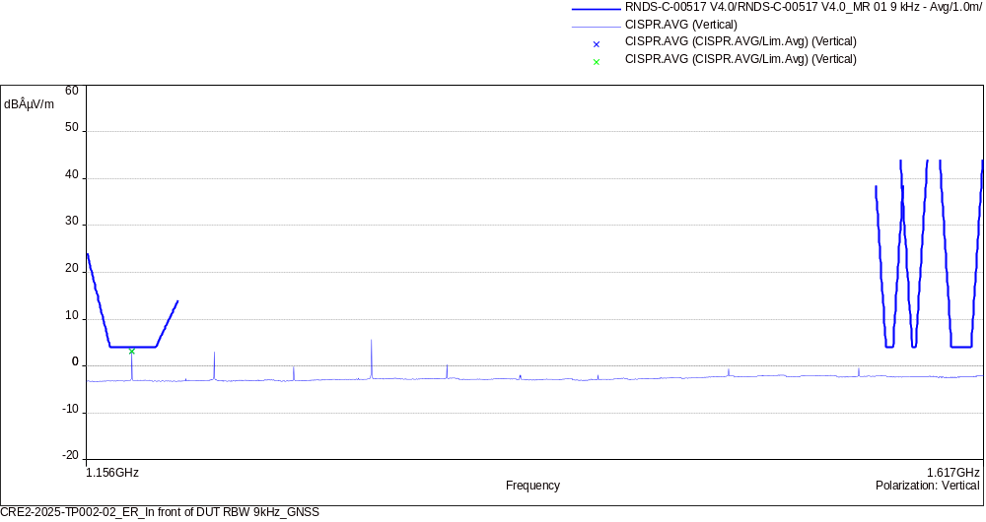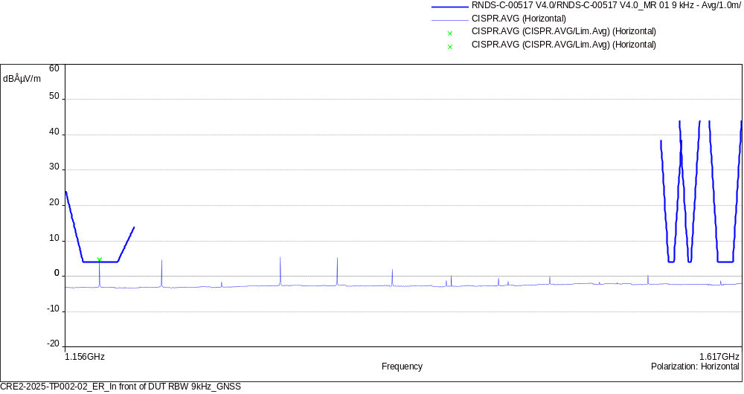
CISPR.AVG/Lim.Avg (2)
Frequency (MHz) | SR | CISPR.AVG (dBÂµV/m) | Lim.Avg (dBÂµV/m) | CISPR.AVG-Lim.Avg (dB) | Polarization | Correction (dB)
1175.908 | 1 | 3.13 | 4.00 | -0.87 | Vertical | 20.75
1175.908 | 2 | 4.68 | 4.00 | 0.68 | Horizontal | 20.75

Test parameters
Name test: | CRE2-2025-TP002-02_ER_In front of DUT RBW 9kHz_GNSS

name | 1.156GHz-1.617GHz |  | filename | CRE2-2025-TP002-02_ER_In front of DUT RBW 9kHz_GNSS
step | 2.25kHz |  | pre-amplifier | ON
set up | USE_CRE2_RESAC (A) 1.1-1.7GHz_GPS_horn |  | number of sweeping | 3
RBW | 9kHz |  | dynamic | 120 dB
Span | 0.1 MHz |  | reference level | 70 dBµV
VBW | Auto |  | RF attenuation | 0 dB
sweep time | 1000 ms/Step |  | RF attenuation min
Maxhold | 5 s

name | 1.156GHz-1.617GHz |  | filename | CRE2-2025-TP002-02_ER_In front of DUT RBW 9kHz_GNSS
step | 2.25kHz |  | pre-amplifier | ON
set up | USE_CRE2_RESAC (A) 1.1-1.7GHz_GPS_horn |  | number of sweeping | 3
RBW | 9kHz |  | dynamic | 120 dB
Span | 0.1 MHz |  | reference level | 70 dBµV
VBW | Auto |  | RF attenuation | 0 dB
sweep time | 1000 ms/Step |  | RF attenuation min
Maxhold | 5 s
EQ/MR 01: Measurement of radio frequency radiated emission test

Sample: |  |  | CRE2-2025-TP002-02
Project: | CRE2-2025-TP002 RESAC
Operator: |  | NDN/WD, 19/02/2025 15:27:53
Test Configuration: |  |  |  |  | Antenna position:in front of DUT, DUT Orientation:axis Y, Housing connected to the ground plane:no, Configuration of the power return line LV:remotely grounded, -
Operating mode: |  |  |  | Mode 3, Conclusion : not comply
GraphiqueEMIRE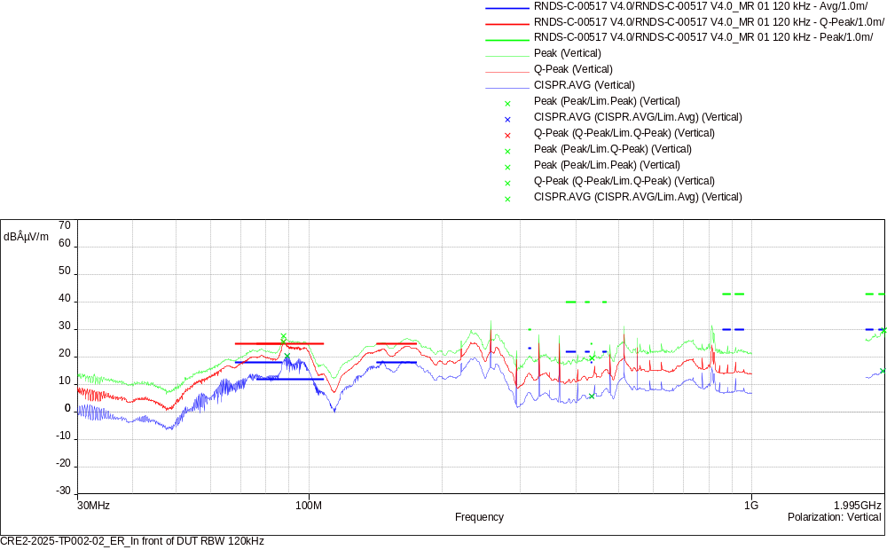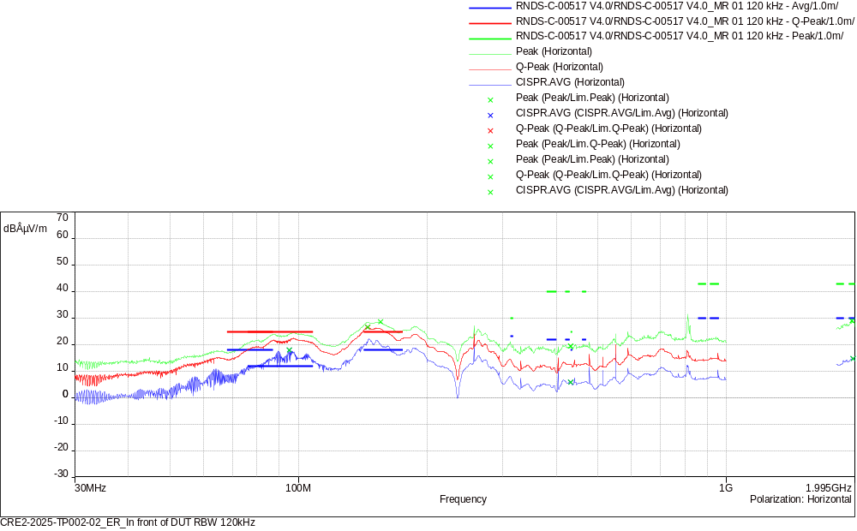
CISPR.AVG/Lim.Avg (6)
Frequency (MHz) | SR | CISPR.AVG (dBÂµV/m) | Lim.Avg (dBÂµV/m) | CISPR.AVG-Lim.Avg (dB) | Polarization | Correction (dB)
89.28 | 1 | 20.33 | 12.00 | 8.33 | Vertical | -18.61
95.07 | 2 | 17.87 | 12.00 | 5.87 | Horizontal | -18.31
434.45 | 3 | 5.58 | 18.00 | -12.42 | Vertical | -10.11
432.02 | 4 | 5.77 | 18.00 | -12.23 | Horizontal | -10.22
1976.63 | 5 | 14.77 | 30.00 | -15.23 | Vertical | 6.16
1976.72 | 6 | 14.71 | 30.00 | -15.29 | Horizontal | 6.16

Q-Peak/Lim.Q-Peak (2)
Frequency (MHz) | SR | Q-Peak (dBÂµV/m) | Lim.Q-Peak (dBÂµV/m) | Q-Peak-Lim.Q-Peak (dB) | Polarization | Correction (dB)
87.63 | 1 | 25.45 | 25.00 | 0.45 | Vertical | -18.73
144.93 | 2 | 26.53 | 25.00 | 1.53 | Horizontal | -15.56

Peak/Lim.Peak (4)
Frequency (MHz) | SR | Peak (dBÂµV/m) | Lim.Peak (dBÂµV/m) | Peak-Lim.Peak (dB) | Polarization | Correction (dB)
435.95 | 3 | 19.54 | 25.00 | -5.46 | Vertical | -10.10
432.11 | 4 | 19.45 | 25.00 | -5.55 | Horizontal | -10.21
1987.43 | 5 | 29.70 | 43.00 | -13.30 | Vertical | 6.26
1964.33 | 6 | 28.93 | 43.00 | -14.07 | Horizontal | 6.06

Test parameters
Name test: | CRE2-2025-TP002-02_ER_In front of DUT RBW 120kHz

name | 30MHz-200MHz |  | filename | CRE2-2025-TP002-02_ER_In front of DUT RBW 120kHz
step | 30kHz |  | pre-amplifier | OFF
set up | USE_CRE2_RESAC (A) 20MHz-300MHz_biconical with preamp |  | number of sweeping | 3
RBW | 120kHz |  | dynamic | 120 dB
Span | 0.1 MHz |  | reference level | 70 dBµV
VBW | Auto |  | RF attenuation | 0 dB
sweep time | 1000 ms/Step |  | RF attenuation min
Maxhold | 5 s

name | 30MHz-200MHz |  | filename | CRE2-2025-TP002-02_ER_In front of DUT RBW 120kHz
step | 30kHz |  | pre-amplifier | OFF
set up | USE_CRE2_RESAC (A) 20MHz-300MHz_biconical with preamp |  | number of sweeping | 3
RBW | 120kHz |  | dynamic | 120 dB
Span | 0.1 MHz |  | reference level | 70 dBµV
VBW | Auto |  | RF attenuation | 0 dB
sweep time | 1000 ms/Step |  | RF attenuation min
Maxhold | 5 s

name | 200MHz-1GHz |  | filename | CRE2-2025-TP002-02_ER_In front of DUT RBW 120kHz
step | 30kHz |  | pre-amplifier | OFF
set up | USE_CRE2_RESAC (A) 200MHz-2GHz_log-periodic with preamp |  | number of sweeping | 3
RBW | 120kHz |  | dynamic | 120 dB
Span | 0.1 MHz |  | reference level | 70 dBµV
VBW | Auto |  | RF attenuation | 0 dB
sweep time | 1000 ms/Step |  | RF attenuation min
Maxhold | 5 s

name | 200MHz-1GHz |  | filename | CRE2-2025-TP002-02_ER_In front of DUT RBW 120kHz
step | 30kHz |  | pre-amplifier | OFF
set up | USE_CRE2_RESAC (A) 200MHz-2GHz_log-periodic with preamp |  | number of sweeping | 3
RBW | 120kHz |  | dynamic | 120 dB
Span | 0.1 MHz |  | reference level | 70 dBµV
VBW | Auto |  | RF attenuation | 0 dB
sweep time | 1000 ms/Step |  | RF attenuation min
Maxhold | 5 s

name | 1.805GHz-1.995GHz |  | filename | CRE2-2025-TP002-02_ER_In front of DUT RBW 120kHz
step | 30kHz |  | pre-amplifier | OFF
set up | USE_CRE2_RESAC (A) 200MHz-2GHz_log-periodic with preamp |  | number of sweeping | 3
RBW | 120kHz |  | dynamic | 120 dB
Span | 0.1 MHz |  | reference level | 70 dBµV
VBW | Auto |  | RF attenuation | 0 dB
sweep time | 1000 ms/Step |  | RF attenuation min
Maxhold | 5 s

name | 1.805GHz-1.995GHz |  | filename | CRE2-2025-TP002-02_ER_In front of DUT RBW 120kHz
step | 30kHz |  | pre-amplifier | OFF
set up | USE_CRE2_RESAC (A) 200MHz-2GHz_log-periodic with preamp |  | number of sweeping | 3
RBW | 120kHz |  | dynamic | 120 dB
Span | 0.1 MHz |  | reference level | 70 dBµV
VBW | Auto |  | RF attenuation | 0 dB
sweep time | 1000 ms/Step |  | RF attenuation min
Maxhold | 5 s
EQ/MR 01: Measurement of radio frequency radiated emission test

Sample: |  |  | CRE2-2025-TP002-02
Project: | CRE2-2025-TP002 RESAC
Operator: |  | NDN/WD, 19/02/2025 15:31:48
Test Configuration: |  |  |  |  | Antenna position:in front of DUT, DUT Orientation:axis Y, Housing connected to the ground plane:no, Configuration of the power return line LV:remotely grounded, -
Operating mode: |  |  |  | Mode 3, Conclusion : not comply
GraphiqueEMIRE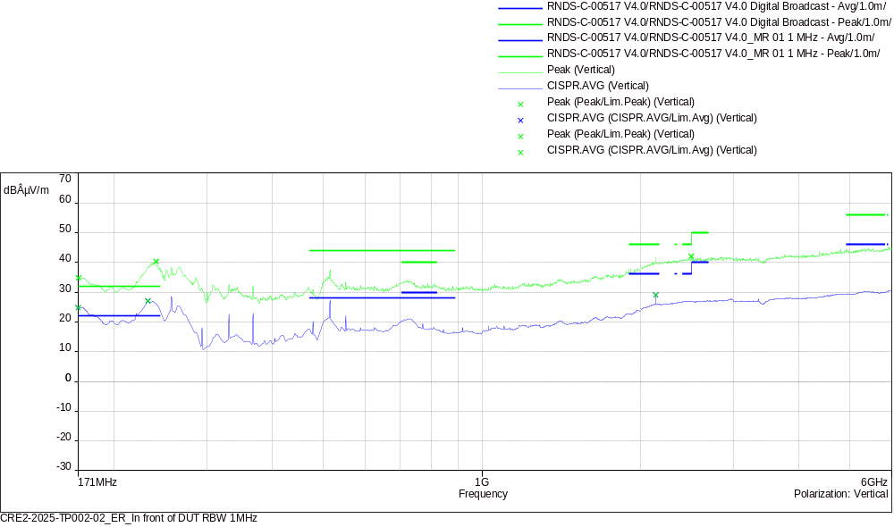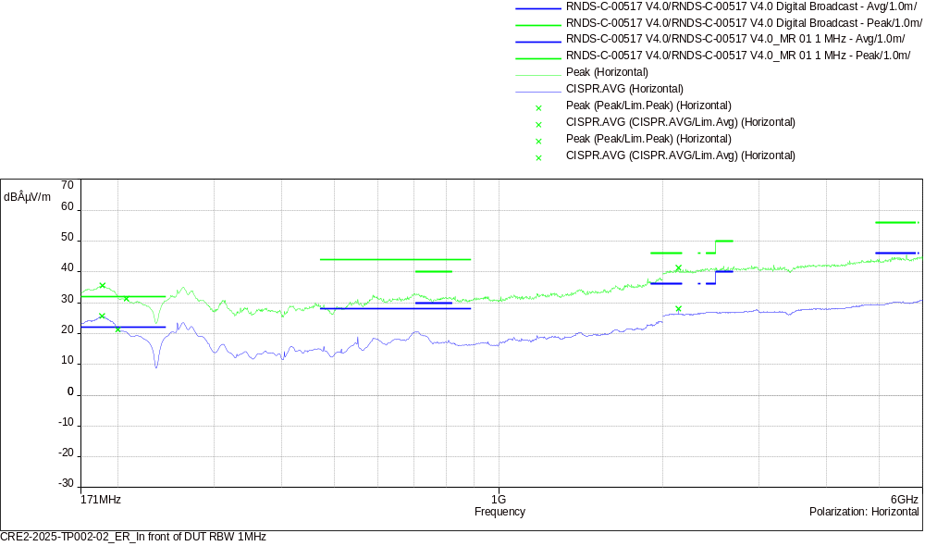
CISPR.AVG/Lim.Avg (6)
Frequency (MHz) | SR | CISPR.AVG (dBÂµV/m) | Lim.Avg (dBÂµV/m) | CISPR.AVG-Lim.Avg (dB) | Polarization | Correction (dB)
171 | 1 | 24.82 | 22.00 | 2.82 | Vertical | -14.36
187 | 2 | 25.59 | 22.00 | 3.59 | Horizontal | -13.66
232 | 3 | 27.06 | 22.00 | 5.06 | Vertical | -14.42
200 | 4 | 21.29 | 22.00 | -0.71 | Horizontal | -16.04
2137.5 | 5 | 29.09 | 36.00 | -6.91 | Vertical | 8.85
2137.5 | 6 | 28.05 | 36.00 | -7.95 | Horizontal | 8.85

Peak/Lim.Peak (6)
Frequency (MHz) | SR | Peak (dBÂµV/m) | Lim.Peak (dBÂµV/m) | Peak-Lim.Peak (dB) | Polarization | Correction (dB)
171.25 | 1 | 34.86 | 32.00 | 2.86 | Vertical | -14.35
187.25 | 2 | 35.59 | 32.00 | 3.59 | Horizontal | -13.64
240.75 | 3 | 40.36 | 32.00 | 8.36 | Vertical | -14.42
207.25 | 4 | 31.34 | 32.00 | -0.66 | Horizontal | -15.55
2496 | 5 | 42.04 | 46.00 | -3.96 | Vertical | 9.77
2137.25 | 6 | 41.30 | 46.00 | -4.70 | Horizontal | 8.85

Test parameters
Name test: | CRE2-2025-TP002-02_ER_In front of DUT RBW 1MHz

name | 171MHz-200MHz |  | filename | CRE2-2025-TP002-02_ER_In front of DUT RBW 1MHz
step | 250kHz |  | pre-amplifier | OFF
set up | USE_CRE2_RESAC (A) 20MHz-300MHz_biconical with preamp |  | number of sweeping | 3
RBW | 1MHz |  | dynamic | 120 dB
Span | 0.1 MHz |  | reference level | 70 dBµV
VBW | Auto |  | RF attenuation | 0 dB
sweep time | 1000 ms/Step |  | RF attenuation min
Maxhold | 5 s

name | 171MHz-200MHz |  | filename | CRE2-2025-TP002-02_ER_In front of DUT RBW 1MHz
step | 250kHz |  | pre-amplifier | OFF
set up | USE_CRE2_RESAC (A) 20MHz-300MHz_biconical with preamp |  | number of sweeping | 3
RBW | 1MHz |  | dynamic | 120 dB
Span | 0.1 MHz |  | reference level | 70 dBµV
VBW | Auto |  | RF attenuation | 0 dB
sweep time | 1000 ms/Step |  | RF attenuation min
Maxhold | 5 s

name | 200MHz-2GHz |  | filename | CRE2-2025-TP002-02_ER_In front of DUT RBW 1MHz
step | 250kHz |  | pre-amplifier | OFF
set up | USE_CRE2_RESAC (A) 200MHz-2GHz_log-periodic with preamp |  | number of sweeping | 3
RBW | 1MHz |  | dynamic | 120 dB
Span | 0.1 MHz |  | reference level | 70 dBµV
VBW | Auto |  | RF attenuation | 0 dB
sweep time | 1000 ms/Step |  | RF attenuation min
Maxhold | 5 s

name | 200MHz-2GHz |  | filename | CRE2-2025-TP002-02_ER_In front of DUT RBW 1MHz
step | 250kHz |  | pre-amplifier | OFF
set up | USE_CRE2_RESAC (A) 200MHz-2GHz_log-periodic with preamp |  | number of sweeping | 3
RBW | 1MHz |  | dynamic | 120 dB
Span | 0.1 MHz |  | reference level | 70 dBµV
VBW | Auto |  | RF attenuation | 0 dB
sweep time | 1000 ms/Step |  | RF attenuation min
Maxhold | 5 s

name | 2GHz-6GHz |  | filename | CRE2-2025-TP002-02_ER_In front of DUT RBW 1MHz
step | 250kHz |  | pre-amplifier | OFF
set up | USE_CRE2_RESAC (A) 1-7GHz_horn with preamp |  | number of sweeping | 3
RBW | 1MHz |  | dynamic | 120 dB
Span | 0.1 MHz |  | reference level | 70 dBµV
VBW | Auto |  | RF attenuation | 0 dB
sweep time | 1000 ms/Step |  | RF attenuation min
Maxhold | 5 s

name | 2GHz-6GHz |  | filename | CRE2-2025-TP002-02_ER_In front of DUT RBW 1MHz
step | 250kHz |  | pre-amplifier | OFF
set up | USE_CRE2_RESAC (A) 1-7GHz_horn with preamp |  | number of sweeping | 3
RBW | 1MHz |  | dynamic | 120 dB
Span | 0.1 MHz |  | reference level | 70 dBµV
VBW | Auto |  | RF attenuation | 0 dB
sweep time | 1000 ms/Step |  | RF attenuation min
Maxhold | 5 s
EQ/MR 01: Measurement of radio frequency radiated emission test

Sample: |  |  | CRE2-2025-TP002-02
Project: | CRE2-2025-TP002 RESAC
Operator: |  | NDN/WD, 18/02/2025 07:54:39
Test Configuration: |  |  |  |  | Antenna position:in front of harness, DUT Orientation:axis X, Housing connected to the ground plane:no, Configuration of the power return line LV:remotely grounded, -
Operating mode: |  |  |  | Mode 3, Conclusion : not comply
GraphiqueEMIRE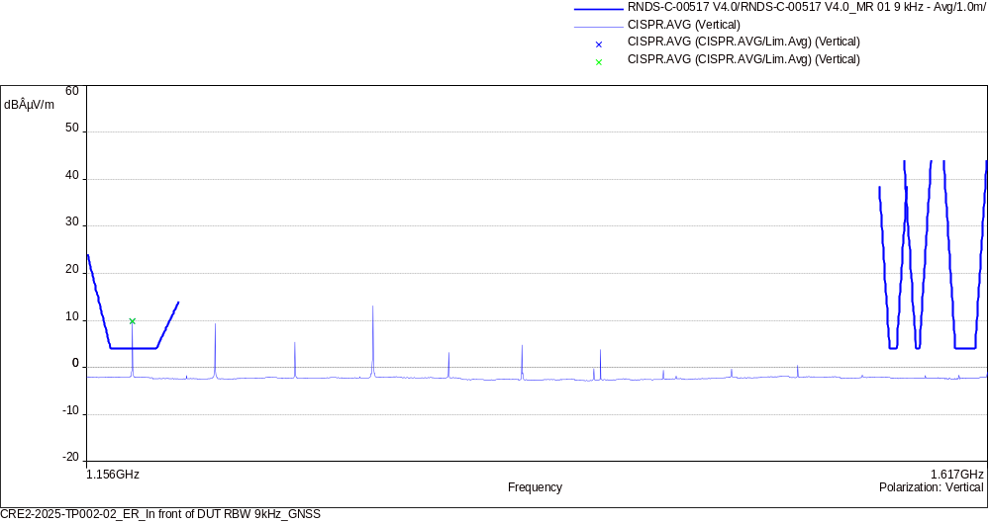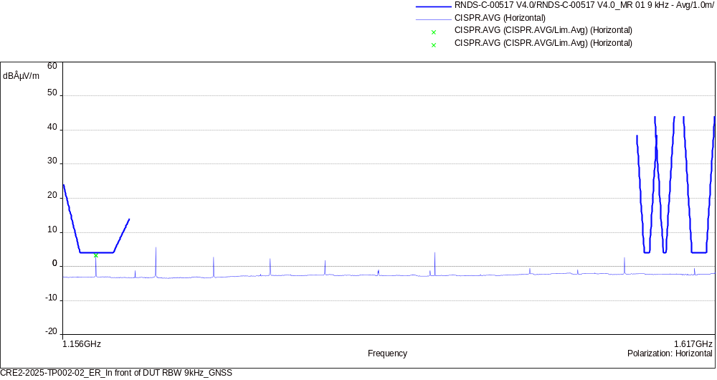
CISPR.AVG/Lim.Avg (2)
Frequency (MHz) | SR | CISPR.AVG (dBÂµV/m) | Lim.Avg (dBÂµV/m) | CISPR.AVG-Lim.Avg (dB) | Polarization | Correction (dB)
1175.908 | 1 | 9.85 | 4.00 | 5.85 | Vertical | 20.75
1175.908 | 2 | 3.27 | 4.00 | -0.73 | Horizontal | 20.75

Test parameters
Name test: | CRE2-2025-TP002-02_ER_In front of DUT RBW 9kHz_GNSS

name | 1.156GHz-1.617GHz |  | filename | CRE2-2025-TP002-02_ER_In front of DUT RBW 9kHz_GNSS
step | 2.25kHz |  | pre-amplifier | ON
set up | USE_CRE2_RESAC (A) 1.1-1.7GHz_GPS_horn |  | number of sweeping | 3
RBW | 9kHz |  | dynamic | 120 dB
Span | 0.1 MHz |  | reference level | 70 dBµV
VBW | Auto |  | RF attenuation | 0 dB
sweep time | 1000 ms/Step |  | RF attenuation min
Maxhold | 5 s

name | 1.156GHz-1.617GHz |  | filename | CRE2-2025-TP002-02_ER_In front of DUT RBW 9kHz_GNSS
step | 2.25kHz |  | pre-amplifier | ON
set up | USE_CRE2_RESAC (A) 1.1-1.7GHz_GPS_horn |  | number of sweeping | 3
RBW | 9kHz |  | dynamic | 120 dB
Span | 0.1 MHz |  | reference level | 70 dBµV
VBW | Auto |  | RF attenuation | 0 dB
sweep time | 1000 ms/Step |  | RF attenuation min
Maxhold | 5 s
EQ/MR 01: Measurement of radio frequency radiated emission test

Sample: |  |  | CRE2-2025-TP002-02
Project: | CRE2-2025-TP002 RESAC
Operator: |  | NDN/WD, 20/02/2025 11:12:24
Test Configuration: |  |  |  |  | Antenna position:in front of DUT, DUT Orientation:axis Z, Housing connected to the ground plane:no, Configuration of the power return line LV:remotely grounded, -
Operating mode: |  |  |  | Mode 3, Conclusion : not comply
GraphiqueEMIRE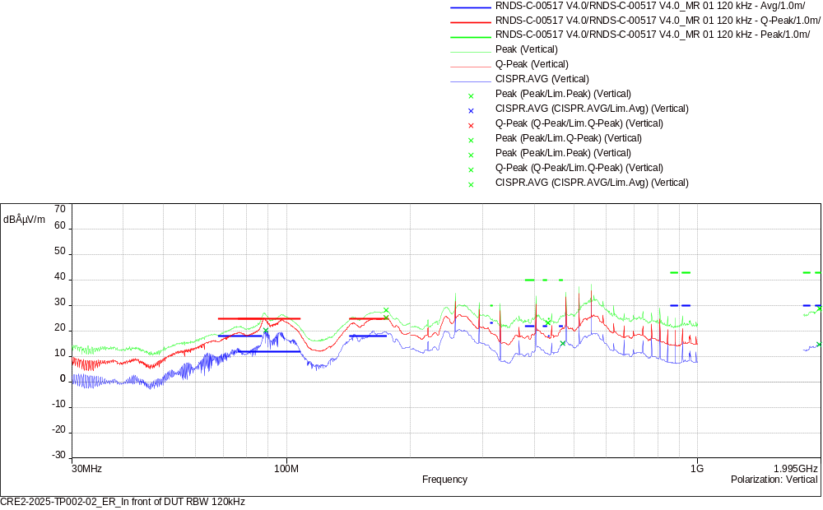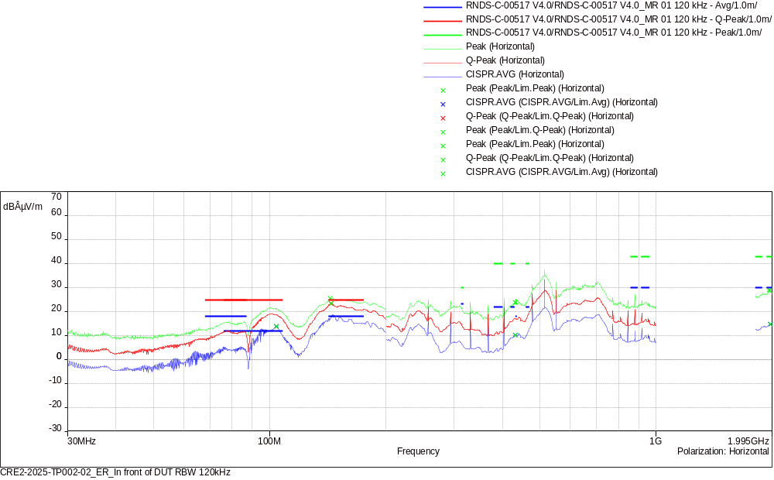
CISPR.AVG/Lim.Avg (6)
Frequency (MHz) | SR | CISPR.AVG (dBÂµV/m) | Lim.Avg (dBÂµV/m) | CISPR.AVG-Lim.Avg (dB) | Polarization | Correction (dB)
88.92 | 1 | 20.23 | 12.00 | 8.23 | Vertical | -18.63
104.04 | 2 | 13.78 | 12.00 | 1.78 | Horizontal | -17.86
469.46 | 3 | 15.05 | 22.00 | -6.95 | Vertical | -8.71
432.14 | 4 | 10.07 | 18.00 | -7.93 | Horizontal | -10.21
1976.75 | 5 | 14.63 | 30.00 | -15.37 | Vertical | 6.16
1976.42 | 6 | 14.62 | 30.00 | -15.38 | Horizontal | 6.16

Q-Peak/Lim.Q-Peak (2)
Frequency (MHz) | SR | Q-Peak (dBÂµV/m) | Lim.Q-Peak (dBÂµV/m) | Q-Peak-Lim.Q-Peak (dB) | Polarization | Correction (dB)
174.51 | 1 | 25.24 | 25.00 | 0.24 | Vertical | -14.23
144.27 | 2 | 23.29 | 25.00 | -1.71 | Horizontal | -15.60

Peak/Lim.Peak (4)
Frequency (MHz) | SR | Peak (dBÂµV/m) | Lim.Peak (dBÂµV/m) | Peak-Lim.Peak (dB) | Polarization | Correction (dB)
432.56 | 3 | 23.15 | 25.00 | -1.85 | Vertical | -10.19
432.26 | 4 | 23.74 | 25.00 | -1.26 | Horizontal | -10.21
1978.58 | 5 | 28.87 | 43.00 | -14.13 | Vertical | 6.18
1961.15 | 6 | 28.81 | 43.00 | -14.19 | Horizontal | 6.03

Test parameters
Name test: | CRE2-2025-TP002-02_ER_In front of DUT RBW 120kHz

name | 30MHz-200MHz |  | filename | CRE2-2025-TP002-02_ER_In front of DUT RBW 120kHz
step | 30kHz |  | pre-amplifier | OFF
set up | USE_CRE2_RESAC (A) 20MHz-300MHz_biconical with preamp |  | number of sweeping | 3
RBW | 120kHz |  | dynamic | 120 dB
Span | 0.1 MHz |  | reference level | 70 dBµV
VBW | Auto |  | RF attenuation | 0 dB
sweep time | 1000 ms/Step |  | RF attenuation min
Maxhold | 5 s

name | 30MHz-200MHz |  | filename | CRE2-2025-TP002-02_ER_In front of DUT RBW 120kHz
step | 30kHz |  | pre-amplifier | OFF
set up | USE_CRE2_RESAC (A) 20MHz-300MHz_biconical with preamp |  | number of sweeping | 3
RBW | 120kHz |  | dynamic | 120 dB
Span | 0.1 MHz |  | reference level | 70 dBµV
VBW | Auto |  | RF attenuation | 0 dB
sweep time | 1000 ms/Step |  | RF attenuation min
Maxhold | 5 s

name | 200MHz-1GHz |  | filename | CRE2-2025-TP002-02_ER_In front of DUT RBW 120kHz
step | 30kHz |  | pre-amplifier | OFF
set up | USE_CRE2_RESAC (A) 200MHz-2GHz_log-periodic with preamp |  | number of sweeping | 3
RBW | 120kHz |  | dynamic | 120 dB
Span | 0.1 MHz |  | reference level | 70 dBµV
VBW | Auto |  | RF attenuation | 0 dB
sweep time | 1000 ms/Step |  | RF attenuation min
Maxhold | 5 s

name | 200MHz-1GHz |  | filename | CRE2-2025-TP002-02_ER_In front of DUT RBW 120kHz
step | 30kHz |  | pre-amplifier | OFF
set up | USE_CRE2_RESAC (A) 200MHz-2GHz_log-periodic with preamp |  | number of sweeping | 3
RBW | 120kHz |  | dynamic | 120 dB
Span | 0.1 MHz |  | reference level | 70 dBµV
VBW | Auto |  | RF attenuation | 0 dB
sweep time | 1000 ms/Step |  | RF attenuation min
Maxhold | 5 s

name | 1.805GHz-1.995GHz |  | filename | CRE2-2025-TP002-02_ER_In front of DUT RBW 120kHz
step | 30kHz |  | pre-amplifier | OFF
set up | USE_CRE2_RESAC (A) 200MHz-2GHz_log-periodic with preamp |  | number of sweeping | 3
RBW | 120kHz |  | dynamic | 120 dB
Span | 0.1 MHz |  | reference level | 70 dBµV
VBW | Auto |  | RF attenuation | 0 dB
sweep time | 1000 ms/Step |  | RF attenuation min
Maxhold | 5 s

name | 1.805GHz-1.995GHz |  | filename | CRE2-2025-TP002-02_ER_In front of DUT RBW 120kHz
step | 30kHz |  | pre-amplifier | OFF
set up | USE_CRE2_RESAC (A) 200MHz-2GHz_log-periodic with preamp |  | number of sweeping | 3
RBW | 120kHz |  | dynamic | 120 dB
Span | 0.1 MHz |  | reference level | 70 dBµV
VBW | Auto |  | RF attenuation | 0 dB
sweep time | 1000 ms/Step |  | RF attenuation min
Maxhold | 5 s
EQ/MR 01: Measurement of radio frequency radiated emission test

Sample: |  |  | CRE2-2025-TP002-02
Project: | CRE2-2025-TP002 RESAC
Operator: |  | NDN/WD, 20/02/2025 09:26:46
Test Configuration: |  |  |  |  | Antenna position:in front of DUT, DUT Orientation:axis Z, Housing connected to the ground plane:no, Configuration of the power return line LV:remotely grounded, -
Operating mode: |  |  |  | Mode 3, Conclusion : not comply
GraphiqueEMIRE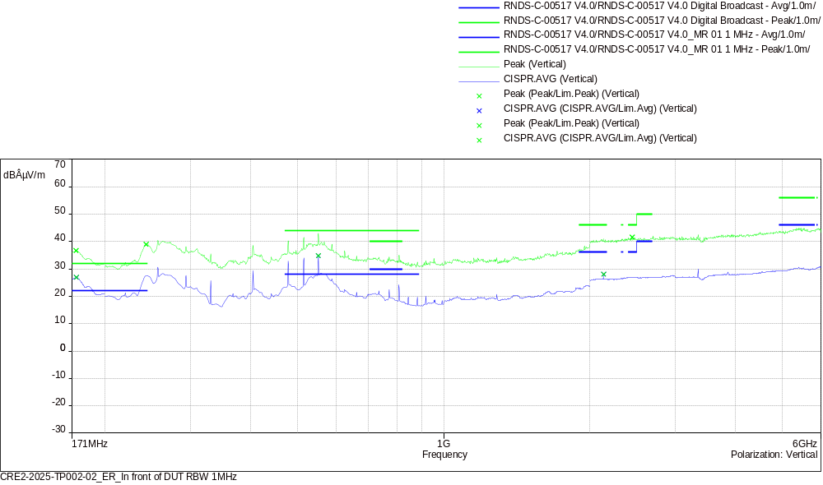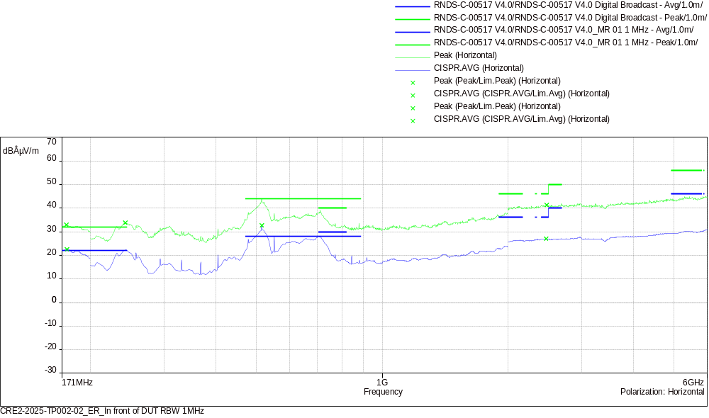
CISPR.AVG/Lim.Avg (6)
Frequency (MHz) | SR | CISPR.AVG (dBÂµV/m) | Lim.Avg (dBÂµV/m) | CISPR.AVG-Lim.Avg (dB) | Polarization | Correction (dB)
174.75 | 1 | 26.85 | 22.00 | 4.85 | Vertical | -14.23
175.75 | 2 | 22.58 | 22.00 | 0.58 | Horizontal | -14.19
551.25 | 3 | 34.82 | 28.00 | 6.82 | Vertical | -7.70
514.5 | 4 | 32.73 | 28.00 | 4.73 | Horizontal | -8.37
2137.5 | 5 | 28.05 | 36.00 | -7.95 | Vertical | 8.85
2467 | 6 | 26.99 | 36.00 | -9.01 | Horizontal | 9.85

Peak/Lim.Peak (6)
Frequency (MHz) | SR | Peak (dBÂµV/m) | Lim.Peak (dBÂµV/m) | Peak-Lim.Peak (dB) | Polarization | Correction (dB)
174.5 | 1 | 36.67 | 32.00 | 4.67 | Vertical | -14.24
175.25 | 2 | 32.94 | 32.00 | 0.94 | Horizontal | -14.21
243.25 | 3 | 38.98 | 32.00 | 6.98 | Vertical | -14.47
242.5 | 4 | 33.79 | 32.00 | 1.79 | Horizontal | -14.48
2449.25 | 5 | 41.54 | 46.00 | -4.46 | Vertical | 9.89
2475.25 | 6 | 41.25 | 46.00 | -4.75 | Horizontal | 9.83

Test parameters
Name test: | CRE2-2025-TP002-02_ER_In front of DUT RBW 1MHz

name | 171MHz-200MHz |  | filename | CRE2-2025-TP002-02_ER_In front of DUT RBW 1MHz
step | 250kHz |  | pre-amplifier | OFF
set up | USE_CRE2_RESAC (A) 20MHz-300MHz_biconical with preamp |  | number of sweeping | 3
RBW | 1MHz |  | dynamic | 120 dB
Span | 0.1 MHz |  | reference level | 70 dBµV
VBW | Auto |  | RF attenuation | 0 dB
sweep time | 1000 ms/Step |  | RF attenuation min
Maxhold | 5 s

name | 171MHz-200MHz |  | filename | CRE2-2025-TP002-02_ER_In front of DUT RBW 1MHz
step | 250kHz |  | pre-amplifier | OFF
set up | USE_CRE2_RESAC (A) 20MHz-300MHz_biconical with preamp |  | number of sweeping | 3
RBW | 1MHz |  | dynamic | 120 dB
Span | 0.1 MHz |  | reference level | 70 dBµV
VBW | Auto |  | RF attenuation | 0 dB
sweep time | 1000 ms/Step |  | RF attenuation min
Maxhold | 5 s

name | 200MHz-2GHz |  | filename | CRE2-2025-TP002-02_ER_In front of DUT RBW 1MHz
step | 250kHz |  | pre-amplifier | OFF
set up | USE_CRE2_RESAC (A) 200MHz-2GHz_log-periodic with preamp |  | number of sweeping | 3
RBW | 1MHz |  | dynamic | 120 dB
Span | 0.1 MHz |  | reference level | 70 dBµV
VBW | Auto |  | RF attenuation | 0 dB
sweep time | 1000 ms/Step |  | RF attenuation min
Maxhold | 5 s

name | 200MHz-2GHz |  | filename | CRE2-2025-TP002-02_ER_In front of DUT RBW 1MHz
step | 250kHz |  | pre-amplifier | OFF
set up | USE_CRE2_RESAC (A) 200MHz-2GHz_log-periodic with preamp |  | number of sweeping | 3
RBW | 1MHz |  | dynamic | 120 dB
Span | 0.1 MHz |  | reference level | 70 dBµV
VBW | Auto |  | RF attenuation | 0 dB
sweep time | 1000 ms/Step |  | RF attenuation min
Maxhold | 5 s

name | 2GHz-6GHz |  | filename | CRE2-2025-TP002-02_ER_In front of DUT RBW 1MHz
step | 250kHz |  | pre-amplifier | OFF
set up | USE_CRE2_RESAC (A) 1-7GHz_horn with preamp |  | number of sweeping | 3
RBW | 1MHz |  | dynamic | 120 dB
Span | 0.1 MHz |  | reference level | 70 dBµV
VBW | Auto |  | RF attenuation | 0 dB
sweep time | 1000 ms/Step |  | RF attenuation min
Maxhold | 5 s

name | 2GHz-6GHz |  | filename | CRE2-2025-TP002-02_ER_In front of DUT RBW 1MHz
step | 250kHz |  | pre-amplifier | OFF
set up | USE_CRE2_RESAC (A) 1-7GHz_horn with preamp |  | number of sweeping | 3
RBW | 1MHz |  | dynamic | 120 dB
Span | 0.1 MHz |  | reference level | 70 dBµV
VBW | Auto |  | RF attenuation | 0 dB
sweep time | 1000 ms/Step |  | RF attenuation min
Maxhold | 5 s

